

**Etiology, Risk Factors and Interactions of Enteric Infections and Malnutrition and the Consequences for Child Health and Development**

Birth Cohort Studies

Manual of Procedures

November, 2014

**Table of Contents**

Introduction to the Manual of Procedures iii

Background and Rationale iv

Abbreviations vii

**Recruit, Consent and Enroll** 1

SCR—Screening Process 2

PID—Participant ID Log SOP 4

NPF—Non-Participant Form SOP 5

Consenting Process 8

CAF—Child Assesment Form SOP 10

**Demographic, SES and Food Security Assessments** 12

DAF—Baseline Demographic Questionnaire 13

FSQ—Food Security Questionnaire 15

FSE—Followup SES Questionnaire 17

**Household Surveillance** 25

SAF—Surveillance Assessment Form 26

XAF—Surveillance Check Form 34

NUR—Nursing Notes Form 36

REF—Child Referral Form SOP 37

MOA—Monthly Form A 40

MAF—Maternal Assessment Form 45

MOB—Monthly Form B 47

MOC—Monthly Form C 50

ANT – Anthropometry Check Form 55

NCF—Non-Continuation Form SOP 57

QCS—Surveillance Quality Monitoring: Guidelines for Field Supervisors 59

Surveillance Assessment Form – Quality Control Plan 63

Anthropometry Quality Control Plan 65

Supervisor checklist 66

VIF—Vaccine Information Form SOP 68

**Collection and Processing of Clinical SampleS** 70

SIL—Sample ID Log SOP 71

**Stool** 72

SCT/SFC—Stool Collection, Processing and Transport to the Laboratory 73

RSS/SRF—Receiving and Storage of Stool Samples SOP 79

Stool Specimen Test Quantities and Storage 87

QNS—Processing and Testing Quantity Not Sufficient Stool 88

Microbiology Stool Aliquoting Flow Chart 92

ELISA thawed specimen stability & work flow 93

BDF—Stool Bacteriology Culture and Identification: Bacteriology Data Form SOP 94

ECP—Identification of Diarrheagenic E.coli by Multiplex PCR SOP 110

FVF—Fecal Viral ELISA Tests 116

NRV—Detection of Norovirus by RT-PCR 120

MDF—Microscopy for the Detection of Ova and Parasites in Stool: Microscopy Data Form SOP 128

PEF—Detection of Protozoa By ELISA 135

ALA—Alpha -1- Antitrypsin Assay 140

MPO—Myeloperoxidase ELISA: In Vitro Determination of Myeloperoxidase in Stool 146

NEO—Neopterin ELISA: Quantitative Determination of Neopterin in Stool 152

QCB—Quality Control: Bacterial Growth Media 158

QCM—Quality Control/Quality Assurance: Microbiology 160

**Urine** 161

UCF—Urine Collection, Processing, and Transport 162

USV—Small Volume Urine Collection, Processing and Transport SOP 168

ULM—Lactulose: Mannitol Assay SOP 171

UIL—Urinary Iodine Assay SOP 179

**Blood** 182

BCH/DCF—Blood Collection SOP 183

Appendix A: Blood Collection & Hemoglobin (BCH) SOP Flow Chart 191

HEM—HemoCue Assay for Determining Hemoglobin Levels in Blood 191

BPT—Blood Processing, Transport and Storage 196

Micronutrient Assays 201

AGP—Alpha-1-Acid Glycoprotein SOP 202

HTR—Plasma Human Transferrin Receptor SOP 207

FAR—Plasma Ferritin Assay SOP 218

ZAR—Plasma Zinc Assay SOP 221

RAR—Plasma Retinol Assay SOP (Needs proof reading by Technical subcommittee) 223

PGA—Plasma Glutamine and Arginine Assay SOP 226

BLL—Blood Lead SOP 229

Vaccine Response Assays 230

VRT—Detection of Tetanus*-*Specific IgG in human sera/plasma by ELISA 231

VRM—Detection of Measles*-*Specific IgG by ELISA 239

VRP—Detection of Anti-Bordetella Pertussis Toxin Specific IgG by ELISA 247

VRR—Detection of anti-Rotavirus Specific IgA By ELISA 254

VRF - Form Guidance for Vaccine Response forms 300

**Collection of OTHER Clinical Specimens** 302

AXT—Axillary Temperature Recording and Thermometer Calibration 303

SAL—Saliva Collection SOP 305

BCM – Breast Milk Collection 310

BCT—Breast Milk Sample Transport and Processing SOP 313

MSC—Maternal Stool Collection, Processing and Transport to the Laboratory 315

MSR—Receiving and Storage of Maternal Stool Samples SOP 319

**Growth and Nutrition** 325

Dietary Assessment Overview 326

FRQ/FRS—24 Hour Food Recall SOP 329

ANM—Anthropometry Measurements of Children and Mothers 344

DBE─Detection of Bipedal Edema SOP 351

**Cognitive Development** 353

Cognitive Development Overview 354

HIT—HOME Inventory (Infant/Toddler Version) 357

RCM—Raven’s Combined Progressive Matrices 364

SRQ—Self-Reporting Questionnaire 20 369

BSD—Bayley Scales of Infant Development 371

ITS—Infant Temperament Scale 374

MWG—MacArthur Adapted Communicative Development Inventory (CDI): Words and Gestures 379

VID—Video Collection SOP 381

VFT—Video File Transfer SOP 383

**OTHER** 396

PDF—Protocol Deviation Form SOP 397

AEF—Adverse Event Recording and Reporting SOP 399

GPS - Geographic Positioning System SOP (GPS) 402

**Double Data Entry and Barcode Sample Tracking** 406

BST—Barcode Sample Tracking Database SOP 407

Introduction to the Manual of Procedures

The success of the MAL-ED Network Project depends, to a very large extent, not only on the collaboration and collegial working relationships of all the scientists, administrators and support staff involved in the project, but also on the use of harmonized protocols and methods. Following common protocols will allow us to compare and contrast study results across sites. The implementation of these common protocols is the real strength of the Network and that which makes the MAL-ED Network unique. Indeed, the usefulness of the data and the samples that we gather and archive depends on this collaborative approach and will be the legacy of this project. This Manual of Procedures (MOP) is intended to serve as a field reference guide on how to conduct our studies and as a source of the most current version of the various forms and procedures in use by all sites in the Network.

It is very important that we strive to make this a living document, one that reflects changes in the technologies available to us in the pursuit of our goals, as well as one that is informed by the experience of the researchers and Study Researcher / Nurse / Fieldworkers who have to translate these protocols and data forms into real work and output. We want to hear your comments on what does and does not work and what needs to be changed. We will make collective decisions based on that information and will ensure that all participants are made aware of changes to the procedures that will affect the way investigators do their work.

We realize that any document as large and diverse in its content as this one, which has been assembled by committees, will not be perfect when it is released to the sites for implementation. It is important for you to send your comments on content or ambiguities that you note to MAL-ED administrative staff at The Foundation for the National Institutes of Health (FNIH) or at the Fogarty International Center, NIH (FIC) to coordinate changes and updates.

Background and Rationale

Malnutrition is considered one of the most prevalent risk factors for morbidity and mortality in children under five. An estimated 20% of children in the developing world are malnourished [1] and poor nutrition is linked to more than half of all child deaths worldwide [2]. Malnutrition in early childhood may lead to cognitive and physical deficits and may cause similar deficits in future generations as malnourished mothers give birth to low birth weight children [3]. In addition, malnutrition increases susceptibility and incidence of infections and is associated with diminished response to vaccines.

The root of malnutrition in early childhood is complex and has a variety of direct and underlying contributors: lack of food, insufficient breastfeeding, inadequate complementary foods, catabolic states due to infection, and inadequate response of the host and the host’s gut microbiome to caloric deficit. But pathogenic bacteria, viruses, and parasites in the gut also impact nutritional status. Firstly, enteric pathogens impair nutrient absorption by damaging the absorptive capacity of the intestine, causing protein-energy and micronutrient malnutrition. Secondly, enteric infections can compromise the intestinal barrier, causing increased intestinal permeability to pathogens, endotoxins, and other macromolecules that can result in the chronic stimulation of the immune system. Importantly, both micronutrient deficiencies and chronic immune stimulation have been found to impair growth and increase susceptibility to infectious diseases [4]. Additionally, altered gut flora and pathogens may also influence the effectiveness of orally-delivered vaccines. Understanding the complex and synergistic relationships between enteric infections and malnutrition, therefore, is fundamental to the design of better intervention strategies.

While it is likely that enteric infections can lead to malnutrition, existing data on enteropathogen etiologies are limited by small sample sizes, limited geographic locales, and robustness of diagnostic tests. Additionally, there has been relatively little study of morbidity and mortality due to chronic and recurrent enteric infectious microorganisms and parasites, their contribution to the global burden of disease in children under five, and the consequential long-term effects in adulthood. To date, there have also been no systematic studies elucidating the relationship between growth/development and specific micro-organisms, incidence rates at specific ages in early childhood, or mixed infections. Furthermore, there have not been demonstrative studies on associations of these factors with intermediary indicators, such as gut dysfunction, which would presumably link enteric infections with growth and development. Finally, there are also limited studies looking at vaccine response associated with mixed infection, and the role of micronutrient supplementation in developing countries.



**Hypotheses, Study Aims, and Methods**

**We hypothesize that infection with certain enteropathogens leads to malnutrition by (1) causing intestinal inflammation and/or by altering intestinal barrier and adsorptive function and by (2) failure of normal growth and development.** In addition to quantifying the associations between enteric infection and malnutrition, our study also aims to shed light on relevant questions such as: (1) which micro-organisms or mixed infections are most relevant to growth faltering and poor development and (2) at what age in early life do specific infections cause the most disruption to growth and development?

In order to investigate these hypotheses, we have established a coordinated network of sites in populations with a high prevalence of malnutrition and enteric infections for a comprehensive study, using shared and harmonized protocols, to determine factors that impact early childhood health and development. Intensive surveillance of children during the first two years of life at the proposed network of sites will allow us to elucidate some of these complex relationships and hopfeully lead to more targeted and cost-effective interventions in the future.

We will undertake prospective longitudinal and case control epidemiological studies to identify the factors associated with a child’s risk of enteric infection, chronic diarrhea, malnutrition, as well as with impaired gut function, vaccine response and development.

**Longitudinal Cohort Studies** – At each site, project community health workers will identify, consent and enroll at least 200 infants at birth. The infants will be followed at regular intervals from birth up to 24 months of age and up to 36 months of age when feasible and as budget and protocols allows. Active surveillance for infectious diseases and general child health will include twice weekly household visits. Using harmonized protocols, each site will perform a number of tests and assessments including those for gut function, anthropometry and cognitive development, micronutrient status, and vaccine responses. The standardized procedures for the longitudinal cohort studies are detailed in this document.

**Case Control Studies–** For the case control studies (in Brazil and Bangladesh), moderate to severely underweight (weight for age Z score (WAZ) <-2) children 6-24 months attending nutrition clinics or from the community will be identified and enrolled. Age, sex, and neighborhood matched controls will also be enrolled over the first 4 years (to reach at least 500 cases and 500 controls at each of the two sites) with quarterly follow-up to be conducted for at least one year thereafter. Please note that the standardized procedures for the case-control studies will be outlined in a companion document.

**It is important that all sites follow the standardized procedures detailed below to ensure that data collected for the longitudinal cohort studies at each site will be comparable with data collected at other sites.**

**References:**

1. Black, R.E., et al., *Maternal and child undernutrition: global and regional exposures and health consequences.* Lancet, 2008. **371**(9608): p. 243-60.

2. Caulfield, L.E., et al., *Undernutrition as an underlying cause of child deaths associated with diarrhea, pneumonia, malaria, and measles.* Am J Clin Nutr, 2004. **80**(1): p. 193-8.

3. Victora, C.G., et al., *Maternal and child undernutrition: consequences for adult health and human capital.* Lancet, 2008.

4. Campbell, D.I., M. Elia, and P.G. Lunn, *Growth faltering in rural Gambian infants is associated with impaired small intestinal barrier function, leading to endotoxemia and systemic inflammation.* J Nutr, 2003. **133**(5): p. 1332-8.

### Abbreviations

|  |  |  |
| --- | --- | --- |
| **ID** | **Form/SOP Name** | **Associated Form/SOP ID** |
| AEF | Adverse Event Recording and Reporting SOP |  |
| AGP | Alpha 1-acid Glycoprotein |  |
| ALA | Alpha-1 Antitrypsin |  |
| ANM | Anthropometry Measurements SOP | MOA, MOB, ANM, ANT |
| ANT | Anthropometry Check Form SOP | MOA, MOB, ANM, ANT |
| AXT | Axillary Temperature SOP | MOA, MOB |
| BCH | Blood Collection SOP | HEM, BPT |
| BCM | Breast Milk Collection SOP | BCT |
| BCT | Breast Milk Transport and Processing | BCM |
| BDF | Bacteriology Data Form |  |
| BLL | Blood Lead Assay | SOP is not final |
| BPT | Blood Processing, Transport and Storage | BCH, BRF |
| BSD | Bayley Scales of Infant and Toddler Development |  |
| BST | Barcode Sample Tracking Database SOP |  |
| CAF | Baseline Child Assessment Form |  |
| CBQ | Child Behavior Questionnaire | dependent on future funding |
| DAF | Baseline Demographic Form |  |
| DCF | DNA Collection Form |  |
| DPF | DNA Processing Form |  |
| ECP | E. coli PCR form |  |
| FAR | Ferritin Assay Results Form |  |
| FRQ/FRS | 24 Hour Food Recall SOP |  |
| FSE | Follow-up SES Questionnaire |  |
| FSQ | Food Security Questionnaire |  |
| FVF | Fecal Viral Form |  |
| HEM | HemoCue Assay for Determining Hemoglobin Levels in Blood | BCH |
| HIT | HOME: Infant Toddler Version |  |
| HTR | Plasma Human Transferrin Receptor SOP |  |
| IAR | Urinary Iodine Assay Results Form | UIL |
| ITS | Infant Temperament Scale |  |
| MAF | Maternal Assessment Form | BCH, SAL |
| MDF | Microscopy Data Form |  |
| MEP | MPO ELISA Plate Form | MPO |
| MOA | Monthly Combined Form A | ANM, ANT, AXT |
| MOB | Monthly Combined Form B | ANM, ANT, AXT |
| MOC | Monthly Combined Form C | ANM, ANT, AXT |
| MPO | Myeloperoxidase ELISA Form | MEP |
| MSC | Maternal Stool Collection Form | MSR |
| MSR | Receiving and Storage of Maternal Stool Samples SOP | MSC |
| MWG | MacArthur Words and Gestures |  |
| MWS | MacArthur Words and Sentences | dependent on future funding |
| NCF | Non-Continuation Form |  |
| NEO | Neopterin ELISA Form | NEP |
| NEP | NEO ELISA Plate Form | NEO |
| NPF | Non-Participant Form |  |
| NRV | Detection of Noroviruses |  |
| NUR | Nursing Notes |  |
| PDF | Protocol Deviation Form SOP | PDF |
| PEF | Protozoa ELISA form |  |
| PGA | Plasma Glutamine & Arginine Assay Form |  |
| PID | Participant ID Log |  |
| QCB | Quality Control: Bacterial Growth Media |  |
| QCM | Quality Control/Quality Assurance: Microbiology |  |
| QCS | Surveillance Quality Monitoring | MOA, MOB, ANT, XAF |
| QNS | Quantity Not Sufficient Form |  |
| RAR | Retinol Assay Results Form |  |
| RCM | Raven's Combined Matrices |  |
| REF | Referral Form |  |
| RSS | Receiving and Storage of Stool Samples | SRF, SIL, SFC, QNS |
| SAF | Surveillance Assessment Form | XAF |
| SAL | Saliva Collection SOP | MAF |
| SCR | Screening Form |  |
| SCT | Stool Collection, Processing and Transport to Laboratory | SFC, MOA, MOB, SAF |
| SFC | Stool Field Collection Form | SCT |
| SIL | Sample ID Log |  |
| SRF | Stool Receiving Form | RSS |
| SRQ | SRQ-20 |  |
| STS | Specimen Transport and International Shipping SOP |  |
| UCF | Urine Collection & Receiving Form |  |
| UIL | Urinary Iodine Assay SOP | IAR |
| ULM | Urinary Lactulose-Mannitol Lab Form |  |
| USV | Small Volume Urine Collection Form |  |
| VID | Video Collection SOP | BSD, RCM |
| VIF | Vaccine Information Form SOP | VIF |
| VFT | Video File Transfer SOP | VID |
| VR1 | Vaccine Response Laboratory Report Form, 7 Months | VRM, VRT, VRO, VRP, VRT |
| VR2 | Vaccine Response Laboratory Report Form, 15 Months | VRM, VRT, VRO, VRP, VRT |
| VRM | Vaccine Response ELISA measles SOP | VR1, VR2 |
| VRO | Vaccine Response Polio Plaque Assay SOP | VR1, VR2 |
| VRP | Vaccine Response ELISA Pertussis SOP | VR1, VR2 |
| VRR | Vaccine Response ELISA Rotavirus SOP | VR1, VR2 |
| VRT | Vaccine Response ELISA Tetanus SOP | VR1, VR2 |
| XAF | Surveillance Check Form SOP | SAF |
| ZAR | Zinc Assay Results Form |  |

**Recruit, Consent and Enroll**

SCR—Screening Process

I. Purpose

To screen potential participants for entry into cohort.

II. Material

Screening form, Participant ID log, pen, clipboard.

III. Methods

1. Study Researcher / Nurse / Fieldworker will visit households within 17 days of childbirth in order to screen mothers and children for entry into study. Potential participants will be identified through site-specific methods (e.g. census, antenatal clinics) and informal follow up with the pregnant women will occur in order to ensure screening within 17 days of birth.
2. Participant ID (PID) will be assigned at the start of the visit by writing the name and address of the child on the PID log. This PID will be transferred to the top of the screening form.
3. Question guidance

|  |  |  |
| --- | --- | --- |
| # | Question | Guidance |
|  | Participant ID | Write the participant ID in the space provided at the upper left corner. |
| 01 | Study Researcher / Nurse / Fieldworker ID | The Study Researcher / Nurse / Fieldworker’s unique ID number should be written here. |
| 02 | Today’s date | Today’s date – DD/MMM/YY |
| 03 | Plans to move outside community? | This question asks whether the family plans to move outside the community in the next six months. This includes planned absence from the study area of greater than 30 days if the Study Researcher / Nurse / Fieldworker will be unable to make contact with the caregiver during that time. If the family will move but the Study Researcher / Nurse / Fieldworker can retain contact with the family and collect morbidity information and other data, the child can be enrolled, but if the family plans to be out of the study area for more than 30 days, they should not be enrolled in the study. |
| 04 | Mother <16 years of age? | This question asks the age of the mother. The Study Researcher / Nurse / Fieldworker may already have the age of the mother from the census; in that case, this question will serve to verify the age of the mother. |
| 05 | Mother has another child in MAL-ED study? | This question asks if the mother has another child in the MAL-ED study. The field site should not send a Study Researcher / Nurse / Fieldworker to enroll women who already have a child enrolled in the cohort, but this question serves to verify this information. |
| 06 | Multiple pregnancy? | This question asks if the birth resulted in a single child or multiples (twins, triplets, etc.). |
| 07 | Is the child healthy? | This question asks if the child is healthy. Healthy, for this study, is defined as **not** having:  - Severe disease requiring hospitalization for something other than typical healthy birth  - Severe or chronic condition diagnosed by medical doctor (e.g. neonatal disease, renal disease, chronic heart failure, liver disease, cystic fibrosis, congenital conditions)  - Enteropathies diagnosed by medical doctor |
| 08 | Is the mother able to give informed consent? | This question asks if the mother is living and available to provide informed consent. |

The child is eligible to participate in the study if:

1. The answer to questions 3, 4, 5, and 6 is No, &
2. The answer to questions 7 and 8 is Yes.

If the child is eligible to participate, continue on to the consent form, or if consent has already been obtained, continue to the Child Assessment Form (CAF).

If the child is **not** eligible to participate (answer to question 3, 4, 5, or 6 is Yes, or answer to question 7 or 8 is No) or if the caregiver is unwilling to answer any of the screening questions, the child **cannot** be enrolled in the study and the Non-Participation Form (NPF) should be filled out with the caregiver.

IV. Notes

* Women do not need to have delivered in order to give consent; however, sites may wish to delay the consenting process until after screening is complete (after birth) in order to avoid consenting women who ultimately will not be enrolled in the study.
* The mother needs to be living and able to give consent in order for the child to be enrolled in this study.

V. General QC instructions

- 100% of each Study Researcher / Nurse / Fieldworker’s forms should be reviewed by the supervisor on at least a weekly basis, ideally, at the end of each working day. Supervisors should ensure the forms are complete (no missing fields), that the data appear to be correct, and that visits planned for the day were made.

- Corrections to the forms should be minimized (data should be correct the first time), but if needed, the Study Researcher / Nurse / Fieldworker should follow proper correction procedures. If form corrections are necessary:

* + 1. Cross through the incorrect information once,
    2. Write the correct information,
    3. Write the date the correction was made, and
    4. Write their initials.

- Make sure forms are kept confidential and protected (in a locked file drawer, for example) when they are returned from the field.

- Data center transmission of forms

* + Once forms have been completely filled out by the Study Researchers / Nurses / Fieldworkers and reviewed by the supervisor, they must be delivered within 48 hours to the local data center for data entry. Data entry of the forms should occur within one month of delivery to the data center (preferably sooner).

PID—Participant ID Log SOP

I. Purpose

To assign unique confidential participant IDs (PIDs) to all screened families.

II. Material

Participant ID log, pen, clipboard

III. Methods

1. Study Researcher / Nurse / Fieldworker will visit households within 17 days of childbirth in order to screen mothers and children for entry into study and obtain consent.
2. Participant ID (PID) will be assigned at the start of the visit by writing the name (last, first) and address of the child on the PID log. This PID will be transferred to the top of all forms filled out for the child.
3. The PID log is the link between the PID and the participant’s names and addresses. As such, it should be guarded carefully for the participant’s privacy and for the study’s ability to identify participants.
4. The PID log information will be stored locally in a secure and locked place and will **not** be uploaded to the central database.

IV. Notes

- What is the PID?

Digits 1 & 2 – Indicate country (PE-Peru, BR-Brazil, Bangladesh-BG, Nepal-NP, Pakistan-PK, India-IN, Tanzania-TZ, South Africa-SA)

Digit 3 – Indicates site # (most countries have only one study site at this time)

Digit 4 – Indicates family member – C=Child, M=Mother

Digits 5-8 – Indicates the household number 0001-9999

- In the cohort, the PID Log is the only data collection form that will include names and addresses. The PID will be used to identify participants on all other study forms.

NPF—Non-Participant Form SOP

I. Purpose

To collect some basic information on the mothers / children who were not eligible for the study or refused to participate.

II. Material

Non-Participant form, Participant ID log, pen, clipboard

III. Methods

If the child was not enrolled in the study, either because the family refused to participate or because they did not pass the screening process, this form must be filled out. Start by asking for verbal consent to ask some questions – if consent is given, you may continue with the form. If no consent is given, fill in only the first three questions. If no Participant ID has been assigned (mother refused to go through screening process), document the child’s name (or, if the woman is still pregnant, the mother’s name) and address on the Participant ID log and transfer the PID to the top of the NPF. If the mother does not want to answer any of the questions, fill in ‘NA’.

Some sites may want to collect additional information about why the individual refused to participate. In addition, some sites may want to have supervisors perform follow up visits to families that refuse to participate so that the supervisor can provide additional information about the study.

IV. General QC instructions

- 100% of each Study Researcher / Nurse / Fieldworker’s forms should be reviewed by the supervisor on at least a weekly basis, ideally, at the end of each working day. Supervisors should ensure the forms are complete (no missing fields), that the data appear to be correct, and that visits planned for the day were made.

- Corrections to the forms should be minimized (data should be correct the first time), but if needed, the Study Researcher / Nurse / Fieldworker should follow proper correction procedures. If form corrections are necessary:

* + 1. Cross through the incorrect information once,
    2. Write the correct information,
    3. Write the date the correction was made, and
    4. Write their initials.

- Make sure forms are kept confidential and protected (in a locked file drawer, for example) when they are returned from the field.

- Data center transmission of forms

* + Once forms have been completely filled out by the Study Researchers / Nurses / Fieldworkers and reviewed by the supervisor, they must be delivered within 48 hours to the local data center for data entry. Data entry of the forms should occur within one month of delivery to the data center (preferably sooner).

|  |  |  |
| --- | --- | --- |
| # | Question | Guidance |
|  | Participant ID | Write the child’s participant ID in the space provided at the upper left corner. |
| 01 | Study Researcher / Nurse/Fieldworker ID | Enter the Study Researcher / Nurse / Fieldworker’s unique ID number here. |
| 02 | Today’s date | Format DD/MMM/YY |
| 03 | Reason for not participating | Enter the reason for not participating here. Additional information can be entered into the notes section on the bottom of the form. |
| 04 | Mother’s age | If verbal consent is given, continue with these questions on the form. This is the age of the child’s mother. If she does not know her exact age ask for an estimate, and enter that number. |
| 05 | Number of children | This question asks about the number of live births a woman has had, not including the most recent one. Include only live births, rather than all pregnancies. |
| 06 | Drinking water | The purpose of this question is to assess the cleanliness of the household drinking water by asking about the household’s main source of water. If drinking water is obtained from several sources, probe to determine the source from which the household obtains the majority of its drinking water. If the source varies by season, record the main source used at the time of interview. Below are explanations of each of the response categories.  **Piped into dwelling:** Pipe connected with in-house plumbing to one or more taps, e.g. in the kitchen and bathroom. Sometimes called a house connection.  **Piped to yard/plot:** Pipe connected to a tap outside the house in the yard or plot. Sometimes called a yard connection.  **Public tap or standpipe:** Public water point from which community members may collect water. A standpipe may also be known as a public fountain or public tap. Public standpipes can have one or more taps and are typically made of brickwork, masonry or concrete.  **Tubewell or borehole:** A deep hole that has been driven, bored or drilled with the purpose of reaching ground water supplies. Water is delivered from a tubewell or borehole through a pump which may be human, animal, wind, electric, diesel or solar-powered.  **Protected well:** A well that is (1) protected from runoff water through a well lining or casing that is raised above ground level and a platform that diverts spilled water away from the well and (2) covered so that bird droppings and animals cannot fall down the hole. Both conditions must be observed for a dug well to be considered as protected.  **Unprotected well:** A well which is unprotected from runoff water; 2) unprotected from bird droppings and animals; or (3) both.  **Protected spring:** A spring protected from runoff, bird droppings, and animals by a “spring box” which is typically constructed of brick, masonry, or concrete and is built around the spring so that water flows directly out of the box into a pipe without being exposed to outside pollution.  **Unprotected spring:** A spring that is subject to runoff and/ or bird droppings or animals. Unprotected springs typically do not have a “spring box”.  **Rainwater:** Rain that is collected or harvested from surfaces by roof or ground catchment and stored in a container, tank or cistern.  **Tanker truck:** Water is obtained from a provider who uses a truck to transport water into the community. Typically the provider sells the water to households.  **Cart with small tank:** Water is obtained from a provider who transports water into a community using a cart and then sells the water. The means for pulling the cart may be motorized or non-motorized (e.g., a donkey).  **Surface water:** Water located above ground and includes rivers, dams,  lakes, ponds, streams, canals, and irrigation channels  **Bottled water:** Water that is bottled and sold to the household in bottles. |
| 07 | Toilet facility | The purpose of this question is to obtain a measure of the sanitation level of the household, since toilet facilities are important for disease control and health improvement. Below are some definitions for the terms used in the codes:  **Flush/pour flush toilet:** A flush toilet uses a cistern or holding tank for flushing water and has a water seal, which is a U-shaped pipe, below the seat or squatting pan that prevents the passage of flies and odors. A pour flush toilet uses a water seal, but unlike a flush toilet, a pour flush toilet uses water poured by hand for flushing (no cistern is used).  - **Flush** **to piped sewer system:** A system of sewer pipes (also called sewerage), that is designed to collect human excreta (feces and urine) and wastewater and remove them from the household environment. Sewerage systems consist of facilities for collection, pumping, treating and disposing of human excreta and wastewater.  - **Flush** **to septic tank:** An excreta collection device consisting of a watertight settling tank normally located underground, away from the house or toilet.  - **Flush** **to pit latrine**: A system that flushes excreta to a hole in the ground.  - **Flush** **to somewhere else:** A system in which the excreta is deposited in or nearby the household environment in a location other than a sewer, septic tank, or pit, e.g., excreta may be flushed to the street, yard/plot, drainage ditch or other location.  **- Flush, don’t know where:** The toilet flushes but the participant does not know where the waste goes.  **Pit latrine:** Excreta is deposited without flushing directly into a hole in the ground  **- Ventilated improved pit latrine (VIP):** A latrine ventilated by a pipe extending above the latrine roof. The open end of the vent pipe is covered with gauze mesh or fly-proof netting and the inside of the superstructure is kept dark.  - **Pit latrine with slab**: A latrine with a squatting slab, platform or seat firmly supported on all sides which is raised above the surrounding ground level to prevent surface water from entering the pit and for ease of cleaning.  - **Pit latrine without slab/open pit:** A latrine without a squatting slab, platform or seat. An open pit is a rudimentary hole in the ground where excreta is collected.  **Composting toilet:** A toilet into which excreta and carbon-rich material are combined (vegetable wastes, straw, grass, sawdust, ash) and special conditions maintained to produce inoffensive compost.  **Bucket toilet:** Involves the use of a bucket or other container for the retention of feces (and sometimes urine and anal cleaning material), which is periodically removed for treatment or disposal.  **No facility/bush/field:** The household has no facility and/or uses the bush or a field near the household.  **Public toilet:** Household members use a public toilet.  **Other:** Any other option that does not fall into one of these categories. |
| 08 | Primary way to distinguish population | This question asks about the *primary* method for distinguishing between members of the population. While more than one of these categories might apply, emphasize that you would like to know which of the categories is used most often. For questions 9-13, only ask the question that corresponds to the response to question 8. For example, if the respondent states that *language spoken (04)* is the primary way of distinguishing members of her/his population, then only ask question 12 and write ‘NA’ for questions 9, 10, 11 and 13. |
| 09 | Caste | Only ask this question if the response to question 8 was *caste (01).* |
| 10 | Race | Only ask this question if the response to question 8 was *race (02).* |
| 11 | Tribe | Only ask this question if the response to question 8 was *tribe (03).* |
| 12 | Language spoken | Only ask this question if the response to question 8 was *language spoken (04).* |
| 13 | Religion | Only ask this question if the response to question 8 was *religion (05).* |

Consenting Process

1. Purpose

To obtain informed consent from the parent/guardian in accordance with the guidelines of human study research.

1. Material

IRB-Approved Informed Consent Form in local language, Pen Clipboard,

1. Methods
2. The Study Researcher/Nurse/Fieldworker (FW) uses the Screening Form (SCR) to visit the homes with newborn babies (or when the mother is in the end of her 3rd trimester). If the mother is eligible, the FW obtains signed consent from the parent or guardian using the site-specific Informed Consent Form. Consent is obtained as close to birth as possible.
3. The consent form is of utmost importance and must be signed or, in the case of illiterate persons, a thumbprint must be obtained before any study procedure is performed. The FW explains who the study team is and why we are there, maintaining a good rapport with the parent/guardian and observing whether the words are being understood well.
4. The FW carefully explains the details of the study to the parents or guardians of the participant, who will be asked to read, understand and sign an informed consent form approved by a local institutional review board (IRB) prior to any study-related evaluations being performed. Any questions will be clarified prior to obtaining consent. In the case of illiterate persons, the consent form will be read to him/her in the presence of a witness and a digital impression (thumbprint) will be obtained in place of a signature. The witness cannot be associated with the study and is not needed for literate persons.
5. Information obtained will always be repeated in order to verify that the person understood. It will be made clear that the person is autonomous and free to leave the study at his or her wish at any time.
6. The FW will explain the importance of the accuracy of the information obtained to the subject’s parent or guardian, reinforcing the need to closely follow and accurately report their subject’s symptoms.
7. The FW will inform the parent or guardian of the subject of the discomforts that may occur, and the benefits anticipated, and assure them of our respect for their privacy and confidentiality.
8. After the FW is confident that the parent/guardian understands the study, they are asked to sign the consent form. The signatures and signature dates of the responsible parent /guardian, witness (if needed) and the FW are hand-written on the consent form. A copy of the consent form is given to the parent/guardian.
9. Completed consent forms are placed in the subject’s folder, which is kept locked and is accessible only to the members of the study team.
10. Documentation

All signatures and dates are made on the consent form. These are to be hand-written, original signatures and dates. If the parent/guardian is not able to write the date or their name, the FW obtaining the consent will write the following statements:

Parent/guardian of the child is not able to write her name so a thumbprint is made for her, the FW prints name.

1. Verification

Signatures and dates written on the Consent Forms are checked for completion and verification with PID# recorded on the Screening Form (SCR).

CAF—Child Assesment Form SOP

I. Purpose

To collect baseline demographic, feeding, and anthropometric information.

II. Material

Child Assessment Form (CAF), Anthropometry SOP and equipment, pen

III. Methods

1. A Study Researcher / Nurse / Fieldworker trained in measuring anthropometry will administer this form:
   1. After screening has occurred and consent has been obtained
   2. Within 17 days of birth
2. Before starting this form, request hospital or doctor’s record of the birth, if available.

IV. General QC instructions

- 100% of each Study Researcher / Nurse / Fieldworker’s forms should be reviewed by the supervisor on at least a weekly basis, ideally, at the end of each working day. Supervisors should ensure the forms are complete (no missing fields), that the data appear to be correct, and that visits planned for the day were made.

- Corrections to the forms should be minimized (data should be correct the first time), but if needed, the Study Researcher / Nurse / Fieldworker should follow proper correction procedures. If form corrections are necessary:

* + 1. Cross through the incorrect information once,
    2. Write the correct information,
    3. Write the date the correction was made, and
    4. Write their initials.

- Make sure forms are kept confidential and protected (in a locked file drawer, for example) when they are returned from the field.

- Data center transmission of forms

* + Once forms have been completely filled out by the Study Researchers / Nurses / Fieldworkers and reviewed by the supervisor, they must be delivered within 48 hours to the local data center for data entry. Data entry of the forms should occur within one month of delivery to the data center (preferably sooner).

- Standard rounding techniques are recommended: Round down if last digit is <5 and round up if the last digit is >5).

|  |  |  |
| --- | --- | --- |
| # | Question | Guidance |
|  | Participant ID | Write the child’s participant ID in the space provided at the upper left corner. |
| 01 | Study Researcher / Nurse / Fieldworker ID | Enter the Study Researcher / Nurse / Fieldworker’s unique ID number here. |
| 02 | Today’s date | Format DD/MMM/YY |
| 03 | Screen completed and consent obtained | Prior to beginning this form, the Child Screening Form (SCR) should be completed and Consent should be obtained. |
| 04 | Date of birth | This question asks about the child’s date of birth. If there are hospital or doctor’s records, they can be used to verify the mother’s information. If the mother is uncertain about the date, the Study Researcher / Nurse / Fieldworker can ask locally relevant ways to determine how many days have passed since the birth. |
| 05 | Gender of child | Enter here whether the enrolled child is male or female. |
| 06 | Birth weight | If birth weight is documented in available medical records, write the birth weight (in kilograms) on the form. If records are not available or the birth weight is not recorded, ask the mother if she knows the birth weight. If so, write it on the form. If there are no hospital / doctor records and the mother does not know the birth weight, write NA. |
| 07 | How long after childbirth did the mother begin breastfeeding the child? | This question asks about how much time passed after birth before the child was first breastfed. If the mother says the child was first breastfed immediately after birth or sometime within one hour, write 00 on the form. If the child was not breastfed in the first hour, but was first breastfed between 1 and 24 hours after birth, write 01 on the form. If the child was first breastfed 1-3 days after birth, write 02. If the child was first breastfed 4 or more days after birth, write 03. If the child has not yet been breastfed at all, write NA. |
| 08 | Was the child fed the first milk (colostrum)? | The first milk is the milk that is produced immediately after childbirth. |
| 09 | Was there pre-lacteal feeding of the child? | This question asks whether the child was given anything before receiving the first breast milk. |
| 10 | Current weight | Enter here the value obtained by weighing the child in kilograms to two decimal places. *Refer to SOP on anthropometry*. |
| 11 | Current length | Enter here the value obtained by measuring the child’s height in centimeters to one decimal place. *Refer to SOP on anthropometry*. |
| 12 | Current head circumference | Enter here the value obtained by measuring the child’s head circumference in centimeters to one decimal place. *Refer to SOP on anthropometry*. |

**Demographic, SES and Food Security Assessments**

DAF—Baseline Demographic Questionnaire

I. Purpose

The Baseline Demographic Questionnaire (DAF) form will be implemented at each household at 0 months. The mother of the child enrolled in the MAL-ED study must be present and willing to respond in order to complete this survey for the household.

II. Material

Baseline Demographic Questionnaire Form (DAF), pen and clipboard.

III. Methods

1. The first 8 questions should be answered by the head of household, if this person is different from the child’s mother. The remaining questions should be answered by the child’s mother. Mother is defined as the biological mother of the child, or the woman who gave birth to the child, not someone acting as a caretaker who may consider herself the child’s mother. If the mother is the head of household, skip questions 1-10 and begin with question 11. If the head of household is unavailable, skip to question 11 and begin with the mother.
2. Question Guidance

|  |  |  |
| --- | --- | --- |
| # | Question | Guidance |
|  | Participant ID | Write the child’s participant ID in the space provided at the upper left corner. |
| 1 | Study Researcher / Nurse / Fieldworker ID | Enter the Study Researcher / Nurse / Fieldworker’s unique ID number here. |
| 2 | Today’s date | Format DD/MMM/YY |
| 3 | What is your age? | This is the age of the head of household in years. If the head of household does not know her or his exact age ask for an estimate, and enter that number. |
| 4 | *(Record sex)* | Record the sex of the head of household. You can answer this question using observation rather than asking it. |
| 5 | What is your relationship to [CHILD’S NAME]? | This is the head of household’s relationship to the study child, whose height and weight you will be measuring. Refer to the child by name when asking this question. |
| 6 | Are you currently married, divorced, widowed, or never married? *If never married, skip to question 8.* | For this question, married is defined as either legally married or cohabiting with a partner. Similarly, divorced includes legally divorced or no longer cohabiting with a partner. |
| 7 | How old were you when you got married for the first time? | This question asks the age of the head of household when she or he was first married. Again, marriage includes cohabiting with a partner as well as legal marriage. |
| 8 | Have you ever attended school?  *If no, skip to question 11.* | This question refers to formal school only, and includes any formal schooling beginning with kindergarten. |
| 9 | How many years of schooling have you completed? | This question is asking about years of schooling completed, beginning with kindergarten and through any university or post-university education. If the respondent began a year of school but did not complete it, do not include that year. If the respondent repeated any years of schooling, only include that grade level once. For example, if the respondent repeated 5th grade, include that as 1 year only, rather than 2 years. |
| 10 | *If younger than 25 years*  *old:* Are you currently attending school or college? | This question refers to formal school only, but might include technical schools as well as university programs. |
| 11 | How old are you? | This is the age of the child’s mother. If she does not know her exact age ask for an estimate, and enter that number. |
| 12 | Are you currently married, divorced, widowed, or never married? | For this question married is defined as either legally married or cohabiting with a partner. Similarly, divorced includes legally divorced or no longer cohabiting with a partner. |
| 13 | How old were you when you got married for the first time? | This question asks the age of the mother when she was first married. Marriage includes cohabiting with a partner as well as legal marriage. |
| 14 | What is your relationship to [NAME OF HEAD OF HOUSEHOLD]? | This question asks about the mother’s relationship to the head of the household, who answered questions 1-10. If the mother is the head of household, enter “self” (11) as the response. Otherwise, the answer should specify the mother’s role in the relationship. For example, if she is the daughter of the head of household enter ‘02’. |
| 15 | Have you ever attended school?  *If no, skip to question 18.* | This question refers to formal school only, and includes any formal schooling beginning with kindergarten. |
| 16 | How many years of schooling have you completed? | This question is asking about years of schooling completed, beginning with kindergarten and through any university or post-university education. If the respondent began a year of school but did not complete it, do not include that year. If the respondent repeated any years of schooling, only include that grade level once. For example, if the respondent repeated 5th grade, include that as 1 year only, rather than 2 years. |
| 17 | *If younger than 25 years old:* Are you currently attending school or college? | This question refers to formal school only, but might include technical schools as well as university programs. |
| 18 | What is the last name of the father of your child? | This question asks about the surname of the child’s father. If the mother does not know this information, enter NA. If she is not sure of the spelling, or is illiterate, the FW should ask her to state the name, and attempt to spell it as closely as possible. |
| 19 | Does your household pay any domestic workers? | This question is asking about hired domestic workers that the household pays regularly and who sleep in the household. It does not include family members who do unpaid domestic work. |
| 20 | How old were you when you first became pregnant? | This question asks about the mother’s age when she became pregnant for the first time. In this case, include all pregnancies, whether or not they resulted in live births. |
| 21 | How many pregnancies have you had in your lifetime? | This question asks about the number of pregnancies a woman has had in her lifetime. Include all pregnancies, whether or not they resulted in live births. |
| 22 | How many live births have you had in your lifetime? | This question asks about the number of live births a woman has had in her lifetime. Include only live births, rather than all pregnancies. |
| 23 | Are all of these children still alive? *If yes, skip the next question.* | This question asks about whether all children born alive to the mother, given in response to question 22, are still living. If the answer is yes, the questionnaire is complete. |
| 24 | How many children have died? | This question asks the mother about the number of children who were born alive (question 22), but who later died. |

FSQ—Food Security Questionnaire

I. Purpose

The Food Security Questionnaire (FSQ) will be implemented at each household at the 0, 6, 12, 18, 24, 30 and 36 month study visits—30 & 36 month visits if resources and protocols allow. At the 0 month study visit, the FSQ will be administered with the Baseline Demographic Questionnaire (DAF); at the follow-up visits, the FSQ will accompany the SES Assessment Form (FSE). These questions can be answered by the mother of the child, the child’s primary caregiver, or the head of household. However, it is important that the same person respond each time this questionnaire is administered.

II. Material

Food Security Questionnaire Form (FSQ), pen and clipboard.

III. Methods

1. Each of the questions in the Food Security section is asked with a recall period of four weeks (30 days). The respondent is first asked a frequency-of-occurrence to determine whether the condition happened rarely (once or twice), sometimes (three to ten times) or often (more than ten times) in the past four weeks.
2. Some of the nine questions inquire about the respondents’ perceptions of food vulnerability or stress (e.g., did you worry that your household would not have enough food?) and others ask about the respondents’ behavioral responses to insecurity (e.g., did you or any household member have to eat fewer meals in a day because there was not enough food?). The questions address the situation of all household members and do not distinguish adults from children or adolescents. All of the questions ask whether the respondent or other household members either felt a certain way or performed a particular behavior over the previous four weeks.
3. The questionnaire should be asked in its entirety. Project staff should avoid picking and choosing only certain questions. Research has shown that the complete set of questions does a better job of distinguishing the household food insecurity (access) level than any question on its own.
4. Question Guidance

|  |  |  |
| --- | --- | --- |
| # | Question | Response |
|  | Participant ID | Write the child’s participant ID in the space provided at the upper left corner. |
| 1 | Study Researcher / Nurse / Fieldworker ID | Enter the Study Researcher / Nurse / Fieldworker’s unique ID number here. |
| 2 | Today’s date | Format DD/MMM/YY |
| 3 | In the past four weeks, did you worry that your household would not have enough food? | This question asks the respondent to report their personal experience with uncertainty and anxiety about acquiring food during the previous month. The interviewer should explain that household is defined as the people who usually sleep in the household. Mention that this definition of household applies to all the questions with that term. |
| 4 | In the past four weeks, were you or any household member not able to eat the kinds of foods you preferred because of a lack of resources? | One domain of food insecurity (access) is having limited choices in the type of food that a household eats. This question asks whether any household member was not able to eat according to their preference due to a lack of resources. Preference can refer to the form of a particular food (i.e., whole rice vs. broken rice), type of staple (i.e., millet vs. corn) or a high quality food (i.e., a piece of meat or fish). Preferred foods may or may not be nutritionally high quality. The interviewer should also read the definition of a “lack of resources.” Mention that this definition of household applies to all the questions with that term. The respondent needs to answer on behalf of all household members |
| 5 | In the past four weeks, did you or any household member have to eat a limited variety of foods due to a lack of resources? | This question asks about dietary choices related to variety – i.e., whether the household had to eat an undesired monotonous diet (little diversity in the different types of foods consumed). The respondent needs to answer on behalf of all household members. |
| 6 | In the past four weeks, did you or any household member have to eat some foods that you really did not want to eat because of a lack of resources to obtain other types of food? | This question, which also captures the dimension of limited choices, asks whether any household member had to eat food that they found socially or personally undesirable due to a lack of resources. Often these are foods or food preparations that are consumed only under hardship. Different people may consider different foods to be undesirable, so it is best not to provide examples here at first. The respondent needs to answer on behalf of all household members, according to his or her own perception of the types of food household members ate during the previous four weeks. For all questions, it is important to remind respondents that the examples are not an exhaustive list. |
| 7 | In the past four weeks, did you or any household member have to eat a smaller meal than you felt you needed because there was not enough food? | This question asks whether the respondent felt that the amount of food (any kind of food, not just the staple food) that any household member ate in any meal during the past four weeks was smaller than they felt they needed due to a lack of resources. The respondent should answer according to his or her perception of what constitutes enough food for the needs of the household members. The respondent needs to answer on behalf of all household members. |
| 8 | In the past four weeks, did you or any other household member have to eat fewer meals in a day because there was not enough food? | This question asks whether any household member, due to lack of food, had to eat fewer meals than the number typically eaten in the food secure households in their area. The respondent needs to answer on behalf of all household members. |
| 9 | In the past four weeks, was there ever no food to eat of any kind in your household because of lack of resources to get food? | This question asks about a situation in which the household has no food to eat of any kind in the home. This describes a situation where food was not available to household members through the households’ usual means (e.g., through purchase, from the garden or field, from storage, etc.). |
| 10 | In the past four weeks, did you or any household member go to sleep at night hungry because there was not enough food? | This question asks whether the respondent felt hungry at bedtime because of lack of food or whether the respondent was aware of other household members who were hungry at bedtime because of lack of food. The respondent needs to answer on behalf of all household members. |
| 11 | In the past four weeks, did you or any household member go a whole day and night without eating anything because there was not enough food? | This question asks whether any household member did not eat from the time they awoke in the morning to the time they awoke the next morning due to lack of food. The respondent needs to answer on behalf of all household members. |

FSE—Followup SES Questionnaire

I. Purpose

The Followup Socioeconomic Status Form (FSE) will be administered in each MAL-ED household every six months starting when the infant is six months old (i.e. 6, 12, 18, 24, 30, 36 month visits—30 & 36 month visits if resources and protocols allow).

II. Material

Followup Socioeconomic Status Form (FSE), pen and clipboard.

III. Methods

The following people should respond to the questions on this form: head of household, mother of the child, and primary caregiver (if different from the mother).

* **Head of household** is defined as the person who contributes most financially to the household.
* **Mother** is defined as the biological mother of the child, or the woman who gave birth to the child, not someone acting as a caregiver who may consider herself the child’s mother.
* **Primary caregiver** is the person who most often cares for the child, including taking care of the child when he/she is sick, feeding the child, etc.

The first 8 questions should be answered by the head of household, if this person is different from the child’s mother or primary caregiver. Questions 9-20 are for the mother of the child. If the mother is deceased skip to question 21. If the mother is unavailable, return to the household at another time to complete these questions. If the mother is alive, it is important that she respond to questions 9-20, even if she is not the child’s primary caregiver. Questions 21-28 should be addressed to the child’s primary caregiver. *Complete these questions only if the mother is not the primary caregiver.*  If the mother is the primary caretaker skip to question 29.The remaining questions should be answered by the child’s primary caregiver. Questions 29-88 should be answered by the child’s primary caregiver.

**Header information**

The first section, including date, fieldworker ID and child ID should be completed by the fieldworker once the mother has consented to participate.

|  |  |  |
| --- | --- | --- |
| # | Question | Guidance |
| **DEMOGRAPHIC QUESTIONS** | | |
| *Questions for head of household (if mother/primary caregiver of child is the head of household skip to question 9)* | | |
| 1 | What is your age? | This is the age of the head of household in years. If the head of household does not know her or his exact age ask for an estimate, and enter that number. |
| 2 | *(Record sex)* | Record the sex of the head of household. You can answer this question using observation rather than asking it. |
| 3 | What is your relationship to [CHILD’S NAME]? | This is the head of household’s relationship to the infant/child. Refer to the infant/child by name when asking this question. |
| 4 | Are you currently married, divorced, widowed, or never married?  *If never married, skip to question 6.* | For this question, married is defined as either legally married or cohabiting with a partner. Similarly, divorced includes legally divorced or no longer cohabiting with a partner. |
| 5 | How old were you when you got married for the first time? | This question asks the age of the head of household when she or he was first married. Again, marriage includes cohabiting with a partner as well as legal marriage. |
| 6 | Have you ever attended school?  *If no, skip to question 9.* | This question refers to formal school only, and includes any formal schooling beginning with kindergarten. |
| 7 | How many years of schooling have you completed? | This question is asking about years of schooling completed, beginning with kindergarten and through any university or post-university education. If the respondent began a year of school but did not complete it, do not include that year. If the respondent repeated any years of schooling, only include that grade level once. For example, if the respondent repeated 5th grade, include that as 1 year only, rather than 2 years. |
| 8 | *If younger than 25 years old:* Are you currently attending school or college? | This question refers to formal school only, but might include technical schools as well as university programs. |
| *Questions 9-20 are for the mother of the child. If the mother is deceased skip to question 21. If the mother is unavailable, return to the household at another time to complete these questions. Complete these questions even if the mother is not the primary caregiver for the enrolled child.* | | |
| 9 | What is your age? | This is the age of the child’s mother. If she does not know her exact age ask for an estimate, and enter that number. |
| 10 | Are you currently married, divorced, widowed, or never married?  *If never married, skip to question 12.* | For this question married is defined as either legally married or cohabiting with a partner. Similarly, divorced includes legally divorced or no longer cohabiting with a partner. |
| 11 | How old were you when you got married for the first time? | This question asks the age of the mother when she was first married. Marriage includes cohabiting with a partner as well as legal marriage. |
| 12 | Have you ever attended school?  *If no, skip to question 15.* | This question refers to formal school only, and includes any formal schooling beginning with kindergarten. |
| 13 | How many years of schooling have you completed? | This question is asking about years of schooling completed, beginning with kindergarten and through any university or post-university education. If the respondent began a year of school but did not complete it, do not include that year. If the respondent repeated any years of schooling, only include that grade level once. For example, if the respondent repeated 5th grade, include that as 1 year only, rather than 2 years. |
| 14 | *If younger than 25 years old:* Are you currently attending school or college? | This question refers to formal school only, but might include technical schools as well as university programs. |
| 15 | How old were you when you first became pregnant? | This question asks about the mother’s age when she became pregnant for the first time. In this case, include all pregnancies, whether or not they resulted in live births. |
| 16 | How many pregnancies have you had in your lifetime? | This question asks about the number of pregnancies a woman has had in her lifetime. Include all pregnancies, whether or not they resulted in live births. |
| 17 | How many live births have you had in your lifetime? | This question asks about the number of live births a woman has had in her lifetime. Include only live births. This number should be less than or equal to the number of pregnancies. |
| 18 | Are all of these children still alive?  *If yes, skip to question 20.* | This question asks about the number of children who are still alive, out of the number of live births. This number should be less than equal to the number of live births. |
| 19 | How many children have died? | This question asks about the number of children, out of the live births, who have died. For many women the answer might be 0. Otherwise this number should be less than or equal to the number of live births from question 17. |
| 20 | Are you the primary caregiver for [CHILD’S NAME]? | The primary caregiver is the person who most often cares for the child, including taking care of the child when he/she is sick, feeding the child, etc. If the answer is no, ask questions 21-28 to the child’s primary caregiver. Is the answer is yes, skip questions 21-28 and continue with question 29. |
| *Questions 21-28 should be addressed to the child’s primary caregiver. Complete these questions only if the mother is not the primary caregiver. If the mother is the primary caregiver skip to question 29.* | | |
| 21 | What is your relationship to [CHILD’S NAME]? | This is the primary caregiver’s relationship to the infant/child. Refer to the infant/child by name when asking this question. |
| 22 | How old are you? | This is the age of the child’s primary caregiver. If he or she does not know his/her exact age ask for an estimate, and enter that number. |
| 23 | Are you currently married, divorced, widowed, or never married?  *If never married, skip to question 25.* | For this question married is defined as either legally married or cohabiting with a partner. Similarly, divorced includes legally divorced or no longer cohabiting with a partner. |
| 24 | How old were you when you got married for the first time? | This question asks the age of the primary caregiver when she/he was first married. Marriage includes cohabiting with a partner as well as legal marriage. |
| 25 | What is your relationship to [NAME OF HEAD OF HOUSEHOLD]? | This question asks about the relationship of the caregiver to the head of household. |
| 26 | Have you ever attended school?  *If no, skip to question 29.* | This question refers to formal school only, and includes any formal schooling beginning with kindergarten. |
| 27 | How many years of schooling have you completed? | This question is asking about years of schooling completed, beginning with kindergarten and through any university or post-university education. If the respondent began a year of school but did not complete it, do not include that year. If the respondent repeated any years of schooling, only include that grade level once. For example, if the respondent repeated 5th grade, include that as 1 year only, rather than 2 years. |
| 28 | *If younger than 25 years old:* Are you currently attending school or college? | This question refers to formal school only, but might include technical schools as well as university programs. |
| **SOCIO-ECONOMIC STATUS QUESTIONS** | | |
| 29 | How long has your family lived in this house? | This question asks about the length of time that the child’s family has lived in their current home. If the head of household’s family lived in the home prior to the child’s mother living there, record the length of time that the head of households family has lived in the home. The goal is to understand how long the extended family of the child and lived in this home, not the child or mother specifically. |
| 30 | How many rooms are there in your house? | The total number of rooms in the house includes the veranda, the living and sleeping rooms, as well as attached kitchens used only by this household. It excludes storerooms and separate kitchens that are shared with other families/households. |
| 31 | How many rooms in this household are used for sleeping? | This question is seeking information on which rooms in the house are usually used for people to sleep. For example, this would not include the kitchen or toilet facilities. |
| 32 | How many people usually sleep in this household? | This question asks about the number of people who usually sleep in this household on an average night. |
| 33 | Does your household pay any domestic workers? | Domestic workers are defined as non-family members who work in the household for pay. |
| 34 | What is the main source of drinking water for members of your household?  *If answered 04, 05, 06, 07, or 08 skip to question 37.* | The purpose of this question is to assess the cleanliness of the household drinking water by asking about the household’s main source of water. If drinking water is obtained from several sources, probe to determine the source from which the household obtains the majority of its drinking water. If the source varies by season, record the main source used at the time of interview. Below are explanations of each of the response categories.  **01= Piped into dwelling:** Pipe connected with in-house plumbing to one or more taps, e.g. in the kitchen and bathroom. Sometimes called a house connection.  **02= Piped to yard/plot:** Pipe connected to a tap outside the house in the yard or plot. Sometimes called a yard connection.  **03= Public tap or standpipe:** Public water point from which community members may collect water. A standpipe may also be known as a public fountain or public tap. Public standpipes can have one or more taps and are typically made of brickwork, masonry or concrete.  **04= Tubewell or borehole:** A deep hole that has been driven, bored or drilled with the purpose of reaching ground water supplies. Water is delivered from a tubewell or borehole through a pump which may be human, animal, wind, electric, diesel or  solar-powered.  **05= Protected well:** A well that is (1) protected from runoff water through a well lining or casing that is raised above ground level and a platform that diverts spilled water away from the well and (2) covered so that bird droppings and animals cannot fall down the hole. Both conditions must be observed for a dug well to be considered as protected.  **06= Unprotected well:** A well which is (1) unprotected from runoff water; (2) unprotected from bird droppings and animals; or (3) both.  **07= Surface water:** Water located above ground and includes rivers, dams, lakes, ponds, streams, canals, and irrigation channels  **08= Other** |
| 35 | Is your piped water supply continuous or is it sometimes interrupted? | This question is for subjects who responded either “piped into dwelling”, “piped to yard/plot”, or “public tap or standpipe” to question 34. If continuous, skip to question 37. |
| 36 | How often do these interruptions last? | If the subject responded that their water is sometimes interrupted to question 35, ask how often these interruptions usually last for. If the interruptions are seasonal, enter “05” for “more than 24 hours”. |
| 37 | What is the main source of water used by your household for other purposes such as cooking and hand-washing? | This question asks about the main source of water used for purposes other than drinking. In many cases it will be the same response as that given to question 34. |
| 38 | Do you pay or barter for water? | This question asks about whether the household ever pays or barters for any source of water, either formally or informally. |
| 39 | Where is the water source located? | This question asks about the location of the household’s drinking water source. |
| 40 | How long does it take to go there, get water and come back in one trip? *If water is located on the premises, response is 000.* | If the source of drinking is located within the dwelling or yard/plot, or if the household relies on rainwater, enter “000” as the response to this question. Otherwise, include the time it takes to get to the source, wait to get water (if necessary), and get back to the house. Record the time it takes to get water by whatever means of transportation the person generally uses, whether the person walks or rides a bicycle or motor vehicle. Convert answers given in hours to minutes. Put zeroes in front of the response if necessary; for example, “30 minutes” would be ‘030,’ and “one hour and a half” would be ‘090.’ |
| 41 | Who is the main person in the household who goes to fetch water from this source? | The purpose if this question is to know which family member usually performs the task of fetching water. Knowing which member of the household usually hauls the water gives us an idea of whether gender and generational disparities exist with respect to water hauling responsibilities. If the respondent answers that there are several members from the household who perform this chore, emphasize that you are interested in the person who usually fetches the water (i.e., most of the time). |
| 42 | Do you treat your water in any way to make it safer to drink? | The purpose of questions 42 and 43 is to know whether the household drinking water is treated within the household and if so, what type of treatment is used. The type of treatment used at the household level provides an indication of the safety of the drinking water used in the household. |
| 43 | What do you usually do to the water to make it safer to drink?  *Note that the order of response categories has changed since the PSE for this question.* | The meaning of response categories for this question are:  **01= Let it stand and settle:** Holding or storing water undisturbed and without mixing long enough for larger particles to settle out or sediment by gravity  **02= Solar disinfection:** Exposing water, which is stored in buckets, containers, or vessels, to sunlight.  **03= Using a water filter (ceramic/sand/composite/etc.):** The water flows through a media to remove particles and at least some microbes from water. Media used in filtering systems usually include ceramic, sand and composite.  **04= Strain it through a cloth:** Pouring water through a cloth which acts as a filter for collecting particulates from the water  **05= Add bleach/chlorine:** Use of free chlorine to treat drinking water. Free chlorine may be in the form of liquid sodium hypochlorite, solid calcium hypochlorite, or bleaching powder  **06= Boil:** Boiling or heating of water with fuel  **07= Other** |
| 44 | Do you wash your hands after helping your child defecate? | Questions 44-46 ask about the respondent’s hand-washing practices. This question asks about whether the respondent washes her hands after helping her child defecate, which includes changing diapers. In all cases hand-washing must include use of soap. |
| 45 | Do you wash your hands before preparing food? | This question asks about whether the respondent washes her hands with soap directly before preparing food. |
| 46 | Do you wash your hands after using the toilet? | This question asks about whether the respondent washes her hands with soap after using the toilet herself. |
| 47 | Do you use toilet paper? | This question refers to whether the respondent uses toilet paper after urinating or defecating herself (as opposed to helping her child). |
| 48 | What kind of toilet facility do members of your household usually use?  *Note that the order of response categories has changed since the PSE for this question.* | The purpose of this question is to obtain a measure of the sanitation level of the household, since toilet facilities are important for disease control and health improvement. Below are some definitions for the terms used in the codes:  **01= No facility/bush/field or bucket toilet:** The household has no facility and/or uses the bush, field, or a bucket toilet near the household.  **02= Pit latrine without flush:** Excreta is deposited without flushing directly into a hole in the ground. Pit latrines without flush include:  - Ventilated improved pit latrine (VIP): A latrine ventilated by a pipe extending above the latrine roof. The open end of the vent pipe is covered with gauze mesh or fly-proof netting and the inside of the superstructure is kept dark.  - Pit latrine with slab: A latrine with a squatting slab, platform or seat firmly supported on all sides which is raised above the surrounding ground level to prevent surface water from entering the pit and for ease of cleaning.  - Pit latrine without slab/open pit: A latrine without a squatting slab, platform or seat.  An open pit is a rudimentary hole in the ground where excreta is collected.  **03= Flush** **to piped sewer system:** A system of sewer pipes (also called sewerage), that is designed to collect human excreta (feces and urine) and wastewater and remove them from the household environment. Sewerage systems consist of facilities for collection, pumping, treating and disposing of human excreta and wastewater.  **04= Flush** **to septic tank:** An excreta collection device consisting of a watertight settling tank normally located underground, away from the house or toilet.  **05= Flush** **to pit latrine**: A system that flushes excreta to a hole in the ground.  **06= Flush** **to somewhere else** A system in which the excreta is deposited in or nearby the household environment in a location other than a sewer, septic tank, or pit, e.g., excreta  may be flushed to the street, yard/plot, drainage ditch or other location.  **07= Other** |
| 49 | Do you share this toilet facility with other households? | Question 49 asks about whether the toilet facilities are shared with one or more other households. In question 50 we want to find out how many households use the same facility. This is an important measure of the level of hygiene in the household. |
| 50 | How many households use this toilet facility? | This question asks how many households regularly use the same toilet facility as the respondent household. If 10 or more households use this toilet facility enter “10”. |
| 51 | Does your household ever have electricity?  *If no, skip to question 55.* | This question asks whether the household ever has access to electricity. Even if the electricity access is irregular or unreliable, respond yes “01” to this question. |
| 52 | Is your electricity supply continuous year-round, or is it sometimes interrupted?  *If continuous, skip to question 55.* | This question asks whether the household’s electricity supply is ever interrupted. |
| 53 | *If sometimes interrupted:* How long do these interruptions usually last? | This question asks, when household electricity supply is interrupted, how long do these interruptions usually last. The respondent should give an approximate response that captures what happens most often when interruptions take place. |
| 54 | In case of discontinued power supply what source does this household usually use? | If there is no alternate electricity supply in cases of discontinued power, enter “NA”. |
| *The answers to these questions on ownership of certain items will be used to form a rough measure of the socioeconomic status of the household. Read out each item and enter the answer given for each item. Do not leave any item(s) blank. If the respondent reports that a household item such as a radio is broken, try to find out how long it has been broken and whether it will be fixed. If the item appears to be out of use only temporarily, enter ‘01’ for Yes. Otherwise, enter ‘00’ for No. If household assets were donated or given to the household, either as gifts or as part of a poverty alleviation program, they should still be included as long as they are in working form.* | | |
| 55 | Does your household have an iron (either charcoal or electric)? |  |
| 56 | Does your household have a mattress? |  |
| 57 | Does your household have a chair or bench? |  |
| 58 | Does your household have a sofa? |  |
| 59 | Does your household have a cupboard? | This includes includes cupboards with shutters and open shelves. |
| 60 | Does your household have a table? |  |
| 61 | Does your household have an electric fan? |  |
| 62 | Does your household have a radio or transistor? |  |
| 63 | Does your household have a computer? | This includes all computers that can be used for word processing and are in working form. |
| 64 | Does your household have a television? | This includes both black and white and color TVs. |
| 65 | Does your household have a mobile telephone? | This refers to whether any member of the household owns a working mobile phone. |
| 66 | Does your household have a refrigerator? |  |
| 67 | Does your household have a watch or clock? | This refers to any functioning watch or clock, regardless of quality. |
| 68 | Does your household have a bicycle? | A small child’s bicycle is primarily a toy and should not be recorded here. |
| 69 | Does any member of your household own a bank account? | This refers to formal bank accounts only, and does not include microfinance structures that operate outside of the formal banking system. |
| 70 | Does this household own any agricultural land?  *If no, skip to question 72.* | Ownership of agriculture land is another important indicator of the socioeconomic status of the household. First ask question 69 to find out whether any member of the household owns any land that can be used for agriculture. If the answer is YES, ask question 70 on the number of acres owned altogether by the members of the household. Record the answer in the respective boxes. |
| 71 | How much agricultural land does this household own? |  |
| 72 | Does your household own cows, bulls, or buffaloes? | For questions 72-73, answer “yes” if the household owns any of the animals listed, regardless of the number. |
| 73 | Does your household own chickens or ducks? |  |
| 74 | Do you ever heat your house?  *If no, skip to question 76.* |  |
| 75 | What is the primary source of fuel used for heating in your household? | If the household uses more than one fuel for heating, find out the fuel used most often and enter the code for that fuel. |
| 76 | What type of cooking stove is mainly used in your house? | In these questions we want to find out whether the food in the household is cooked on a stove or an open fire and the approach used if any to channel the smoke, i.e. a chimney or a hood or both. You may need to probe for an exact description of the type of stove. |
| 77 | Is cooking done inside the house, outside the house, or both? | The purpose of this question is to collect information on the location where food is prepared in the household: in the household, outside the household, or both. This information is important in providing an indicator of the air quality inside and around the dwelling. |
| 78 | *Main material of the floor (observation)* | This is an observation not a question since you will usually be able to see for yourself what kind of floor the house has. However, ask if you are not sure. If there is more than one kind of flooring material, record the main type of material (the material that covers the largest amount of floor space). |
| 79 | *Main material of the roof (observation)* | As with the floor material, you will usually be able to see for yourself what kind of roof material the house has. However, observing the roof material may not always be easy or you may be able to observe part but not the whole roof. Ask the respondent if you are not sure or if you can not observe the roof properly. If the household lives in an apartment building, look at the roof from a reasonable distance and ask the respondent if necessary. If there is more than one kind of roofing material, record the main type of material (the material that covers the largest amount of roof space). |
| 80 | *Main material of the exterior walls (observation)* | This is not a question but an observation. You will usually be able to see for yourself what kind of material the exterior walls are made of. However, ask the respondent if you are not sure. Again, if there is more than one kind of wall material, record the main type of material (the material that covers the largest amount of wall space). |
| 81 | Do you have a separate room which is used as a kitchen? | This question seeks information on whether the household has a separate room used as a kitchen in order to provide additional information on the hygiene status of the household. |
| 82 | Which of the following is the primary way you distinguish members of your population? | This question asks about the *primary* method for distinguishing between members of the population. While more than one of these categories might apply, emphasize that you would like to know which of the categories is used most often. For questions 83-87, only ask the question that corresponds to the response on question 82. For example, if the respondent states that *language spoken (04)* is the primary way of distinguishing members of her/his population, then only ask question 86. Do not ask questions 83, 84, 85, or 87. |
| 83 | *If caste (01) is the response for question 82:* What caste are you a member of? | Only ask this question if the response to question 82 was *caste (01).* |
| 84 | *If race (02) is the response for question 82:* Which racial group are you a member of? | Only ask this question if the response to question 82 was *race (02).* |
| 85 | *If tribe (03) is the response for question 82:* Which tribal group are you a member of? | Only ask this question if the response to question 82 was *tribe (03).* |
| 86 | *If language spoken (04) is the response for question 82:* What language do you speak in your household? | Only ask this question if the response to question 82 was *language spoken (04).* |
| 87 | *If religion (05) is the response for question 82:* What religion do you practice in your household? | Only ask this question if the response to question 82 was *religion (05).* |
| 88 | What is the average monthly income for the entire household? | This question asks about the average monthly income in the household. In most cases this amount will be an estimate as most households may not receive a regular income. Encourage the respondent to include monetary income from all household members. Enter the amount in the top row given for responses, and the letter associated with the local currency in the box next to *(currency)* on the bottom row. |

**Household Surveillance**

SAF—Surveillance Assessment Form

I. Purpose

To collect twice weekly information on child illness and intake of specific foods throughout two to three years of participation.

II. Material

Surveillance Assessment Form (SAF), Child Referral Form (REF), thermometer, timer (or watch with second hand), materials for diarrhea stool specimen collection, pen, clipboard.

III. Methods

1. A Study Researcher / Nurse / Fieldworker trained in measuring respiratory rate / temperature will administer this form:
   1. After screening has occurred and consent has been obtained
   2. Within 17 days of birth
2. The form is set up to collect data on a monthly basis – At the beginning of the month (or beginning of surveillance), write the child’s Participant ID and the month/year at the top of the form.
3. The Study Researcher / Nurse / Fieldworker will begin collecting surveillance information on the same day as the child is enrolled in the study. If that is not possible, the surveillance form can be completed on the day after enrollment. On the first day of surveillance, the Study Researcher / Nurse / Fieldworker will ask the mother if the child has been sick at all since birth (giving examples of diarrhea, cough, fever, etc.) and if illness is reported, ask all of the questions under that day. Please enter NA for the days prior to the birth of the child.
4. The Study Researcher / Nurse / Fieldworker will visit the houses of enrolled children twice a week in order to collect data on illness and diet using the SAF. Study Researcher / Nurse / Fieldworkers will visit houses on regularly scheduled days (e.g., Tuesdays and Fridays, Mondays and Thursdays) and ask about illness and food intake on the days since the last visit.
5. The Study Researcher / Nurse / Fieldworker will generally ask about symptoms on the 3 or 4 days since the last visit; e.g., if today is May 8th and the last visit was on May 5th, the Study Researcher / Nurse / Fieldworker will fill in information for May 5th-7th (columns 5, 6, 7). Information on today (May 8th) will be collected during the next visit. Days begin at 08:00 am and end at 07:59 am the following morning. For food intake, refer only to intake on the day before the visit (ending that morning).
6. For those questions that require measurement/collection on the day of visit, enter the data in the column for the day of visit. For example, in the course of asking about yesterday (May 7th), if a diarrhea episode is identified, then for question 17, diarrhea sample collected, the study researcher / nurse / fieldworker will collect a stool sample and fill in Yes in the column corresponding to the day the sample was collected (May 8th). Another example relates to the ALRI information. If the mother reports cough or shortness of breath yesterday (May 7th), the study researcher / nurse / fieldworker will collect respiratory rate information today – these respiratory rates will be recorded under today’s date (May 8th). For the diet questions, you should enter the information in the column corresponding to yesterday’s date, since the data collected is yesterday’s dietary intake.
7. The form should be started at the beginning of the month (or at the beginning of surveillance). When the form is complete (at the end of the month), it should be given to the Data Management team for entry into the database by the 7th of the following month. There will be some months when the Study Researcher / Nurse / Fieldworker needs to carry two months’ forms to the field (e.g., if the date of the visit is May 2nd, the Study Researcher / Nurse / Fieldworker should have the April and May forms to collect data from April 29th, 30th, and May 1st).
8. It is very important that the Study Researcher / Nurse / Fieldworker contacts the mother/caregiver and fills out the forms on the assigned days; however, in some cases the mother/caregiver will not be available. If the mother/caregiver is not available when the Study Researcher / Nurse / Fieldworker visits the home, the Study Researcher / Nurse / Fieldworker will return to the home at least three times on that day, and then at least once a day on all following days until the Study Researcher / Nurse / Fieldworker contacts the mother/caregiver and fills out the form. The Study Researcher / Nurse / Fieldworker will fill out the form for all days since the last contact, up to 7 days. If the last contact was more than 7 days ago, the days since the last contact up to 7 days ago will be missing data. If the Study Researcher / Nurse / Fieldworker cannot make contact with the mother/caregiver for 60 consecutive days within the first two years of follow up, the child will be dropped from the study. Within the third year (months 25-36), children should be retained in the study whenever possible, even if gaps in follow up occur.If more than two weeks of SAF data are missing, fill out a single PDF for each gap..
9. Phone collection of data – In some cases, study researchers may be able to contact the family using the phone if they have left the area for a short time. While this is okay for data collection in the short-term, this should not be done over a long period (>4 weeks). If the family is gone from the study area for more than 60 days in the first two years of the study, they will be dropped from the study.
10. On some days, the child may be ill on the day of the field worker visit. In order to standardize the timing of the data collection, we are **not** generally asking about today’s illnesses, only about illnesses on previous days. Information about diarrheal illness **today** will be collected on the next visit. There are some data that will be collected today: if the child had cough or shortness of breath yesterday, the Study Researcher / Nurse / Fieldworker will look for indrawing and measure respiratory rate, and those data will be collected under today’s date. In the same way, if the caregiver reports fever in the past 24 hours, the temperature will be taken today and documented under today’s date. The data collector is very welcome to make a note of the symptoms not documented today (e.g. diarrhea) on another piece of paper so that they are sure to not miss collection of those data on the next visit.)
11. If the child is found to have a serious or life-threatening condition (e.g., seizure, high fever, dyspnea, more than 8 episodes daily of liquid diarrhea, coma, paralysis, hemorrhage), the child will be referred to the local emergency hospital.
12. If the child is found to have a less severe condition (ALRI, dehydration, fever, blood in stool), the child will be referred to the nearest health center for assessment and treatment.
13. All referrals will be noted on the Child Referral Form (REF).

IV. General QC instructions

- 10% of study participants will receive a QC visit by the supervisor each month at which SAF data will be collected on the XAF form for comparison with the Study Researcher / Nurse / Fieldworker. Detailed instructions can be found in the XAF SOP.

- 100% of each Study Researcher / Nurse / Fieldworker’s forms should be reviewed by the supervisor on at least a weekly basis, ideally, at the end of each working day. Supervisors should ensure the forms are complete (no missing fields), that the data appear to be correct, and that visits planned for the day were made.

- Corrections to the forms should be minimized (data should be correct the first time), but if needed, the Study Researcher / Nurse / Fieldworker should follow proper correction procedures. If form corrections are necessary:

* + 1. Cross through the incorrect information once,
    2. Write the correct information,
    3. Write the date the correction was made, and
    4. Write their initials.

- Make sure forms are kept confidential and protected (in a locked file drawer, for example) when they are returned from the field.

- Data center transmission of forms

* + Once forms have been completely filled out by the Study Researchers / Nurses / Fieldworkers and reviewed by the supervisor, they must be delivered within 48 hours to the local data center for data entry. Data entry of the forms should occur within one month of delivery to the data center (preferably sooner).

- Standard rounding techniques are recommended: Round down if last digit is <5 and round up if the last digit is >5).

V. Question Guidance

|  |  |  |  |
| --- | --- | --- | --- |
| # | Question | Guidance | |
| At the beginning of the month (or start of surveillance), write the month and year in the upper right hand corner in spaces provided. Always ask if the child has been taken to see a health care provider since the last visit, and if so, get out a REF to fill in with the information about the visit. | | | |
| 01 | Date | The days in the Date row represent days of the month. | |
| 02 | Successful visit today? | Enter ‘0’ if you did not successfully collect any information or if you did not make a visit to the household. Enter ‘1’ under today’s day of the month (e.g., if today is May 15th, enter 1 in the box below 15) if you successfully make contact with the mother / caregiver to ask questions about the child’s morbidity, as this field is an indicator of when data are collected. If the mother / caregiver is not available, enter ‘0’, fill in the number of times you visit the household for question number 3 and return the following day. | |
| 03 | # times visits were made to the household | If you make contact with the mother / caregiver on the first visit and successfully complete the survey, enter ‘1’. If the mother / caregiver is not available, enter the number of visits made to the house each day. Additional visits should be made until the data are collected. | |
| 04 | Field Researcher ID | Enter the field researcher’s unique ID number here. | |
| For the following questions, answers should be recorded for all days since last visit. If this visit is at the beginning of surveillance, ask about any illnesses since birth (give examples of diarrhea, cough, fever, etc.) and if the mother reports any illness, fill in the column under the date the illness was experienced. If the last contact was more than 7 days ago, the days since the last contact up to 7 days ago will be missing data. For all questions up through question 19, you will never record illesses today after 0800 – you are only asking about illnesses in the past, starting with yesterday, 0800 through 0759 this morning. | | | |
| 05 | Illness | Was <CHILD> sick yesterday? If so, write 1 in the appropriate column. If the caregiver responds that the child was not sick, probe and ask if the child had any diarrhea, cough, fever yesterday. If the answer is still no, write 0. Continue with all of the following questions and then ask about the other days since the last visit. When finished with all days since the last visit, continue to second page. | |
| 06 | Activity level | What was <CHILD>’s activity level? Possible answers: 0=normal, 1=sleepy, and 2=difficult to awaken. | |
| 07 | Oral intake / Appetite | How was <CHILD>’s appetite? Possible answers: 0=normal or more than normal, 1=less than normal. | |
| 08 | Vomiting | Did <CHILD> vomit? Possible answers: 1=yes or 0=no. | |
| 09 | Ear pain / pulling | Did <CHILD> have ear pain / pulling? Possible answers: 1=yes or 0=no. | |
| 10 | Antibiotic use | Did <CHILD> take oral or injected antibiotics? Possible answers: 1=yes or 0=no. If yes, ask to see package, other documentation of antibiotics / medication for question 11. If no, write ‘NA’ for question 11 and go on to question 12. If antibiotics were used on the eye or skin, answer 0 to this question and document the antibiotics used on the NUR form. | |
| 11 | Antibiotic type | What kind of antibiotics did <CHILD> take? Refer to package or rely on maternal report – antibiotic options on form. If there is no package and the mother does not know what kind of antibiotics were given, ask if the caretaker has any paperwork from the healthcare provider that might list the recommended medications, or if there are pills left over that the Study Researcher / Nurse / Fieldworker can look at. If there is no documentation and the Study Researcher / Nurse / Fieldworker cannot identify the antibiotic by looking at the pills, enter 7 (unknown) in this box. All available information (color of the pills, field researcher’s best guess of what medication names are written) should be entered into the Nursing Notes Form for discussion with the supervisor. If the name of the antibiotic is known, but the data collector does not know what class of antibiotic it is, they should write down the name on the Nursing Notes Form and ask the supervisor. Ideally, the supervisor will generate a list of the most common antibiotics in the study site and the corresponding class of antibiotics for entry into the form.  If a child is using antibiotics from 2 different classes (e.g. penicillin and sulfonamides), please record one antibiotic on one day and the other antibiotic on the next day. In the NUR (Nursing Notes form) you should record that both antibiotics were being given to the child on the same day of visit. | |
| 12 | Diarrhea | Did <CHILD> have diarrhea? Possible answers: 1=yes or 0=no. If a respondent is not sure what we mean by diarrhea, tell her it means “loose or runny stools That take the shape of their container.” This question is supposed to assess whether or not the mother thinks the child had diarrhea (ie, it does not matter if the diarrhea met the study definition – it is the mother’s perception of illness in the form of diarrhea). Continue to ask the following questions, regardless of whether the mother reports that the child had loose stools or not. | |
| 13 | # loose stools | How many loose stools did <CHILD> pass? (Loose stools take the shape of their container). If the child passed 8 or more loose stools in a 24 hour period, refer to the nearest health center for assessment / treatment (and fill out the Child Referral Form (REF)). This question is to assess whether the child had any loose stools and if the child met the definition for diarrhea yesterday and may therefore require a sample collection (if no sample has been collected for this particular episode, see Q17). | |
| 14 | Blood in stool | Was there any blood in <CHILD>’s stools? Possible answers: 1=yes or 0=no. If the answer to this question is yes, refer to the nearest health center for assessment / treatment (and fill out the Child Referral Form (REF)). | |
| 15 | Dehydrated | Was <CHILD> dehydrated? If the mother answers no, enter 0 (none). If the mother answers yes, ask whether the dehydration was mild to moderate (some) (1) or severe (2). Dehydration is defined as:  None: non-sunken eyes, no lethargy, if irritable, easily consoled, drinks or breast feeds well, normal abdominal skin pinch  Some: irritable/difficult to console, delay in skin pinch return, eyes sunken, when offered liquid drinks eagerly/demonstrates greater than normal thirst  Severe: lethargic child, sunken eyes, listless, difficulty in mother/child interaction  If the mother reports severe dehydration, refer to the nearest health center for assessment / treatment (and fill out the Child Referral Form (REF)). | |
| 16 | ORT administered | Was <CHILD> given oral rehydration salts (ORS) such as [LOCAL NAME FOR ORS PACKET], a pre-packaged ORS liquid, or a government-recommended homemade fluid? Possible answers: 1=yes or 0=no. | |
| 17 | Sample collected | Possible answers: 1=yes, 0=no, NA.  Enter this information in the column for the day of the visit, for example, if diarrhea is reported yesterday, one would collect the stool sample during today’s visit and note the sample collection under the column for today’s date. See Diarrhea Specimen Collection section of the Stool Collection SOP for detailed sample collection instructions.  Diarrhea sample should be collected if :   1. the child had diarrhea yesterday (>3 loose stools) AND 2. if no diarrhea sample has been collected for this episode of diarrhea within the past two weeks.   Only one diarrhea sample should be collected for each diarrhea episode or, in the case of persistent diarrhea, samples should be taken every two weeks during the extended episode. Diarrhea episodes are separated by at least two diarrhea-free days. For example, if the child had diarrhea yesterday, but no diarrhea on the two previous days, you would collect a diarrhea sample. On the next visit in 3 or 4 days, if the child continued to have diarrhea and the episode did not end (the child did not have two or more consecutive diarrhea-free days), you would not take another diarrhea sample. If, however, the child experienced two or more diarrhea-free days and then started a new diarrhea episode, you would collect another sample.  When the sample is collected, enter Yes in the column corresponding to the day of collection. The answer to this question should be ‘NA’ if no stool sample collection is indicated (because of no diarrhea or because a sample has already been collected during this episode) and No if the sample should have been collected but collection was not successful (and additional attempts should be made to collect this sample). If a child goes two days without diarrhea and no sample was collected for that episode, the Study Researcher / Nurse / Fieldworker has missed collection for that episode and a Protocol Deviation Form should be filled out. | |
| 18 | Cough | Did <CHILD> have an illness with a cough? Possible answers: 1=yes or 0=no. | |
| 19 | Short of breath | Was <CHILD> short of breath? Short, rapid breathing or difficulty breathing are signs of pneumonia or other acute respiratory infection, which are a principal cause of death among children. Possible answers: 1=yes or 0=no. | |
| If the answer to Question 18 or 19 was YES yesterday, continue to Question 20. Questions 20-23 and 25-27 should be recorded in the column for the day of the visit (since you are measuring respiratory rate, taking temperature, and making referrals today). If the caregiver does not report coughing or shortness of breath in the child yesterday, fill in ‘NA’ for questions 20-23 and go to Question 24. | | | |
| 20 | Indrawing | Observe the child’s chest for indrawing. Possible answers: 1=yes or 0=no. If the answer to this question is YES, refer the child to the nearest health center for assessment / treatment (and fill out the Child Referral Form (REF)). | |
| 21 | Respiratory rate 1 | Take the child’s respiratory rate (breaths per minute) twice. Enter the first respiratory rate here. | |
| 22 | Respiratory rate 2 | Enter the second respiratory rate here. | |
| 23 | Acute lower respiratory infection (ALRI) | Possible answers: 1=yes or 0=no. If the child has cough or shortness of breath PLUS rapid respiratory rate (defined as: >60 breaths per minute in children aged 0 to <2 months, >50 breaths per minute in children aged 2 to <12 months and >40 breaths per minute in children aged 12 months to three years), then answer yes (1) to this question and refer the child to the nearest health center for assessment / treatment (and fill out the Child Referral Form (REF)). | |
| 24 | Fever | Has <CHILD> been ill with a fever? Possible answers: 1=yes or 0=no. If the answer is ‘no’, enter ‘NA’ in question 25 and go on to question 26. If the answer is ‘yes’, take the child’s temperature and record in question 25. | |
| 25 | Temperature | If the mother reports a fever yesterday, take the child’s temperature and record here XX.XoC. If the temperature is above 39oC, refer the child to the nearest health center for assessment / treatment (and fill out the Child Referral Form (REF)). | |
| 26 | Referral made | If the child was referred to a health center for any reason, enter 1 in this space in the column that corresponds to today’s date and fill out the Child Referral Form (REF). If the child was not referred for any reason, enter ‘0’. | |
| 27 | Nursing notes | The Nursing Notes Form (NUR) can be used to collect any other information about the child’s health status. This form is not required by the study, but can be used at the discretion of the local site. If the NUR form was used, enter 1 here. If no nursing notes were written, enter ‘0’. | |
| The following questions should be asked about the diet yesterday (from yesterday sunrise until this morning sunrise). This first section asks about all liquids the child has consumed during the past 24 hours. Fill in the column corresponding to yesterday’s date since you are asking about yesterday’s dietary intake. | | | |
| 28 | Breast milk | Are you breastfeeding <CHILD>? Possible answers: 1=yes or 0=no. If NO, enter ‘NA’ for questions 29 and 30, and then skip to Q.31 | |
| 29 | Breast milk during night | Last night, how many times did you breastfeed <CHILD> from sunset to sunrise? Enter the number here. If answer is 'as often as the baby wanted' or 'I don't know' then probe with 'how often did the baby want to nurse, 2 times or 5 times or 10 times?' | |
| 30 | Breast milk during day | Yesterday, during the day, how many times did you breastfeed <CHILD>? Enter the number here. If answer is 'as often as the baby wanted' or 'I don't know' then probe with 'how often did the baby want to nurse, 2 times or 5 times or 10 times?' | |
| 31 | Infant formula | Do you give <CHILD> infant formula? Possible answers: 1=yes or 0=no. If NO, enter ‘NA’ for questions 32 and 33 and then skip to Q.34 | |
| 32 | Infant formula during night | Last night, how many times did you feed <CHILD> formula from sunset to sunrise? Enter the number here. If answer is 'as often as the baby wanted' or 'I don't know' then probe with 'how often did the baby want to eat, 2 times or 5 times or 10 times?' | |
| 33 | Infant formula during day | Yesterday, during the day, how many times did you feed <CHILD> formula? Enter the number here. If answer is 'as often as the baby wanted' or 'I don't know' then probe with 'how often did the baby want to eat, 2 times or 5 times or 10 times?' | |
| 34 | Animal milk | Do you give <CHILD> other milks, such as canned, powdered or fresh animal milk? Possible answers: 1=yes or 0=no. If NO, enter ‘NA’ for questions 35 and 36, and then skip to Q.37 | |
| 35 | Animal milk during night | Last night, how many times did you feed <CHILD> animal milks from sunset to sunrise? Enter the number here. If answer is 'as often as the baby wanted' or 'I don't know' then probe with 'how often did the baby want to eat, 2 times or 5 times or 10 times?' | |
| 36 | Animal milk during day | Yesterday, during the day, how many times did you feed <CHILD> animal milk? Enter the number here. If answer is 'as often as the baby wanted' or 'I don't know' then probe with 'how often did the baby want to eat, 2 times or 5 times or 10 times?' | |
| 37 | Plain water | Yesterday, during the day or last night, did <CHILD> have plain water? Possible answers: 1=yes or 0=no. | |
| 38 | Tea, coffee, local examples | Yesterday, during the day or last night, did <CHILD> have tea or coffee or <local examples>? Possible answers: 1=yes or 0=no. | |
| 39 | Fruit juices | Yesterday, during the day or last night, did <CHILD> have any fruit juices? Possible answers: 1=yes or 0=no. | |
| 40 | Other liquids | Yesterday, during the day or last night, did <CHILD> have any other liquids, such as sugar water, thin soup or broth, carbonated drinks, <local examples>? Possible answers: 1=yes or 0=no. | |
| The following questions are about solid foods. This is not meant to be a comprehensive look at the child’s diet; rather, these questions ask about specific foods that are thought to have beneficial effects on the child’s digestive system. | | | |
| 41 | Semi-solid foods | Is <CHILD> eating any semi-solid, mashed or solid foods? Possible answers: 1=yes or 0=no. If NO, stop and draw a line through questions 42 through 50. If yes, continue to Q.42. | |
| Thinking about yesterday, during the day and at night, did <CHILD> have any of the following foods (even if they were in combination with other foods)? Fill in the column corresponding to yesterday’s date since you are asking about yesterday’s dietary intake. | | | |
| 42 | Porridges, breads, other foods/drinks made from wheat, oat, barley, soy? | | Possible answers: 1=yes or 0=no. |
| 43 | Rice, millet? | | Possible answers: 1=yes or 0=no. |
| 44 | White potatoes, white yams, manioc, other roots? | | Possible answers: 1=yes or 0=no. |
| 45 | Peanuts, spreads with peanuts? | | Possible answers: 1=yes or 0=no. |
| 46 | Beans, peas, lentils? | | Possible answers: 1=yes or 0=no. |
| 47 | Bananas? | | Possible answers: 1=yes or 0=no. |
| 48 | Yogurt, keifer? | | Possible answers: 1=yes or 0=no. |
| 49 | Onion, leeks, shallots, garlic? | | Possible answers: 1=yes or 0=no. |
| 50 | Fermented foods or drinks? | | Possible answers: 1=yes or 0=no. |
| 51 | Supervisor check | | The supervisor should review every surveillance form after every completed visit and write his or her initials in this space to demonstrate that he or she has reviewed that day’s data collection and found it to be complete. The supervisor only needs to initial on the days that the review is performed (does not need to initial all days). |

XAF—Surveillance Check Form

I. Purpose

To allow supervisors to ensure that Study Researcher / Nurse / Fieldworkers are making their scheduled visits and obtaining accurate data.

II. Summary

The supervisor goes to the household and collects Surveillance Assessment Form data (XAF – the supervisor’s version of the SAF) for comparison with regular Study Researcher / Nurse / Fieldworker’s data collection.

III. Number

10% of participants – The supervisor must visit 10% of the participants one time each month. At the beginning of each month, the supervisor will calculate the total number of participants enrolled in the study and make plans to visit at least 10% of those households one time to administer the XAF. In order to standardize the process, the supervisor will ask about illnesses on the last three days.

IV. Process options

One suggested process is that the supervisor (or their designee) chooses a random day of the month to visit all households (or a random sample) that are scheduled to receive a Study Researcher / Nurse / Fieldworker visit on that day. The supervisor should not tell the Study Researcher / Nurse / Fieldworker which day the check will happen, nor should they be at the house at the exact same time. The supervisor may need to choose additional days for data collection checks if the total visits possible on one day do not total at least 10% of the participants currently enrolled in the study. Some sites may want to make SAF QC visits evenly over the month and that is fine as well. The 10% sample should be random and representative of the participants’ ages, locations, and all other variables.

V. Additional Notes

If the supervisor would like to check a higher percent of the total participants, particularly in the beginning or when a new Study Researcher / Nurse / Fieldworker is hired, they are encouraged to do so.

The supervisor should review the XAF and SAF forms daily (or at least weekly, if daily is untenable) and discuss discrepancies found with the Study Researcher / Nurse / Fieldworker and provide additional training if necessary. Do not change the data that the Study Researcher / Nurse / Fieldworker collected!

VI. Inconsistencies

The original data collected by the Study Researcher / Nurse / Fieldworker will be entered into the database. There is no need to ‘correct’ the data based on the supervisor’s responses. This comparison is done simply to guarantee that the Study Researcher / Nurse / Fieldworker is administering the form correctly and consistently in the field.

1. Minor inconsistencies

The supervisor should discuss the different responses with the Study Researcher / Nurse / Fieldworker. In many cases, the different answers may be due entirely to the respondent’s mood or ability to recall information at that moment. For instance, the first time the mother answers the question about liquid stools, she might answer 2, but the second time, she might have thought more about it and remembered another liquid stool on that day, so she answered 3 the second time. This is normal and does not need to cause major concern.

1. Major inconsistencies:

If, for example, the Study Researcher / Nurse / Fieldworker records no illness on a certain day but the supervisor records that the mother reported diarrhea, antibiotics, fever and a cough, the supervisor should attempt to verify that the Study Researcher / Nurse / Fieldworker is making their visits as scheduled and that they are asking the questions in a way that encourages complete answers. Major inconsistencies can be defined as more than 15% of the total answers that are discrepant. If a Study Researcher / Nurse / Fieldworker consistently returns data that poorly correlates with the supervisor’s data, and does not improve after additional training, that Study Researcher / Nurse / Fieldworker should be replaced.

VII. Example

In month 6, as of July 1st, there are 72 children enrolled in the study. In July, the supervisor will visit seven of the households and collect XAF data.

The supervisor (or designee) can initially choose one day and one Study Researcher / Nurse / Fieldworker, and will visit every household on that Study Researcher / Nurse / Fieldworker’s schedule for the day.

The supervisor only needs to ask the questions on the form and does not need to actually collect diarrheal stool samples; however if a stool sample was indicated due to presence of diarrhea, the supervisor should answer question 17 on the XAF yes (01) and ensure that the Study Researcher / Nurse / Fieldworker actually collected a sample.

If the supervisor only visited 4 households on the initial QC visiting day, he or she can choose another day during the month to visit additional households until he or she has visited at least 10%. In this case, 10% is 7.2 – it is allowable to round down to 7 households. If the number were 7.6, 8 households would be required.

If the supervisor completed a visit, but the Study Researcher / Nurse / Fieldworker was unable to complete the visit on that day, the supervisor’s data should be discarded and not used for quality control. Visits must occur on the same day for a valid comparison.

In this example, if the supervisor chooses to schedule visits throughout the month, they would visit approximately two households each week to complete the XAF.

NUR—Nursing Notes Form

I. Purpose

To allow the Study Researcher / Nurse / Fieldworker to document additional information about the child during twice weekly surveillance throughout two years of participation.

II. Material

Nursing Notes Form (NUR), pen, clipboard

III. Methods

A Study Researcher / Nurse / Fieldworker will utilize this form as dictated by the particular site. If nursing notes are written on a particular day, this should be noted on the Surveillance Assessment Form (SAF), Q27. Nursing notes should not be entered into the central database, but can be entered into the local database. The NUR form should be returned to the MAL-ED study center when the page is full or when the Surveillance Assessment Form (SAF) is returned, whichever comes first.

IV. General QC instructions

- 100% of each Study Researcher / Nurse / Fieldworker’s forms should be reviewed by the supervisor on at least a weekly basis, ideally, at the end of each working day. Supervisors should ensure the forms are complete (no missing fields), that the data appear to be correct, and that visits planned for the day were made.

- Corrections to the forms should be minimized (data should be correct the first time), but if needed, the Study Researcher / Nurse / Fieldworker should follow proper correction procedures. If form corrections are necessary:

* + 1. Cross through the incorrect information once,
    2. Write the correct information,
    3. Write the date the correction was made, and
    4. Write their initials.

- Make sure forms are kept confidential and protected (in a locked file drawer, for example) when they are returned from the field.

- Data center transmission of forms

* + Once forms have been completely filled out by the Study Researchers / Nurses / Fieldworkers and reviewed by the supervisor, they must be delivered within 48 hours to the local data center for data entry. Data entry of the forms should occur within one month of delivery to the data center (preferably sooner).

|  |  |  |
| --- | --- | --- |
| # | Question | Guidance |
|  | Participant ID | Write the participant ID in the space provided at the upper left corner. |
| 01 | Study Researcher / Nurse / Fieldworker ID | Enter the Study Researcher/Nurse/Fieldworker’s unique ID number here. |
| 02 | Today’s date | Format DD/MMM/YY |
| 03 | Nursing notes | This space can be used for any notes the fieldworker would like to make about the child’s health, information about the family (e.g., future travel plans), or any other information that the fieldworker would like to document (such as other medications used, injections given i.e. malaria vaccine or local folk medication or healing practices i.e. gripe water). This form can also be used to document adverse events. If adverse events occur, notify the site PI within 24 hours of the event. |

REF—Child Referral Form SOP

I. Purpose

To document child illness referrals and outcome of those referrals.

II. Material

Child Referral Form (REF), pen, clipboard

III. Methods

1. This form is filled out as a follow up to referrals made by the Study Researcher / Nurse / Fieldworker, to document self-referral to medical care, and to document medication taken without contact with the medical system. It is important for the study to document medical care and treatment received by the child in order to have a good picture of the health of the child.
2. If the child is hospitalized or the Study Researcher / Nurse / Fieldworker is unable to get information about a diagnosis, the Study Researcher / Nurse / Fieldworker should wait until the child is discharged or until the information is available to fill out questions 9-14.
3. If the child becomes seriously ill or is hospitalized, the Principal Investigator must be notified.
4. When filling out this form, the Study Researcher / Nurse / Fieldworker should request to see the documentation from the healthcare provider. This can help the Study Researcher / Nurse / Fieldworker identify the diagnosis.

IV. General QC instructions

- 100% of each Study Researcher / Nurse / Fieldworker’s forms should be reviewed by the supervisor on at least a weekly basis, ideally, at the end of each working day. Supervisors should ensure the forms are complete (no missing fields), that the data appear to be correct, and that visits planned for the day were made.

- Corrections to the forms should be minimized (data should be correct the first time), but if needed, the Study Researcher / Nurse / Fieldworker should follow proper correction procedures. If form corrections are necessary:

* + 1. Cross through the incorrect information once,
    2. Write the correct information,
    3. Write the date the correction was made, and
    4. Write their initials.

- Make sure forms are kept confidential and protected (in a locked file drawer, for example) when they are returned from the field.

- Data center transmission of forms

* + Once forms have been completely filled out by the Study Researchers / Nurses / Fieldworkers and reviewed by the supervisor, they must be delivered within 48 hours to the local data center for data entry. Data entry of the forms should occur within one month of delivery to the data center (preferably sooner).

|  |  |  |
| --- | --- | --- |
| # | Question | Guidance |
|  | Child ID | Write the child ID in the space provided at the upper left corner. |
| 01 | Study Researcher / Nurse / Fieldworker ID | Enter the Study Researcher / Nurse / Fieldworker’s unique ID number here. |
| 02 | Referral source | Enter here whether the child was referred for medical care by a Study Researcher/Nurse/Fieldworker (00) or if they sought care on their own (01). If no medical care was sought, but nutritional supplementation or medical treatment was given to the child, enter NA. |
| If the Study Researcher / Nurse / Fieldworker referred the child for medical care, fill in questions 3 and 5. | | |
| 03 | Referral date | Enter the date the child was referred for care. Format DD/MMM/YY |
| 04 | Today’s date | Enter today’s date. Format DD/MMM/YY |
| 05 | Visit healthcare provider | If the caregiver followed through with the referral and visited a health center based on the Study Researcher / Nurse / Fieldworker’s referral, enter 01 (Yes) and continue with the questions. If the caregiver did not seek out medical care, enter 00 (No). If the caregiver did not seek out medical care and the medical problem continues, the fieldworker should refer the child again for medical care (and fill out another Referral Form (REF)). |
| The following questions should be filled in for all reported interactions with health care providers (both referred by study staff and self-referred). Also, if the caregiver reports giving medication or nutritional supplementation to the child without consulting with the health care system, document this in questions 16-19. | | |
| 06 | Reason for seeking health care | Enter here the primary reason for seeking healthcare – if the primary reason for referral was diarrhea related illness, enter 01. If the primary reason for referral was ALRI related illness, enter 02. If the primary reason for referral was malaria, enter 03. If the primary reason for referral was poor growth, enter 05. If the primary reason for referral was anemia, enter 06. If the primary reason for referral was another reason (not 1, 2, 3, 5, or 6), enter 04 and write the reason in Q7.  If there is more than one reason for seeking care, enter the primary option in question 6 and write the other (secondary) option(s) in question 7 (other). |
| 07 | Other | If the reason for referral was not listed above (or if there was more than one reason), write the (secondary) reason here. |
| 08 | Date treatment was sought | Enter the date treatment was first sought. Format DD/MMM/YY |
| 09 | Source of health care | Enter here the source of healthcare – If the caregiver sought health care at a pharmacy, enter 01. If the caregiver sought health care at a formal health center or hospital, enter 02. If the caregiver sought care at another location, enter 03. |
| 10 | Diagnosis - dehydrating diarrhea | Enter here if the child was diagnosed with dehydrating diarrhea by a medical professional (doctor or nurse). Possible answers yes=01, no=00. |
| 11 | Diagnosis - ALRI | Enter here if the child was diagnosed with ALRI by a medical professional (doctor or nurse). Possible answers yes=01, no=00. |
| 12 | Diagnosis - Malaria | Enter here if the child was diagnosed with malaria by a medical professional (doctor or nurse). Possible answers yes=01, no=00. |
| 13 | Diagnosis – Other | Write the diagnosis here if the child was diagnosed with another condition by a medical professional (doctor or nurse). |
| 14 | Hospitalized? | Enter here whether the child was hospitalized as a result of this health center visit. Possible answers yes=01, no=00. |
| 15 | Hospitalized - # days | If the child was hospitalized, enter the number of days hospitalized here. |
| 16 | Nutritional supplementation | Enter 01 here if nutritional supplementation (e.g., pushti packet, vitamins, plumpynut, etc.) was given and write in supplement type in question 17. Enter 00 if no supplementation was given and go to question 18. |
| 17 | Supplement description | Write in type of nutritional supplementation that was given to the child. |
| 18 | Medication | Enter 01 here if medication (western or traditional) was given and write in medication type in question 19. Enter 00 if no medication was given. |
| 19 | Medication name | Write in type of medication that was given to the child. |

MOA—Monthly Form A

I. Purpose

To document dietary diversity, vaccine history, and anthropometry on a monthly basis up to and including 8 months of age.

II. Material

Monthly Form A, pen, clipboard, equipment to measure weight, height and head circumference (see Anthropometry SOP), materials for monthly stool specimen collection (see Monthly Stool Specimen Collection SOP)

III. Methods

The Study Researcher / Nurse / Fieldworker trained in measuring anthropometry and dietary assessment will administer this form monthly when the child is one to eight months of age. Ideally, the fieldworker will visit the home on the anniversary of the child’s date of birth (for a child born on May 17th, the fieldworker would visit on June 17th, July 17th, etc.) but it may not always be possible to visit on the exact day. At times when the exact anniversary date visit is not possible, the form can be filled out within two days before or after (for a child born on May 17th, the fieldworker can go between June 15th and June 19th for the one month visit, between July 15th and July 19th for the two month visit, etc.). It is very important that the form be completed within the given +/- two day window; however, if the visit is missed within that window, the Study Researcher / Nurse / Fieldworker may visit the household to collect the MOA / MOB information up to 7 days beyond the birthdate anniversary. If data collection occurs outside the +/- 2 day window, a PDF form must be completed. If the visit is performed, but no anthropometry is collected, the reason for the missed anthropometry collection should be documented in a PDF.

The site should follow site-specific guidelines when poor growth is identified.

IV. General QC instructions

- QC of the anthropometry measurements will be done using the ANT form – In brief, 5% of the participants will have their anthropometric measurements taken a second time by a different Study Researcher / Nurse / Fieldworker and these measurements will be compared (see ANT SOP for further details).

- 100% of each Study Researcher / Nurse / Fieldworker’s forms should be reviewed by the supervisor on at least a weekly basis, ideally, at the end of each working day. Supervisors should ensure the forms are complete (no missing fields), that the data appear to be correct, and that visits planned for the day were made.

- Corrections to the forms should be minimized (data should be correct the first time), but if needed, the Study Researcher / Nurse / Fieldworker should follow proper correction procedures. If form corrections are necessary:

* + 1. Cross through the incorrect information once,
    2. Write the correct information,
    3. Write the date the correction was made, and
    4. Write their initials.

- Make sure forms are kept confidential and protected (in a locked file drawer, for example) when they are returned from the field.

- Data center transmission of forms

* + Once forms have been completely filled out by the Study Researchers / Nurses / Fieldworkers and reviewed by the supervisor, they must be delivered within 48 hours to the local data center for data entry. Data entry of the forms should occur within one month of delivery to the data center (preferably sooner).

- Standard rounding techniques are recommended: Round down if last digit is <5 and round up if the last digit is >5).

|  |  |  |
| --- | --- | --- |
| # | Question | Guidance |
|  | Participant ID | Write the child’s participant ID in the space provided at the upper left corner. |
| 01 | Study Researcher / Nurse / Fieldworker ID | Enter the Study Researcher / Nurse / Fieldworker’s unique ID number here. |
| 02 | Today’s date | Format DD/MMM/YY |
| The following questions should be asked about the diet yesterday (from yesterday sunrise until this morning sunrise). This first section asks only about the liquids the child has consumed. | | |
| 03 | Breast milk | Are you breastfeeding <CHILD>? Possible answers: 1=yes or 0=no. If NO, enter ‘NA’ for questions 4 and 5, and then skip to Q.6 |
| 04 | Breast milk during night | Last night, how many times did you breastfeed <CHILD> from sunset to sunrise? Enter the number here. If answer is 'as often as the baby wanted' or 'I don't know' then probe with 'how often did the baby want to nurse, 2 times or 5 times or 10 times?' |
| 05 | Breast milk during day | Yesterday, during the day, how many times did you breastfeed <CHILD>? Enter the number here. If answer is 'as often as the baby wanted' or 'I don't know' then probe with 'how often did the baby want to nurse, 2 times or 5 times or 10 times?' |
| 06 | Infant formula | Do you give <CHILD> infant formula? Possible answers: 1=yes or 0=no. If NO, enter ‘NA’ for questions 7 and 8, and then skip to Q.9 |
| 07 | Infant formula during night | Last night, how many times did you feed <CHILD> formula from sunset to sunrise? Enter the number here. If answer is 'as often as the baby wanted' or 'I don't know' then probe with 'how often did the baby want to eat, 2 times or 5 times or 10 times?' |
| 08 | Infant formula during day | Yesterday, during the day, how many times did you feed <CHILD> formula? Enter the number here. If answer is 'as often as the baby wanted' or 'I don't know' then probe with 'how often did the baby want to eat, 2 times or 5 times or 10 times?' |
| 09 | Animal milk | Do you give <CHILD> other milks, such as canned, powdered or fresh animal milk? Possible answers: 1=yes or 0=no. If NO, enter ‘NA’ for questions 10 and 11, and then skip to Q.12 |
| 10 | Animal milk during night | Last night, how many times did you feed <CHILD> animal milks from sunset to sunrise? Enter the number here. If answer is 'as often as the baby wanted' or 'I don't know' then probe with 'how often did the baby want to eat, 2 times or 5 times or 10 times?' |
| 11 | Animal milk during day | Yesterday, during the day, how many times did you feed <CHILD> animal milk? Enter the number here. If answer is 'as often as the baby wanted' or 'I don't know' then probe with 'how often did the baby want to eat, 2 times or 5 times or 10 times?' |
| 12 | Plain water | Yesterday, during the day or last night, did <CHILD> have plain water? Possible answers: 1=yes or 0=no. |
| 13 | Tea, coffee, local examples | Yesterday, during the day or last night, did <CHILD> have tea or coffee or <local examples>? Possible answers: 1=yes or 0=no. |
| 14 | Fruit juices | Yesterday, during the day or last night, did <CHILD> have any fruit juices? Possible answers: 1=yes or 0=no. |
| 15 | Other liquids | Yesterday, during the day or last night, did <CHILD> have any other liquids, such as sugar water, thin soup or broth, carbonated drinks, <local examples>? Possible answers: 1=yes or 0=no. |
| The following questions are about solid foods that were consumed yesterday (from yesterday sunrise until this morning sunrise). | | |
| 16 | Semi-solid foods | Is <CHILD> eating any semi-solid, mashed or solid foods? If NO, enter ‘NA’ for questions 17 through 31 (can draw a line through the boxes), and skip to Q. 32. If yes, continue to Q.17. |
| Thinking about yesterday, during the day and at night, did <CHILD> have any of the following foods (even if they were in combination with other foods)? | | |
| 17 | Rice, porridge, bread, noodles or other foods/drinks made from grains? | Possible answers: 1=yes or 0=no. |
| 18 | White potatoes, white yams, manioc, or other roots? | Possible answers: 1=yes or 0=no. |
| 19 | Carrots, squash, or sweet potatoes that are yellow or orange inside? | Possible answers: 1=yes or 0=no. |
| 20 | Any dark green leafy vegetables such as spinach? | Possible answers: 1=yes or 0=no. |
| 21 | Foods made with beans, lentils, peas, corn, ground nuts? | Possible answers: 1=yes or 0=no. |
| 22 | Ripe mangoes, papayas, or other sweet yellow, orange, or red fruit? | Possible answers: 1=yes or 0=no. |
| 23 | Any other fruits or vegetables such as banana, apple, oranges, tomatoes, avocado? | Possible answers: 1=yes or 0=no. |
| 24 | Liver, kidney, heart or other organ meats? | Possible answers: 1=yes or 0=no. |
| 25 | Any meat, such as chicken, beef, lamb, goat, duck (others)? | Possible answers: 1=yes or 0=no. |
| 26 | Eggs? | Possible answers: 1=yes or 0=no. |
| 27 | Fresh or dried fish or shellfish? | Possible answers: 1=yes or 0=no. |
| 28 | Cheese, yogurt or other dairy products? | Possible answers: 1=yes or 0=no. |
| 29 | Any sugary foods such as pastries, cakes or biscuits? | Possible answers: 1=yes or 0=no. |
| 30 | Any commercially available foods for infants or young children? | Possible answers: 1=yes or 0=no. |
| 31 | # times child was fed | Enter here the number of times the child was fed yesterday (yesterday sunrise until this morning sunrise) |
| 32 | Child’s appetite | 4='very good' (likes to eat, interested in food, willing to try new foods); 3='good' (shows interest in food, eats well); 2='fair' (sometimes interested in food, doesn't like some foods); 1='poor' (not interested in new foods, likes a few foods, prefers breast milk or milks) |
| 33 | Vitamin A | Possible answers: 1=yes or 0=no. |
| 34 | Vitamin syrups | ‘Regular' is 2+ times/week. Possible answers: 1=yes or 0=no. |
| 35 | Iodized salt | Possible answers: 1=yes or 0=no. |
| 36 | Washed salt | Possible answers: 1=yes or 0=no. |
| 37 | Non-food items | Possible answers: 1=yes or 0=no. |
| Vaccines administered since last visit – Ask to see vaccine records. If vaccine records are available, check to see if any vaccines have been given in the past month. If vaccines have been given since the last monthly visit, document the date the vaccine was given here. If no vaccine records are available, ask the caregiver if the child has received any vaccines since the last monthly visit, and if so, document the type and date of vaccination. If more than one dose was given of a particular vaccine since the last visit (because a monthly visit was missed, for example), use the ‘Other‘ field (questions 50-57) to document the additional dose(s). If you only know the name of the vaccine but you do not know which diseases the vaccine protects against, write down the name of the vaccine on the Nursing Notes Form and discuss with your supervisor. For example, if the mother tells you the child received Pentaxim, you will enter the date for DPT, HiB, and IPV since pentaxim is a combination of all of those vaccines. If you don’t know what vaccines are included in a combination vaccine, ask your supervisor. You will notice there is a Measles option and there is an MMR option – If the child received measles vaccine, you should fill out either the Measles date (Q42) or MMR date (Q45), not both. If the child received only measles vaccine (not in combination with mumps and rubella vaccines), fill out the date for measles. If the child received the combination vaccine with measles, mumps and rubella (MMR), fill out the date for MMR (do not fill out the date for measles alone). | | |
| 38 | BCG date (DD/MMM/YY) | Format DD/MMM/YY |
| 39 | DPT date (DD/MMM/YY) | Format DD/MMM/YY |
| 40 | Hepatitis B date (DD/MMM/YY) | Format DD/MMM/YY |
| 41 | OPV date (DD/MMM/YY) | Format DD/MMM/YY |
| 42 | Measles date (DD/MMM/YY) | Format DD/MMM/YY |
| 43 | Rotavirus date (DD/MMM/YY) | Format DD/MMM/YY |
| 44 | Hib date (DD/MMM/YY) | Format DD/MMM/YY |
| 45 | Measles, Mumps, and Rubella (MMR) date (DD/MMM/YY) | Format DD/MMM/YY |
| 46 | Japanese Encephalitis date (DD/MMM/YY) | Format DD/MMM/YY |
| 47 | Pneumococcal conjugate vaccine (PCV) date | Format DD/MMM/YY |
| 48 | Inactivated polio vaccine (IPV) date | Format DD/MMM/YY |
| 49 | Yellow fever vaccine date | Format DD/MMM/YY |
| 50 | Other (1) | Write in the type of vaccine if not listed above |
| 51 | Date of other (1) | Format DD/MMM/YY |
| 52 | Other (2) | Write in the type of vaccine if not listed above |
| 53 | Date of other (2) | Format DD/MMM/YY |
| 54 | Other (3) | Write in the type of vaccine if not listed above |
| 55 | Date of other (3) | Format DD/MMM/YY |
| 56 | Other (4) | Write in the type of vaccine if not listed above |
| 57 | Date of other (4) | Format DD/MMM/YY |
| 58 | Weight (kg) | Enter here the value obtained by weighing the child in kilograms to at least two decimal places. *Refer to SOP on anthropometry*. |
| 59 | Length (cm) | Enter here the value obtained by measuring the child’s length in centimeters to one decimal place. *Refer to SOP on anthropometry*. |
| 60 | Head circumference (cm) | Enter here the value obtained by measuring the child’s head circumference in centimeters to one decimal place. *Refer to SOP on anthropometry*. |
| 61 | Stool specimen collected? | For this question, enter whether or not the monthly (diarrheal or non-diarrheal) stool sample was collected within the birth date +/- 2 day window prescribed for the monthly visit. If the sample is collected within that window, answer this question 1 (Yes), if it is not collected within the window, answer 0 (No). *Refer to SOP on Monthly Stool Collection for details on how to collect the sample*. **Do not collect monthly stool samples within 48 hours after the administration of the Lactulose Mannitol solution because LM interferes with some of the gut function biomarker assays done with stool samples.** In the event that a stool specimen is not collected within the +/- 2 day window, you should still collect it as soon as possible up to 7 days after the birth date anniversary and treat it as a monthly specimen, but it should be recorded as a protocol deviation using the PDF form. Be sure to also complete a Stool Field Collection (SFC) form for all samples collected. If a diarrheal stool sample was collected from the child within the window for collection for the monthly sample (+/- 2 days of monthly birth date anniversary), it is not necessary to collect a separate monthly stool sample. If the child has diarrhea during the monthly visit and a sample has not been collected for this diarrheal episode in the past two weeks, a stool sample should be collected. If the person conducting the Monthly form data collection does not know whether a diarrheal sample has been collected, they should collect the sample and a decision to process the sample can be made at the laboratory/study center. |
| 62 | Does the child have bipedal edema? | Enter if child has bipedal edema (YES/NO). Refer to SOP on Detection of Bipedal Edema. Format Yes = 01; No= 00. |

MAF—Maternal Assessment Form

I. Purpose

To collect maternal anthropometric information and pregnancy characteristics at the two month visit.

II. Material

Maternal Assessment Form (MAF), Anthropometry SOP and related equipment, pen, clipboard

III. Methods

A Study Researcher / Nurse / Fieldworker trained in measuring anthropometry will administer this form at the two month visit (+/-two days of child turning two months of age). If the window period is missed, collect the data and fill out a PDF.

IV. General QC instructions

- 100% of each Study Researcher / Nurse / Fieldworker’s forms should be reviewed by the supervisor on at least a weekly basis, ideally, at the end of each working day. Supervisors should ensure the forms are complete (no missing fields), that the data appear to be correct, and that visits planned for the day were made.

- Corrections to the forms should be minimized (data should be correct the first time), but if needed, the Study Researcher / Nurse / Fieldworker should follow proper correction procedures. If form corrections are necessary:

* + 1. Cross through the incorrect information once,
    2. Write the correct information,
    3. Write the date the correction was made, and
    4. Write their initials.

- Make sure forms are kept confidential and protected (in a locked file drawer, for example) when they are returned from the field.

- Data center transmission of forms

* + Once forms have been completely filled out by the Study Researchers / Nurses / Fieldworkers and reviewed by the supervisor, they must be delivered within 48 hours to the local data center for data entry. Data entry of the forms should occur within one month of delivery to the data center (preferably sooner).

- Standard rounding techniques are recommended: Round down if last digit is <5 and round up if the last digit is >5).

|  |  |  |
| --- | --- | --- |
| # | Question | Guidance |
|  | Participant ID | Write the mother’s participant ID in the space provided at the upper left corner. (The mother’s PID is the same as the child’s PID, only with an ‘M’ instead of a ‘C’. For example, if BG1C0001 is the child’s PID, BG1M0001 is the mother’s PID.) |
| 01 | Study Researcher / Nurse / Fieldworker ID | Enter the Study Researcher / Nurse / Fieldworker’s unique ID number here. |
| 02 | Today’s date | Format DD/MMM/YY |
| 03 | Do you have any problems seeing at night or in dim light? | Enter here whether the woman suffered from diminished vision at night (night blindness) while pregnant. This condition should resolve soon after birth. Possible answers: 1=yes or 0=no. |
| 04 | Difficulty with vision during daylight? | Enter here whether the woman had poor vision during daylight. Possible answers: 1=yes or 0=no. |
| 05 | Smoke tobacco while pregnant? | Enter here whether the woman smoked any tobacco while pregnant. Possible answers: 1=yes or 0=no. |
| 06 | Number of cigarettes smoked per day? | Enter here the average number of cigarettes (or other tobacco sources) smoked per day while pregnant. |
| 07 | Drink alcohol while pregnant? | Enter here whether the woman drank any alcohol while pregnant. Possible answers: 1=yes or 0=no. |
| 08 | Number of alcoholic drinks per week? | Enter here the average number of alcoholic drinks the woman had per week while pregnant. |
| 09 | Current weight | Enter here the value obtained by measuring the mother’s weight in kilograms to at least one decimal place. *Refer to SOP on anthropometry*. |
| 10 | Current height | Enter here the value obtained by measuring the mother’s height in centimeters to one decimal place. *Refer to SOP on anthropometry*. |
| Collection of blood and saliva samples from the mothers is a site-specific decision. Some sites may wish to collect samples whereas other sites may not. Please ask the field supervisor if you are expected to collect maternal samples, and if not, simply answer no to questions 11 and 12. | | |
| 11 | Blood sample | Enter here if a blood sample was collected. Possible answers: 1=yes or 0=no. If the answer is yes, please complete the DNA collection form (DCF). |
| 12 | Saliva sample | Enter here if a saliva sample was collected. Possible answers: 1=yes or 0=no. If the answer is yes, please complete the DNA collection form (DCF). |

MOB—Monthly Form B

I. Purpose

To document vaccine history and anthropometry on a monthly basis from nine months to two years of age.

II. Material

Monthly Form B, pen, clipboard, equipment to measure weight, height and head circumference (see Anthropometry SOP), materials for monthly stool specimen collection (see Monthly Stool Specimen Collection SOP)

III. Methods

A Study Researcher / Nurse / Fieldworker trained in measuring anthropometry and dietary assessment will administer this form monthly when the child is nine to twenty-four months of age. Ideally, the fieldworker will visit the home on the anniversary of the child’s date of birth (for a child born on May 17th, the fieldworker would visit on June 17th, July 17th, etc.) but it may not always be possible to visit on the exact day. At times when the exact anniversary date visit is not possible, the form can be filled out within two days before or after (for a child born on May 17th, the fieldworker can go between June 15th and June 19th for the one month visit, between July 15th and July 19th for the two month visit, etc.). It is very important that the MOB form be completed within the given +/- two day window; however, if the visit is missed within that window, the Study Researcher / Nurse / Fieldworker may visit the household to collect the MOA / MOB information up to 7 days beyond the birthdate anniversary. If data collection occurs outside the +/- 2-day window, a PDF must be completed.For the FRQ dietary assessment form, there is an allowed window period of upto 15 days to capture a typical day of food intake. If the visit is performed, but no anthropometry is collected, the reason for the missed anthropometry collection should be documented in a PDF.

The site should follow site-specific guidelines when poor growth is identified.

IV. General QC instructions

- QC of the anthropometry measurements will be done using the ANT form – In brief, 5% of the participants will have their anthropometric measurements taken a second time by a different Study Researcher / Nurse / Fieldworker and these measurements will be compared. (see ANT SOP for further details)

- 100% of each Study Researcher / Nurse / Fieldworker’s forms should be reviewed by the supervisor on at least a weekly basis, ideally, at the end of each working day. Supervisors should ensure the forms are complete (no missing fields), that the data appear to be correct, and that visits planned for the day were made.

- Corrections to the forms should be minimized (data should be correct the first time), but if needed, the Study Researcher / Nurse / Fieldworker should follow proper correction procedures. If form corrections are necessary:

* + 1. Cross through the incorrect information once,
    2. Write the correct information,
    3. Write the date the correction was made, and
    4. Write their initials.

- Make sure forms are kept confidential and protected (in a locked file drawer, for example) when they are returned from the field.

- Data center transmission of forms

* + Once forms have been completely filled out by the Study Researchers / Nurses / Fieldworkers and reviewed by the supervisor, they must be delivered within 48 hours to the local data center for data entry. Data entry of the forms should occur within one month of delivery to the data center (preferably sooner).

- Standard rounding techniques are recommended: Round down if last digit is <5 and round up if the last digit is >5).

|  |  |  |
| --- | --- | --- |
| # | Question | Guidance |
|  | Participant ID | Write the child’s participant ID in the space provided at the upper left corner. |
| 01 | Study Researcher / Nurse / Fieldworker ID | Enter the Study Researcher / Nurse / Fieldworker’s unique ID number here. |
| 02 | Today’s date | Format DD/MMM/YY |
| Vaccines administered since last visit – Ask to see vaccine records. If vaccine records are available, check to see if any vaccines have been given in the past month. If vaccines have been given since the last visit, document the date the vaccine was given here. If no vaccine records are available, ask the caregiver if the child has received any vaccines since the last monthly visit, and if so, document the type and date of vaccination. If more than one dose was given of a particular vaccine since the last visit (because a monthly visit was missed, for example), use the ‘Other‘ field (questions 50-57) to document the additional dose(s). If you only know the name of the vaccine but you do not know which diseases the vaccine protects against, write down the name of the vaccine on the Nursing Notes Form and discuss with your supervisor. For example, if the mother tells you the child received Pentaxim, you will enter the date for DPT, HiB, and IPV since pentaxim is a combination of all of those vaccines. If you don’t know what vaccines are included in a combination vaccine, ask your supervisor. You will notice there is a Measles option and there is an MMR option – If the child received measles vaccine, you should fill out either the Measles date (Q7) or MMR date (Q10), not both. If the child received only measles vaccine (not in combination with mumps and rubella vaccines), fill out the date for measles. If the child received the combination vaccine with measles, mumps and rubella (MMR), fill out the date for MMR (do not fill out the date for measles alone). | | |
| 03 | BCG date (DD/MMM/YY) | Format DD/MMM/YY |
| 04 | DPT date (DD/MMM/YY) | Format DD/MMM/YY |
| 05 | Hepatitis B date (DD/MMM/YY) | Format DD/MMM/YY |
| 06 | OPV date (DD/MMM/YY) | Format DD/MMM/YY |
| 07 | Measles date (DD/MMM/YY) | Format DD/MMM/YY |
| 08 | Rotavirus date (DD/MMM/YY) | Format DD/MMM/YY |
| 09 | Hib date (DD/MMM/YY) | Format DD/MMM/YY |
| 10 | Measles, Mumps, Rubella (MMR) date (DD/MMM/YY) | Format DD/MMM/YY |
| 11 | Japanese Encephalitis date (DD/MMM/YY) | Format DD/MMM/YY |
| 12 | Pneumococcal conjugate vaccine (PCV) date | Format DD/MMM/YY |
| 13 | Inactivated polio vaccine (IPV) date | Format DD/MMM/YY |
| 14 | Yellow fever vaccine date | Format DD/MMM/YY |
| 15 | Other (1) | Write in the type of vaccine if not listed above |
| 16 | Date of other (1) | Format DD/MMM/YY |
| 17 | Other (2) | Write in the type of vaccine if not listed above |
| 18 | Date of other (2) | Format DD/MMM/YY |
| 19 | Other (3) | Write in the type of vaccine if not listed above |
| 20 | Date of other (3) | Format DD/MMM/YY |
| 21 | Other (4) | Write in the type of vaccine if not listed above |
| 22 | Date of other (4) | Format DD/MMM/YY |
| 23 | Weight (kg) | Enter here the value obtained by weighing the child in kilograms to at least one decimal place. *Refer to SOP on anthropometry*. |
| 24 | Length (cm) | Enter here the value obtained by measuring the child’s length in centimeters to one decimal place. *Refer to SOP on anthropometry*. |
| 25 | Head circumference (cm) | Enter here the value obtained by measuring the child’s head circumference in centimeters to one decimal place. *Refer to SOP on anthropometry*. |
| 26 | Stool specimen collected? | For this question, enter whether or not the monthly (diarrheal or non-diarrheal) stool sample was collected within the birth date +/- 2 day window prescribed for the monthly visit. If the sample is collected within that window, answer this question 1 (Yes), if it is not collected within the window, answer 0 (No). *Refer to SOP on Monthly Stool Collection for details on how to collect the sample*. **Do not collect monthly stool samples within 48 hours after the administration of the Lactulose Mannitol solution because LM interferes with some of the gut function biomarker assays done with stool samples.** In the event that a stool specimen is not collected within the +/- 2 day window, you should still collect it as soon as possible up to 7 days after the birth date anniversary and treat it as a monthly specimen, but it should be recorded as a protocol deviation using the PDF form. Be sure to also complete a Stool Field Collection (SFC) form for all samples collected. If a diarrheal stool sample was collected from the child within the window for collection for the monthly sample (+/- 2 days of monthly birth date anniversary), it is not necessary to collect a separate monthly stool sample. If the child has diarrhea during the monthly visit and a sample has not been collected for this diarrheal episode in the past two weeks, a stool sample should be collected. If the person conducting the Monthly form data collection does not know whether a diarrheal sample has been collected, they should collect the sample and a decision to process the sample can be made at the laboratory/study center. |
| 27 | Does the child have bipedal edema? | Enter if child has bipedal edema (YES/NO). Refer to SOP on Detection of Bipedal Edema. Format Yes = 01; No= 00. |

MOC—Monthly Form C

I. Purpose

To document dietary pattern, vaccine history, and anthropometry on a monthly basis from 25 to 36 months of age.

II. Material

Monthly Form C, pen, clipboard, equipment to measure weight, height and head circumference (see Anthropometry SOP)

III. Methods

The Study Researcher / Nurse / Fieldworker trained in measuring anthropometry and dietary assessment will administer this form monthly when the child is 25 to 36 months of age. Ideally, the fieldworker will visit the home on the anniversary of the child’s date of birth (for a child born on May 17th, the fieldworker would visit on June 17th, July 17th, etc.) but it may not always be possible to visit on the exact day. At times when the exact anniversary date visit is not possible, the form can be filled out within two days before or after (for a child born on May 17th, the fieldworker can go between June 15th and June 19th for the 25 month visit, between July 15th and July 19th for the 26 month visit, etc.). It is very important that the form be completed within the given +/- two day window; however, if the visit is missed within that window, the Study Researcher / Nurse / Fieldworker may visit the household to collect the MOC information up to 7 days beyond the birthdate anniversary. If data collection occurs outside the +/- 2 day window, a PDF form must be completed. If the visit is performed, but no anthropometry is collected, the reason for the missed anthropometry collection should be documented in a PDF.

The site should follow site-specific guidelines when poor growth is identified.

The 24 hour recall should not be conducted on the same day as the MOC.

IV. General QC instructions

QC of the anthropometry measurements will be done using the ANT form – In brief, 5% of the participants will have their anthropometric measurements taken a second time by a supervisor or someone with a high level of expertise in the collection of anthropometric data and these measurements will be compared (see ANT SOP for further details). Second measurements will be considered to be the gold standard. For the three months when both height and length will be collected, only the height and weight need to be collected. In other words, you do not need to collect both the length and the height for the ANT in the 25-36 month period – only the height (and the weight) need to be collected.

- 100% of each Study Researcher / Nurse / Fieldworker’s forms should be reviewed by the supervisor on at least a weekly basis, ideally, at the end of each working day. Supervisors should ensure the forms are complete (no missing fields), that the data appear to be correct, and that visits planned for the day were made.

- Corrections to the forms should be minimized (data should be correct the first time), but if needed, the Study Researcher / Nurse / Fieldworker should follow proper correction procedures. If form corrections are necessary:

i. Cross through the incorrect information once,

ii. Write the correct information,

iii. Write the date the correction was made, and

iv. Write their initials.

- Make sure forms are kept confidential and protected (in a locked file drawer, for example) when they are returned from the field.

- Data center transmission of forms

* + Once forms have been completely filled out by the Study Researchers / Nurses / Fieldworkers and reviewed by the supervisor, they must be delivered within 48 hours to the local data center for data entry. Data entry of the forms should occur within one month of delivery to the data center (preferably sooner).

- Standard rounding techniques are recommended: Round down if last digit is <5 and round up if the last digit is >5).

|  |  |  |
| --- | --- | --- |
| # | Question | Guidance |
|  | Participant ID | Write the child’s participant ID in the space provided at the upper left corner. |
| 01 | Study Researcher / Nurse / Fieldworker ID | Enter the Study Researcher / Nurse / Fieldworker’s unique ID number here. |
| 02 | Today’s date | Format DD/MMM/YY |
| The following questions should be asked about the diet yesterday (from yesterday sunrise until this morning sunrise). This first section asks only about the liquids the child has consumed. | | |
| Yesterday, during the day or last night, did <CHILD> have any of the following liquids? | | |
| 03 | Breast milk | Possible answers: 1=yes or 0=no. |
| 04 | Animal milk (canned, powdered or fresh) | Possible answers: 1=yes or 0=no. |
| 05 | Plain water | Possible answers: 1=yes or 0=no. |
| 06 | Tea, coffee, local examples | Possible answers: 1=yes or 0=no. |
| 07 | Fruit or vegetable juices | Possible answers: 1=yes or 0=no. |
| 08 | Carbonated beverages (Cola, Fanta, local examples)? | Possible answers: 1=yes or 0=no. |
| 09 | Thin soup or broth? | Possible answers: 1=yes or 0=no. |
| The following questions are about solid foods that were consumed yesterday (from yesterday sunrise until this morning sunrise). | | |
| Thinking about yesterday, during the day and at night, did <CHILD> have any of the following foods (even if they were in combination with other foods)? | | |
| 10 | Rice, porridge, bread, noodles or other foods made from grains? | Possible answers: 1=yes or 0=no. |
| 11 | White potatoes, white yams, manioc, or other roots? | Possible answers: 1=yes or 0=no. |
| 12 | Carrots, squash, or sweet potatoes that are yellow or orange inside? | Possible answers: 1=yes or 0=no. |
| 13 | Any dark green leafy vegetables such as spinach? | Possible answers: 1=yes or 0=no. |
| 14 | Foods made with beans, lentils, peas, corn, ground nuts? | Possible answers: 1=yes or 0=no. |
| 15 | Ripe mangoes, papayas, or other sweet yellow, orange, or red fruit? | Possible answers: 1=yes or 0=no. |
| 16 | Any other fruits or vegetables such as banana, apple, orange, tomato, avocado? | Possible answers: 1=yes or 0=no. |
| 17 | Liver, kidney, heart or other organ meats? | Possible answers: 1=yes or 0=no. |
| 18 | Any meat, such as chicken, beef, lamb, goat, duck (others)? | Possible answers: 1=yes or 0=no. |
| 19 | Eggs? | Possible answers: 1=yes or 0=no. |
| 20 | Fish or shellfish? (fresh, canned or dried) | Possible answers: 1=yes or 0=no. |
| 21 | Cheese, yogurt or other dairy products? | Possible answers: 1=yes or 0=no. |
| 22 | Any sugary foods such as pastries, cakes, biscuits or jam? | Possible answers: 1=yes or 0=no. |
| 23 | Margarine, butter or ghee? (as a spread) | Possible answers: 1=yes or 0=no. If ghee is not eaten in your site, do not ask about it. This question refers to ‘oil’ (ie, butter, margarine, ghee) as a spread (eg, on bread). |
| 24 | # times child was fed | Enter here the number of times the child was fed yesterday (yesterday sunrise until this morning sunrise) |
| 25 | After cooking, was oil (or butter or ghee) added to child’s food? | Possible answers: 1=yes or 0=no. This question refers to ‘oil’ (ie, butter, margarine, ghee) as a condiment or addition to cooked food. |
| 26 | Was yesterday a typical day? | Possible answers: 1=yes, 2=no, the child was sick, 3=no, yesterday was a holiday/celebration, 4=no, other  This question is meant to determine whether the diet described in the previous questions was typical for the child, or if yesterday was unusual. |
| 27 | Other text | If the answer to question 26 was 4=no, other, write in what made yesterday different here. |
| 28 | Child’s appetite | 4='very good' (likes to eat, interested in food, willing to try new foods); 3='good' (shows interest in food, eats well); 2='fair' (sometimes interested in food, doesn't like some foods); 1='poor' (not interested in new foods, likes only a few foods) |
| 29 | Vitamin A | Possible answers: 1=yes or 0=no. |
| 30 | Vitamin syrups | ‘Regular' is 2+ times/week. Possible answers: 1=yes or 0=no. |
| 31 | Iodized salt | Possible answers: 1=yes or 0=no. |
| 32 | Washed salt | Possible answers: 1=yes or 0=no. |
| 33 | Non-food items | Possible answers: 1=yes or 0=no. |
| 34 | Caregivers | This question is meant to assess the different people who took care of the child yesterday. Individuals should have cared for the child for more than 15 minutes to be listed here. Fill in as many caregivers as are named by the respondent. Options: 01= Mother; 02=Sibling; 03=Other relative in household; 04=Relative outside the household; 05=Unpaid non-relative; 06=Paid childcare (nanny, babysitter); 07=Household staff (not childcare specific, like a housekeeper or cook); 08=Preschool; 09=Other. |
| 35 | Provided information about food yesterday | This question is meant to assess the different people who reported food consumption of the child yesterday. Fill in as many people as are named by the respondent. Options: 01= Mother; 02=Sibling; 03=Other relative in household; 04=Relative outside the household; 05=Unpaid non-relative; 06=Paid childcare (nanny, babysitter); 07=Household staff (not childcare specific, like a housekeeper or cook); 08=Preschool; 09=Other. |
| Vaccines administered since last visit – Ask to see vaccine records. If vaccine records are available, check to see if any vaccines have been given in the past month. If vaccines have been given since the last monthly visit, document the date the vaccine was given here. If no vaccine records are available, ask the caregiver if the child has received any vaccines since the last monthly visit, and if so, document the type and date of vaccination. If more than one dose was given of a particular vaccine since the last visit (because a monthly visit was missed, for example), use the ‘Other‘ field (questions 50-57) to document the additional dose(s). If you only know the name of the vaccine but you do not know which diseases the vaccine protects against, write down the name of the vaccine on the Nursing Notes Form and discuss with your supervisor. For example, if the mother tells you the child received Pentaxim, you will enter the date for DPT, HiB, and IPV since pentaxim is a combination of all of those vaccines. If you don’t know what vaccines are included in a combination vaccine, ask your supervisor. You will notice there is a Measles option and there is an MMR option – If the child received measles vaccine, you should fill out either the Measles date (Q42) or MMR date (Q45), not both. If the child received only measles vaccine (not in combination with mumps and rubella vaccines), fill out the date for measles. If the child received the combination vaccine with measles, mumps and rubella (MMR), fill out the date for MMR (do not fill out the date for measles alone). | | |
| 36 | BCG date (DD/MMM/YY) | Format DD/MMM/YY |
| 37 | DPT date (DD/MMM/YY) | Format DD/MMM/YY |
| 38 | Hepatitis B date (DD/MMM/YY) | Format DD/MMM/YY |
| 39 | OPV date (DD/MMM/YY) | Format DD/MMM/YY |
| 40 | Measles date (DD/MMM/YY) | Format DD/MMM/YY |
| 41 | Rotavirus date (DD/MMM/YY) | Format DD/MMM/YY |
| 42 | Hib date (DD/MMM/YY) | Format DD/MMM/YY |
| 43 | Measles, Mumps, and Rubella (MMR) date (DD/MMM/YY) | Format DD/MMM/YY |
| 44 | Japanese Encephalitis date (DD/MMM/YY) | Format DD/MMM/YY |
| 45 | Pneumococcal conjugate vaccine (PCV) date | Format DD/MMM/YY |
| 46 | Inactivated polio vaccine (IPV) date | Format DD/MMM/YY |
| 47 | Yellow fever vaccine date | Format DD/MMM/YY |
| 48 | Other (1) | Write in the type of vaccine if not listed above |
| 49 | Date of other (1) | Format DD/MMM/YY |
| 50 | Other (2) | Write in the type of vaccine if not listed above |
| 51 | Date of other (2) | Format DD/MMM/YY |
| 52 | Other (3) | Write in the type of vaccine if not listed above |
| 53 | Date of other (3) | Format DD/MMM/YY |
| 54 | Other (4) | Write in the type of vaccine if not listed above |
| 55 | Date of other (4) | Format DD/MMM/YY |
| Anthropometry | | |
| 56 | Weight (kg) | Enter here the value obtained by weighing the child in kilograms to at least two decimal places. *Refer to SOP on anthropometry*. |
| Note about length and height: Due to the different values obtained when measuring length and height, both need to be measured for at least the first three months of MOC for each child. Three months of both height and length measurements are needed – preferably in months 25-27, but if those months are missed, any three months are okay (earlier preferred). This will allow us to generate a participant-specific correction to the measurement and will allow us to model linear growth continuously throughout the 36-month period. After three months of measuring both length and height, only height is required (although sites are welcome to continue measuring both height and length beyond that time). | | |
| 57 | Length (cm) | Enter here the value obtained by measuring the child’s length in centimeters to one decimal place. *Refer to SOP on anthropometry*. |
| 58 | Height (cm) | Enter here the value obtained by measuring the child’s height in centimeters to one decimal place. *Refer to SOP on anthropometry*. |
| 59 | Head circumference (cm) | Enter here the value obtained by measuring the child’s head circumference in centimeters to one decimal place. *Refer to SOP on anthropometry*. |
| 60 | Does the child have bipedal edema? | Enter if child has bipedal edema (YES/NO). Refer to SOP on Detection of Bipedal Edema. Format Yes = 01; No= 00. |

ANT – Anthropometry Check Form

I. Purpose

Assess measurement error and identify training needs

II. Summary

Each month, a senior study nurse or field worker well-trained in anthropometry and who will be considered the gold standard should visit 5% of the households within 24 hours of the Monthly form data collection (MOA, MOB, MOC) in order to collect duplicate anthropometric measurements for quality control purposes. The 5% sample should be random and representative of the participants’ ages, locations, and all other variables.

III. Methods

Every month, the weight, length (height in 25-36m time period), and head circumference of 5% of the children will be collected using the ANT form and entered into the database. These anthropometric measurements will be used to assess measurement error and identify the need for retraining of staff. At the beginning of each month, the supervisor will calculate the number of participants in the study and then schedule quality control visits for a random sample of 5% of the participants to occur within 24 hours of regular administration of the MOA, MOB, or MOC. Only length should be measured in 0-24 month time period, and only height will be measured in the ANT in the 25-36 month time period (length need not be measured for the ANT in 25-36 months, even if both length and height may be measured in the MOC).

IV. Additional notes

The supervisor should review the ANT and MOA/MOB/MOC forms at the end of the day (or on a weekly basis) and discuss discrepancies found with the Study Researcher / Nurse / Fieldworker and provide additional training if necessary. Do not change the data that the Study Researcher / Nurse / Fieldworker collected!

V. Inconsistencies

The original data collected by the Study Researcher / Nurse / Fieldworker will be entered into the database. There is no need to ‘correct’ the data based on the second data collector’s responses. This comparison is done simply to guarantee that the Study Researcher / Nurse / Fieldworker is making the visits and measuring the children, and for us to calculate measurement error and identify opportunities for additional training.

1. Minor inconsistencies

The supervisor should discuss the different measures with the Study Researcher / Nurse / Fieldworker. In many cases, the different measures may be due to the child’s state of mind, whether they were fidgeting or hungry or energetic and not wanting to be still for measurement. A small degree of variation is normal and does not need to cause concern.

1. Major inconsistencies

If there are large differences between the measurements (greater than 3 cm in length, 1 cm in head circumference, or 500 g in weight), the supervisor should ensure that a refresher training is completed by both Study Researcher / Nurse / Fieldworkers if both measurements were taken by Study Researcher / Nurse / Fieldworkers, or if the QC measurement was taken by the trainer (gold standard), the trainer should conduct the refresher training with the Study Researcher / Nurse / Fieldworker. If a Study Researcher / Nurse / Fieldworker consistently returns data that poorly measures anthropometry, and does not improve after additional training, that Study Researcher / Nurse / Fieldworker should be replaced.

VI. General QC instructions

- 100% of each Study Researcher / Nurse / Fieldworker’s forms should be reviewed by the supervisor on at least a weekly basis, ideally, at the end of each working day. Supervisors should ensure the forms are complete (no missing fields), that the data appear to be correct, and that visits planned for the day were made.

- Corrections to the forms should be minimized (data should be correct the first time), but if needed, the Study Researcher / Nurse / Fieldworker should follow proper correction procedures. If form corrections are necessary:

* + 1. Cross through the incorrect information once,
    2. Write the correct information,
    3. Write the date the correction was made, and
    4. Write their initials.

- Make sure forms are kept confidential and protected (in a locked file drawer, for example) when they are returned from the field.

- Data center transmission of forms

* + Once forms have been completely filled out by the Study Researchers / Nurses / Fieldworkers and reviewed by the supervisor, they must be delivered within 48 hours to the local data center for data entry. Data entry of the forms should occur within one month of delivery to the data center (preferably sooner).

- Standard rounding techniques are recommended: Round down if last digit is <5 and round up if the last digit is >5).

|  |  |  |
| --- | --- | --- |
| # | Question | Guidance |
|  | Participant ID | Write the child’s participant ID in the space provided at the upper left corner. |
| 01 | Study Researcher / Nurse / Fieldworker ID | Enter the Study Researcher / Nurse / Fieldworker’s unique ID number here. |
| 02 | Today’s date | Format DD/MMM/YY |
| 03 | Weight (kg) | Enter here the value obtained by weighing the child in kilograms to at least one decimal place. *Refer to SOP on anthropometry*. |
| 04 | Length (cm) in 0-24 months, height (cm) in 25-36 months | Enter here the value obtained by measuring the child’s length (0-24 months) or height (25-36 months) in centimeters to one decimal place. *Refer to SOP on anthropometry*. |
| 05 | Head circumference (cm) | Enter here the value obtained by measuring the child’s head circumference in centimeters to one decimal place. *Refer to SOP on anthropometry*. |

NCF—Non-Continuation Form SOP

I. Purpose

To collect information about the reason a study participant is lost to follow up.

II. Material

Non-Continuation form, pen, clipboard

III. Methods

The Study Researcher / Nurse / Fieldworker will fill out this forms if:

- the primary caretaker would like to withdraw the child from the study, or

- the child’s family decides to move out of the surveillance area, or

- the child dies during follow up, or

- the child is less than 24 months of age and the primary caretaker is not available to answer questions for more than 60 days and their whereabouts are unknown.

- the mother is enrolled in the BMMI study and decides to discontinue.

The supervisor is encouraged to identify specific reasons for dropping out of the study and to put into place measures to minimize additional drop outs.

IV. General QC instructions

- 100% of each Study Researcher / Nurse / Fieldworker’s forms should be reviewed by the supervisor on at least a weekly basis, ideally, at the end of each working day. Supervisors should ensure the forms are complete (no missing fields), that the data appear to be correct, and that visits planned for the day were made.

- Corrections to the forms should be minimized (data should be correct the first time), but if needed, the Study Researcher / Nurse / Fieldworker should follow proper correction procedures. If form corrections are necessary:

* + 1. Cross through the incorrect information once,
    2. Write the correct information,
    3. Write the date the correction was made, and
    4. Write their initials.

- Make sure forms are kept confidential and protected (in a locked file drawer, for example) when they are returned from the field.

- Data center transmission of forms

Once forms have been completely filled out by the Study Researchers / Nurses / Fieldworkers and reviewed by the supervisor, they must be delivered within 48 hours to the local data center for data entry. Data entry of the forms should occur within one month of delivery to the data center (preferably sooner).

|  |  |  |
| --- | --- | --- |
| # | Question | Guidance |
|  | Participant ID | Write the participant ID in the space provided at the upper left corner.  - If the child is only enrolled in the MAL-ED study use the **child’s** PID.  - If the child is enrolled in both the MAL-ED study and the BMMI study, and the mother discontinues the BMMI study but the child remains in the MAL-ED cohort, use the **mother’s** PID.  -If the child is enrolled in both the MAL-ED study and the BMMI study, and the child drops out of both the MAL-ED and BMMI studies, use the **child’s** PID. |
| 01 | Study Researcher / Nurse / Fieldworker ID | Enter the Study Researcher / Nurse / Fieldworker ID number here. |
| 02 | Today’s date | Format DD/MMM/YY |
| 03 | Reason for leaving the study | Document the reason for leaving the study here.  Dropped out=00: If the subject is being withdrawn from the study, enter 00 and probe for reasons why they do not want to participate. Write any reasons they give for dropping out in the notes section of the form.  Moved=01 - If they are moving, determine if they are moving out of the study area. If they move within the study area, we can continue to follow them. If they are moving out of the study area, enter 01.  Dead=02 If the subject dies, enter 02.  Unknown=03 - If the child is less than 24 months of age and both the child and the primary caretaker have not been available for 60 days or more and you cannot get information about where they are, enter 03. |
| 04 | Date of last contact | Enter the date of last contact with the study subject. Format DD/MMM/YY. |
| 05 | Dropping out from which study? | MALED Cohort = Enter “01” if the participant is dropping out of cohort study and never consented for BMMI study or enrolled before BMMI study started.  BMMI = Enter “02” If the participant is only dropping out of BMMI study but will remain part of the cohort study  BMMI & MALED Cohort = Enter “03” If the participant is dropping out of both BMMI and the Cohort study. |
|  | Notes | Enter notes here, if relevant. Notes can include: reasons for leaving the study, new address if available, cause of death, any additional information. |

QCS—Surveillance Quality Monitoring: Guidelines for Field Supervisors

I. Purpose

To provide general guidelines and minimum standards for surveillance data collection quality control activities by the field supervisor.

II. Methods

The field supervisor will supervise a team of Study Researchers / Nurses / Fieldworkers / Data Collectors who will administer all of the surveillance forms at the appropriate times. The field supervisor should use locally appropriate management techniques in order to ensure complete, accurate and timely data collection.

The field supervisor should monitor:

1. Training
   * The supervisor should ensure that all staff is appropriately trained to collect the data.
   * The supervisor should be aware of changes to forms and procedures and ensure timely retraining of staff (within one week of announcement of changes).
   * The supervisor should review all forms collected by staff and identify inconsistencies or mistakes that indicate retraining is necessary.
   * The supervisor should hold periodic (at least quarterly) refresher training sessions with a focus on data collection topics identified as problem areas. For example, if retention is becoming a problem, the supervisor should organize a training session on how to keep participants in the study. During that training session, staff can brainstorm about retention methods or (no- or very low-cost) incentives that might be offered in order to increase retention, or the supervisor could bring in an expert from the local university to discuss these issues.
2. Recruitment
   * The supervisor should ensure adequate and representative recruitment occurs throughout the study (on average between 9 and 18 recruited per month, representative of larger population). It is important to recruit approximately equal numbers throughout the year so that we do not have large numbers of children born in one season and few born in another. Based on a final number of 200 children at the end of two years, we think 9-18 children per month is a good goal.

c) Enrollment

- When enrolling a mother/child, the following forms are needed:

PID log

SCR

Consent

CAF

DAF

FSQ

SAF

(REF, NUR, NPF may be needed as well)

If the mother does not want to participate or if the child is ineligible, fill out the NPF and do not fill out any other forms.

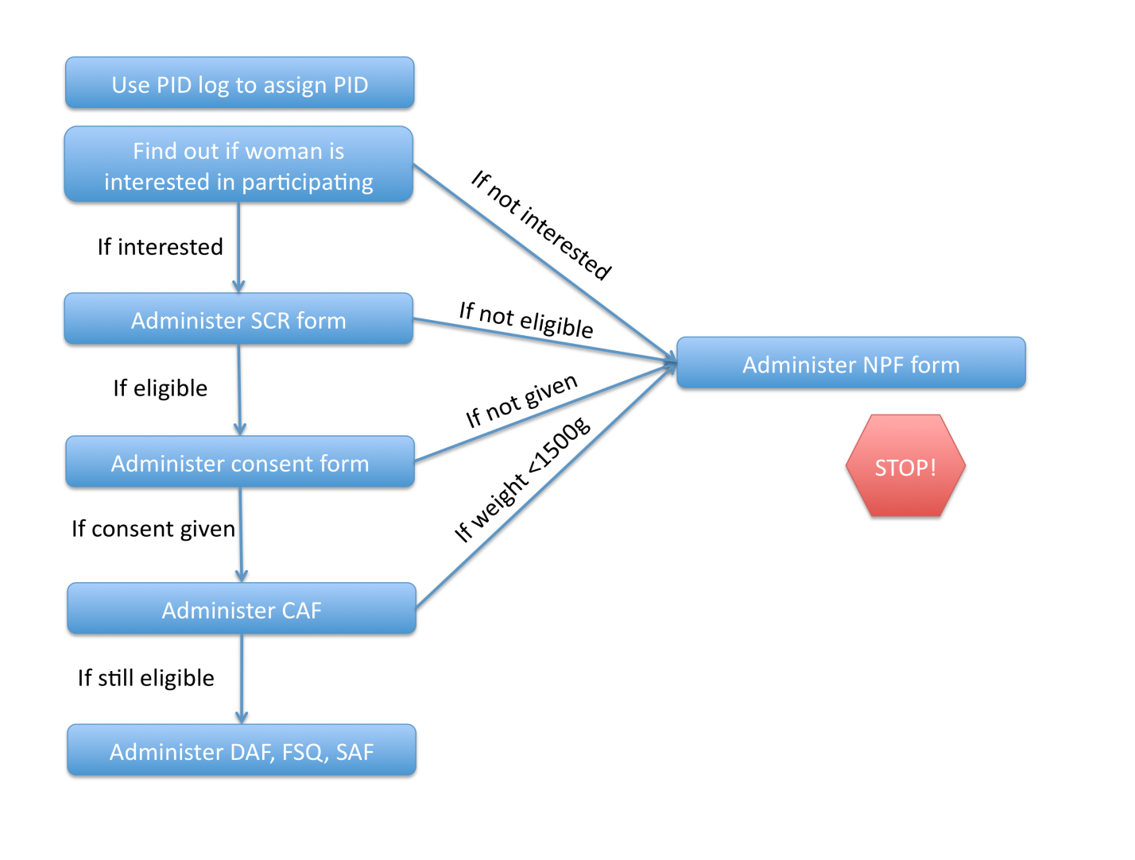

d) Data collection

Ideal collection windows for key forms/samples

|  |  |  |  |
| --- | --- | --- | --- |
| Forms | Form name | Month(s) | Visit range |
| BCH | Blood collection | 7, 15 | DOB - 2/+12 DAYS |
| BSD | Bayley Scales | 6, 15, 24, 36 | DOB (+/-) 15 DAYS |
| FRQ | 24 hour food recall | 9 TO 24 (25-36 optional) | DOB -2 /+15 DAYS |
| FSE | Follow-up SES | 6, 12, 18, 24, 30, 36 | DOB (+/-) 15 DAYS |
| FSQ | Food security questionnaire | 6, 12,18,24, 30, 36 | DOB (+/-) 15 DAYS |
| HIT | HOME | 6, 24 | DOB (+/-) 15 DAYS |
| ITS | Infant temperament scale | 6 | DOB (+/-) 15 DAYS |
| MAF | Maternal assessment form | 2 | DOB (+/-) 2 DAYS |
| MOA | Monthly form A | 1 TO 8 | DOB (+/-) 2 DAYS |
| MOB | Monthly form B | 9 TO 24 | DOB (+/-) 2 DAYS |
| MOC | Monthly form C | 25 to 36 | DOB (+/-) 2 DAYS |
| MWG | MacArthur words and gestures | 8, 15 | DOB (+/-) 15 DAYS |
| RCM | Raven's combined matrices | 6-8 | DOB (+/-) 15 DAYS |
| SFC | Stool field collection | 1 TO 24 | DOB (+/-) 2 DAYS |
| SRQ | SRQ-20 | 1,6,15, 24, 36 | DOB (+/-) 15 DAYS |
| UCF | Urine collection form | 3,6,9,15 | DOB -2/+7 DAYS |

* + Organize schedules for Study Researchers / Nurses / Fieldworkers in order to ensure all data are collected on each participant in a timely manner (see schedule of forms/sample collection above). Data should be collected within the collection windows identified for each form, and if data are collected outside the window, a PDF should be filled out.
  + Review 100% of each Study Researcher / Nurse / Fieldworker’s forms at least on a weekly basis, ideally, at the end of each working day. Supervisors should ensure the forms are complete (no missing fields), that the data appear correct, and that visits planned for the day / week were made.
  + Corrections to the forms should be minimized (data should be correct the first time), but if needed, the supervisor should ensure that the Study Researcher / Nurse / Fieldworker follows proper correction procedures. If form corrections are necessary, the data collector should:
    1. Cross through the incorrect information with one line only,
    2. Write the correct information,
    3. Write the date the correction was made, and
    4. Write their initials.
  + Make sure forms are kept confidential and protected (in a locked file drawer, for example) when they are returned from the field.
  + Specific quality control plans have been developed for the SAF and for anthropometry (as part of the forms: MOA and MOB). Apart from the general quality control methods listed above (supervisor review of 100% of forms at the end of each day) there are no specific quality control plans for other forms.
  + The QC for the SAF and MOA/MOB forms can be done during a single visit as long as the SAF data are collected on that day and the MOA/MOB data are collected within 24 hours of the ANT data
  + Supervisors should keep up-to-date on changes in the SOPs and CRFs and retrain staff as needed. Frequent meetings, preferably weekly, should be held with the data collection staff in order to provide form or procedural updates to the staff, talk about any issues that have been observed, and in general, touch base with the staff and identify any questions or training needs.
  + Real-time check of anthropometry – In order to correct errors in anthropometry measurement in a timely manner, supervisors (or field workers) are encouraged to print out growth charts and draw points on the chart for each measurement. If the point is wildly inconsistent with the previous points (decrease of more than 2 centimeters in height, gain/loss of approximately more than 1 z-score of height or weight), prompt remeasurement (within 3 days of original measurement) is recommended. Growth charts can be found in the forms appendix and here: <http://www.who.int/childgrowth/standards/en/>. If remeasurement occurs and the original value was approximately correct, it should remain as originally written. If the original value was grossly inaccurate (>10% difference), replace with the more accurate value as long as the remeasurement occurs within one week (preferably sooner) of the original measurement. Follow standard cross-out procedures, and add a note with the date that remeasurement occurred to the form. If the child is very underweight or stunted, please follow your site-specific guidelines for managing/referring these children.

Data center transmission of forms - Once forms have been completely filled out by the Study Researchers / Nurses / Fieldworkers and reviewed / initialed by the supervisor, they must be delivered within five days to the local data center for data entry. Data entry of the forms should occur within one month of delivery to the data center (preferably sooner).

1. Database review
   1. After the data are entered, reports will be generated by the DCC so that supervisors can review the collected data for inconsistencies and errors. (e.g., With your knowledge of the expected diarrhea rates in the area, are the numbers what you expect them to be? Are the diarrhea rates similar across Study Researchers / Nurses / Fieldworkers? Etc.) Quality control reports can be generated more frequently at the local level if desired.

#### Surveillance Assessment Form – Quality Control Plan

I. Purpose

To allow supervisors to ensure that Study Researcher / Nurse / Fieldworkers are making their scheduled visits and obtaining accurate data.

II. Summary

The supervisor (or designee) visits the household and collects Surveillance Assessment Form data (XAF – the supervisor’s version of the SAF) for comparison with regular Study Researcher / Nurse / Fieldworker’s data collection.

III. Number: 10% of participants

The supervisor must visit 10% of the participants one time each month. At the beginning of each month, the supervisor (or supervisor’s designee) will calculate the total number of participants enrolled in the study and make plans to visit at least 10% of those households one time to administer the XAF.

IV. Methods

One suggested process is that the supervisor (or their designee) chooses a random day of the month to visit all households (or a random sample) that are scheduled to receive a Study Researcher / Nurse / Fieldworker visit on that day. The supervisor should not tell the Study Researcher / Nurse / Fieldworker which day the check will happen, nor should they be at the house at the exact same time. The supervisor may need to choose additional days for data collection checks if the total visits possible on one day do not total at least 10% of the participants currently enrolled in the study. In order to standardize the process, the supervisor will ask about illnesses on the last three days. Some sites may want to make SAF QC visits evenly over the month and that is fine as well. The 10% sample should be random and representative of the participants’ ages, locations, and all other variables.

V. Additional Notes

If the supervisor would like to check a higher percent of the total participants, particularly in the beginning or when a new Study Researcher / Nurse / Fieldworker is hired, they are encouraged to do so.

The supervisor should review the XAF and SAF forms, discuss discrepancies found with the Study Researcher / Nurse / Fieldworker, and provide additional training if necessary. Do not change the data that the Study Researcher / Nurse / Fieldworker collected!

VI. Inconsistencies

The original data collected by the Study Researcher / Nurse / Fieldworker will be entered into the database. There is no need to ‘correct’ the data based on the supervisor’s responses. This comparison is done simply to guarantee that the Study Researcher / Nurse / Fieldworker is administering the form correctly and consistently in the field.

1. Minor inconsistencies

The supervisor should discuss the different responses with the Study Researcher / Nurse / Fieldworker. In many cases, the different answers may be due entirely to the respondent’s mood or ability to recall information at that moment. For instance, the first time the mother answers the question about liquid stools, she might answer 2, but the second time, she might have thought more about it and remembered another liquid stool on that day, so she answered 3 the second time. This is normal and does not need to cause concern.

1. Major inconsistencies

If, for example, the Study Researcher / Nurse / Fieldworker records no illness on a certain day but the supervisor records that the mother reported diarrhea, antibiotics, fever and a cough, the supervisor should attempt to verify that the Study Researcher / Nurse / Fieldworker is making their visits as scheduled and that they are asking the questions in a way that encourages complete answers. Major inconsistencies can be defined as more than 15% of the total answers that are discrepant. If a Study Researcher / Nurse / Fieldworker consistently returns data that poorly correlates with the supervisor’s data, and does not improve after additional training, that Study Researcher / Nurse / Fieldworker should be replaced.

Example: In month 6, as of July 1st, there are 72 children enrolled in the study. In July, the supervisor will visit seven of the households and collect XAF data.

The supervisor (or designee) can initially choose one day and one Study Researcher / Nurse / Fieldworker, and will visit every household on that Study Researcher / Nurse / Fieldworker’s schedule for the day.

The supervisor only needs to ask the questions on the form and does not need to actually collect diarrheal stool samples; however if a stool sample was indicated due to presence of diarrhea, the supervisor should answer question 17 on the XAF yes (01) and ensure that the Study Researcher / Nurse / Fieldworker actually collected a sample.

If the supervisor only visited 4 households on the initial QC visiting day, he or she can choose another day during the month to visit additional households until he or she has visited at least 10%. In this case, 10% is 7.2 – it is allowable to round down to 7 households. If the number were 7.6, 8 households would be required.

If the supervisor completed a visit, but the Study Researcher / Nurse / Fieldworker was unable to complete the visit on that day, the supervisor’s data should be discarded and not used for quality control. Visits must occur on the same day for a valid comparison.

If the supervisor chooses to schedule visits throughout the month, they would visit approximately two households each week to complete the XAF.

#### Anthropometry Quality Control Plan

I. Purpose

Assess measurement error and identify training needs

II. Summary

Each month, a study nurse or field worker trained in anthropometry should visit 5% of the households within 24 hours of the Monthly form data collection (MOA, MOB, MOC) in order to collect duplicate anthropometric measurements for quality control purposes. The 5% sample should be random and representative of the participants’ ages, locations, and all other variables.

III. Methods

Every month, the weight, length (0-24m) or height (25-36m), and head circumference of 5% of the children will be collected using the ANT form and entered into the database. These anthropometric measurements will be used to assess measurement error and identify the need for retraining of staff. At the beginning of each month, the supervisor will calculate the number of participants in the study and then schedule quality control visits for a random sample of 5% of the participants to occur within 24 hours of regular administration of the MOA/MOB/MOC.

IV. Notes

The supervisor should review the ANT and MOA/MOB/MOC forms at the end of the day (or on a weekly basis) and discuss discrepancies found with the Study Researcher / Nurse / Fieldworker and provide additional training if necessary. Do not change the data that the Study Researcher / Nurse / Fieldworker collected!

V. Inconsistencies

The original data collected by the Study Researcher / Nurse / Fieldworker will be entered into the database. There is no need to ‘correct’ the data based on the second data collector’s responses. This comparison is done simply to guarantee that the Study Researcher / Nurse / Fieldworker is making the visits and measuring the children, and for us to calculate measurement error and identify opportunities for additional training.

1. Minor inconsistencies

The supervisor should discuss the different measures with the Study Researcher / Nurse / Fieldworker. In many cases, the different measures may be due to the child’s state of mind, whether they were fidgeting or hungry or energetic and not wanting to be still for measurement. A small degree of variation is normal and does not need to cause concern.

1. Major inconsistencies

If there are large differences between the measurements (greater than 3 cm in length, 1 cm in head circumference, or 500 g in weight), the supervisor should ensure that a refresher training is completed by both Study Researcher / Nurse / Fieldworkers if both measurements were taken by Study Researcher / Nurse / Fieldworkers, or if the QC measurement was taken by the trainer (gold standard), the trainer should conduct the refresher training with the Study Researcher / Nurse / Fieldworker. If a Study Researcher / Nurse / Fieldworker consistently returns data that poorly measures anthropometry, and does not improve after additional training, that Study Researcher / Nurse / Fieldworker should be replaced.

#### Supervisor checklist

The supervisor is responsible for supervising timely and accurate data collection by staff. In order to assist the supervisor in his/her efforts with the surveillance forms, the following checklist is provided. The supervisor has the option to train and assign these tasks to other study staff members.

On a daily basis, the supervisor should:

* Be available for questions by field worker/data collection and data entry staff.
* Ensure that data collection staff knows what visits must be made.
* Monitor that the forms are kept confidential and safe in a locked cabinet in the office when they are not being used in the field.
* Be notified of any adverse events that occur in the study.
* Report all Adverse Events related to the study to the site-PI within 24 hours of notification of these events.

On a weekly basis, the supervisor should:

* Plan out weekly schedules and responsibilities for field workers (using database scheduler or local equivalent) and communicate expectations to field workers.
* Review 100% of data collection forms filled out in the past week (prefer daily, but should be within 7 days) to see that:
  + All forms are filled out completely and correctly. Supervisor/designee initials and dates each reviewed form.
  + All scheduled visits were made by study staff. Each site is responsible for monitoring missed visits and enacting corrective action.
  + PDFs were completed for all visits made outside the allowable window.
  + Recruitment targets are being met (goal is 9-18 recruited per month)
  + Participants are being retained in the study (not dropping out/missing)
* Deliver all completed forms to the data entry staff.
* Convene a weekly meeting with all field staff to discuss past issues, future plans, and any updates to forms or procedures. It is preferable that the on-site PI attends these weekly meetings or at least is available for consult as needed.
* Meet with individual field workers to discuss the results of any QC forms that were collected (XAF or ANT).

On a monthly basis, the supervisor should:

* Determine if overall recruitment targets were met for the previous month (9-18 per month) (and if not, troubleshoot why not) and make plans to meet recruitment targets for upcoming month.
* Determine how well data collectors performed in the previous month (visits completed within windows), and make schedule for field worker visits during the upcoming month.
* Determine if quality control visits planned for the previous month were made, and schedule quality control visits (ANT (5%) and XAF (10%)) for the upcoming month.
* Review DCC quality control report (and perform any local QC checks)
* Meet with site PI to discuss progress (enrollment, participant retention rates), review QC reports, and troubleshoot problems.
* Check if any study participants are missing the maximum of 60 consecutive days of data collection.
* Share “lessons learned” for issues that have come up in the field or in lab with other site’s staff and MALED admin.

On a quarterly basis (or more often if needed), the supervisor should:

* Hold a formal training session on a locally relevant topic to increase quality and/or timeliness of surveillance data collected (can be refresher training or an outside expert in retention methods, for example).

VIF—Vaccine Information Form SOP

I. Purpose

To collect information regarding childhood vaccinations source for each study participant. Information on the names of the vaccines, the dates of administration, and the sources of the information will be collected. This will be used as a validation tool for source of vaccine questions adminstred in the MOA form.

II. Material

Vaccine Information Form (VIF), Pen

III. Methods

The Vaccine Information Form (VIF) is to be used at months 3, 6, 9, 12, 24,27, 30 33 and 36 (or the end of the study). It will be used concurrently with the Monthly Form A (MOA) at months 3 and 6, with the Monthly Form B (MOB) at months 9, 12 and 24, and with the Monthly Form C (MOC) at month 27, 30, 33 and 36 (or the end of the study).

As with the Monthly Forms A, B and C, FWs should ideally visit a study participant on the monthly anniversary of his/her birthday. Sometimes this may not be possible. However, it is important the forms be completed within the given +/- two day window. If data collection occurs outside the +/- 2 day window, a PDF form must be completed. Please see the MOA SOP for more detailed information regarding the window of data collection.

IV. Further Instructions

Record information regarding the *Vaccine Name*, *Date of Administration*, and *Source* of information, for each vaccine received by the study participant since the last VIF was filled.

Vaccination information from children’s vaccination cards or clinic records is STRONGLY preferred.

When visiting the study participant’s household, ask to see vaccine records. If vaccine records are available, check to see if any vaccines have been given since the last VIF was completed. If vaccines have been given since the last VIF was filled, document them here. In the *Vaccine Name* column, write down the name of the vaccine exactly as it appears on the vaccination card (e.g. if the child received “Pentaxim”, write “Pentaxim” in *Vaccine Name* column). In the *Date of Administration* column, write down the date the study participant received the corresponding vaccine exactly as it appears on the vaccination card. For the *Source* column, write “1”, since this information was obtained from the study participant’s vaccination history card.

If vaccination history records for the study participant are unavailable, obtain information regarding childhood vaccinations from clinic records. As above, enter information on the *Vaccine Name* and *Date of Administration* exactly as they appears on the clinic record. For the *Source* column, write “2”, since this information was obtained from the study participant’s clinic records.

If the study participant lacks both vaccination history records and clinic records, ask the mother, caregiver or other guardian for a verbal history of the child’s vaccinations and the approximate dates that the vaccines were administered. Record this information in the *Vaccine Name* and *Date of Administration* columns. For *Source*, write “3”, since this information was obtained from a verbal source.

If information on a study participant’s vaccination history was obtained by some other means, record this information as above, and in the *Source* column, write “4”, for other.

To summarize, options for the *Source* column are:

1. From vaccination card
2. From clinic record
3. From verbal source (e.g. mother, guardian etc.)
4. Other

If information on vaccines given to the study participant comes from a variety of different sources, mark the source of information regarding each vaccine in the corresponding *Source* column appropriately.

If no vaccines have been given during the period covered by the VIF, fill out the participant ID, date, and fieldworker ID, and leave the rest blank. If this is not done, the form will be consider ‘missed’.

**Collection and Processing of Clinical SampleS**

SIL—Sample ID Log SOP

I. Purpose

To assign unique Sample IDs (SIDs) to all biological specimens collected.

II. Material

Sample ID logbook, pen

III. Methods

1. After a biological specimen (e.g. child or maternal stool, blood, urine, saliva, breastmilk) has been received in the laboratory, the laboratory technician will immediately assign a unique Sample ID to this biological specimen.
2. The laboratory technician will use the Sample ID logbook provided to each site to assign the Sample ID to this specimen. The laboratory technician will enter information on PID, specimen type (B, U, M, D, S), and date (DD/MMM/YY) and time of collection (HH:MM; 24 hour time scale) adjacent to the first blank entry next to the pre-printed column of Sample IDs.
3. The SID will be hand-written by the laboratory technician on the labels for all of the specimen collection containers for a specific study subject on a certain date and time of specimen collection.
4. The unique SID attached to the specimen will remain with the specimen and its aliquots throughout the testing and evaluation process.
5. The SID log is the link between the PID, SID, and time and date of collection.
6. The SID log information will be stored locally and will be entered to the central MAL-ED database on a weekly basis.

IV. Notes

- What is the SID?

Digits 1 & 2 – Indicate country (PE-Peru, BR-Brazil, Bangladesh-BG, Nepal-NP, Pakistan-PK, India-IN, Tanzania-TZ, South Africa-SA)

Digit 3 – Indicates site # (most countries have only one study site at this time)

Digit 4-9 – Indicates the ascension number for the specimen

- The SID will be used to identify biological specimens on all other study forms.

**Collection and Processing of Clinical Samples**

**Stool**

SCT/SFC—Stool Collection, Processing and Transport to the Laboratory

**This SOP has been read and understood by:**

|  |  |
| --- | --- |
| **Name** | **Date** |
|  |  | |
|  |  | |
|  |  | |
|  |  | |
|  |  | |
|  |  | |
|  |  | |
|  |  | |
|  |  | |
|  |  | |

**Document History:**

|  |  |  |
| --- | --- | --- |
| **Version Number** | **Reason for Changes** | **Date** |
|  |  |  |
|  |  |  |
|  |  |  |
|  |  |  |

1.0 **Purpose**

This protocol describes the procedure for stool specimen collection from MAL-ED research subjects enrolled in the cohort and timely transport to the laboratory for further processing.

2.0 **Responsibility**

Field coordinator is responsible for ensuring that standard methodology described here is followed in stool collection and transport.

3.0 **Materials**

3.1 Stool specimen (4 – 10 grams or ml)

3.2 Pre-printed PID labels (4 plus 1 extra)

3.3 Cary-Blair media transport tube

3.4 Plastic disposable transfer pipette for liquid stools

3.5 Cotton-tipped wooden stick

3.6 Wide-mouthed plastic container suitable for collecting stools

3.7 Wooden spatula

3.8 Vial with 10 ml of 10% buffered formalin

3.9 Frozen ice packs

3.10 Cold box

3.10 Tube rack

3.11 Disposable latex gloves

3.12 Disposable diaper

3.13 Sealable plastic bags

3.14 Plastic spoon

3.15 Pen

3.16 Surveillance Assessment Form (SAF) or Monthly Combined Form A (MOA) or Monthly Combined Form B (MOB)

3.17 Stool Field Collection Form (SFC)

4.0 **Collection Procedure for Monthly Stool**

4.1 Monthly stool sample will be collected on the same day as the scheduled day for completion of the monthly surveillance form. This visit shall occur on the monthly anniversary of the child’s birth (+/- 2 days). So, if a child is born on February 17th,for example, the monthly visits will occur every month from the 15th to the 19th of that month. It is very important that the surveillance form and the stool sample are completed/collected within the +/- two day window. If you are unable, even with the best of efforts, to visit the child within the 5 day window (birth date anniversary +/- 2 days), the field worker may visit the home up to 5 days beyond the +2 timeframe (the birth date anniversary + 7 days). However, if the visit takes place beyond 2 days after the birth date anniversary, a PDF must be filled out.  **Do not collect monthly stool samples within 48 hours after the administration of the Lactulose Mannitol solution because LM interferes with some of the gut function biomarker assays done with stool samples.**

4.2 Monthly stool samples will be collected every month for two years (24 months) as described above. Samples collected on month 1-12, 15, 18, 21, and 24 will be worked up for the detection of enteric pathogens as described in subsequent protocols in this document. Samples collected on months 13, 14, 16, 17, 19, 20, 22, 23, (and if extension funded, 27, 30, 33 and 36) will be frozen at -80C as archival samples. Samples collected on months 13, 14, 16, 17, 19, 20, 22, 23, (and if extension funded, 27, 30, 33 and 36) do NOT require recollection if greater than 2 grams but less than 4 grams. If samples collected on months 13, 14, 16, 17, 19, 20, 22, 23, (and if extension funded, 27, 30, 33 and 36) are less than 2 grams, recollection should be requested. Additionally, we encourage sites to obtain a stool sample as soon as possible after enrollment for freezing in the archive. This “0” time sample will not be characterized for pathogens, but will be valuable for future studies to determine the earliest gut microbiome in children enrolled in this cohort. The time “0” stool does NOT require recollection.

If the MAL-ED extension project is funded, sites should collect at a minimum quarterly (at 27, 30, 33, 36 months) stool samples for archiving only. These quarterly samples should be collected on the anniversary of the child’s birth (+/- 2 days). If you are unable, even with the best of efforts, to visit the child within the 5 day window (birth date anniversary +/- 2 days), the field worker may visit the home AT ANYTIME to collect the stool sample. However, if the visit takes place beyond 2 days after the birth date anniversary, a PDF must be filled out. Sites may choose to collect stools more frequently and/or work up these samples for some or all of the microbiology assays however these activities will not be covered by MAL-ED funds.

4.3 For collection of Monthly Stool, inform child’s primary caretaker one day before planned stool collection and request caretaker to collect the first available fresh stool sample from the child on the morning of the planned visit.

4.4 The mother should be provided with the labeled stool container, diaper for infants, cold box, ice packs, gloves, plastic spoon, and 2 plastic bags the evening before planned stool collection. There should be enough ice packs in the cold box to keep it cold for up to 16 hours.

4.5 Instruct the caretaker to use the plastic spoon to collect 3-4 spoons of stool and place it in the stool container, close the lid tightly, and place the container in the plastic bag. If the child is also enrolled in the BMMI project, collect all of the stool sample.

5.0 **Collection Procedure for Diarrheal Stool**

Collection of diarrheal stool poses a challenge to the Study Researcher / Nurse / Fieldworker. We recommend that sites develop collection methods that are consistent with their local situation. We suggest some general methodology here for consideration. Remember that the definition of diarrhea is 3 loose stools in a single day. When that definition is met, every attempt should be made to visit the home as soon as possible to collect a sample before the episode ends. Caregivers should be instructed about the urgency of collection of a fresh sample and getting that sample into transport medium as soon as possible to increase the likelihood of identifying causative bacterial pathogens.

5.1 Caretakers of infants with liquid stools should be instructed to use an inverted diaper so that the stool doesn’t get absorbed in the lining.

5.2 We suggest leaving extra stool containers (without Cary Blair transport media) with the family with instructions to collect stool samples when a child has diarrhea. If the first sample is watery and the definition of diarrhea is not met, then the sample can be discarded. Sometimes, when an episode is of short duration, it does happen that the mother fails to collect any of the 3 or more stools, in which case that episode will have no sample associated with it. It should still be recorded as a diarrheal episode, but with no sample collected.

5.3 When a Study Researcher / Nurse / Fieldworker arrives at the home and a sample has already been collected by the caregiver, ask the caregiver what time the sample was produced and record that time (on SFC, question #4). In most cases this will only be an estimate. However it may be useful to estimate the time prior to storage in Cary Blair transport medium. Every attempt should be made to get the sample into Cary Blair within 2 hours of production. The time that the sample was preserved in Cary Blair should recorded on the SFC, question #5. The time that the Study Researcher / Nurse / Fieldworker arrives at the home and collects the specimen should also be recorded on the stool field collection form (SFC) (question #2, Time of visit).

5.4 If a diarrheal stool sample is not available, the Study Researcher / Nurse / Fieldworker may be able to wait at the home for a sample to be produced. The Study Researcher / Nurse / Fieldworker should assess the likelihood that they can collect a sample while waiting in light of other visits they need to make that day. If they cannot wait, they should leave collection material (specimen receptacle and cold box with ice packs) with the caregiver if they have not done so previously and provide instructions on collection procedure and plan to return to the home every 2 hours until a sample is collected. The arrival time of the visit should be documented on the SFC, question #2.

5.5 As soon as it is available to the Study Researcher / Nurse / Fieldworker, a portion of the diarrheal stool sample should be placed in Cary Blair (within 2 hours of production if possible) and refrigerated in cold packs for transport to the laboratory and processing (see below). Follow the temporary storage and transport procedures listed directly below.

6.0 **Temporary Storage and Transport Procedures**

6.1 Instruct the caretaker to place the plastic bag with the stool in the cold box immediately after collection (maximum time: 1 hour).

6.2 Collect the stool specimen early in the morning (maximum time from placement of stool in cold box to collection: 5 hours).

6.3 Document if the sample was in a cold environment on the requisition CRF. Also document if specimen is acceptable (estimated quantity, lid closed, and no leakage)

7.0 **Processing**

7.1 Label the original stool container, the Cary Blair tube and formalin vial with pre-printed PID labels. Circle the type of specimen received on the label (M=monthly stool collection, D=diarrheal stool recollection), and write the date of collection (DD/MMM/YY) and time of collection (hh:mm; 24 hour time scale) on the label.

7.2. Immediately upon collecting the stool sample, the Study Researcher / Nurse / Fieldworker must dip two cotton-tipped wooden sticks in the fecal specimen and place in Cary Blair transport media, breaking off the tip. This is the specimen that will be used for bacteriological culture.

7.3. Place 1 gram of stool using the wooden spatula, or 1 ml of liquid stool using the transfer pipette in 10% formalin vial. The preserved stool will be used for microscopic examination for ova and parasites. The preferred Formalin to stool ratio is 3:1.

7.4 Place the original stool container with the remaining stool, and the stool in formalin vial in a fresh plastic bag, and the Cary Blair tube in the tube rack, and transport in the cold box with fresh ice packs to the laboratory for further processing.

7.5 Maximum time from placement of stool swab in Cary Blair to receipt of all the specimens in the laboratory should be 18 hours.

1. **Reporting**

8.1 Record information on Stool Field Collection Form (SFC). The SFC form is completed for every diarrheal episode, each recollection attempt, and for each time the fieldworker travels to the home to complete the monthly surveillance form and to collect the monthly stool sample. Please see the table below for assistance. There is space provided at the end of the form to provide additional information, if necessary.

|  |  |  |
| --- | --- | --- |
| # | Question | Guidance |
|  | Participant ID | Write the child’s participant ID in the space provided at the upper left corner. |
| 01 | Date of visit | Enter the date of the visit (DD/MMM/YY) by the Study Researcher / Nurse / Fieldworker. |
| 02 | Time of visit | Enter the time that the Study Researcher / Nurse / Fieldworker visited the home to collect and pick-up the stool sample. If no sample was collected, this is the arrival time of the visit. |
| 03 | Was a stool sample collected? | Indicate whether or not a stool sample was collected. If yes, go to question #4. If no, go to question #8. |
| 04 | Time stool sample was produced | Enter the time (24 hour time scale, HH:MM) that the stool sample was produced. If this time is not available, estimate if time cannot be confirmed by care giver. |
| 05 | Time stool sample was preserved in Cary Blair | Enter the time that the stool sample was preserved in Cary Blair. |
| 06 | Type of stool collected | Indicate whether the stool sample was a monthly, diarrheal, monthly recollection, or diarrheal recollection. If the stool sample is a time zero stool sample, record as a monthly stool sample (M1). All initial collections of monthly stools are recorded as M1. There is no sequential numbering for the number of monthly stools collected. |
| 07 | Month of stool collected | Enter the number (#) of months that the child has been followed and in which this monthly stool sample was collected for this particular child. For example, if a child has been followed for 14 months and the stool is being collected for his 14th monthly stool sample, enter 14. If the stool sample is a diarrheal stool sample, enter NA. |
| 08 | Recollection necessary? | Indicate if recollection is necessary. Every effort must be made to collect 4 to 10 grams of stool- the quantity stated in the protocol. It is recognized that some specimens received in the laboratory will be QNS- (Quantity Not Sufficient) -less than 4 grams, and require a recollection attempt. Recollection of the specimen may ONLY continue for up to 48 hours. If the stool sample is a time zero stool sample, no recollection is necessary, and the response should be NA. Samples collected on months 13, 14, 16, 17, 19, 20, 22, 23, 27, 30, 33, and 36 do NOT require recollection if greater than 2 grams but less than 4 grams. If samples collected on months 13, 14, 16, 17, 19, 20, 22, 23, 27, 30, 33, and 36 are less than 2 grams, recollection should be requested. |
| 09 | Fieldworker ID | Enter the fieldworker’s unique ID number who picked up the stool sample and/or visited the home. |

### RSS/SRF—Receiving and Storage of Stool Samples SOP

**This SOP has been read and understood by:**

|  |  |
| --- | --- |
| **Name** | **Date** |
|  |  | |
|  |  | |
|  |  | |
|  |  | |
|  |  | |
|  |  | |
|  |  | |
|  |  | |
|  |  | |
|  |  | |

**Document History:**

|  |  |  |
| --- | --- | --- |
| **Version Number** | **Reason for Changes** | **Date** |
|  |  |  |
|  |  |  |
|  |  |  |
|  |  |  |

1. Purpose

This document describes the procedures for receiving stool samples collected from study subjects, and the assignment of Sample ID to the stool samples. The stool specimens are collected for assessment of enteric infections and gut function. The procedures are designed to maintain the integrity of clinical specimens by proper handling and storage and the management of associated records. Personnel handling the samples and data are trained to receive and handle clinical specimens and records.

1. Materials

Refrigerator

-70°C freezer

-20°C freezer

Wooden spatula

Sterile cryovials

Cryovial labels

Cryovial racks

Storage boxes

Pipettes (20-200 µl and 100-1000 µl)

Scale

Stool receiving form (SRF)

1. Methods

**Safety:**

1. Universal precautions must be followed while handling samples (http://www.cdc.gov/ncidod/dhqp/gl_isolation_standard.html).
2. Technicians must wear appropriate proper personal protective equipment (PPE) (e.g. gloves, masks, etc.) when handling samples as well as when handling ultra cold freezer items.
3. Disinfect work areas before and after performing these procedures.
4. Avoid using techniques that are likely to generate aerosols.

Additional information can be found at <http://www.cdc.gov/OD/ohs/biosfty/bmbl5/bmbl5toc.htm>.

**Transfer of samples to the laboratory:**

Proper transfer of samples from field to laboratory will require coordination between field workers and laboratory technicians. Collection and transport of samples should be carried out in clean, labeled, dry, leak-proof containers. Transport the samples to the laboratory as soon as possible after collection. Samples should be transported in an ice chest or insulated carrier containing adequate amount of cold packs as well as cushioning material to protect the samples. Do not use wet ice for transport of clinical specimens. There will be three sets of stool samples for each individual. Each of the sets will be transferred from the field to the laboratory with pre-printed PID labels, and information regarding time and date of stool collection and type of stool collected (monthly or diarrheal stool).

***Three*** sets of stool samples will be received from each study subject –

1. Whole stool sample or unpreserved stool sample (UP)
2. Stool in Cary-Blair medium (CB)
3. Stool in 10% formol-saline (FS)

Samples in CB will be used for bacterial culture while samples in FS will be used for microscopic examination for ova and parasites. These samples have to be processed as soon as received in the laboratory. The unpreserved sample will be used for gut function assessment, viral and parasite ELISAs, RNA / DNA extractions and PCRs. These samples can be batched and stored at -70°C before testing. If the child is also enrolled in the BMMI project, an additional aliquot/s of unpreserved stool sample (total of 2 grams) should also be frozen and stored for later shipment.

**Receipt of specimens:**

When the stool sample is received at the laboratory, the Sample ID is immediately assigned using the Sample ID logbook provided to each individual site. Please see Sample ID log (SIL) SOP for detailed instructions. After the Sample ID has been successfully assigned, the Sample ID is written on the existing label on all sets of stool samples made from this stool collection. All stool sample sets collected at that specific time will have the SAME Sample ID for each individual study subject. Any future aliquots of this stool sample collected at that specific time will also have the same Sample ID. Future stool samples collected a different time from the same individual will have different Sample IDs. Recollection samples have a different Sample ID than the initial sample’s Sample ID.

**Reporting:**

Record information on Stool Receiving Form (SRF). Please see the table below for assistance. Information for questions #02, 03, 04, 05, 09, 10, 11, can be found on the Stool Field Collection (SFC) form completed by the fieldworker.

|  |  |  |
| --- | --- | --- |
| # | Question | Guidance |
|  | Participant ID | Write the child’s participant ID in the space provided at the upper left corner. |
| 01 | Sample ID | Write the 9-digit unique Sample ID. |
| 02 | Date of collection | Enter the date of collection (DD/MMM/YY) of the stool sample. Information located on SFC, question #1. |
| 03 | Time stool specimen was produced | Enter the time that the stool specimen was produced. If this time is not available, estimate if time cannot be confirmed by care giver. Information located on SFC, question #4. |
| 04 | Time stool specimen was picked up by Study Researcher / Nurse / Fieldworker | Enter the time that the stool specimen was picked up by the Study Researcher / Nurse / Fieldworker. Information located on SFC, question #2, time of visit. |
| 05 | Time stool specimen was preserved in Cary Blair | Enter the time that the stool specimen was preserved in Cary Blair. Information located on SFC, question #5. |
| 06 | Time stool specimen was received at field site/ laboratory | Enter the time that the stool specimen was received at the main laboratory or the intermediate field site, if appropriate. |
| 07 | Technician code | Enter the technician’s unique ID number who processed the specimen. |
| 08 | Unpreserved specimen? | Indicate whether or not an unpreserved specimen was received from the field. If no unpreserved specimen was received, complete QNS form and go to question #9. If yes, go to question #9. |
| 09 | Type of specimen | Indicate whether the stool specimen was a monthly, diarrheal, monthly recollection, and diarrheal recollection. Information located on SFC, question #6 and on sample container. |
| 10 | Month of stool collected | Enter the number (#) of months that the child has been followed and in which this monthly stool sample was collected for this particular child. For example, if a child has been followed for 14 months and the stool is being collected for his 14th monthly stool sample, enter 14. If the stool sample is a diarrheal stool sample, enter NA. |
| 11 | If recollection, what is Sample ID of initial sample? | If the stool sample is a recollection sample, enter the Sample ID of the initial sample. If the stool sample is not a recollection sample, enter NA. **Recollection samples have a different Sample ID than the initial sample’s Sample ID.** All sample IDs are unique values. |
| 12 | Amount of stool | Enter the number of grams of stool received. |
| 13 | Recollection? | Indicate if recollection was requested, and what type of recollection (monthly vs. diarrheal) is requested. Information located on SFC, question #8. If the stool sample is a time zero stool sample, no recollection is necessary, and the response should be NA. Recollection of the specimen may ONLY continue for up to 48 hours. If samples collected on months 13, 14, 16, 17, 19, 20, 22, 23, 27, 30, 33, and 36 are less than 2 grams, recollection should be requested. |
| 14 | Consistency | Indicate the consistency of the stool sample, WATERY (very loose, watery stool with very little solid material) = 01, LIQUID (loose stool taking the shape of the container) = 02, SOFT (semi-solid, smooth stool) = 03, FORMED (solid, firm stool) = 04 |
| 15 | Bloody? | Indicate if the stool specimen was bloody or not bloody. **If bloody, refer the child for medical treatment of suspected dysentery.** |
| 16 | Mucus? | Indicate if the stool specimen had mucus or did not have mucus. |
| 17 | Was Cary Blair used in the field? | Indicate yes or no if Cary Blair was used in the field. If yes, go to question #19. If no, go to question #18. |
| 18 | Time Cary Blair used in the laboratory | Indicate what time Cary Blair was used in the laboratory. |
| 19 | Was formalin used in the field? | Indicate yes or no if formalin was used in the field. If yes, go to question #21. If no, go to question #20. |
| 20 | Time formalin used in the laboratory. | Indicate what time formalin was used in the laboratory. |
| 21 | Time stool left field site laboratory | For SELECT SITES ONLY, indicate what time the stool sample left field site laboratory. If your site does NOT have an intermediate field site processing laboratory, please respond NA. |
| 22 | Time stool received at main testing laboratory | For SELECT SITES ONLY, indicate what time the stool sample was received at the main testing laboratory. If your site does not have an intermediate field site processing laboratory, please respond NA. |
| 23 | QNS set up? | Indicate yes or no if this stool specimen requires a QNS setup. If there is less than 4 grams, the stool specimen requires a QNS setup. If yes, complete the QNS form and refer to SOP number QNS “Processing and Testing of QNS Stool Samples” for detailed instructions on how to proceed. If the stool sample is a time zero stool sample, no QNS set-up is necessary, and the response should be NA. If samples collected on months 13, 14, 16, 17, 19, 20, 22, 23, 27, 30, 33, and 36 for archiving purposes are less than 2 grams, these samples require a QNS set-up. A recollection sample does not need to be worked up as a QNS sample. If sample is a recollection sample, enter NA. |

**Internal Log-in of Specimens:**

All specimens must be held at 2 – 8°C until ready to process.

We recommend that sites develop tracking methods for sample testing, short-term sample storing, and general laboratory procedures that are consistent with their local situation. We suggest some general methodology here for consideration. Determine that all specimen information is available on the laboratory’s specimen receipt form (including PID and sample ID). Each laboratory will responsible for creating a logbook to track the specimens internally. The MAL-ED storage database can be used to assist in storing and tracking of samples.

*A sample stool specimen information form is given below.*

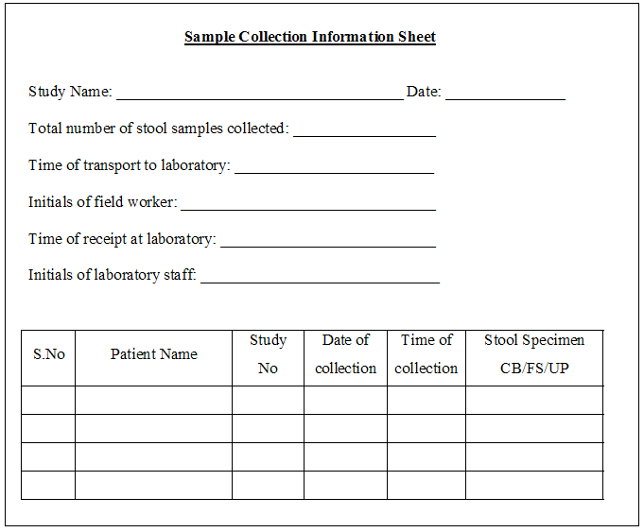

The details on the specimen form must agree with the information recorded on the specimen label (include PID and Sample ID on labels).

*An example of a stool specimen label is given below.*

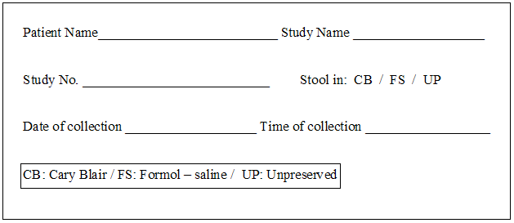

Log in the specimen details (including PID and sample ID) in the designated database or spreadsheet as well as any internal laboratory logbooks for the study. **Recollection samples have a different Sample ID than the initial sample’s Sample ID.**

There should be individual spreadsheets, log sheets and/or laboratory log books for each type of sample (blood, urine, stool, saliva) in the study.

Ensure that all details are entered including participant ID, sample ID, type of sample, volume of sample collected and date and time of sample collection. Enter the initials of the person handling the specimen in the appropriate column.

Approximately 4 – 10 g or ml of stool is collected from each study subject. When Cary Blair and Formalin are received, there should be a minimum of 2.5 grams unpreserved specimen available for ELISAs, PCR and archive. If there is less than 4 grams, refer to SOP number QNS “Processing and Testing of QNS Stool Samples” for detailed instructions on how to proceed. For a monthly stool collection, recollection should be requested if there is less than 4 grams of stool, and QNS should be followed. For a diarrhea stool sample, recollection should be requested is there is less than 2 grams of stool, and QNS should be followed. For a diarrhea stool sample between 2-4 grams, no recollection is necessary but QNS should be followed, If samples collected on months 13, 14, 16, 17, 19, 20, 22, and 23 for archiving purposes are less than 2 grams, recollection should be requested, and QNS form should be completed. Determine if recollection was requested and/or received. Lab technicians need to communicate to field workers as soon as possible to indicate if recollection is required. Methods of communication may include telephone, email, text message, personal communication. It is essential that field workers are aware that recollection has been requested. If the stool sample is a time zero stool sample, no recollection or QNS set-up are necessary.

*A sample laboratory log book and MS-Excel worksheet are given below:* 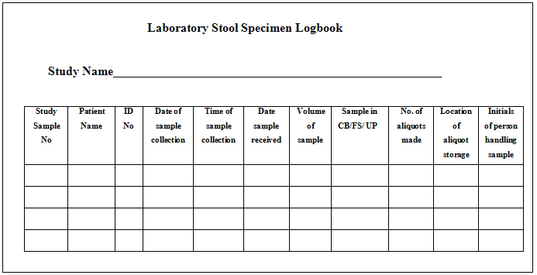

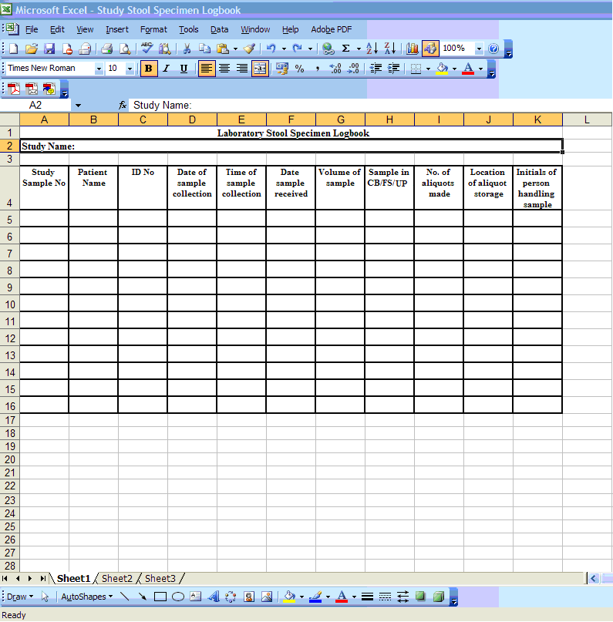

**Procedure for Aliquoting and Storage:**

1. For each sample, 4 aliquots will be made, depending on the volume of original sample available. 4 vials with 0.5 grams each vial is the standard protocol. If less is available for archive, refer to SOP QNS “Processing and Testing of QNS Stool Samples” for detailed instructions. If the stool sample is a time zero stool sample, no QNS set-up is necessary. Samples collected on months 13, 14, 16, 17, 19, 20, 22, 23, 27, 30, 33, and 36 do NOT require a QNS set-up if less than 4 grams but greater than 2 grams. Samples collected on months 13, 14, 16, 17, 19, 20, 22, 23, 27, 30, 33, and 36 DO require a QNS set-up if less than 2 grams.
2. Prepare 4 barcode labels per sample. Place each of these labels on individual cryo vials. Refer to SOP “Barcode Sample Tracking” instructions for assistance in creating label for archiving/storage.
3. Sample aliquots are done on ice.
4. Store aliquots at -70˚C.
5. Log-in the information of where the aliquots are stored with details of freezer number and rack both in the barcode database for sample storage as well as in the laboratory specimen storage logbook.
6. Bacterial isolates will also be frozen and stored at -70˚C. Refer to the Stool Bacteriology Culture and Identification: BDF SOP for additional information as well as the SOP for Barcode Sample Tracking.
7. If the child is also enrolled in the BMMI project, an additional 2 grams of unpreserved stool should also be frozen. These 2 grams can be left in one tube or placed into aliquots; this decision is at the discretion of the site. This sample will be later shipped to the BMMI project.

Stool Specimen Test Quantities and Storage

|  |  |  |  |  |  |  |  |  |
| --- | --- | --- | --- | --- | --- | --- | --- | --- |
| **Test** | **Specimen or Derivative** | **Qty** | **4 oC**  **storage** | **-20 oC storage** | **-70 oC storage** | **Room Temp storage** | **Storage after initial processing** | **QNS Alternate Specimen** |
| Primary Specimen | Stool | 4-10 grams | 2 hours | NA | NA | 2 hours | NA | None |
| O&P microscopy (inclusive concentrate Microscopy & M. acid fast ) | Formalin | 1 gram | NA | NA | NA | Long term-indefinitely | after concentration RT Long term /indefinitely | Unpreserved -direct microscopy |
| Bacteriology Culture | Cary-Blair | 0.2g | 18-48 hours | NA | NA | 2 hours | NA | Unpreserved 4 oC  4 hours |
| Campy ELISA | Unpreserved | 0.1 g or 100 ul | 72 hours | Long term | Long term | NA | In kit diluent 4oC  72 hours | Formalin  (not concentrated) |
| Viral ELISA (inclusive Adeno, Astro Rota) | Unpreserved | 0.1 g or  100 ul | 8 days | Long term | Long term | NA | In kit diluent 4oC  8 days | Adeno only-Formalin (not concentrated) |
| Giardia & Crypto ELISA | Unpreserved | 0.1g or  100 ul | 24 hours | Long term | Long term | NA | NA | Formalin  (not concentrated) |
| E.hist ELISA | Unpreserved | 0.2g or  200 ul | 48 hours | 2 months- Long term | 2 months-Long term | NA | NA | None |
| Norovirus RT PCR | Unpreserved | 0.1 g or 100 ul | 48 hours | NA | NA | Long term | Extracted RNA  4 oC 4 hours,  -70 oC long term | None |
| Archive | Unpreserved | 2 g  (4 x0.5 g) | NA | NA | Long term | NA | NA | None |
| E.coli PCR | Colonies from Culture | 5 colonies | NA | NA | Long term | Slant 2 months | Not Specified | None |
| Lactoferrin Techlab IBD Check | Unpreserved | 50 ul | 2 weeks | Long term | Long term | 2 weeks | In kit diluent 4oC  48 hours | None |
| a1 antitrypsin?? | Unpreserved | 0.1 g | ? | ? | ? | ? | ? | ? |

QNS—Processing and Testing Quantity Not Sufficient Stool

**This SOP has been read and understood by:**

|  |  |
| --- | --- |
| **Name** | **Date** |
|  |  | |
|  |  | |
|  |  | |
|  |  | |
|  |  | |
|  |  | |
|  |  | |
|  |  | |
|  |  | |
|  |  | |

**Document History:**

|  |  |  |
| --- | --- | --- |
| **Version Number** | **Reason for Changes** | **Date** |
|  |  |  |
|  |  |  |
|  |  |  |
|  |  |  |

1. Purpose

A complete set of laboratory test results on every stool specimen is of critical importance in the analysis of MAL-ED data. Every effort must be made to collect 4 to 10 grams of stool- the quantity stated in the protocol. It is recognized that some specimens received in the laboratory will be QNS- (Quantity Not Sufficient) -less than 4 grams. The purpose of this procedure is to describe the processing and list the prioritization of tests when the laboratory receives less than 4 grams of stool specimen. Samples collected on months 13, 14, 16, 17, 19, 20, 22, 23, 27, 30, 33, and 36 for archiving purposes do NOT require a QNS set-up if less than 4 grams but greater than 2 grams.

1. Materials

No materials necessary.

1. Methods

Refer to SOP SSC, “Stool Collection and Transport,” and SOP RSS, “Receipt and Storage of Stool Samples in the Laboratory”. Specimen Quantities covered in this procedure: Standard testing 4-10 g.; QNS Monthly: <4 g.; QNS Diarrheal: <2 g.; Diarrheal 2g to <4g.

1. Notify Field Worker and Field Supervisor of all QNS Specimens and request recollection. Requests should be made by the lab technician to the appropriate field worker as soon as possible. Methods of communication to convey that recollection is necessary may include telephone, email, and/or text message. Document request on the Stool Receiving Form (SRF) and complete QNS form.

2. Proceed with specimen processing based upon the quantity and type of specimen received.

**4-10 grams** – **Follow Standard Testing Procedures**

|  |  |  |
| --- | --- | --- |
| *Standard Procedure Testing* | *Specimen* | *Qty* |
| Primary Specimen | Stool | 4-10 grams |
| O&P microscopy (concentrate Microscopy & Mod AF ) | Formalin | 1g |
| Bacteriology Culture | Cary-Blair | 0.2g |
| Campy ELISA | Unpreserved | 0.1g or 100ul |
| Viral ELISA (inclusive Adeno, Astro, and Rotavirus) | Unpreserved | 0.1g or 100ul |
| Giardia and Crypto ELISA | Unpreserved | 0.1g or 100ul |
| E. hist ELISA | Unpreserved | 0.2g or 400ul |
| Norovirus RT-PCR | Unpreserved | 0.1g or 100ul |
| Archive sample | Unpreserved | 2g (4 x 0.5 g) |
| Lactoferrin | Unpreserved | 50 ul |
| Alpha-1- antitrypsin | Unpreserved | 0.1g |

**Monthly Specimen Less Than 4 grams**

1. Request Recollection

2. Proceed with testing in the order below.

3. As additional specimen is received, continue testing- picking up where the previous specimen left off. Complete as many tests as the quantity will allow.

4. Continue testing the recollected specimens for up to 48 hours. Recollection samples have a different Sample ID than the initial sample’s Sample ID.

5. After 48 hours from when the first monthly specimen was collected, stop testing for that monthly specimen.

6. Complete the QNS Form.

|  |  |  |
| --- | --- | --- |
| *“Monthly” Specimen QNS Testing* | *Specimen* | *Qty* |
| Primary Specimen | Stool | Less the 4g |
| Bacteriology Culture | Cary-Blair | 0.2g |
| Campy ELISA | Unpreserved | 0.1g or 100ul |
| Viral ELISA (inclusive Adeno, Astro, and Rotavirus) | Unpreserved | 0.1g or 100ul |
| Norovirus RT-PCR | Unpreserved | 0.1g or 100ul |
| Giardia and Crypto ELISA | Unpreserved | 0.1g or 100ul |
| E. hist ELISA | Unpreserved | 0.2g or 400ul |
| Archive sample | Unpreserved | 2 g (4 x 0.5 g) |
| O&P microscopy (concentrate Microscopy & Mod AF ) | Formalin | 1g |
| Lactoferrin | Unpreserved | 50 ul |
| Alpha-1-antitrypsin | Unpreserved | 0.1g |

**Diarrheal Specimen Less Than 2 grams**

1. Request Recollection

2. Proceed with testing in the order below.

3. As additional specimen is received, continue testing- picking up where the previous specimen left off. Complete as many tests as the quantity will allow. Recollection samples have a different Sample ID than the initial sample’s Sample ID.

4. Continue testing the recollected specimens for up to 48 hours.

5. 48 hours after the first diarrheal specimen was collected, stop testing for that diarrheal episode and complete the QNS Form.

|  |  |  |
| --- | --- | --- |
| *“Diarrheal” Specimen QNS Testing* | *Specimen* | *Qty* |
| Primary Specimen | Stool | Less than 2g |
| Bacteriology Culture | Cary-Blair | 0.2g |
| Campy ELISA | Unpreserved | 0.1g or 100ul |
| Viral ELISA (inclusive Adeno, Astro, and Rotavirus) | Unpreserved | 0.1g or 100ul |
| Norovirus RT-PCR | Unpreserved | 0.1g or 100ul |
| Giardia & Crypto ELISA | Unpreserved | 0.1g or 100ul |
| E. hist ELISA | Unpreserved | 0.2g or 400ul |
| Archive sample | Unpreserved | 2g (4 x 0.5 g) |

**Diarrheal Specimen 2g to <4g**

1. Proceed with testing in the order below.

2. Complete the QNS Form.

|  |  |  |
| --- | --- | --- |
| *“Diarrheal” Specimen QNS Testing* | *Specimen* | *Qty* |
| Primary Specimen | Stool | 2g to <4 g |
| Bacteriology Culture | Cary-Blair | 0.2g |
| Campy ELISA | Unpreserved | 0.1g or 100ul |
| Viral ELISA (inclusive Adeno, Astro, and Rotavirus) | Unpreserved | 0.1g or 100ul |
| Norovirus RT-PCR | Unpreserved | 0.1g or 100ul |
| Giardia and Crypto ELISA | Unpreserved | 0.1g or 100ul |
| E. hist ELISA | Unpreserved | 0.2g or 400ul |
| Archive sample | Unpreserved | 2 g (4 x 0.5 g) |
| Lactoferrin | Unpreserved | 50 ul |
| Alpha-1- antitrypsin | Unpreserved | 0.1g |

**Reporting:**

1. Specimen logs should be reviewed monthly to determine rates and patterns of QNS specimen collection.
2. Record information and results on the Quantity not Sufficient form (QNS).

|  |  |  |
| --- | --- | --- |
| # | Question | Guidance |
|  | Participant ID | Write the participant ID in the space provided at the upper left corner. |
| 01 | Sample ID | Write the 9-digit Sample ID. |
| 02 | O&P concentrate? | Indicate whether or not ova and parasite concentrates will be performed. |
| 03 | Lactoferrin? | Indicate whether or not a lactoferrin test will be conducted. |
| 04 | E. histolytica ELISA be performed? | Indicate whether or not E. histolytica ELISA tests will be performed. |
| 05 | Cryptosporidium and Giardia ELISAs be performed? | Indicate whether or not Cryptosporidium and Giardia ELISA tests will be performed. |
| 06 | Campylobacter ELISA be performed? | Indicate whether or not Campylobacter ELISA tests will be performed. |
| 07 | Specimen archived? | Indicate whether or not a specimen will be archived. |
| 08 | Alpha-1-antitrypsin? | Indicate whether or not an alpha-1-antitrypsin test will be performed. |
| 09 | Viral tests? | Indicate whether or not viral tests will be conducted. |
| 10 | Norovirus RT-PCR be performed? | Indicate whether or not Norovirus RT-PCR will be performed. |
| 11 | Culture set up? | Indicate whether or not a culture will be set up. |
| 12 | Technician code | Enter the technician’s unique ID number who completed the QNS form. |
| 13 | Date | Enter the date that the QNS form was completed. |

**Safety:**

Specimens should be handled, processed and disposed of using standard guidelines for biohazardous materials. Spills should be immediately disinfected.

Microbiology Stool Aliquoting Flow Chart

Field

Stool Specimen Primary

Field Worker retrieves

Aliquot in the Field by FW Aliquot in the Field by FW

Formalin

“FS” 1g

Unpreserved

“UP” 3g

Transport

Data Entry

Lab

Lab “UP”

Archive 2g

-700 C

Lab “FS”

Concentrate

Lab “UP”

ELISA 0.7g

-700 C

Lab “UP”

Noro 0.1g

40 C

*or may store in smaller aliquots*

Mod AF

O&P

Wet prep

LacF

0.05g

Viral

0.1g

Giard &Cryp

0.1g

Camp

0.1g

E.hist

0.4g

#1

0.5g

#2

0.5g

#3

0.5g

#4

0.5g

ELISA thawed specimen stability & work flow 

Unpreserved 0.7g stool

for ELISA

-20 to -70 0 C Storage

ELISA workflow is dependent upon the number of stored aliquots designated for ELISAs and specimen stability after thawing.

Repeated freeze-thaw should be avoided.

If only one 0.7g aliquot is stored specifically for ELISAs, then after thawing, testing must occur on Day One through Day 8 (assay dependent).

Storing multiple smaller aliquots for ELISAs permits a more flexible testing schedule but uses more specimen and vials

**DAY 1: Thaw 0.7g stool vial**

**Run assays = “Same Day” ELISA (E hist, Giardia, Crypto)**

Crypto

Test

Same Day

Giardia

Test

Same Day

E.hist

Test

Same Day

Same

Diluent

**DAYs 1-2: “48 hours” ELISA (Lactoferrin)**

Lactoferrin Suspend in

Kit Diluent

Test within

48 hours

**DAYs 1-3: “72 hours” ELISA (Campylobacter)**

Campy

Suspend in

Kit Diluent

Test within

72 hours

**DAYs 1-8: “8 days” ELISA (Adenovirus, Astrovirus, Rotavirus)**

Adeno Suspend in

Kit Diluent

Test within

8 days

Rota Suspend in

Kit Diluent

Test within

8 days

Astro Suspend in

Kit Diluent

Test within

8 days

Same Same

Diluent Diluent

BDF—Stool Bacteriology Culture and Identification: Bacteriology Data Form SOP

**This SOP has been read and understood by:**

|  |  |
| --- | --- |
| **Name** | **Date** |
|  |  | |
|  |  | |
|  |  | |
|  |  | |
|  |  | |
|  |  | |
|  |  | |
|  |  | |
|  |  | |
|  |  | |

**Document History:**

|  |  |  |
| --- | --- | --- |
| **Version Number** | **Reason for Changes** | **Date** |
|  |  |  |
|  |  |  |
|  |  |  |
|  |  |  |

I. Purpose

To identify *Salmonella* and *Shigella,* *Vibrio, Yersinia, Aeromonas* and *Plesiomonas* in stool specimens.

Stool cultures can detect common causes of bacterial gastroenteritis. Selective and differential media are used to facilitate the isolation of organisms from the complex microbial flora in feces.

Stool specimens will be cultured for *Salmonella* and *Shigella,* *Vibrio, Yersinia, Aeromonas* and *Plesiomonas*. Biochemical tests are used to screen suspicious colonies and identify bacterial species. All presumptive *Salmonella, Shigella* and *Vibrio,* are confirmed by serotyping. *Yersinia, Aeromonas* and *Plesiomonas* will be confirmed by supplemental biochemical tests. The diagnosis of intestinal Campylobacter infection historically relied upon culture using selective media incubated at elevated temperatures in a microaerophilic atmosphere. Studies comparing the ProSpecT Campylobacter microplate antigen assay to standard culture show functional equivalence of the two methods Thus, the identification of *Campylobacter* in stool specimens is achieved by using either the ProSpecT microplate assay or culture; both methods are in Appendix 2.

II. Material

Stored in the refrigerator at 2-8°C:

1. MacConkey agar (MAC)
2. Xylose-Lysine-Deoxycholate (XLD) agar
3. Thiosulphate Citrate Bile Salt Sucrose Agar (TCBS) for Vibrio
4. Campy-BAP
5. Kligler Iron Agar Slants (KIA)
6. Lysine Decarboxylase (LDC) tubes
7. Motility Indole Ornithine Medium (MIO) tubes
8. Urea Slants
9. API 20E identification system or MicroScan Identification System
10. Difco or Denka- Seiken antisera kit

Stored at room temperature:

1. Oxidase reagent
2. Gram’s stain kit
3. Freezer vials

Other supplies and equipment:

1. Inoculating loops/needles
2. Applicator swabs
3. Pasteur pipettes
4. Microscope slides
5. 35 C hot air incubator

III. Methods

**Safety:**

Specimens should be handled, processed and disposed of using standard guidelines for biohazardous materials. Spills should be immediately disinfected.

**Quality control:**

QC requirements vary by test, from once per lot to weekly to each day of use. Refer to “Quality Control Requirements for Media and Reagents” for guidance.

**External quality assurance:**

Five unknown bacteria isolates will be sent to participating site laboratories two times per year. Bacterial identification will be performed by the bench microbiologist and results compared to peer labs.

**Specimen:**

Preserved stool in Cary-Blair transport medium (Two swabs Preferred). May be refrigerated up to 2 days.

Unpreserved stool should be received within 2 hours of passage.

**Procedure:**

1. **Media inoculation and incubation**

Cary-Blair preserved stool

1. Roll the stool-containing swab from the Cary-Blair medium over a one inch area in zone 1 of the MAC, XLD, TCBS, or other selective media. Use a second swab for the Campy-BAP or Columbia Blood Agar (if used for Campylobacter Culture refer to Appendix 2).
2. Streak for isolation.
3. Incubate plates at 35°C (For Campylobacter Culture refer to Appendix 2).

Zone 1

Zone 2

Zone 3

**2. Culture observation**

Examine all cultures after 18-24 hours incubation.

|  |  |  |
| --- | --- | --- |
| **Medium** | Pathogens | Suspect colonies |
| MacConkey Agar (MAC) | *Salmonella, Shigella, Aeromonas, Plesiomonas Yersinia, Vibrio, E.coli* | Non-Lactose Fermenter, colorless or transparent, E.coli- PCR archive |
| XLD | *Salmonella, Shigella, Aeromonas, Plesiomonas, Yersinia, Vibrio* | Transparent , red with or without H2S |
| TCBS | *Vibrio, Aeromonas* | Yellow, green, transparent blue-green (any growth) |

1. MAC: Examine plate for non-lactose fermenting (clear) colonies. If all colonies are lactose fermenters (pink), reincubate
2. XLD: Examine plate for clear, red or clear colonies with black centers (H2S production). If all colonies are yellow or yellow with black centers, reincubate.
3. TCBS: Examine plate for yellow colonies (sucrose fermenting) or green colonies (non -fermenting). Subculture any colonies, regardless of color, to Tryptic soy agar (TSA) or blood agar (BAP) for oxidase test. Reincubate and reexamine TCBS for 3 days.
4. If no suspicious colonies are observed after 18-24 hours incubation, reincubate overnight and reexamine MAC, XLD and BAP as above. Reexamine TCBS as above for 3 days.

**3. Screen Suspect Colonies**

MAC& XLD

1. Screening biochemical tubes can be inoculated directly from the MAC or XLD if the suspect colony is well isolated. Otherwise, reisolate suspect colonies. At the discretion of the microbiologist, an API20E or MicroScan may be used in lieu of tubes.

2. Select up to 5 suspect colony morphologies, and inoculate a set of biochemicals for each colony: KIA, LDC, MIO and Urea.

3. Incubate at 35oC for 18-24 hours.

4. Read and record results.

5. Discard all tubes sets that are K/K, or A/A, H2S +/-, gas+/-

6. Perform oxidase from KIA.

**Table 1 Interpretation of Screen Biochemicals**

|  |  |  |  |  |  |  |  |
| --- | --- | --- | --- | --- | --- | --- | --- |
| KIA  Slant/Butt gas H2S | LDC | Motility | Indole | Ornithine | Urea | Oxidase | Suspected  Organism |
| K/A gas- H2S +/- | + | + | - | - | - | - | *Salmonella* Typhi |
| K/A gas+ H2S - | - | + | - | + | - | *-* | *Salmonella* Paratyphi A |
| K/A gas+ H2S - | + | + | - | + | - | *-* | *Salmonella* Cholerasuis |
| K/A gas+/- H2S- | + | - | - | - | - | *-* | *Salmonella* Gallinarum |
| K/A gas+ H2S +/- | + | +/- | - | +/- | - | - | Other *Salmonella* |
| K/A gas- H2S- | - | - | +/- | - | - | *-* | *Shigella dysenteriae* |
| K/A gas+/- H2S - | - | - | +/- | - | - | *-* | *Shigella flexerni* |
| K/A gas- H2S- | - | - | +/- | - | - | *-* | *Shigella boydii* |
| K/A gas- H2S- | - | - | - | + | - | *-* | *Shigella sonnei* |
| K/A gas- H2S- | +/- | + | + | - | - | + | *Aeromonas spp* |
| K/A gas- H2S- | + | + | + | + | - | + | *Plesiomonas shigelloides* |
| K/A gas- H2S- | + | + | + | + | - | + | *Vibrio spp* |
| K/A gas- H2S- | - | - at 35°C  + at 25°C | +/- | + | + | *-* | *Yersinia spp* |

**A. Urea negative and oxidase negative: Possible *Salmonella* or *Shigella* Refer to Table 1.**

If screening biochemical results indicate *Salmonella* or *Shigella,* test the isolate with the appropriate Denka- Seiken or Difco antisera kits to confirm identification. Refer to Serotype Procedures in Appendix 1.

1. Resolution of Inconclusive or Suspect Serotype Results: If screening biochemical results indicate *Salmonella* or *Shigella,* but the isolate does not agglutinate with any antisera, then attempt to fully identify biochemically using additional tube biochemicals or API 20E. If the supplemental biochemical testing identifies an isolate as *Salmonella* or *Shigella*, then attempt again to confirm with antisera agglutination kits. If the isolate will still not agglutinate, then archive for further testing.
2. Resolution of Inconclusive or Suspect Biochemical Results: If *Salmonella* or *Shigella* are suspected but the biochemical screen results do not completely fit the expected profile, then attempt to resolve by setting up supplemental tube biochemicals or use API20E. If the biochemical testing identifies an isolate as *Salmonella* or *Shigella*, confirm with antisera agglutination kits.

**B. Urea Positive and oxidase negative: Possible *Yersinia* Refer to Table 1.**

1. If screening biochemical results indicate *Yersinia,* set up room temperature motility (25°C).
2. If motile at 25°C and non-motile at 35°C, then perform API20E to confirm *Yersinia* identification.

**C. Urea Negative and oxidase positive: Possible *Plesiomonas shigelloides or Aeromonas spp or Vibrio spp.* Refer to Table 1.**

***Aeromonas and Plesiomonas*** Refer to Table 1 if screening biochemical tube results set up from MAC indicate possible *Plesiomonas shigelloides* or *Aeromonas.* Correlate with BAP growth.

*Aeromonas* appear as large, flat colonies that are oxidase positive. Most *Aeromonas* isolates are beta-hemolytic.on BAP subculture.

*Plesiomonas shigelloides* colonies are shiny, opaque, smooth, non-hemolytic and oxidase-positive

1. Test suspicious colonies for oxidase
2. If all colonies tested are oxidase negative, no further action is required
3. If a colony is oxidase positive and is not obviously *Pseudomonas*, set up API 20E

***Vibrio spp*** Refer to Table 1 and Table 2 if screening biochemical tubes set up from MAC indicate possible *Vibrio* spp (Table 1), correlate with TCBS plate growth.

**TCBS** for *Vibrio:* Examine plate, pay close attention to yellow colonies (sucrose fermenting, possible *V.cholerae*) or translucent, green colonies (non fermenting, possible *V.parahaemolyticus*). Subculture any colonies, regardless of color, to a TSA or BAP. Note: *Aeromonas* is inhibited on TCBS but can grow (green/ translucent)

1. On **BAP subculture**  *Vibrio* appears as large, flat colonies, non-hemolytic and will have a greenish hue.
2. Perform oxidase test from TSA or BAP , *Vibrio* are oxidase positive, except for *V. metschnikovii*
3. If TCBS colonies or tube screened colonies from the MAC or XLD are consistent with *V.cholerae,* confirm identification by testing with antisera O1, Inaba, Ogawa, 0139. Refer to Serotype Procedures in Appendix 1.
4. If screening indicates *V.cholerae* but the isolate does not agglutinate with any antisera, identify biochemically with NaCl growth tubes or API 20E (Table 2).
5. If biochemically identified as *V.cholerae,* attempt again to confirm with antisera. If the isolate will still not agglutinate, archive for further testing.
6. If isolates are suspicious for *V.parahaemolyticus*, set up API20E. If biochemically confirmed as *V.parahaemolyticus or Vibrio spp*, archive for further testing.

**Table 2**

|  |  |  |  |  |  |  |  |
| --- | --- | --- | --- | --- | --- | --- | --- |
|  | TCBS colony | Oxidase | 0% NaCl | 3% NaCl | 6% NaCl | 8% NaCl | Serogroup |
| *Vibrio cholerae* | Yellow | + | + | + | +/- | - | 01 ,Inaba Ogawa;  0139. |
| *Vibrio parahaemolyticus* | Green, translucent | + | - | - | + | + | Archive for reference lab |
| *Aeromonas spp* | inhibited, green | + | + | - | - | - | None |

**D. Archive E.coli for PCR:**

1. After Day 2 incubation, examine MAC for flat, lactose fermenting (pink) colonies. Select 5 colonies that morphologically resemble E. coli to be archived for PCR testing. When there are multiple E. coli-like colony morphologies, choose a variety of morphotypes (up to 5).
2. Reisolate possible E.coli # 1-5 to a TSA. Incubate 35 C for 18-24 hours
3. After incubation, perform an indole test on each of the morphotypes If indole positive,isolates will be archived for PCR If indole negative, but E. coli is suspected, perform additional biochemicals for presumptive E. coli identification. If E.coli is identified, archive for PCR.
4. Refer to SOP “**IDENTIFICATION OF DIARRHEAGENIC E. COLI BY MULTUPLEX PCR** ” for detailed archive instructions.
5. If five presumptive E.coli colony types are not found, return to original plate and pick additional colonies for screening and archive.

**4. Interpretation**

Positive cultures: Isolation of any quantity of *Salmonella* and *Shigella,* *Vibrio, Yersinia, Aeromonas* and *Plesiomonas.*

Negative cultures: The isolation of only normal fecal flora.

**5. Archive**

Archive all pathogens and other isolates that may require additional testing.

*Archiving Isolates for Long Term Storage*

1. Use a 1.8-2.0ml cryovial containing cryopreservation fluid such as TSB with 15% glycerol, skimmed milk media or a commercially prepared product such as “Cryocare” vials by Key Scientific.

2. Inoculate the cryopreservative fluid with a pure culture of 24-48 hour growth to approximately a 3 McFarland standard.

3. Close vial tightly and invert 4-5 times to emulsify the organism. Do not vortex.

4. Store the inoculated cryovial at -70°C for long term archive. Below is the list of codes for each bacterial isolate. Please refer to the SOP for Barcode Sample Tracking for additional information regarding archiving of isolates. The bacterial isolate codes will be printed on the barcode label for each inoculated cryovial.

**Codes for Archived Bacterial Isolates**

|  |  |
| --- | --- |
| **Organism** | **Code** |
| Salmonella Typhi | SALTI |
| Salmonella Paratyphi A | SALPA |
| Salmonella Cholerasuis | SALCH |
| Salmonella Gallinarum | SALGL |
| Salmonella spp | SALSP |
| Salmonella GpB | SALGB |
| Salmonella GpC | SALGC |
| Salmonella GpD | SALGD |
| Other Salmonella | SALOT |
|  |  |
| Shigella dysenteriae GpA | SHIDY |
| Shigella flexneri GpB | SHIFL |
| Shigella boydii GpC | SHIBO |
| Shigella sonnei GpD | SHISO |
| Shigella sp non-typable | SHNTY |
| Aeromonas spp | AERSP |
| Aeromonas hydrophila | AERHY |
| Plesiomonas shigilloides | PLESH |
| Yersinia enterocolitica | YEREN |
|  |  |
| Vibrio cholera (all others) | VIBCH |
| Vibrio Parahaemolyticus | VIBPA |
| Vibrio cholera 01, Inaba | VIBCI |
| Vibrio cholera 01, Ogawa | VIBCO |
| Vibrio cholera 0139 | VIBCN |
|  |  |
| Campylobacter jejuni | CAMJE |
| Campylobacter spp | CAMSP |
|  |  |
| Isolate archived for further testing | IAFFT |

**6. Reporting**

1. Record results on Bacteriology Data Form (BDF) (See below for guidance).
2. Report all pathogens isolated.

|  |  |  |
| --- | --- | --- |
| # | Question | Guidance |
|  | Participant ID | Write the participant ID in the space provided at the upper left corner. |
| 01 | Sample ID | Write the 9-digit Sample ID. |
| 02 | Date specimen was received | Enter the date that the specimen was received. |
| 03 | Technician code | Enter the technician’s unique ID number who processed the sample. |
| 04 | Was a culture performed? | Indicate whether or not a culture was performed. If no, go to question #12. If yes, continue completing the form (go to question #5). |
| 05 | Was Cary Blair used for the culture? | Indicate whether or not Cary Blair was used for the culture. |
| 06 | Was Aeromonas detected? | Indicate whether or not Aeromonas was detected and, if yes, what type of Aeromonas. |
| 07 | Was Salmonella detected? | Indicate whetheror not Salmonella was detected and, if yes, what type of Salmonella. |
| 08 | Was Plesiomonas detected? | Indicate whether or not Plesiomonas was detected |
| 09 | Was Shigella detected? | Indicate whether or not Shigella was detected and, if yes, what type of Shigella. |
| 10 | Was Vibrio detected? | Indicate whether or not Vibrio was detected and, if yes, what type of Vibrio. |
| 11 | Was Yersinia enterocolitica detected? | Indicate whether or not Yersinia enterocolitica was detected. |
| 12 | What method was used to test for Campylobacter? | Enter the test method for Campylobacter, either ELISA or culture. If ELISA, go to question #13. If culture, go to question #14. |
| 13 | Campylobacter ELISA Result | Record the result of the Campylobacter ELISA test. Refer to the ELISA worksheet, if appropriate. |
| 14 | Was Campylobacter isolated? | Indicate whether or not Campylobacter was isolated and what type of Campylobacter. |
| 15 | Technician code | Enter the technician’s unique ID number who performed the Campylobacter test. |
| 16 | Date of Campylobacter test | Enter the date that the Campylobacter test was performed. |
| 17 | Was E. coli detected? | Indicate whether or not E. coli was observed |
| 18 | Was E. coli archived for PCR? | Indicate whether E. coli was archived for PCR assay. |

7. References

1. Clinical Microbiology Procedures Handbook 2nd Edition, Volume I 3.8.1
2. Manual of Clinical Microbiology, 9th Ed. ASM Press, Washington, DC
3. Color Atlas and Textbook of Diagnostic Microbiology, 6th ed., Chapter 6.
4. Bailey and Scott’s Diagnostic Microbiology 12th Edition
5. Manual for the Laboratory Identification and Antimicrobial Susceptibility Testing of Bacterial Pathogens of Public Health Importance in the Developing, World. World Health Organization 2003.

**APPENDIX 1**

**SALMONELLA, SHIGELLA AND VIBRIO SEROLOGICAL TESTING**

**Purpose:**

Serological tests are based on the fact that antibodies in serum, produced in response to exposure to bacterial antigens, will agglutinate with bacteria carrying homologous antigens. Identification procedures include cultural and biochemical examination in addition to serology. Thus, agglutinating sera is used in confirmatory tests but may also be used with appropriate caution in screening tests.

**Quality control:**

Antisera are checked for reactivity upon receipt and should produce 3+ -4+ agglutination when tested against its complimentary antigen. No reactivity should be observed when with tested with non-complimentary antigen. QC antisera monthly or with each isolate tested if used less frequently, to ensure that no deterioration has occurred.

**Materials:**

Glass slides

Bacteriology loop

Test Tube 13x75

Sterile saline

Appropriate Salmonella, Shigella Vibrio antisera (Store refrigerated) Denka- Seiken or Difco

**References:**

1.Manufactures Package Insert- Denka- Seiken or Difco

2. Manual of Clinical Microbiology ASM Press, 9th Ed 2007

**A. Serological Confirmation of Salmonella spp.**

The majority of Salmonella isolates encountered will belong to O Serogroup A-E. Serotype all isolates biochemically suspect or identified as Salmonella spp. with polyvalent O Group and if necessary, Vi. Isolates that have a biochemical reaction typical of S. Typhi should first be tested with Vi and D antisera. Other suspected Salmonella species will be tested first with the polyvalent O Group. If polyvalent O is positive, then proceed with other O Group mono antisera. Refer to Table 1.

**Procedure:**

1. Prepare bacteria suspension: From the KIA or other non selective media create a heavy suspension of bacteria in 0.5 mL saline, approximately equivalent to a 3 McFarland standard. Mix thoroughly.

2. Divide slides into two sections using a china marker.

3. Place a drop (10 μl) of each antiserum and saline control in separate sections of the slides.

4. Add 10 μl of the bacterial suspension to each antiserum and the saline control.

5. Rock the slide gently and observe for agglutination using indirect lighting over a dark background. Agglutination should be strong and clearly visible within one minute.

6. Examine the saline control suspension carefully to ensure that it is even and does not show clumping resulting from auto agglutination. If auto agglutination occurs, the culture is termed “rough” and cannot be serotyped.

**Note:**

Isolates that have a biochemical reaction typical of S. Typhi should first be tested with Vi and D antisera. If Vi is positive and D is negative, place the organism suspension in boiling water for 15-30 minutes, cool and retest with D antiserum.

**Reporting:**

Report findings in BDF, Bacterial Data Form.

Vi positive and D positive report “Yes, SalmonellaTyphi.”

Positive in Poly A-D and positive in mono A: report “Salmonella Paratyphi A”, (can be biochemically identified; and it is the only commonly encountered Serogroup A)

Positive in Poly A-D and Positive in Mono B. “Salmonella Gp B isolated”

Positive in Poly A-D and Positive in Mono C. “Salmonella Gp C isolated”

Positive in Poly A-D and Positive in Mono D, Negative in Vi. “Salmonella Gp D isolated”

Negative in Poly A-D and highly suspicious for Salmonella: do API and archive for further testing.

**B. Serological Confirmation of Shigella spp.**

Serological confirmation of Shigella isolates is based only on O antigen testing. If the isolate is biochemically a Shigella species, test suspect colonies with grouping antisera: A-D, Shigella dysenteriae GpA; Shigella flexneri GpB; Shigella boydii; GpC; Shigella sonnei GpD.

**Procedure:**

1. Prepare Bacterial Suspension: From KIA or other non-selective media, suspend bacterial growth from a pure culture of biochemically identified Shigella spp. in 0.5 mL saline to the turbidity of a 1 McFarland standard. Mix thoroughly.

2. Partition glass slides using the glass marker pencil. Each specimen requires five sections (A-D antiserum and one saline control).

3. Place a drop (10 µl) of each antiserum (A – D) and saline control in separate sections of the slides.

4. Add 10 μl of the bacterial suspension to each antiserum and the corresponding saline on the slide.

5. Rock the slide gently and observe for agglutination using indirect lighting over a dark background. Agglutination should be strong and clearly visible within one minute.

6. Examine the saline suspension carefully to ensure that it is even and does not show clumping resulting from auto agglutination. If auto agglutination occurs, the culture is termed “rough” and cannot be serotyped.

7. Confirm Serogroup and biochemical identification correlate.

**Reporting:**

Report findings on Bacteriology Data Form (BDF).

Group A positive =Shigella dysenteriae GpA

Group B positive= Shigella flexneri GpB

Group C positive= Shigella boydii; GpC

Group D positive =Shigella sonnei GpD

Negative in A-D and highly suspicious for Shigella, do API and repeat agglutination if necessary.

**C. Serological Confirmation of Vibrio cholerae**

Identification of Vibrio cholerae can be confirmed by slide agglutination testing with polyvalent O1 or O139 antisera. Fresh growth of suspected V. cholerae from a nonselective agar medium should be used. Using growth from TCBS agar may result in false-negative reactions

**Procedure:**

1. Suspend bacterial growth from a pure culture of biochemically suspected Vibrio cholerae in 0.5 mL saline. Mix thoroughly to create a moderately milky suspension.

2. Partition glass slides using the glass marker pencil. One section for each antiserum and one saline control.

3. Place a drop (10 μl) of each antiserum and saline control in separate sections of the slides.

4. Add 10 μl of the bacterial suspension to each antiserum and the saline control on the slide.

5. Rock the slide gently and observe for agglutination using indirect lighting over a dark background. Agglutination should be strong and clearly visible within one minute.

6. Examine the saline suspension carefully to ensure that it is even and does not show clumping resulting from auto agglutination. If auto agglutination occurs, the culture is termed “rough” and cannot be serotyped.

**Note:** If an isolate is positive in the polyvalent O1 or in the O139 antiserum, it may be reported as V. cholerae O1 or O139. Presumptive V. cholerae O1 isolates may then be tested in monovalent Ogawa and Inaba antisera. Inaba and Ogawa antisera should never be used with strains that are negative with polyvalent O1 antiserum. Strains of one serotype frequently produce slow or weak agglutination in antiserum to the other serotype. For this reason, agglutination reactions with Inaba and Ogawa antisera should be examined simultaneously, and the strongest and most rapid reaction should be used to identify the serotype.

**Reporting:**

Report findings on Bacteriology Data Form (BDF).

Positive in 01 only report “Vibrio Cholerae 01”

Positive in 01 and Ogawa report “Vibrio cholerae 01 Ogawa”

Positive in 01 and Inaba report “Vibrio cholerae 01 Inaba”

Positive in 0139 report “Vibrio cholerae 0139”

Negative in 01 and Negative in 0139, confirm identification biochemically and archive for further testing. Report “Presumptive Vibrio cholerae non-01”

**APPENDIX 2 IDENTIFICATION OF CAMPYLOBACTER IN STOOL**

Purpose:

Campylobacter species, especially Campylobacter jejuni, are major causes of acute diarrhea in humans. Campylobacteriosis is characterized by fever, abdominal pain, nausea, muscle pain, and watery diarrhea. The ProSpecT Campylobacter Microplate Assay is a solid-phase immunoassay for the detection of Campylobacter Specific Antigen (CSA). Diluted stool is added to plastic microtiter wells containing antibody to CSA. Any antigen present in the sample will be bound by this antibody and is subsequently detected by an anti-CSA conjugate. The diagnosis of intestinal Campylobacter infection has historically relied upon culture using selective media incubated at elevated temperatures in a microaerophilic atmosphere. Studies comparing the ProSpecT Campylobacter microplate antigen assay to standard culture show functional equivalence of the two methods Thus, the identification of *Campylobacter* in stool specimens can be done using either the ProSpecT microplate assay or culture.

**A. ProSpecT *Campylobacter* Microplate Assay**

**Specimen:**

1. Fresh, unpreserved stool specimens may be stored at 2-8°C and tested within 72 hours. Store stools at -20°C or lower if testing is to be performed later than 72 hours. Avoid repeated freeze-thawing.

2. Specimens in the Bacterial Specimen Diluent and stored refrigerated at 2-8°C for up to 72 hours prior to testing. (See Specimen Preparation below)

3. Stool specimens collected in Cary-Blair should be refrigerated at 2-8°C and tested within 1 week after collection.

**Materials:**

Kit Components:

1. Microwell strips–coated with rabbit polyclonal anti-CSA antibody
2. Enzyme conjugate–HRP-labeled rabbit polycolonal anti-CSA antibody with 0.01% thimerosal
3. Positive control–*C. jejuni* culture supernatant suspended in Negative Control with fetal bovine serum and 0.02% thimerosal
4. Negative control–human fecal material with rabbit serum and 0.02% thimerosal
5. Bacterial specimen diluent–buffered solution with rabbit serum and 0.02% thimerosal
6. Wash buffer–10X concentrate with 0.1% thimerosal, diluted before use (see below)
7. Color substrate–TMB in buffer
8. Stop solution–0.5N HCl

Other supplies

1. transfer pipettes
2. microplate cover
3. glass tubes
4. wooden sticks
5. distilled or deionized water
6. laboratory timer
7. Preparation of reagents:
8. Bring all reagents to room temperature before use. Mix gently.
9. Dilute 10X wash buffer concentrate to 1X by adding 1 part concentrate to 9 parts distilled or deionized water. Diluted wash buffer is stable for 1 month at 4°C.

**Quality control:**

1. Positive and Negative Controls must be included each time the test is performed.

2. The Positive and Negative Controls serve as both reagent and procedural controls.

3. The optical density (O.D.) of the Negative Control should be <0.100 at 450 nm or <0.070 at 450/630 nm. The Negative Control should be colorless when read visually.

4, The O.D. of the Positive Control should be >0.500 at 450nm or 450/630nm. Visually the intensity of color in the Positive Controlshould be equal to or greater than the 2+ reaction on the procedure card.

**Procedure:**

*Specimen preparation*

1. Specimens in Cary-Blair may be tested directly.

2. For unpreserved stool, add 0.6 ml Bacterial Specimen Diluent to a clean glass or plastic tube. Mix liquid or loose stool as thoroughly as possible. Using a kit-provided transfer pipette, transfer 0.3 ml of sample (third mark from tip opening) to the tube with diluent. Mix by drawing the sample up and down ONCE. Leave pipette in tube.

3. For formed stools: Using a wooden stick, transfer 0.3 gram (size of small pea) into the tube with diluent. Emulsify the stool using the applicator stick. Place a kit-provided transfer pipette into the tube and mix by drawing the sample up and down ONCE. Leave pipette in tube.

*Test Procedure*

Complete a ProSpecT Campylobacter Microplate Assay worksheet (internal lab worksheet in kit). Record the lab specimen number in the box corresponding to the well location in the actual microtiter plate. NOTE: Skip a well location between each control and patient sample.

Remove enough microplate strip wells from the foil pouch for each sample and control to be tested. Be sure to re-seal the pouch after opening to exclude moisture and return to the refrigerator.

1. Add 4 drops of Negative Control to the Neg Con well.

2. Add 4 drops of Positive Control to the Pos Con well.

3. Using a transfer pipette, add 4 drops of diluted specimen to the corresponding wells. Take care not to splash sample between wells.

4. Cover the microplate with the provided microplate cover and incubate at room temperature (20-25°C) for 60 minutes. Begin timing after the addition of the last patient sample.

5. Wash

First Wash: Shake out the contents of the wells over a sink. Wash by completely filling each well with diluted Wash Buffer. Shake out all fluid from the wells after each wash. **Wash a total of 3 times.**  After the last wash, remove all fluid from the wells by dumping the contents and striking the plate on clean paper towels. Remove as much buffer as possible but do not allow the wells to dry out before proceeding to the next step.

6. Add 4 drops of Enzyme Conjugate to each well. Cover the microplate and incubate at room temperature for 30 minutes.

Second wash – shake out the contents of the wells and **wash 5 times using the same technique described** as in step 5 above. After the last wash, remove all fluid from the wells by dumping the contents and striking the plate on clean paper towels.

Add 4 drops of Color Substrate to each well. Cover the microplate and incubate at room temperature for 10 minutes.

Add 1 drop of Stop Solution to each well. Gently tap the microplate until the yellow color is uniform. Read reactions within 10 minutesafter adding the Stop Solution.

**Interpretation:**

A. Reading plates visually (refer to Procedure Card)

1. Read the controls:

*Positive control* – should be equal to or greater than the 2+ reaction on the Procedure Card.

*Negative control* – colorless. NOTE: if a yellow color develops that is equal to or greater than 1+ on the Procedure Card, the test should be repeated with careful attention to the wash procedure.

1. Patient Samples

Negative: Colorless

Indeterminate: Faint yellow color, less than the 1+ reaction

Positive: Yellow color of at least 1+ intensity

B. Reading Spectrophotometrically at 450nm (single wavelength) and/or 450/630-650nm (dual wavelength).

Single Wavelength 450nm  **Fresh Stool Transport Media**

**Negative:** OD <0.130 <0.100

**Indeterminate:** OD 0.130-0.170 0.100 – 0.130

**Positive:** OD >0.170 >0.130

Dual Wavelength 450/630-650 **Fresh Stool Transport Media**

**Negative:** OD <0.100 <0.070

**Indeterminate:** OD 0.100-0.140 0.070 – 0.100

**Positive:** OD >0.140 >0.100

**Interpretation of results:**

1. Negative – no *Campylobacter* SA or an undetectable level of *Campylobacter* SA is present in the sample.
2. Indeterminate:

a) Indeterminate samples should be repeated.

b) If the repeat test is positive, the specimen is positive.

c) If the repeat test is negative, the specimen is negative.

d) If the repeat test is again indeterminate, a new sample should be obtained and tested.

1. Positive – the sample contains *Campylobacter* SA.

**Reporting:**

Report findings on Bacteriology data form, BDF.

Test negative – report “Campylobacter antigen test negative.”

Test indeterminate – report “Campylobacter antigen test indeterminate

Test positive – report “Campylobacter antigen test positive.”

**Procedure notes:**

Other than the Wash Buffer, all provided reagents are provided at working strength; do not dilute.

Microwell strips must be stored in the resealable foil pouch to protect microwells from moisture.

Add reagents to the test wells in the same order throughout the procedure.

**References:**

Package Insert ProSpecT Campylobacter Microplate Assay.**B. CAMPYLOBACTER CULTURE AND IDENTIFICATION**

**Inoculation and incubation:**

Use a swab from Cary-Blair to inoculate a Campy-BAP. If using unpreserved stool inoculation, this must be done immediately after receiving the sample (no longer than 2 hours after passage). Place in a microaerophilic atmosphere (example Campy-Gen) and incubate at 42 C for up to 3 days.

**Culture observation:**

After 48-72 hours incubation, observe plate for colonies resembling Campylobacter: nonhemolytic with irregular edges, colonies may spread or swarm on moist surface, if no suspect colonies are seen at 48 hours, reincubate overnight and reexamine plate.

**Screen suspect colonies:**

The following tests are performed on suspected colonies:

Campylobacter spp

Gram Stain: Gram-Negative curved bacilli

Oxidase: Positive

Catalase: Positive

Sodium Hipurate Hydrolysis: Positive (purple ring) C.jejuni or Negative (yellow) Campylobacter spp.

OXIDASE - use sterile wooden sticks, never metal. The isolations have to be in a non-selective medium with neutral pH, since acid mediums tend to neutralize oxidase activity. Place an aliquot of the culture medium on filter paper previously dampened with a drop of the oxidase reagent and wait 30 seconds. A purple tint is read as POSITIVE.

CATALASE - use sterile wooden sticks, never metal. Place an aliquot of the culture medium in a drop of 3% hydrogen peroxide reagent (or in the spot catalase test) placed on a slide. The presence of bubbles after a few seconds indicates oxygen formation and is read as POSITIVE.

HIPURATE HYDROLISIS - Take a sample with inoculating loop and place it in a tube with 400 uL of 1% sodium hipurate, incubate for 2 hours at 37°C in a water bath. Add 200 uL of 3.5% Ninhidrine reagent (avoid removing sample from water bath) allow to incubate for 10 minutes more. A purple ring is read as POSITIVE. A yellow ring is NEGATIVE.

**Reporting:**

Record findings on Bacteriology data form (BDF).  
Report “C.jejuni” or “Campylobacter species” if positive. Report “No” if no Campylobacter was isolated.

**References:**

1. DIFCO LABORATORIES. 1998. "Manual Difco". Division of Becton Dickinson and Company. Sparks, Maryland 21152-USA

2. MAC FADDIN, j. 1980. "Biochemical Tests for Identification of Medical Bacteria", Second edition. Edit. Willams & Wilkins. Baltimore-USA.

3. MURRAY, P.; BARON, E.; PFALLER, M.; TENOVER, F.; YOLKEN, R. 1999. Manual of Clinical Microbiology". 7th Edition. American Society for Microbiology. Washington D.C-USA

4. Nachamkin Irvin, Blaser Martin. 2000 “Campylobacter” 2nd edition. Edit ASM Press. Washington DC –USA.

ECP—Identification of Diarrheagenic E.coli by Multiplex PCR SOP

**This SOP has been read and understood by:**

|  |  |
| --- | --- |
| **Name** | **Date** |
|  | | |
|  |  | |
|  |  | |
|  |  | |
|  |  | |
|  |  | |
|  |  | |
|  |  | |
|  |  | |
|  |  | |
|  |  | |

**Document History:**

|  |  |  |
| --- | --- | --- |
| **Version Number** | **Reason for Changes** | **Date** |
|  |  |  |
|  |  |  |
|  |  |  |
|  |  |  |

Protocol for the identification of 5 strains of diarrheagenic E. coli using a 9-plex PCR.

**PRINCIPLE**

E.coli can be isolated from nearly all human fecal cultures. Some strains of E.coli are known to be diarrheagenic and are an important cause of diarrhea in children, particularly in the developing world. Pathogenic strains of E.coli are generally categorized according to the toxins produced or virulence associated characteristics. This procedure describes the identification of diarrheagenic E.coli using a 9-plex PCR assay. DNA from E.coli colonies cultured from stool is extracted and a multiplex PCR assay is performed. The PCR products are separated using agarose gel electrophoresis; bands are visualized under UV illumination and photographed. 9 associated virulence genes tested in this multiplex PCR assay are:

Stx1 348 bp

Stx2 584 bp  
LT 508 bp

ST 147 bp  
eae 881 bp

bfpA 300 bp  
ipaH 423 bp  
aatA 650 bp

aaiC 215 bp  
**SAFETY**

Specimens should be handled, processed and disposed of using standard guidelines for biohazardous materials. Spills should be immediately disinfected.

**QUALITY CONTROL**

A positive control and a negative control must be included in each run. The positive control is made up of a combination of characterized E.coli strains that includes every virulence gene tested.

The negative control is E.coli ATCC 25922 or another E.coli strain negative for all virulence genes.

**EXTERNAL QUALITY ASSURANCE**

Five E.coli isolates will be sent to participating site laboratories two times per year. Identification will be performed and results compared to peer labs.

**SPECIMEN**

Refer to SOP Stool Bacteriology Culture and Identificationfor instructions on initial colony selection. Subculture the 5 morphotypes onto non selective media i.e. TSA or BAP, incubate at 35-37°C for 24-48 hours to obtain fresh growth for testing. The five E.coli morphotypes will be tested in a pool.

**SUPPLIES AND EQUIPMENT**

1. Qiagen multiplex PCR kit
2. microcentrifuge tubes and racks
3. nuclease free water (nfw)
4. 20uM primer forwards ETEC508F, ETEC147F, STEC (EHEC) 348F, STEC (EHEC)584F, EPEC881F, EPEC300F, EIEC423F, EAEC650F, EAEC215F
5. 20uM primer reverses ETEC508R, ETEC147R, STEC (EHEC) 348R,STEC (EHEC) 584R, EPEC881R, EPEC300R, EIEC423R, EAEC650R, EAEC215R
6. P200 pipette and tips
7. P20 pipette and tips
8. P10 pipette and tips
9. vortex
10. microcentrifuge
11. Thermocycler
12. PCR plates, seals
13. Gel electrophoresis set up with 100bp ladder and camera.

**PROCEDURE**

1. **Isolate Preparation:**

Use 24-48 hour colony growth from non selective media

1. **DNA Extraction:**

DNA from E.coli colonies can be extracted using a 0.5% Triton boil method:

1. Add 1ml nuclease free water and 5ul of Triton X-100 to a microcentrifuge tube.
2. A. Test isolates: Add 1-2 colonies of each of the 5 E.coli morphotypes to the single tube, (try to add an equal amount of each type). Vortex 5 seconds

B. Postive Controls: Combine 2 colonies of each of the control strains into a single tube Vortex 5 seconds

1. Boil or incubate in a heat block at 100C for 20min
2. Centrifuge at 10,000 rpm for 10 minutes
3. Use supernatant directly for PCR.
4. **PCR:**

Determine the number of reactions to set up per run. Prepare the master mix in a clean DNA free area. Reaction master mix is made and dispensed into the 96-well plates. Extracted DNA is then added. A negative control and positive control is included in each run.

Prepare master mix and PCR plate

1. Thaw Qiagen multiplex MM, Q-solution, and primers in a DNA free room

2. Vortex Qiagen multiplex MM, Q-solution, and primers

3. Prepare master mix in a 1.5ml microcentrifuge tube:

**9-Plex Master Mix for E. coli Assay**

Per Well:

1. Qiagen multiplex MM 25.00 µl
2. 20µM ETEC508F 0.5 µl
3. 20µM ETEC508R 0.5 µl
4. 20µM ETEC147F 0.5 µl
5. 20µM ETEC147R 0.5 µl
6. 20µM STEC (EHEC)348F 0.5 µl
7. 20µM STEC (EHEC)348R 0.5 µl
8. 20µM STEC (EHEC)584F 0.5 µl
9. 20µM STEC (EHEC)584R 0.5 µl
10. 20µM EPEC881F 0.5 µl
11. 20µM EPEC881R 0.5 µl
12. 20µM EPEC300F 0.5 µl
13. 20µM EPEC300R 0.5 µl
14. 20µM EIEC423F 0.5 µl
15. 20µM EIEC423R 0.5 µl
16. 20µM EAEC650F 0.5 µl
17. 20µM EAEC650R 0.5 µl
18. 20µM EAEC215F 0.5 µl
19. 20µM EAEC215R 0.5 µl
20. Q-solution 5.00 µl
21. nfw 6.00 µl

4. Aliquot 45ul of master mix into each well

5. Place lid on the PCR plate and take the plate to another room for the DNA addition

6. Vortex extracted DNA

7. Add 5ul of DNA to sample or control wells

8. Seal plate

9. Run PCR

PCR cycling conditions

1× 15 min 95°C

40× 30 sec 94°C

90 sec 58°C

90 sec 72°C

1× 10 min 72°C

1× ∞ 4°C

**D.** **Post PCR**

A. Egel: When using the Egel apparatus from Invitrogen, use a 2% gel cartridge with either Ethidium Bromide (EtBr) or SYBR safe. For best band resolution use 2 ladders: 1) E-Gel® Low Range Quantitative DNA Ladder (100bp to 2000bp) and 2) TrackIt™ 50 bp DNA Ladder (50bp to 800bp). Use Mode 1 and run E-gel for 26 min. Image gel using either UV light for EtBr or safe imager for SYBR safe cartridges.

B. In house electrophoresis: Prepare 2% agarose gel and stain with EtBr. Use 2 ladders for best band resolution (100bp to 2000bp and 50bp to 800bp. Run the gel at 50V for 45 min.

**INTERPRETATION**

Positive: Presence of any virulence gene bands,

E. coli pathotypes were defined based on the presence of the following genes:

Shiga-toxin producing E. coli (STEC): stx1 or stx2,

ST-producing enterotoxigenic E. coli (ST-ETEC): ST and LT or ST alone,

LT-producing enterotoxigenic E. coli LT-ETEC: LT without ST,

typical enteropathogenic E.coli (EPEC): eae and bfpA,

atypical EPEC: (aEPEC): eae, (without bfpA, or stx1,or stx2),

enteroinvasive E.coli (EIEC): ipaH,

enteroaggregative E. coli: (EAEC) aatA or aaiC

Negative: No bands

**ARCHIVE**

E.coli pools positive for any of the virulence genes will be archived as a pool. To archive select 10 colonies of each morhoptype and combine all 5 morphotypes into one freezer vial. Store at -70 °C

**REPORTING**

1. Record information and results on the E. coli PCR (ECP) data form. Save the gel photograph for review.
2. If no bands are observed, report “No” for all nine genes.

|  |  |  |
| --- | --- | --- |
| # | Question | Guidance |
|  | Participant ID | Write the child’s participant ID in the space provided at the upper left corner. |
| 01 | Sample ID | Write the 9-digit Sample ID |
| 02 | Was E. coli PCR performed? | Record whether or not E. coli PCR was performed. |
| 03 | Technician code | Enter the technician’s unique ID number who performed the E. coli PCR. |
| 04 | Date of E. coli PCR | Enter the date (DD/MMM/YY) that the E. coli PCR was performed |
| 05-13 | Detection of the nine virulence genes | Record which of the nine virulence genes were detected. If no bands are observed, report “No” for all virulence genes. |

**REFERENCES**

1.Manual of Clinical Microbiology, 9th Ed. ASM Press, Washington, DC

2.Taniuchi M, Walters CC, Gratz J, et al. Development of a multiplex polymerase chain reaction assay for diarrheagenic Escherichia coli and Shigella spp. and its evaluation on colonies, culture broths, and stool. Diagn Microbiol Infect Dis 2012; 73(2): 121-8

3.Nguyen et al. Detection and Characterization of diarrheagenic *E. coli* from young children in Hanoi, Vietnam. JCM 2005; 43(2):755-760.

4. Multiplex PCR for Diagnosis of Enteric Infections Associated with Diarrheagenic Escherichia coli Roberto Vidal, Maricel Vidal, Rossana Lagos, Myron Levine and Valeria Prado J. Clin. Microbiol. 2004, 42(4):1787. DOI: 10.1128/JCM.42.4.1787-1789.2004.

**5.** Luscher, D., and M. Athwegg. 1994. Detection of Shigellae, enteroinvasive and enterotoxigenic Escherichia coli using the polymerase chain reaction (PCR) in patients returning from tropical countries. Mol. Cell. 8:285-2

E. coli type Target Gene Nguyen et al Protocol Length

EAEC aaiC n/a 215bp

EAEC aatA 630bp 630bp (650 is more accurate)

EHEC Stx 1 130bp 348bp

EHEC Stx 2 298bp 584bp

EPEC bfpA 367bp 300bp

EPEC/EHEC eae 376bp 881bp

ETEC LT 322bp 508bp

ETEC ST 147bp 147bp

EIEC ipaH n/a 423bp

**PRIMER SEQUENCES**

**ETEC (LT)**

ETEC508F 5′-CACACGGAGCTCCTCAGTC-3′

ETEC508R 5′-CCCCCAGCCTAGCTTAGTTT-3′

**ETEC (ST)**

ETEC147F 5′-GCTAAACCAGTAGAGGTCTTCAAAA-3′

ETEC147R 5′-CCCGGTACAGAGCAGGATTACAACA-3′

**EHEC (Stx1)**

EHEC348F 5’- CAGTTAATGTGGTGGCGAAGG -3’

EHEC348R 5’- CACCAGACAATGTAACCGCTG -3’

**EHEC (Stx2)**

EHEC584F 5’- ATCCTATTCCCGGGAGTTTACG-3’

EHEC584R 5’- GCGTCATCGTATACACAGGAGC -3’

**EPEC (eae)**

EPEC881F 5′-CCCGAATTCGGCACAAGCATAAGC-3′

EPEC881R 5′-CCCGGATCCGTCTCGCCAGTATTCG-3′

**EPEC (bfpA)**

EPEC300F 5’-GGAAGTCAAATTCATGGGGGTAT-3’

EPEC300R 5’-GGAATCAGACGCAGACTGGTAGT-3’

**EIEC (ipaH)**

EIEC423F 5’-TGGAAAAACTCAGTGCCTCT -3’

EIEC423R 5’-CCAGTCCGTAAATTCATTCT -3’

**EAEC (aatA)**

EAEC650F 5’-CTGGCGAAAGACTGTATCAT-3’

EAEC650R 5’-CAATGTATAGAAATCCGCTGTT-3’

**EAEC (aaiC)**

EAEC215F 5’-ATTGTCCTCAGGCATTTCAC-3’

EAEC215R 5’-ACGACACCCCTGATAAACAA-3’

FVF—Fecal Viral ELISA Tests

**This SOP has been read and understood by:**

|  |  |
| --- | --- |
| **Name** | **Date** |
|  |  | |
|  |  | |
|  |  | |
|  |  | |
|  |  | |
|  |  | |
|  |  | |
|  |  | |
|  |  | |
|  |  | |

**Document History:**

|  |  |  |
| --- | --- | --- |
| **Version Number** | **Reason for Changes** | **Date** |
| 3.0 | Washer buffer modified | 11/JAN/10 |
|  |  |  |
|  |  |  |
|  |  |  |

**I. Purpose**

To determine the presence or absence of Adenovirus, Astrovirus, and Rotavirus antigens in stool specimens by enzyme immunoassay.

**II. Material**

Stored in the refrigerator at 2-8°C:

1. ProSpecT Rotavirus R240396 kit (usable 16 wks after opening)
2. ProSpecT Adenovirus R240096 kit
3. ProSpecT Astrovirus R240196 kit

Each kit contains:

1. One Microtiter plate

2. One bottle of Positive Control

3. One bottle of Conjugate

These are test-specific.

One bottle each of

1. Sample Diluent

2. Wash Buffer (X25)

3. Substrate TMB

4. Stop Solution

These are test-interchangeable.

Containers for collection of fecal specimens

Clean screw-capped disposable containers for preparing fecal suspensions

Clean vial for negative control

Clean absorbent paper

Waste container with disinfectant (bleach)

Automated plate washer (optional)

EIA plate reader capable of reading 96 well plate at absorbance of 450nm with reference 620-650nm

**III. Methods**

All tests involve addition of fecal suspensions to coated microwells, incubation, and detection with horseradish peroxidase conjugated detection antibody.

The ProSpecT Rotavirus test detects Group A rotavirus major inner capsid protein (VP6); capture and detection antibodies are polyclonal.

The ProSpecT Adenovirus test detects all human adenovirus serotypes via a genus-specific adenovirus hexon antigen; capture and detection antibodies are monoclonal.

The ProSpecT Astrovirus test detects all known strains of human astroviruses; capture antibody is a genus specific polyclonal antibody. Capture antibody is a dextran conjugated genus specific monoclonal antibody which incorporates multiple horseradish peroxidase molecules and thereby amplifies the signal.

**Quality control:**

A positive control and negative control (diluent) for each viral assay must be tested with every test run.

**Specimen:**

Refer to SOP SSC “Stool Specimen Collection and Transport” for details.

In setting of diarrhea, collect fecal specimens as soon as possible after onset. Peak excretion of rotavirus and astrovirus occurs 3-5 days and 3-13 days, respectively, after onset.

1. Specimens should be collected into empty containers with no additives (media, preservatives, sera, ions, oxidizers, detergents).

2. Rectal swabs may be used if sufficient material to obtain a 10% suspension for testing.

3. Storage at 2-8C is allowed for 8 days before testing.

4. Storage at -20C to -70C is allowed “long term” before testing.

5. ProSpecT Adenovirus sample also allows testing of fecal suspensions preserved in formalin however we will not use this specimen routinely/ Refer to SOP QNS, “Processing and Testing QNS Stool Samples” for guidance.

**Procedure:**

1. Open and prepare each kit.

Bring reagents to room temperature.

Return unused microwells to sealed pouch for storage at 2-8C.

Prepare working strength wash buffer (x10): 1 part concentrate: 9 parts deionized or distilled water. Unused working strength wash buffer can be stored by 2-8C for up to 30 days for subsequent use.

Protect substrate from light.

Return all materials to 2-8C upon completion.

2. Prepare fecal specimens.

Add approximately 0.1g feces (small pea sized portion), 100ul of liquid stool, or a rectal swab to 1ml of sample diluent (any of the 3 kit’s sample diluent is acceptable) in a vial. Mix and let settle for 10 minutes.

3. Test Procedure.

a. Count wells: count number of samples to test + 1 positive control + 1 negative control.

b. Add 2 drops of positive control to positive control well, add 2 drops (or 100ul) of sample to each sample well, and add 100ul of diluent to negative control well.

c. Add 2 drops of kit-specific conjugate to each microwell, mix gently for 20-30 sec.

d. Incubate at room temperature for 55-65 minutes.

e. Wash by instilling and removing approximately 350ul of working-strength wash buffer. Repeat 5 times. After the final wsh, tap inverted plate on absorben towels to remove the last traces of wash buffer. *Note:* washing is the most error-prone step for EIA testing.

f. Add 2 drops of substrate to each well.

g. Incubate at room temperature for 10 minutes.

h. Read and record visually.

i. Add 2 drops of stop solution.

j. Read in EIA reader set at 450 nm within 30 min of addition of stop solution.

**Interpretation:**

All positive control reactions must be visually positive and have OD > 0.500.

All negative control reactions should be colorless and have OD < 0.150.

Visual

Any sample that is more intensely blue than the negative control is positive.

Any specimen visually equal or less blue than negative control is negative.

If, after addition of substrate, a microwell turns dark blue and forms a blue black precipitate the sample is positive.

ELISA reader

Calculate cutoff value by adding 0.10 to the negative control.

Positive: Any sample above the cutoff (negative control + 0.10 OD is positive.

Negative: Any sample below the cutoff is negative.

Equivocal: Any sample within 0.010 of the cutoff. These samples should be retested.

**Reporting:**

1. Record and report the Visual Interpretation and the ODs and OD interpretation on the ELISA Worksheet and report results on the Fecal Viral Form (FVF).

|  |  |  |
| --- | --- | --- |
| # | Question | Guidance |
|  | Participant ID | Write the child’s participant ID in the space provided at the upper left corner. |
| 01 | Sample ID | Write the 9-digit Sample ID. |
| 02 | Date specimen was received | Enter the date that the specimen was received. |
| 03 | Technician code | Enter the technician’s unique ID number who processed the sample. |
| 04 | Was Adenovirus ELISA performed? | Enter yes or no if the Adenovirus ELISA was performed. If test was not performed, go to question #8. |
| 05 | Technician code | Enter the technician’s unique ID number who performed the Adenovirus ELISA test. |
| 06 | Date of Adenovirus ELISA test | Enter the date that the Adenovirus ELISA test was performed. |
| 07 | Result | Record the result of the ELISA test. Refer to the ELISA worksheet, if appropriate. |
| 08 | Was Astrovirus ELISA performed? | Enter yes or no if the Astrovirus ELISA was performed. If test was not performed, go to question #12. |
| 09 | Technician code | Enter the technician’s unique ID number who performed the Astrovirus ELISA test. |
| 10 | Date of Astrovirus ELISA test | Enter the date that the Astrovirus ELISA test was performed. |
| 11 | Result | Record the result of the ELISA test. Refer to the ELISA worksheet, if appropriate. |
| 12 | Was Rotavirus ELISA performed? | Enter yes or no if the Rotavirus ELISA was performed. If test was not performed, go to question #16. |
| 13 | Technician code | Enter the technician’s unique ID number who performed the Rotavirus ELISA test. |
| 14 | Date of Rotavirus ELISA test | Enter the date that the Rotavirus ELISA test was performed. |
| 15 | Result | Record the result of the ELISA test. Refer to the ELISA worksheet, if appropriate. |

NRV—Detection of Norovirus by RT-PCR

**This SOP has been read and understood by:**

|  |  |
| --- | --- |
| **Name** | **Date** |
| **1.** |  | |
| **2.** |  | |
| **3.** |  | |
| **4.** |  | |
| **5.** |  | |
| **6.** |  | |
| **7.** |  | |
| **8.** |  | |
| **9.** |  | |
| **10.** |  | |

**Document History:**

|  |  |  |
| --- | --- | --- |
| **Version Number** | **Reason for Changes** | **Date** |
| 2.1 | Changed RNA extraction to QIAamp Viral RNA Kit | 02Jan2010 |
| 3.1 | Inclusion of Qiagen extraction protocol and minor comments regarding site-specific adjustments for real-time PCR | 02Sep2010 |
|  |  |  |
|  |  |  |

**1. Purpose**

Human caliciviruses (HuCVs) have been recognized to be the leading cause of outbreaks of gastroenteritis in adults and an important cause of gastroenteritis in children in developed countries. HuCVs comprise noroviruses (NoVs), previously referred to as ‘‘Norwalk-like viruses’’ or ‘‘small round structured viruses’’ and Sapoviruses (SaVs), which are small (27–32 nm in diameter), single-stranded positive sense RNA viruses recently designated as separate genera in the Caliciviridae family. The genus Norovirus has extensive genetic diversity and is divided into at least two genogroups, I (GI) and II (GII) based on sequence analysis of genes encoding structural and nonstructural proteins This protocol describes the RNA extraction and real time RT-PCR procedures for the identification of Norovirus genogroup I and II from human fecal specimens

**2. Quality Assurance**

A. Quality Control

Positive and negative controls are included in each run.

Positive Control: A sample previously confirmed as positive for Norovirus

Negative Control: DEPC treated water as negative control.

Acceptance criteria are specified in the protocol. If the acceptance criteria are not met, further examination, documentation and review may be conducted.

B.Assay Validation Prior to assay implementation for study samples, each of the site laboratories performing Norovirus RT-PCR will receive a 5 (undiluted) stool specimens, which have been well characterized. The results of testing of these 10 samples must be returned to the microbiology sub-committee within 6 weeks of receipt of the samples. Laboratories with recurring problems in detection will be assisted with retraining.

C.EQA Twice a year, a panel of norovirus positive and negative samples will be used to assess the accuracy and reproducibility of results from all study sites. The panel will consist of 5 samples and will include both GI and GII positives. Each study site will test all samples independently from making fecal suspensions to real time PCR. This protocol describes the experiments and analysis required for characterization of noroviruses from human fecal samples.

**3. Materials**

The following are needed for sample preparation, storage, RNA extraction and real time RT-PCR.

1. Biological safety cabinet
2. Vortex
3. Microcentrifuge
4. Water bath
5. Dry baths
6. Pipettes (0.5-10 µl, 5-20 µl, 20-200 µl and 100-1000 µl)
7. Real Time Thermal cycler
8. -70°C freezer
9. -20°C freezer
10. QIAamp Viral RNA Kit ( Qiagen cat 52906 or 52904)
11. Ag-Path One-Step RT-PCR Kit (Ambion cat no. AM1005)
12. Nuclease Free Water
13. 96%-100% Ethanol
14. PCR Primers & Probes (Kageyama et al. J.Clin. Microbiol. 2003) refer to Table 2
15. 1.5 ml Microcentrifuge tubes
16. PCR plates or strips

**4. Sample**

Aliquot ~0.1 g of unpreserved fecal sample into a 2 ml cryovial and store at -70°C prior to processing.

**5. Preparation of Fecal Suspension**

1. Thaw specimen and prepare 10-20% fecal suspensions in 0.89% NaCl in 2ml screw cap tubes (0.1g fecal sample in 1 ml NaCl)

2. Centrifuge at 4000g for 20 minutes

4. Use 140 ul of the filtrate as starting material following the QIAamp Viral RNA extraction procedure

NOTE Fecal suspension may be stored at 4°C for up to 72 hours prior to extraction of viral RNA until processing. Once all investigations have been carried out the remaining suspension can be stored at -20ºC or 70°C.

Avoid freezing and thawing the specimens repeatedly.

**6. Extraction of viral RNA Using QIAamp Viral RNA Kit**

Refer to QIAamp Viral RNA Mini Handbook 12/2007 for additional details and guidance

Preparation of reagents

A. Addition of carrier RNA to Buffer AVL

NOTE: Buffer AVL–carrier RNA should be prepared fresh, and is stable at 2–8°C for up to

48 hours. This solution develops a precipitate when stored at 2–8°C that must be redissolved by warming at 80°C before use. Do not warm Buffer AVL–carrier RNA solution no more than 6 times. Do not incubate at 80°C for more than 5 minutes. Frequent warming and extended incubation will cause degradation of carrier RNA, leading to reduced recovery of viral RNA and eventually false negative RT-PCR results. This is particularly the case with low-titer samples.

Add 310 µl Buffer AVE to the tube containing 310 µg lyophilized carrier RNA to obtain

a solution of 1 µg/µl. Dissolve the carrier RNA thoroughly, divide it into conveniently sized aliquots, and store it at –20°C. Do not freeze–thaw the aliquots of carrier RNA more than 3 times. Check Buffer AVL for precipitate, and if necessary incubate at 80°C until the precipitate is dissolved. Calculate the volume of Buffer AVL–carrier RNA mix needed per batch of samples by selecting the number of samples to be simultaneously processed from Table 1.

For larger numbers of samples, volumes can be calculated using the following sample calculation: n x 0.56 ml = y ml y ml x 10 µl/ml = z µl

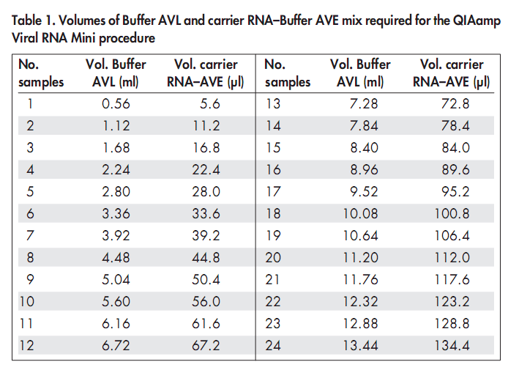

B.Prepare Buffer AW1:

Buffer AW1 is supplied as a concentrate. Before using for the first time, add the appropriate amount of ethanol (96–100%) as indicated on the bottle Buffer AW1 is stable for 1 year when stored closed at room temperature, but only until the kit expiration date.

C. Prepare Buffer AW2

Buffer AW2 is supplied as a concentrate. Before using for the first time, add the appropriate amount of ethanol (96–100%) to Buffer AW2 concentrate as indicated on the bottle.

Extraction Procedure

1. Pipet 560 µl of prepared Buffer AVL containing carrier RNA into a 1.5ml microcentrifuge tube.

2. Add 140 µl fecal suspension supernatant, to the Buffer AVL–carrier RNA in the microcentrifuge tube. Mix by pulse-vortexing for 15 s. To ensure efficient lysis, it is essential that the sample is mixed thoroughly with Buffer AVL to yield a homogeneous solution.

3. Incubate at room temperature (15–25°C) for 10 min.

4. Briefly centrifuge the tube to remove drops from the inside of the lid.

5. Add 560 µl of ethanol (96–100%) to the sample, and mix by pulse-vortexing for 15 s. After mixing, briefly centrifuge the tube to remove drops from inside the lid.

6. Carefully apply 630 µl of the solution from step 5 to the QIAamp Mini column

(in a 2ml collection tube) without wetting the rim. Close the cap, and centrifuge at 6000 x g (8000 rpm) for 1 min. Place the QIAamp Mini column into a clean 2ml collection tube, and discard the tube containing the filtrate. Optional vacuum step is excellent for processing multiple specimens (but need vacuum setup and Qiagen vacuum manifold (catalog No. 19413) is $238.).

NOTE: Close each spin column in order to avoid cross-contamination during centrifugation.

7. Carefully open the QIAamp Mini column, and repeat step 6.

8. Carefully open the QIAamp Mini column, and add 500 µl of Buffer AW1. Close the cap, and centrifuge at 6000 x g (8000 rpm) for 1 min. Place the QIAamp Mini column in a clean 2ml collection tube, and discard the tube containing the filtrate.

9. Carefully open the QIAamp Mini column, and add 500 µl of Buffer AW2. Close

The cap and centrifuge at full speed (20,000 x g; 14,000 rpm) for 3 min. Continue

Directly with step 11, or to eliminate any chance of possible Buffer AW2

Carryover, perform step 10, and then continue with step 11.

10. Recommended: Place the QIAamp Mini column in a new 2ml collection tube, and discard the old collection tube with the filtrate. Centrifuge at full speed for 1 min.

11. Place the QIAamp Mini column in a clean 1.5ml microcentrifuge tube. Discard the old collection tube containing the filtrate. Carefully open the QIAamp Mini column and add 60 µl of Buffer AVE equilibrated to room temperature. Close the cap, and incubate at room temperature for 1 min.

Centrifuge at 6000 x g (8000 rpm) for 1 min.

Extract storage

Viral RNA is stable for up to one year when stored at –20°C or –70°C. [Before storage, samples can be supplemented with equal volume of RNA storage solution (Ambion AM7000 or AM7001) to acquire greater RNA stability; this is recommendation from CDC Norovirus lab)

The extract may be stored at 4°C for 24h before RT-PCR.

The remaining sample and fecal extracts will be stored at -70°C for any further use.

**7. Real time RT PCR for detection of noroviruses**

The primers and probes are as described by Kageyama et al. J.Clin. Microbiol. 2003).

The protocol described in this SOP is for the use of Ag-Path One-Step RT-PCR Kit. This kit includes: 2X RT-PCR Buffer, 25X RT-PCR Mix, Detection Enhancer, and nuclease free water. Sites may make minor adjustments such as primer concentration to optimize this procedure for their site but the primers, probes and AgPath RT PCR kit specified in this SOP must be used by all sites.

Equipment preparation

1. Wipe and clean work surfaces, pipettes, and centrifuges to remove any potential RNase contamination.

2. Turn on the Real time PCR system to allow warm up for 15 min prior to use.

PCR Reagent preparation

1. Keep all reagents on ice during assay set up.

2. Mix the 2X Master Mix by inversion.

3. Vortex all primers for 5 sec.

4. Mix all probes by inversion.

5. Spin tubes with primers and probes for 5 sec and then place on ice.

Master Mix Preparation

Prepare the master mix in a PCR clean area. A No Template Control (NTC) and Positive Control (PC) for all primer and probe sets are included in each run. Determine the number of reactions (N) to set up per assay. Reaction master mixtures are made and dispensed into the 96-well reaction plate or 8-well strips as required. The reaction setup for GI and GII are as follows.

***Genogroup I Noroviruses***

2X RT-PCR Buffer 12.50 μl

25X RT-PCR Mix 1.00 μl

Forward primer – Cog1F (10 μM) 1.00 μl

Reverse primer - Cog1R (10 μM) 1.00 μl

Probe 1 – Ring1a (10 μM) 0.15 μl

Probe 2 – Ring 1b (10 μM) 0.15 μl

Detection Enhancer 1.67 μl

Nuclease-free water 5.53 μl

**Total volume 23.00 μl**

***Genogroup II Noroviruses***

2X RT-PCR Buffer 12.50 μl

25X RT-PCR Mix 1.00 μl

Forward primer – Cog2F (10 μM) 1.00 μl

Reverse primer - Cog2R (10 μM) 1.00 μl

Probe – Ring 2 (10 μM) 0.30 μl

Detection Enhancer 1.67 μl

Nuclease-free water 5.53 μl

**Total volume 23.00 μl**

RNA

Leave the clean area. Add 2 μlof the RNA sample, PC RNA or RNAase free water into wells labeled as sample, PC and NTC respectively. The final reaction volume is 25 μl, cover plate.

Centrifuge the plate at 500 x g for 1 min to remove bubbles or drops that may be present in the wells.

**Cycling Conditions Realtime RT-PCR**

Flourophore: FAM (530nm)

Step Temperature Time

RT 1 cycle 45C 10min

PCR 1 cycle 95C 10min

PCR 40 cycles 95C 15sec

60C 1min

The primer sequences, probes, cycling conditions and amplicon sizes for GI and GII real time PCRs are summarized in Table 2.

**Interpretation:**

1. The NTC reactions for primer/probe sets should not exhibit fluorescence growth curves that cross the threshold line. If, one or more of the primer/probe set NTCs is positive, invalidate the run and repeat the assay. Sample contamination may have occurred.
2. Positive control should result in reaction fluorescence curves (amplification plots) that cross the threshold with all primers and probes. If not, invalidate the run and repeat the assay.
3. A sample is deemed positive when a curve crosses the threshold before or at 40 CT and all controls worked properly.

**Reporting:**

1. Record and report results on Norovirus RT-PCR (NRV) Form

|  |  |  |
| --- | --- | --- |
|  | Participant ID | Write the child’s participant ID in the space provided at the upper left corner. |
| 01 | Sample ID | Write the 9-digit Sample ID. |
| 02 | Date specimen was received | Enter the date that the specimen was received. |
| 03 | Technician code processing sample | Enter the technician’s unique ID number who processed the sample. |
| 04 | Was Norovirus RT-PCR performed? | Enter yes or no if the Norovirus RT-PCR was performed. If RT-PCR was not performed, STOP completing form. |
| 05 | Technician code performing test | Enter the technician’s unique ID number who performed the Norovirus RT-PCR test. |
| 06 | Date of Norovirus RT-PCR test | Enter the date that the Norovirus RT-PCR test was performed. |
| 07 | Result | Record the result of the RT-PCR test: Negative=00,  Positive for Genogroup I =01, Positive for Genogroup II=02, Positive for Genogroup I and II = 03. |
| 08 | Cycle time to become positive for Genogroup I | Enter the number of cycles to become positive. |
| 09 | Cycle time to become positive for Genogroup II | Enter the number of cycles to become positive. |

**Limitations:**

The presence of excess DNA/RNA template in the specimen may result in false negative results. If a negative result is obtained and high levels of nucleic acid are suspected, the extracted sample may be tested at 2 or more dilutions (e.g., 1:10 and 1:100) to verify the result.

Table 2

**PCR primers, probes and cycling conditions used for GI and GII ORF1/2 region**

|  |  |  |  |  |  |
| --- | --- | --- | --- | --- | --- |
| **PCR** | **Cycling Conditions** | **Primer** | **Primer sequence** | **Position** | **Amplicon size** |
| GI | 45 oC – 10min  95 oC – 10 min  95 oC – 15 sec  X 40  60 oC – 1 min | COG1F COG1R  RING1 a  RING1 b | 5' cgY tgg atg cgN ttY cat ga 3'  5' CTT AGA CGC CAT CAT CAT TYA C 3'  FAM-AGA TYG CGA TCY CCT GTC CA-TAMRA  FAM-AGA TCG CGG TCT CCT GTC CA-TAMRA | 5291  5375  5340  5340 | 84 bp |
| GII | COG2F  COG2R  RING 2 | 5' CAR GAR BCN ATG TTY AGR TGG ATG AG3'  5' TCG ACG CCA TCT TCA TTC ACA3'  FAM-TGG GAG GGC GAT CGC AAT CT-TAMRA | 5003  5100  5048 | 97 bp |

MDF—Microscopy for the Detection of Ova and Parasites in Stool: Microscopy Data Form SOP

**This SOP has been read and understood by:**

|  |  |
| --- | --- |
| **Name** | **Date** |
| **1.** |  | |
| **2.** |  | |
| **3.** |  | |
| **4.** |  | |
| **5.** |  | |
| **6.** |  | |
| **7.** |  | |
| **8.** |  | |
| **9.** |  | |
| **10.** |  | |

**Document History:**

|  |  |  |
| --- | --- | --- |
| **Version Number** | **Reason for Changes** | **Date** |
|  |  |  |
|  |  |  |
|  |  |  |
|  |  |  |

1. **Purpose**

To detect ova and parasites in stool specimens.

Parasitic organisms can be detected in preparations made from stool samples using light microscopy. The organisms are identified morphologically by examining the shape, size, nuclear and cytoplasmic characteristics of the eggs, cysts, and parasites (trophozoites or worms). Oocysts can be identified using a modified acid fast stain.

Scope: Concentration and microscopic examination of formalin preserved stool by wet prep and modified acid fast stain.

**Quality control:**

1. Atlases, photographs and charts of parasites will be available and used by laboratory microscopists for the confirmation of positives.
2. Positive control slide containing Cryptosporidium oocysts will be stained with each batch of study modified acid fast slides.
3. Digital photographs may be taken of any questionable results and can be reviewed internally or sent to the Desktop for confirmation or resolution.

**External quality assurance:**

1. Five formalin stool concentrates for wet prep microscopy will be sent to site laboratories every 6 months Results will be compared to peer labs. A pass rate of 80% must be maintained.
2. Five methanol fixed slides for modified acid fast staining will be sent to site laboratories every 6 months after study opening. Routine staining and identification procedures will be performed by the bench technologist and results compared to peer labs. A pass rate of 80% must be maintained.
3. Positive modified acid fast slides will be archived and made available for review.

**Internal quality assurance:**

1. At least annually, the bench technologist will re-examine five stored, randomly selected formalin-fixed samples that have the original results blinded. The results of the re-examination will be compared to the original result.

**Safety:**

1. Specimens should be handled, processed and disposed of using standard guidelines for biohazardous materials.
2. Spills should be immediately disinfected with 6% hydrogen peroxide (preferred) or 10% bleach.
3. Lab bench should be disinfected at the completion of every work day

**Specimen**:

Refer to the Stool Specimen Collection and Transport SOP for details.

1. Fecal specimens (1-2 ml or grams) or rectal swabs are collected into sterile empty containers with no additives.
2. Specimens may be preserved in the field in 10% formalin at a ratio of one part stool to three parts formalin preservative if samples cannot be transported to the laboratory within 4 hours of passage.
3. Stool ova and parasites in formalin are preserved and may be tested in batches.
4. The specimens should not be frozen or placed in an incubator because of rapid parasitic degradation.
5. A portion of unpreserved stool will be archive for additional tests. Refer to SOP RSS, “Receipt and Storage of Stool Specimens”.

**Fecal Parasite Concentration**

1. **Purpose**

The concentration method is designed to separate protozoan cysts, oocysts and helminth eggs and larvae from fecal debris by centrifugation and differences in specific gravity. The suspension fluid (formalin and ethyl acetate) is less dense than cysts and eggs and thus they are found in the sediment in the bottom of the tube. Straining and defatting steps (using ethyl acetate to dissolve fecal fats and make the fecal debris float) remove fecal debris and clarify the specimen.

**Specimen:**

1. Stool preserved in 10% formalin at a ratio of one part stool to three parts formalin preservative.

2. Formalin preserved stools may be batch tested.

1. **Materials**

FPC Fecal Parasite Concentration kit (Evergreen Scientific, (800)421-6261)

10% buffered (or unbuffered) Formalin:

Combine and store in a tightly closed bottle (pH ~7.4):

100 ml formaldehyde (37% solution) + 900 ml water

For buffered, add 12g Na2HPO4 + 3g KH2PO4

Lugol’s Iodine:

Dissolve 10 g potassium iodide (KI) + 5 g powdered iodine crystals in 100 ml distilled water in a brown bottle (excess iodine crystals should remain on the bottom of the bottle). Store at room temperature for up to 1 year.

Working solution = dilute 1:5 with distilled water (prepare fresh every 10-14 days)

0.85% NaCl

Ethyl acetate

Centrifuge

Light microscope with 10x and 40x objectives

Disposable transfer pipets

Microscope slide & coverslip

**Quality Control:**

1. Check reagents daily, formalin should appear clear, without contamination.
2. Known positive control specimens should be examined quarterly.
3. Microscope should be cleaned and have the ocular micrometer calibrated annually.
4. Centrifuge speed calibration should be performed annually.
5. **Methods:**

Follow Concentration Procedure for manual sedimentation described below or use a commercial concentration kit such as, Evergreen Fecal Parasite Concentrator (FPC) kit.

**Option I – Manual Concentration:**

* + - 1. Line up test tubes in a rack; label tubes with laboratory specimen number.
      2. For specimens received in 10% formalin, resuspend stool/formalin mixture. To obtain the desired end product of 0.5 to 1 ml of sediment, processing 3 ml of the mixture should be sufficient. Strain approximately 3 ml of the formalinized stool mixture through wet gauze into a 15 ml conical tube.
      3. For unpreserved specimens, mix ~ 1 g of stool with 10 ml of 10% formalin, let mixture stand for a minimum of 30 minutes. Strain mixture through wet gauze into a 15 ml conical tube.
      4. Add ~7 ml of 0.85% NaCl (normal saline) to the tube and centrifuge for 10 minutes at 500 x g.
      5. Decant supernatant and resuspend sediment in saline (refill tube with ~14 ml saline, almost to the top of the tube, mix and centrifuge a second time for 10 minutes at 500 x g).
      6. Decant the supernatant and resuspend the sediment in ~10 ml saline and let mixture stand for 10 minutes.
      7. Add 4-5 ml of Ethyl acetate, cover tube and shake vigorously for 30 seconds.
      8. Centrifuge for 10 minutes at 500 x g.
      9. Observe for 4 layers = small sediment (containing parasites), layer of formalin, layer of fecal debris, topped by ethyl acetate.
      10. Ring the fecal plug using an applicator stick and decant all of the supernatant.
      11. While holding tube upside down, remove fluid from walls of the tube with a cotton-tipped swab.
      12. Add 1-2 drops of saline or formalin to resuspend the sediment and place a drop on a slide and cover with a 22x22 coverslip.

**Option II – Evergreen Fecal Parasite Concentrator (FPC) kit:** as per product insert

1. Line up the flat-bottom tubes in a rack; label tubes with laboratory accession number.

2. Place the conical centrifuge tubes (with the green filtration screen attached) in a rack directly behind the flat-bottom tubes.  Label tubes with laboratory accession number.

3. Add the following to the flat-bottom tube in the order specified:

A. 9 ml of 10% formalin

B. Two spoonfuls of formalinized feces (1.0 g)

C. Three drops of Triton X-100

D. 3 ml of ethyl acetate

4. Attach the conical centrifuge tube (with strainer attached with the aerator tube extended 3.5 cm above the top of the green mid-piece screen so that it extends above the fluid level when the tube is inverted.) to each flat bottom tube.

BE SURE TO MATCH THE CORRECT TUBE NUMBERS WITH EACH OTHER.  Tighten each connection to prevent leakage.

5. Shake vigorously for 30 seconds.

6. Flip the tubes over and allow the mixture to filter into the strainer into the conical tube.  If the sample stops flowing, tap the conical tube on the countertop to re-start the transfer.

7. Unscrew the centrifuge tube/strainer assembly and discard.

8. Screw a white plastic cap onto each conical centrifuge tube.

9. Centrifuge conical tubes at 500 x g for 10 minute. Ring the fecal plug using an applicator stick and decant all of the supernatant.

10. While holding tube upside down, remove fluid from walls of the tube with a cotton-tipped swab.

11. Add 1-2 drops of saline or formalin to resuspend the sediment and place a drop on a slide and cover with a 22x22 cover slip.

**Microscopic Examination of Sediment:**

Protozoan cysts and helminth eggs and larvae may be seen and identified. In a heavy infection with *Cryptosporidium*, oocysts may be seen in a direct smear; however, the modified acid-fast stain is normally used to detect these organisms. Oocysts of *Isospora belli* can also be seen in a direct smear. Spores of the microsporidia are too small, and the shape resembles other debris within the stool; therefore, they are not readily visible.

1. Examine the slides using a microscope at 10X and 40X:

a. Systematically scan the entire coverslip with the 10X objective (low power). If something suspicious is seen, turn to the 40X objective for more detailed exam.

* 1. Scan at least one-third of the coverslip with the 40X objective (high dry power), even if nothing suspicious has been seen at 10X.
  2. Consult photographs and refer to parasitology atlas for identification guidance. Study site may email problem or unknown parasite photographs to the microbiology subcommittee for consultation.

2. For enhanced morphological detail, Lugol’s Iodine stain (1:5 dilution) may be used.

**Reporting:**

1. Record results on Microscopy Data Form (MDF). See below for additional guidance.

|  |  |  |
| --- | --- | --- |
| # | Question | Guidance |
|  | Participant ID | Write the child’s participant ID in the space provided at the upper left corner. |
| 01 | Sample ID | Write the 9-digit Sample ID. |
| 02 | Date specimen was received | Enter the date that the specimen was received. |
| 03 | Technician code | Enter the technician’s unique ID number who processed the sample. |
| 04 | Was wet prep microscopy performed? | Indicate whether or not wet prep microscopy was performed. If no, STOP completing the form. |
| 05 | Were parasites observed? | Indicate yes if parasites were observed and no if parasites were not observed upon wet prep microscopy. If no, continue to question #42. If yes, continue to question #6. |
| 06-39 | Which parasite was observed? | For each parasite listed, indicate whether or not this parasite was observed using either concentrate wet prep and/or direct wet prep. |
| 40-41 | Other parasites observed? | Indicate whether additional parasites not listed were observed using either concentrate wet prep and/or direct wet prep. If additional parasites were observed, complete parasite reporting log. |
| 42 | Technician code | Enter the technician’s unique ID number who performed the wet preps. |
| 43 | Date specimen was tested for parasites | Enter the date that the specimen was tested for parasites. |
| 44-47 | See information contained within the Modified Acid Fast Stain section. | |

**Modified Acid Fast Stain (cold Ziehl-Neelson)**

1. **Purpose**

*Cryptosporidium*, *Cyclospora*, and *Isospora* cause severe diarrhea in immunocompromised persons. They can also cause diarrhea in immunocompetent hosts. The modified Ziehl-Neelsen acid fast staining technique is useful for the identification of oocysts, which may be difficult to detect with other stains such as trichrome.

**Specimen:**

Concentrated sediment of formalin-preserved stool

1. **Materials**

TB Stain Kit ZN (BD, (800)675-0908, cat. # 212520) – containing carbolfuchsin ZN, acid-alcohol and methylene blue solutions

Light Microscope (with 40X and 100X oil immersion objectives)

Microscope slide

**Quality Control:**

Frequency – stain a Control slide (prepared from a specimen containing *Cryptosporidium* oocysts) with each batch stained

Acceptable results - *Cryptosporidium* oocysts 4-6um staining red against a blue background.

1. **Methods**
2. Prepare a smear on a glass slide by placing 1-2 drops of fixed/concentrated stool sediment (note: Do not make the smears too thick, you should be able to see through the material while still wet.)
3. Allow the slide to air dry.
4. Fix the slide by flooding slide with 100% methanol for 1 minute.

(Note: fixed slides are valid indefinitely)

1. Stain the slide using a modified Ziehl-Neelson stain kit:

a. Flood slide with Carbolfuchsin ZN, stain for 1 minute

b. Rinse thoroughly with water.

c. Decolorize by rinsing briefly with acid-alcohol until no more color runs from the slide.

d. Rinse thoroughly with water.

e. Flood slide with methylene blue, stain for 1 minute.

f. Rinse thoroughly with water and air-dry.

(Note: Stained slides are valid indefinitely)

**Examination of Slide:**

Examine the stained sediment form concentrate using 40X (high dry power) and 100X oil immersion:

a. Systematically scan 200-300 fields with the 40X objective. If something suspicious is seen, turn to the 100X objective for more detailed exam.

b. Consult photographs and refer to atlas for identification guidance.

**Interpretation:**

*Cryptosporidium spp.* oocysts are oval or round oocysts, will stain red to pink, measuring 4-6 μm, with a clear internal structure (some of the 4 sporozoites may be visible).

*Isospora sp*. will stain pink to red to deep purple, oval in shape and measuring 10-20 μm (in some immature oocysts the entire oocyst may stain, in mature oocysts the two sporocysts within the oocyst wall usually stain pink to purple with a clear area between the stained sporocysts and the oocyst wall).

*Cyclospora cayetanensis* oocysts resemble *Cryptosporidium* but larger (8-10 μm) and have no definite internal morphology, the acid-fast staining more variable light pink to deep red, some will contain granules or have a bubbly appearance like “wrinkled cellophane” and some oocysts may appear clear or very pale.

Microsporidia spores are acid fast, but identification is very difficult because of their small size (1-2 um).

Study site may send questionable or unknown parasite photographs to the Study Desktop for identification.

**Documentation and Reporting:**

1. Parasitological test results are recorded on Microscopy Data Form (MDF).
2. Completed MDFs are submitted to the Data Management team for double entry into the database.
3. The Lab coordinator reviews lab reports before submission to the Data Management team.

|  |  |  |
| --- | --- | --- |
| 44 | Was a modified acid-fast stain performed? | Indicate whether or not a modified acid-fast stain was performed. If the stain was not performed, STOP; form is complete. |
| 45 | Did modified acid-fast stain detect an organism? | Indicate whether or not an organism was detected and what organism was detected. |
| 46 | Technician code | Enter the technician’s unique ID number who performed the modified acid-fast stain. |
| 47 | Date | Enter the date (DD/MMM/YY) that the modified acid-fast stain was performed. |

**Archive:**

1. Store the remaining formalized and concentrated stool specimens in labeled boxes at ambient temperature until completion of the study.
2. Store all slides in numbered slide boxes until completion of the study.

**References:**

1. Baily and Scott’s, Diagnostic Microbiology edition, C.V.Mosby Company
2. Laboratory Diagnosis of Cryptosporidiosis, D.P.Case et al, J.Clin.Pathol.38:1337-1341, 1985.
3. Sydney Finegold & William J. Martin: Diagnostic Microbiology. The C.V. Mosby Company, St. Louis
4. Clinical Laboratory Standards Institute CLSI M28A2 Procedure for the Recovery and Identification of Parasites from the Intestinal Tract. Approved Guideline
5. Diagnostic Medical Parasitology L.S Garcia 5th ed 2007

PEF—Detection of Protozoa By ELISA

**This SOP has been read and understood by:**

|  |  |
| --- | --- |
| **Name** | **Date** |
|  |  | |
|  |  | |
|  |  | |
|  |  | |
|  |  | |
|  |  | |
|  |  | |
|  |  | |
|  |  | |
|  |  | |

**Document History:**

|  |  |  |
| --- | --- | --- |
| **Version Number** | **Reason for Changes** | **Date** |
|  |  |  |
|  |  |  |
|  |  |  |
|  |  |  |

1. **Purpose**

To detect Giardia, Cryptosporidium, and Entamoeba histolytica antigens by enzyme immunoassay.

1. **Materials**

Stored in the refrigerator at 2-8° C:

Entamoeba histolytica II kit (Techlab, Inc.)

Giardia II kit (Techlab, Inc.)

Cryptosporidium II kit (Techlab, Inc.)

Clean screw-capped disposable containers for preparing fecal suspensions

Clean vial for negative control

Clean absorbent paper

Waste container with disinfectant (bleach)

Automated plate washer (optional)

EIA plate reader capable of reading 96 well plate at absorbance of 450nm with reference 620-650nm

1. **Methods**

**Quality control:**

A single positive control and single negative control (diluent) must be tested with every test run.

**Specimen:**

Refer to the Stool Specimen Collection and Transport SOP for details.

1. Fresh or frozen unpreserved stool collected into sterile empty containers with no additives.

2. Samples can be stored at -20° to -70°C and batch tested. It is advisable to test within two months. Frozen fecal specimens are thawed. Repeated freeze-thaw should be avoided.

3. Although the Giardia and Cryptosporidium package insert allows for the testing of formalin preserved specimens, this option will not be routinely used.

4. In case of small specimen quantities refer to SOP QNS “Processing and Testing of QNS Stool Specimens”.

**Procedure:**

1. Open and prepare each kit.

2. Prepare fecal specimens.

**A. Entamoeba histolytica test**

**Specimen Preparation**

For liquid stools, transfer 400μl of specimen in 1.5 ml microcentrifuge.

400μl of diluent is added to the tube (containing stool).

For formed stool, transfer 0.150 to 0.200 g of stool in 1.5 ml microcentrifuge tube and mix thoroughly by vortexing.

**Test Procedure**

1. One drop of conjugate is added to a positive control well, negative control well, and patient sample well.
2. The positive control is shaken for several seconds, and then one drop is added to the positive control well.
3. 100μl of diluents is added to the negative control well.
4. 200μl of vortexed diluted specimen is transferred to a test well of micro assay plate.
5. Cover wells with a plastic adhesive sheet.
6. Incubate for 2 hours at room temperature.
7. Contents of assay wells are shaken out into a discard pan.
8. Each well is washed using a diluted wash solution. The wash solution is supplied as a 20x concentrate, and 50ml of this is added to 950ml of distilled water.
9. Washing steps are repeated for four times, or washing should be continued if any fecal material remains in any well.
10. After washing, the plate is inverted and tapped firmly onto dry paper towel to remove residual liquid in well.
11. 2 drops of substrate are added to each well.
12. Gently tap the wells initially and again at 5 min to mix the substrate.
13. Incubate for 10 minutes at room temperature.
14. Add one drop of stop solution to each well, gently tap to mix, and wait for 2 minutes before reading.
15. Blue color converts to yellow color after mixing of stop solution.
16. The absorbance of color is measured at 450nm wavelength.
17. Reading should be taken within 10 minutes after mixing in stop solution.

**Spectrophotometric Reading:**

* 1. Set the microplate ELISA reader to read at 450 nm. If a dual wavelength reader is used, set the ELISA reader to read at 450 nm and reference at 620 nm.
  2. Determine the absorbance value for the negative control. The negative control reading should be 0.150 or less. If not, the test is not valid and should be repeated, paying attention to the wash procedure.
  3. Subtract the reading of the negative control well from the readings of the positive control well and test wells before interpreting the results (the microplate ELISA reader may be set to blank on the negative control well so this step is performed automatically).
  4. The reading for the positive control should be 0.500 or higher after the negative control reading has been subtracted. If this value is not obtained, the test should be repeated.
  5. A specimen is considered positive for adhesin if the reading is 0.050 or higher after the negative control reading has been subtracted. A specimen is considered negative for the adhesin if the reading is <0.050.
  6. A positive test result indicates that E. histolytica adhesin is present in the fecal specimen. A specimen is considered negative for the adhesin if the reading is <0.050 after the negative control has been subtracted.
  7. Record on ELISA worksheet.

**Interpretation of results:**

|  |  |  |
| --- | --- | --- |
| Absorbance (after subtracting Negative Control) | Visual Color | INTERPRETATION |
| <0.050 | Clear | Negative - does not contain *E. histolytica* |
| ≥0.050 | Pale yellow to strong yellow | Positive - Specimen contains *E. histolytica* adhesin |

***Visual Interpretation*:**

**Negative:** Any sample that is colorless or resembles the negative control well in intensity of color.

**Positive:** Any sample that is obviously more yellow than the negative control well.

NOTE: The negative control, as well as some test wells, may show some slight yellow color. A sample well must be obviously more yellow than the negative control well to be called a positive result.

**B. Giardia and Cryptosporidium tests**

**Specimen Preparation:**

Frozen fecal specimens should be thawed. Add 400µL of *Diluent* to a microcentrifuge tube (one per sample), then add 100µL of sample to the tube and mix well. If the specimen cannot be pipetted, use an applicator stick to transfer approximately 0.1 gram of feces. This is about the size of a small pea (about 4mm in diameter).

**Methods:**

1. Positive control is shaken for several seconds, then added one drop to a positive control well.

2.100μl of diluents are added to the negative control well.

3.100μl of diluents are transferred to each test well, and then 50μl of diluted specimen is transferred to a test well of micro assay plate by using plastic pipettes.

4. The wells are gently tapped to mix well after sealing with a plastic adhesive sheet.

5. Incubation for 1 hour at room temperature.

6. Contents of assay wells are shaken out into a discard pan.

7. Each well is washed with 1x wash solution in a squirt bottle with a fine-tipped nozzle.

8. Washing steps are repeated for four times or washing should be continued if any fecal material remains in well.

9. After washing the plate is inverted and tapped firmly onto a dry paper towel to remove residual liquid in well.

10. One drop of conjugate is added to each well.

11. Plate is sealed with a plastic adhesive sheet, and gently tapped to mix well.

12. Incubation for 30 min. at room temperature.

13. Steps 8 and 9 are repeated for washing.

14. 2 drops of substrate are added to each well.

15. Gently tap to mix.

16. Incubation for 10 minutes at room temperature.

17. One drop of stop solution is added to each well, gently tap to mix and wait 2 min. before reading.

18. Blue color converts to yellow color after mixing of stop solution.

19. The absorbance of color is measured at 450nm and for dual reader blank against air at 620 nm and read at 450 nm.

20. Reading should be taken within 10 minutes after mixing stop solution.

**Interpretation:**

***Spectrophotometric Interpretation:***

1. Determine the absorbance value of the Negative Control. The Negative Control reading should be <0.150 OD 450 or < 0.090 OD 450/620. If not, the test is not valid and should be repeated, paying attention to the wash procedure.

2. The reading for the *Positive Control* should be ≥0.500 or higher.

3. Test results

Negative: < 0.150 (absorbance at 450 nm) or < 0.090 (absorbance at 450/620 nm)

Positive: ≥ 0.150 (absorbance at 450 nm) or ≥ 0.090 (absorbance at 450/620 nm)

|  |  |  |  |
| --- | --- | --- | --- |
| Absorbance (nm) | | Visual Color | Interpretation |
| 450 | 450/620 |
| < 0.150 | < 0.09 | Clear to slight yellow | Negative – Below detectable limits of assay |
| ≥ 0.150 | ≥ 0.090 | Pale yellow to strong yellow | Positive Specimen - contains the target antigen |

***Visual Interpretation*:**

**Negative:** Any sample that is colorless or resembles the negative control well in intensity of color.

**Positive:** Any sample that is obviously more yellow than the negative control well.

NOTE: The negative control, as well as some test wells, may show some slight yellow color. A sample well must be obviously more yellow than the negative control well to be called a positive result.

**Reporting:**

1. Record and report the Visual Interpretation and the ODs and OD interpretation on the ELISA Worksheet and report results on the Protozoa ELISA Form (PEF).

|  |  |  |
| --- | --- | --- |
| # | Question | Guidance |
|  | Participant ID | Write the child’s participant ID in the space provided at the upper left corner. |
| 01 | Sample ID | Write the 9-digit Sample ID. |
| 02 | Date specimen was received | Enter the date that the specimen was received. |
| 03 | Technician code | Enter the technician’s unique ID number who processed the sample. |
| 04 | Was Cryptosporidium ELISA performed? | Enter yes or no if the Cryptosporidium ELISA was performed. If test was not performed, go to question #8. |
| 05 | Technician code | Enter the technician’s unique ID number who performed the Cryptosporidium ELISA test. |
| 06 | Date of Cryptosporidium ELISA test | Enter the date that the Cryptosporidium ELISA test was performed. |
| 07 | Result | Record the result of the Cryptosporidium ELISA test. Refer to the ELISA worksheet, if appropriate. |
| 08 | Was Giardia ELISA performed? | Enter yes or no if the Giardia ELISA was performed. If test was not performed, go to question #12. |
| 09 | Technician code | Enter the technician’s unique ID number who performed the Giardia ELISA test. |
| 10 | Date of Giardia ELISA test | Enter the date that the Giardia ELISA test was performed. |
| 11 | Result | Record the result of the Giardia ELISA test. Refer to the ELISA worksheet, if appropriate. |
| 12 | Was E. histolytica ELISA performed? | Enter yes or no if the E. histolytica ELISA was performed. If test was not performed, form is complete. |
| 13 | Technician code | Enter the technician’s unique ID number who performed the E. histolytica ELISA test. |
| 14 | Date of E. histolytica ELISA test | Enter the date that the E. histolytica ELISA test was performed. |
| 15 | Result | Record the result of the E. histolytica ELISA test. Refer to the ELISA worksheet, if appropriate. |

**References:**

Entamoeba histolytica II kit (Techlab, Inc.)

Giardia II kit (Techlab, Inc.)

Cryptosporidium II kit (Techlab, Inc.)

ALA—Alpha -1- Antitrypsin Assay

**This SOP has been read and understood by:**

|  |  |
| --- | --- |
| **Name** | **Date** |
| **1.** |  | |
| **2.** |  | |
| **3.** |  | |
| **4.** |  | |
| **5.** |  | |
| **6.** |  | |
| **7.** |  | |
| **8.** |  | |
| **9.** |  | |
| **10.** |  | |

**Document History:**

|  |  |  |
| --- | --- | --- |
| **Version Number** | **Reason for Changes** | **Date** |
| 2 | Clarify dilutions to be run to consistently obtain values on the standard curve | 14-Aug-10 |
| 2 | Dilutions are to be run in duplicate; 2 wells of 1:250 and 2 wells of 1:500 are run | 14-Aug-10 |
| 2 | Use of standards clarified | 14-Aug-10 |
| 2 | AAT reporting form changed | 14-Aug-10 |
| 5 | Dilutions to be run in duplicate; 2 wells of 1:500 are run | 27-Oct-10 |
| 6 | Dilutions to be run singly; 1 well of 1:500 is run | 09-May-11 |
| 6.1 | Added option for 1:10000 dilution | 07-Jul-14 |

**I.** **Purpose**

For the quantitative determination of alpha-1-antitrypsin in stool specimen as an indication of gut inflammation.

**Intended use**

The ELISA Kit is intended for the quantitative determination of alpha-1-antitrypsin in serum and stool. For in vitro diagnostic use only.

**Introduction**

Alpha-1-Antitrypsin is a 52 kD glycoprotein, which is produced by the liver, intestinal macrophages, monocytes and mucous membrane cells of the gut. It belongs to the group of acute phase proteins and is one of the most important proteinase inhibitors. Alpha-1-antitrypsin inhibits, beside others, the proteinases trypsin and the elastase of neutrophils. A lack of α-1-AT leads to an enhanced proteolysis. Only a very small amount of alpha-1-antitrypsin is cleaved or resorbed in the gut. Therefore the measurement of α-1-AT in stool reflects the permeability of the gut during inflammatory processes.

This protocol has been modified significantly from the kit instructions based on MALED data showing that Alpha-anti-trypsin values in Peru and Pakistan are consistently too high to derive valid results from when run at the recommended 1:250 dilution. It is both more efficient and more likely to generate valid results if a further dilution is run instead of the 1:250 dilution on the initial plates (it saves the sample from freeze thaw process which effects the results of the assay).

**Safety**

All reagents of this kit are strictly intended for in vitro diagnostic use only.

This assay was produced and put on the market according to the IVD guidelines of 98/79/EC. Do not interchange kit components from different lots. The stop solution (STOP) contains acid and has to be handled carefully. It is corrosive and causes burns. It should be handled with gloves, eye protection, and appropriate protective clothing in a hood. Any spill should be wiped out immediately with copious quantities of water. Do not breathe vapor and avoid inhalation. In case of an accident or indisposition contact immediately a physician.

The substrate TMB (tetramethyl benzidine) is toxic by ingestion and contact with the skin. Any spill should be wiped out immediately with copious quantities of water. Wear disposable gloves while handling specimens or kit reagents and wash hands thoroughly afterwards. Do not pipette by mouth. Do not eat, drink, smoke or apply makeup in areas where specimens or kit reagents are handled. The reagents of the test kit contain bactericides to protect against bacterial growth. Avoid the contact with the skin or mucous membrane. Reagents should not be used beyond the expiration date shown on kit label. Observe the guidelines for performing quality control in medical laboratories by assaying controls and/or pooled sera. During handling of all kit reagents, controls and serum samples observe the existing legal regulations.

**II. Material**

1. Alpha -1- antitrypsin ELISA form (AEF)
2. BioVendor Research and Diagnostic Products cat # RIC6200R (phone: + 420–549 124 185
3. Other Materials:

• Laboratory balance

• Centrifuge, 3000xg

• Glass or plastic vials

• Various pipettes

• Foil to cover the microtiterplate

• Multichannel or multipipette

• ELISA reader with filter 450 nm (reference filter 620 or 690 nm)

• Microtiterplate shaker

• Vortex mixer

**III. Methods – also refer to Product insert**

Reagent Prep:

1. Microtiterplate (MTP): Take the needed strips out of the bag and mount them on the holder. Please take care that the package has reached room temperature before opening the bag. Strips that are not needed can be stored at 2-8°C. Please dispose of the holder when all strips are used.
2. Washbuffer (WASHBUF): Dilute the washbuffer concentrate 1:10 with deionized (DI) water (1 part buffer + 9 parts DI water.) The dilution is stable for 14 days at 2-8°C.

* Important: When storing the washbuffer concentrate at 2-8°C crystalization could occur. Before dilution, all crystals must be dissolved.
* Note: It is recommended to dilute only the amount of buffer which is used to process the given samples.
* All other test reagents are stable at 2-8 °C, up to the date of expiry stated on the label.

Sample Prep: Note- avoid multiple freeze thaw cycles

Alpha-1-antitrypsin is extracted by the sample dilution buffer out of the stool sample.

1. **100 mg** stool are mixed with **5 ml** WASHBUF on a vortex mixer until the mixture is homogenous.
2. **1 ml** of the mixture is transferred into an Eppendorf vial and centrifuged for **10 min** at 10,000xg.
3. Dilute the supernatant **1:250** with WASHBUF (4 µl + 996 µl WASHBUF) for dilution 1 (1:250).
4. Make dilution 2 (1:500) by taking 120 ul of dilution 1 and 120 ul of WASHBUF.
5. **100 µl** of the **dilution 2** are used per well.

Procedure

All reagents and samples should be at room temperature (18-26°C) and mixed well before use. The position of standards, controls and samples should be noted on a protocol sheet.

1. Take out the needed strips for the microtiter plate and wash **1x** with **250 µl** diluted WASHBUF. Remove residual buffer by tapping the plate on absorbent paper after the washing step.
2. Pipette **100 µl** of all five **STDs (0, 3.3, 10, 30, 90 ng/ml), CTRL** and **dilution 2 (1:500)** of **samples** in the microtiterplate. The dilution 2 of samples is to be runsingly, meaning only one well per sample will be run.
3. The strips are covered and incubated by shaking for **60 min** at room temperature (18-26 °C).
4. The reaction begins with pipetting into the antibody coated microwell. **Pipetting should be done as quickly as possible**. When processing many samples at once, the samples should be pipetted from a separate microtiterplate (150 µl) and transferred simultaneously using a multichannel pipette.
5. Discard the content of the microwells and wash **5x** with **250µl** of diluted WASHBUF. Remove residual buffer by tapping the plate on absorbent paper after the last washing step.
6. Pipette **100 µl** CONJ in each microwell.
7. The strips are covered and incubated by shaking for **60 min** at room temperature (18-26 °C).
8. Discard the content of the microwells and wash **5x** with **250 µl** diluted WASHBUF. Remove residual buffer by tapping the plate on absorbent paper after the last washing step.
9. Pipette **100 µl** SUB in each microwell. Incubate for **10-15 min** at room temperature (18-26 °C) in the dark.
10. Pipette **50 µl** STOP in each microwell, mix well.
11. Read the absorbance at 450 nm. If the microtiterplate reader allows use of a reference wavelength, select 620 or 690 nm as reference wavelength.

**Reading should be done within 5 min after stopping reaction.**

If the highest standard exceeds the range of the reader the reading should be done at 405 nm against 620 nm (690 nm).

**IV. Results**

For the α-1-antitrypsin concentration of fecal samples you must describe the relationship between absorbance at 405 (OD) and the concentration of Alpha-1-antitrypsin in ng/ml by generating a standard curve on each run. This is best done with the 4-parameter algorithm- if not available on your microplate reader a point to point or spline function can be used. Depending on your ELISA plate reader (many have a function that is programmable, ie SoftMaxPro from molecular diagnostics units) this can be done automatically. If not, this requires the generation of a graph like that displayed below in this SOP for each plate.  
After generating the standard curve, the measured alpha-1-AT concentration (NOT THE OPTICAL DENSITY) is recorded on the results form along with the dilution (1:500) that yielded the result. In the case that the OD is above the value of the 90 ng/ml standard, report NA on the results form for questions 7,8 or 9 on the report form (do not report a value over 90 ng/ml per dilution). Questions on the report form have been added for the dilutions of 1:1000 and 1:10000. If you obtain a OD on the standard curve (ie below 90 ng/ml) at 1:500 there is no need to run the sample at 1:1000 or 1:10000.



*The curve given above is only for demonstration. It must not be used for calculation of your samples*

**V. Reporting:**

1. Record results on Alpha-1-antitrypsin (ALA) form.

|  |  |  |
| --- | --- | --- |
| # | Question | Guidance |
|  | Participant ID | Write the child’sparticipant ID in the space provided at the upper left corner. |
| 01 | Sample ID | Write the 9-digit Sample ID. |
| 02 | Date specimen was received | Enter the date that the stool specimen was received. |
| 03 | Technician code processing sample | Enter the technician’s unique ID number who processed the sample. |
| 04 | Was α-1- antitrypsin ELISA performed? | Enter yes or no if the α-1- antitrypsin ELISA was performed. If test was not performed, STOP, form is complete. |
| 05 | Technician code | Enter the technician’s unique ID number who performed the α-1- antitrypsin ELISA test. |
| 06 | Date of α-1- antitrypsin ELISA test | Enter the date that the α-1- antitrypsin ELISA test was performed. |
| 07 | Calculated α-1- antitrypsinconcentration value at 1:250 | Enter the α-1- antitrypsin concentration in **ng/ml If the optical density of the sample is greater than the 90 ng/ml standard record NA**  **NOTE:** As of 27-Oct-10 1:250 dilution will no longer be run, so record **NA** |
| 08 | Calculated α-1- antitrypsinconcentration value at 1:500 | Enter the α-1- antitrypsin concentration in **ng/ml If the optical density of the sample is greater than the 90 ng/ml standard record NA** |
| 09 | Calculated α-1- antitrypsinconcentration value at 1:1000 | Enter the α-1- antitrypsin concentration in **ng/ml If the sample was not run at this concentration because values on the standard curve were obtained at lower dilutions, record NA** |
| 10 | Calculated α-1- antitrypsinconcentration value at 1:10000 | Enter the α-1- antitrypsin concentration in **ng/ml If the sample was not run at this concentration because values on the standard curve were obtained at lower dilutions, record NA** |

**VI. Limitation -**

**Stool samples** with α-1-antitrypsin concentrations greater than the highest standard value at a dilution of 1:500 should be further diluted 1:1000 with wash buffer and assayed again. To do this, prepare 400 ul of dilution 2 (1:500) by combining 200 ul of dilution 1 and 200 ul WASHBUFF (as described in Methods, section IIIB step 4). In a separate tube dilute 110 ul of dilution 2 with 110 ul of WASHBUFF to yield dilution 3 (1:1000). To make dilution 4 (1:10000), dilute 110 ul of dilution 3 with 110 of WASHBUFF. Place 100 ul of dilution 3 (1:1000) or dilution 4 (1:10000) in a single well on the plate run. Again, the sample dilution 3 (1:1000) or dilution 4 (1:10000) should be run **singly**.

**VII. Quality Control -**

Control samples should be analyzed with each run. Results, generated from the analysis of control samples, should be analyzed by technicians on the same day of the run. Because of the sensitivity of the assay to temperature and time, it is expected that ODs will vary between laboratories that should develop their own normal range with special attention to the standard with 0 ng/ml and the CTRL sample.

If within the same assay one or more values of the quality control sample are outside of the acceptable limits, then the results for the samples may not be valid. If the duplicates of the same dilution have significantly disparate values, the assay should be rerun.

**Notes:** The local Principal Investigator is notified immediately when an event occurs outside of the standards of practice (this event is called a ***protocol deviation,* which is any unapproved change, deviation, or departure from the study design or procedures). A Protocol Deviation Form is completed by the individual having committed the deviation and the study coordinator/ sponsor/IRBs are notified.**

**VIII. References -**

1. G. Beckmann (Hrsg.). Mikroökologie des Darmes; ISBN 3-87706-521-X;

### MPO—Myeloperoxidase ELISA: In Vitro Determination of Myeloperoxidase in Stool

**This SOP has been read and understood by:**

|  |  |
| --- | --- |
| **Name** | **Date** |
| **1.** |  |
| **2.** |  |
| **3.** |  |
| **4.** |  |
| **5.** |  |
| **6.** |  |
| **7.** |  |
| **8.** |  |
| **9.** |  |
| **10.** |  |

**Document History:**

|  |  |  |
| --- | --- | --- |
| **Version Number** | **Reason for Changes** | **Date** |
| 2 | Added instructions for completing MPO and MEP forms | 9/APR/12 |
| **3** | Added question (6) about dilution factor to MPO form | 24/Apr/12 |
|  |  |  |
|  |  |  |

**I. Summary and Explanation of the Test**

The granules of neturophils (approx. 70% of the white blood cells) contain a large number of different enzymes. **Myeloperoxidase** (MPO) catalyzes the oxidation of substances through H2O2. The **MPO** H2O2-system has a toxic effect on many micro-organisms such as bacteria, fungi, viruses and mycoplasma. The efficiency of the bacteria-destructive Myeloperoxidase H2O2-system is increased by MN-Elastase. **MPO** determination in the stool reflects the inflammatory activity of Crohn’s disease or ulcerative colitis.

**II. Test Principle**

This Enzyme-Linked-Immuno-Sorbent-Assay (ELISA) is suitable for the quantitative determination of Myeloperoxidase in urine and stool. In a first incubation step, the Myeloperoxidase in the samples is bound to an available excess of antibodies against Myeloperoxidase, which are immobilized to the surface of the microtiter plates. To remove all unbound substances, a washing step is carried out. In a second incubation step, a Peroxidase-labeled antibody against MPO is added. After another washing step, to remove all unbound substances, the solid phase is incubated with the substrate Tetramethylbenzidine (TMB). An acidic stop solution is then added to stop the reaction. The color converts from blue to yellow. The intensity of the yellow color is directly proportional to the concentration of MPO in the sample. A dose response curve of the absorbance unit (optical density, OD) vs. concentration is generated, using results obtained from the calibrators. MPO, present in the patient samples, is determined directly from the curve.

**III. Materials Required but not Supplied**

1. Ultra pure water *
2. Laboratory balance
3. Precision pipettors and disposable tips to deliver 10-1000 µl
4. Foil to cover the microtiter plate
5. Horizontal microtiter plate shaker
6. A multi-channel dispenser or repeating dispenser
7. Centrifuge
8. Vortex-Mixer
9. Standard laboratory glass or plastic vials, cups, etc.
10. Microtiter plate reader at 450 or 405 nm (reference wavelength 620 or 690 nm)
11. MEP Form
12. MPO Form

* Immundiagnostik AG recommend the use of Ultra Pure Water (Water Type 1; ISO 3696), which is free of undissolved and colloidal ions and organic molecules (free of particles > 0.2 µm) with an electrical conductivity of 0.055 µS/cm at 25 °C (≤18.2 MΩ cm).

**IV. Preparation and Storage of Reagents**

1. To run the assay more than once, ensure that reagents are stored at conditions stated on the label. **Prepare only the appropriate amount necessary for each assay.** The kit can be used up to 4 times within the expiry date stated on the label.
2. Reagents with a volume less than **100 µl** should be centrifuged before to avoid loss of volume.
3. The **WASBUF** (wash buffer concentrate) should be diluted with ultra pure water **1:10** before use (100 ml WASHBUF + 900 ml ultra pure water), mix well. Crystals could occur due to high salt concentration in the stock solutions. The crystals must be redissolved at 37 °C in a water bath before dilution. The **WASHBUF** (wash buffer concentrate) is stable at **2-8 °C** until the expiry date stated on the label. Diluted **buffer solution** can be stored in a closed flask **2-8 °C for one month**.
4. The lyophilized **standards (STD) and controls (CTRL)** are stable at **2-8 °C** until the expiry date stated on the label. Reconstitution details are given in the data sheet.
5. The **AB** (detection antibody, biotinylated) must be diluted **1:101** in wash buffer (e.g. 100 µl AB + 10 ml wash buffer). The undiluted AB is stable at **2-8 °C** until the expiry date given on the label. **Diluted antibody solution is not stable and cannot be stored.**
6. The **CONJ** (conjugate, POD-antibody) must be diluted **1:101** in wash buffer (e.g. 100 µl CONJ + 10 ml wash buffer). The undiluted CONJ is stable at **2-8 °C** until the expiry date stated on the label. **Diluted conjugate is not stable and cannot be stored.**
7. All other test reagents are ready to use. Test reagents are stable until the expiry date (see label of test package) when stored at **2-8 °C**.

**V. Specimen Collection and Preparation**

For stool samples:

1. Weigh precisely **0.1g**  of the sample and add **5 ml** of the wash buffer and vortex until sample is mixed thoroughly.
2. Centrifuge the sample suspension for 10 min at 900g. Transfer 1 ml of the supernatant into an Eppendorf tube and centrifuge again at 16,000g for 5 min. The resulting supernatant can be stored at -20 °C for about 1 month.
3. Centrifuge the supernatant at 16,000g for 2 min before use. Dilute the supernatant **1:10** in wash buffer (100 µl supernatant + 900 µl wash buffer). Use **100 µl** of the end-dilution in the assay

**VI. Test Procedure**

Prior to use in the assay allow all reagents and sample to come to room temperature (22 °C) and mix well.

Wash the pre-coated microtiter plate 5x with 250 µl ELISA wash buffer.

1. Pipette **100 µl** of **STD** (standards), **CTRL** (controls) or **samples** into each well.
2. Incubate for **1 hour** at room temperature, shaking on a horizontal mixer.
3. Decant the contents of the plate and wash the wells **5x with 250 µl** of washing buffer solution.
4. Add **100 µl** of diluted **AB** (detection antibody solution).
5. Incubate for **1 hour** at room temperature, shaking on a horizontal mixer.
6. Decant the contents of the plate and wash the wells **5x with 250 µl** of washing buffer solution.
7. Add **100 µl** of diluted **CONJ** (conjugate solution).
8. Incubate for **1 hour** at room temperature, shaking on a horizontal mixer.
9. Decant the contents of the plate and wash the wells **5x with 250 µl** of washing buffer solution.
10. Add **100 µl** of **SUB** (TMB-substrate) solution.
11. Incubate approx. **10-20 minutes** at room temperature, shaking delicately (be sure not to agitate so vigorously that wells overflow or bubbles are formed ) once at the beginning middle and end of the incubation period (ie at least 3 times in total) until sufficient coloring is achieved.
12. Add **50 µl** of **STOP** (stop solution) and mix briefly.
13. Determine **absorption immediately** with an ELISA reader at **450 nm** against 620 nm (or 690 nm) as a reference. If no reference wavelength is available, read only at 450 nm. If the extinction of the highest standard exceeds the measurement range of the photometer, absorption must be measured immediately at 405 nm against 620 nm (or 690 nm) as reference.

**VII. Results**

A calibration curve is constructed from the calibrator values and the results of the samples are read from it. Commercially available software can be used as well as graph paper for evaluation.

The calibration curve **is not linear**, therefore a spline- or 4PL-algorithm is recommended.

**If results obtained are not on the standard curve, the sample should be diluted further and run again.**

For stool samples:

The concentrations of the samples must be read directly from the standard curve. Results are to be reported as concentrations at a given dilution, NOT optic densities.

*The concentration read from the calibration curve must be multiplied by* ***500 (or the final dilution factor used)*** *to obtain the MPO concentration of the sample. This value should be reported on the MPO form.* Sample calculations:

Step 1. 0.1g of stool+5mL wash buffer. (Dilution factor 1:50).

Step 3. 100ul supernatant + 900ul wash buffer (Dilution factor 1:10).

**Total dilution factor**: 1/50 *1/10 =1:500

**Final result**: Concentration obtained from standard curve * dilution factor

eg. 11.8703 * 500 = 5935.15ng/ml

Examples of other dilutions:

Step 1. 0.1g of stool+5mL wash buffer. (Dilution factor 1:50).

Step 3. 50ul supernatant + 950ul wash buffer (Dilution factor 1:20).

Total dilution factor: 1/50 *1/20 =1:1000

Step 1. 0.1g of stool+5mL wash buffer. (Dilution factor 1:50).

Step 3. 100ul supernatant + 400ul wash buffer (Dilution factor 1:5).

Total dilution factor: 1/50 *1/5 =1:250

**VIII. Reporting:**

1. Record ELISA plate run information on the MEP form—complete 1 MEP form per plate.

|  |  |  |
| --- | --- | --- |
| **#** | **Question** | **Guidance** |
| 01 | Plate ID | Write the 13-digit Plate ID. The ID consists of the plate run number (eg 1st plate run of that day, 2nd plate run that day etc.) + the type of plate (MPO) + the date (DDMMMYY) + the 2 letter Country_ID. |
| 02 | Date of MPO assay | Enter the date that the MPO assay was run. |
| 03 | Time of MPO assay | Enter the time of the MPO assay (24 hour scale HH:MM) |
| 04 | Technician code processing sample | Enter the technician’s unique ID number who processed the sample. |
| **Information for standards (On the page that derives standard curve)** | | |
| 05 | Kit lot # for Standards | Enter the lot number of the Standards included with the MPO assay kit |
| 06 | Vender reported OD for Standard 1 | Enter the OD for Standard 1 reported in the manufacturer’s materials with the MPO assay kit. Standard 1 has the lowest OD. |
| 07 | Vender reported OD for Standard 2 | Enter the OD for Standard 2 reported in the manufacturer’s materials with the MPO assay kit. Standard 2 has the 2nd lowest OD. |
| 08 | Vender reported OD for Standard 3 | Enter the OD for Standard 3 reported in the manufacturer’s materials with the MPO assay kit. Standard 3 has the middle OD. |
| 09 | Vender reported OD for Standard 4 | Enter the OD for Standard 4 reported in the manufacturer’s materials with the MPO assay kit. Standard 4 has the 2nd highest OD. |
| 10 | Vender reported OD for Standard 5 | Enter the OD for Standard 5 reported in the manufacturer’s materials with the MPO assay kit. Standard 5 has the highest OD. |
| 11 | Concentration for Standard 1 | Enter the Concentration for Standard 1 reported in the manufacturer’s materials with the MPO assay kit. Standard 1 has the lowest concentration. |
| 12 | Concentration for Standard 2 | Enter the Concentration for Standard 2 reported in the manufacturer’s materials with the MPO assay kit. Standard 2 has the 2nd lowest concentration. |
| 13 | Concentration for Standard 3 | Enter the Concentration for Standard 3 reported in the manufacturer’s materials with the MPO assay kit. Standard 3 has the middle concentration. |
| 14 | Concentration for Standard 4 | Enter the Concentration for Standard 4 reported in the manufacturer’s materials with the MPO assay kit. Standard 4 has the 2nd highest OD. |
| 15 | Concentration for Standard 5 | Enter the Concentration for Standard 5 reported in the manufacturer’s materials with the MPO assay kit. Standard 5 has the highest concentration. |
| **Information for controls (On the product specification page)** | | |
| 16 | Kit lot for Controls | Enter the lot number of the Controls included with the MPO assay kit |
| 17 | Concentration for  Control 1 | Enter the Concentration for Control 1 reported in the manufacturer’s materials with the MPO assay kit. |
| 18 | Concentration for  Control 2 | Enter the Concentration for Control 2 reported in the manufacturer’s materials with the MPO assay kit. |
| **OD values and results obtained for controls (generated by MAL-ED lab)** | | |
| 19 | OD for Control 1 | Enter the OD for Control 1 obtained in the lab. |
| 20 | Result for Control 1 | Enter the calculated result for Control 1 obtained in the lab. |
| 21 | OD for Control 2 | Enter the OD for Control 2 obtained in the lab. |
| 22 | Result for Control 2 | Enter the calculated result for Control 2 obtained in the lab. |
| **OD values for standards (generated by MAL-ED lab)** | | |
| 23 | OD for Standard 1 | Enter the OD for Standard 1 obtained in the lab. |
| 24 | OD for Standard 2 | Enter the OD for Standard 2 obtained in the lab. |
| 25 | OD for Standard 3 | Enter the OD for Standard 3 obtained in the lab. |
| 26 | OD for Standard 4 | Enter the OD for Standard 4 obtained in the lab. |
| 27 | OD for Standard 5 | Enter the OD for Standard 5 obtained in the lab. |
| 28 | Observations | Record any observations. |

1. Record MPO sample results on the MPO form--complete 1 MPO form per sample.

|  |  |  |
| --- | --- | --- |
| **#** | **Question** | **Guidance** |
|  | Participant ID | Write the child’sparticipant ID in the space provided at the upper left corner. |
| 01 | Sample ID | Write the 9-digit Sample ID. |
| 02 | Date specimen was received | Enter the date that the stool specimen was received. |
| 03 | Technician code processing sample | Enter the technician’s unique ID number who processed the sample. |
| 04 | Was Myeloperoxidase ELISA performed? | Enter yes or no if the myeloperoxidase ELISA was performed. If test was not performed, STOP, form is complete. |
| 05 | Date of Myeloperoxidase ELISA test | Enter the date that the myeloperoxidase ELISA test was performed. |
| 06 | Final dilution | Enter 01 for 1:250 dilution; 02 for 1:500 dilution; 03 for 1:1000 dilution; 04 for other (if other, report the actual dilution in the Observations section). |
| 07 | Optical density | Enter the OD value obtained for the specimen. |
| 08 | Results (ng/ml) | Enter the **final** myeloperoxidase concentration in ng/ml.(Multiply the concentration obtained from the standard curve by the final dilution) |
| 09 | Plate ID | Write the 13-digit Plate ID. The ID consists of the plate run number (eg 1st plate run of that day, 2nd plate run that day etc.) + the type of plate (MPO) + the date (DDMMMYY) + the 2 letter Country_ID. |
| 10 | Observations | Record any observations. |

**IX. Limitations**

Samples with Myeloperoxidase levels greater than the highest calibrator should be further diluted and re-assayed.

**X. Quality Control**

Control samples should be analyzed with each run. Results, generated from the analysis of control samples, should be evaluated for acceptability using appropriate statistical methods. The results from the patient samples may not be valid, if within the same assay one or more values of the quality control sample are outside the acceptable limits.

### NEO—Neopterin ELISA: Quantitative Determination of Neopterin in Stool

**This SOP has been read and understood by:**

|  |  |
| --- | --- |
| **Name** | **Date** |
| **1.** |  |
| **2.** |  |
| **3.** |  |
| **4.** |  |
| **5.** |  |
| **6.** |  |
| **7.** |  |
| **8.** |  |
| **9.** |  |
| **10.** |  |

**Document History:**

|  |  |  |
| --- | --- | --- |
| **Version Number** | **Reason for Changes** | **Date** |
| 2 | Low values at extreme of standard curve. Change final dilution from 1:1000 to 1:500 | 12-OCT-2011 |
| 3 | Added instructions for completing the NEP and NEO forms. | 9/APR/12 |
|  |  |  |
|  |  |  |
|  |  |  |

**I. Intended Use**

Enzyme immunoassay for the *in-vitro-diagnostic* quantitative determination of neopterin in human urine and sera. This protocol has been adapted for stool.

**II. Summary and Explanation**

Neopterin biosynthesis is closely associated with activation of the cellular immune system. Increased concentrations of neopterin were reported in patients with viral infections, suggesting that increased values may originate from the immune response of patients directed against virally infected cells. It was shown that antigenic stimulation of human peripheral blood mononuclear cells leads to neopterin release into cell culture medium and that human macrophages produce neopterin in vitro when stimulated by interferon gamma.

**III. Test Principle**

Solid phase enzyme-linked immunosorbent assay (ELISA) based on the basic principle of a competitive ELISA. An unknown amount of antigen in the sample and a fixed amount of enzyme labeled antigen compete for the antibody-binding sites (rabbit-anti-neopterin). Both antigen-antibody complexes bind to the wells of the microtiter strips coated with a goat-anti-rabbit antibody. Unbound antigen is removed by washing. The intensity of the color developed after the substrate incubation is inversely proportional to the amount of antigen in the sample. Results of samples can be determined directly using the standard curve.

**IV. Materials Required but not Supplied**

1. Micropipettes (Multipette Eppendorf or similar devices, < 3% CV). Volume: 10; 50; 100; 1000 µL
2. Vortex mixer with adapter for multiple samples (See <http://www.usascientific.com/productimages/74043010_300.jpg> for an example)
3. Orbital shaker (500 rpm)
4. 8-Channel Micropipettor with reagent reservoirs
5. Wash bottle, automated or semi-automated microtiter plate washing system
6. Microtiter plate reader capable of reading absorbance at 450 nm (reference wavelength 600-650 nm)
7. Bidistilled or deionised water
8. Paper towels, pipette tips and timer
9. NaCl 0.9%
10. NEO Form
11. NEP Form

**V. Procedure Notes**

1. Any improper handling of samples or modification may influence the results. The indicated pipetting volumes, incubation times, temperatures, and pretreatment steps have to be performed strictly according to the instructions. Use calibrated pipettes and devices only.
2. Once the test has been started, all steps should be completed without interruption. Make sure that required reagents, materials and devices are prepared ready at the appropriate time. Allow all reagents and specimens to reach room temperature (18-25 °C) and gently swirl each vial of liquid reagent and sample before use. Mix reagents without foaming.
3. Avoid contamination of reagents, pipettes and wells/tubes. Use new disposable plastic pipette tips for each component and specimen. Do not interchange caps. Always cap not used vials. Do not reuse wells/tubes or reagents.
4. Some components contain ≤ 250 µL solution. Take care that the solution is completely on the bottom of the vial before opening.
5. Incubation time affects results. All wells should be handled in the same order and time sequences. It is recommended to use an 8-channel Micropipettor for pipetting of solutions in all wells.
6. Microplate washing is important. Improperly washed wells will give erroneous results. It is recommended to use a multichannel pipette or an automatic microplate washing system. Do not allow the wells to dry between incubations. Do not scratch coated wells during rinsing and aspiration. Rinse and fill all reagents with care. While rinsing, check that all wells are filled precisely with Wash Buffer, and that there are no residues in the wells.
7. Humidity affects the coated wells/tubes. Do not open the pouch until it reaches room temperature. Unused wells/tubes should be returned immediately to the resealed pouch including the desiccant.

**VI. Procedure**

1. Weigh 0.1 g of stool and dilute sample in 0.5 ml NaCl (dilution 1:5).
2. Vortex 30 minutes (using an adapter for multiple samples).
3. Centrifuge at 1200g for 20 minutes.
4. Remove **10µL** of supernatant and dilute in **990 µL** of NaCl (dilution of 1:100 bringing final dilution to 1:500)-- protect from light by pre-wrapping tubes with aluminum foil or doing this dilution in an amber tube.
5. Vortex for one minute.
6. Pipette **10 µL** of each **Standard, Control, and diluted stool sample** into the respective wells of the Microtiter plate.
7. Pipette **100 µL** of freshly prepared **Enzyme Conjugate (1:201)** into each well.
8. Pipette **50 µL** of **Neopterin Antiserum** into each well.
9. Cover plate with black adhesive foil. **Incubate 90 minutes** at **RT (18-25 °C)** on an orbital shaker (500 rpm) in the dark.
10. Remove adhesive foil. Discard incubation solution. Wash plate **4 x** with **300 µL** diluted **Wash Buffer**. Remove excess solution by tapping the inverted plate on a paper towel.
11. For adding of Substrate and Stop Solution use, if available, an 8-channel Micropipettor. Pipetting should be carried out in the same time intervals for Substrate and Stop Solution. Use positive displacement and avoid formation of air bubbles.
12. Pipette **150 µL** of **TMB Substrate Solution** into each well.
13. **Incubate 10 minutes** at **RT (18-25 °C)**.
14. Stop the substrate reaction by adding **150 µL** of **TMB Stop Solution** into each well. Briefly mix contents by gently shaking the plate.
15. **Measure** optical density with a photometer at **450 nm** (Reference wavelength: 600-650 nm) within **15 minutes**.

**VII. Calculation of Results**

The obtained OD of the standards (y-axis, linear) are plotted against their concentration (x-axis, logarithmic) either on semi-logarithmic graph paper or using an automated method. A good fit is provided with cubic spline, 4 Parameter Logistics or Logit-Log.

For the calculation of the standard curve, apply each signal of the standard (one obvious outlier of duplicated might be omitted and the more plausible single value might be used).

The concentrations of the samples must be read directly from the standard curve. Results are to be reported as concentrations (in nmol/L) at a given dilution, NOT optic densities.

***Samples showing concentrations above the highest standard have to be diluted and re-assayed.***

*Note: Due to the dilution of stool samples the stool values obtained have to be multiplied by* ***500 (or the final dilution factor used)*** *to obtain the final Neopterin concentration of the sample. This value should be reported on the NEO form.*

Sample calculations

Step 1. 0.1g of stool+0.5mL NaCl. (Dilution factor 1:5).

Step 3. 10ul supernatant + 990ul NaCl (Dilution factor 1:100).

**Total dilution factor**: 1/5 *1/100 =1:500

**Final result**: Concentration obtained from standard curve * dilution factor

eg. 1.3433* 500 = 671.65nmol/L

Examples of other dilutions:

Step 1. 0.1g of stool+5mL NaCl. (Dilution factor 1:5).

Step 3. 5ul supernatant + 995ul NaCl (Dilution factor 1:200).

Total dilution factor: 1/5 *1/200 =1:1000

Step 1. 0.1g of stool+5mL NaCl. (Dilution factor 1:5).

Step 3. 10ul supernatant + 490ul NaCl (Dilution factor 1:50).

Total dilution factor: 1/5 *1/50 =1:250

For your own site analyses (**not for MAL-ED**)**,** in order to convert to ng/ml:

multiply the final MAL-ED result (in nmol/L) by 0.253 in order to get Neopterin in ng/ml. This is only for site use and is not to be entered in the MAL-ED database.

*Conversion:*

*Neopterin (nmol/L) x 0.253 = ng/mL*

**VIII. Reporting:**

1. Record ELISA plate run information on the NEP form—complete 1 NEP form per plate.

|  |  |  |
| --- | --- | --- |
| **#** | **Question** | **Guidance** |
| 01 | Plate ID | Write the 13-digit Plate ID. The ID consists of the plate run number (eg 1st plate run of that day, 2nd plate run that day etc.) + the type of plate (NEO) + the date (DDMMMYY) + the 2 letter Country_ID. |
| 02 | Date of NEO assay | Enter the date that the NEO assay was run. |
| 03 | Time of NEO assay | Enter the time of the NEO assay (24 hour scale HH:MM) |
| 04 | Technician code processing sample | Enter the technician’s unique ID number who processed the sample. |
| **Information for standards (obtained from Quality Control Certificate)** | | |
| 05 | Kit lot # for Standards | Enter the lot number of the Standards included with the NEO assay kit |
| 06 | Vender reported OD for Standard A | Enter the OD for Standard A reported in the manufacturer’s materials with the NEO assay kit. |
| 07 | Vender reported OD for Standard B | Enter the OD for Standard B reported in the manufacturer’s materials with the NEO assay kit. |
| 08 | Vender reported OD for Standard C | Enter the OD for Standard C reported in the manufacturer’s materials with the NEO assay kit. |
| 09 | Vender reported OD for Standard D | Enter the OD for Standard D reported in the manufacturer’s materials with the NEO assay kit. |
| 10 | Vender reported OD for Standard E | Enter the OD for Standard E reported in the manufacturer’s materials with the NEO assay kit. |
| 11 | Vender reported OD for Standard F | Enter the OD for Standard F reported in the manufacturer’s materials with the NEO assay kit. |
| 12 | Concentration for Standard A | Enter the Concentration for Standard A reported in the manufacturer’s materials with the NEO assay kit. |
| 13 | Concentration for Standard B | Enter the Concentration for Standard B reported in the manufacturer’s materials with the NEO assay kit |
| 14 | Concentration for Standard C | Enter the Concentration for Standard C reported in the manufacturer’s materials with the NEO assay kit. |
| 15 | Concentration for Standard D | Enter the Concentration for Standard D reported in the manufacturer’s materials with the NEO assay kit |
| 16 | Concentration for Standard E | Enter the Concentration for Standard E reported in the manufacturer’s materials with the NEO assay kit. |
| 17 | Concentration for Standard F | Enter the Concentration for Standard F reported in the manufacturer’s materials with the NEO assay kit. |
| **Information for controls (obtained from Quality Control Certificate)** | | |
| 18 | Concentration for  Control 1 | Enter the Concentration for Control 1 reported in the manufacturer’s materials with the NEO assay kit. |
| 19 | Concentration for  Control 2 | Enter the Concentration for Control 2 reported in the manufacturer’s materials with the NEO assay kit. |
| **OD values and results obtained for controls (generated by MAL-ED lab)** | | |
| 20 | OD for Control 1 | Enter the OD for Control 1 obtained in the lab. |
| 21 | Result for Control 1 | Enter the calculated result for Control 1 obtained in the lab. |
| 22 | OD for Control 2 | Enter the OD for Control 2 obtained in the lab. |
| 23 | Result for Control 2 | Enter the calculated result for Control 2 obtained in the lab. |
| **OD values for standards (generated by MAL-ED lab)** | | |
| 24 | OD for Standard A | Enter the OD for Standard A obtained in the lab. |
| 25 | OD for Standard B | Enter the OD for Standard B obtained in the lab. |
| 26 | OD for Standard C | Enter the OD for Standard C obtained in the lab. |
| 27 | OD for Standard D | Enter the OD for Standard D obtained in the lab. |
| 28 | OD for Standard E | Enter the OD for Standard E obtained in the lab. |
| 29 | OD for Standard F | Enter the OD for Standard F obtained in the lab. |
| 28 | Observations | Record any observations. |

1. Record Neopterin sample results on the NEO form—Complete 1 NEO form per sample.

|  |  |  |
| --- | --- | --- |
| **#** | **Question** | **Guidance** |
|  | Participant ID | Write the child’sparticipant ID in the space provided at the upper left corner. |
| 01 | Sample ID | Write the 9-digit Sample ID. |
| 02 | Date specimen was received | Enter the date that the stool specimen was received. |
| 03 | Technician code processing sample | Enter the technician’s unique ID number who processed the sample. |
| 04 | Was Neopterin ELISA performed? | Enter yes or no if the neopterin ELISA was performed. If test was not performed, STOP, form is complete. |
| 05 | Date of Neopterin ELISA test | Enter the date that the neopterin ELISA test was performed. |
| 06 | Final dilution | Enter 01 for 1:250 dilution; 02 for 1:500 dilution; 03 for 1:1000 dilution; 04 for 1:125 dilution; 05 for 1:200 dilution; 06 for Other (if other, report the actual dilution in the Observations section). |
| 07 | Optical density | Enter the OD value obtained for the specimen. |
| 08 | Results (nmol/L) | Enter the **final** neopterin concentration in nmol/L.(Multiply the concentration obtained from the standard curve by the final dilution) |
| 09 | Plate ID | Write the 13-digit Plate ID. The ID consists of the plate run number (eg 1st plate run of that day, 2nd plate run that day etc.) + the type of plate (NEO) + the date (DDMMMYY) + the 2 letter Country_ID. |
| 10 | Observations | Record any observations. |

### QCB—Quality Control: Bacterial Growth Media

**PURPOSE:** To assure the quality of prepared media and maintain its ability to support the growth of bacteria for which it is intended.

Media prepared in house is tested for:

1. Sterility, if it is autoclaved or filtered during preparation.
2. Ability to support growth, using at least one organism to demonstrate the ability of the media to support growth
3. Selectivity and/or inhibition, using at least one organism to confirm its selective characteristic, and at least one organism to confirm its inhibitory characteristic
4. Biochemical response, using at least one organism which will produce the expected reaction (positive control) and with at least one organism which will not produce the expected reaction (negative control). Commercially prepared media is performance tested by the manufacturer and requires only visual inspection and a sterility check.

All reagents are tested to make sure the expected reactions are obtained.

Antisera should be checked for reactivity upon receipt.

Document the date of preparation or receipt and quality control test results.

Refer to Table 1 for control strains and frequency requirements.

**A. Sterility Check**

1. Incubate one tube or plate from each autoclaved or filter-sterilized batch of media 35 C for 48 hours.
2. Document acceptable sterility on MEDIA LOG.
3. If any are contaminated, incubate 10% of the shipment.
4. Complete a QC DEVIATION FORM if any are not sterile.
5. Discard all contaminated media.
6. Arrange for replacement of contaminated media.

**B. Ability to support growth of the target organisms**

Use at least one strain to test for ability of the media to support growth of the target pathogen.

1. Inoculate the control strain to nonselective broth (e.g.TSB]) and incubate overnight.
2. Prepare a standardized inoculum for testing the medium by making a 1:100 dilution of the broth culture.
3. Inoculate test media, incubate, and examine growth.
4. Document whether the strain produces the appropriate reactions

**C. Confirmation of, selective growth and differential biochemical reactions**

For selective media use at least one organism that will grow on the medium and at least one organism that will not grow on the selective medium to test for the medium’s ability to differentiate target organisms from competitors. If the medium is both selective and differential, include two organisms that will grow on the medium and produce different reactions (e.g.,for MacConkey agar: a lactose-nonfermenting organism such as S. flexneri; a lactose-fermenting organism such as E. coli; and, S. aureus, which should not grow).

1. Inoculate the control strains to nonselective broth (e.g.TSB]) and incubate overnight.
2. Prepare a standardized inoculum for testing the medium by making a 1:10 dilution of the broth culture.
3. Inoculate test media, incubate, and examine growth and reactions.
4. Document whether the strains produce the appropriate reactions

**D. Biochemicals and reagents :**

Use at least one organism that will produce a positive reaction and at least one organism that will produce a negative reaction (e.g., or urea medium, a urease-positive organism such as Proteus and a urease- negative organism such as E. coli).

1. Pick 18-24 hour colony growth from control strains.
2. Inoculate test media, incubate, examine for biochemical reaction
3. Document whether the strains produce the appropriate reactions

**E. Antisera** QC antisera upon receipt to ensure that no deterioration has occurred.

TABLE 1 Acceptable Organisms for Performance Quality Control

|  |  |  |  |
| --- | --- | --- | --- |
| Media/Reagent | Positive Controls | Negative Control | Frequency |
| Cary Blair Transport | S.flexneri ,C.jejuni | N.A. | Each Batch |
| Catalase | S.aureus | Streptococcus sp | Each day of use |
| Gram Stain | E.coli | S.aureus | Weekly |
| Hipurate Hydrolysis | C.jejuni IV | C.coli I | Each Batch |
| Indole (spot) | E.coli | K.pneumoniae | Each day of use |
| Kligler Iron Agar Slants | Salmonella : K/A H2S | E.coli A/A, gas | Each Batch |
| Lysine Decarboxylase | K.pneumoniae | P.mirabilis | Each Batch |
| MacConkey agar | E. coli ,LF pink  Salmonella sp NLF Colorless | S.aureus inhibited | Each Batch |
| MIO Motility  Indole  Ornithine | E.coli  E.coli  E.coli | K..pneumoniae  K.pneumoniae  P.mirabilis | Each Batch |
| Nitrate | Campylobacter |  | Each Batch |
| Oxidase | Aeromonas sp | E.coli | Each day of use |
| TCBS | *Vibrio cholerae ,*yellow | E.coli ,inhibited | Each Batch |
| Toluidine Blue-DNA agar | C.jejuni IV | C.coli I | Each Batch |
| Urea | Proteus sp | E.coli | Each Batch |
| Xylose-Lysine-Deoxycholate | E. coli ,LF yellow  Salmonella sp , Black H2S | S.aureus ,inhibited | Each Batch |
| Rapid H2S | C.jejuni IV | C.coli I | Each Batch |
| Antisera | Each Target serotype, 3+ | No agglutination | Upon receipt, then monthly |
| API 20E | Refer to API SOP | Refer to API SOP | Upon receipt |

### 

### QCM—Quality Control/Quality Assurance: Microbiology

**PURPOSE**

To address central questions of the MAL-ED project, we need accurate, comparable, and complete microbiology data. Also, we must ensure that all sites adhere to the harmonized protocols. The Microbiology QC/QA activities are designed to support the site labs and verify data quality but not impose an excessive financial or unnecessary time burden on the Mal-ED Consortium.

1. Quality Assurance Site Visit

The microbiology procedures are mostly routine and easily implemented with minimal training at the study sites. The goal of the QA site visit is to confirm and document the capacity of each site to adhere to the standardized protocols and deliver reliable microbiology data.

The QA site visit will include:

* Review of the microbiology SOPs and data forms
* Specimen Dry Run (collection or receipt to archive)
* Identification and resolution of any site specific obstacles to compliance
* Site specific training assistance if needed
* IATA specimen shipping certification

2. Laboratory Proficiency: QC/QA

QC- Quality Control

Each Microbiology SOP specifies QC measures to ensure that all kits and reagents are working to their design /operational specifications.

EQA- External Quality Assurance

Site labs will receive blinded samples for testing two times per year. The results will be compared with peer labs. An acceptable pass rate is 80%. However, all discrepant results will be investigated and corrective action taken. A lab experiencing reoccurring problems will receive retraining.

The following will be sent *twice a year*.

* Five formalin stool concentrates for wet prep microscopy
* Five methanol fixed slides for modified acid fast staining
* Five *E.coli* isolates or DNA extracts for Identification of Diarrheagenic *E. coli* by Multiplex PCR
* Five blinded bacteria isolates for identification
* Five undiluted stool specimens, (that have been well characterized for Norovirus) will be sent to participating site labs for Norovirus PCR testing

IQA -Internal Quality Assurance

IQA includes annual competency assessment of staff, continuing education, investigation of internal discrepant results, etc. Some MAL-ED Consortium sites have well developed Quality Management Plans in place. These sites may share tools with the other site labs on the Central Desktop. Sharing resources (e.g., training check sheets, annual competency tests, etc) will help build the capacity of the MAL-ED consortium.

**Collection and Processing of Clinical Specimens**

**Urine**

UCF—Urine Collection, Processing, and Transport

NOTE: This SOP describes urine collection when administering the Lactulose Mannitol Solution (3, 6, 9, 15 months). Sites conducting the lactulose mannitol assay at 24 months (SA & TZ) should also use this UCF SOP.

Instructions for collecting small urine volumes (without administering LM solution first) at months 24, 36 and BMMI-only timepoints (12, 18, 21m) can be found in the Small Urine Collection SOP that follows).

**Urine Collection Schedule**

|  |  |  |  |  |  |  |  |  |  |  |
| --- | --- | --- | --- | --- | --- | --- | --- | --- | --- | --- |
|  |  | 3m | 6m | 9m | 12m | 15m | 18m | 21m | 24m | 36m |
| MAL-ED only child | Urine Collected | Yes | Yes | Yes | No | Yes | No | No | Yes | Yes |
| LM administered? | Yes | Yes | Yes |  | Yes |  |  | TZ & SA only | No |
| Volume of chlorhexidine-free urine collected | 2ml | 2ml | 2ml |  | 2ml |  |  | 2ml | 2ml |
| Form used | UCF | UCF | UCF |  | UCF |  |  | USV | USV |
| MAL-ED + BMMI child | Urine Collected | Yes | Yes | Yes | Yes | Yes | Yes | Yes | Yes | (for MAL- ED only) |
| LM administered? | Yes | Yes | Yes | No | Yes | No | No | No | No |
| Volume of chlorhexidine-free urine collected | 4ml | 4ml | 4ml | 2ml | 4ml | 2ml | 2ml | 4ml | 2ml |
| Form used | UCF | UCF | UCF | USV | UCF | USV | USV | USV | USV |

1. **Purpose**

Urine specimens will be collected during the monthly surveillance visits at 3, 6, 9, and 15 months of age and will be used to assess the ratio of lactulose mannitol excretion and iodine concentration (only at 6 and 15 months). Iodine is measured as part of the micronutrient assessment; the lactulose:mannitol (LM) test is considered a consistent and sensitive method to measure small intestinal epithelial area, paracellular and transcellular transport, damage and permeability. Children will be fasted for **at least 2 hours**) before ingesting a solution containing lactulose (250 mg/ml) and mannitol (50 mg/ml) in a dose of 2 ml/Kg of weight or a maximum 20 ml. The children are requested to empty their bladders whenever possible while fasting and before ingesting the test sugar solution. The children are allowed to return to their regular diet **30 minutes** after ingestion of the lactulose:mannitol test solution and total urine is collected for five hours, during which time the caregiver should offer children liquids frequently in order to permit collection of an adequate volume of urine. Total urine volume is measured and recorded and a sample of five ml is stored in a -80 °C freezer until lactulose and mannitol concentration is determined by HPLC employing pulsed amperometric detection (PAD). Most sites will send these urine samples to either Dr. Aldo Lima, Fortaleza, Brazil or to Dr. Zulfi Bhutta, AKU, Karachi, Pakistan for centralized testing of L/M. A 2 ml sample of urine (without chlorhexidine) is placed in a cryotube and frozen at each time point (iodine testing will be conducted on the 6 and 15 month specimens, however the chlorhexidine-free specimen may be useful for future assays). Children in the BMMI cohort should have an **additional** 2ml chlorhexidine-free sample of urine collected.

1. **Material**

Oral L:M Solution (**see SOP for method of preparation and conduct of the LM test**)

2 Urine collection jars/cups (graduated 100 mL)

2 Pediatric urine collection bags (Fisher cat. #22275347 or Hollister U-bag #7501)

Chlorhexidine preservative solution in a dropper bottle (2.35% = 40 mg chlorohexidine / ml water) (Sigma Chemical Co., St. Louis, MO)

Pasteur pipets

5-15 ml Test tube

2 ml cryotube (for iodine urine sample)

**if applicable** cryotubes for BMMI (2ml of sample in 4 X 0.5ml aliquots)

2 Coolers with ice packs (1 dedicated food-only for L:M solution & 1 for urine samples)

Min/Max thermometers (Fisher cat. #S90201)

Pre-printed specimen labels

Bath soap and paper towels and cleansing towelettes

Urine Collection Form (UCF) NOTE this form has been updated to include questions about BMMI collection.

1. **Methods**

A.1 week prior to L:M testing:

Data Management team notifies FWs and Pharmacy of subjects to be L:M tested. The FWs are given a list of children and the Pharmacy is given a list of PID numbers with their corresponding weights. The Pharmacy prepares and stores the L:M solution vials in a food-only refrigerator for the FWs to take on the morning of the testing.

B. Day before testing:

24 hours before the test is to be performed on the study child, the family is informed that the subject is not to eat or drink for a mimimum of 2 hours (ie. no eating or drinking after sunrise) before the test is to be performed.

C. Morning of testing:

NOTE**** As of May 20, 2011, we are asking sites to record the number of **loose** (not total) stools passed during the 5 hour urine collection period on the UCF because it has been observed that there is an association between higher zscores and loose stool production (ie well nourished children show increased development of loose stools during testing).

1. The L:M solution is kept refrigerated until the day of the study. The L:M solution is transported by FWs from the laboratory to the field in a cooler with a thermometer and ice pack (L:M solution vials may be stored refrigerated at a Field office, if one is available).
2. The L:M assay is performed on urine samples collected during the monthly surveillance visits conducted at 3, 6, 9, and 15 months of age. Fieldworkers should make every effort to collect the urine sample during the window allowed for that visit (DOB +/- 2 days). However, to allow for problems encountered in administration of the L:M solution or collection of the urine sample, repeat collection can be attempted during an extended window **for this assay only**. This window is defined as DOB -2/+7 days (a total of 10 days) at the 3, 6, 9, and 15 month visits. If a sample is obtained outside of this 10 day window, a protocol deviation form must be completed.
3. Early in the morning of testing (ie. 2 hours after sunrise), the FW places the L:M solution into a dedicated food-only cooler containing an ice pack and carries the cooler to each subject’s home.
4. FW describes the procedure to the mother/guardian and verifies that the child has not had any food or drink for at least 2 hours (ie. since sunrise).
5. FW attaches a pediatric urine collection bag to the infant/child (see following Urine Collection Bag SOP)
6. After bag is attached, the FW gives the L:M solution to the subject to drink by pouring the solution into a drinking or medicine cup. Dose is 2 ml/Kg of weight to a maximum 20 ml. Record time of completed ingestion on the Urine Collection Form in the Time of Injestion field.
7. Thirty (30) minutes after the complete ingestion of the LM solution the family is instructed to resume regular feedings (i.e. breastfeeding and/or breast milk alternated with other milk, water and other weaning foods).
8. For 5 hours, the FW stays near the child’s home and collects the urine in a urine collection bag. FW may move between 2-3 houses to perform testing of 2-3 children on the same morning.
9. After 2 hours or if the bag is filled, the bag is replaced with a new bag and the urine is poured into a labeled graduated jar/cup (jar placed into a ziplock baggie and kept cool in a BSL2 labeled cooler with ice). At the 6 and 15 month testing, a 2 ml sample is pipeted from the urine jar/cup and place into a labeled cryotube for iodine testing.

NOTE 1: Sites may wish to collect and archive additional 2ml chlorhexidine-free urine specimens at each time point to be used in future assays as determined by the Gut Function Committee.

NOTE 2: For those enrolled in the BMMI project, at 3, 6, 9, and 15 months, you MUST collect an additional 2 ml chlorhexidine-free sample by pipetting from the urine jar/cup and placing into 4 labeled cryotubes for freezing and subsequent shipment to Washington University. After performing the additional collection, complete the BMMI specific questions on the UCF form.

1. After removing the chlorhexidine-free sample for iodine and other testing , for every 50mL of urine remaining in the graduated jar/cup, 1-2 drops of 2.35% chlorhexidine is added as a preservative.
2. After the 5 hours +/-15 minutes, the urine collection is complete and the urine collection bag is removed and the urine added to the 2-hour sample. Additional drops of chlorohexidine are added as needed (1-2 drops for every 50 ml of additional urine).
3. The time of completion is recorded on the Urine Collection Form in the End Time field and the final volume of the collected urine is noted in the Total Volume field.

Note: 2 ml is added to the total volume to account for the removal of 2 ml for iodine and other testing. If the child is in the BMMI cohort, an additional 2ml should be added to account for the removal of the BMMI sample

1. Enter the date of collection (DD/MMM/YY) and time of collection (hh:mm; 24 hour time scale) On the pre-printed labels, circle the U indicating that the sample is a urine sample. Please also indicate by circling if the urine sample is for iodine testing (I), or BMMI (BM). or laculose:mannitol (L:M). The Sample ID will be entered once it is assigned in the laboratory.
2. The FW places all of the urine samples (iodine (chlorhexidine-free), BMMI if applicable (chlorhexidine-free), and L/M) into a ziplock bag containing absorbent toweling. All specimens are refrigerated (or kept cold in a cooler with a frozen ice pack) until transported to the research laboratory for analysis. For transport, urines are placed into a plastic cooler (labeled Biohazardous, BSL#2) containing a frozen ice pack. The cooler is securely sealed with tape and sent to the Laboratory, preferrably on the same day as collection.
3. At the time of arrival at the research laboratory, the Sample ID is assigned to the urine specimens. About 5-15 ml of urine with added chlorohexidine is transferred to another pre labeled (with subject’s PID, and Lactulose:Mannitol) sample mailing tube and sealed with parfilm. Enter the date and time of collection on the label. The remaining urine is discarded. Both aliquots (with and without chlorhexidine) are labeled with the same Sample ID. The lab technician should write the Sample ID on the existing labels.
4. Urine specimens should be stored at -80C until shipping or processing. BMMI samples will be shipped to Washington University.
5. Collection information is completed on the Urine Collection Form (UCF) and are placed in drawer #A-1 in the data management room for double entry into the database.
6. **Documentation**

All collections are noted on the Urine Collection and Receiving Form (UCF) as mentioned above. Please ensure that the samples are labeled clearly (for Iodine or for Lactulose:Mannitol). Any notes about spillage or other required information should be noted in the Observations field. Any problems during aliquoting or transport should be noted in the lower Observations field.

|  |  |  |
| --- | --- | --- |
| # | Question | Guidance |
|  | Participant ID | Write the child’s participant ID in the space provided at the upper left corner. |
|  | **Urine collection** | |
| 01 | Fieldworker ID | Enter the fieldworker’s unique ID number who collected the urine sample. |
| 02 | Date | Enter the date of collection (DD/MMM/YY) of the urine sample. Should be collected during the monthly surveillance visit within the window DOB -2/+7 days. |
| 03 | Start time (solution ingestion completed) | Record the time of completed ingestion of the lactulose:mannitol solution by the study subject. Enter the time using the 24 hour time scale (HH:MM). |
| 04 | End time of urine collection | Record the time of completed urine collection. Enter the time using the 24 hour time scale (HH:MM). |
| 05 | Total Urine Volume | Measure the volume of collected urine in a graduated container. Record the total volume in mL. |
| 06 | Time of departure from field | Enter the time of departure from the field (either the site of urine collection or the field laboratory if applicable). Enter the time using the 24 hour time scale (HH:MM). |
| **B.** | **Urine transport and receiving** | |
| 07 | Lab Technician ID | Enter the Lab Technician’s unique ID number who processes or receives the urine sample, if different from the FW who collected the sample. If not applicable, strike through the first box and enter NA. |
| 08 | Was a 2 mL aliquot of urine without chlorhexidine obtained | Indicate whether an aliquot of urine without chlorhexidine was obtained. Possible answers: 00= No, 01= Yes. |
| 09 | Was a 5-15 mL aliquot of urine with chlorhexidine obtained | Indicate whether an aliquot of urine with chlorhexidine was obtained. Possible answers: 00= No, 01= Yes. |
| 10 | Time of arrival at research lab | Enter the time of arrival at the Research Laboratory. Enter the time using the 24 hour time scale (HH:MM). |
| 11 | Sample ID | Write the 9 digit Sample ID. |
| 12 | How many loose stools were passed during the 5 hr urine collection? | Record the number of loose stools passed during the collection period. Range (00-15; NA allowed for sites not wanting to collect this information.) |
|  | Observations | Note any spillage, information, or problems |

NOTE: This section added April 2012.

This section is to be completed by sites participating in the BMMI project (BR, BG, IN, PE, & SA only)

|  |  |  |
| --- | --- | --- |
| **BMMI urine collection** | | |
| 13 | Is this child in the BMMI cohort? | Indicate whether the child is in the BMMI cohort.  Possible answers: Yes=01, No=00  (IF NO, THE FORM IS COMPLETE) |
| 14 | Was urine without chlorhexidine obtained for BMMI? | Yes=01, No=00 |
| 15 | Volume of urine collected for BMMI (ml) | #.# (maximum of 2ml) |
| **BMMI urine receiving** | | |
| 16 | Number of aliquots for BMMI  (maximum of 0.5ml per tube) | Range (00-04) |

**VII. Verification**

The study agent ingestion is always directly observed by the trained Study Researcher / Nurse / Fieldworker. When informed by the data staff, FW will review any form that requires revision or clarification. These forms will be kept in the data office.

Use of Urine Collection Bag

1. **Purpose**

The urine collection bag is used for collection of urine from infants and young children. Most often the bags are used in conjunction with the Lactulose:Mannitol assay (see Lactulose Mannitol Assay SOP) and iodine micronutrient assay.

1. **Material**

Pediatric urine collection bags (Fisher cat. #22275347) or Hollister U-bag #7501)

Pre-printed labels

**III. Methods** – see below diagram

* Wash hands before attaching the bag.
* Cleanse the infant’s genital area with bath soap, rinse, dry and wipe with cleasing towelette.
* Allow the newly cleansed area to air-dry. DO NOT wipe over the area to speed drying.
* Firmly attach the pediatric urine collection bag to the child’s genital area.



### USV—Small Volume Urine Collection, Processing and Transport SOP

1. **Purpose**

As part of the MAL-ED Extension protocol, a small volume of urine (chlorhexidine free) will be collected from EVERY enrolled child at 24 and 36 months of age in order to determine iodine concentration. The small volumes collections will NOT be preceded by Lactulose Mannitol ingestion and will be relatively simple to obtain.

Children enrolled in the BMMI project will provide a small volume of urine (chlorhexidine free) at 12, 18, 21, and 24 months of age for archiving at -80C and subsequent shipment to Washington University in St. Louis, USA.

At 12, 18, 21, and 24 months, a 2 ml sample of chlorhexidine-free urine will be placed in 4 x 0.05ml aliquots in cryotubes and frozen at -80C for those enrolled in the BMMI project. At 24 and 36 months a 2 ml sample of chlorhexidine-free urine will be placed in a cryotube and frozen for those enrolled in the MAL-ED cohort project. **Please note that at 24 months of age, those enrolled in the BMMI project will need to collect a total of 4 ml in order to fulfill both the MAL-ED cohort and BMMI requriements.**

1. **Material**

Urine collection jars/cups (graduated 100 mL)

Pediatric urine collection bags (Fisher cat. #22275347 or Hollister U-bag #7501)

Pasteur pipets

2 ml cryotube (for iodine urine sample)

cryotubes for BMMI if applicable (4 tubes of 0.5ml of urine each)

2 Coolers with ice packs (1 dedicated food-only for L:M solution & 1 for urine samples)

Min/Max thermometers (Fisher cat. #S90201)

Pre-printed specimen labels

Bath soap and paper towels and cleansing towelettes

Small Volume Urine Collection Form (USV)

1. **Methods**
   * + 1. At 12, 18, and 21 months of age, for BMMI participants only, FW attaches a pediatric urine collection bag to the infant/child following the SOP for cleaning the urogenital area and attaching the bag (see prior Urine Collection Bag SOP).
       2. As soon as the bag has been filled with at least 2 ml of urine, the bag is removed and urine is collected by pipet and transferred to a labeled cryotube for archiving and subsequent shipment to Washington University. This sample is chorhexidine-free.
       3. For all children in MAL-ED, at 24 and 36 months of age, depending on the ability of the child, the FW may choose to follow the Urine Collection Bag SOP or may ask the child to urinate on command. Should the FW choose to use the collection bag, the same procedure as in steps 1 and 2 are followed for all MAL-ED children.

**Note at 24 months that children enrolled in BMMI will need to collect a total of at least 4 ml in order to aliquot into cryotubes for both iodine testing and shipment of 2 ml to Washington University.**

* + - 1. Should the FW choose to let the child urinate on command, the FW should wash her hands first, cleanse the infant’s genital area with bath soap, rinse, dry and wipe with cleasing towelette, and allow the newly cleansed area to air-dry. DO NOT wipe over the area to speed drying. Once the cleanse and dry is performed, the child should urinate into a collection cup. The contents of the cup should be transferred via pipet to appropriately labeled cryotubes.

1. Urine collected for BMMI should be divided into 4 x 0.5ml aliquots in cryotubes.
2. Enter the date of collection (DD/MMM/YY) and time of collection (hh:mm; 24 hour time scale) On the pre-printed labels, circle the U indicating that the sample is a urine sample. Please also indicate by circling if the urine sample is for iodine testing (I) or BMMI (BM). The Sample ID will be entered once it is assigned in the laboratory.
3. The FW places the urine sample(s) into a ziplock bag containing absorbent toweling. All specimens are refrigerated (or kept cold in a cooler with a frozen ice pack) until transported to the research laboratory for analysis. For transport, urines are placed into a plastic cooler (labeled Biohazardous, BSL#2) containing a frozen ice pack. The cooler is securely sealed with tape and sent to the Laboratory, preferrably on the same day as collection.
4. At the time of arrival at the research laboratory, the Sample ID is assigned to the urine specimen(s). If there are multiple aliquots, all aliquots (iodine and BMMI) are labeled with the same Sample ID. The lab technician should write the Sample ID on the existing labels.
5. Urine specimens should be stored at -80C until it is shipping or processing. BMMI samples will be shipped to Washington University.
6. Collection information is completed on the Small Volume Urine Collection Form (USV) and are placed in drawer #A-1 in the data management room for double entry into the database.
7. **Documentation**

All collections are noted on the Urine Collection and Receiving Form (USV) as mentioned above. Please ensure that the samples are labeled clearly (for Iodine or for BMMI). Any notes about spillage or other required information should be noted in the Observations field.

|  |  |  |
| --- | --- | --- |
| # | Question | Guidance |
|  | Participant ID | Write the child’s participant ID in the space provided at the upper left corner. |
| **Urine collection (Chlorhexidine Free)** | | |
| 01 | Fieldworker ID | Enter the fieldworker’s unique ID number who collected the urine sample. |
| 02 | Date | Enter the date of collection (DD/MMM/YY) of the urine sample. Should be collected during the monthly surveillance visit within the window DOB -2/+7 days. |
| 03 | Month of collection (scheduled) | Enter the scheduled month of collection. Possible answers: 12, 18, 21 (for BMMI only), 24, 36. |
| 04 | Is this child in the BMMI cohort? | Indicated whether this child is in the BMMI cohort. 00=No; 01=Yes. |
| 05 | Total Urine Volume | Measure the volume of collected urine in a graduated container. Record the total volume in mL.  **For children in the MAL-ED cohort (24 and 36m): at least 2ml of urine should be collected**  **For children in the BMMI cohort (12, 18, 21, 24m): at least 2ml of urine should be collected**  **For children in the BMMI cohort—At month 24, at least 4ml of urine should be collected (2ml for MAL-ED and 2ml for BMMI).** |
| 06 | Time of departure from field | Enter the time of departure from the field (either the site of urine collection or the field laboratory if applicable). Enter the time using the 24 hour time scale (HH:MM). |
| **Urine transport and receiving** | | |
| 07 | Lab Technician ID | Enter the Lab Technician’s unique ID number who processes or receives the urine sample, if different from the FW who collected the sample. If not applicable, strike through the first box and enter NA. |
| 08 | Time of arrival at research lab | Enter the time of arrival at the Research Laboratory. Enter the time using the 24 hour time scale (HH:MM). |
| 09 | Sample ID | Write the 9 digit Sample ID. |
| 10 | Was urine collected for MAL-ED iodine testing? | Indicate whether urine was collected for iodine testing (should be collected at 24 and 36m).  Possible answers: 00=No; 01=Yes; NA=Not Applicable |
| 11 | Number of aliquots for BMMI | Enter the number of aliquots collected for BMMI. Enter the number as 2 digits. If no urine was collected for BMMI, enter NA. |
|  | Observations | Record any observations here. |

1. **Verification**

When informed by the data staff, FW will review any form that requires revision or clarification. These forms will be kept in the data office.

### ULM—Lactulose: Mannitol Assay SOP

Pharmacy Preparation of Lactulose:Mannitol Solution for Ingestion by Study Subjects

1. Objective

Prior to the administration of the LM test, prepare doses of lactulose and mannitol for ingestion by participating children. L:M solution contains lactulose (250 mg/ml) and mannitol (50 mg/ml) in a dose of 2 ml/Kg of weight or a maximum of 20 ml.

II. Materials

Balance

Mortar, Pestle

Petri dish

Spatula

Sterile capped tube/vial or a flask with metal top and stopper

Beakers - 100ml, 200ml, 2000ml

Magnetic stir bar, Magnetic stirrer

Pipetter, 1ml Pipette tips

Bunsen burner

Cotton, Gauze

70% ethanol

Sterile water

Mannitol (HenriFarma Productos, Sao Paulo, Brazil or Spectrum cat #MA165)

Lactulose solution USP 10g/15ml (667 mg/ml) (Lactulose syrup 50% HenriFarma Productos or Qualitest, NDC#0603-1378-58, The Coghlan Group)

1. Methodology

Pharmacist (or local equivalent) or pharmacist technician (under the direct supervision of the pharmacist) prepares and packages the study agent in accordance with local pharmacy standards.

1. Preparation process:
2. Preparation of the lactulose/mannitol solution will be performed in the agent packaging room, entrance to which is limited to workers wearing appropriate clothing (clean labcoat, hat, mask, shoe covers, gloves). Work benches will be sterilized with 70% ethanol prior to preparation of study agents.
3. All supplies are autoclaved prior to use: stir bars, spatula, beakers, flasks, stoppers, gauze, water
4. Determine the volume of L:M solution to be prepared based on the L:M list submitted to the pharmacy by the Data Management team.

DM team notifies FWs and Pharmacy of subjects to be L:M tested 1 week prior to scheduled testing.

The FWs are given a list of children and the Pharmacy is given a list of PID numbers with their corresponding weights.

The Pharmacy prepares and stores the L:M solution vials in a food-only refrigerator for the FWs to take on the morning of the testing.

Final concentation of 20 mL Lactulose:Mannitol = 1 g mannitol + 5 g lactulose

|  |  |  |  |
| --- | --- | --- | --- |
|  | **20 ml** | **200 ml** | **1000 ml** |
| Sterile water (mL) | 12.5 | 125 | 625 |
| Mannitol (g) | 1.0 | 10 | 50 |
| Lactulose solution (mL) [conc. = 10g/15mL] | 7.5 | 75 | 375 |

1. Add sterile water to a sterile beaker. Weigh mannitol and add to water. Mix for 15 minutes using magnetic stir bag.
2. After dissolving mannitol completely, measure lactulose solution and add it to the beaker. Mix for an additional 15 minutes**.**
3. Aliquot L:M solution into PID#-labeled sterile vials according to the weight of each subject (at a dose of 2 ml/Kg of weight or a maximum 20 ml). For example, a 6 kg infant would receive 12 ml of the L:M solution.

b) Packaging procedure:

1. Tightly close lid to tube/vial or when using flasks, remove top (aluminum foil, gauze, cotton) from sterile flask and flame mouth of flask over Bunsen burner. Place the lactulose/mannitol solution into the flask. Flame mouth of flask again, close with stopper and cover with lid.
2. Labels containing participant ID, lot number, production date and expirationg dates are placed on the tubes/vials/flasks

c) Storage procedure:

Products are stored at 2-8 C. Prepared product has a shelf life of 3 months.

d) Quality Control:

Remove a 5 mL aliquot from each batch of L:M solution produced and store frozen for any future QC testing.

1. Record

Prepared samples are recorded in the quality control log, accounted for on the Product Accountability-Dispensation Log and stored at 2-8°C for later analysis if it proves necessary.

Urinalysis for Lactulose:Mannitol Assay

Note: To be conducted on urine aliquots containing chlorhexidine. HPLC assay performed at selected study sites (ie. Brazil and Pakistan)

**I. Purpose and rationale**

Some of the noninvasive permeability techniques are simple and reliable such that they may be utilized to assess many clinical conditions. The permeation of water-soluble molecules through the intestinal mucosa can occur either through cells (transcellular uptake), or between cells (paracellular uptake). Small molecules (glucose, mannitol, etc.) readily penetrate cells and passively diffuse through them. Larger molecules such as disaccharides (e.g. lactulose) normally are excluded by cells. The rate-limiting barrier in this case is the tight junction between cells. Thus, tight junctions help maintain epithelial integrity.

The lactulose:mannitol test (LM test) is a quantitative assay for directly measuring the ability of two nonmetabolized sugar molecules-mannitol and lactulose-to permeate the intestinal mucosa. Mannitol, a monomer, is readily absorbed and serves as a marker of transcellular uptake. Lactulose, a dimer, is only slightly absorbed and serves as a marker for mucosal integrity. An elevated lactulose:mannitol ratio is an indicator of intestinal barrier dysfunction. The LM test can be used as a noninvasive diagnostic aid to detect intestinal barrier dysfunction in patients with diarrheal diseases, malnutrition, HIV infection, trauma, surgical stress, celiac disease, Crohn disease, active inflammatory bowel disease (IBD), irritable bowel syndrome (IBS), allergy and intolerance to cow’s milk, lactase deficiency, mucositis induced by chemotherapy or anti-inflammatory agents, as well as a sensitive parameter to follow intervention studies to repair intestinal barrier dysfunction.

To perform the test, the patient drinks a premeasured amount of lactulose/mannitol solution. The test measures the amount of lactulose and mannitol recovered in a 5-hour urine sample. High-performance anion-exchange chromatography of the sugar alcohol and disaccharides is carried out on the Dionex BioLC system. For HPLC testing, 50 μl of each urine sample is diluted with 50 μl of melibiose solution (3.6 mM) and completed with distilled and deionized water up to 2.9 ml. All samples are filtered (0.22 μl) and 50 μl from each sample is automatically injected into the HPLC column system.

**CAUTION**: **Do not collect monthly stool samples within 48 hours after the administration of the Lactulose Mannitol solution because L/M interferes with some of the gut function biomarker assays that are performed with stool samples.**

**II. Material**

* Urinary Lactulose Mannitol Report Form (ULM)
* Deionized water
* Melibiose (Sigma # L 5500)
* Myo-inositol, D-(+)-glucosamine hydrochloride, sorbitol, mannitol, D-(+)-glucose, ß-lactose and lactulose (Sigma)
* Lactulose (Sigma # L 7877)
* Mannitol (Sigma # M 4125)
* GP-40 HPLC equipment, detector ED-40 and autosampler AS-40 (Dionex Co., Sunnyvale, CA)
* Pre-column [CarboPac MA1Guard] cat. # 1553 (Dionex Co.)
* Column [CarboPac MA1 (4x250) cat. # 1169 (Dionex Co.)
* HPLC PeakNet Software (Dionex Co.)

**III. EQUIPMENT**

The BioLC carbohydrate analyzer HPLC system (Dionex Co., Sunnyvale, CA, USA) is composed of the following modules: GPM-2 gradient pump, EDM-II eluent degassing device, AS40 Automated Sampler for injections, GP40 Gradient Pump and ED40 Electrochemical Detector (PAD-II pulsed amperometric detector with a gold working electrode). A CarboPac MA-1 anion-exchange column (250 x 4.0 mm i.d., pellicular resin) with an associated guard column is also from Dionex. Elution of the sugar alcohols, monosaccharides and disaccharides is achieved with an isocratic eluent of 480 mM NaOH at a flow-rate of 0.4 ml/min using the GP40 and MA1 CarboPac column. Column temperature is ambient. Detection uses the ED40 detector with a waveform consisting of the following potential-duration profile: sampling = 0.15 V, 720 ms; oxidation = 0.70 V, 120 ms; reduction = -0.30 V, 360 ms. Output range of the detector is set at 1.0 mA with integration response time of 3 s. A 50 μl volume of each sample is injected automatically using the AS40 Sampler.

Myo-inositol, D-(+)-glucosamine hydrochloride, sorbitol, mannitol, D-(+)-glucose, melibiose, ß-lactose and lactulose are purchased from Sigma Chemical Co. as standards for the analysis. Low-carbonate 50% (v/v) sodium hydroxide is used as eluent for HPLC.

1. **QUALITY CONTROL**

The concentration of all components of interest in each injection are calibrated against the amount of the internal standard, ie, melibiose, in order to compensate for the possible variation in injected quantity between runs. A standard sample with known amount of lactulose, mannitol and melibiose is used every four patient samples for quality control. Thus, the intra- and inter-experiment variation recovery of standard sugars and intra- and inter-experiment variation of retention times of standard sugars can be measured for quality control by the HPLC-PAD.

1. **CALIBRATION**

Two standard solutions of sugars are used to calibrate the HPLC-PAD system. Each standard contains 60 μM of the following sugars: glucosamine, mannitol, melibiose and lactulose (group I); and inositol, sorbitol, glucose and lactose (group II). Standard solutions with lactulose, mannitol and melibiose are used to calibrate the HPLC system at the beginning of the measurements and then after every four injections (four samples) to correct for the loss of sensitivity due to the accumulation of materials on the electrodes. For the determination of intra-experiment variation, four 50-μl samples from groups I and II are analyzed at the concentration of 0.1 mM successively. To determine the inter-experiment variation, four independent samples from groups I and II at the concentration of 1.0 mM are prepared and diluted to the following concentrations: 1.0, 0.3, 0.1, 0.03 and 0.01 mM, and 50 μl of each sugar solution is analyzed.

For the patient study we mix 50 μl of urine plus 50 μl of a solution containing melibiose (3.6 mM) diluted in 2.9 ml of twice-distilled and deionized water. After centrifugation, 50 μl is employed for sugar determination by HPLC-PADA example of calibration data are shown in **Tables** **1** and **2** below (3).

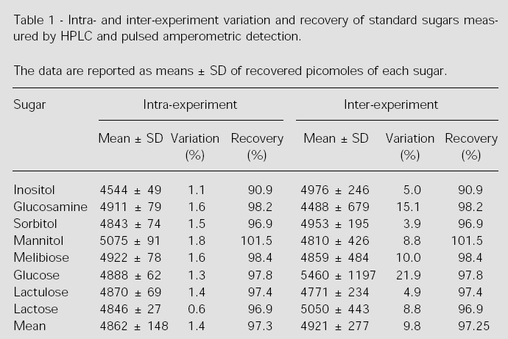

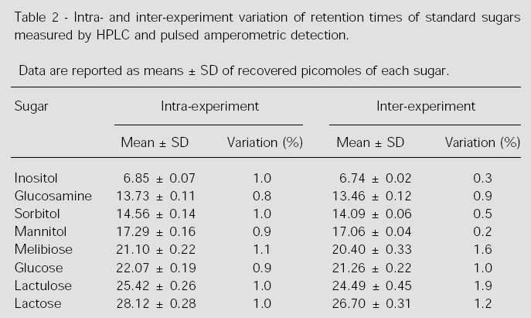

1. **Methods**
   1. Remove urine samples from the freezer and bring to ambient temperature (defrost only at time of testing).
   2. Vortex the urine container.
   3. Prepare the sample dilution: 2900 ul of distilled H2O + 50 ul of the standard of melibiose (3.6mM) + 50 ul urine sample
   4. Vortex the tube.
   5. Pipet 800ul of the dilution and place in an Eppendorf tube with a filter.
   6. Centrifuge in microcentrifuge at 9000rpm for 6 min.
   7. Pipet 600ul of the supernatant into one for the tubes of the autosampler.
   8. Samples are placed in autosampler and read in the detector.
   9. Values are electronically transferred into the software program and results are calculated.
2. **INTERPRETATION**

After standard samples and patient sample preparations and injections are run, as described above, a typical chromatogram is produced as is shown below (3).

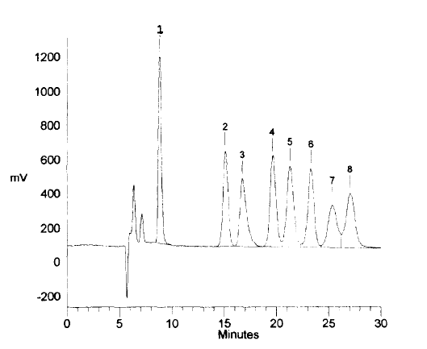

**Figure 1** shows the chromatogram of the standards.

Each numbered peak represents 3 nmole of each sugar as follows: (1) myo-inositol, (2) glucosamine, (3) sorbitol, (4) mannitol, (5) glucose, (6) melibiose, (7) lactulose, (8) lactose.

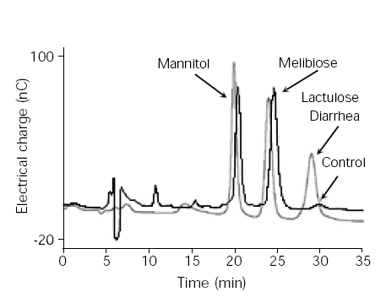**Figure 2** shows the detection of lactulose and mannitol in urine of children with and without diarrhea (3).

The figure shows two chromatograms of the lactulose and mannitol peaks for children with and without diarrheal disease. The mannitol peak showed no significant difference between children with diarrhea and healthy children. In contrast, children with diarrhea have a higher peak for lactulose compared to children without diarrhea, suggesting a change in intestinal permeability or mucosal damage. Melibiose peaks in both chromatograms are used as internal control standards for the quantification of the sugars.

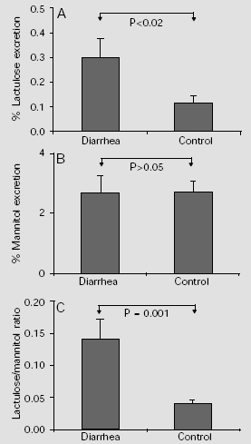**Figure 3** shows the quantification of LM test in children with and without diarrhea (3).

*A*, A significant increase in percent lactulose excretion is observed in the diarrhea group compared to control children.

*B*, No significant difference is observed between percent mannitol excretion in control group and in children with diarrhea.

*C*, The lactulose/mannitol ratio was significantly increased in the diarrhea group.

1. **CALCULATIONS**

The integration and quantitation of the isolated peaks (analytes) in the chromatograms is performed using the PeakNet software program from Dionex. The concentrations of all components of interest in each injection are calibrated against the amount of internal standard, ie, melibiose, to compensate for the possible variation in injected quantity between runs. The final percentage of urinary sugar excretion is calculated using the Excel software program.

1. **EXPECTED VALUES**

The lactulose/mannitol permeability test is considered abnormal or positive for comparison purposes if the lactulose:mannitol ratio is ≥ 0.0864. These values equal to normal mean plus two standard deviations as previously reported (3).

1. **REPORTING RESULTS**

Report the result obtained from the quantitation of the sugar markers after calculation in the Excel software program in percentage of lactulose and mannitol urinary excretion and ratio of lactulose:mannitol. The technician should complete all fields on the Urinary Lactulose Mannitol Report Form (ULM) for each specimen and record any notes or observations about the procedure.

|  |  |  |
| --- | --- | --- |
| # | Question | Guidance |
|  | Participant ID | Write the child’s participant ID in the space provided at the upper left corner. |
| 01 | Date of test | Enter the date of the assay (DD/MMM/YY). |
| 02 | Sample ID | Write the 9 digit Sample ID. |
| 03 | Percent Lactulose | Enter the lactulose percentage. Range of values: 000-100. |
| 04 | Percent Mannitol | Enter the lactulose percentage. Range of values: 000-100. |
| 05 | Lactulose/Mannitol Ratio | Enter the ratio of lactulose to mannitol. Range of values 0.0000-1.0000. |
| 06 | Technician ID | Enter the Lab Technician’s unique ID number who conducts the lactulose-mannitol assay. |

1. **LIMITATIONS AND PROCEDURAL NOTES**
   1. The LM test is a quantitative test and it is considered a consistent and sensitive method to measure small intestinal epithelial area, paracellular and transcellular transport, damage and permeability. This test is not recommended to diagnose specific disease such as diarrheal diseases, malnutrition or others. Thus, the clinical and more specific tools are necessary for these purposes.
   2. LM test should not be interpreted as absolute evidence for the presence of a gastrointestinal illness. Prediction of active and inactive disease should be based on a clinical and laboratory evaluation that may include multiple LM tests determination.
   3. Urine specimens that have been not preserved in chlorhexidine cannot be used for measurements due to potential bacterial degradation of sugar markers.
2. **CLINICAL SIGNIFICANCE**

Clinically, the ratio of lactulose:mannitol excretion in urine after administration of these non-metabolized sugars has been used to evaluate the extent of malabsorption and intestinal permeability disruption in several infections and nutritional diseases, including human immunodeficiency virus (HIV) infection (1,2). A range of methodologies have been reported to determine the lactulose:mannitol ratio, including enzymatic assay, gas-liquid chromatography (GC), thin-layer chromatography (TLC) and high-performance liquid chromatography (HPLC). Most published methods involve tedious sample preparations, rendering them unsuitable for routine or automated clinical laboratory testing. In this method, weak anion-exchange high-performance liquid chromatography in conjunction with a pulsed amperometric detector and a very simple sample preparation avoids interference by other components present in the urine. The linear range of determination for mannitol, lactulose and glucose are up to 10 nmol, in a single injection. The limits of detection are 8, 12, 47 and 52 pmol, respectively, for mannitol, glucose, lactose and lactulose. The separation and quantification using this method are highly reproducible, yielding standard errors of less than 2.5% for retention times and less than 3.5% for quantitation. Children with diarrhea present a greater lactulose:mannitol ratio compared to children without diarrhea.

1. **Verification**

The Lab coordinator will record if an event occurs outside of the standards of practice (this event is called a ***protocol deviation,* which is any unapproved change, deviation, or departure from the study design or procedures). A Protocol Deviation Form is completed by the individual having committed the deviation and the study coordinator/ sponsor/IRBs are notified.**

1. **REFERENCES**
2. Bao Y, Silva TMJ, Guerrant RL, et al. Direct analysis of mannitol, lactulose and glucose in urine samples by high-performance anion-exchange chromatography with pulse amperometric detection. Clinical evaluation of intestinal permeability in human immunodeficiency virus infection. J Chromatogr B Biomed Appl 1996; 685: 105-12.
3. Lima AA, Silva TM, Gifoni AM,et al. Mucosal injury and disruption of intestinal barrier function in HIV-infected individuals with and without diarrhea and cryptosporidiosis in northeast Brazil. Am J Gastroenterol 1997; 92: 1861-6
4. Barboza Junior MS, Silva TM, Guerrant RL, Lima AA. Measurement of intestinal permeability using mannitol and lactulose in children with diarrheal diseases. Braz J Med Biol Res 1999; 32:1499-1504.

UIL—Urinary Iodine Assay SOP

Note: to be conducted on chlorhexidine-free urine samples at 6 and 15 months.

**Principle**

Urine is digested with ammonium persulphate. Iodide is the catalyst in the reduction of cerric ammonium sulphate (yellow) to cerrous (colorless) and is detected by rate of color disappearance (Sandell – Kolthoff reaction)

**Materials**

* Microplate Reader (ELISA)
* Water Bath or heating block, thermometer
* Test tube (13 x 100 mm)
* Reagent flasks and bottles
* Multi Channel pipettes
* Balance scales
* Urinary Iodine Assay Results Form (IAR)

**Reagents:**

* Ammonium Persulphate (analytical grade)
* As2O3
* NaCl
* H2S04
* Ce (NH4)4(SO4)42H2O
* Deionized H2O
* KIO3

**Solutions**

* 1.0 M Ammonium persulphate
* Dissolve 114.1 g H2N2O8S2 in H2O; make up to 500 ml with H2O. Store away from light. Stable for at least one month
* 5 N H2SO4
  + Slowly add 139 ml concentrated (36 N) H2SO4 to about 700 ml deionized water *(careful - this generates heat!)*. When cool, adjust with deionized water to a final volume of 1 liter.
* Arsenious acid solution (0.05 mol/L)
  + .Arsenic trioxide (5 g) is dissolved in 100 mL of 0.875 mol/L sodium hydroxide solution. Concentrated sulfuric acid (16 mL) is then added slowly to the solution in an ice bath. After cooling, 12.5 g of sodium chloride is added to the solution, and the mixture is diluted to 500 mL with cold water and filtered.
* Cerric ammonium sulphate solution (0.019mol/L)
  + Tetraammonium cerium (IV) sulfate dihydrate (6 g) is dissolved in 1.75 mol/L sulfuric acid and adjusted to a final volume of 500 mL with the same acid solution.
* Standard iodine solution, 1µg iodine/ml (7.9µmol/l)
  + Dissolve 0.168 mg KIO3 in deionized water to a final volume of 100 ml (1.68 mg KIO3 contains 1.0 mg iodine; KIO3 is preferred over KI because it is more stable, but KI has been used by some laboratories without apparent problems). It may be more convenient to make a more concentrated solution, e.g., 10 or 100 mg iodine/ml, then dilute to 1g/ml. Store in a dark bottle. The solution is stable for months. Useful standards are 20, 50, 100, 150, 200, and 300 g/l.

**Procedure:**

* Mix urine to suspend sediment
* Pipette 250 µl of each urine sample into a 13 x 100 mm test tube. Pipette each iodine standard into a test tube, and add H2O as needed to make a final volume of 250 µl. Duplicate iodine standards and a set of internal urine standards should be included in each assay
* Add 1 mL 1.0 M ammonium persulphate to each tube.
* Heat all tubes for 60 minutes at 100oC. (in water bath or heating block)
* Cool tubes to room temperature
* (After this digestion step, follow the Simple Microplate Method for Determination of Urinary Iodine- APDM method)

**APDM Method:** (after the digestion procedure),

* Transfer **50 µL** aliquots of the resulting digests and standards to the corresponding wells of a polystyrene 96-well microtiter plate.
* Add **100 µL Arsenious acid solution** to the wells and mix (by pipeting up and down).
* Add 50 **µL ceric ammonium sulphate solution** quickly (within 1 min) to all wells using a multichannel pipette.
* Allow the reaction mixture to sit for 30 **min at 25 oC,**
* Measure the absorbance at **405nm** with a Microplate Reader. Water is used for the zero calibrator.

**Calculation of Results**

* Linear Trend/Regression Type analysis should be used for optimal estimation of sample values.
  + If a computer program is not available, the data may be plotted using graph paper. Construct a standard curve on graph paper by plotting iodine concentration of each standard on the abscissa (x-axis) against its optical density at 405µg/L **(OD405)** on the ordinate (y-axis)
* Perform the Linear Trend/Regression Type analysis and determine if the R2 value is ≥ 0.98. If the correlation coefficient for the linearity is <0.98, the assay should be repeated.
* Instruct the program to produce the equation for the plotted line.
  + The equation should fit the equation of a line which is Y = MX + B
    - Y = OD450 of the sample,
    - M = Slope,
    - B = Y-intercept and
    - X = Concentration of the unknown sample.
* Solve the equation for X to determine the concentration of iodine in the specimen.

**Reporting:**

Record results on the Urinary Iodine Assay Results Form (IAR)

**Expected values:**

The cutoff points proposed by WHO/UNICEF/ICCIDD for classifying iodine deficiency are based on median urinary iodine concentrations. As an indicator of iodine deficiency “elimination”, they proposed that the median iodine concentration should be 0.79 mmol/L, i.e., 50% of samples should be above 0.79 mmol/L, and not more than 20% of samples should be below 0.39 mmol/L.

The theoretical detection limit of urinary iodine, defined as 2 SD from the zero calibrator = 0.11 mmol/L (range, 0.07–1.4 mmol/L),

**Clinical Significance:**

The World Health Organization and ICCIDD proposed the use of these cutoffs for interpreting urinary iodine concentration results as follows:

“severe deficiency” = 0.16 mmol/L;

“moderate deficiency” = 0.16–0.39 mmol/L;

“mild deficiency” = 0.39–0.79 mmol/L;

“normal” = 0.79 mmol/L *(1*, *10)*.

**Verification:**

The Lab coordinator will record if an event occurs outside of the standards of practice (this event is called a ***protocol deviation,* which is any unapproved change, deviation, or departure from the study design or procedures). A Protocol Deviation Form is completed by the individual having committed the deviation and the study coordinator/ sponsor/IRBs are notified.**

**References:**

1. ICCIDD, UNICEF, WHO, Dunn JT et al. Method for measuring iodine in urine. The Netherlands, ICCIDD, 1993. ([www.iccidd.org](http://www.iccidd.org), under about IDD, where the Unrecompensed. Method of Dr. John T. Dunn, [jtd@virginia.edu](mailto:jtd@virginia.edu))

<http://www.iccidd.org/media/assessment%20tools/urinary_iodine-method_a.pdf>

2. Clinical Chemistry. 2000; 46: 529-536) C 2000 American Association for Clinical chemistry, Inc.

3. Toshinori Ohashi, Mitsuo Yamaki, Chandrakant S. Pandave, Madhu G, Karmarkar and Minoru Irie. Simple Microplate Method for the Determination of Urinary Iodine *Clinical Chemistry.* 2000;46:529-536.) http://www.clinchem.org/cgi/reprint/46/4/529

**Collection and Processing of Clinical Specimens**

**Blood**

BCH/DCF—Blood Collection SOP

Purpose:

This SOP provides instructions for blood collection in MAL-ED study. The two child blood samples, collected at 7 ,15, 24, and 36 months, are among the most critical of the MAL-ED study as they will be used to assess micronutrient status and vaccine response. Field workers and a nurse phlebotomist should work as a team to collect these samples in the subject’s home or in the clinic (depending on site). A maximum of 5 mL of blood will be obtained from participating children when they are 7 15, 24 and 36 months of age. In addition to the 5ml collection at 15, 24, and 36 month, there will be an additional collection of .5ml for lead assay. Information regarding the child’s blood collection will be recorded on the Blood Collection and Hemoglobin Form (BCH). Information regarding the mother’s blood collection will be recorded on the DNA collection form (DCF). The maternal blood collection is optional. See details on reporting at the end of this SOP.

1. Responsibility:
   1. The principal investigator ensures that designated personnel for children blood collection and mother blood/saliva sample collection are qualified and receive documented training on this SOP and follow this SOP.
   2. Field worker and Phlebotomist are responsible for being trained, understanding and following this SOP.
2. Abbreviations
   1. ALRI: Acute lower respiratory infection
   2. BCH: Blood Collection & Hemoglobin
   3. BD: Becton-Dickinson (manufacturer of phlebotomy supplies)
   4. BPT: Blood Processing & Transport
   5. Cat.#: Catalog number (usually found on manufacturer or distributor website)
   6. cc: cubic centimeter (frequently used as interchangeable term for mL (milliliter))
   7. DOB : Target date of blood sample collection
   8. EDTA: ethylenediaminetetraacetic acid (an anticoagulant)
   9. FW : Field Worker
   10. g: gauge (size of needle or tubing – SMALLER g is BIGGER needle)
   11. g/dL: grams/deciliter
   12. in: inch (obsolete measure of length)
   13. K: Potassium
   14. mL: milliliter
   15. mm: millimeter (measure of length)
   16. PID: Participant ID
   17. PVC: Polyvinyl chloride (type of plastic used in tubing & pipes)
   18. SOP: Standard Operating Procedure

2.19 DCF: DNA collection form

1. Materials and Equipment:
   1. Blood Collection Kit - store items listed in a box or container to carry to the field.
   2. Blood collection SOP , BCH form or DCF form, pen, lab marker
   3. Alcohol hand wash toweling
   4. Disposable, trace element free, polyethylene or nitrile gloves, free of talc and other coatings - no rubber!
   5. Alcohol wipe/swab
   6. Syringes 5-10cc (polyethylene syringe and plunger – no rubber)
   7. 21-23 gauge butterfly blood collection system
   8. 6-7 mL trace element-free vacutainer tube with anti-coagulant (EDTA or heparin)
   9. Hemoglobin Cuvette (HemoCue cat.#651200XX)
   10. 3 mL vacutainer tube with K2EDTA anticoagulant for lead determination at the 15, 24, and 36 month blood collection only (i.e. BD tan stopper #367855)
   11. Single sample transfer needle (19-21g)
   12. Aluminum foil (for wrapping tubes for light sensitive vitamin A analysis)
   13. Cotton ball or 2X2 gauze
   14. Adhesive bandage
   15. Tube racks
   16. Zippered plastic baggie
   17. Sharps disposal container for needles and syringes
   18. Cooler with blue ice packs and tube rack for blood tubes
   19. Min-Max Thermometer (optional, for monitoring cooler temperature)
2. Other considerations:
   1. It is vitally important that all the materials - syringes, tubing, needles, stoppers, vacutainers, and gloves - be certified by the manufacturer for use for trace minerals or follow best practices, which are detailed in the table below.
   2. For determination of vitamin A (retinol), it is important that light exposure be minimized. Serum or plasma is more sensitive to light than is whole blood, and available means to limit light exposure should be used. In the field, this includes drawing blinds/shades, turning off existing lighting, and covering the collected sample tube with aluminum foil prior to putting on cold packs.
   3. In the laboratory, special lighting should be used, amber crepe paper can be placed over the lights, or work can be scheduled during daylight hours and in a room with indirect lighting to enable work without compromising the sample.

|  |  |  |
| --- | --- | --- |
| Item | Requirements | Suggested Options |
| Gloves | Non-latex, no talc, no rubber  Polyethylene—yes!  Nitrile – ok based on track record among zinc labs | [www.fishersci.com](http://www.fishersci.com) Cat.#19-166-709 Cardinal Health Nitrile gloves (medium)  <http://www.kcprofessional.com/us/Product-Catalog/Gloves/gloves.asp> |
| Tubes | Certified for trace mineral analyses | Becton Dickinson:  ([http://www.bd.com/vacutainer/products/venous/ordering info tubes.asp#special ty trace plastic](http://www.bd.com/vacutainer/products/venous/ordering%20info%20tubes.asp#special ty trace plastic)  #368381: 6 mL tube with K2EDTA for plasma (royal blue stopper)  – Fishersci.com #14-816-155  #365855: 3 mL tube with K2EDTA for lead (tan stopper),  -Fishersci.com #02-689-04  Kendall Health Care:  [http://www.kendallhealthcare.com/kendallhealthcare/pageBuilder.aspx?webPage ID=0&topicID=75982&xsl=xsl/productPagePrint.xsl](http://www.kendallhealthcare.com/kendallhealthcare/pageBuilder.aspx?webPageID=0&topicID=75982&xsl=xsl/productPagePrint.xsl)  #8881307022: 7 mL tube with NaEDTA for plasma (royal blue stopper)  Sarstedt:  <http://www.gbo.com/en/index_1779.php>  Vacuette #456080: with NaHeparin for plasma |
| Transfer needles | 21 gauge recommended to reduce hemolysis  Stainless steel, siliconized or polypropylene | Various suppliers  Becton Dickinson:  #305764 – 21 g. Eclipse safety needle  – Fishersci.com #1482123 OR  #305915 – 21 g. SafetyGlide needle  – Fishersci.com #1482912 |
| Butterfly blood collection system | According to Dr. Krebs, Terumo Medical is the only vendor they have found to produce butterfly systems free of zinc.  Experience amongst other researchers and the manufacturers is that the tubing is PVC and not likely to be a source of zinc contamination – so they might be fine. | Becton Dickinson:  #367342 – 23 g. Vacutainer Push Button Blood Collection Set  - Fishersci.com #367342  Terumo Medical Products  <http://www.terumotmp.com/ProductDetails.aspx?categoryId=6&productId=298> |
| Cryovials | Tubes with screw cap without rubber O-ring | [www.fishersci.com](http://www.fishersci.com) Cat.#12-565-168N ThermoScientific/Nunc cat.#377224 - 1.0 mL freestanding conical cryotube |
| Labels |  | Laser cryo-babies and cryotags [www.divbio.com](http://www.divbio.com)  Cryo Tags .94 in.x 0.5 in. cat.# LCRY2380  – Fishersci.com #NC9501286 |

1. Procedure: Depending on the skill level of the phlebotomist, different systems for blood collection may be available. Thus, while both the equipment list and the protocol are written for a butterfly needle system and for the dorsal hand, this is written only as a guide. Each site will make decision and order supplies as appropriate for their site, following the principles laid out here. The recommendation regarding needle gauge is to reduce the likelihood of hemolysis, which would affect the determination of zinc, ferritin, and AGP.
   1. Collection Window: Because time of day can affect nutrient values, we want to standardize the time of day for blood collection. Based on a survey of the sites, it seems that morning blood collection (7-11 am) is possible but may need to be adjusted if moms are working. Time of day will be recorded in the Blood Collection & Hemoglobin Form. (BCH).
      1. The window for collection of the blood samples should be as close as possible to the same as for the other monthly samples. However, due to the importance of the blood sample and potential difficulties with scheduling, the blood sample may be collected (DOB +/- 2 days).
      2. Also, due to the possibility that the child may be ill (see illness criteria that would delay collection of blood sample, below) we will permit this collection for up to 12 days after the DOB (window = DOB -2/+12 days for a total of 15 days). If the extended time is needed for illness, fill out a protocol deviation form and explain the illness or reason that prevented collection in the regular window (DOB +/- 2 days).
   2. Illness criteria that would delay blood draw:
      1. Child is listless, unable to perform normal activity
      2. Axillary temperature > 37.5 degrees C
      3. ALRI (pneumonia)
      4. Moderate to severe dehydration - demonstrates 2/4 of the following criteria: (1) restless, irritable, (2) sunken eyes, (3) drinks eagerly, thirsty, (4) skin pinch goes back slowly. Child must be rehydrated before blood is taken. Child must be referred to a clinic for rehydration.
      5. Bloody stool (caregiver reported, fieldworker observed)
      6. Frequent diarrhea (>8 loose stools in previous 24 hour period)
      7. Persistent diarrhea (child meets definition of diarrhea for 14 or more days)
   3. Prepare supplies for venipunture
      1. Blood collection kit
      2. Place refrigerated blue cool packs in cooler (optional: add thermometer to cooler)
      3. Phlebotomist and 1-2 FWs transport blood collection kit and cooler to the subject’s home (or clinic)
   4. Label forms and tubes
      1. Label BCH form for child or DCF for mother
      2. Gather following specimen collection containers and label them with the child’s PID as appropriate.
      3. One 6-7 mL trace element free plasma tube (5 mL whole blood)
      4. One HemoCue cuvette for drop of blood for Hemoglobin
   5. Identify subject
      1. Field worker should introduce the nurse / phlebotomist to the caregiver. Be warm and friendly, establish eye contact, and show concern about the child’s health and comfort. You first should instill a trust and confidence in parent and child.
      2. Ask about the child’s past experience with blood drawing.
      3. Ask about the child’s current health and take child’s temperature, if fever is suspected (>37.5C). Postpone if child is ill as determined by the Illness Criteria.
   6. Positions for restraining a child:
      1. The physical restraint of the child by a supportive parent is the best situation. The parent holds the child in their lap and wraps their legs around the child’s so that the child cannot kick the phlebotomist.
      2. In the horizontal position, the child lies supine, with the phlebotomist on one side of the bed and the parent on the other. The parent gently but firmly leans over the child, restraining the near arm and body while holding the opposite extended arm securely.
      3. In the event the child cannot be restrained without potential physical injury, discontinue attempt and notify the research staff.
      4. FW may help distract child
   7. Perform Venipuncture
      1. The dorsal hand technique is appropriate for neonates and infants who are younger than 2 years old. Antecubital fossa vein may also be considered.

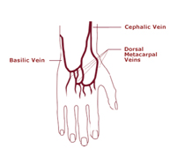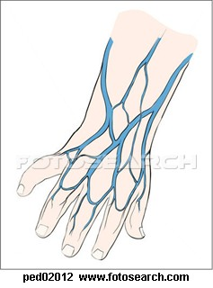

* + 1. Wash hands and put on gloves.
    2. Attach a 21-23g butterfly needle collection set to a 5-10 ml syringe. Keep equipment out of the view of toddlers. (A 21g is preferred to a 23g to reduce chance of hemolysis but it is at the discretion of the phlebotomist).
    3. Select the hand that has easily visible veins. Warm the site if hand is cold. No tourniquet is necessary. The blood collector’s middle and forefinger will encircle the infant’s wrist and are used to apply pressure to distend the dorsal veins. By placing the blood collector’s thumb against the infant’s fingers, the infant’s wrist can be flexed downward as the dorsum of the infant’s hand is examined.
    4. Be careful not to bend the wrist too much or the vein may collapse. Lightly palpate for a vein. Once the vein has been located, release the finger tourniquet.
    5. Disinfect the site with 70% isopropyl alcohol swab in concentric circles. Let alcohol air dry.
    6. Reposition fingers around infant’s wrist and flex infant’s hand. The needle should be angled 15 degrees to the skin. The skin should be pierced 3-5 mm distal to the vein, then advanced slowly and carefully until vein is punctured.
    7. As soon as blood appears in the tubing of the butterfly, pull the syringe plunger to fill with blood. Make sure not to exceed maximum daily blood volume (5 mL).
    8. Release fingers from infant’s wrist and remove needle and hold direct pressure on the puncture site with 2 x 2 gauze sponges until bleeding stops. Apply an adhesive bandage.
    9. Engage Safety-Lok feature on butterfly needle and hand the syringe and butterfly tubing to the FW.
    10. FW disconnects butterfly from the syringe and extracts the blood from the tubing for the cuvette for the HemoCue. Use one drop of blood contained in the collection tubing (between the butterfly needle and the syringe) for the HemoCue assay of hemoglobin. (NOTE: This assay is ordinarily done soon after blood draw and the value obtained recorded on the BCH Blood Collection Form. Refer to the HemoCue SOP for further instructions on this assay.) Discard needle/tubing into a Sharps container.
    11. Connect 19-21 g single sample transfer needle to syringe to add blood to the vacutainer tubes.
    12. At 15 , 24, and 36 months only - 0.5 mL whole blood preserved with K2EDTA will be required for lead determination. This sample may be obtained from the tubing if butterfly system is used, in addition to the drop needed for the HemoCue cuvette. If enough blood is not available from tubing, transfer 0.5 mL of whole blood from syringe to a K2EDTA vacutainer tube (tan stopper) for lead.
    13. Without removing vacutainer tube from tube holder, insert needle into tube and fill appropriately:
    14. Note: Let vacuum draw the blood into the tubes. Angle needle against the inside of the vacutainer wall. Never force blood into the tubes. Dispose syringe and needle into Sharps container. Do not disconnect or recap the needle.
    15. Gently invert additive tubes 8-10 times
    16. Confirm tubes are labeled with:
        - Child’s PID number
        - Research record number
        - Date
        - Time of draw
        - Blood collector’s initials
    17. Wrap vacuum tube in aluminum foil to protect from light (for vitamin A analysis)
    18. NOTE: the sample must immediately be placed in cooler with cold packs or be refrigerated. Keep on cold packs or refrigerated until centrifugation, preferably within 2 hours.
    19. NOTE: Transport and processing are covered in SOP for Blood Processing, Transport, and Storage (BPT).

1. Reporting (Blood Collection and Hemoglobin Form, BCH)
   1. Study Researchers/ Phlebotomists will record information regarding child’s blood collection on the Blood Collection and Hemoglobin Form (BCH). A BCH form is completed at the 7 month blood draw and at the 15 , 24, and 36 month blood draw. A BCH form may also be completed each time that the Study Researcher/Phlebotomist travels to the home to collect these samples but is unable to.
   2. Completing the BCH Form. Please see the table below for assistance in completing the BCH form. There is space provided at the end of the form to provide additional information, observations and notes.

|  |  |  |
| --- | --- | --- |
| # | Question | Guidance |
|  | Participant ID | Write the child’s participant ID in the space provided at the upper left corner. |
| 01 | Phlebotomist ID | Enter Phlebotomist’s unique ID number, who will perform the blood draw. |
| 02 | 7 month OR 15 month OR 24 month OR 36 month blood draw? | Enter number  01 = The 7th month old blood draw collection  02 = The 15th month blood draw collection  03 = The 24th month blood draw collection  04 = The 36th month blood draw collection |
| 03 | Date of collection | Enter the date of the collection (DD/MMM/YY) by Phlebotomist. |
| 04 | Time of collection | Enter the time that Phlebotomist visited the home to collect the blood sample. If no sample was collected, this is the arrival time of the visit. |
| 05 | Last meal/breastfeed | Enter information about the last meal or breastfeed given to the study participant.  01 = Breast milk only  02 = Food or snack only  03 = Food or Meal only  04 = Food and Breast milk |
| 06 | Time since last meal/breastfeed | Enter the time since the study participant last had a meal or was breastfeed. 01 = The last meal or breastfeed was within the last 30 minutes.  02 = It was within the last 2 hours.  03 = It was greater than 2 hours ago. |
| 07 | Tube 1 with up to 5 ml blood collected? | Indicate whether up to 5 mL of blood was collected from the study participant in a trace element free tube with EDTA or heparin.  01 = The blood was collected.  00 = The blood was not collected. |
| 08 | Hemocue filled (one drop)? | Indicate if one drop of whole blood was used for hemoglobin determination via Hemocue.  01 = The Hemocue was filled.  00 = The Hemocue was not filled.  See the relevant Hemocue SOP (HEM). |
| 09 | Hemocue Hb level reading | Enter the hemoglobin measurement (##.# g/dL). See the relevant Hemocue SOP (HEM). |
| 10 | Tube 2 with 0.5 mL blood collected (15, 24, 36 month blood draw only)? | If this is the 15, 24, 36month blood draw, indicate if 0.5 mL whole blood was collected from the study participant  01 = Yes  00 = Not  NA = Not Applicable. Put “NA” if sample collected at 7 month. |
|  | Observations/Notes | Enter any relevant observations or notes here. If, for example, the child was ill and the Study Researcher/ Phlebotomist was unable to obtain a blood sample, explain in this section. |

1. Reporting (DNA collection form (DCF)) for maternal blood collection.
   1. Complete the DNA collection form (DCF) for maternal blood collection

Please see the table below for assistance in completing the DCF form. There is space provided at the end of the form to provide additional information, observations and notes.

|  |  |  |
| --- | --- | --- |
|  | Participant ID | Write the child’s participant ID in the space provided at the upper corner |
| 01 | Type of specimen received | Enter the type of specimen collected : Maternal blood = 01, Maternal saliva = 02, Child saliva = 03 |
| 02 | Date specimen was collected | Enter the date specimen was collected: DD/MMM/YY |
| 03 | Time specimen was collected | Enter the time specimen was collected (24 Hr Scale; HH:MM) |
| 04 | FW code collecting sample | ### |
| 05 | Sample ID | Enter the Sample ID of the specimen |

1. Safety and Infection Control Procedures
   1. Conduct good hand washing technique prior to venipuncture.
   2. Put on gloves when handing needles and blood-filled tubes.
   3. When working with needles, lancets, and other “sharps”, be careful not to prick your finger.
   4. If injury occurs, wash injury with soap and water. If injury occurs, apply pressure to injury wound to curtail bleeding if necessary and apply a bandage. Report any injury involving sharps to Study Coordinator or Principal Investigator and report to your local Casualty Department for treatment and evaluation for post-exposure prophylaxis.

#### Appendix A: Blood Collection & Hemoglobin (BCH) SOP Flow Chart

Version 4 23 August 2010

### HEM—HemoCue Assay for Determining Hemoglobin Levels in Blood

**This SOP has been read and understood by:**

|  |  |
| --- | --- |
| **Name** | **Date** |
|  |  |
|  |  |
|  |  |
|  |  |
|  |  |
|  |  |
|  |  |
|  |  |
|  |  |
|  |  |
|  |  |
|  |  |

**PURPOSE**

Quantitative determination of hemoglobin in blood using the HemoCue HB201 analyzer at 7, 15, 24 and 36 month blood draw.

**PRINCIPLE**

The blood sample is drawn into a microcuvette by capillary action and is mixed with sodium deoxycholate reagent deposited on its inner wall. This disintegrates the erythrocyte membranes releasing hemoglobin. Sodium nitrite converts the hemoglobin iron from the ferrous to the ferric state to form methemoglobin which then combines with azide to form azidemethemoglobin. The microcuvette is then placed in HemoCue Hb analyzer in which the transmittance is measured and the hemoglobin level calculated. The HB 201 requires HB 201 specific cuvettes.

**SCOPE**

This Standard Operating Procedure applies to all point of care testing for hemoglobin performed by the Study Researcher / Nurse / Fieldworker who has been trained and is competent in performing this test.

**STANDARD PRECAUTIONS**

Observe Standard Precautions when collecting and handling blood samples and performing the test. Wear gloves to protect against exposure to bloodborne pathogens.

**SPECIMEN COLLECTION**

Specimen: See BCH- Blood Collection SOP for collection of EDTA venous blood in purple top vacutainer

Minimal volume required: 5 ul (one 4-5 mm drop of blood)

Test is performed immediately

**EQUIPMENT**

1. HemoCue HB 201 analyzer

**MATERIALS**

1. HemoCue Hb 201 microcuvettes
2. Disposable pipettes (if blood is collected in EDTA tube)
3. Non-fraying swab (lint-free)
4. 4AA batteries if main power is not available
5. Biohazard disposable container

**STORAGE REQUIREMENTS**

Microcuvettes - 15 – 30ºC

***Microcuvettes are moisture sensitive so it is important that the cap of the vial is closed properly between uses. Unused microcuvettes must be kept in vials. DO NOT REFRIGRATE***

**QUALITY CONTROL**

**1. HEMOCUE Hb ANALYSER PERFORMANCE CHECK**

The HemoCue 201 analyzer has an internal electronic “SELF TEST” which automatically verifies the performance of the optronic unit of the analyzer. This test is performed at regular intervals when the analyzer is on. Each day of use, analyzer performance must be checked prior to testing patient samples.

**Frequency:** Each day of use prior to patient testing.

**Procedure:**

1. Pull cuvette holder out to its loading position.
2. Press and hold the left button until the display is activated.
3. The display shows the version number of the program followed by an hourglass then “Hb”. During this time the analyzer will automatically verify the unit.
4. After 10 seconds the display will show 3 flashing dashes and the HemoCue symbol which indicates the analyzer is ready for use.

**Acceptable Results**: HemoCue display shows the HemoCue symbol indicating the unit is ready for use.

**Corrective Action:** Repeat Performance Check. If still unacceptable do not use analyzer for patient tests. Arrange for repair or replacement of unit.

**Documentation:** Enter date, initials of person performing test and “OK” on HemoCue Analyzer QC Record sheet.

**2. HEMOCUE 201 ANALYSER MAINTENANCE**

Periodic cleaning of HemoCue 201 Analyzer is recommended by the manufacturer.

**Frequency**: Once per week

**Performed by:** lab staff

**Materials Required:** alcohol, HemoCue Cleaner Swab

**Procedure:** (Refer to drawings on Page 28 of Operating Manual)

1. Turn off the analyzer.
2. Pull the cuvette holder out to its loading position.
3. Use a pointed object to carefully depress the small catch in the upper right corner of the cuvette holder.
4. With the catch depressed, carefully pull the cuvette holder in the direction in which the handle of the cuvette holder is pointing.
5. Clean the cuvette holder with alcohol.
6. Insert the HemoCue Cleaner swab into the opening of the cuvette holder.
7. Pull out and push in 5-10 times. If the swab is stained, repeat with a new swab. Cleaning is complete when swab comes out unstained.
8. Wait 15 minutes before using the analyzer.

**Documentation:** Record number of analyzer, date, initials of person cleaning the analyzer on the appropriate QC Record Sheet.

**3. Internal QC: Control Reagents**

**Control:** Manufacturer’s Control Reagents: Low, Normal, and High. ***Do not use beyond expiry date***.

**Frequency:** Weekly prior to patient testing and new lot numbers

**Procedure:**

1. Mix Control Reagent thoroughly.
2. Perform test in the same manner as for patient blood testing.

**Acceptable results:** Within acceptable range stated on reagent control

• Any QC “out of range” must be recorded and the follow-up action indicated.

◦ If the initial QC is out of range, repeat the same QC and document the corrective action taken.

◦ If the second QC determination is out of range proceed with problem solving.

◦ Document all action(s) taken.

Unless or until the QC is performed as within range, no patient testing may occur

**Corrective Actions**:

1. Check that microcuvettes and Reagent Control have been properly stored and are not expired.
2. Check cuvette for air bubbles and if present repeat test with new microcuvette.
3. Clean optronic unit with HemoCue Cleaner and repeat test.
4. If still unsatisfactory, do not perform patient testing and arrange for repair or replacement of analyzer.

**Documentation**:

1. Record date, lot# of Control Reagent, expiration date of Control Reagent, initials of person performing QC and the results obtained on the HemoCue Test QC Record sheet.
2. QC results will be reviewed monthly by Laboratory Supervisor or designee.
3. All Corrective Action should be documented and reviewed.
4. Submit completed QC sheets to Biotechnology Laboratory Supervisor.

**External QC:**

1. Splitting samples among different operators within the laboratory times/year (operator proficiency) twice yearly.
2. Comparison of 2 test methodologies : Hemocue vs reference instrument (on site automated hematology analyzer) Twice yearly with an allowable difference of 7.5%

**TEST PROCEDURE**

***Must be performed within 10 minutes of blood collection***.

1. Pull the cuvette holder out to its loading position .Press and hold the on/off button until the display is activated.
2. Take the microcuvette out of the package. If microcuvettes from a vial are used, replace the cap immediately after the microcuvette has been removed.
3. EDTA specimen: Mix blood by gently inverting 8-10 times. Using a pipette, remove a few drops on to a hydrophobic plastic or glass slide. Hold the microcuvette opposite the filling end and bring into contact with blood sample, allow the cavity of the microcuvette to fill completely by capillary action.
4. When completely filled, wipe off the outside of the microcuvette with a clean lint – free tissue, being carefully not to touch the open end of the microcuvette.

***If air bubbles are seen in the optical eye, discard the microcuvette and refill new microcuvette. Small air bubbles around the edge do not influence the result.***

1. Place filled HemoCue Hb 201 microcuvette in the cuvette holder for the analyzer.
2. Push the cuvette holder to its measuring position within 10 seconds after filling
3. After 10 sec HemoCue Hb 201 analyzer will find the steady state of the chemical reaction and the result will appear in the display. Records Result
4. Pull the cuvette holder out to its loading position and discard used microcuvette in a biohazard waste container.

**INTERPRETATION OF RESULTS**

Hemoglobin value is read directly from HemoCue Hb 201 analyzer in g/dL (grams per deciliter)

Results above 25.6g/dL are displayed as **HHH** or **over-range.**

**HHH/Over-range Results** – Repeat test.

Reasons for abnormally high results include:

Expired microcuvettes

Contaminated optical eye of microcuvette

Improper mixing if Control Reagent

Air bubbles in the microcuvette

Optronic unit is dirty.

**RECORDING/REPORTING RESULTS**

1. Enter test result on the Blood Collection and Hemoglobin (BCH) Form in the space provided.
2. A hemoglobin of **<8 g/dL** is considered an indicator of **severe anemia at most sites and should be a criteria for referral for futher medical evaluation**. Sites may refer for anemia at other levels of hemoglobin as defined by your site.
3. Referal for anemia should be done using the the Child Referral Form (REF) by responding appropriately to Q #6..

**TEST LIMITATIONS**

1. Measurement of hemoglobin should be made as soon as possible after the blood has been drawn into the microcuvette. If the readings are made after 10-minutes of filling the microcuvette inaccurate results may be obtained.
2. Mixing for too long a period can produce unreleased oxygen pressure and viscosity that may cause falsely high results.
3. Failure to hold the microcuvette by the filling end may stain the optical eye and give inaccurate results.
4. Failure to wipe excess specimen from the outer surface of the optical eye may give inaccurate results.

**REFERENCES:**

Package insert, HemoCue HB 201, HemoCue AB, Angelholm, Sweden.

Operating Manual, HemoCue HB 201, Version 901702/020828. HemoCue AB, Box 1204, Angelholm, Sweden.

Paiva, AA, etal. 2004. Comparison between the HemoCue and an automated counter for measuring hemoglobin. Rev. Saude. Publica. 38:585.

BPT—Blood Processing, Transport and Storage

1. Purpose: This SOP describes the procedure for processing, transport and storage specimen from study site to Laboratory for MAL-ED study
2. Responsibility
   1. Principal investigator, Project Management Section
      1. Ensures that all specimen processing personnel have read and understood the written procedure.
      2. Ensures that all specimen processing personnel have been trained prior to the performance of this procedure.
   2. Assigned personnel
      1. Ensures that they have read and understood the written procedure.
      2. Ensures that they are trained on this procedure prior to its conduct.
3. Abbreviations
   1. BCH: Blood Collection & Hemoglobin
   2. BD: Becton-Dickinson (manufacturer of phlebotomy supplies)
   3. BPT: Blood Processing & Transport
   4. Cat.#: Catalog number (usually found on manufacturer or distributor website)
   5. cc: cubic centimeter (frequently used as interchangeable term for mL (milliliter))
   6. EDTA: ethylenediaminetetraacetic acid (an anticoagulant)
   7. FW : Field Worker
   8. g: gravity (measure of centrifugal force)
   9. in: inch (obsolete measure of length)
   10. mL: milliliter
   11. mm: millimeter (measure of length)
   12. PID: Participant ID
   13. PBS: Phosphate buffered saline
   14. PVC: Polyvinyl chloride (type of plastic used in tubing & pipes)
   15. SOP: Standard Operating Procedure
   16. UPS: uninterruptible power supply
4. Material and Equipment (with possible sources; many other sources are satisfactory)
   1. Centrifuge with rotor for blood collection tubes
   2. Trace mineral free transfer pipet (e.g. [www.fishersci.com](http://www.fishersci.com) Cat.#13-711-31)
   3. 6-1mL trace element free cryotubes for storage (ie. [www.fishersci.com](http://www.fishersci.com) Fisher Catt#12-565-168N; ThermoScientific/Nunc cat.#377224 - 1.0mL freestanding conical cryotube)
   4. Cryovial storage boxes
   5. Coolers with cold packs to transport blood to the laboratory (See BCH SOP)
   6. Ultra-low freezer (-70 C) with UPS system
   7. Labels (eg. Laser cryo-labels or cryotags ([www.divbio.com](http://www.divbio.com) Cryo Tags .94 in.x 0.5 in. cat.# LCRY2380))
   8. Buffy coat processing material and equipment (optional)
      1. Microfuge (centrifuge capable of spinning small microfuge tubes fast enough to pellet cells)
      2. Microfuge tubes (1 mL or 2 mL)
      3. Phosphate buffered saline (pH7.4)(usually comes as powder in pre-measured packets)
      4. Dimethylsulfioxide (DMSO)
      5. Fetal calf serum (also known as fetal bovine serum)
      6. Cryo-labels, cryovials, and cryovial storage boxes as above
5. Procedure: See specimen processing flow chart in Appendix A
   1. Transport specimens: The tube with the 4-5mL whole blood sample and any other tubes containing blood should be transported in a secure container with cold packs to the laboratory for processing.
   2. Record specimen receipt: The laboratory technician will label the BRF form with Participant ID and complete questions 1-6. The sample ID will be generated by the label program (see labeling SOP).
   3. Centrifugation: The tube with the 4-5 mL blood specimen should be centrifuged at 2000 x g for 10-15 minutes.
      1. Note: It is important that the sample be centrifuged and processed as soon as possible. If not possible, the sample should be refrigerated until processing. The time the sample is processed will be logged so that we can examine the effect of time from blood draw to processing on plasma zinc concentrations. We expect that zinc will leave the RBC and elevate the zinc concentration and so it is important that delay between blood draw and processing be minimized.
      2. Approximately 2.5 mL of plasma will be aliquoted into cryotubes (about 0.5mL per tube, see below) and the buffy coat may be recovered and stored as archival material (see below for preparation and storage of PBMCs from buffy coat).
   4. Plasma transfer: Use a trace mineral free transfer pipet to aspirate the plasma fraction, being careful not to aspirate the buffy coat at the interface of the plasma and the red cells, and aliquot the plasma into labeled cryovials as indicated below.
      1. Note: Be careful not to disturb cells when drawing plasma into a pipette. If cells mix with the plasma, re-centrifuge the sample to insure obtaining the maximum amount possible. When using pipettes, avoid drawing buffy coat or red cells into the bulb. The cryovials need labels appropriate for low temperature exposure (see table). How the sample is then aliquoted for storage at -70 degree Centigrade depends on the study site.
      2. Plasma aliquots: Aliquot plasma as below (listed in decreasing order of importance if the blood sample is limited.)
         1. 1 cryotube for vaccine response (0.5mL)
         2. 1 cryotube for micronutrients (0.6 mL at JHU, other sites may need more)
         3. 1 cryotube for amino acids (0.5 mL)
         4. 1-2 cryotube for any remaining plasma
   5. Buffy coat processing (optional): We suggest that sites collect the buffy coat to be used as an archival sample for either DNA and/or cellular immune response studies. This is up to the sites discretion, but this represents a valuable sample for potential future studies.
      1. With a transfer pipet transfer buffy coat to a sterile microfuge tube
      2. Wash buffy coat 2 x with an equal volume of cold, sterile phosphate buffered saline (PBS) followed by centrifugation at 2000 x g for 10-15 minutes.
      3. Resuspend final cell pellet in 1 ml of freezing solution (90% heat inactivated fetal bovine serum, 10% DMSO.
      4. Aliquot the washed, resuspended cells to two cryotubes suitable for liquid N2 storage. Label tubes with ink and labels that can withstand liquid N2 storage.
      5. Freeze at -70 C for 1-2 hours, and then quickly transfer cryotubes to liquid N2 storage tank for long-term storage (archive) if possible.

**Figure 1: Appearance of Blood Samples and Recovery of WBCs (Buffy coat)**

1. Storage: Place the storage vials containing plasma immediately in a cryovial storage box and store in a freezer at -70°C. Buffy coat fraction should be stored in liquid nitrogen if possible..
   1. Note: Transport overseas: Shipping of plasma samples overseas should be done on liquid nitrogen in IATA-approved tanks, or by using dry ice (see STS - Shipment Transport and International Shipping SOP). These stay charged longer than dry ice in case of issues with customs for incoming shipments.
2. Reporting (Blood Receiving and Processing Form, BRF): Laboratory Technicians will record information regarding the receipt of blood samples on the Blood Receiving Form (BRF).
   1. For the 7 month blood draw, laboratories will receive one tube of blood per study participant (one trace element free heparin or EDTA tube containing 4-5 mL whole blood).
   2. For the 15, 24 and 36 month blood draws, two tubes of blood will be received per study participant (one trace element free heparin or EDTA tube containing 4-5 mL whole blood, and one 3mL lithium-heparin/tan top tube containing 0.5 mL whole blood).
   3. One sample ID will be assigned to the 7 months blood sample, and one sample ID will be assigned to the two blood samples collected at 15, 24, or 36 months..
   4. Please see the table below for assistance. There is space provided at the end of the form to provide additional information, observations and notes.

|  |  |  |
| --- | --- | --- |
| # | Question | Guidance |
|  | Participant ID | Write the child’s participant ID in the space provided at the upper left corner. |
| 01 | Technician ID: | Enter the Laboratory Technician’s unique ID number, who received the blood sample. |
| 02 | Date of collection | Enter the date when the blood was collected (DD/MMM/YY) |
| 03 | Date of Arrival: | Enter the date of the arrival (DD/MMM/YY) at the laboratory. |
| 04 | Time of Arrival: | Enter the time that the blood sample(s) arrived in the laboratory (HH:MM) |
| 05 | Trace element free heparin or EDTA tube with up to 5mL whole blood received? | Enter information on the receipt of the trace element free heparin or EDTA tube containing 4-5 mL of whole blood.  Received = 01  Not received = 00 |
| 06 | Lithium-heparin/tan top tube with 0.5 mL whole blood received (at 15 month blood draw only)? | Enter information on the receipt of the lithium-heparin/tan top tube containing 0.5 mL whole blood.  Received = 01  Not received = 00  **Note that this sample concerns the 15, 24, and 36 month blood draws only.** |
| 07 | Sample ID: | Enter the Sample ID number assigned to the blood samples. **Note that if samples were collected at the 15, 24 or 36 month blood draws, both samples will receive the same Sample ID number.** |
| 08 | Date of Centrifugation | Enter the date of Centrifugation (DD/MMM/YY) at laboratory. |
| 09 | Time of Centrifugation | Enter the time of Centrifugation at laboratory. (HH:MM) |
| 10 | Number of Plasma Aliquots | Enter number of Plasma Aliquots  0-9 |
|  | Observations/Notes | Enter any relevant observations or notes here. |

1. Procedure Notes
   1. Risk of contamination is high in the laboratory unless proper procedures are maintained. Trace mineral free supplies must be used, and care must be taken to reduce exposure of the sample to air, dust, water, hair, and skin cells from the lab technician. Samples should be processed in laminar flow clean rooms, laminar flow hoods, or otherwise clean, dust and smoke free. Laboratory technicians should use trace element free polyethylene gloves, free of talc or other coatings.
   2. To the extent possible, samples should be processed in a lab with indirect lighting. There is special lighting that can be used, or the lab can put amber crepe paper over the lights to enable work without compromising the sample for retinol determination, or to work in natural (indirect) light. If such safe lighting conditions are not possible, the sample should be covered in aluminum foil to shield it from the light.

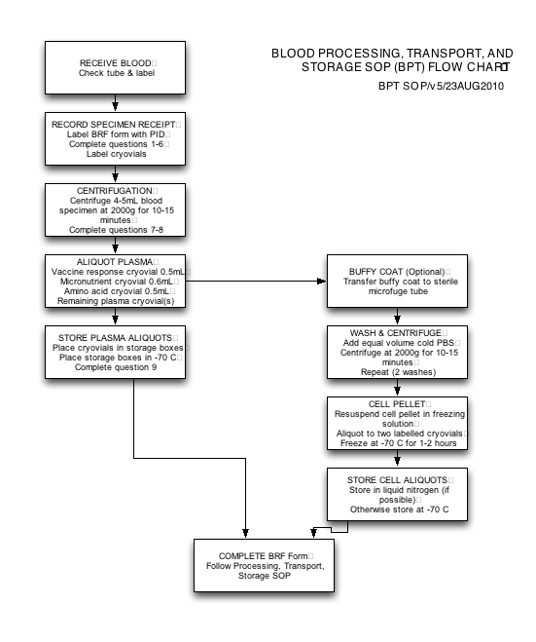

Micronutrient Assays

#### AGP—Alpha-1-Acid Glycoprotein SOP

**Radial Immunodiffusion Plate Procedures**

**INTENDED USE**The quantitation of plasma proteins as an aid in diagnosing deficiency disorders. It is used in the MAL-ED protocol as an indicator of the acute phase of infection/inflammation, which is known to influence the indicators of iron, vitamin A, and zinc status (all change during infection). We want to know if the values we measure of these micronutrients are true values or values distorted by infection/inflammation.

**SUMMARY**Single radial immunodiffusion tests have evolved from the work of Fahey and McKelvey [1] and Mancini et al [2]. They are specific for the various proteins in plasma/serum or other fluids and depend on the reaction of each protein with its specific antibody.

When the wells in antibody containing gels are completely filled with the antigen, the precipitin rings which develop after 10-20 hours at room temperature are measured. The diameter of the ring and the logarithm (base 10) of the protein concentration are related in a linear fashion. Using appropriate reference standards, the concentration of unknown samples may be measured.

**PRINCIPLE**Radial immunodiffusion is based on the diffusion of antigen from a circular well radial into a homogeneous gel containing specific antiserum for each particular antigen. A circle of precipitated antigen and antibody forms, and continues to grow until equilibrium is reached. The diameters of the rings are a function of antigen concentration. After overnight incubation, the zone diameters of reference sera are plotted against the logarithm (base 10) of the antigen concentration. If equilibrium is reached, the reference sera zone diameters are squared and plotted against their concentration (linear). At intervals in between, a linear relationship does not occur. Unknown concentrations are measured by reference to the standard curve.

**REAGENTS**A. Radial immunodiffusion plates contain specific antiserum in agarose gel, 0.1M phosphate buffer, pH 7.0, 0.1% sodium azide as bacteriostatic agent, 1ug/ml amphotericin B as an antifungal agent. Plates also contain 0.002M Ethylenediaminetetraacetic acid. Store at refrigerator temperatures of 2-8o C.

B. Human Reference Sera – (Pooled human serum at three levels*). These sera contain sodium azide (0.1%) as bacteriostatic agent. Store at refrigerator temperature. Each human serum contained in the reference standards has been tested for hepatitis associated antigen (Hb) and found nonreactive. However, a negative test does not eliminate the possibility that the causative agent may be present, and the sera should be considered infectious.

**FOR IN VITRO DIAGNOSTIC USE**

**SPECIMEN & PREPARATION HANDLING**A. Collect whole blood without anticoagulant and allow clotting at room temperature.

B. Separate plasma by centrifugation at about 2000 x g for 10-15 mins, within 2-3 hours of collection.

C. Because we will use plasma samples, be aware of non-specific precipitation of fibrin, which may obscure precipitation rings. In addition, liquid anticoagulents such as ACD fluid will dilute the specimen

D. CAUTION: As noted above, - the unknown specimens should be treated as infectious.

**PROCEDURE  
A. Materials Provided**1. Three, 24-well (3x8) radial immunodiffusion plates.

2. Human Reference Sera: 3 x 0.2ml vials (in kits only).

3. Directions for use.

4. Alpha-1-Acid Glycoprotein Assay Results Form (AGP), found in the forms appendix.

**B. Materials Required**1. Blood collection tubes

2. Centrifuge (2000 x g)

3. Microliter dispenser (5 microliters) - available separately

4. Reference sera (required if not provided in kit form)

5. Measuring device - calibrated in 0.1mm increments – available separately.

6. Two cycle semi-logarithmic graph paper or linear graph paper.

7. Alpha 1-Acid Glycoprotein Assay Results Form (AGP)—use a different form on each day the assay is done.

**C. General**1. Do not overfill or underfill wells. An improperly filled well yields erroneous results and the same specimen should be placed in another well. Overfilling with a 5 microliter sample indicates that some gel shrinkage has occurred.

2. Reference serum zone diameters should be measured at the same time as test plasma samples. If a delay in measurement is anticipated allow sufficient intervals between filling wells.

3. The time of filling each plate should be marked on the cover and if more than one plate is filled, they should be read in order of filling.

4. Excess moisture is required to prevent drying. Replace each plate in its plastic bag and reseal carefully before incubation.

5. Shrinkage of gel or oval shaped wells indicates drying and the plate should not be used.

6. If temperature fluctuations are anticipated, the plates in their bags may be incubated in an insulated container. Fluctuations in temperature may result in multiple precipitin ring formation.

7. Unused sections may be run at a later date if the plate has been stored at 2-8o C between incubations in its plastic bag. Check carefully for evidence of drying and include new standards.

8. Rough granulation of the gel indicates freezing, plates should be discarded.

**D. Performance of Test**1. Remove plates from refrigerator to room temperature approximately 30 minutes before filling wells. Do not open bag until ready for use.

2. If excess moisture is present, remove plate from its bag and remove cover until evaporation has dried the surface and wells. Replace cover until used.

3. For best results, three wells should be filled with reference sera for each plate. Location of each should be noted. Mix each vial of reference serum thoroughly.

4. Deliver specimen to well by placing the pipette tip at the bottom of the well. Allow the well to fill to the top of the agar surface. Avoid bubbles to ensure proper volume and diffusion of sample. Visualization may be aided by placing the plate on dark background. If practice is required, a used plate may be utilized.

5. More consistent results may be obtained when wells are filled with a 5 microliter pipette.

6. Mark time of completion on plate cover and replace cover.

7. Replace plate in bag and reseal carefully.

8. Incubate plates upright on a flat surface at room temperature (20-24° C) for 16-20 hours. Overnight readings and >48 hours readings (for End Point) readings should be recorded. See C6 above.

9. Measure diameters of precipitin zones to within 0.1mm. Variations in incubation times of more than 30 minutes will produce changes in diameters, especially those at higher levels of antigen except when plates have reached endpoint.

**E. Calibration**1. Using the reference sera provided in kits, or other, such as the College of American Pathologists reference standard, determine their ring diameters to the nearest 0.1mm.

2. Using 2 or 3 cycle semi-logarithmic graph paper plot the concentration on the Y axis and the zone diameters on the X axis for each protein for Overnight readings (Figure 1).

3. Using regular graph paper plot the concentration on the X axis and the zone diameters squared on the Y axis for each protein for End Point readings.(see Figure 2.)

4. Draw a straight line of "best fit" between the three points. A curved line usually indicates that the incubation time and/or temperature should be reduced. For valid results, a smooth curve should be fitted to the points and control sera included for additional verification.

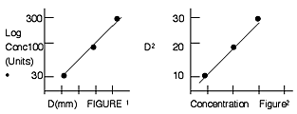

**F.Quality Control**For consistent results and a comparison of lot to lot, day to day, and week to week variations, a "normal" and abnormal plasma sample should be included each day. The diameters and concentrations obtained can be charted to determine means and standard deviations. For the same specimen, an appropriate series of wells on the same plate should yield diameters within 0.2mm of one another. Control plasma samples/sera should be freshly thawed or reconstituted.

**G. Reference Sera**All reference sera supplied have been calibrated from Kent Standard sera and where applicable, the College of American Pathologist reference standard.

**RESULTS**A. Determine the concentration of each unknown or specimen protein by reading its zone diameter on the reference curve and the corresponding concentration. Zone diameter must be squared for End Point calibration.

INTERPRETATION OF RESULTS & LIMITATIONS OF PROCEDURE  
A. When an unknown diameter exceeds that of the top standard, the specimen should be diluted with saline and rerun.

B. When an unknown diameter is smaller than that of the lowest standard, its concentration should be reported as "less than" the concentration of the reference serum. If available, "low level" radial immunodiffusion plates may be utilized.

C. Lack of a precipitin ring may be due to:  
1. Sample not applied to well.  
2. A concentration too low to be detected by the method.  
3. A concentration too high, resulting in the formation of soluble complexes, which are not precipitated.

**EXPECTED VALUES**Determination of normal ranges has been established by analysis of serum from random blood donors, all of whom were 18-50 years of age. Variables such as sex, age, race, were not studied. Significant skewness occurs especially at higher levels and with increasing age. Other unknown variables may also affect each laboratory’s results. The range is listed as comprising 10 - 90% of the ranked population.

|  |  |  |
| --- | --- | --- |
| **Protein** | **Catalog #** | **Assay Range (MG/dl)** |
| IgG | 101511 | 147-2800 |
| IgA | 102511 | 38-569 |
| IgM | 103511 | 48-700 |
| IgD | 127511 | 1-25 |
| C1 Esterase Inhibitor | 135511 | 4-70 |
| C1q | 111511 | 3-30 |
| C-3(B1C/B1A) | 105511 | 37-404 |
| C-4 | 109511 | 3-70 |
| C-5 | 110511 | 4-45 |
| Factor B | 106511 | 4-52 |
| Factor B | 106511 | 4-52 |
| Alpha-1-Antitrypsin | 122511 | 23-383 |
| Alpha-1-Acid Glycoprotein | 123511 | 18-133 |
| Alpha-2-Macroglobulin | 124511 | 44-660 |
| CRP | 134511 | 1-16 |
| Ceruloplasmin | 126511 | 2-81 |
| Haptoglobin | 112511 | 19-410 |
| Transferrin | 125511 | 52-700 |
| Antithromin III | 148511 | 2-35 |
| Prealbumin | 154511 | 2-44 |
| IgG Low Level | 101531 | 14-220 |
| IgA Low Level | 102531 | 2-113 |
| IgM Low Level | 103531 | 3-98 |
| *These values are intended as a guideline-each laboratory should establish it own "normal" range. Values vary with age and should be separately established.* | | |

**PERFORMANCE CHARACTERISTICS**A. Precision: deviation - maximum 10% based on a pooled normal control serum.

B. Sensitivity: for each standard curve, sensitivity is best noted by the user. It can be assessed by noting the percent (mg/dl or I.U./ml) changed in value which occurs when a change of 0.1mm in diameter read.

**REFERENCES**1. Fahey, J.L. and McKelvey, E.M. Quantitative determination of serum immunoglobulins in antibody agar plates. J. Immunol. 94, 84, 1965.

2. Mancini, G., Carbonara, AQ and Heremans, J.F. Immunochemical quantitation of antigens by single radial immunodiffusion. Immunochemistry 2, 235, 1965.

3. Rowe, D.S., Grag, B. and Anderson, S.G. An international Reference Preparation for Human Immunoglobulins G, A and M. Content of Immunoglobulin

HTR—Plasma Human Transferrin Receptor SOP

**INTENDED USE**

The Ramco **TfR** test kit is an enzyme immunoassay (EIA) for the quantitative determination of transferrin receptor concentration in human serum or plasma as an aid in the diagnosis of iron deficiency, particularly in the presence of other disease states.

**SUMMARY AND EXPLANATION**

The transferrin receptor (TfR) is a transmembrane protein present in all body cells which facilitates the uptake and internal transport of iron bound to circulating transferrin.1,2 The cellular content of TfR varies with the iron needs of the tissue and is therefore highest in human placentum and in the erythroid marrow. The serum TfR is a truncated fragment of cellular TfR.3,4 Clinical studies have demonstrated that the concentration of serum TfR is proportional to the total body mass of tissue receptors, two-thirds of which are contained in erythroid marrow. Consequently, an elevation of serum TfR levels occurs whenever erythroid precursors are increased as in iron deficiency anemia.5,6,7 The levels of serum TfR in iron deficiency anemia are elevated in excess of red cell precursor mass due to increased density of TfR on red cell precursors. Measurements of serum transferrin receptor provide a useful clinical index of tissue iron deficiency.4,5,8,9

**PRINCIPAL OF TEST**

Ramco's TfR assay is an enzyme immunoassay based upon the double antibody sandwich method. Plasma or serum samples are diluted in buffer and pipetted into microwells pre-coated with polyclonal antibody to TfR. Horseradish peroxidase (HRP) conjugated murine monoclonal antibody specific for TfR is added to the wells and the wells are incubated for two hours at room temperature. During this incubation, the TfR binds to the polyclonal antibodies adsorbed to the wells and the HRP-conjugated second antibodies bind to the captured TfR. Any unbound TfR and excess HRP conjugate are removed from the wells by washing. Enzyme substrate (chromogen TMB) is added to the wells and through the action of HRP forms a blue product. Upon the addition of an acid stop solution, the blue product is converted to a yellow color, the intensity of which is measured in a plate reader set at 450nm. The optical density of the resulting solution is directly proportional to the concentration of the TfR in the standard samples. A standard curve is generated by plotting the absorbance versus concentration of the TfR standards provided in the kit. The concentration of the TfR in the sample is then determined by comparing the sample's optical density reading with the standard curve graph.

**REAGENT KIT SUPPLIER**

Ramco Laboratories, Inc. (Texas, USA), catalog # TFC-94

The kit insert is copied below. We run subject samples in singlicate after verifying that CV’s for quality control samples (3 per assay run in duplicate) are within 5%. This minimizes the number of assays that need to be run, thus limiting the impact of inter-assay variability on results.

An in vitro enzyme immunoassay for quantifying **Human Transferrin Receptor** in serum or plasma as an aid in the diagnosis of iron deficiency anemia, particularly in the presence of other disease states

**For In Vitro Diagnostic Use Only**

**KIT CONTENTS**

**Microwell Strips**:   12 (twelve) 1 x 8 microwell strips (96 total wells), pre-coated with polyclonal anti-TfR antibody and stabilized in dry form. The plate is provided in a resealable, ziploc foil pouch containing an inert gas and a drying agent. Store at 2 - 8C.

**Plate Sealing Tape**:   2 sheets

**Microwell Frame**:   1

**HRP-Conjugate**:   1 vial containing 16 ml of Horseradish Peroxidase-conjugated anti-TfR monoclonal antibody and detergent with ProClin 300™ as a preservative. Store at 2 - 8C.

**Sample Diluent**:   1 vial containing 45 ml of phosphate buffered saline, detergent, and an inert coloring agent with ProClin 300™ as a preservative. Store at 2 - 8C.

**Wash Solution 5X Concentrate**:   1 bottle containing 50 ml of concentrated phosphate buffered saline and detergent with ProClin 300™ as a preservative. Store at room temperature.

**Pre-diluted Standards**:   7 vials each containing 0.5 ml of purified TfR protein diluted to concentrations of 0, 10, 20, 40, 100, 200 and 400 ng/ml in phosphate buffer containing BSA, normal rabbit serum, and inert coloring agents with ProClin 300™ as a preservative. Store at 2 - 8C.

**Control Sera**:   2 vials containing 100 l of undiluted serum, one having a normal level and one having a high level of human transferrin receptors. Store at 2 - 8C.

**TMB Substrate Solution A**:   1 vial containing 12 ml of a stabilized solution of tetramethylbenzidine (TMB) substrate. Store at 2 - 8C.

**TMB Substrate Solution B**:   1 vial containing 12 ml of a TMB substrate component in a citric acid buffer containing hydrogen peroxide (H2O2). Store at 2 - 8C.

**Acid Stop Solution**:   1 bottle containing 10 ml of 2.5 Molar sulfuric acid (H2SO4). Store at 2 -8C.

***Caution:*** *Caustic material. Wear eye, hand, face and clothing protection.*

**Graph Paper**:   4 sheets of 3 cycle log x log graph paper.

**PRECAUTIONARY STATEMENT**

**WARNING**: The Acid Stop Solution is a solution of 2.5 Molar sulfuric acid (H2SO4). Wear appropriate eye, hand, face and clothing protection when using this material.

**Human Specimens**:   Standards provided in this kit contain purified protein obtained from human donors. Each donor's serum was tested by FDA approved methods for the presence of antibodies to HIV-1 as well as for hepatitis B surface antigen and found to be negative. However, since no test method can absolutely guarantee the absence of these or other infectious agents, all standards, controls and human sera tested with this assay should be handled in accordance with NCCLS guidelines for preventing the transmission of blood-borne infections during laboratory procedures. Wear gloves and avoid contact with skin and mucous membranes.

**Glassware**:   Disposable glassware is preferred; however, before use, all non-disposable glassware should be rinsed with 1N HCl or 1N sulfuric acid followed by at least six rinses with deionized water. There should be no acid or detergent residues.

**OTHER PRECAUTIONS**

* Kit reagents should not be used beyond the expiration date.
* Avoid exposure of reagents to strong light during incubation and storage.
* Samples or solutions containing sodium azide should not be used as the sodium azide will interfere with the assay performance.
* Reagents containing ProClin 300™ may be toxic if ingested.
* Perform the assay only as provided and described in this product insert.
* Substitution of kit reagents and/or alteration of incubation times or conditions may lead to erroneous results.
* Use only high quality (deionized and filtered or distilled) water for dilution of the 5X Wash Solution.

**STORAGE OF KIT**

Reagents provided in this kit should be stored at 2 - 8C for the life of the kit, except for the 5X Wash Solution which may be stored at room temperature.

Reagents should be returned to 2 - 8C as soon as possible after their use in the assay.

**INDICATIONS OF REAGENT INSTABILITY OR DETERIORATION**

All solutions should be clear and free of cloudiness and precipitates. The optical density of the color generated by the 200 ng/ml Pre-diluted Standard should be at least 0.4. If any of the above conditions are not met, the reagents in question should be discarded.

**MATERIALS REQUIRED BUT NOT PROVIDED**

* Purified water (deionized or distilled).
* Precision pipettes capable of delivering 2 - 20 ul, 20 - 200 ul, and 200 - 1000 ul. Alternatively, single volume pipettors of 10 ul, 50 ul, 150 ul, 200 ul, and 1 ml volumes can be used.
* Glass, polypropylene, or polyethylene disposable test tubes. Do Not Use tubes made of Polystyrene.
* Measuring pipettes and cylinders.
* Microplate reader capable of reading at 450nm.
* Absorbent pad or paper towels.
* Microplate washing device or wash bottle.
* Laboratory horizontal rotator table (Optional).
* Statistical/Scientific calculator with regression program or a computer program for point to point or polynomial curve fitting (Optional).

**SAMPLE COLLECTION**

Collect at least 2 ml of venous blood aseptically. Allow the blood to coagulate and separate the clot from the serum by centrifugation as soon as possible. Plasma may also be used for TfR measurements. If the assay will be performed within 7 days, the serum/plasma may be stored at 2 - 8C, otherwise store the serum/plasma frozen at -20C for up to 6 months or -80C for up to 2 years. Avoid repeated freezing and thawing.

Because less than 50 ul of plasma or serum is required to perform triplicate determinations of serum TfR, capillary samples of 100 ul drawn into heparinized capillary tubes and centrifuged in a micro hematocrit centrifuge to obtain plasma can also be used.

Samples must be diluted 1:100 in the Sample Diluent prior to evaluating in the assay.  DO NOT DILUTE STANDARDS.

**REAGENT PREPARATION**

**Wash Solution**:   Prepare a 1X Wash Solution by pouring the entire contents of the Wash Solution 5X Concentrate into a clean 250 ml graduated cylinder. Bring the total volume to 250 ml with distilled water. Cover and invert to mix. Transfer to a clean wash bottle and store at room temperature.

**ASSAY PROCEDURE**

Bring all reagents to room temperature before beginning assay.

Determine the number of microwells needed for the assay (each sample, standard, and control should be assayed in duplicate).

1.   Remove the necessary strips from the packet and place in Microwell Frame.   **NOTE**:   Once a foil packet is opened, any unused Microwell Strips should be immediately resealed in the ziploc foil packet, along with the packet containing desiccant, and returned to 2 - 8C storage. These opened strips should be utilized within 6 weeks.

2.   Prepare a 1:100 dilution of each patient sample and Control by dispensing 1 ml of Sample Diluent into a test tube and adding 10 ul of patient serum or plasma or Control. Mix thoroughly.  DO NOT DILUTE THE STANDARDS.

3.   Pipette 50 ul of each Pre-diluted Standard, in duplicate, into individual wells of the 8-well strips.

4.   Pipette 50 ul of each diluted patient sample and Control, in duplicate, into individual wells of the 8-well strips.

A typical plate map might be as shown below:

|  |  |  |  |  |  |  |  |  |  |  |  |
| --- | --- | --- | --- | --- | --- | --- | --- | --- | --- | --- | --- |
| Blank | Blank | Control 1 | Control 1 |  |  |  |  |  |  |  |  |
| 0 ng/ml | 0 ng/ml | Control 2 | Control 2 |  |  |  |  |  |  |  |  |
| 10 ng/ml | 10 ng/ml | Sample 1 | Sample 1 |  |  |  |  |  |  |  |  |
| 20 ng/ml | 20 ng/ml | Sample 2 | Sample 2 |  |  |  |  |  |  |  |  |
| 40 ng/ml | 40 ng/ml | Sample 3 | Sample 3 |  |  |  |  |  |  |  |  |
| 100 ng/ml | 100 ng/ml | Sample 4 | Sample 4 |  |  |  |  |  |  |  |  |
| 200 ng/ml | 200 ng/ml | Sample 5 | Sample 5 |  |  |  |  |  |  |  |  |
| 400 ng/ml | 400 ng/ml | Sample 6 | Sample 6 |  |  |  |  |  |  |  |  |

5.   Pipette 150 ul of HRP-Conjugate into all individual wells containing samples, controls, and Standards.

6.   Seal the Microwell Strips with the self-adhesive plastic film and place on a laboratory horizontal rotating table and mix for 10 minutes at 190 rpm or rotate by hand, pressing the Frame firmly against the counter to avoid sloshing, to ensure mixing of the HRP-Conjugate with the samples, Controls, and Standards. Allow reaction to proceed for an additional two hours (no rotation) at room temperature upon completion of the mixing.

7.   Prepare the Substrate Solution: Calculate the amount of Substrate Solution needed by multiplying 0.2 ml by the number of wells in the assay run plus 0.5 - 1.0 ml dead volume. Mix equal volumes of TMB Substrate Solution A and TMB Substrate Solution B just prior to addition to the microwells. This solution must be used within 30 minutes of preparation. Discard any unused portion.

8.   After the two hour incubation in #6 above, remove the plastic film, invert the plate, and dump the contents of the Microwell Strips. Tap the plate dry on an absorbent pad or paper towels. Wash the wells with the previously prepared Washing Solution using a plate washing device or by using the wash bottle to flood the wells and then inverting and dumping the contents of the wells. The wells should be washed a total of three times, tapping dry between each wash. After the final wash, make sure the wells are completely empty and free of bubbles.

9.   Pipette 200 ul of Substrate Solution into each blank well and those containing samples, Controls, and Standards, mix for 1 minute at 190 rpm on the horizontal rotator, and incubate in the dark at room temperature for 30 minutes. A blue color should develop in those wells containing TfR.

10.  Stop the color reaction by pipetting 50 ul of Acid Stop Solution into the wells and mix for 1 minute at 190 rpm on the horizontal rotator to remove any air bubbles.

11.  Read the absorbance optical density (OD) of each well at 450nm using a microplate reader and, if available, use a background correction wavelength of 570 - 630nm. It is recommended that the reader be zeroed using blanks prepared with 200 ul of Substrate Solution and 50 ul of Acid Stop Solution. Alternatively, the reader can be zeroed on the 0 ng/ml Standard.

12.  If automatic background correction is not available, it is suggested that the plate be read a second time at 570 - 630 nm and that these readings be manually subtracted from the initial 450nm readings. Failure to compensate for the background absorbance may increase the variability of the assay and result in potentially erroneous values.

13.  Calculate the results by plotting a standard curve of absorbance vs. concentration of the Pre-diluted Standards. See below.

**CALCULATION of  RESULTS**

Calculate the average OD for each set of Standards. If the microplate reader has not already done so, subtract the average OD of the 0 ng/ml Standard from the averageOD of each of the other Standards (= Net OD). Plot the Net OD on the vertical (Y) axis and the corresponding TfR concentration on the horizontal (X) axis of the enclosed 3 -cycle log x log Graph Paper. Construct the standard curve by connecting the points with a best fit line.

Calculate the average OD for each Control and unknown sample and, if the plate reader has not already done so, subtract the average OD of the 0 ng/ml Standard from each (= Net OD). Determine the location of the Net OD on the Y-axis. Follow this point horizontally until it intersects the standard curve. Follow this point of intersection with the curve vertically until it intersects the X-axis. This X-axis value, multiplied by 100 (due to the pre-dilution of the samples), will be the TfR concentration of the Control or unknown sample.

Alternatively, the TfR concentration can be determined by calculating a linear regression plot of the logarithms of the Net OD and TfR concentration values of theStandards using a statistical/scientific calculator or computer. Computer programs are commercially available for point to point and polynomial best-fitting standard curves.

**DILUTION OF SERA WITH HIGH TfR VALUES**

If the calculated TfR value of the sample is greater than 40 ug/ml, it must be re-assayed at a higher dilution. For example, 50 ul of the 1:100 dilution would be added to a tube containing 450 ul of Sample Diluent. The measured TfR value would be multiplied by 1000 to determine the concentration of the original sample.

**QUALITY CONTROL**

Control sera of known TfR values are included and should be run with each assay as quality control. If the measured values of the Controls are not within the expected ranges or the optical density of the 200 ng/ml Standard is less than 0.4, the assay may be considered invalid.

**LIMITATIONS**

1.   Moderate hemolysis of the sample has no effect on the reproducibility or accuracy of the procedure.

2.   Anticoagulants do not influence the test results as long as there is no dilution of the sample. No other drugs have been tested for interference in this assay.

3.   Some elevation in serum TfR can occur following a blood donation.

4.   Strict adherence to precise laboratory procedure is essential for maximum accuracy of the final results.

5.   Values lower than 1 ug/ml (the limit of this assay) should be reported as less than 1 ug/ml.

6.   The optical density of the 200 ng/ml TfR standard should be greater than 0.4.

7.   If the OD reading for any unknown sample is greater than the OD reading for the 400 ng/ml Standard, the sample should be diluted appropriately with Sample Diluent and re-assayed.

**EXPECTED VALUES**

**Normal Range**:   The serum TfR values for 239 normal, healthy volunteers from the Kansas City area were measured and the average serum TfR was 5.55 ± 1.35 ug/ml. The normal range for serum TfR as measured by the Ramco TfR assay has been determined to be 2.9 - 8.3 ug/ml. There is no significant sex or age difference in serum TfR values. Variations in serum TfR values in healthy subjects are believed to reflect differences in the rate of red cell production9.

**Iron Deficiency Anemia**: In a composite group of 22 patients with uncomplicated iron deficiency anemia, the mean serum TfR value was 18.6 ug/ml with a range of 5.1 to 35 ug/ml. In 21 out of 22 patients, the TfR value was greater than the upper cut-off level of the normal range (8.3 ug/ml).

Unlike most conventional measurements of iron deficiency, the serum TfR is useful for distinguishing iron deficiency anemia from the anemia associated with chronic infection or inflammation11,12. In 31 patients with the latter, the mean serum TfR was 5.36 ±2.1 ug/ml and 29 of the 31 patients had serum TfR levels below the 8.3 ug/ml upper cut-off of the normal range.

Additionally, the serum TfR is useful for identifying iron deficiency anemia when it develops in patients with chronic disease. In one study of anemic patients with inflammatory joint disease, the serum TfR was elevated above 8.3 ug/ml in 9 out of 13 patients with absent iron on bone marrow examination but was normal in all 9 patients with iron stores. Similarly, the serum TfR concentration was elevated above 8.3 ug/ml in 8 out of 10 anemic patients with inflammatory bowel disease and absent marrow iron but was normal in 3 out of 4 patients with stainable marrow iron.

**PERFORMANCE CHARACTERISTICS**

**Analytical Sensitivity (limit of detection)**:   Sensitivity has been defined as the lowest measurable concentration of TfR that differs significantly from zero (p = 0.001). In two assays performed on separate days, the 0 Standard was run in quadruplicate along with the set of Standards and Controls. The mean OD and standard deviation of the zero standard were calculated: 0.006 ± 0.0008. The mean OD of the zero standard plus three times the standard deviation is considered the lowest detectable TfR concentration. This converts to 0.7 ng/ml, which corresponds to a serum TfR concentration of 0.07 ug/ml.

**Linearity**: As demonstrated below, serial dilutions of sera with high TfR levels gave a linear response when normal rabbit serum (NRS) was added to keep serum levels of all dilutions constant while a progressive increase in apparent recovery occurred when NRS was not added. Because of this serum effect, 1% NRS is added to all Standards to equalize serum concentrations between Standards and diluted samples.

|  |  |  |  |  |  |
| --- | --- | --- | --- | --- | --- |
| Diluting Buffer | Sample # | Dilutions | Expected TfR (E) | Actual TfR (A) | Recovery (% A/E) |
| No NRS | H1 | normal | 60.0 | 60.0 | 100 |
|  |  | 1:2 | 30.0 | 31.0 | 103 |
|  |  | 1:4 | 15.0 | 16.5 | 110 |
|  |  | 1:8 | 7.5 | 8.5 | 113 |
|  |  | 1:16 | 3.8 | 4.8 | 126 |
|  |  | 1:32 | 1.9 | 2.5 | 132 |
| Plus NRS | H2 | normal | 50.0 | 50.0 | 100 |
|  |  | 1:2 | 25.0 | 25.0 | 100 |
|  |  | 1:4 | 12.5 | 12.5 | 100 |
|  |  | 1:8 | 6.3 | 6.2 | 98 |
|  |  | 1:16 | 3.1 | 3.1 | 100 |
| Plus NRS | H3 | normal | 45.0 | 45.0 | 100 |
|  |  | 1:2 | 22.5 | 22.5 | 100 |
|  |  | 1:4 | 11.3 | 11.5 | 102 |
|  |  | 1:8 | 5.6 | 5.5 | 98 |
|  |  | 1:16 | 2.8 | 2.9 | 104 |

**Analytical Specificity**: No assay interference occurred at normal serum levels of transferrin, serum albumin and bilirubin nor at concentrations 50% higher than normal. A slight increase in TfR measurements occur at twice the normal concentrations of transferrin and bilirubin. No change occurred in measured TfR levels when samples became highly hemolyzed. When the dilution of the blood is accounted for, there is no difference in the TfR levels of blood collected into vacutainer tubes containing EDTA, Sodium Citrate, Heparin or no additives.

|  |  |  |  |
| --- | --- | --- | --- |
| Additive | Concentration Added | TfR Before Addition | TfR After Addition |
| None | n/a | 4.7 ug/ml | 4.7 ug/ml |
| Transferrin | 1.0 mg/ml | 4.7 | 4.7 |
| Transferrin | 2.0 mg/ml | 5.0 | 5.8 |
| Serum Albumin | 20.0 mg/ml | 4.7 | 4.7 |
| Serum Albumin | 40.0 mg/ml | 5.0 | 5.2 |
| Bilirubin | 5.0 ug/ml | 4.7 | 4.9 |
| Bilirubin | 10.0 ug/ml | 5.0 | 5.8 |
| Hemoglobin | 15.0 mg/ml | 4.7 | 4.8 |
| Hemoglobin | 75.0 mg/ml | 5.0 | 7.2 |
| EDTA | 0.07 ml/0.34M | 4.7 | 4.7 |
| Sodium Citrate | 0.5 ml/0.129U | 4.7 | 4.6 |
| Heparin | 0.5 ml/100.0U | 4.7 | 4.7 |

**Intra-Assay Variability**:   Performing 10 replicate measurements on six control sera with mean TfR levels between 5.0 and 15.0 ug/ml yielded within-assay variability of 2.3 to 5.8% with a mean of 4.2%.

|  |  |  |  |  |
| --- | --- | --- | --- | --- |
| Sample # | Number of Reps | Mean TfR ug/ml | Standard Deviation | % C.V. |
| 1 | 10 | 5.5 | 0.13 | 2.4 |
| 2 | 10 | 5.9 | 0.17 | 2.9 |
| 3 | 10 | 7.8 | 0.45 | 5.8 |
| 4 | 10 | 9.4 | 0.55 | 5.8 |
| 5 | 10 | 14.5 | 0.54 | 3.7 |
| 6 | 10 | 14.9 | 0.54 | 3.5 |

**Inter-Assay Variability**:   Performing duplicate measurements on twelve serum samples over a period of five weeks yielded between-assay variability of 3.6 to 8.1% with a mean C.V. of 6.0%.

|  |  |  |  |  |
| --- | --- | --- | --- | --- |
| Sample # | Number of Reps | Mean TfR ug/ml | Standard Deviation | % C.V. |
| 1 | 10 | 4.1 | 0.18 | 4.4 |
| 2 | 10 | 4.4 | 0.23 | 5.2 |
| 3 | 10 | 5.5 | 0.29 | 5.3 |
| 4 | 10 | 5.6 | 0.31 | 5.5 |
| 5 | 10 | 6.3 | 0.42 | 6.7 |
| 6 | 10 | 6.4 | 0.52 | 8.1 |
| 7 | 10 | 7.3 | 0.53 | 7.3 |
| 8 | 10 | 7.4 | 0.30 | 4.1 |
| 9 | 10 | 8.0 | 0.48 | 6.0 |
| 10 | 10 | 9.6 | 0.71 | 7.4 |
| 11 | 10 | 13.8 | 0.98 | 6.9 |
| 12 | 10 | 16.1 | 0.80 | 5.0 |

**Recovery**: Studies in which purified TfR was added to normal serum samples showed recoveries of 92.8 to 103.2% with a mean of 97.4%. Purified TfR was added to control sera at three levels. Percent recovery of added TfR was calculated as the actual measured TfR divided by the expected TfR concentration.

|  |  |  |  |  |  |
| --- | --- | --- | --- | --- | --- |
| Sample # | Serum TfR ug/ml | TfR Added ug/ml | Exp'd TfR ug/ml (E) | Actual TfR ug/ml (A) | Recovery % A/E |
| 1 | 3.0 | 15.5 | 18.5 | 18.2 | 98.4 |
| 2 | 4.0 | 15.5 | 19.5 | 19.3 | 99.0 |
| 3 | 6.9 | 15.5 | 22.4 | 21.5 | 96.0 |
| 4 | 6.6 | 15.5 | 22.1 | 20.5 | 92.8 |
| 5 | 2.1 | 20.0 | 22.1 | 21.0 | 95.0 |
| 6 | 3.1 | 20.0 | 23.1 | 23.6 | 102.2 |
| 7 | 9.7 | 31.0 | 40.7 | 42.0 | 103.2 |
| 8 | 6.6 | 31.0 | 37.6 | 36.0 | 95.7 |
| 9 | 4.0 | 31.0 | 35.0 | 33.0 | 94.3 |

**BIBLIOGRAPHY**

1. Huebers HA, Finch CA: The physiology of transferrin and transferrin receptors. Physiol Rev 67:520, 1987

2. Trowbridge IS: Transferrin receptor as a potential therapeutic target. Prog Allergy, 45:121, 1988

3. Shih YJ, Baynes RD, Hudson BG, Flowers CH, Skikne BS, Cook JD: Serum transferrin receptor is a truncated form of tissue receptor. J Biol Chem 265:19077, 1990

4. Baynes RD, Skikne BS, Cook JD: Circulating transferrin receptors and assessment of iron status. J Nutr Biochem 5:322, 1994

5. Huebers HA, Bequin Y, Pootrakul P, Einspahr D, Finch CA: Intact transferrin receptors in human plasma and their relation to erythropoiesis. Blood 75:102, 1990

6. Kohgo Y, Nishisato T, Kondo H, Tsushima N, Niitsu Y, Urushizaki I: Circulating transferrin receptor in human serum. Br J Haematol 64:277, 1986.

7. Flowers CH, Skikne BS, Covell AM, Cook JD: The clinical measurement of serum transferrin receptor. J Lab Clin Med 114:368, 1989

8. Skikne BS, Flowers CH, Cook JD: Serum transferrin receptor: A quantitative measure of tissue iron deficiency. Blood 75:1870, 1990

9. Cook JD, Skikne BS, Baynes RD: Serum transferrin receptor. Annu Rev Med 44:63, 1993

10. Kohgo Y, Niitsu Y, Nishisato T, Dato J, Kondo H, Sasaki K, Urushizaki I: Quantitation and characterization of serum transferrin receptor in patients with anemias and polycythemias. Jpn J Med 27:64, 1988

11. Ferguson BJ, Skikne BS, Simpson KM, Baynes RD, Cook JD: Serum transferrin receptor distinguishes the anemia of chronic disease from iron deficiency anemia. J Lab Clin Med 119:385, 1992

12. Pettersson T, Kivivuori SM, Siimes MA: Is serum transferrin receptor useful for detecting iron-deficiency in anaemic patients with chronic inflammatory diseases? Br J Rheumatol 33:740, 1994

13. Carriaga MT, Skikne BS, Finley B, Cutler B, Cook JD: Serum transferrin receptor for the detection of iron deficiency in pregnancy. Am J Clin Nutr 54:1077, 1991 Ramco Laboratories, Inc.

4100 Greenbriar Drive Suite 200

Stafford, Texas 77477

281-313-1200

800-231-6238

Issued: 3/23/98

Revised: 11/07/2003; 05/02/2006; 7/23/07

FAR—Plasma Ferritin Assay SOP

Laboratory technicians will use the Ferritin Assay Results form (FAR), found in the forms appendix.

|  |  |
| --- | --- |
| **Ferritin Normal Ranges** | |
| **Men:** | 18-270 [nanograms per milliliter (ng/mL)](http://www.webmd.com/hw-popup/nanograms-per-milliliter-ngml) or 18-270 [micrograms per liter (mcg/L)](http://www.webmd.com/hw-popup/micrograms-per-liter-mgl) |
| **Women:** | 18-160 ng/mL or 18-160 mcg/L |
| **Children 6 months to 15 years:** | 7-140 ng/mL or 7-140 mcg/L |
| **Babies 1 to 5 months:** | 50-200 ng/mL or 50-200 mcg/L |
| **Newborns:** | 25-200 ng/mL or 25-200 mcg/L |

**Antibodies (from abcam.com):**

Cat # ab31662 rabbit polyclonal for capture antibody

Cat # ab7334 or ab31996 rabbit polyclonal HRP conjugated for detection antibody

**Standards:**

Sigma cat # F6879

**Solutions**

1. **1L COATING BUFFER:** 0.30g NaH2PO4

2.68g Na2HPO4·12H2O

8.474g NaCl

Add chemicals to ~800mL nanopure H2O, pH 7.2+0.3, bring up 1L

Can be stored in refrigerator.

1. **1L WASH BUFFER:** 0.30g NaH2PO4 (2L = 0.6g)

2.68g Na2HPO4·12H2O (2L = 5.36g)

29.22g NaCl (2L = 58.44g)

1mL Tween 20 (2mL)

Add chemicals to ~800mL nanopure H2O, pH 7.2+0.3, bring up 1L.

Can be stored in refrigerator.

1. **HRP CONJUGATED ANTIBODY (1ug/1uL):**

Dilute 4µL HRP antibody in 4mL coating buffer.

Then dilute 3mL of above solution in 17mL coating buffer.

Final concentration is 0.015ug/100µL

This is enough for 2 plates.

1. **COLOR REAGENT:**

Make and use in the dark. Make less than 30 minutes before use.

Make .1M citric acid phosphate buffer:

7.30g citric acid·H2O

23.87g Na2HPO4·12H2O

pH =5.0

Bring total volume to 1L with H2O

Dissolve 0.016g o-phenylenediamine in 24mL citric acid phosphate buffer.

Mix in 10µL of 30% H2O2 right before use.

This is enough for 2 plates.

1. **STOP COLOR REAGENT (1M H2SO4):**

Place 5.8mL H2SO4 in volumetric flask and bring up to 100mL with nanopure water. (This is enough for 10 plates and can be stored at room temperature.)

**A. Plate Coating Protocol**

Make coating buffer solution. Dilute 100µL Primary Antibody into 200mL Coating Buffer. Add 100µL to each well. Cover and refrigerate at least 24 hours. (This solution will coat 20 plates.)

**B. Assay Protocol**

1. Dilute 5µL High standard into 5mL wash buffer, then do the following dilutions from that:

|  |  |  |  |  |  |  |
| --- | --- | --- | --- | --- | --- | --- |
|  | **0 µg/mL** | **3 µg/mL** | **6 µg/mL** | **9 µg/mL** | **12 µg/mL** | **15 µg/mL** |
| **Amt Standard** | 0mL | .25mL | .5mL | .75mL | 1mL | 1.25mL |
| **Amt Wash Buffer** | 1.25mL | 1mL | .75mL | .5mL | .25mL | 0mL |

1. Dilute Normal standard, internal standard, and all samples 1:1000 (10µL into 10mL) in 15mL centrifuge tubes.
2. Dump Coating Buffer from plate and pre wash plate with Wash Buffer. Dump immediately. Then wash 3 more times, letting the plate sit 3 minutes in between dumpings.
3. Pipet 100µL of standards and plasma samples into already coated 96-well plates in triplicate. 24 samples, internal standard, and normal sample can be run on one plate.
4. Cover plate and let stand at room temperature for 2 hours.
5. Dump plate and pre wash plate with Wash Buffer. Then wash 3 more times, letting the plate sit 3 minutes in between dumpings.
6. Make diluted HRP Conjugate and add 100µL to all wells.
7. Cover plate and let stand at room temperature for 1 hour.
8. Dump plate and pre wash plate with Wash Buffer. Then wash 3 more times, letting the plate sit 3 minutes in between dumpings.
9. Make Color Reagent and add 100µL to all wells in the dark. (Do NOT make more than ½ hour before it will be used.)
10. Let stand at room temperature in the dark for exactly 10 minutes.
11. Make Stop Color Reagent and add 100µL to all wells.
12. Read immediately on plate reader at a wavelength of 490.

ZAR—Plasma Zinc Assay SOP

Laboratory technicians will use the Zinc Assay Results form (ZAR), found in the forms appendix.

AA Instructions

**1% Magnesium Nitrate (Matrix Modifier) - #1 slot**

Use a clean 50mL centrifuge tube. Dissolve 0.4g of ultrapure magnesium nitrate (Mg2NO3)2 in 40mL of nanopure water. Vortex.

1%=1g/100mL

**0.2% Nitric Acid (Blank) - #2 slot**

Use an acid washed 500mL bottle. Add 1mL of ultrapure nitric acid (HNO3) to 500mL of nanopure water. Vortex.

0.2%=.2mL/100mL

**40**μ**g Fe/L (Standard) - #3 slot**

Use a clean 15mL centrifuge tube. Add 400µL Iron Standard (30µg Fe/mL) to 5.6mL nanopure water. This stock solution is 2000µg Fe/L. Add 800µL of the stock solution to 39.2mL nanopure water. The final solution is 40µg Fe/L. Vortex.

**Rinse Solution**

Measure 2000mL Nanopure water into rinse bottle. Add 1% Nitric Acid (20mL) and 0.05% Triton X-100 (1mL) to the water. Flush Sampler in Winlab.

………………………………………………………………………………………………

1. Turn on the atomic absorption spectrophotometer (AAS), open the gas valve, and open WinLab32 software. Open the Fe Workspace and turn on and set up the Fe Lamp (let lamp warm up 10 minutes)
2. Turn on the water supply and the exhaust fan before running the machine
3. Make sure the tip is aligned properly both in the tube and in the sample cup
4. In Automated Analysis Control, go to the Setup page. Click open under Sample Information File. Open Sample SIF. Go to SamInfo @ top of the screen. Change Batch ID to today’s date (ex/ 02-08-05). Go to File, Save As, Sample Info File. File name should be the same as above (ex/ 02-08-05).
5. Click the boxes on the Setup page for Use Sample Info and also Save Data. Open Results Data Set Name. Give it a new name (ex/ 02-08-05). Click OK
6. Go to the Analyze page. When the lamp is warmed up, calibrate the machine. Calibrate with the matrix in slot 1, the blank in slot 2, and the standard in slot 3
7. Run a 20g Fe/L standard placed in slot #4 at the beginning, end, and every 15-20 samples throughout the run to check for accuracy. Also run the internal QC-1 sample and the Bovine Liver sample as quality controls.
8. While the machine is calibrating, prepare the samples by diluting with the blank until samples fit on the AA standard curve
9. If calibration is satisfactory, load the samples into the carousel, click on Select Loc, and have the machine run all samples
10. After the run is completed, go to File, Utilities, Data Manager. Click on the file you need to export and click Export. Use an Existing Design by browsing and choosing Carrie.xpt, then click Finish. Click Export data then Finish again
11. Open Excel. Open the file you just exported (it will be under C: data-AA: Workstation: Reports). Then click Next, Delimiters should be comma not tab, then Finish
12. Go to File, Save As and save it under C: Carrie’s AA Excel Data and call it the date (make sure it is saving as a Microsoft Excel Workbook)
13. Save the file again to a USB drive so the data can be transferred to the main computer

Instructions for Zinc

**1% Magnesium Nitrate (Matrix Modifier) - #1 slot**

**0.2% Nitric Acid (Blank) - #2 slot**

**20**μ**g Fe/L (Standard) - #3 slot**

RAR—Plasma Retinol Assay SOP (Needs proof reading by Technical subcommittee)

Laboratory technicians will use the Retinol Assay Results form (RAR), found in the forms appendix.

DETERMINATION OF PLASMA RETINOL BY HPLC

The HPLC consisted of a standard Quaternary pump, a programmable UV/Visdetector and an autosampler (PerkinElmer/Agilent Technologies). The separation was achieved using a ZORBAX C-18, 4.6 x150mm, 5-µm Column. Isocraticmobile phase 100% Methanol wasused. The flow rate wasmaintained at 2.0 mL/min. From 0 to 5.5 min the wavelength will beset at 325 nm to getthe maximum absorbance of retinol. A diode array detectorwill be use to check the purity of the peaks. The NIST StandardReference material SRM968c were used for calibration.Unknown samples were calibrated against the matching standard pooled serum.

**Instrument/Model:**

High Performance Liquid Chromatography(HPLC)

* 1200 Series, Agilent Technologies
* 200 Series, PerkinElmer

**Standards & Reagents:**

* Retinyl Acetate (RAC) as internal standard
* NIST Standard Reference Material (SRM 968c) for samples calibration
* Calibrated pooled serum
* Methanol HPLC Grade
* n-Hexane HPLC Grade

**Methodology:**

**Preparation of Stock Standards**

Prepare 50 μg /dl at 325 nm.

Take a small amount of RAC in 5 ml / 10 ml Methanol and take reading at 325 nm on spectrophotometer against Methanol in blank.

Extinction Coefficient for RAC is 1560.

Sample Calculation

**Step # 1**  O.D would be 0.875 then Conc. = 0.875/1560 gm% or 560.8 μg%.

For working internal standard (50μg %)

M1V1=M2V2

560.8×V1=50×5

V1=0.445ml or 445 μl

Therefore to make 5ml of 50μg% Pipette out 445 μl stock and make up the volume 5ml.

**Step #2** Take the O.D of working standard in order to confirm the conc. of RAC i.e. 50μg%.

Extraction Procedure:

Preparation of pool serum:

Collect blood from at least 15 – 20 healthy volunteers, separate serum and mix all the sera together in glass volumetric flask and stir it continuously under ice for at least 5 hrs. Then store 300 μl of pool serum in different μvials and store at 4°C. This pool is used as reference standard.

(2) Standard Reference Material (SRM) 968c

SRM is intended for use in validating methods for determining fat-soluble vitamins, carotenoids and cholesterol in human serum. This SRM (968c) has an assigned value of 0.484±0.012 μg/ml. The lyophilized serum in each vial must be reconstituted with 1.0 ml of HPLC grade water before use. This SRM 968c is specific for retinol determination in serum.

**Step # 1.** Take 100μl of SRM, add 100μl (50 μg/dl) of RAC as internal standard. Vortex for 20 seconds then adds 300 μl of n-hexane. Vortex again for 40 seconds, then centrifuges for 1 minute at 2500 rpm. Collect the supernatant. Extract twice with hexane. Pool the hexane volume and dry it under the stream of Nitrogen. Reconstitute in 100 μl mobile phase. Inject 25 μl of it onto HPLC.

**Step # 2.** Take 100μl of pooled serum, add 100μl of RAC as internal standard. Vortex for 20 s. Add 300μl of n-hexane, vortex for 40s and centrifuge for 1 min at 2500rpm. Collect the supernatant, extract twice with hexane. Pool the hexane volume and dry under nitrogen. Reconstitute in 100 μl mobile phase and inject 25 μl of it onto HPLC system.

Sample Calculation:

IN SRM (Standard Reference Material)

AUC of retinol =X1

AUC of retinyl acetate =X2

Ratio =X1/X2 =X

X is corresponding to 48.4 μg/dl of retinol in SRM.

IN POOL IN SERUM

AUC of retinol =Y1

AUC of retinyl acetate =Y2

Ratio =Y1/Y2 =Y

Now compare proportional value of pool serum with SRM,

If X have value of 48.4 then

Y = 48.4/X Y=Z

This Z is the assigned value of pool serum as used as reference standard.

EXTRACTION & PREPARATION OF SAMPLES

Take plasma samples 100μl in a conical base centrifuge tube, add 100μl of RAC (50μg%), vortex for 30 seconds, add 300μl of hexane, vortex for 40 seconds and centrifuge for 1min at 2500 rpm. Collect supernatant and extract twice with hexane. Pool the hexane volume and dry under nitrogen. Reconstitute in 100 μl mobile phase and inject 25μl of it on to HPLC.

Pool samples will be assigned a value against standard serum from National Institute of Standard and Technology (NIST) are run with each set of samples and the concentration of retinol calculated based on the known concentration of retinol in pool samples.

Sample Calculation

*Peak area*

|  |  |  |  |
| --- | --- | --- | --- |
|  | **Retinol** | **RAC** | **Ratio** |
| Pool 1 | 1.988 | 2.124 | 0.9363 |
| Pool 2 | 1.883 | 2.074 | 0.9079 |

Determine the precision of the pool samples:

Mean value (X) =0.9363+0.9079/2

Mean value =0.9221

∴ SD±0.0201

CV% =2.2% CV% =SD/Xtimes100

The coefficient of variation should be less then5% if not, the samples should be rerun.

Peak area

|  |  |  |  |
| --- | --- | --- | --- |
|  | **Retinol** | **RAC** | **Ratio** |
| Sample 1 | 1.912 | 2.034 | 0.9398 |
| Sample 2 | 2.322 | 2.1273 | 1.0915 |

The mean ratio of retinol/RAC in plasma pool is 0.9221

So if X (AUC of retinol in SRM) have value 48.4 then,

The value of retinol in serum pool is 0.9221= 48.4/X is equal to Z, the conc. of retinol in μg/dl.

Therefore the conc. of retinol in the samples can be calculated as:

|  |
| --- |
| Sample 1 0.9398/0.9221 * Z = **Aμg/dl Retinol** |
| Sample 2 1.0915/0.9221 * Z = **Bμg/dl Retinol** |

**References:**

1. J. Chromatogr. 231, (1982), 439-444
2. Biochemistry and Nutrition, ICDDRB, 1986, 1992
3. J. Chromatogr. 311, (1984), 239-248

PGA—Plasma Glutamine and Arginine Assay SOP

Laboratory technicians will use the Plasma Glutamine and Arginine Assay Results form (PGA), found in the forms appendix.

**I. PURPOSE**

Amino acid concentration in biological fluids has significant importance in laboratory medicine and research. MAL-ED will utilize subject plasma samples for the determination of glutamine and arginine as an indicator of malnutrition. The total amino acids in plasma reflect nutritional and metabolic status, and changes in this profile are associated with amino acidopathies. Quantification of individual amino acids, such as glutamine and arginine, is important in monitoring nutrient deficiency in malnourished children and often helps in therapeutic intervention such as dietary manipulations and/or vitamin supplement therapy. The reversed-phase high liquid chromatography (HPLC) method based on phenylisothiocyanate (PITC) derivatization offers an opportunity to quantify most individual amino acids in biological fluids (1-3). The use of the electrochemical detection of PITC derivatives can eliminate interference and enables measurement of the secondary amino acids such as in plasma and urine from patients with cystinuria and maple syrup urine disease. The derivatization method is rapid, efficient, sensitive, and specific for the amino acid profile. The HPLC system allows for the rapid, bonded-phased separation with ultraviolet detection (254 nm) of most amino acids within 12 minutes analysis time and with a sensitivity of 1 pmol.

**II. MATERIAL**

* High-purity water (Milli-QTN purification system, Millipore, Badford, MA)
* Trichloroacetic acid
* Standard H of amino acids (Pierce H, Waters Co., Milford, MA), all 2.0 μmol/mL, except cysteine = 1.25 μmol/mL: aspartic acid; glutamic acid; serine; glycine; histidine; arginine; threonine; alanine; proline; tyrosine; valine; methionine; cysteine; isoleucine; phenylalanine; and lysine.
* Dry reagent: ethanol-water-triethylamine (TEA) (2:2:1).
* Derivatization reagent: ethanol-TEA-water-PICT (7:1:1:1).
* Eluent A: 0.14 M sodium acetate containing 0.5 ml/L TEA and titrated to pH = 6.35 with glacial acetic acid.
* Eluent B: acetonitrile solution 60% in high-purity water.
* Plasma Glutamine and Arginine Assay Results Form (PGA)

**III. EQUIPMENT**

The Alliance HPLC system (Waters Co) is composed of the following modules: pump; automatic injector; degas and column (Pico Tag column for hydrolyzed amino acids; Waters Co.) chamber for temperature control; UV detector (model 486). The system is operated by a millennium software-32 from Waters Co. A centrifuge and a lyophilizer are also used for sample preparation.

**IV. QUALITY CONTROL**

A standard sample with known amount of glutamine and arginine is used after every fourth patient sample for quality control. Thus, the inter- and intra-experiment variation in recovery of standard amino acids and inter- and intra-experiment variation of retention times of standard amino acids can be measured for quality control by the HPLC. The following parameters of the assay are required for acceptance of experimental results: (a) linearity up to 1.0 μmol/mL; (b) low limit quantification of 0.1 μmol/mL; (c) inter- and intra-experiment variation of < 5%; and (d) recovery > 95%.

**V. CALIBRATION**

One standard solution of amino acids is used to calibrate the HPLC system. The standard contains 2.0 μmol/mL (except for cysteine, 1.25 μmol/mL) of the amino acids as described in package insert material for standard solution H. The standard solution with these amino acids is used to calibrate the HPLC system at the beginning of the measurements and then after every fourth patient sample to correct for the loss in sensitivity. For the determination of intra-experiment variation, four 50-μl samples from the standard solution are analyzed at the concentration of 0.1 mM successively. To determine the inter-experiment variation, four independent samples from the standard solution at a concentration of 1.0 mM are prepared and diluted to the following concentrations: 1.0, 0.3, 0.1, 0.03 and 0.01 mM; 50 μl of the standard amino acid solution is analyzed.

**VI. METHODS**

Pre-column PITC Derivatization General Principle - Phenylisothiocyanate (PITC) reacts with amino acids to form phenylthiocarbamyl (PTC) derivatives which can be detected with high sensitivity at 245 nm. Therefore, pre-column derivatization of amino acids with PITC followed by a reversed-phase HPLC separation with UV detection is used to analyze the amino acid composition.

After the reagent is removed under vacuum, the derivatized amino acids can be stored dry and frozen for several weeks with no significant degradation. If the solution for injection is kept cold, no noticeable loss in chromatographic response occurs after three days.

Separation of the PTC-amino acids on a reversed-phase HPLC with ODS column is accomplished through a combination of changes in concentrations of acetonitrile and buffer ionic strength. PTC-amino acids eluted from column are monitored at 254 nm.

Detection limit is considered to be 1 pmol for most of the amino acid derivatives. Response linearity is obtained in the range of 20 to 500 pmol with correlation coefficients exceeding 0.999. To obtain good compositional data, samples larger than 500 ng of protein/peptide before hydrolysis is best suited for this amino acid analysis of proteins/peptides.

The following practical steps are described below:

* 1. Remove 200 μl of subject serum sample or standard solution and add to the tubes (5 mL).
  2. Add to each tube 200 μl of trichloroacetic acid (6 mol/L) and vortex each tube for 30 seconds.
  3. Centrifuge in microcentrifuge at 3000 rpm for 10 min.
  4. Pipet 100 μl of the supernatant and transfer to reaction tubes and dry the tubes on a lyophilizer for at least 6 hours.
  5. Add 10 μl of dryer reagent to each tube and dry the tubes on a lyophilizer for 1 hour.
  6. Add 20 μl of derivatization reagent and dry on a lyophilizer for at least 8 hours.
  7. Add 100 μl of eluent A to each tube.
  8. Transfer a volume to the injector tubes.
  9. Samples are placed in autosampler and inject 10 μl of each sample into the HPLC system. Each sample is read in the UV detector (254 nm).
  10. Values are electronically transferred into the software program and results are calculated. The results are transferred to the database.

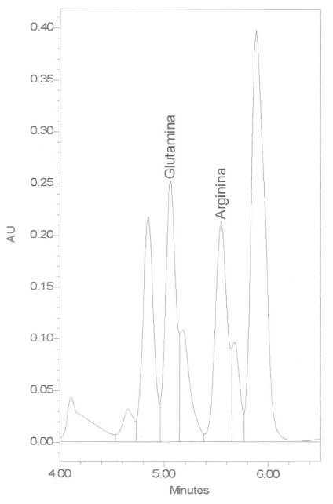

**Figure 1**

**VII. INTERPRETATION**

**Figure 1** shows a typical chromatogram for glutamine and arginine from a serum sample in a child (4). Serum/plasma concentration values above or below the normal range (see item **VIII** and **IX**) is considered abnormal (4).

**VIII. CALCULATIONS**

The integration and calculation of the isolated peaks (analytes) in the chromatograms are performed using software milennium-32 from Waters Co. The concentrations of all components of interest in each injection are calibrated against the amount of external standard, i.e., known amount of glutamine and arginine. The final calculation to correct for dilution factor is done using the Excel software program.

**IX. EXPECTED VALUES**

The normal range of serum/plasma concentration for glutamine is 0.479 – 0.821 μmol/mL and for arginine 0.120 – 0.144 μmol/mL (4).

**X. REPORTING RESULTS**

The results are reported as μmol/mL in the Excel file using the same software program.

**XI. LIMITATIONS AND PROCEDURAL NOTES**

* 1. The amino acid concentration measurements by HPLC and PITC are considered a consistent and sensitive method to quantify the amount of amino acids in biological fluids.
  2. The amino acids concentrations in biological fluids are recommended to diagnose specific amino acidopathies.
  3. Quantification of individual amino acids, such as glutamine and arginine, is important in monitoring nutrient deficiency in malnourished children and often helps in therapeutic intervention such as dietary manipulations and/or vitamin supplement therapy.

**XII. CLINICAL SIGNIFICANCE**

As mentioned, the quantification of amino acids in biological fluids is clinically important to diagnose specific amino acidopathies and also for monitoring nutrient deficiency in malnourished children.

**XIII. VERIFICATION**

The Lab coordinator will record if an event occurs outside of the standards of practice (this event is called a ***protocol deviation,* which is any unapproved change, deviation, or departure from the study design or procedures). A Protocol Deviation Form is completed by the individual having committed the deviation and the study coordinator/ sponsor/IRBs are notified**.

**XIV. REFERENCES**

1. Fekkes D. State-of-the-art of high-performance liquid chromatographic analysis of amino acids in physiological samples. J Chromatogr B Biomed Appl 1996; 682:03-22.
2. Sherwood RA, Titheradge AC, Richards DA. Measurements of plasma and urine amino acids by high-performance liquid chromatography with electrochemical detection using phenylisothiocyanate. J Chromatogr 1990; 528:293-303.
3. Bidlingmeyer BA, Cohen SA, Tarvin TL. Rapid of amino acids using pre-column derivatization. J Chromatogr 1984; 336:93-104.
4. Lima NL, Soares AM, Mota RM, Monteiro HS, Guerrant RL, Lima AA. Wasting and intestinal barrier function in children taking alanyl-glutamine supplemented enteral formula. J Pediatr Gastroenterol Nutr 2007; 44:365-374.

BLL—Blood Lead SOP

**Method for the Determination of Lead (Pb) in Whole Blood by Graphite Furnace Atomic Absorption Spectroscopy (AAS)**

Nutrition Research Laboratory

Department of Paediatrics & Child Health, Aga Khan University

**INSTRUMENTATION**

The M Series Atomic Absorption Spectrophotometer (M5 and MQZ) from Thermo Electron Corporation UK fitted with GF95 Zeeman Graphite Furnace with GFTV and FS95 Furnace Auto sampler was used for all analyses.

**MATERIALS AND METHOD**

Reagent and Standards:

Nitric Acid (Analytical Grade (from BDH Company)

Lead master standard (1000mg/L Spectrosol grade from Merck Company, Germany)

Triton® X-100 and Ammonium dihydrogen phosphate ([NH3]2HPO4) (AnalaR grade (form Sigma-Aldrich company Germany),

Preparation of Stock standard:

The stock standard solution were prepared by diluting 10µL lead master standard (1000mg/L) concentration rang of 100µg/dL in 10mL 0.1% conc. Nitric Acid (HNO3) solution.

Preparation of Sub-Stock Standard:

The sub-stock standard solution were prepared by diluting 100µg/dL stock standard (2mL stock standard in 8mL 0.1% HNO3 solution) to concentration range of 20µg/dL

Preparation of Working Standards:

Working standard solutions were prepared by auto dilution from 20µg/dL sub-stock standard to concentration ranging 2, 4, 8, and 12µg/dL

Matrix Modifier:

0.2% Triton X-100 solution, diluting 200µL Triton X-100 in 100 Ml deionized water

0.5% Ammonium dihydrogen Phosphate solution, dissolved 0.5gm of dry Ammonium dihydrogen phosphate in 100mL deionized water

Matrix Modifier Solution for samples preparation:

100µL 0.2% Triton X-100 solution and 500µL Ammonium dihydrogen phosphate solution and 100 µL 0.1% concentrated Nitric Acid (HNO3), make up to volume 100mL with deionized water.

**Samples Preparation:**

Blood samples were prepared in acid washed auto sampler cups immediately before analysis.

100uL portion of whole blood were mixed with 900uL of mixed matrix modifier solution.

**METHOD VALIDATION AND QUALITY CONTROL**

Four – Level Lead whole blood toxicological certified reference materials were obtained from:

UTAK LABORATORIES INC, (25020 Avenue Tibbitts VALENCIA, CA 91355)

RECIPE CHEMICALS+INSTRUMENTATION, Germany

ClinChek -Whole Blood Control, Lyphil for Trace Elements

**References**:

Walker, A. Trace Element Analysis, SAS, 1987, 10

Center for Disease Control, Preventing Lead poisoning in Young Children, U.S Dept of Health and Human Services Atlanta, GA. 1991

Vaccine Response Assays

VRT—Detection of Tetanus*-*Specific IgG in human sera/plasma by ELISA

**Enzyme Linked Immunosorbent Assay (ELISA) for determination of IgG antibodies against Tetanus toxoid in human sera/plasma using EUROIMMUN test kit**

**Purpose-** To establish a standard specific procedure (SSP) for quantitative determination of IgG antibodies against Tetanus toxoid in human sera/plasma by EUROIMMUN ELISA test kit.

**Responsibility-** The Study Director or Principal Investigator or Laboratory Supervisor shall ensure that all technical staffs are properly trained and capable of performing the techniques outlined in this procedure, with minimum supervision. The technician(s) is responsible for following the SSP and recording the results.

**Materials** **and Equipment-**

Anti-Tetanus Toxoid ELISA (IgG) test kit from EUROIMMUN, Germany (Product no: EI 2060-9601 G) containing:

Microplate wells coated with Tetanus toxoid: 12 microplate strips each containing 8 individual break-off wells in a strip holder, ready for use

Calibrators 1-4 (ready for use);

Calibrator 1: 5 IU/ml (human IgG)

Calibrator 2: 2 IU/ml (human IgG)

Calibrator 3: 1 IU/ml (human IgG)

Calibrator 4: 0.1 IU/ml (human IgG)

Calibrator 5: 0.01 IU/ml (human IgG)

IgG human Positive Control (PC), ready for use

IgG human Negative Control (NC), ready for use

Enzyme conjugate, peroxidase-labeled anti-human IgG (rabbit), ready for use

Sample buffer, ready for use

10x Wash Buffer (concentrate)

Chromogen/Substrate solution (TMB/H2O2), ready for use

Stop solution (0.5M sulphuric acid) ready for use

Test sample: human sera/plasma

Refrigerated centrifuge (Eppendorf, USA or equivalent)

Single-channel, Multi-channel, Electronic Multi stepper pipette with tips

Electronic Pipette Aid

Disposable serological pipette 1 ml, 5 ml,10 ml and 25 ml

96 well deep-well plate (2 ml/well) with sealing mat

High speed micro plate shaker (Troemner Henry, USA or equivalent)

Sterile containers capable of holding 100-2000 ml

Magnetic stirrer with bar

Thermometer

Sterile deionized water (Milli-Q or equivalent)

Sterile conical tubes 5 ml, 15 ml and 50 ml

Microplate Spectrophotometer (Spectra MAX 340, Molecular Devices, USA or equivalent) connected to PC-compatible computer installed with SoftmaxPro version 5.2 software (or equivalent)

Refrigerator, 2-8 ºC

Upright Freezer, -70±5 °C

Incubator, 37±1 °C

Water bath

Vortex

Reagent reservoir

Strip holder

Plate sealer/Microplate cover

Biohazard bags with stands

Disposable Gloves

Timers or clock

Disinfectant (Sodium hypochlorite or equivalent)

Absorbent paper or paper towel

Para film

Protective foil

**Definitions/Abbreviations-**

ELISA: Enzyme Linked Immunosorbent Assay

IgG : Immunoglobulin G

CAL: Calibrator

PC: Positive Control

NC: Negative Control

°C : Degree Celsius

IU: International Unit

M: Molar

ml : Milliliter

µl : Microliter

xg: Gravity forces

TMB: 3,3’,5,5’-Tetramethylbenzidine

min : Minute

sec: second

hrs: Hours

nm : Nanometer

OD : Optical Density

RT: Room Temperature (18 to 25 °C)

TET: Tetanus

Strip holder is a blank plate with no strips. Once one or more strips are added, a strip holder becomes a microplate

PPE: Personal Protective Equipment, Specialized clothing or equipment worn by an employee for protection against a hazard.  General work clothes (e.g. uniforms, pants, shirts, blouses) not intended to function as protection against a hazard are not considered personal protective equipment

**Safety and Precautions-**

Manipulation of potentially infectious materials.

Manipulation of blood, blood products, tissues, and other body fluids.

Manipulation of chemicals.

Accidents involving blood or other potentially infected fluids.

Manipulation of laboratory waste.

**Procedure-**

**Storage and Stability of the kits**

Test kit must be stored at 2-8°C. Do not freeze. Unopened, all test kit components are stable until the indicated expiry date.

All reagents must be brought to RT for 30-40 min and thoroughly mix before use. Do not mix reagents of different lot number. After use, the reagents should be stored at 2-8°C.

Coated wells:

To prevent the individual strips from moistening, do not open the protective wrapping until the microplate has reached RT. Immediately replace the remaining unused strips in the protective wrapping with desiccant and tightly seal with the integrated grip seam.

Once the protective wrapping has been opened for the first time, the well coated with antigens can be stored at 2-8oC for 4 months. Label the new expiration date on the package.

Do not allow the coated wells to dry between incubations.

Exchangeability of EUROIMMUN ELISA Reagents: According to the manufacturer’s instruction, the sample buffer (used as sample diluent) is exchangeable between different ELISA test systems if colored is identifical. To avoid multiple-freeze thaw cycles of the samples, therefore the diluted sample can be used for detection with different ELISA test systems. For example; the test kits as given in the table below have the identical color of sample buffer. Once diluted sample is prepared, the diluted sample can be assayed by these 3 test kits on the same working day (within 8 hrs).

|  |  |
| --- | --- |
| ***Test kit*** | ***Product no.*** |
| Bordetella pertussis toxin IgG ELISA kit | EI 2050-9601 G |
| Tetanus Toxoid IgGELISA kit | EI 2060-9601 G |
| Measles Virus IgG ELISA kit | EI 2610-9601 G |

**Reagent preparation:** Use VRP-SOP Worksheet 1 (attached) for documentation.

Preparation of 1x Wash buffer (working)

Dilute 10 folds of 10x Wash Buffer by adding 1 part of 10x Wash Buffer to 9 parts of sterile deionized water. Mix thoroughly by vortex or stirring with a magnetic bar.

*Note: If crystallization occurs in 10x Wash Buffer, warm the reagent at 37oC in a water bath or an incubator until no crystal is observed and mix well before use.*

Label as 1x Wash Buffer, lot no., expiration date of 1 month and storage condition of 2-8oC.

Store the reagent in a 2-8°C refrigerator until expired.

**Sample preparation:**

**Sample processing:** Sera/plasma samples will be re-centrifuged to remove debris or precipitates. However this step can be prepared before the date of assay. Use VRP-SOP Worksheet 2 (attached) for documentation.

Bring out sera/plasma samples from -70±5oC freezer and thaw completely at RT.

Mix well by vortex and centrifuge at 2,000xg for 15 min at 4oC.

Collect supernatant without disturbing pellet and transfer into a sterile microcentrifuge tube with appropriate labeling. The supernatant will be used for the assay. Sample appearance and the obtained volume may be recorded if required. Sample can be dispensed into aliquots depending on the volume obtained.

Stored tubes in the cryobox and keep at -70±5oC freezer until assayed.

**Sample recording:** Use VRP-SOP Worksheet 3 (attached) for documentation.

Sample ID/Identifiers will be documented. The barcode scanning of identifiers can be used for data entry as required. In case more than one ELISA kit will be run on the prepared diluted samples, a true and exact copy of sample plate layout will be attached to the study folder.

Sample plate layout will be followed as Figure 1. Test samples will be run in vertical configuration. A maximum of 88 samples can be run in one assay plate.

**Figure 1:** Sample plate layout (for sample dilution)

|  |  |  |  |  |  |  |  |  |  |  |  |  |
| --- | --- | --- | --- | --- | --- | --- | --- | --- | --- | --- | --- | --- |
|  | **1** | **2** | **3** | **4** | **5** | **6** | **7** | **8** | **9** | **10** | **11** | **12** |
| **A** |  | U1 | U9 | U17 | U25 | U33 | U41 | U49 | U57 | U65 | U73 | U81 |
| **B** |  | U2 | U10 | U18 | U26 | U34 | U42 | U50 | U58 | U66 | U74 | U82 |
| **C** |  | U3 | U11 | U19 | U27 | U35 | U43 | U51 | U59 | U67 | U75 | U83 |
| **D** |  | U4 | U12 | U20 | U28 | U36 | U44 | U52 | U60 | U68 | U76 | U84 |
| **E** |  | U5 | U13 | U21 | U29 | U37 | U45 | U53 | U61 | U69 | U77 | U85 |
| **F** |  | U6 | U14 | U22 | U30 | U38 | U46 | U54 | U62 | U70 | U78 | U86 |
| **G** |  | U7 | U15 | U23 | U31 | U39 | U47 | U55 | U63 | U71 | U79 | U87 |
| **H** |  | U8 | U16 | U24 | U32 | U40 | U48 | U56 | U64 | U72 | U80 | U88 |

U = Unknown test sample (in single)

1-88 = Number of samples

Leave wells empty for A1, B1,…, to H1

**Sample dilution:** To minimize timing effect when manipulating large number of samples at a time**,** this step can be prepared in a 96 well deep-well plate.

Use VRT-SOP Worksheet 6 (attached) for documentation.

Take out the required sera/plasma samples (section 6.4.1.4) from -70±5oC freezer and thaw completely at RT.

Pipette 10 µl of sera/plasma samples into assigned wells of a 96 well deep-well plate following the sample plate layout (Figure 1). Label with plate no. and assay date.

*Note: The plate containing samples can be kept at 2-8oC until the assay is ready for proceed. Once sample is diluted, the diluted sample should be incubated within 8 hrs.*

Use electronic multi-stepper to pipette 1 ml of sample buffer into each well of 96 well deep-well plate containing sera/plasma samples. Seal the plate with sealing mat. The sample dilution of 1:101 will be obtained.

Mix thoroughly by using microplate shaker for 60-90 sec. The diluted sample should be used within 8 hrs and the leftover will be discarded after use.

**ELISA procedure:** The sample collected in multiple times point is recommended to run on the same assay plate.

Use VRT-SOP Worksheet 6 (attached) for documentation.

Bring out the protective wrapping containing antigen coated microplate from 2-8oC refrigerator and leave at RT. The microplate will be taken out after reached RT.

Place the required number of microwell strips into a strip holder. Immediately return the unused strips to the protective wrapping with desiccant, seal and store at 2-8°C.

**Add Calibrators, Controls and Test samples:** Follow diagram placement in Figure 2.

**Figure 2:** Assay plate layout

|  |  |  |  |  |  |  |  |  |  |  |  |  |
| --- | --- | --- | --- | --- | --- | --- | --- | --- | --- | --- | --- | --- |
|  | **1** | **2** | **3** | **4** | **5** | **6** | **7** | **8** | **9** | **10** | **11** | **12** |
| **A** | CAL1 | U1 | U9 | U17 | U25 | U33 | U41 | U49 | U57 | U65 | U73 | U81 |
| **B** | CAL2 | U2 | U10 | U18 | U26 | U34 | U42 | U50 | U58 | U66 | U74 | U82 |
| **C** | CAL3 | U3 | U11 | U19 | U27 | U35 | U43 | U51 | U59 | U67 | U75 | U83 |
| **D** | CAL4 | U4 | U12 | U20 | U28 | U36 | U44 | U52 | U60 | U68 | U76 | U84 |
| **E** | CAL5 | U5 | U13 | U21 | U29 | U37 | U45 | U53 | U61 | U69 | U77 | U85 |
| **F** | PC | U6 | U14 | U22 | U30 | U38 | U46 | U54 | U62 | U70 | U78 | U86 |
| **G** | NC | U7 | U15 | U23 | U31 | U39 | U47 | U55 | U63 | U71 | U79 | U87 |
| **H** | BL | U8 | U16 | U24 | U32 | U40 | U48 | U56 | U64 | U72 | U80 | U88 |

CAL = Calibrators

NC =Negative control

PC = Positive control

BL = Blank

U = Unknown test sample (in single)

1-88 = Number of samples

**For test samples:**

After mixing the diluted samples with microplate shaker (6.4.3.5), carefully remove sealing mat to avoid spilling samples across the wells.

Transfer 100 µl of diluted samples by using multi-channel pipette into the assigned wells of microplate. Do not touch the bottom of the well.

*Note: Be careful when transferring samples from a 96 well deep-well plate to microplate, the same well position of the sample must be transferred.*

**For calibrators and controls:** Pipette 100 µl of CAL1-5, PC and NC into wells A1 to G1, respectively. Then add 100 µl of sample buffer into well H1 to be served as Blank. Do not touch the bottom of the well.

Cover the plate and gently tap to ensure that the solution not adhered on the side of the well and to eliminate any air bubbles. Be careful not to splash liquid onto the cover. Wrap the plate with protective foil. Incubate at **37±1oC** for **60±5 min**.

**Washing step:**

After incubation is finished, bring out the plate from incubator. Carefully remove protective foil and plate cover. Empty the plate by inverting plate and shaking contents out over the waste container, keep inverted and tap dry on absorbent paper.

Manually wash the plate by using multi-stepper pipette to add 300 µl of 1x Wash Buffer to each well, leave for 30-60 sec and empty the plate as described in section 6.5.4.1.

Repeat washing procedure (section 6.5.5.1 - 6.5.5.2) two more times.

After the last wash, thoroughly dispose of all liquid from the microplate by tapping on absorbent paper with the opening facing downwards to remove all residual wash buffer.

*Note: Residual liquid (> 10 μl) in the reagent wells after washing can interfere with the substrate and lead to false low extinction values. Insufficient washing (e.g., less than 3 wash cycles, too small wash buffer* *volumes, or too short reaction times) can lead to false high extinction values.*

**Add Enzyme conjugate**

Add 100 µl of Enzyme conjugate (peroxidase-labeled anti-human IgG) into each well by using electronic multi-stepper pipette. Do not touch the side and bottom of the wells. Gently tapping the plate to mix contents. Cover the plate and wrap with protective foil. Incubate at **RT** for **30±5 min**.

Empty the wells and wash plate 3 times as described in section 6.5.4.

**Add Substrate**

Add 100 µl of TMB substrate into each well by using electronic multi-stepper pipette in the same pipetting sequence as applied for conjugate. Gently tapping the plate to avoid bubbles. The timer (count up) will start after adding substrate into the last column of the first plate. Similarly substrate will be added to the next plate, there will be 1-5 min interval between plate to plate for adding substrate.

*Note: TMB substrate is light sensitive. It should be protected from direct sunlight.*

Cover the plate and wrap with protective foil. Incubate at **RT** for **15±1 min**.

**Add Stop solution**

Add 100 µl of stop solution into each well by using electronic multi-stepper pipette in the same sequence and at the same speed as the substrate solution was introduced.

Prior to measuring OD, slightly shake the microplate to ensure a homogenous distribution of the solution. The plate should be measured OD within 30 min of adding the stop solution.

*Note: Each of assay plate should be read at constant time after adding stop solution. For example; read OD within 5 min after addition of stop solution to each assay plate.*

**Measure OD of the plate**

Turn on the Microplate Spectrophotometer for 5-10 min before use.

Read the plate at OD450/650 nm (a wavelength of 450 nm minus the interference wavelength of 650 nm).

**Evaluation and Result Interpretation**

**Data analysis:** The data will be analyzed by Soft-Max Pro software or equivalent software.

Point-To-Point fit will be used for generating standard curve by plotting the extinction values measured at OD450/650 for the 5 calibration sera versus the corresponding units.

From plotted standard curve, IgG antibody concentration in the test samples, PC and NC will be determined.

Define the multiply factor of diluted sample:

Test sample at dilution 1:101, the result in IU/ml read from standard curve will be considered as calculated value. The multiply factor is as 1.

Test sample at dilution higher than 1:101, a multiply factor of that dilution will be used for calculation of the result. For example, re-test sample at dilution 1:404 the determined value read from standard curve for this sample must be multiplied by a factor of 4.

**Result interpretation of test sample**

If anti-Tetanus toxoid IgG antibody concentration is **<0.01 IU/ml**, that sample will be considered as **“Negative”.**

If anti- Tetanus toxoid IgG antibody concentration is **0.01 - 0.1 IU/ml**, that sample will be considered as **“Borderline”**.

If anti- Tetanus toxoid gG antibody concentration is **>0.1 IU/ml**, that sample will be considered as **“Positive”**.

**Acceptance criteria**

**For controls:**

Refer to valid ranges of calibrators and controls in the quality control certificate, that assay plate will be accepted if the determined value of calibrators and controls are within the range.

If the determined value of calibrators and controls are out of reference ranges, the result of that plate will be considered as failed and that plate shall be repeated.

**For test samples:**

If the determined value is above the value of CAL1 (5 IU/ml), it is recommended to re-test the sample at a dilution of 1:404.

To re-test sample at 1:404 dilution and higher, it is recommended to dilute sample in two-step dilution with a minimum of 10 µl sample required for the 1st step dilution as an example below.

Perform the 1st step dilution of 1:101 by pipetting 10 µl of sera/plasma samples into 1 ml of sample buffer and mix thoroughly.

Perform the 2nd step dilution at 1:4 by pipetting 100 µl of diluted sample from the 1st step into 300 µl of sample buffer. The final dilution of 1:404 is obtained.

**Data recording**

Data of each analysis day will be saved (true and exact copies) onto hard drive as SoftMax version in the study folder divided into subfolders with type of assay and assay date. The file name will be assigned as type of assay, plate no. follows with assay date (dd-mmm-yy), for example TET-Plate1-01Jan12 (assay for anti-Tetanus toxoid IgG, Plate no.1, data reading on 1 January 2012).

A true and exact copy of the data will be printed. The print-out will be verified versus the saved data, a minimum of 10%. This verification will be indicated on print-out then initialed and dated.

A true and exact copy of the data will also be saved onto USB drive and/or external hard drive.

**References-**

|  |  |
| --- | --- |
| Regulation No, SOP, Guideline, or applicable document | Document Title |
| NA | Instruction manual version: 08/09/11 |
| NA | Product information of Exchangeability of EUROIMMUN ELISA Reagents (version 08/2010) |

**Forms and Appendices-**

|  |  |
| --- | --- |
| Form or Appendix Number | Title |
| VRP-SOP Worksheet 1 | EUROIMMUN ELISA Reagent Preparation Worksheet |
| VRP-SOP Worksheet 2 | Sample Processing Worksheet |
| VRP-SOP Worksheet 3 | Sample Recording Worksheet |
| VRP-SOP Worksheet 6 | Tetanus toxoid IgG ELISA (EUROIMMUN) Worksheet |

#### VRM—Detection of Measles*-*Specific IgG by ELISA

**Enzyme Linked Immunosorbent Assay (ELISA) for determination of IgG antibodies against Measles virus in human sera/plasma using EUROIMMUN test kit**

**Purpose-** To establish a standard specific procedure (SSP) for quantitative determination of IgG antibodies against Measles virus in human sera/plasma by EUROIMMUN ELISA test kit.

**Responsibility-** The Study Director or Principal Investigator or Laboratory Supervisor shall ensure that all technical staffs are properly trained and capable of performing the techniques outlined in this procedure, with minimum supervision. The technician(s) is responsible for following the SSP and recording the results.

**Materials** **and Equipment-**

Anti-Measles virus ELISA (IgG) test kit from EUROIMMUN, Germany (Product no: EI 2610-9601 G) containing:

Microplate wells coated with Measles virus antigens antigens: 12 microplate strips each containing 8 individual break-off wells in a strip holder, ready for use

Calibrators 1-4 (ready for use);

Calibrator 1: 5000 IU/l (human IgG)

Calibrator 2: 1000 IU/l (human IgG)

Calibrator 3: 250 IU/l (human IgG)

Calibrator 4: 50 IU/l (human IgG)

IgG human Positive Control (PC), ready for use

IgG human Negative Control (NC), ready for use

Enzyme conjugate, peroxidase-labeled anti-human IgG (rabbit), ready for use

Sample buffer, ready for use

10x Wash Buffer (concentrate)

Chromogen/Substrate solution (TMB/H2O2), ready for use

Stop solution (0.5M sulphuric acid) ready for use

Test sample: human sera/plasma

Refrigerated centrifuge (Eppendorf, USA or equivalent)

Single-channel, Multi-channel, Electronic Multi stepper pipette with tips

Electronic Pipette Aid

Disposable serological pipette 1 ml, 5 ml,10 ml and 25 ml

96 well deep-well plate (2 ml/well) with sealing mat

High speed micro plate shaker (Troemner Henry, USA or equivalent)

Sterile containers capable of holding 100-2000 ml

Magnetic stirrer with bar

Thermometer

Sterile deionized water (Milli-Q or equivalent)

Sterile conical tubes 5 ml, 15 ml and 50 ml

Microplate Spectrophotometer (Spectra MAX 340, Molecular Devices, USA or equivalent) connected to PC-compatible computer installed with SoftmaxPro version 5.2 software (or equivalent)

Refrigerator, 2-8 ºC

Upright Freezer, -70±5 °C

Incubator, 37±1 °C

Water bath

Vortex

Reagent reservoir

Strip holder

Plate sealer/Microplate cover

Biohazard bags with stands

Disposable Gloves

Timers or clock

Disinfectant (Sodium hypochlorite or equivalent)

Absorbent paper or paper towel

Para film

Protective foil

**Definitions/Abbreviations-**

ELISA: Enzyme Linked Immunosorbent Assay

IgG : Immunoglobulin G

CAL: Calibrator

PC: Positive Control

NC: Negative Control

°C : Degree Celsius

IU: International Unit

M: Molar

ml : Milliliter

µl : Microliter

xg: Gravity forces

TMB: 3,3’,5,5’-Tetramethylbenzidine

min : Minute

sec: second

hrs: Hours

nm : Nanometer

OD : Optical Density

RT: Room Temperature (18 to 25 °C)

MEA: Measles

Strip holder is a blank plate with no strips. Once one or more strips are added, a strip holder becomes a microplate

PPE: Personal Protective Equipment, Specialized clothing or equipment worn by an employee for protection against a hazard.  General work clothes (e.g. uniforms, pants, shirts, blouses) not intended to function as protection against a hazard are not considered personal protective equipment

**Safety and Precautions-**

Manipulation of potentially infectious materials.

Manipulation of blood, blood products, tissues, and other body fluids.

Manipulation of chemicals.

Accidents involving blood or other potentially infected fluids.

Manipulation of laboratory waste.

**Procedure-**

**Storage and Stability of the kits**

Test kit must be stored at 2-8°C. Do not freeze. Unopened, all test kit components are stable until the indicated expiry date.

All reagents must be brought to RT for 30-40 min and thoroughly mix before use. Do not mix reagents of different lot number. After use, the reagents should be stored at 2-8°C.

Coated wells:

To prevent the individual strips from moistening, do not open the protective wrapping until the microplate has reached RT. Immediately replace the remaining unused strips in the protective wrapping with desiccant and tightly seal with the integrated grip seam.

Once the protective wrapping has been opened for the first time, the well coated with antigens can be stored at 2-8oC for 4 months. Label the new expiration date on the package.

Do not allow the coated wells to dry between incubations.

Exchangeability of EUROIMMUN ELISA Reagents: According to the manufacturer’s instruction, the sample buffer (used as sample diluent) is exchangeable between different ELISA test systems if colored is identifical. To avoid multiple-freeze thaw cycles of the samples, therefore the diluted sample can be used for detection with different ELISA test systems. For example; the test kits as given in the table below have the identical color of sample buffer. Once diluted sample is prepared, the diluted sample can be assayed by these 3 test kits on the same working day (within 8 hrs).

|  |  |
| --- | --- |
| ***Test kit*** | ***Product no.*** |
| Bordetella pertussis toxin IgG ELISA kit | EI 2050-9601 G |
| Tetanus Toxoid IgGELISA kit | EI 2060-9601 G |
| Measles Virus IgG ELISA kit | EI 2610-9601 G |

**Reagent preparation:** Use VRP-SOP Worksheet 1 (attached) for documentation.

Preparation of 1x Wash buffer (working)

Dilute 10 folds of 10x Wash Buffer by adding 1 part of 10x Wash Buffer to 9 parts of sterile deionized water. Mix thoroughly by vortex or stirring with a magnetic bar.

*Note: If crystallization occurs in 10x Wash Buffer, warm the reagent at 37oC in a water bath or an incubator until no crystal is observed and mix well before use.*

Label as 1x Wash Buffer, lot no., expiration date of 1 month and storage condition of 2-8oC.

Store the reagent in a 2-8°C refrigerator until expired.

**Sample preparation:**

**Sample processing:** Sera/plasma samples will be re-centrifuged to remove debris or precipitates. However this step can be prepared before the date of assay. Use VRP-SOP Worksheet 2 (attached) for documentation.

Bring out sera/plasma samples from -70±5oC freezer and thaw completely at RT.

Mix well by vortex and centrifuge at 2,000xg for 15 min at 4oC.

Collect supernatant without disturbing pellet and transfer into a sterile microcentrifuge tube with appropriate labeling. The supernatant will be used for the assay. Sample appearance and the obtained volume may be recorded if required. Sample can be dispensed into aliquots depending on the volume obtained.

Stored tubes in the cryobox and keep at -70±5oC freezer until assayed.

**Sample recording:** Use VRP-SOP Worksheet 3 (attached) for documentation.

Sample ID/Identifiers will be documented. The barcode scanning of identifiers can be used for data entry as required. In case more than one ELISA kit will be run on the prepared diluted samples, a true and exact copy of sample plate layout will be attached to the study folder.

Sample plate layout will be followed as Figure 1. Test samples will be run in vertical configuration. A maximum of 88 samples can be run in one assay plate.

**Figure 1:** Sample plate layout (for sample dilution)

|  |  |  |  |  |  |  |  |  |  |  |  |  |
| --- | --- | --- | --- | --- | --- | --- | --- | --- | --- | --- | --- | --- |
|  | **1** | **2** | **3** | **4** | **5** | **6** | **7** | **8** | **9** | **10** | **11** | **12** |
| **A** |  | U1 | U9 | U17 | U25 | U33 | U41 | U49 | U57 | U65 | U73 | U81 |
| **B** |  | U2 | U10 | U18 | U26 | U34 | U42 | U50 | U58 | U66 | U74 | U82 |
| **C** |  | U3 | U11 | U19 | U27 | U35 | U43 | U51 | U59 | U67 | U75 | U83 |
| **D** |  | U4 | U12 | U20 | U28 | U36 | U44 | U52 | U60 | U68 | U76 | U84 |
| **E** |  | U5 | U13 | U21 | U29 | U37 | U45 | U53 | U61 | U69 | U77 | U85 |
| **F** |  | U6 | U14 | U22 | U30 | U38 | U46 | U54 | U62 | U70 | U78 | U86 |
| **G** |  | U7 | U15 | U23 | U31 | U39 | U47 | U55 | U63 | U71 | U79 | U87 |
| **H** |  | U8 | U16 | U24 | U32 | U40 | U48 | U56 | U64 | U72 | U80 | U88 |

U = Unknown test sample (in single)

1-88 = Number of samples

Leave wells empty for A1, B1,…, to H1

**Sample dilution:** To minimize timing effect when manipulating large number of samples at a time**,** this step can be prepared in a 96 well deep-well plate.

Use SSP-MAL-001-F1 for documentation.

Take out the required sera/plasma samples (section 6.4.1.4) from -70±5oC freezer and thaw completely at RT.

Pipette 10 µl of sera/plasma samples into assigned wells of a 96 well deep-well plate following the sample plate layout (Figure 1). Label with plate no. and assay date.

*Note: The plate containing samples can be kept at 2-8oC until the assay is ready for proceed. Once sample is diluted, the diluted sample should be incubated within 8 hrs.*

Use electronic multi-stepper to pipette 1 ml of sample buffer into each well of 96 well deep-well plate containing sera/plasma samples. Seal the plate with sealing mat. The sample dilution of 1:101 will be obtained.

Mix thoroughly by using microplate shaker for 60-90 sec. The diluted sample should be used within 8 hrs and the leftover will be discarded after use.

**ELISA procedure:** The sample collected in multiple times point is recommended to run on the same assay plate.

Use VRM-SOP Worksheet 5 (attached) for documentation.

Bring out the protective wrapping containing antigen coated microplate from 2-8oC refrigerator and leave at RT. The microplate will be taken out after reached RT.

Place the required number of microwell strips into a strip holder. Immediately return the unused strips to the protective wrapping with desiccant, seal and store at 2-8°C.

**Add Calibrators, Controls and Test samples:** Follow diagram placement in Figure 2.

**Figure 2:** Assay plate layout

|  |  |  |  |  |  |  |  |  |  |  |  |  |
| --- | --- | --- | --- | --- | --- | --- | --- | --- | --- | --- | --- | --- |
|  | **1** | **2** | **3** | **4** | **5** | **6** | **7** | **8** | **9** | **10** | **11** | **12** |
| **A** | CAL1 | U1 | U9 | U17 | U25 | U33 | U41 | U49 | U57 | U65 | U73 | U81 |
| **B** | CAL2 | U2 | U10 | U18 | U26 | U34 | U42 | U50 | U58 | U66 | U74 | U82 |
| **C** | CAL3 | U3 | U11 | U19 | U27 | U35 | U43 | U51 | U59 | U67 | U75 | U83 |
| **D** | CAL4 | U4 | U12 | U20 | U28 | U36 | U44 | U52 | U60 | U68 | U76 | U84 |
| **E** | PC | U5 | U13 | U21 | U29 | U37 | U45 | U53 | U61 | U69 | U77 | U85 |
| **F** | NC | U6 | U14 | U22 | U30 | U38 | U46 | U54 | U62 | U70 | U78 | U86 |
| **G** | BL | U7 | U15 | U23 | U31 | U39 | U47 | U55 | U63 | U71 | U79 | U87 |
| **H** | BL | U8 | U16 | U24 | U32 | U40 | U48 | U56 | U64 | U72 | U80 | U88 |

CAL = Calibrators

NC =Negative control

PC = Positive control

BL = Blank

U = Unknown test sample (in single)

1-88 = Number of samples

**For test samples:**

After mixing the diluted samples with microplate shaker (6.4.3.5), carefully remove sealing mat to avoid spilling samples across the wells.

Transfer 100 µl of diluted samples by using multi-channel pipette into the assigned wells of microplate. Do not touch the bottom of the well.

*Note: Be careful when transferring samples from a 96 well deep-well plate to microplate, the same well position of the sample must be transferred.*

**For calibrators and controls:** Pipette 100 µl of CAL1-4, PC and NC into wells A1 to F1, respectively. Then add 100 µl of sample buffer into wells G1 and H1 to be served as Blank. Do not touch the bottom of the well.

Cover the plate and gently tap to ensure that the solution not adhered on the side of the well and to eliminate any air bubbles. Be careful not to splash liquid onto the cover. Wrap the plate with protective foil. Incubate at **RT** for **30±5 min**.

**Washing step:**

After incubation is finished, bring out the plate from incubator. Carefully remove protective foil and plate cover. Empty the plate by inverting plate and shaking contents out over the waste container, keep inverted and tap dry on absorbent paper.

Manually wash the plate by using multi-stepper pipette to add 300 µl of 1x Wash Buffer to each well, leave for 30-60 sec and empty the plate as described in section 6.5.4.1.

Repeat washing procedure (section 6.5.5.1 - 6.5.5.2) two more times.

After the last wash, thoroughly dispose of all liquid from the microplate by tapping on absorbent paper with the opening facing downwards to remove all residual wash buffer.

*Note: Residual liquid (> 10 μl) in the reagent wells after washing can interfere with the substrate and lead to false low extinction values. Insufficient washing (e.g., less than 3 wash cycles, too small wash buffer* *volumes, or too short reaction times) can lead to false high extinction values.*

**Add Enzyme conjugate**

Add 100 µl of Enzyme conjugate (peroxidase-labeled anti-human IgG) into each well by using electronic multi-stepper pipette. Do not touch the side and bottom of the wells. Gently tapping the plate to mix contents. Cover the plate and wrap with protective foil. Incubate at **RT** for **30±5 min**.

Empty the wells and wash plate 3 times as described in section 6.5.4.

**Add Substrate**

Add 100 µl of TMB substrate into each well by using electronic multi-stepper pipette in the same pipetting sequence as applied for conjugate. Gently tapping the plate to avoid bubbles. The timer (count up) will start after adding substrate into the last column of the first plate. Similarly substrate will be added to the next plate, there will be 1-5 min interval between plate to plate for adding substrate.

*Note: TMB substrate is light sensitive. It should be protected from direct sunlight.*

Cover the plate and wrap with protective foil. Incubate at **RT** for **15±1 min**.

**Add Stop solution**

Add 100 µl of stop solution into each well by using electronic multi-stepper pipette in the same sequence and at the same speed as the substrate solution was introduced.

Prior to measuring OD, slightly shake the microplate to ensure a homogenous distribution of the solution. The plate should be measured OD within 30 min of adding the stop solution.

*Note: Each of assay plate should be read at constant time after adding stop solution. For example; read OD within 5 min after addition of stop solution to each assay plate.*

**Measure OD of the plate**

Turn on the Microplate Spectrophotometer for 5-10 min before use.

Read the plate at OD450/650 nm (a wavelength of 450 nm minus the interference wavelength of 650 nm).

**Evaluation and Result Interpretation**

**Data analysis:** The data will be analyzed by Soft-Max Pro software or equivalent.

Point-To-Point fit will be used for generating standard curve by plotting the extinction values measured at OD450/650 for the 4 calibration sera versus the corresponding units.

From plotted standard curve, IgG antibody concentration in the test samples, PC and NC will be determined.

Define the multiply factor of diluted sample:

Test sample at dilution 1:101, the result in IU/ml read from standard curve will be considered as calculated value. The multiply factor is as 1.

Test sample at dilution higher than 1:101, a multiply factor of that dilution will be used for calculation of the result. For example, re-test sample at dilution 1:404 the determined value read from standard curve for this sample must be multiplied by a factor of 4.

**Result interpretation of test sample**

If anti-Measles virus IgG antibody concentration is **<200 IU/l**, that sample will be considered as **“Negative”.**

If anti-Measles virus IgG antibody concentration is **≥200 to <275 IU/l**, that sample will be considered as **“Borderline”**.

If anti-Measles virus gG antibody concentration is **≥275 IU/l**, that sample will be considered as **“Positive”**.

**Acceptance criteria**

**For controls:**

Refer to valid ranges of calibrators and controls in the quality control certificate, that assay plate will be accepted if the determined value of calibrators and controls are within the range.

If the determined value of calibrators and controls are out of reference ranges, the result of that plate will be considered as failed and that plate shall be repeated

**For test samples:**

If the determined value is above the value of CAL1 (5000 IU/l), it is recommended to re-test the sample at a dilution of 1:404.

To re-test sample at 1:404 dilution and higher, it is recommended to dilute sample in two-step dilution with a minimum of 10 µl sample required for the 1st step dilution as an example below.

Perform the 1st step dilution of 1:101 by pipetting 10 µl of sera/plasma samples into 1 ml of sample buffer and mix thoroughly.

Perform the 2nd step dilution at 1:4 by pipetting 100 µl of diluted sample from the 1st step into 300 µl of sample buffer. The final dilution of 1:404 is obtained.

**Data recording**

Data of each analysis day will be saved (true and exact copies) onto hard drive as SoftMax version or equivalent software version in the study folder divided into subfolders with type of assay and assay date. The file name will be assigned as type of assay, plate no. follows with assay date (dd-mmm-yy), for example MEA-Plate1-01Jan12 (assay for anti-Measles virus IgG, Plate no.1, data reading on 1 January 2012).

A true and exact copy of the data will be printed. The print-out will be verified versus the saved data, a minimum of 10%. This verification will be indicated on print-out then initialed and dated.

A true and exact copy of the data will also be saved onto USB drive and/or external hard drive.

**References-**

|  |  |
| --- | --- |
| Regulation No, SOP, Guideline, or applicable document | Document Title |
| NA | Instruction manual version: 07/07/2011 |
| NA | Product information of Exchangeability of EUROIMMUN ELISA Reagents (version 08/2010) |

**Forms and Appendices-**

|  |  |
| --- | --- |
| Form or Appendix Number | Title |
| VRP-SOP Worksheet 1 | EUROIMMUN ELISA Reagent Preparation Worksheet |
| VRP-SOP Worksheet 2 | Sample Processing Worksheet |
| VRP-SOP Worksheet 3 | Sample Recording Worksheet |
| VRM-SOP Worksheet 5 | Measles virus IgG ELISA (EUROIMMUN) Worksheet |

#### VRP—Detection of Anti-Bordetella Pertussis Toxin Specific IgG by ELISA

**Enzyme Linked Immunosorbent Assay (ELISA) for determination of IgG antibodies against Bordetella pertussis toxin in human sera/plasma using EUROIMMUN test kit**

**Purpose-** To establish a standard specific procedure (SSP) for quantitative determination of IgG antibodies against Bordetella pertussis toxin in human sera/plasma by EUROIMMUN ELISA test kit.

**Responsibility-** The Study Director or Principal Investigator or Laboratory Supervisor shall ensure that all technical staffs are properly trained and capable of performing the techniques outlined in this procedure, with minimum supervision. The technician(s) is responsible for following the SSP and recording the results.

**Materials** **and Equipment-**

Anti-Bordetella pertussis toxin ELISA (IgG) test kit from EUROIMMUN, Germany (Product no: EI 2050-9601 G) containing:

Microplate wells coated with Bordertella pertussis toxin: 12 microplate strips each containing 8 individual break-off wells in a strip holder, ready for use

Calibrators 1-4 (ready for use);

Calibrator 1: 200 IU/ml (human IgG)

Calibrator 2: 100 IU/ml (human IgG)

Calibrator 3: 25 IU/ml (human IgG)

Calibrator 4: 5 IU/ml (human IgG)

IgG human Positive Control (PC), ready for use

IgG human Negative Control (NC), ready for use

Enzyme conjugate, peroxidase-labeled anti-human IgG (rabbit), ready for use

Sample buffer, ready for use

10x Wash Buffer (concentrate)

Chromogen/Substrate solution (TMB/H2O2), ready for use

Stop solution (0.5M sulphuric acid) ready for use

Test sample: human sera/plasma

Refrigerated centrifuge (Eppendorf, USA or equivalent)

Single-channel, Multi-channel, Electronic Multi stepper pipette with tips

Electronic Pipette Aid

Disposable serological pipette 1 ml, 5 ml,10 ml and 25 ml

96 well deep-well plate (2 ml/well) with sealing mat

High speed micro plate shaker (Troemner Henry, USA or equivalent)

Sterile containers capable of holding 100-2000 ml

Magnetic stirrer with bar

Thermometer

Sterile deionized water (Milli-Q or equivalent)

Sterile conical tubes 5 ml, 15 ml and 50 ml

Microplate Spectrophotometer (Spectra MAX 340, Molecular Devices, USA or equivalent) connected to PC-compatible computer installed with SoftmaxPro version 5.2 software (or equivalent)

Refrigerator, 2-8 ºC

Upright Freezer, -70±5 °C

Incubator, 37±1 °C

Water bath

Vortex

Reagent reservoir

Strip holder

Plate sealer/Microplate cover

Biohazard bags with stands

Disposable Gloves

Timers or clock

Disinfectant (Sodium hypochlorite or equivalent)

Absorbent paper or paper towel

Para film

Protective foil

**Definitions/Abbreviations-**

ELISA: Enzyme Linked Immunosorbent Assay

IgG : Immunoglobulin G

CAL: Calibrator

PC: Positive Control

NC: Negative Control

°C : Degree Celsius

IU: International Unit

M: Molar

ml : Milliliter

µl : Microliter

xg: Gravity forces

TMB: 3,3’,5,5’-Tetramethylbenzidine

min : Minute

sec: second

hrs: Hours

nm : Nanometer

OD : Optical Density

RT: Room Temperature (18 to 25 °C)

PER: Pertussis

Strip holder is a blank plate with no strips. Once one or more strips are added, a strip holder becomes a microplate

PPE: Personal Protective Equipment, Specialized clothing or equipment worn by an employee for protection against a hazard.  General work clothes (e.g. uniforms, pants, shirts, blouses) not intended to function as protection against a hazard are not considered personal protective equipment

**Safety and Precautions-**

Manipulation of potentially infectious materials

Manipulation of blood, blood products, tissues, and other body fluids.

Manipulation of chemicals.

Accidents involving blood or other potentially infected fluids.

Manipulation of laboratory waste.

**Procedure-**

**Storage and Stability of the kits**

Test kit must be stored at 2-8°C. Do not freeze. Unopened, all test kit components are stable until the indicated expiry date.

All reagents must be brought to RT for 30-40 min and thoroughly mix before use. Do not mix reagents of different lot number. After use, the reagents should be stored at 2-8°C.

Coated wells:

To prevent the individual strips from moistening, do not open the protective wrapping until the microplate has reached RT. Immediately replace the remaining unused strips in the protective wrapping with desiccant and tightly seal with the integrated grip seam.

Once the protective wrapping has been opened for the first time, the well coated with antigens can be stored at 2-8oC for 4 months. Label the new expiration date on the package.

Do not allow the coated wells to dry between incubations.

Exchangeability of EUROIMMUN ELISA Reagents: According to the manufacturer’s instruction, the sample buffer (used as sample diluent) is exchangeable between different ELISA test systems if colored is identifical. To avoid multiple-freeze thaw cycles of the samples, therefore the diluted sample can be used for detection with different ELISA test systems. For example; the test kits as given in the table below have the identical color of sample buffer. Once diluted sample is prepared, the diluted sample can be assayed by these 3 test kits on the same working day (within 8 hrs).

|  |  |
| --- | --- |
| ***Test kit*** | ***Product no.*** |
| Bordetella pertussis toxin IgG ELISA kit | EI 2050-9601 G |
| Tetanus Toxoid IgGELISA kit | EI 2060-9601 G |
| Measles Virus IgG ELISA kit | EI 2610-9601 G |

**Reagent preparation:** Use VRP-SOP Worksheet 1 (attached) for documentation.

Preparation of 1x Wash buffer (working)

Dilute 10 folds of 10x Wash Buffer by adding 1 part of 10x Wash Buffer to 9 parts of sterile deionized water. Mix thoroughly by vortex or stirring with a magnetic bar.

*Note: If crystallization occurs in 10x Wash Buffer, warm the reagent at 37oC in a water bath or an incubator until no crystal is observed and mix well before use.*

Label as 1x Wash Buffer, lot no., expiration date of 1 month and storage condition of 2-8oC.

Store the reagent in a 2-8°C refrigerator until expired.

**Sample preparation:**

**Sample processing:** Sera/plasma samples will be re-centrifuged to remove debris or precipitates. However this step can be prepared before the date of assay. Use VRP-SOP Worksheet 2 (attached) for documentation.

Bring out sera/plasma samples from -70±5oC freezer and thaw completely at RT.

Mix well by vortex and centrifuge at 2,000xg for 15 min at 4oC.

Collect supernatant without disturbing pellet and transfer into a sterile microcentrifuge tube with appropriate labeling. The supernatant will be used for the assay. Sample appearance and the obtained volume may be recorded if required. Sample can be dispensed into aliquots depending on the volume obtained.

Stored tubes in the cryobox and keep at -70±5oC freezer until assayed.

**Sample recording:** Use VRP-SOP Worksheet 3 for documentation.

Sample ID/Identifiers will be documented. The barcode scanning of identifiers can be used for data entry as required. In case more than one ELISA kit will be run on the prepared diluted samples, a true and exact copy of sample plate layout will be attached to the study folder.

Sample plate layout will be followed as Figure 1. Test samples will be run in vertical configuration. A maximum of 88 samples can be run in one assay plate.

**Figure 1:** Sample plate layout (for sample dilution)

|  |  |  |  |  |  |  |  |  |  |  |  |  |
| --- | --- | --- | --- | --- | --- | --- | --- | --- | --- | --- | --- | --- |
|  | **1** | **2** | **3** | **4** | **5** | **6** | **7** | **8** | **9** | **10** | **11** | **12** |
| **A** |  | U1 | U9 | U17 | U25 | U33 | U41 | U49 | U57 | U65 | U73 | U81 |
| **B** |  | U2 | U10 | U18 | U26 | U34 | U42 | U50 | U58 | U66 | U74 | U82 |
| **C** |  | U3 | U11 | U19 | U27 | U35 | U43 | U51 | U59 | U67 | U75 | U83 |
| **D** |  | U4 | U12 | U20 | U28 | U36 | U44 | U52 | U60 | U68 | U76 | U84 |
| **E** |  | U5 | U13 | U21 | U29 | U37 | U45 | U53 | U61 | U69 | U77 | U85 |
| **F** |  | U6 | U14 | U22 | U30 | U38 | U46 | U54 | U62 | U70 | U78 | U86 |
| **G** |  | U7 | U15 | U23 | U31 | U39 | U47 | U55 | U63 | U71 | U79 | U87 |
| **H** |  | U8 | U16 | U24 | U32 | U40 | U48 | U56 | U64 | U72 | U80 | U88 |

U = Unknown test sample (in single)

1-88 = Number of samples

Leave wells empty for A1, B1,…, to H1

**Sample dilution:** To minimize timing effect when manipulating large number of samples at a time**,** this step can be prepared in a 96 well deep-well plate.

Use VRP-SOP Worksheet 4 (attached) for documentation.

Take out the required sera/plasma samples (section 6.4.1.4) from -70±5oC freezer. Thaw completely at RT and mix well by vortex.

Pipette 10 µl of sera/plasma samples into assigned wells of a 96 well deep-well plate following the sample plate layout (Figure 1). Label with plate no. and assay date.

*Note: The plate containing samples can be kept at 2-8oC until the assay is ready for proceed. Once sample is diluted, the diluted sample should be incubated within 8 hrs.*

Use electronic multi-stepper to pipette 1 ml of sample buffer into each well of 96 well deep-well plate containing sera/plasma samples. Seal the plate with sealing mat. The sample dilution of 1:101 will be obtained.

Mix thoroughly by using microplate shaker for 60-90 sec. The diluted sample should be used within 8 hrs and the leftover will be discarded after use.

**ELISA procedure:** The sample collected in multiple times point is recommended to run on the same assay plate.

Use VRP-SOP Worksheet 4 (attached) for documentation.

Bring out the protective wrapping containing antigen coated microplate from 2-8oC refrigerator and leave at RT. The microplate will be taken out after reached RT.

Place the required number of microwell strips into a strip holder. Immediately return the unused strips to the protective wrapping with desiccant, seal and store at 2-8°C.

**Add Calibrators, Controls and Test samples:** Follow diagram placement in Figure 2.

**Figure 2:** Assay plate layout

|  |  |  |  |  |  |  |  |  |  |  |  |  |
| --- | --- | --- | --- | --- | --- | --- | --- | --- | --- | --- | --- | --- |
|  | **1** | **2** | **3** | **4** | **5** | **6** | **7** | **8** | **9** | **10** | **11** | **12** |
| **A** | CAL1 | U1 | U9 | U17 | U25 | U33 | U41 | U49 | U57 | U65 | U73 | U81 |
| **B** | CAL2 | U2 | U10 | U18 | U26 | U34 | U42 | U50 | U58 | U66 | U74 | U82 |
| **C** | CAL3 | U3 | U11 | U19 | U27 | U35 | U43 | U51 | U59 | U67 | U75 | U83 |
| **D** | CAL4 | U4 | U12 | U20 | U28 | U36 | U44 | U52 | U60 | U68 | U76 | U84 |
| **E** | PC | U5 | U13 | U21 | U29 | U37 | U45 | U53 | U61 | U69 | U77 | U85 |
| **F** | NC | U6 | U14 | U22 | U30 | U38 | U46 | U54 | U62 | U70 | U78 | U86 |
| **G** | BL | U7 | U15 | U23 | U31 | U39 | U47 | U55 | U63 | U71 | U79 | U87 |
| **H** | BL | U8 | U16 | U24 | U32 | U40 | U48 | U56 | U64 | U72 | U80 | U88 |

CAL = Calibrators

NC =Negative control

PC = Positive control

BL = Blank

U = Unknown test sample (in single)

1-88 = Number of samples

**For test samples:**

After mixing the diluted samples with microplate shaker (6.4.3.5), carefully remove sealing mat to avoid spilling samples across the wells.

Transfer 100 µl of diluted samples by using multi-channel pipette into the assigned wells of microplate. Do not touch the bottom of the well.

*Note: Be careful when transferring samples from a 96 well deep-well plate to microplate, the same well position of the sample must be transferred.*

**For calibrators and controls:** Pipette 100 µl of CAL1-4, PC and NC into wells A1 to F1, respectively. Then add 100 µl of sample buffer into well G1 and H1 to be served as Blank. Do not touch the bottom of the well.

Cover the plate and gently tap to ensure that the solution not adhered on the side of the well and to eliminate any air bubbles. Be careful not to splash liquid onto the cover. Wrap the plate with protective foil. Incubate at **37±1oC** for **60±5 min**.

**Washing step:**

After incubation is finished, bring out the plate from incubator. Carefully remove protective foil and plate cover. Empty the plate by inverting plate and shaking contents out over the waste container, keep inverted and tap dry on absorbent paper.

Manually wash the plate by using multi-stepper pipette to add 300 µl of 1x Wash Buffer to each well, leave for 30-60 sec and empty the plate as described in section 6.5.4.1.

Repeat washing procedure (section 6.5.5.1 - 6.5.5.2) two more times.

After the last wash, thoroughly dispose of all liquid from the microplate by tapping on absorbent paper with the opening facing downwards to remove all residual wash buffer.

*Note: Residual liquid (> 10 μl) in the reagent wells after washing can interfere with the substrate and lead to false low extinction values. Insufficient washing (e.g., less than 3 wash cycles, too small wash buffer* *volumes, or too short reaction times) can lead to false high extinction values.*

**Add Enzyme conjugate**

Add 100 µl of Enzyme conjugate (peroxidase-labeled anti-human IgG) into each well by using electronic multi-stepper pipette. Do not touch the side and bottom of the wells. Gently tapping the plate to mix contents. Cover the plate and wrap with protective foil. Incubate at **RT** for **30±5 min**.

Empty the wells and wash plate 3 times as described in section 6.5.4.

**Add Substrate**

Add 100 µl of TMB substrate into each well by using electronic multi-stepper pipette in the same pipetting sequence as applied for conjugate. Gently tapping the plate to avoid bubbles. The timer (count up) will start after adding substrate into the last column of the first plate. Similarly substrate will be added to the next plate, there will be 1-5 min interval between plate to plate for adding substrate.

*Note: TMB substrate is light sensitive. It should be protected from direct sunlight.*

Cover the plate and wrap with protective foil. Incubate at **RT** for **15±1 min**.

**Add Stop solution**

Add 100 µl of stop solution into each well by using electronic multi-stepper pipette in the same sequence and at the same speed as the substrate solution was introduced.

Prior to measuring OD, slightly shake the microplate to ensure a homogenous distribution of the solution. The plate should be measured OD within 30 min of adding the stop solution.

*Note: Each of assay plate should be read at constant time after adding stop solution. For example; read OD within 5 min after addition of stop solution to each assay plate.*

**Measure OD of the plate**

Turn on the Microplate Spectrophotometer for 5-10 min before use.

Read the plate at OD450/650 nm (a wavelength of 450 nm minus the interference wavelength of 650 nm).

**Evaluation and Result Interpretation**

**Data analysis:** The data will be analyzed by Soft-Max Pro software or equivalent.

Point-To-Point fit will be used for generating standard curve by plotting the extinction values measured at OD450/650 for the 4 calibration sera versus the corresponding units.

From plotted standard curve, IgG antibody concentration in the test samples, PC and NC will be determined.

Define the multiply factor of diluted sample:

Test sample at dilution 1:101, the result in IU/ml read from standard curve will be considered as calculated value. The multiply factor is as 1.

Test sample at dilution higher than 1:101, a multiply factor of that dilution will be used for calculation of the result. For example, re-test sample at dilution 1:404 the determined value read from standard curve for this sample must be multiplied by a factor of 4.

**Result interpretation of test sample**

If anti-Pertussis IgG antibody concentration is **<40 IU/ml**, that sample will be considered as **“Negative”.**

If anti-Pertussis IgG antibody concentration is greater than and equal to 40 IU/ml but less than 100 IU/ml (**≥40 - <100 IU/ml**), that sample will be considered as **“Borderline”**.

If anti-Pertussis IgG antibody concentration is **≥100 IU/ml**, that sample will be considered as **“Positive”**.

**Acceptance criteria**

**For calibrators and controls:**

Refer to valid ranges of calibrators and controls in the quality control certificate, that assay plate will be accepted if the determined value of calibrators and controls are within the range.

If the determined value of calibrators and controls are out of reference ranges, the result of that plate will be considered as failed and that plate shall be repeated.

**For test samples:**

If the determined value is above the value of CAL1 (200 IU/ml), it is recommended to re-test the sample at a dilution of 1:404.

To re-test sample at 1:404 dilution and higher, it is recommended to dilute sample in two-step dilution with a minimum of 10 µl sample required for the 1st step dilution as an example below.

Perform the 1st step dilution of 1:101 by pipetting 10 µl of sera/plasma samples into 1 ml of sample buffer and mix thoroughly.

Perform the 2nd step dilution at 1:4 by pipetting 100 µl of diluted sample from the 1st step into 300 µl of sample buffer. The final dilution of 1:404 is obtained.

**Data recording**

Data of each analysis day will be saved (true and exact copies) onto hard drive as SoftMax version or equivalent software version in the study folder divided into subfolders with type of assay and assay date. The file name will be assigned as type of assay, plate no. follows with assay date (dd-mmm-yy), for example PER-Plate1-01Jan12 (assay for Bordetella pertussis toxin IgG, Plate no.1, data reading on 1 January 2012).

A true and exact copy of the data will be printed. The print-out will be verified versus the saved data, a minimum of 10%. This verification will be indicated on print-out then initialed and dated.

A true and exact copy of the data will also be saved onto USB drive and/or external hard drive.

**References-**

|  |  |
| --- | --- |
| Regulation No, SOP, Guideline, or applicable document | Document Title |
| NA | Instruction manual version: 09/06/2011 |
| NA | Product information of Exchangeability of EUROIMMUN ELISA Reagents (version 08/2010) |

**Forms and Appendices-**

|  |  |
| --- | --- |
| Worksheet or Appendix Number | Title |
| VRP-SOP Worksheet 1 | EUROIMMUN ELISA Reagent Preparation Worksheet |
| VRP-SOP Worksheet 2 | Sample Processing Worksheet |
| VRP-SOP Worksheet 3 | Sample Recording Worksheet |
| VRP-SOP Worksheet 4 | Bordetella pertussis toxin IgG ELISA (EUROIMMUN) Worksheet |

#### VRR—Detection of anti-Rotavirus Specific IgA By ELISA

**NOTE: Rotavirus antibody will be determined at 7 and 15 months of age as a measure of natural rotavirus exposure in those countries that do not provide rotavirus immunization as part of the EPI schedule.**

Purpose- To establish a specific standard procedure to determine the amount of Rotavirus antigen specific IgA titer in human plasma/sera samples.

Responsibility- The Study Director or Principle Investigator or Laboratory Supervisor shall ensure that all technical staffs are properly trained and capable of performing the techniques outlined in this procedure, with minimum supervision. The technician(s) is responsible for following the SSP and recording the results.

Materials and Equipment-

Antigen for plate coating

Rotavirus Antigen: Rabbit anti-rotavirus IgG, isolated from GIMR rabbits (LSCS) or equivalent.

Rotavirus Lysate, WC3 strain from University of Virginia or from other reference Lab.

MA104 Cell Lysate, mock infected (LSCS) from University of Virginia or from other reference Lab.

IgA Standard- Human Serum Pool, assigned value of 10,000 units/ml from University of Virginia or from other reference Lab

Peroxidase-Labeled Affinity Purified Rabbit anti-human IgA (KPL or equivalent).

Bovine Serum Albumin (BSA) 10% Fraction V, (Sigma or equivalent).

Phenol Red, (Sigma Cat# P5530 or equivalent).

Tetramethylbenzidine (TMB) substrate and TMB Stop Solution kit from KPL or equivalent.

Sodium Carbonate (Na2CO3), (Fisher Cat # S263-1 or equivalent).

Sodium Bicarbonate (NaHCO3), (Fisher Cat # S233-3 or equivalent).

Sodium Chloride (NaCl), (Fisher Cat # S271-10 or equivalent).

Sodium Phosphate (Na2HPO4), dibasic (Sigma Cat # S-0876 or equivalent). Phosphate Buffered Saline (PBS) (Sigma or equivalent).

Potassium Phosphate(KH2PO4), monobasic (Fisher Cat # P285-500 or equivalent)

Hydrochloric Acid (HCl) (Sigma or equivalent).

Sodium Hydroxide (NaOH) (Sigma or equivalent).

Tween 20 (Polyoxethylene-20-Sorbitan Monolaurate), (Fisher Cat # BP337-500 or equivalent).

Citric Acid (C6H8O7H2O), Monohydrate (Fisher Cat # A104-500 or equivalent).

Sterile deionized water (Milli-Q or equivalent).

Single-channel, Multi-channel and Multi stepper pipette with tips.

Electronic Pipette Aid.

Disposable pipette 1 ml, 5 ml,10 ml and 25 ml.

Sterile containers capable of holding 50-4000 ml.

Magnetic stirrer with bar.

Centrifuge

Sterile conical tube 5 ml, 15 ml and 50 ml.

ELISA Plate Washer (Skan stacker 300, Molecular Devices, USA) or equivalent.

Microplate Spectrophotometer with a personal computer (Spectra MAX 340, Molecular Devices, USA) or equivalent.

SoftmaxPro version 5.2 software (or equivalent).

96-Well Plate.

EIA Plates 2 HB (Costar Product # 3590 or 9018 or equivalent)

Lids for Costar Plates (Costar Product # 3096 or equivalent)

Cell Wells for dilution plates (Costar Product # 3585 or equivalent)

Top-loading Balance

Weighing boats

Spatula

pH Meter

Refrigerator, 2-8 ºC

Upright Freezer, -20±5 °C

Upright Freezer, -70±5 °C

Incubator, 37±1 °C

Biological Safety Cabinet Class II

Filter Units, Nylon membrane 0.2 µm

Cryovials

Micro-centrifuge tubes

Vortex

Rotating platform

Biohazard bags with stand

Disposable Gloves

Timers or clock

Vial rack

Tube rack

Plate sealer

Paper towel or gauze

Definitions/Abbreviations-

°C : Degree Celsius

µl : Microliter

µm : Micron

Ab : Antibody

Ag : Antigen

BSA: Bovine Serum Albumin

C6H8O7H2O Citric Acid Monohydrate

%CV: Coefficient of variance = (standard deviation / mean) x 100

EIA: Enzyme Immunological Assay

ELISA : Enzyme Linked Immunosorbent Assay

HCl: Hydrochloric Acid

hr: Hour

Ig : Immunoglobulin

IR: Internal Reference

KH2PO4: Potassium Phosphate

Min : Minute

ml : Milliliter

MN: Mean

Na2CO3: Sodium Carbonate

NaCl: Sodium Chloride

Na2HPO4: Sodium Phosphate

NaHCO3: Sodium Bicarbonate

NaOH: Sodium Hydroxide

nm : Nanometer

OD : Optical Density

PBS: Phosphate Buffered Saline

PBS-T: Phosphate Buffered Saline-Tween 20

rpm: round per minute

RT : Room Temperature, 22 to 25 °C

SD: Standard Deviation

Std : Standard

TMB: Tetramethylbenzidine

**Procedure**- Universal laboratory precautions are to be followed throughout this SSP.

Bring all reagents to RT for 30-40 min and mix thoroughly before use. Avoid bubbles or foam. Do not allow the wells of ELISA coated plate to dry between incubations. Do not mix reagents or disposables of different lot number

**Reagent preparation**. Refer to SSP-ROT-000-F1 for documentation

**0.1 M Citric Acid Phosphate Buffer, pH 5.0±0.2**

Dissolve 21.70 g of C6H8O7H2O and 28.38 g of Na2HPO4 in 2500 ml of sterile deionized water using magnetic stirrer until completely dissolve.

Adjust final volume to 3000 ml with sterile deionized water

Adjust pH within range to 5.0±0.2, with HCl and/or NaOH.

Aliquot into three (3) 1000 ml bottles.

Label with 0.1M Citric Acid Phosphate Buffer pH 5.0, lot no., expiration date of 2 months and storage condition.

Store at 2-8°C until expired.

**Coating Buffer, pH 9.6±0.2**

Dissolve 1.59 g of Na2CO3 and 2.93 g of NaHCO3 in 1,000 ml of sterile deionized water using magnetic stirrer until completely dissolve. Add a dash of phenol red so that the solution appears pink.

Adjust pH is within range of 9.6±0.2, with HCl and/or NaOH.

Aliquot into two (2) 500 ml sterile bottles.

Label with Coating Buffer pH 9.6, lot no., expiration date of 2 weeks and storage condition.

Store at 2-8°C until expired

**5X EIA Wash Buffer, pH 6.6-6.8**

Dissolve 404 g of NaCl, 4.00 g of KH2PO4, 18.34 g of Na2HPO4 and 10.0 ml of Tween 20 in 3,500 ml of sterile deionized water using magnetic stirrer until completely dissolve.

Adjust volume to 4,000 ml with deionized water.

Adjust pH is within range 6.6-6.8, with HCl and/or NaOH.

Aliquot into four (4) 1,000 ml sterile bottles.

Label with 5X EIA wash buffer, pH 6.6-6.8, Lot no., Expiration date of 2 months and storage condition.

Store at 2-8°C until expired.

**1X EIA Wash Buffer**

Dilute 5X EIA wash buffer by adding one part of 5X EIA wash buffer into 4 parts of sterile deionized water using magnetic stirrer until completely dissolve.

Aliquot into sterile containers.

Label with 1X EIA wash buffer, Lot no., Expiration date of 1 day and store at RT.

1X EIA wash buffer is prepared for daily use. Discard after use.

**1% BSA**

Dilute 10% BSA in 1X EIA wash buffer so that the final volume contains 1% BSA (example: dissolve 1ml of 10% BSA in 9 ml of 1X EIA wash buffer) using magnetic stirrer or vortex until completely dissolve.

Label as 1% BSA, Lot no. expiration date and storage condition.

This reagent is prepared fresh for daily assay. Discard after the end of each day.

Store at RT for a day of use.

**Phosphate Buffered Saline (PBS), pH 7.1-7.4**

Dissolve a pack of ready to use PBS powder in 1,000 ml of sterile deionized water using magnetic stirrer until completely dissolve.

Adjust pH to be between range 7.1-7.4, with HCl and/or NaOH

Filter PBS through 0.2 µm into sterile container in BSC using vacuum pump.

Label with PBS (pH 7.1 - 7.4), lot no., expiration date of 1 year and storage condition.

Store at RT until expired.

**Working IgA Standard**

Stock IgA Standard- Human Serum Pool, assigned value of 10,000 units/ml and stored at -70±5°C in 0.9-1.0 ml aliquots

Working IgA Standard Serum is prepared by making 1:10 dilutions of the IgA stock Standard Serum in sterile PBS to get a working stock of 1,000 units/ml mix well by vortex.

Divide working stock into 1 ml aliquots and labeled with working IgA Standard, Lot no., Expiration date of 3 years, Aliquot no. and storage condition of -70±5°C.

Thaw 1 aliquot at a time for assay. Once thawed keep at 2-8°C until expired or exhausted or testing is complete.

Plate Coating**: EIA for Detection of Serum Anti-Rotavirus IgA**

SSP-ROT-000-F2 will be used for documentation.

Calculate volume of Coating Buffer used. Prepare at least 10 ml/plate.

Bring out stock vial of rabbit anti-rotavirus IgG and warm at RT until completely thawed. Calculate volume of stock rabbit anti-rotavirus IgG needed for plate coating.

Dilute rabbit anti-rotavirus IgG at the currently accepted dilutions in coating buffer. Prepare 10.0 ml for each plate. Mix well by using magnetic stirrer or vortex until completely dissolves.

Add 100 µl of diluted rabbit anti-rotavirus IgG into each well of EIA plate, skipping column 1.

Cover plates by plate sealer..

Label plates cover with Protocol reference no., coated date, expiration date of 14 days and storage condition at 2-8 ºC.

Store at 2-8 ºC for 16-24 hrs before use.

ELISA procedure

SSP-ROT-000-F3 will be used for ELISA procedure documentation.

Fill out plate lay out sheet for samples to be run in assay.

Keep all plates covered during incubations by placing a lid for Costar plates on the top of the stack of the plates.

Diluents used is 1% BSA unless otherwise indicated. Volume to be prepared depends upon the number and dilutions of the sera to be assayed.

Dilute current lot of MA 104 cell lysate in diluents at currently acceptable dilution. Prepare 2.4 ml per plate.

Dilute current lot of virus lysate in diluents at currently acceptable dilution. Prepare 2.4 ml per plate.

Bring out coated plate(s) from 2-8 ºC refrigerator, warm at RT for 30-35 min.

Dump contents from EIA plates into container with 10% Clorox and blot dry on the stacks of paper towel.

Wash EIA plate(s) 4 times with 250-300 µl 1X EIA wash buffer using ELISA plate washer then blot dry on paper towel. If the plate washer in malfunctioning plate will be washed manually by adding 250-300 µl of 1X EIA wash buffer with multi-stepper, dumped and blotted dry by tapping upside down on paper towel.

Add 100 µl of the diluted MA104 cells lysate to each well of column 2-12 of rows A, B, G and H of EIA plates.

Add 100 µl of the diluted virus lysate to each well of column 2-12 of rows C, D, E and F of EIA plates.

Incubate plates for 60± 10 min at 35-38 ºC on a rotating platform adjusted to 140 rpm.

Prepare the standard curve, internal reference and sample dilutions

Dilute the serum IgA standard in diluents at the currently accepted dilution. Generate a standard curve by starting at the current dilution. Make nine 2-fold dilutions.

Transfer 230 µl of each point of the standard curve to row A, B, C and D, wells 2-11 of the first dilution plate as shown in plate layout 1.

Dilute the internal reference by diluting the standard to 1.56 units/ml.

Transfer 230 µl of internal reference to column 12, rows B, D, F and H, as shown in plate layout 1.

**Plate Layout 1**

|  |  |  |  |  |  |  |  |  |  |  |  |  |  |
| --- | --- | --- | --- | --- | --- | --- | --- | --- | --- | --- | --- | --- | --- |
|  | **1** | **2** | **3** | **4** | **5** | **6** | **7** | **8** | **9** | **10** | **11** | **12** |  |
| **A** |  | Std.  1X | Std.  2X | Std.  4X | Std.  8X | Std.  16X | Std.  32X | Std.  64X | Std.  128X | Std.  256X | Std.  512X |  | -ve cell lysate |
| **B** |  | Std.  1X | Std.  2X | Std.  4X | Std.  8X | Std.  16X | Std.  32X | Std.  64X | Std.  128X | Std.  256X | Std.  512X | IR |
| **C** |  | Std.  1X | Std.  2X | Std.  4X | Std.  8X | Std.  16X | Std.  32X | Std.  64X | Std.  128X | Std.  256X | Std.  512X |  | +ve viral lysate |
| **D** |  | Std.  1X | Std.  2X | Std.  4X | Std.  8X | Std.  16X | Std.  32X | Std.  64X | Std.  128X | Std.  256X | Std.  512X | IR |
| **E** |  | S1  1:20 | S1  1:200 | S2  1:20 | S2  1:200 | S3  1:20 | S3  1:200 | S4  1:20 | S4  1:200 | S5  1:20 | S5  1:200 |  | +ve viral lysate |
| **F** |  | S1  1:20 | S1  1:200 | S2  1:20 | S2  1:200 | S3  1:20 | S1  1:200 | S4  1:20 | S4  1:200 | S1  1:20 | S5  1:200 | IR |
| **G** |  | S1  1:20 | S1  1:200 | S2  1:20 | S2  1:200 | S3  1:20 | S3  1:200 | S4  1:20 | S4  1:200 | S5  1:20 | S5  1:200 |  | -ve cell lysate |
| **H** |  | S1  1:20 | S1  1:200 | S2  1:20 | S2  1:200 | S3  1:20 | S3  1:200 | S4  1:20 | S4  1:200 | S5  1:20 | S5  1:200 | IR |

**Plate Layout 2**

|  |  |  |  |  |  |  |  |  |  |  |  |  |  |
| --- | --- | --- | --- | --- | --- | --- | --- | --- | --- | --- | --- | --- | --- |
|  | **1** | **2** | **3** | **4** | **5** | **6** | **7** | **8** | **9** | **10** | **11** | **12** |  |
| **A** | NA | S6  1:20 | S7  1:20 | S8  1:20 | S9  1:20 | S10  1:20 | S11  1:20 | S12  1:20 | S13  1:20 | S14  1:20 | S15  1:20 |  | -ve cell lysate |
| **B** | NA | S6  1:20 | S7  1:20 | S8  1:20 | S9  1:20 | S10  1:20 | S11  1:20 | S12  1:20 | S13  1:20 | S14  1:20 | S15  1:20 | IR |
| **C** | NA | S6  1:20 | S7  1:20 | S8  1:20 | S9  1:20 | S10  1:20 | S11  1:20 | S12  1:20 | S13  1:20 | S14  1:20 | S15  1:20 |  | +ve viral lysate |
| **D** | NA | S6  1:20 | S7  1:20 | S8  1:20 | S9  1:20 | S10  1:20 | S11  1:20 | S12  1:20 | S13  1:20 | S14  1:20 | S15  1:20 | IR |
| **E** | NA | S6  1:200 | S7  1:200 | S8  1:200 | S9  1:200 | S10  1:200 | S11  1:200 | S12  1:200 | S13  1:200 | S14  1:200 | S15  1:200 |  | +ve viral lysate |
| **F** | NA | S6  1:200 | S7  1:200 | S8  1:200 | S9  1:200 | S10  1:200 | S11  1:200 | S12  1:200 | S13  1:200 | S14  1:200 | S15  1:200 | IR |
| **G** | NA | S6  1:200 | S7  1:200 | S8  1:200 | S9  1:200 | S10  1:200 | S11  1:200 | S12  1:200 | S13  1:200 | S14  1:200 | S15  1:200 |  | -ve cell lysate |
| **H** | NA | S6  1:200 | S7  1:200 | S8  1:200 | S9  1:200 | S10  1:200 | S11  1:200 | S12  1:200 | S13  1:200 | S14  1:200 | S15  1:200 | IR |

S= Sample wells.

Std= Standard wells

IR= Internal Reference wells.

Dilute the serum samples in diluents as shown in Plate layout 1 and 2. Dilutions may vary, but for initial testing dilute samples 1:20 and 1:200.

Sample ID, sample type and collection date will be documented. In case of frozen samples, samples will be thawed at RT, gently mixed by vortex and kept in a 2-8 ºC refrigerator until use. The appearance of sample should be clear, if not leave those samples undisturbed for 10 min or spin down at 1500 rpm for 5 min at 4 ºC and collect clear supernatant part for assay and document sample appearance so study director will have a reference in case of unexpected data.

Vortex each sample prior to diluting.

Dilute samples 1:20 by adding 285 µl of diluents and 15 µl of serum to the appropriate wells and mix well by votexing.

Dilute samples to 1:200 by pipetting 30 µl of 1:20 diluted samples to 270 µl of diluents and mix well by pipetting before transferring to the appropriate test wells plate.

After incubation is finished, dump plate contents into container with 10% Clorox and blot plate dry on stacks of paper towel.

Wash EIA plate(s) 4 times with 250-300 µl 1X EIA wash buffer using ELISA plate washer then blot dry on paper towel. If the plate washer in malfunctioning plate will be washed manually by adding 250-300 µl of 1X EIA wash buffer with multi-stepper, dumped and blotted dry by tapping upside down on paper towel.

Add 100 µl per well of the previously diluted IgA standards, internal reference and samples to the EIA plate(s) as shown in plate layout 1 and 2.

Incubate plates for 60±10 min at 35-38 ºC on a rotating platform adjusted to 140 rpm.

Dilute peroxidase rabbit anti-human IgA in diluents at the currently accepted dilutions. Prepare 10 ml per plate.

After incubation is finished, dump plate contents into container with 10% Clorox and blot plate dry on stacks of paper towel.

Wash EIA plate(s) 4 times with 250-300 µl 1X EIA wash buffer using ELISA plate washer then blot dry on paper towel. If the plate washer in malfunctioning plate will be washed manually by adding 250-300 µl of 1X EIA wash buffer with multi-stepper, dumped and blotted dry by tapping upside down on paper towel.

Add 100 µl of diluted rabbit anti-human IgA to each well of EIA plates.

Incubate 30±10 min at 35-38ºC on a rotating platform adjusted to 140 rpm.

Prepare TMB substrate.

The TMB substrate from Kit consists of a solution A and B. Bring both solution A and B from 2-8 ºC refrigerator and warm at RT for at least 20-30 min before use. Calculate the total volume of TMB substrate needed for numbers of plate (100 µl/well). For 1 plate need TMB substrate = 10 ml. Prepare 2-5 ml in excess volume.

Prepare substrate solution A and B in 1:1 ratio in a closed tube or container wrapped with aluminum foil and mix well by vortex. For example, for 1 plate use TMB solution A = 6 ml and TMB solution B= 6 ml.

After incubation is finished, dump plate contents into container with 10% Clorox and blot plate dry on stacks of paper towel.

Wash EIA plate(s) 4 times with 250-300 µl 1X EIA wash buffer using ELISA plate washer then blot dry on paper towel. If the plate washer in malfunctioning plate will be washed manually by adding 250-300 µl of 1X EIA wash buffer with multi-stepper, dumped and blotted dry by tapping upside down on paper towel.

Add 100 µl of prepared TMB substrate into each well.

Incubate 30±2 min at RT in a dark place by covering the plate with aluminum foil or put the plate in drawer.

Add 100 µl of stop solution to each well of EIA plates to stop reactions. The plate should be read within 30 min after adding stop solution.

Data Collection

Reading OD of the plate and Recording data

The Microplate Spectrophotometer, Spectra MAX 340 will be turned on 10-20 min before use for warm up.

The Softmax Pro software version 5.2 will be set on the personal computer as remote control of Spectra MAX 340. Then set OD at wavelength of 492 nm.

The read out data will be printed out, initialed/dated and file in study file. The data of each analysis day will be in Softmax version 5 in study folder on hard disc and/or CD/removable disk, assign file name as plate number and date-month-year of assay date. For example Plate1-280608.pda (Plate no.1, assay date on 28 June 2008).

Interpretation of result

Sample Titer Determination

Each assay run employs a ten point, serially diluted standard curve from which the test samples are calibrated.

Each standard curve point consists of replicate positive wells and replicate negative wells. A point is considered valid if:

All four OD readings are available

All four OD readings are below 3.0

Replicate well absorbances are similar to one another (either the ratio of maximum to minimum is ≤1.5 or the absolute difference is ≤0.1).

Invalid points are excluded from the fit.

The standard curve is modeled using the four parameter logistic regression function.

The fitted curve rises sigmoidally from a minimum level of response to a maximum level of response as a function of concentration.

Assay Validity

For the assay run to be valid there must be at least five valid standard curve points.

For an individual plate to be valid, the internal reference for the plate must correspond to the specified point on the curve within parameters defined in the calculation program. If the IR on the first assay plate, which contains the standard curve, is invalid, the entire run is invalid.

Test Sample Calibration and Validation

Test samples are tested on at least 2 distinct dilutions

Replicate positive wells and replicate negative wells are prepared at each dilution of the test dilution.

An individual dilution is considered to be invalid if either:

any four of the OD readings are not available;

negative well OD exceeds 3.0;

Replicate well absorbances are “dissimilar” from one another (that is the ratio of maximum to minimum is >1.5 and the absorbance difference is >0.1).

Test sample dilutions that are not invalidated by these criteria are calibrated against the standard curve and are displayed as “dilution x calibration concentration” when the calibration falls within the quantifiable range.

If the calibrated concentration (prior to correcting for dilution) does not fall within the quantifiable range of the standard curve, then the resulting titer is displayed as “<dilution x lower quantifiable range” or “>dilution x upper quantifiable range”. An exception occurs if either positive well OD exceeds 3.0. In these cases, the resulting titer is displayed as “>dilution x calibrated concentration” when the calibrated concentration falls within the quantifiable range, as “>dilution x lower quantifiable range” when the calibrated concentration falls below the quantifiable range, and as “>dilution x upper quantifiable range” when the calibrated concentration is above the quantifiable range.

A test sample result will not be reported if the assay run is invalid, or its corresponding plate reference is invalid; otherwise report the final test sample result based upon the following rules applied.

When a determinate titer is obtained at the higher dilution, then the result from the higher dilution is reported (regardless of the result at the lesser dilution).

When the result at the higher dilution is preceded by a “>” symbol, then the result from the higher dilution is reported (regardless of the result at the lesser dilution).

When a determinate titer is obtained at the lesser dilution, and the result at the higher dilution is either invalid or preceded by the “<” symbol, then the result from the lesser dilution is reported.

When the result at the lesser dilution is preceded by the “<” symbol, and the result at the higher dilution is either invalid or preceded by the “<” symbol, then the result from the lesser dilution is reported.

When the result at the lower dilution is preceded by a “>” symbol, and the result at the higher dilution is either invalid or preceded by the “<” symbol, then a final test sample result is not reported.

When the result at the lower dilution is invalid, and the result at the higher dilution is either invalid or preceded by the “<” symbol, then a final test sample result is not reported.

References-

|  |  |
| --- | --- |
| Regulation No, SOP, Guideline, or applicable document | Document Title |
| SSP | University of Virginia |

Forms and Appendices-

|  |  |
| --- | --- |
| Form or Appendix Number | Title |
| SSP-ROT-000-F1 | Reagent preparation for Rotavirus IgA ELISA |
| SSP-ROT-000-F2 | Plate Coating for Rotavirus IgA ELISA |
| SSP-ROT-000-F3 | ELISA worksheet for detection of Rotavirus IgA |

Reagent Preparation for Rotavirus IgA ELISA

**Buffer / Reagent _________________________**

**Lot no. / Preparation date ____________**

|  |  |  |  |
| --- | --- | --- | --- |
| Materials | Manufacturer | Lot no. | Expiration Date |
|  |  |  |  |
|  |  |  |  |
|  |  |  |  |
|  |  |  |  |
|  |  |  |  |
|  |  |  |  |

(Check in □)

**□ 0.1 M Citric Acid Phosphate Buffer pH 5.0±0.2:**

Dissolve_______ g of **C6H8O7H2O** and ________g **Na2HPO4** in _______ml of sterile deionized water using magnetic stirrer until completely dissolve.

Adjust final volume to _______ml with sterile deionized water.

Measure pH of the solution, the pH is ________

If the pH is out of range, adjust pH by adding acid (HCI) and/or adding base (NaOH).

Final pH is _________

Aliquot into _______ of _______ml bottles

pH meter ECN: _________________

Balance ECN: __________________

**□ Coating Buffer, pH 9.6± 0.2:**

Dissolve_______ g of **Na2CO3** and_______ g of **NaHCO3**in _______ml of sterile deionized water using magnetic stirrer until completely dissolve. Add a dash of phenol red so that solution appears pink.

Measure pH of the solution, the pH is ________

If the pH is out of range, adjust pH by adding acid (HCI) and/or adding base (NaOH).

Final pH is _________

Aliquot into _______ of _______ml bottles

pH meter ECN: _________________

Balance ECN: __________________

**□ 5X EIA Wash Buffer, pH 6.6-6.8:**

Dissolve_______ g of **NaCl**, ________g of **KH2PO4**, _______ g of **Na2HPO4** and _______ ml of **Tween 20** in _______ml of sterile deionized water using magnetic stirrer until completely dissolve.

Adjust final volume to _______ml with sterile deionized water.

Measure pH of the solution, the pH is ________

If the pH is out of range, adjust pH by adding acid (HCI) and/or adding base (NaOH).

Final pH is _________

Aliquot into _______ of _______ml bottles

pH meter ECN: _________________

Balance ECN: __________________

**□ 1X EIA Wash Buffer**:

Dilute _______ ml (1 Part) of 5X EIA Wash Buffer in __________ml (4 Part) of sterile deionized water for final volume ________ml of 1X EIA Wash Buffer using magnetic stirrer until completely dissolve. This reagent is prepared fresh for daily assay. Discard after the end of each day.

**□ 1% BSA:**

Dilute_______ml of 10%BSA to __________ml of 1X EIA wash buffer for final volume ________ml of 1% BSA using magnetic stirrer until completely dissolve. This reagent is prepared fresh for daily assay. Discard after the end of each day.

□ **Phosphate Buffered Saline (PBS) pH 7.1-7.4:**

Dissolve_____ pack of PBS powder in______ L of deionized water sterile deionized water (a pack of ready to use PBS powder in 1,000 ml of sterile deionized water) using magnetic stirrer until completely dissolve.

Measure pH of the solution, the pH is ________

If the pH is out of range, adjust pH by adding acid (HCI), adding base (NaOH).

Final pH is _________

Filter PBS through 0.2µm filter unit in BSC using vacuum pump.

Aliquot into _______ of _______ml bottles

BSC: ________________

pH meter ECN: _________________

□ **Working IgA Standard**

Dilute _______ml (1 Part) of **10,000 units/ml of stock IgA** Standard- Human Serum to __________ml (9 Part) of sterile **PBS** for final volume ________ml of 1,000 units/ml of working IgA Standard mix well by vortex. Aliquot 1 ml of working IgA standard into cryovials. (Note: Once thawed working IgA standard will be kept at 2-8oC refrigerator until expiration of 3 months).

**Store at:**

□ Room temperature

□ 2-8 oC, Refrigerator ECN: _____________________________

□ -70±5 oC, Refrigerator ECN: _____________________________

Label ______________ Lot no. ___________

Expiration Date __________Storage condition __________

Initial/Date: _______________________________________

Detection of Rotavirus IgA by ELISA Worksheet

**Protocol Number: ____________ Assay Date: ____________**

**Equipment record**

Single channel pipette ECN: _________,_______________

Multi channel pipette ECN: __________,_______________

Multi-stepper pipette ECN: ___________

2-8ºC Refrigerator ECN: ___________

-20±5ºC Freezer ECN: _________

-70±5ºC Freezer ECN: _________

Rotating platform ECN: _________

37±1°C Incubator ECN: _________

Biological Safety Cabinet ECN: _________

Centrifuge ECN: _____________

RT Thermometer serial number: ___________

ELISA Plate Washer ECN: _________

Microplate Spectrophotometer ECN: _________

Initial/Date: _____________

**Unknown Test Samples**

Select the number of multiple samples from a single individual. In case of frozen samples, samples will be thawed at RT and then gently mixed by vortex and kept at 2-8 ºC refrigerator until use.

Fill in the test sample details according to the table below.

|  |  |  |  |  |
| --- | --- | --- | --- | --- |
| **No.** | **Sample ID** | **Sample type** | **Collection date** | **Appearance** |
| 1 |  |  |  |  |
| 2 |  |  |  |  |
| 3 |  |  |  |  |
| 4 |  |  |  |  |
| 5 |  |  |  |  |
| 6 |  |  |  |  |
| 7 |  |  |  |  |
| 8 |  |  |  |  |
| 9 |  |  |  |  |
| 10 |  |  |  |  |
| 11 |  |  |  |  |
| 12 |  |  |  |  |
| 13 |  |  |  |  |
| 14 |  |  |  |  |
| 15 |  |  |  |  |

Comments: ___________________________________________________________

______________________________________________________________________

______________________________________________________________________

Initial/Date: _____________

**MA 104 cell lysate and virus lysate Dilution**

|  |  |  |  |
| --- | --- | --- | --- |
| **Reagents/**  **Materials** | **Manufacturer** | **Lot no./**  **Prepared Date** | **Expiration date** |
| MA 104 cell lysate |  |  |  |
| Virus lysate |  |  |  |
| Diluent (1%BSA) |  |  |  |

Initial/Date: _____________

**MA 104 cell lysate Concentration______________**

**MA 104 cell lysate Dilution used ___________________**

**€** Calculate total volume of diluted MA104 cell lysate. Prepare at least 2.4 ml/plate

Total volume of diluted MA 104 cell lysate = No. of Assay plate x 2.4 ml

= ________ x 2.4 ml (+ 2-4ml excess volume)

=_________ml

**€** Bring out stock vial of MA 104 cell lysate to RT until have dissolved.

**€** Calculate volume of stock MA 104 cell lysate need for required volume and dilution.

**€** Dilute ______ of MA 104 cell lysate by adding _________µl of stock MA 104 cell lysate in __________ml of diluents to obtain total volume of _______ml working MA 104 cell lysate. Mix well by vortex.

**Virus lysate Concentration______________**

**Virus lysate Dilution used ___________________**

**€** Calculate total volume of diluted Virus lysate. Prepare at least 2.4 ml/plate

Total volume of diluted Virus lysate = No. of Assay plate x 2.4 ml

= _________ x 2.4 ml (+ 2-4ml excess volume)

=___________ml

**€** Bring out stock vial of Virus lysate to RT until have dissolved.

**€** Calculate volume of stock Virus lysate need for required volume and dilution.

**€** Dilute ______ of Virus lysate by adding _________ml of Virus lysate in a sterile container then add __________ml of diluents to obtain total volume of _______ml working Virus lysate. Mix well by vortex.

Initial/Date: _____________

**ELISA Procedure**

|  |  |  |  |
| --- | --- | --- | --- |
| **Reagents/**  **Materials** | **Manufacturer** | **Lot no./**  **Prepared Date** | **Expiration date** |
| ELISA Coated Plate |  |  |  |
| Conjugate rabbit anti-human IgA |  |  |  |
| 1XEIA Wash Buffer |  |  |  |
| TMB Substrate |  |  |  |
| TMB Stop solution |  |  |  |

Initial/Date: _____________

**4.1 Loading cells lysate and virus lysate to EIA plate(s)**

**€** Bring the antigen-coated plate(s) out from 2-8ºC refrigerator and kept at RT for at least 30-35 min.

**€** Wash EIA plate(s) 4 times with 250-300 µl 1X EIA wash buffer using ELISA plate washer then blot dry on paper towel. If the plate washer in malfunctioning plate will be washed manually by adding 250-300 µl of 1X EIA wash buffer with multi-stepper, dumped and blotted dry by tapping upside down on paper towel.

**€** Add 100 µl of the diluted MA104 cell lysate to each well of column 2-12 of rows A, B, G and H of EIA plates.

**€** Add 100 µl of the diluted virus lysate to each well of column 2-12 of rows C, D, E and F of EIA plates.

**€** Incubate plate(s) for 60±10 min at 35-38 ºC on a rotating platform adjusted to 140 rpm.

**Time Start_____________ Temp____________**

**Time End_____________**

Initial/Date: _____________

**4.2. Prepare the standard curve, internal reference and sample dilutions**

**€** Dilute the serum IgA standard in diluents at the currently accepted dilution. Generate a standard curve by starting at the current dilution. Make nine 2-fold dilutions.

**€** Transfer 230 µl of each point of the standard curve to row A, B, C and D, wells 2-11 of the first dilution plate as shown in plate layout 1.

**€** Dilute the internal reference by diluting the standard to 1.56 units/ml.

**€** Transfer 230 µl of internal reference to column 12, rows B, D, F and H

Initial/Date: _____________

**4.3 Sample Dilution**

**€** Vortex each sample prior to diluting.

**€** Dilute samples 1:20 by adding 285 µl of diluents and 15 µl of serum to the appropriate wells and mix well by votexing.

**€** Dilute samples to 1:200 by pipetting 30 µl of 1:20 diluted samples to 270 µl of diluents and mix well by pipetting before transferring to the appropriate test wells plate.

Initial/Date: _____________

**4.4 Loading Plate**

**€** After incubation is finished, dump plate contents into container with 10% Clorox and blot plate dry on stacks of paper towel.

**€** Wash EIA plate(s) 4 times with 250-300 µl 1X EIA wash buffer using ELISA plate washer then blot dry on paper towel. If the plate washer in malfunctioning plate will be washed manually by adding 250-300 µl of 1X EIA wash buffer with multi-stepper, dumped and blotted dry by tapping upside down on paper towel.

**€** Add 100 µl per well of the previously diluted standard curve, internal reference and samples to the EIA plates as shown in plate layout 1 and 2.

**€** Incubate plates for 60±10 min at 35-38 ºC on a rotating platform adjusted to 140 rpm.

**Time Start_____________ Temp____________**

**Time End_____________**

**€** Dilute peroxiodase rabbit anti-human IgA in diluents at the currently accepted dilutions. Prepare 10 ml per plate.

Peroxiodase rabbit anti-human IgA Concentration______________

Peroxiodase rabbit anti-human IgA Dilution used ______________

**€** Dilute ______ of peroxiodase rabbit anti-human IgA by adding _________µl of peroxiodase rabbit anti-human IgA into __________ml of diluents to obtain total volume of _______ml of working conjugate IgA. Mix well by vortex.

**€** After incubation is finished, dump plate contents into container with 10% Clorox and blot plate dry on stacks of paper towel.

**€** Wash EIA plate(s) 4 times with 250-300 µl 1X EIA wash buffer using ELISA plate washer then blot dry on paper towel. If the plate washer in malfunctioning plate will be washed manually by adding 250-300 µl of 1X EIA wash buffer with multi-stepper, dumped and blotted dry by tapping upside down on paper towel.

**€** Add 100 µl of diluted peroxiodase rabbit anti-human IgA to each well of EIA plates.

**€** Incubate 30±10 min at 35-38ºC on a rotating platform adjusted to 140 rpm.

**Time Start_____________ Temp____________**

**Time End_____________**

Initial/Date: _____________

**4.5 Prepare and adding TMB substrate.**

**€** The TMB substrate from Kit consists of a solution A and B. Bring both solution A and B from 2-8 ºC refrigerator and warm at RT for at least 20-30 min before use. Calculate the total volume of TMB substrate needed for numbers of plate (100 µl/well). For 1 plate need TMB substrate = 10 ml. Prepare 2-5 ml in excess volume.

Total Volume of TMB substrate = No. of Assay plate x 10 ml

= _________ x 10 ml (+ 2- 4ml excess volume)

=__________ml

**€** Prepare substrate solution A and B in 1:1 ratio in a closed tube or container wrapped with aluminum foil and vortex to mix well. For example, for 1 plate use TMB solution A used = 6 ml and TMB solution B used = 6 ml.

**€** After incubation is finished, dump plate contents into container with 10% Clorox and blot plate dry on stacks of paper towel.

**€** Wash EIA plate(s) 4 times with 250-300 µl 1X EIA wash buffer using ELISA plate washer then blot dry on paper towel. If the plate washer in malfunctioning plate will be washed manually by adding 250-300 µl of 1X EIA wash buffer with multi-stepper, dumped and blotted dry by tapping upside down on paper towel.

**€** Add 100 µl of prepared TMB substrate into each well.

**€** Incubate 30± 2 min at RT in a dark place by covering the plate with aluminum foil or put the plate in drawer.

**Time Start_____________ Temp____________**

**Time End_____________**

**€** Add 100 µl of stop solution to each well of EIA plates to stop reactions. The plate should be read within 30 min after adding stop solution.

Initial/Date: _____________

4.6 Data Collection

**€** Switch on Spectra MAX 340 to warm up and internal calibrate for 10-20 min before use, set OD at wavelength of 492 nm.

**€** Read each plate within 30 min incubation time after adding stop solution.

**Time Start_____________ Temp____________**

**Time End_____________**

Initial/Date: _____________

**Acceptance Criteria**

**5.1 Standard curve point**

|  |  |
| --- | --- |
| **Criteria** | **Pass (Y/N)** |
| All four OD readings are available |  |
| All four OD reading are below 3.0 |  |
| Replicate well absorbances are similar to one another (either the ratio of maximum to minimum is ≤1.5 or the absolute difference is ≤0.1). |  |
| Invalid points are excluded from the fit |  |
| All Standard curve point criteria 🞎 criteria met 🞎 criteria not met | |

Initial/Date: _____________

**5.2 Assay Validity**

|  |  |
| --- | --- |
| **Criteria** | **Pass (Y/N)** |
| At least five valid standard curve points. |  |
| The IR on the first assay plate, which contains the standard curve must correspond to the specified point on the curve within parameters defined in the calculation program. (If it is invalid, the entire run is invalid) |  |
| The IR for each assay plate must correspond to the specified point on the curve within parameters defined in the calculation program. |  |
| All Assay Validaty criteria 🞎 criteria met 🞎 criteria not met | |

Initial/Date: _____________

**5.3 Test Sample Calibration and Validation**

The necessary pages of data analysis will be printed out to accommodate No. of sample being run.

An individual dilution is considered to be **invalid** if either meets following 3 criteria

|  |  |  |  |
| --- | --- | --- | --- |
| **Sample ID** | **Criteria** | **Pass (Y/N)** | **Valid (Y/N)** |
|  | 1 Any four of the OD readings are not available |  |  |
| 2 Negative well OD exceeds 3.0 |  |
| 3 Replicate well absorbances are “dissimilar” from one another |  |
|  | 1 Any four of the OD readings are not available |  |  |
| 2 Negative well OD exceeds 3.0 |  |
| 3 Replicate well absorbances are “dissimilar” from one another |  |
|  | 1 Any four of the OD readings are not available |  |  |
| 2 Negative well OD exceeds 3.0 |  |
| 3 Replicate well absorbances are “dissimilar” from one another |  |
|  | 1 Any four of the OD readings are not available |  |  |
| 2 Negative well OD exceeds 3.0 |  |
| 3 Replicate well absorbances are “dissimilar” from one another |  |
|  | 1 Any four of the OD readings are not available |  |  |
| 2 Negative well OD exceeds 3.0 |  |
| 3 Replicate well absorbances are “dissimilar” from one another |  |
|  | 1 Any four of the OD readings are not available |  |  |
| 2 Negative well OD exceeds 3.0 |  |
| 3 Replicate well absorbances are “dissimilar” from one another |  |
|  | 1 Any four of the OD readings are not available |  |  |
| 2 Negative well OD exceeds 3.0 |  |
| 3 Replicate well absorbances are “dissimilar” from one another |  |
|  | 1 Any four of the OD readings are not available |  |  |
| 2 Negative well OD exceeds 3.0 |  |
| 3 Replicate well absorbances are “dissimilar” from one another |  |

Note: “dissimilar” refers to the ratio of maximum to minimum OD is >1.5 and the absorbent difference is >0.1)

Initial/Date: _____________

**6. Result Report**

The necessary pages of data analysis will be printed out to accommodate No. of sample being run.

|  |  |  |  |
| --- | --- | --- | --- |
| **Sample ID** | **Collection Date** | **Assay Date** | **Rotavirus-Specific IgA titer** |
|  |  |  |  |
|  |  |  |  |
|  |  |  |  |
|  |  |  |  |
|  |  |  |  |
|  |  |  |  |
|  |  |  |  |
|  |  |  |  |
|  |  |  |  |
|  |  |  |  |
|  |  |  |  |
|  |  |  |  |
|  |  |  |  |
|  |  |  |  |
|  |  |  |  |
|  |  |  |  |
|  |  |  |  |
|  |  |  |  |
|  |  |  |  |
|  |  |  |  |
|  |  |  |  |
|  |  |  |  |
|  |  |  |  |

Comment________________________________________________________________________________________________________________________________________________________________________________________________________________________________________________________

Initial/Date: _____________

Supervisor review _________________Date________________________

VRO—Poliovirus Antibody Neutralizing Assay in HEP-2/HELA Cell Lines

**Purpose-** To establish a Standard Operating Procedure (SOP) that describes an assay to determine the type of poliovirus isolates using HeLa/HEp-2 cell line by neutralizing antibody.

**Responsibility-** The Study Director or Principal Investigator or Laboratory Supervisor shall ensure that all technical staff are properly trained and capable of performing the techniques outlined in this procedure, with minimum supervision. The technician(s) is responsible for following this SOP and recording the results.

**Materials** **and Equipment-**

HEp-2/ HeLa Viable cells grown in T75 flask(s).

Wild poliovirus strains: Mahoney (type 1), MEF-1 (type 2) and Saukett (type 3). They were the production strains of inactivate poliomyelitis vaccine. The attenuated poliovirus strains were Sabin’s original strains.

Polio antiserum pool : the rabbit antisera listed below are available through WHO, Geneva, with homologous titres of:

40 960 to polio type 1

163 840 to polio type 2, and

40 960 to polio type 3

The set of polyclonal antisera against poliovirus types 1,2 and 3 combination includes a pool of:

-antisera type 1 and 2

- antisera type 1 and 3

- antisera type 2 and 3

- antisera type 1, 2 and 3

Fetal Bovine Serum (FBS) (Gibco or equivalent)

MEM without L-Glutamine (Gibco or equivalent)

Basal Medium Eagle (BME) (Sigma or equivalent)

Gentamicin, stock 10 mg/ml (Gibco or equivalent)

0.25% Trypsin-EDTA solution (Sigma or equivalent)

L-Glutamine, stock 200 mM (Sigma or equivalent)

Hanks Balanced Salt Solution (HBSS) (Sigma or equivalent)

Trypan blue, 0.4%, sterile filtrated (Sigma or equivalent)

Pen/Strep/Glut solution(100X); compose of 10,000 units/ml Penicillin G, 10,000 µg/ml Streptomycin and 200mM L-Glutamine (Gibco or equivalent)

Sodium bicarbonate (Sigma or equivalent)

Nystatin drug (Sigma or equivalent)

0.33% Neutral red solution (Sigma or equivalent)

Biological Safety Cabinet (BSC) class II (NUAIRE or equivalent)

CO2 Water-Jacketed Incubator set at 37±1°C, 5±1% CO2 and 95±5% Humidity (NUAIRE or equivalent)

Incubator (36±1°C) (Precision Scientific or equivalent)

ELISA kit to detect intratypic differencial of polio viruses (RIVM or equivalent) The kit supplied by RIVM contains the following:

Bovine serum: IgG fraction of type-specific bovine antiserum to all three poliovirus types.

Rabbit serum: type-specific rabbit antiserum to poliovirus.

Adsorbed rabbit serum: type-specific, cross-adsorbed rabbit antiserum. Poliovirus type 1, NSL and SL; Poliovirus type 2, NSL and SL; Poliovirus type 3, NSL and SL. Antisera have been heat inactivated at 56°C for 30 minutes to render them non-infectious.

Prototype virus: polio prototype strains, non-infectious types 1, 2, and 3, non Sabin-like (NSL). Polio prototype strains should be stored at 4°C and never frozen.

Spectrophotometer: SpectraMAX (molecular device or equivalent)

ELISA plate washer: Skanwasher (molecular device or equivalent)

Sodium bicarbonate (NaHCO3), Anhydrous SigmaUltra, Minimum 98% (Sigma or equivalent)

Sodium carbonate (Na2CO3), Anhydrous SigmaUltra, Minimum 98% (Sigma or equivalent)

Sodium acetate buffer, pH5.5 (Sigma or equivalent)

Tween 20 (Sigma or equivalent)

Sulfuric acid (Sigma or equivalent)

Goat anti rabbit IgG, Horseradish peroxidase-labeled

Substrate solution (KPL or equivalent)

TMB: 3, 3’, 5, 5’ Tetramethyl benzidine

Urea peroxide

96-well microtiter immunological plates or microtitration strips

Vortex

Bright line hematocytometer with cover slip (Sigma or equivalent)

Inverted Microscope

Microtiter plate 96 well, flat bottomed with lid (Falcon or equivalent)

Sterile screw cap tube

Sterile container capable of holding 50-1000 ml

Sterile PBS (Diamedix or equivalent)

Bovine albumin solution (BSA), (Sigma or equivalent)

Sterile microcentrifuge tube, eppendoft

Electronic Pipette Aid

Single-channel and multi-channel pipettes with tips

Multi-stepper with tips

Top loading Balance

Magnetic stirrer with bar

pH meter

Filter unit 0.22 µm

Plate sealer

Aluminum foil

Paraffin

High pressure sensitive film sealer

Sterile conical tube; 5ml, 15ml and 50 ml conical tubes (Falcon or equivalent)

Sterile Serological Pipettes 1 ml, 5 ml, 10 ml and 25 ml

Upright Freezer (-70±5°C)

Upright Freezer (-20±5°C)

Refrigerator (2-8°C)

Disposable gloves

Biohazard bags with stand

Tube rack

Timer or clock

**Definitions/Abbreviations**-

HEp-2: Morphology of epithelial cell from Human Caucasian larynx carcinoma with HeLa cell line characteristics.

HeLa: Human epithelial cells from a fatal cervical carcinoma transformed by human papillomavirus 18

CPE: Cytopathic effects (The presence of the virus often gives rise to morphological changes in the host cell. CPE may consist of cell rounding, disorientation, swelling or shrinking, death and detachment from the surface)

TCID50:50% Tissue Culture Infective Dose (amount of pathogenic Agent that will produce pathogenic change in 50% of cell culture inoculated.

CPD: Cytopathic dose

ELISA: Enzyme-linked immunosorbent assay

cMEM: MEM Complete Medium

EDTA: Ethylenediamine-tetra acetic acid

Pen/Strep/Glut: Penicillin/Streptomycin/L-Glutamine

HBSS: Hanks Balanced Salt Solution

BME: Basal Medium Eagle

BSA: Bovine albumin serum

NaHCO3: Sodium bicarbonate

Na2CO3: Sodium carbonate

Ig: Immunoglobulin

OD: Optical density

PBS-T: Phosphate Buffered Saline-Tween 20

MN: Mean

SD: Standard Deviation

CV%: Coefficient of variance = (standard deviation / mean) x 100

QC: Quality Control

NSL : non-Sabin positive control

SL: Sabin positive control

mg/ml: Milligram per milliliter

   µg/ml: Microgram per milliliter

TMB: tetramethylbenzidine

T75: Tissue culture flask (surface area 75 cm2)

hr(s): Hour(s)

µl: Microliter

µg: Microgram

mM: Millimolar

ml: Milliliter

L: Liter

min: Minutes

sec: Seconds

°C: Degree Celcius

RT: Room Temperature (22 to 25°C)

**Procedure**- Universal laboratory precautions are to be followed throughout this step.

Identification of poliovirus isolates: (used ETR-IM-050-F4 for documentation)

Virus isolate titer determination

Pooled of wild type poliovirus strains include Mahoney (type 1), MEF-1 (type 2) and Saukett (type 3). They were the production strains of inactivate poliomyelitis vaccine. The attenuated poliovirus strains were Sabin’s original strains.

In the pool of virus, each serum type should be present in equal volume of 20 international units of neutralizing antibody which is equal to volume of virus suspension to be used in the neutralization test. The volume of only 25 µl of test sample will be able to show the positive result at the 20 international units of neutralizing antibody.

The identification of isolates is carried out by observing the CPE and its neutralization in the same cell system as that used for the isolation procedure. Virus infection of cells is complex and results in many changes to the host cell, known CPE and such changes include altered shape, detachment from substrate, lysis, membrane fusion, altered membrane permeability, inclusion bodies and apoptosis.

The titer of the virus isolates is determined by diluting them in virus diluents in tenfold steps ranging from 1:10 to 1:1,000,000. A volume of 25 µl of each virus dilution is added to a row of four wells containing 25 µl of virus diluents and 100 µl suspensions of HEp-2/HeLa cells in 96 well microtiter plate. Cells are prepared at a concentration of 5000-10000 cells/ ml in virus diluting medium.

The wells containing virus and HEp-2/HeLa cells are overlaid with 75 µl of liquid paraffin then sealed plate with high pressure sensitive adhesive film.

The plates are incubated for 7 days at 35°C but CPE will be examined and recorded after the 3rd or 4th day and again on the 7th day with an inverted microscope.

Results determination:

Wells with degeneration indicative of virus growth are recorded as positive and the virus titer is determined by the method of Reed and Muench. The dilution of the isolate that contains 100 CPD50 per 0.025 ml is calculated. This dilution is used for viral typing procedure.

Determination of the type of virus isolates by neutralization tests

Label the type of virus isolates added on the sides of the plate as indicated in figure 1 for plate set up for poliovirus identification test.

High-titered polyclonal antisera are used and are mixed with approximately 100 TCID50 of the unknown virus isolate. A suspension of virus from a tube showing 3+ to 4+ CPE in healthy cell cultures is expected to contain approximately 105-106 TCID50 / 50 µl. Dilutions of 10-3 and 10-4 have been selected for the use in this test in the interest of material required for the prior titration of each isolate. A back titration of the isolate is included in each test to allow calculation of the titer of virus actually present in that test.

Dispense 50 µl of each of the antiserum pools in column 1 to 8 in rows A to D, using a single channel pipette or multistepper.

Add 50 µl of medium to virus control wells: A9 to D10, back titration wells: E1 to H10 and 100 µl of medium to cell control wells: G11 to H12 and cover plate.

For each serum to be tested prepare a series of 8 test tubes of which the first contains 0.9 ml of dilution fluid for serum and virus. Label dilution tubes 10 -1 to 10 -7 and marking each tube with the specimen number according to figure 2.

Pipette 900 µl of medium to tubes 1-2 and 5-7, and 1.8 ml to tubes 3 and 4.

Add 100 µl of virus to the first tube (tube 1= 10-1 dilution) using a single pipette and mix by pipetting up and down gently to avoid aerosols.

Using a new pipette tips, make a dilution by transferring 100 µl of 10-1 into the tube 2 and discard pipette tips and mix by pipetting up and down gently to avoid aerosols.

Repeat dilution steps by transferring 200 µl of 10-2 into the tube 3 and 4 (Figure 2). Add 50 µl virus to the back titration wells on the microplate beginning at the 10 -7 dilutions in column 9 and 10, rows E and F.

The same pipette tips may be used to make serial dilutions for one isolates type, working from highest to lowest dilutions, 10 -7 to 10 -3.

Add 50 µl of virus to the test wells as indicated: 10 -3 dilution of isolate 1 to wells A1-A10, 10 -4 dilution to wells B1-B10.

**Figure 1: Plate set-up for poliovirus identification test**

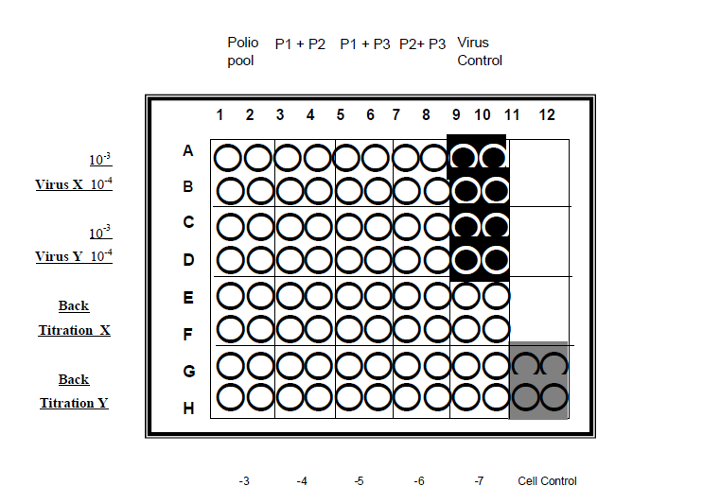****

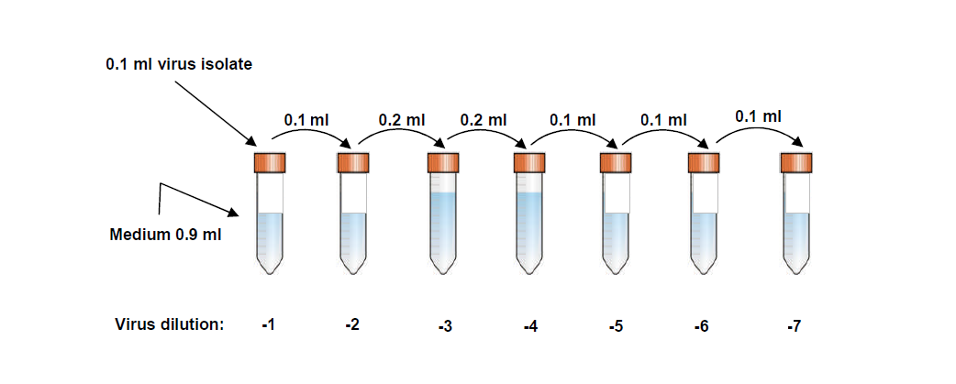**Figure 2: Titration of virus isolates:**



Add 50 µl of virus to the test wells as indicated: 10-3 dilution of isolate 1 to wells A1-A10, 10 -4 dilutions to wells B1-B10.

Repeat step 5.1.12. for the second isolate in rows G and H for the back titration , in wells C1-C10 for the 10 -3 dilution of isolate 2 and wells D1-D10 for the 10 -4 dilution of isolate 2.

Cover the plate with the lid and incubate between 1 and 3 hr at 36±1°C.

During incubation period, trypsinize cells according to step 5.2. and prepare cell suspension of 1.5x 105 cells per ml, calculating at least 10 ml per plate.

Dispense 100 µl of adjusted cell suspension into test and control wells.

Cover the plate with lid and incubate at 36±1°C (If not using incubator, seal plate with non-toxic sealers).

Examine and record daily, using an inverted microscope for the development of CPE. Continue observation and recording until 24 hrs after the virus control wells show 100% CPE (usually takes 3-5 days).

Interpretation of results

Acceptance criteria: The test result should be read from the dilution that corresponds to the correct virus titer for the test. If the virus titer in the test is not within the acceptable range, the test should be repeated with the dilutions adjusted (either higher or lower, as appropriate) to maintain the correct amount of virus.

Cell control wells should have a complete monolayer cells and virus control wells should show complete CPE.

The back titration should confirm that the amount of virus used in the test for one of the dilutions was within the range 32-320 TCID50. (that is virus titer between 101.5 and 102.5 /50 µl corresponding to 104.5 to 106.5 in the original isolate).

The antiserum pools that prevent the development of CPE indicate the identity of virus isolate or mixture of viruses. Failure of a virus to replicate in the presence of a pool of antisera is due to the neutralization of infectivity by one of the antisera present in the pool. Figure 3 shows the typical lay-out of a test plate with interpretation of results.

**Figure 3: The typical lay-out of a test plate with interpretation of results.**



Virus titer of isolate X = 105.5 TCID50/50µl

Test at 10-3, virus dosage= 320 (102.5) TCID50

Test at 10-4, virus dosage= 32 (101.5) TCID50

Isolate neutralized by Polio pools 1+2+3; 1+2; 1+3

Poliovirus type 1

Virus titer of isolate Y = 105 TCID50/50µl

Test at 10-3, virus dosage= 100 (102.0) TCID50

Test at 10-4, virus dosage= 10 (101.0) TCID50

Isolate neutralized by Polio pools 1+2+3; 1+2; 2+3

Poliovirus type 2

**Table 1: Interpretation of virus neutralization patterns in the poliovirus identification test.**

|  |  |  |  |  |
| --- | --- | --- | --- | --- |
| **Pool P1+P2+P3** | **Pool P1+P2** | **Pool P1+P3** | **Pool P2+P3** | **Virus identification** |
| 0 | 0 | 0 | + | Poliovirus type 1 |
| 0 | 0 | + | 0 | Poliovirus type 2 |
| 0 | + | 0 | 0 | Poliovirus type 3 |
| 0 | 0 | + | + | Mixture of poliovirus types 1& 2 |
| 0 | + | 0 | + | Mixture of poliovirus types 1& 3 |
| 0 | + | + | 0 | Mixture of poliovirus types 2& 3 |
| 0 | + | + | + | Mixture of all three poliovirus types |
| + | + | + | + | No poliovirus or mixture of poliovirus with other enterovirus |
| ‘+’ = CPE ‘0’ = no CPE | | | | |

Note: where CPE occurs in test wells containing all combinations of polio antisera (last row of figure) there are two possibilities. The first is that the virus is not polio, but some other virus (example: an enterovirus or adenovirus). The second is that there may be a mixture of polio and another virus.

In Table 1: all possible combinations of CPE and no CPE, which may be observed in wells containing the various poliovirus antiserum pools, are tabulated with the appropriate interpretation.

The confirmation test for virus typing

Collect the virus from the appropriate wells of the plate to be used for typing.

When plate is covered with the plate sealer, do not remove the sealer as this may cause contamination. Wipe the plate sealer with 70% alcohol and puncture the covering of the wells involved with the hot glass pipette or sterile needle. Never try to push a glass pipette through the plastic cover, as the pipette may break and cause serious injuries.

Dilute virus by 1 in 10 using sterile viral diluents.

For each virus to be tested, prepare plate containing: two wells with 50 µl anti P1 serum, two wells with 50 µl anti P2 serum, two wells with 50 µl anti P3 serum, and two wells with 50 µl growth medium, that serve as virus controls.

Add 50 µl of the diluted virus to all 8 wells and incubate for 1 hr at RT.

After incubation, add 100 µl of cells and sealed plate and incubate for 24-48 hr and record CPE.

**HEp-2/HeLa Cell culture preparation:**

Passaging of Cell lines, thawing and freezing of cell lines refer to SOP no. ETR-IM-019.

Trypsinized Cell Lines

Obtain T75 flask(s) containing nearly confluent (range 95-100%) of HeLa/HEp-2 cell lines

For HeLa/HEp-2 cells lines: discard old culture medium and rinse once with equal volume of HBSS using sterile serological pipette. Gently tilt flask back and forth 2-3 times then remove washing medium.

Use sterile serological pipette to gently add 1-2 ml of 0.25% Trypsin-EDTA solution onto the side of the T75 flask without directly disturbing the layer of cells. Close cap tightly and tilt flask back and forth 2-3 times.

Incubate at 37±1°C, 5±1% CO2 and 95±5% humidity for 2-5 min or until see cells detach from the edge of the flask. Quickly transfer the culture flask to the BSC and remove 0.25% Trypsin-EDTA solution by using a sterile serological pipette.

Use sterile serological pipette to quickly add 3-6 ml of cMEM into each flask to stop trypsin reaction. Gently pipette up and down 8-10 times to disperse cells and prevent cell clumping. Use sterile serological pipette to transfer cell suspension to a sterile conical tube. Note: If more than one T75 flask is required, cell suspension from each flask will be combined into a sterile conical tube

Cells preparation for the mixture of serum-virus

Count and adjust 5-10x104 cells/ml for HeLa/HEp-2 cell lines

Pipette 10 µl of cell suspension (from step 5.2.2.2) into a microcentrifuge tube. Add 90 µl of 0.4% Trypan Blue dye to make 1:10 dilution. Gently mix thoroughly by pipetting up and down using single channel pipette to avoid aerosol formation.

Load the hemacytometer with cell mixture (Trypan blue dye + HeLa/HEp-2 cells) until the area under the cover slip is completely filled. Make sure to use a cover slip that is specific for the hemacytometer.

Allow cell suspension to settle in the hemacytometer for 10-15 sec and then immediately count cells in the 4 corner squares (see diagram below). Viable cells will not uptake Trypan Blue and will appear clear. Nonviable cells will uptake Trypan Blue dye and stain blue.

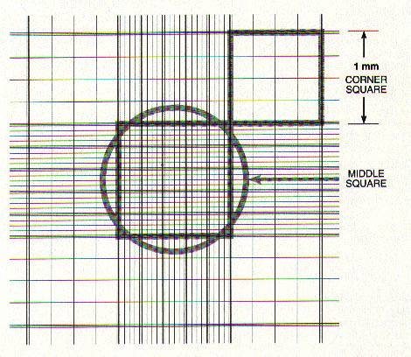

Count both viable and nonviable cells in the 4 corner squares. Include cells that touch either the top line or left vertical perimeter line of any corner square. Do not count any cells that touch either the bottom line or right vertical perimeter line of any corner square.

Calculate % Viability according to formula below.

% Viability = Total viable cells (from 4 corner squares) x 100 Total cells (from 4 corner squares)

Calculate cell concentration (cells/ml)

Cells/ml = Total viable cells (from 4 corner squares) x 104 x 10

4

104 = conversion factor to make 1 ml volume

10 = specimen dilution factor

Calculate cell concentration (cells/ml)

Dilution factor for HeLa/HEp-2 cells = No. of cells/ml obtained 5,000-10,000 cells/ml

Volume of cell suspension (ml) = Total volume needed (ml)

Dilution factor

For HeLa/HEp-2 cells: adjust cell to get a final concentration of 1.5x105 cells/ml with cMEM

**Preparation of Sera and Culture media:**

Sample preparation: the minimum volume of serum needed for an assay is 100 µl. The blood collected is allowed to clot, the serum is separated as soon as possible and aliquot in micro centrifuge and label with Sample ID, date of collection and study days, and store at -70±5°C until assay.

Reagents and cell cultures

WHO international reference sera: these provide a continuing check on the sensibility of assays and permit the antibody levels to be quoted in international units.

Working reference antisera: there should be prepared in laboratory and their potency determined in international units by assay in comparison with the international reference antisera.

Stock virus preparations of proven purity and known titer prepared in laboratory: the suitable samples of each type poliovirus, from which stock viruses for use in the tests can be prepared.

Media Preparation for cell culture

cMEM (supplemented with 2mM L-Glutamine and 10% FBS and 1X Pen/Strep/Glut solution)

To prepare 100 ml of cMEM medium, add 10 ml of FBS, 1 ml of Pen/Strep/Glut solution into a sterile container containing 89 ml of MEM without L-Glutamine.

Gently mix by swirling or repeat pipetting until in solution if prepared in a bottle. Gently vortex if prepared in a conical tube.

Label with cMEM, Lot no., expiration date of 30 days and storage condition.

Store in a 2-8°C refrigerator until expired.

Virus medium

To prepare 100 ml of virus medium, add 10 ml of BSA, add 1.5-2 ml of 56g/L of Sodium bicarbonate (as necessary to adjust pH to 7), add 1 ml of (100X) Pen/Strep/Glut solution, 1 ml of nystatin (0.83 mg/ml in PBS), add 1ml of phenol red (4g/L) into a sterile container containing 86 ml of HBSS.

Gently mix by swirling or repeat pipetting until in solution if prepared in a bottle.

Adjust pH to 7 then label with Virus medium, Lot no., expiration date of 30 days and storage condition.

Dilution medium for serum and virus: Dilution medium for serum and virus consists of Eagle basal medium containing 1.3g/L of sodium bicarbonate and 40 ml/L of FBS and penicillin and streptomycin at 120 µg and 100 µg respectively.

**Intratypic differentiation of polio viruses by ELISA using cross-adsorbed antisera developed by RIVM manufacturing kit.**

Bring all reagents to RT and then mix thoroughly before use. Do not allow the wells of ELISA coating plate to dry between incubations.

Serum samples: The minimum amount of serum required for an assay is 100 µl. the blood is allow to clot and the serum is separated and aliquot into micro-centrifuge tubes for storage at -70±5°C. It is recommended that before storage the serum samples be inactivated at 56°C for 30 min, because this may reduce the problems caused by bacterial contamination of the specimens.

Media preparation for ELISA

Carbonate Coating Buffer pH 9.5: Dissolve 1.27 g of Na2CO3 and 2.34 g of NaHCO3 in 1000 ml sterile deionized water. Mix by magnetic stirrer with magnetic bar and filter through a 0.22 µm filter. Label the solution as Carbonate buffer, preparation date, expiration date of 1 year and store at 2-8°C.

Sodium acetate buffer, pH 5.5: Dissolve 9g of Sodium acetate in 900 ml of sterile deionized water. Mix by magnetic stirrer with magnetic bar and adjust pH to 5.5 with sulfuric acid. Adjust volume to 1L. Label container with name, preparation date, expiration date of 6 months and store at RT.

PBS-T Washing buffer: Dissolve one pack of PBS (dry powder blends) in sterile deionized water and adjust final volume to 1000 ml. Mix by stirring with magnetic bar, then add 0.5 ml of Tween 20 and wash solution out of pipette with repeated pipetting. Label reagent with PBS-T for ELISA, expiration date of 30 days and storage condition. Store at 2-8°C until expired.

Dilution buffer: Add 5 % of FBS of the total volume of PBS-T to be prepared. This media is prepared fresh for daily use only.

Stop Solution: 1M Sulfuric acid

Conjugate: Goat anti rabbit IgG, Horseradish peroxidase-labeled

Substrate solution:

Calculate the required amount of TMB substrate according to formula below. (1plate require 10 ml which included excess volume). Total volume of TMB substrate = 10 ml x no. ELISA plates used.

Bring out TMB solution and urea peroxidase from a 2-8 ºC refrigerator and keep at RT for 30-40 min before use. Prepare TMB substrate by mixing equal parts of TMB solution and urea peroxides. Add of TMB solution in a sterile container then urea peroxides. Mix well and wrap the container with aluminum foil to prevent from light.

Label with TMB substrate, lot no. (Initial preparation technician and date of prepared) and preparation time. The TMB substrate is stable for 8 hrs at RT when keep in the dark.

ELISA Procedure:

Unwrap a sufficient number of plates or strips to accommodate all samples and control to be tested. For each strain at least 4 wells are needed: one blank, one for each reaction with the type-specific antiserum, the NSL and SL-specific cross-adsorbed antisera.

Number the strips and record corresponding numbers to the appropriate form. Plate layout for ELISA is shown in figure 4.

**Figure 4: ELISA plate layout**

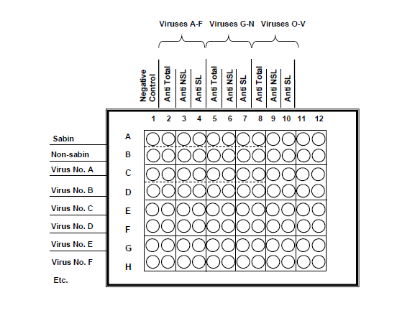

Plate coating:

Bring out stock vial of bovine anti-poliovirus serum and warm at RT until completely thawed.

Add 100 µl of the bovine anti-poliovirus serum diluted 1:500 (or according to manual’s instruction) in pH 0.5; 0.04M Carbonate buffer to each well. Label each plate with coating date and serial number of plate.

Seal plates/strips with plate sealer or cover with lid. Label plates cover with Protocol reference no., coated date, expiration date of 30 days and incubate for 16-24 at 2-8°C before use. The coated plates can be kept 2-8°C up to 30 days.

Warm the plates at RT for 30-35 min before use.

Wash each plate 4X with 250 l of PBS-T using ELISA plate washer then blot dry on paper towel. If the plate washer (multiple or single) is malfunctioning, plates will be washed manually by adding 250 l of PBST with multi-stepper, dumped and blotted dry by tapping upside down on paper towel.

Using a multistepper pipette, add 100 l of PBS+ 5% calf serum to each well, plate will be stacked; cover the first plate with an empty plate and incubate for 60-75 min at RT.

After blocking plates for 60-75 min, wash plates again as in step 5.4.1.3.5.

Then add 100 l of undiluted virus strain of each of 3 wells (A2 to A4), (B2 to B4) and so on. Repeat for each test virus.

Include positive and negative on each plate.

Add 100 l of dilution buffer to the wells of the first strips or column to serve as controls (A1-H1). Document the sample number on plate layout for individual plate loading. If a different layout is use, plate layout will be attached to the appropriate form. Seal each plate with an adhesive plate sealer.

Incubate the plate(s) at RT for 120-135 min.

After incubation, wash plates again as in step 5.4.1.3.5.

Then dilute the cross-adsorbed type-specific rabbit antisera, the NSL-specific antiserum and the SL-specific antiserum to the appropriate wells. (Type-specific, wells A2-H2: NSL, wells A3 –H3: SL, wells A4-H4). Add 100 l of diluents to the control wells (A1-H1). Incubate for 60-75 min at RT.

After incubation, wash plates again as in step 5.4.1.3.5.then add 100 l of conjugate, diluted at 1:1000 in diluents (or according to manual’s instruction) to all wells on the plates. Incubate for 60-75 at RT.

After incubation, wash plates again as in step 5.4.1.3.5. Prepare the substrate dilution during the washing step then add 100 l of the substrate solution to each well. Incubate for 10±1 min at RT in the dark by covering the plates with aluminum foil. Label with TMB substrate, lot no. (Initial preparation technician and date of prepared) and preparation time. The TMB substrate is stable for 8 hrs at RT when keep in the dark.

Stop the absorbance reaction by adding 100 l of 2N Sulfuric acid in the same sequence and at the same time interval as the substrate solution was added. The color of the wells with the positive reaction will change from blue to yellow.

10-20 minute before use, turn on the Microplate Spectrophotmeter, SpectraMAX 190 to warm up. Dry the bottom of the plate before reading plate at 450nm using a spectrophotometer within 30±1 min at RT after adding stop solution. The control wells, incubated with diluents only serve as blanks. Read the wells with NSL and SL controls and perform the validity checks as described in next section.

Save data onto the hard drive and print-out a true and exact copy of the data. Verify the print-out versus the saved data, a minimum of 10%. This verification will be indicated on the print-out then initial and date on the print out. A true and exact copy of the data will also be saved onto USB drive and/or external hard drive. All document/data are reviewed by the supervisor and will be kept in the study file.

Quality control and interpretation of results.

Given a test with SL, NSL and one unknown virus, and observed OD values A to I, the following validity checks and interpretation are made.

|  |  |  |  |
| --- | --- | --- | --- |
|  | anti-total | anti-NSL | anti-SL |
| Sabin | A | B | C |
| Non-Sabin | D | E | F |
| *Virus* | G | H | I |

Test is valid if: OD values A,D and G are ≥1.0

OD values C and E are ≥0.7

OD values B and F are ≤0.3

Ratio C/B ≥2.5 and

Ratio E/F ≥2.5

|  |  |
| --- | --- |
| **Interpretation of results:** |  |
| Ratio H/I ≥2.5 | Non-Sabin-like virus |
| Ratio I/H ≥2.5 | Sabin-like virus |
| If both ratio are < 2.5 and H and I are ≥0.4 | Double reactive virus |
| If both ratio are < 2.5 and H and I are <0.4 | Non-reactive virus |
| If G <1.0 but ≥0.4 | Invalid test: regrow isolate to higher concentration |
| If G < 0.4 | Invalid test: check serotype of isolate |

**References-**

|  |  |
| --- | --- |
| Regulation No, SOP, Guideline, or applicable document | Document Title |
| WHO/IVB/04.10 | Polio laboratory manual, Fourth edition, final version, 31 August 2004 |
| ETR-IM-019 | Freezing & Thawing of Cell Lines, PBMC and Passaging of Cell Lines |

**Forms and Appendices-**

|  |  |
| --- | --- |
| Form or Appendix Number | Title |
| ETR-IM-050-A1 | Titration of laboratory quality control standard |
| ETR-IM-050-A2 | Reed and Muench method |
| ETR-IM-050-F1 | Medium Preparation for Poliovirus neutralizing Assay |
| ETR-IM-050-F2 | HEp-2/HeLa Cell culture preparation |
| ETR-IM-050-F3 | Reagent preparation for Poliovirus ELISA |
| ETR-IM-050-F4 | Identification of poliovirus isolates |
| ETR-IM-050-F5 | Poliovirus ELISA Worksheet |

**SOP Revision History-**

|  |  |  |
| --- | --- | --- |
| **Version Number** | **Brief Description of Changes** | **Effective Date** |
| ETR-IM-050-00 | New SOP |  |

**Titration of laboratory quality control standard**

Before being accepted for routine use, the titer for the quality-control standard must be shown to be reproducible on at least three separate occasions when tested in parallel with the same NIBSC reference standard that is used to validate the titer on all three occasions. The expected titers for the NIBSC reference standard are:

− Sabin type 1: 5.1 log 10 TCID50/0.1ml in RD cells and 4.9 log 10 TCID50/0.1 ml in L20B cells;

− Sabin type 2: 5.1 log 10 TCID50/0.1ml in RD cells and 4.8 log 10 TCID50/0.1ml in L20B cells;

− Sabin type 3: 5.3 log 10 TCID50/0.1ml in RD cells and 4.9 log 10 TCID50/0.1ml in L20B cells.

The titer of the quality-control standard is likely to be higher than the NIBSC reference standard; both titers should not vary by more than +/- 0.5 log 10 when tested on the three occasions. Once these criteria are met, the expected titer to be assigned to the laboratory quality-control standard will be the average of the titers obtained on those three occasions.

**Plate layout for titration of laboratory quality control standard**



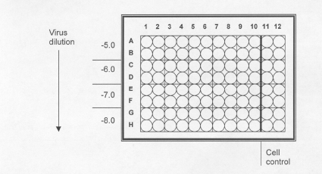

**Example of results of titration of Sabin poliovirus reference standard**



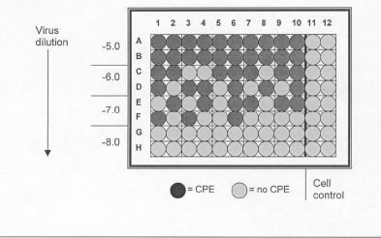

**Calculation of the virus titre by the Kärber formula**

log TCID50 = L – d (S – 0.5), where:

L = log of lowest dilution used in the test

d = difference between log dilution steps

S = sum of proportion of “positive” tests (i.e. cultures showing CPE)

In this example:

L = -5.0; d = 1.0; S = 1 + 0.65 + 0.45 + 0 = 2.10

log TCID50 = - 6.60; Virus titre = 106.60 TTCID50 / 0.1 ml

**Reed and Muench method**

**Calculation of 50% endpoints**

In any biological quantitation, the most desirable endpoint is one representing a situation in which half of the inoculated animals or cells show the reaction (death in the case of animals and in CPE case of cells) and the other half do not. In other words, the endpoint is taken as the highest dilution of the biological material, which produces desired reaction in 50% of the animals or cells. The 50% endpoint can be based on several types of reactions. The most widely used endpoint, based on mortality, is the LD50 (50% lethal dose). This terminology can also be applied to other host systems-for example, tissue cultures- in which the TCID50 represents the dose that gives rise to cytopathic effect in 50% of inoculated cultures. When computing, if closely-placed dilutions are used and in each dilution large number of animals or cells are used, it may be possible to interpolate a correct 50% end point dilution, but it is neither practical nor economical. Reed and Muench devised a simple method for estimation of 50% endpoints based on the large total number of animals, which gives the effect of using at the 2 critical dilutions between which the endpoint lies, larger groups of animals than were actually included in these dilutions.

**Calculation of the LD 50 titre by the Reed-Muench method**

Let us presume that we have titrated a virus suspension by inoculating mice and death is the reaction. The number of deaths and survivals in each dilution is tabulated as given in table I below:

**TABLE I : Arrangement of data used in computation of LD50 titre by the method of Reed-Muench.**

|  |  |  |  |  |  |  |
| --- | --- | --- | --- | --- | --- | --- |
|  | **Accumulated Values** | | | | | |
| **Virus Dilution** | **Died** | **Survived** | **Died** | **Survived** | **Mortality Ratio** | **Percent** |
| 10-3 | 6 | 0 | 17 | 0 | 17/17 | 100 |
| 10 -4 | 6 | 0 | 11 | 0 | 11/11 | 100 |
| 10 -5 | 4 | 2 | 5 | 2 | 5/7 | 71 |
| 10-6 | 1 | 5 | 1 | 7 | 1/8 | 13 |
| 10-7 | 0 | 6 | 0 | 13 | 0/13 | 0 |

Accumulated values for the total number of animals that dies or survival are obtained by adding in the direction of lowest to the highest values. The accumulated mortality ratios and the percentage mortality for each dilution is calculated.

In the example depicted in the table it can be seen that mortality in the 10-5, is higher than 50% and in the next higher dilution, 10-6 it is only 13%. So, we need to find the 50% endpoint dilution, which obviously lies between these dilutions. First, we have to calculate the proportionate distance (PD) of the 50% endpoint from these dilutions by using a simple formula.

DISTANCE = (% mortality at dilution next above 50%) - 50%

----------------------------------------------------------------

(% mortality at next __ (% mortality at next

dilution above 50%) dilution below 50%)

Example : (71 - 50) 21

------------ = ----- = 0.36 or 0.4

(71 - 13) 58

The proportionate distance obtained thus has to be corrected by the dilution factor, which is the logarithm of the dilution step employed, which in this case is 1 (log of 10). Then the 50% endpoint dilution can be calculated thus:

Negative log of LD50 titre = (negative logarithm of the next dilution above 50% mortality + PD) x dilution factor. (in this example, (-5 + 0.4) x 1 = -5.4 or log LD50  titer = 10-5.4  per 0.03 ml which is the amount of material inoculated I/C. The same methodology can also be applied to compute TCID50 when cell culture system is used for virus titration. Each dilution is inoculated into a minimum of 4 to 6 Wells in a 96 well tissue culture plate and observed for CPE, which in this case replaces mortality.

**Medium Preparation for Poliovirus neutralizing Assay**

**Protocol Number: ___________**

**Equipment Record**

2-8oC Refrigerator MMCN/ECN: ___________

-20±5oC Freezer MMCN/ECN: ____________

Electronic Pipette Aid MMCN/ECN: _________

Single channel Pipette MMCN/ECN: _________

Biological Safety Cabinet MMCN/ECN: _________

Initials/Date______________

**Materials/Reagents**

|  |  |  |  |
| --- | --- | --- | --- |
| **Materials/Reagents** | **Manufacturer/Preparer** | **Lot no.** | **Expiration date** |
| FBS |  |  |  |
| Pen/Strep/Glut solution(100x) |  |  |  |
| MEM without L-Glutamine |  |  |  |
| BSA |  |  |  |
| Sodium bicarbonate |  |  |  |
| HBSS |  |  |  |
| nystatin (0.83 mg/ml in PBS) |  |  |  |
| Phenol Red (4g/L) |  |  |  |
| Eagle basal medium |  |  |  |

Initials/Date_________________

**Preparation of MEM Culture Medium:** The medium will be prepared in a Biological Safety Cabinet in sterile conditions.

Composition: **FBS 10 ml**

Pen/Strep/Glut solution(100x) 1 ml

MEM without L-Glutamine 89 ml

Total volume 100 ml

Add _______ ml of FBS into a sterile container containing _______ ml of Pen/Strep/Glut solution (100x) and ________ ml of MEM without L-Glutamine.

Gently mix by swirling or repeat pipetting until in solution if prepared in a bottle. Gently vortex if prepared in a conical tube.

Label as:

MEM Culture Medium

Lot no.: ___________________

Expiration date: ____________

Storage: ____________

Store at 2-8°C (the Culture medium can be stored at 2-8°C up to 30 days).

Initials/Date_________________

**Preparation of Virus medium:** The medium will be prepared in a Biological Safety Cabinet in sterile conditions.

Composition: BSA 10 ml

Sodium bicarbonate(56g/L) 1.5-2 ml

Pen/Strep/Glut solution 1 ml

Nystatin (0.83 mg/ml in PBS) 1 ml

Phenol Red (4g/L) 1 ml

HBSS 86 ml

Total volume 100 ml

Add _______ ml of BSA, ______ of Sodium bicarbonate, ______of Pen/Strep/Glut solution, _____of Nystatin and _____ of Phenol Red into a sterile container containing _______ ml of HBSS.

Gently mix by swirling or repeat pipetting until in solution if prepared in a bottle. Gently vortex if prepared in a conical tube.

Measure pH of the solution, and adjust pH to 7. The pH is ________ (Acceptable pH is ___ ± ___) if the pH is out of range, adjust pH by adding acid (__N HCI) ___ drops, adding base (__N NaOH) ______ drops. Final pH is _____________.

Label as:

MEM Culture Medium

Lot no.: ___________________

Expiration date: ____________

Storage: ____________

Store at 2-8°C (the Culture medium can be stored at 2-8°C up to 30 days).

Initials/Date_________________

**Dilution fluid for serum and virus**

Add _______ ml of FBS, ______ of Sodium bicarbonate, ______of Pen/Strep/Glut solution into a sterile container containing _______ ml of Eagle basal medium.

Label as:

MEM Culture Medium

Lot no.: ___________________

Expiration date: ____________

Storage: ____________

Store at 2-8°C (the Culture medium can be stored at 2-8°C up to 30 days).

Initials/Date________________

**HEp-2/HeLa Cell culture preparation**

**Protocol No. ____________**

**Equipment Record**

Biological safety cabinet MMCN/ECN: __________

2-8oC Refrigerator MMCN/ECN: _______________

-20±5oC Freezer MMCN/ECN: ________________

37±1oC, 5±1%CO2, 95±5%Humidity Water-Jacketed Incubator MMCN/ECN: _________

Centrifuge MMCN/ECN: __________, ___________

Inverted microscope MMCN/ECN: _____________

Single channel pipette MMCN/ECN/SN: _________, _________, _________

Initials/Date _____________

**Materials and Reagents**

|  |  |  |  |
| --- | --- | --- | --- |
| **Materials/Reagents** | **Manufacturer/ Preparer** | **Lot no.** | **Expiration date** |
| 0.25% Trypsin EDTA | Sigma |  |  |
| cMEM | Enteric |  |  |
| HBSS | Sigma |  |  |
| 0.4% Trypan blue dye | Sigma |  |  |

Initials/Date _____________

**HEp-2/HeLa Cell culture**

**3.1. Trypsinized Cell Lines**

Obtain T75 flask(s) containing nearly confluent (range 95-100%) of HEp-2/HeLa cells.

Cell passage no. ________.

Discard old culture medium and rinse once with equal volume of HBSS. Gently tilt flask back and forth 2-3 times then remove washing medium.

Gently add ____ ml of 0.25% Trypsin-EDTA solution onto the side of the T75 flask. Close cap tightly and tilt flask back and forth 2-3 times.

Incubate at 37±1oC, 5±1% CO2 and 95±5% humidity for 2-5 min or until see cells detach from the edge of the flask. Remove 0.25% Trypsin-EDTA solution.

Quickly add _____ ml of cMEM without antibiotic into each flask.

Gently pipette up and down 8-10 times then transfer cell suspension to a sterile conical tube.

Note: If more than one T75 flask is required, cell suspension from each flask will be combined into a sterile conical tube.

Initials/Date _____________

**3.2. Count and adjust HEp-2/HeLa cells to a final concentration of 5-10x104** **cells/ml**

Pipette 10 µl of cell suspension into a microcentrifuge tube. Add 90 µl of 0.4% Trypan Blue dye. Gently mix thoroughly by pipetting up and down using single channel pipette.

Load the hemacytometer with cell mixture (Trypan blue dye + HEp-2/HeLa cells) until the area under the cover slip is completely filled.

Allow cell suspension to settle in the hemacytometer for 10-15 sec then immediately count cells in the 4 corner squares (see diagram).

Viable cells will not uptake Trypan Blue and will appear clear

Nonviable cells will uptake Trypan Blue dye and stain blue



Count both viable and non-viable cells in the 4 corner squares. Include cells that touch either the top line or left vertical perimeter line of any corner square. Do not count any cells that touch either the bottom line or right vertical perimeter line of any corner square.

Calculate % Viability

% Viability = Total viable cells (from 4 corner squares) x 100

Total cells (from 4 corner squares)

Calculate cell concentration (cells/ml)

Cells/ml = Total viable cells (from 4 corner squares) x 104 x 10

4

Calculate to adjust cell suspension to obtain a final concentration of 5,000-10,000 cells/ml

Dilution factor = No. of cells/ml obtained  5,000-10,000 cells/ml

Volume of cell suspension (ml) = Total volume needed (ml)

Dilution factor

|  |  |  |  |  |  |  |  |
| --- | --- | --- | --- | --- | --- | --- | --- |
| **HEp-2/HeLa cells/4 corners squares** | | | | **Dilution factor** | **Cell concentration (cells/ml)** | **Adjust to 5,000-10,000 cells/ml** | |
| Viable cells | Non-viable cells | Total cells | % Viability | Total volume needed  (ml) | Vol. of cell suspension used (ml) |
|  |  |  |  |  |  |  |  |

Adjust cell suspension to get a final concentration of 5,000-10,000 cells/ml by adding ______ ml of cell suspension into ______ ml of MEM Complete Medium.

Gently pipette cell suspension up and down 8-10 times.

Initials/Date _____________

**Reagent preparation for Poliovirus ELISA**

**Buffer / Reagent _____________________________ Lot # __________________________________**

|  |  |  |  |
| --- | --- | --- | --- |
| Materials | Manufacturer | Lot # | Expiry Date |
|  |  |  |  |
|  |  |  |  |
|  |  |  |  |
|  |  |  |  |
|  |  |  |  |
|  |  |  |  |
|  |  |  |  |
|  |  |  |  |
|  |  |  |  |

(Check in □)

□ Carbonate Coating Buffer pH 9.5±0.2:

Dissolve______g of Na2CO3, ______g of NaHCO3 in _____ml of sterile deionized water. Using magnetic stirrer until completely dissolved, filter through a 0.22µm membrane filter. Aliquot into bottles and label as:

Carbonate Coating Buffer pH 9.5

Preparation date: _____________

Expiration date: ______________

Storage condition: ____________

2-8°C Refrigerator MMCN: __________

Balance MMCN: __________________

□ Sodium acetate buffer, pH 5.5:

Dissolve______g of Sodium acetate in______ml of sterile deionized water. Mix by magnetic stirrer with magnetic bar until completely dissolve and adjust pH to 5.5. Adjust final volume to______ml with sterile deionized water. Measure pH of the solution, the pH is______ (Acceptable pH is ___ ± ___) if the pH is out of range, adjust pH by adding acid (__N HCI) ___drops, adding base (__N NaOH) _____drops. Final pH is ______. Aliquot into bottles and label as:

Sodium acetate buffer, pH 5.5

Preparation date: _____________

Expiration date: ______________

Storage condition: ____________

2-8°C Refrigerator MMCN: __________

pH meter MMCN: _________________

Balance MMCN: __________________

□ Phosphate Buffered Saline-Tween 20 (PBS-T):

Dissolve content in 1L of DW/DI/Sterile Water for injection (Circle one). Mix thoroughly to completely dissolve. Then add 0.5ml of Tween20 and wash solution out of pipette with repeated pipetting. Label as:

PBS-T

Preparation date: _____________

Expiration date: ______________

Storage condition: ____________

2-8°C Refrigerator MMCN: __________

□ Dilution buffer:

Add_______ml of FBS into ________ PBS-T. This media is prepared fresh for daily use only. Mix thoroughly until completely dissolve. Label as:

Dilution buffer

Preparation date: _____________

Expiration date: ______________

Storage condition: ____________

Initial/Date: _______________________________________

Identification of poliovirus isolates

Protocol Number:  **______________** Cell line: **__________**

Equipment Record

**2-8 ºC Refrigerator MMCN/ECN: ____________**

**-70 ± 5 ºC Freezer MMCN/ECN: ____________**

**Single-channel pipette MMCN/ECN/SN: ________, ________, ________**

**Biological Safety Cabinets MMCN/ECN: ____________**

**Inverted microscope MMCN/ECN: ____________**

**Incubator MMCN/ECN: ____________**

**Initials/Date: _____________**

Materials/Reagents

|  |  |  |  |
| --- | --- | --- | --- |
| Materials/Reagents | Manufacturer/Preparer | Lot no. | Expiration date |
| **Stock of virus isolate tested**  **_______________________**  **_______________________**  **_______________________**  **_______________________**  **_______________________** |  |  |  |
| **Mixture of antisera poliovirus**  **- Type 1 and 2**  **- Type 1 and 3**  **- Type 2 and 3**  **- Type 1, 2 and 3** |  |  |  |
| **Virus diluent** |  |  |  |
| **Liquid paraffin** |  |  |  |
| **Virus and serum medium:**  **____________________**  **­­­­­­** |  |  |  |

**Initials/Date: _____________**

**Identification of poliovirus isolates:**

**Determination titer of virus isolate**

Dilute stock virus isolate in tenfold steps ranging from 1:10 to 1:1,000,000 as follow.

Pipette 900 µl of virus diluent into six microcentrifuge tubes.

Make a 1:10 dilution by adding 100 µl of stock virus isolate into a microcentrifuge tube containing 900 µl of virus diluent, gently vortex and label as 10-1

Make a 1:100 dilution by adding 100 µl of diluted virus isolate of tube 10-1 to a tube containing 900 µl of virus diluent, gently vortex and label as 10-2.

Make a 1:100 dilution by adding 100 µl of diluted virus isolate of tube 10-2 to a tube containing 900 µl of virus diluent, gently vortex and label as 10-3.

Make a 1:100 dilution by adding 100 µl of diluted virus isolate of tube 10-3 to a tube containing 900 µl of virus diluent, gently vortex and label as 10-4.

Make a 1:100 dilution by adding 100 µl of diluted virus isolate of tube 10-4 to a tube containing 900µl of virus diluent, gently vortex and label as 10-5.

Make a 1:100 dilution by adding 100 µl of diluted virus isolate of tube 10-5 to a tube containing 900 µl of virus diluent, gently vortex and label as 10-6.

Pipette 25 µl of virus diluent to four wells of each row A to F in 96 well microtiter plate.

Pipette 100 µl suspensions of HEp-2/HeLa cells onto wells containing virus diluent.

Note: Cells are prepared at a concentration of 5000-10000 cells per ml in virus diluting medium and documented onto ETR-IM-050-F2

Pipette 25 µl of each virus dilution onto each row of four wells containing virus diluents and suspensions of HEp-2/HeLa cells.

Overlay each well with 75 µl of liquid paraffin and seal the microtiter plate with pressure sensitive adhesive film.

Incubate plate at 35oC for 7 days and examine on the 3rd or 4th day and again on the 7th day with an inverted microscope.

Record results in the following plate format. The necessary number of pages will be printed to accommodate the number of plates used on the assay day

+ve = CPE formation -ve = No CPE formation

**Results determination:** Wells with degeneration indicative of virus growth are recorded as positive and the virus titer is determined by the method of Reed and Muench. The dilution of the isolate that contains 100 TCID50 per 0.025 ml is calculated. This dilution will be used in the viral typing procedure.

**Initials/Date: _____________**

Plate #:______ Virus isolate: _______________

Virus dilution

|  |  |  |  |  |  |  |  |  |  |  |  |  |  |
| --- | --- | --- | --- | --- | --- | --- | --- | --- | --- | --- | --- | --- | --- |
|  |  | 1 | 2 | 3 | 4 | 5 | 6 | 7 | 8 | 9 | 10 | 11 | 12 |
| 10-1 | A |  |  |  |  |  |  |  |  |  |  |  |  |
| ­­­­10-2 | B |  |  |  |  |  |  |  |  |  |  |  |  |
| ­­­­10-3 | C |  |  |  |  |  |  |  |  |  |  |  |  |
| ­­­­10-4 | D |  |  |  |  |  |  |  |  |  |  |  |  |
| ­­­­10-5 | E |  |  |  |  |  |  |  |  |  |  |  |  |
| ­­­­10-6 | F |  |  |  |  |  |  |  |  |  |  |  |  |
| ­­­­ | G |  |  |  |  |  |  |  |  |  |  |  |  |
| ­­­­ | H |  |  |  |  |  |  |  |  |  |  |  |  |

Results**: Virus isolate dilution _________ contains 100 TCID50 per 0.025 ml**

Plate #:______ Virus isolate: _______________

Virus dilution

|  |  |  |  |  |  |  |  |  |  |  |  |  |  |
| --- | --- | --- | --- | --- | --- | --- | --- | --- | --- | --- | --- | --- | --- |
|  |  | 1 | 2 | 3 | 4 | 5 | 6 | 7 | 8 | 9 | 10 | 11 | 12 |
| 10-1 | A |  |  |  |  |  |  |  |  |  |  |  |  |
| ­­­­10-2 | B |  |  |  |  |  |  |  |  |  |  |  |  |
| ­­­­10-3 | C |  |  |  |  |  |  |  |  |  |  |  |  |
| ­­­­10-4 | D |  |  |  |  |  |  |  |  |  |  |  |  |
| ­­­­10-5 | E |  |  |  |  |  |  |  |  |  |  |  |  |
| ­­­­10-6 | F |  |  |  |  |  |  |  |  |  |  |  |  |
| ­­­­ | G |  |  |  |  |  |  |  |  |  |  |  |  |
| ­­­­ | H |  |  |  |  |  |  |  |  |  |  |  |  |

Results**: Virus isolate dilution _________ contains 100 TCID50 per 0.025 ml**

**Comments: ____________________________________________________________**

**______________________________________________________________________**

**______________________________________________________________________**

**______________________________________________________________________**

**Initials/Date: _____________**

**Determination the type of poliovirus isolated by neutralization assay**

Label the edge of the microtiter plate according to plate format below.

**1**

**2**

**3**

**4**

**5**

**6**

**7**

**8**

**9**

**10**

**11**

**12**

Polio

pool

P1+P2

P1+P3

P2+P3

Virus

control

Virus No. X

Virus No. Y

Back titration No. X

Back titration No. Y

10-3

10-4

10-3

10-4

-3

-4

-5

-6

-7

Cell control

**A**

**B**

**C**

**D**

**E**

**F**

**G**

**HA**



Pipette 50 µl of each of the four antiserum pools in column 1 to 8, rows A to D.

Pipette 50 µl virus and serum medium to virus control wells, A9 to D10 and back titration wells, E1 to H10.

Pipette 100 µl medium to cell control wells, G11 to H12 and cover plate.

Prepare virus dilution

Label dilution tubes 10 -1 to 10 -7 and marking each tube with the specimen number.

Pipette 900 µl medium to tubes 1-2 and 5-7, and 1.8 ml to tubes 3 and 4.

Make a 10-1 dilution by transferring 100 µl of stock virus into tube 1 containing 900 µl medium. Take another pipette tip and mix by pipetting up and down gently to avoid aerosols.

Make a 10-2 dilution by transferring 100 µl diluted virus of tube 10-1 into tube 2 containing 900 µl medium. Take another pipette tip and mix by pipetting up and down gently.

Make a 10-3 dilution by transferring 200 µl diluted virus of tube 10-2 into tube 3 containing 1.8 ml medium. Take another pipette tip and mix by pipetting up and down gently.

Make a 10-4 dilution by transferring 200 µl diluted virus of tube 10-3 into tube 4 containing 1.8 ml medium. Take another pipette tip and mix by pipetting up and down gently.

Make a 10-5 dilution by transferring 100 µl diluted virus of tube 10-4 into tube 5 containing 900 µl medium. Take another pipette tip and mix by pipetting up and down gently.

Make a 10-6 dilution by transferring 100 µl diluted virus of tube 10-5 into tube 6 containing 900 µl medium. Take another pipette tip and mix by pipetting up and down gently.

Make a 10-7 dilution by transferring 100 µl diluted virus of tube 10-6 into tube 7 containing 900 µl medium. Take another pipette tip and mix by pipetting up and down gently.

Add each of diluted virus isolate to back titration wells and test wells as follow.

Note: The same pipette tips may be used to make serial dilutions for one isolates type, working from highest to lowest dilutions, 10-7 to 10-3.

**Virus isolate no._________**

Add diluted virus isolate to back titration wells in row E and F as follow.

Pipette 50 µl of 10-7 dilution in column 9 and 10, rows E and F.

Pipette 50 µl of 10-6 dilution in column 7 and 8, rows E and F.

Pipette 50 µl of 10-5 dilution in column 5 and 6, rows E and F.

Pipette 50 µl of 10-4 dilution in column 3 and 4, rows E and F.

Pipette 50 µl of 10-3 dilution in column 1 and 2, rows E and F.

Add the same isolate of 50 µl diluted virus to the test wells as indicated: 10-3 dilution to wells A1-A10, 10-4 dilution to wells B1-B10.

**Virus isolate no._________**

Add diluted virus isolate to back titration wells in row G and H as follow.

Pipette 50 µl of 10-7 dilution in column 9 and 10, rows G and H.

Pipette 50 µl of 10-6 dilution in column 7 and 8, rows G and H.

Pipette 50 µl of 10-5 dilution in column 5 and 6, rows G and H.

Pipette 50 µl of 10-4 dilution in column 3 and 4, rows G and H.

Pipette 50 µl of 10-3 dilution in column 1 and 2, rows G and H

Add the same isolate of 50 µl diluted virus to the test wells as indicated: 10-3 dilution to wells C1-C10,10-4 dilution to wells D1-D10.

Cover the plate with the lid and incubate between1 and 3 hr at 36±1°C.

During incubation period, trypsinize cells and prepare cell suspension of 1.5x 105 cells per ml, calculating at least 10 ml per plate. The preparation will be documented onto ETR-IM-050-F2

Dispense 100 µl of adjusted cell suspension into test and control wells.

Cover the plate with lid. If not using a CO2 incubator, seal plate with non-toxic sealers.

Incubate the plates at 36±1°C.

Examine and record daily, using an inverted microscope for the development of CPE. Continue observation and recording until 24hrs after the virus control wells show 100% CPE (usually takes 3-5 days).

**Interpretation of results:**

Cell control wells should have a complete monolayer cells.

Virus control wells should show complete CPE. The back titration should confirm that the amount of virus used in the test for one of the dilutions was within the range 32-320 TCID50. (that is virus titer between 101.5 and 102.5 /50 µl corresponding to 104.5 to 106.5 in the original isolate).

The test result should be read from the dilution that corresponds to the correct virus titer for the test. If the virus titer in the test is not within the acceptable range, the test should be repeated with the dilutions adjusted (either higher or lower, as appropriate) to maintain the correct amount of virus.

The antiserum pools that prevent the development of CPE indicate the identity of virus isolate or mixture of viruses. Failure of a virus to replicate in the presence of a pool of antisera is due to the neutralization of infectivity by one of the antisera present in the pool.

Record result in the format below. The necessary number of pages will be printed to accommodate the number of plates used on the assay day.

**Initials/Date: _____________**



**‘+’ = CPE ‘0’ = no CPE**

**Results:**

Virus titer of isolate____ = _________TCID50/50µl

Test at 10-3, virus dosage= ___________ TCID50

Test at 10-4, virus dosage= ___________ TCID50

Isolate neutralized by Polio pools ___________________

Poliovirus type­­­________

Virus titer of isolate____ = _________TCID50/50µl

Test at 10-3, virus dosage= ___________ TCID50

Test at 10-4, virus dosage= ___________ TCID50

Isolate neutralized by Polio pools ___________________

Poliovirus type­­­________

Cell controls = Normal growth (Yes/No)

**Initials/Date: _____________**

**Confirmation test for virus typing**

Collect the virus from the appropriate wells of the plate to be used for typing in section 3.2.

Wipe the plate sealer with 70% alcohol and puncture the covering of the wells involved with the hot glass pipette or sterile needle.

Dilute virus 1:10 using sterile viral diluents.

For each virus to be tested: prepare plate containing: two wells with 50µl anti P1 serum, two wells with 50µl anti P2 serum, two wells with 50µl anti P3 serum, and two wells with 50µl growth medium, that serve as virus controls.

Add 50 µl of the diluted virus to all 8 wells and incubate for 1 hr at 37°C.

Add 100 µl of cells and sealed plate and incubate for 24-48 hr and record CPE in the table below.

|  |  |  |  |  |
| --- | --- | --- | --- | --- |
| Virus isolate tested | CPE formation of test virus against polio antisera  [‘+’ = CPE ‘0’ = no CPE] | | | |
| Anti P1 serum | Anti P2 serum | Anti P3 serum | Virus control |
|  |  |  |  |  |
|  |  |  |  |  |
|  |  |  |  |  |
|  |  |  |  |  |
|  |  |  |  |  |
|  |  |  |  |  |
|  |  |  |  |  |
|  |  |  |  |  |
|  |  |  |  |  |
|  |  |  |  |  |

**Protocol Number:** ______________

**Equipment Record**

-20±5oC Freezer MMCN/ECN: __________________

Refrigerator MMCN/ECN: __________________

Multi micropipette SN:___________________

Multistepper micropipette:________________

ELISA multiple-plate washer MMCN/ECN: ____________

Microplate Spectrophotometer MMCN/ECN: _____________

RT Thermometer serial number: ___________

Initials/Date ________________

**Materials/Reagents**

|  |  |  |  |  |
| --- | --- | --- | --- | --- |
| **Materials/Reagents** | | **Manufacturer/ Preparer** | **Lot no.** | **Expiration date** |
| Antigen coated plates |  |  |  |  |
|  |  |  |  |
|  |  |  |  |
|  |  |  |  |
| Carbonate Coating Buffer | |  |  |  |
| Sodium acetate Buffer | |  |  |  |
| PBS-T | |  |  |  |
| Dilution buffer: 5% FBS in PBS-T | |  |  |  |
| Conjugate: Goat anti rabbit IgG | |  |  |  |
| Sterile deionized water | |  |  |  |
| Substrate solution: | |  |  |  |
| TMB stop solution: _____________ | |  |  |  |

Initials/Date ________________

**ELISA Coated Plate and Serum Preparation**

Unwrap a sufficient number of plates or strips to accommodate all samples and control to be tested. Number the strips and record corresponding numbers to the appropriate form.

Bring 5% Bovine Serum Albumin in PBS-T to RT for 30-40 min and mix thoroughly.

In case of frozen samples, sample will be thaw at RT and gently mixed by vortex and kept on ice until use (not more than 60min)

Fill in the test sample (which have been heat inactivated at 56°C for 30min) details in the table below.

|  |  |  |  |  |
| --- | --- | --- | --- | --- |
| **No.** | **Sample ID** | **Antigen Type** | **Study day** | **Collection date** |
| 1 |  |  |  |  |
| 2 |  |  |  |  |
| 3 |  |  |  |  |
| 4 |  |  |  |  |
| 5 |  |  |  |  |
| 6 |  |  |  |  |
| 7 |  |  |  |  |
| 8 |  |  |  |  |
| 9 |  |  |  |  |
| 10 |  |  |  |  |
| 11 |  |  |  |  |
| 12 |  |  |  |  |
| 13 |  |  |  |  |
| 14 |  |  |  |  |
| 15 |  |  |  |  |
| 16 |  |  |  |  |

Comments: _______________________________________________________

________________________________________________________________

________________________________________________________________

________________________________________________________________

________________________________________________________________

________________________________________________________________

Calculate volume of Coating Buffer used. Prepare at least 10 ml/plate

Volume of Coating Buffer needed = No. of Plate x 10 ml (excess volume 2-5 ml)

= _______ x 10 ml (+______ ml) =________ml

Bring out stock vial of bovine anti-poliovirus serum and warm at RT until completely thawed.

Calculate volume of bovine anti-poliovirus serum needed for plate coating.

Dilute ______ of rabbit bovine anti-poliovirus serum by adding _________µl of bovine anti-poliovirus serum in to __________ml of coating buffer to obtain total volume of _______ml working bovine anti-poliovirus serum. Mix well by vortexing or using magnetic stirrer.

Add 100 µl of diluted bovine anti-poliovirus serum into all well of 96-well microtiter plate. Label each plate with coating date and serial number of plate

Cover plates with plate sealer. Label plates cover with Protocol reference no., coated date, expiration date of 30 days and storage condition at 2-8 ºC.

Store at 2-8 ºC for 16-24 hrs before use.

Initial/Date: __________________

**Loading of ELISA Plates**

Take out the antigen coated plates from the refrigerator to warm at RT for at least 30 min.

Time start: __________ Temperature: _______ ºC

Time end: ___________

Remove the plate sealer and dump liquid out of plate and blot dry on paper towel.

Wash ELISA plates 4X with 250 µl of PBS-T using ELISA plate washer or hand washing then blot dry on paper towel.

Add 100 µl of 5% BSA in PBS to each well, the plates will be stacked; cover the first plate with an empty plate.

Multistepper MMCN/ECN/SN: ___________

Incubate at RT for 60-75 min.

Time start: __________ Temperature: _______ ºC

Time end: ___________

Wash ELISA plates 4X with 250 µl of PBS-T using ELISA plate washer or hand washing with multi-stepper then blot dry on paper towel

Add 100 µl of undiluted virus strain of each of 3 wells (A2 to A4), (B2 to B4) and so on. Repeat for each test virus.

Single channel pipette MMCN/ECN/SN: _______

Add 100 µl of buffer to the wells of the first strips or column serve as controls (A1-H1).

Single channel pipette MMCN/ECN/SN: _______

Document the sample number and Ig detection on plate layout in section 9 for individual plate loading. If a different layout is use, plate layout will be attached.

Seal each plate with an adhesive plate sealer.

Incubate the plate(s) at RT for 120-135 min.

Time start: __________ Temperature: _______ ºC

Time end: ___________

Wash ELISA plates 4X with 250 µl of PBS-T using ELISA plate washer or hand washing with multi-stepper then blot dry on paper towel

Add 100 µl of diluted cross-adsorbed type-specific rabbit antisera, the NSL-specific antiserum and the SL-specific antiserum to the appropriate wells. (Type-specific, wells A2-H2: NSL, wells A3 –H3: SL, wells A4-H4). Add 100 l of diluents to the control wells (A1-H1). Incubate for 60-75 min at RT

Single channel pipette MMCN/ECN/SN: _______

Initials/Date ________________

**Preparation and Addition of Conjugate**

Calculate required volume of working Goat anti rabbit IgG, Horseradish peroxidase-labeled.

Required volume of working conjugate = No. of wells X 100 (µl/well)

Required volume of working conjugate = ________ X 100 = _______ ml

Calculate total volume of Goat anti rabbit IgG, Horseradish peroxidase-labeled

= required volume+1-7 ml.

Prepare the working Goat anti rabbit IgG, Horseradish peroxidase-labeled solution in 5% BSA in PBS in dilution 1:1000

Volume of Goat anti rabbit IgG, Horseradish peroxidase-labeled (H+L)

= Total volume/dilution = _______/ ________ = ____ µl

Document the total volume of Goat anti rabbit IgG, Horseradish peroxidase-labeled in table below.

Single-channel pipette MMCN/ECN/SN: __________, __________

Electronic Pipette Aid MMCN/ECN/SN: __________,

|  |  |  |
| --- | --- | --- |
| Total volume (ml) | Vol. Goat anti rabbit IgG, Horseradish peroxidase-labeled (µl) | Vol. of 5% BSA (ml) |
|  |  |  |

When finish incubation, remove the plate sealer and remove the plasma/sera from the plates by dumping to container with 10% Clorox in tap water.

Wash ELISA plates 4X with 250 µl of PBS-T using ELISA plate washer or hand washer then dumped and blotted dry by tapping upside down on paper towel.

Add 100 µl of Goat anti rabbit IgG, Horseradish peroxidase-labeled appropriate wells.

Multistepper MMCN/ECN/SN: ____

Seal each plate with an adhesive plate sealer.

Incubate the plates at RT for 60-75 min at RT

Time start: _________ Temperature: _______ ºC

Time end: _________

Initials/Date ________________

**Preparation of TMB substrate**

Calculate the required amount of TMB substrate according to formula below. (1plate require 10 ml which included excess volume)

Total volume of TMB substrate = 10 ml x no. ELISA plates used

= 10 ml x_______=________ml

Bring out TMB solution and urea peroxidase from a 2-8 ºC refrigerator and keep at RT for 30-40 min before use.

Prepare TMB substrate by mixing equal parts of TMB solution and urea peroxides. Add ________ml of TMB solution in a sterile container then add_________ml of urea peroxides. Mix well and wrap the container with aluminum foil to prevent from light.

Label with TMB substrate, lot no. (Initial preparation technician and date of prepared) and preparation time. The TMB substrate is stable for 8 hrs at RT when keep in the dark.

Preparation time: _________________

Initials/Date_______________

**Add TMB substrate**

Remove the plate sealer and remove conjugated antibody from the plates by dumping.

Wash ELISA plates 4X with 250 µl of PBS-T using ELISA plate washer or hand washer then dumped and blotted dry by tapping upside down on paper towel.

Add 100 µl of TMB substrate into each well and incubate in dark at RT for 10±1 min. Set the timer at end of adding the substrate to the last column of the first plate. Similarly substrate will be added to the next plate. There will be at least 1 min interval between plates for adding substrate.

After incubation is finished, stop the reaction by adding 100 µl of 2N Sulfuric acid to each well. Sequence and time intervals will be followed as same as TMB substrate addition. Shake plate carefully and thoroughly until liquid is completely mixed and a homogeneous yellow color is visible. After adding stop solution plate should be read within 30±1 min at RT.

Multistepper MMCN/ECN/SN: __________

**Reading OD of the plate**

10-20 minute before use, turn on the Microplate Spectrophotmeter, SpectraMAX 190 to warm up.

The SoftmaxPro version 4 software is set at a wavelength of 450 nm.

Read OD of each plate within 30±1 min after adding stop solution.

Save data onto the hard drive and print-out a true and exact copy of the data.

Verify the print-out versus the saved data, a minimum of 10%. This verification will be indicated on the print-out then initial and date on the print out.

A true and exact copy of the data will also be saved onto USB drive and/or external hard drive.

All document/data are reviewed by the supervisor and will be kept in the study file.

Initials/Date ________________

**Sample Loading Layout**

The necessary number of pages of sample loading Layout will be printed to accommodate the number of plates used on the assay day.

The sample ID with study day, detected Ig and sample dilution for each plate will be documented on the layout below (or equivalent).

**Plate #_______ Sample ID: ……… Study Day ………**

|  |  |  |  |  |  |  |  |  |  |  |  |  |  |  |  |
| --- | --- | --- | --- | --- | --- | --- | --- | --- | --- | --- | --- | --- | --- | --- | --- |
|  |  | **Anti total** | | | **Anti NSL** | **Anti SL** | **Anti total** | | **Anti NSL** | **Anti SL** | **Anti total** | **Anti NSL** | | **Anti SL** | |
| 1 | | 2 | 3 | | 4 | | 5 | 6 | 7 | 8 | 9 | 10 | | 11 | | 12 |
| A:_______ | Negative control | |  |  | |  | |  |  |  |  |  |  | |  | |  |
| B:_______ |  |  | |  | |  |  |  |  |  |  | |  | |  |
| C:_______ |  |  | |  | |  |  |  |  |  |  | |  | |  |
| D:_______ |  |  | |  | |  |  |  |  |  |  | |  | |  |
| E:_______ |  |  | |  | |  |  |  |  |  |  | |  | |  |
| F:_______ |  |  | |  | |  |  |  |  |  |  | |  | |  |
| G:_______ |  |  | |  | |  |  |  |  |  |  | |  | |  |
| H:_______ |  |  | |  | |  |  |  |  |  |  | |  | |  |

Substrate added: Timer starting time: ________ Plate read at: ________ Timer time

Comments:__________________________________________________

**Plate #_______ Sample ID: ……… Study Day ………**

|  |  |  |  |  |  |  |  |  |  |  |  |  |  |
| --- | --- | --- | --- | --- | --- | --- | --- | --- | --- | --- | --- | --- | --- |
|  |  | **Anti total** | | | **Anti NSL** | **Anti SL** | **Anti total** | | **Anti NSL** | **Anti SL** | **Anti total** | **Anti NSL** | **Anti SL** |
| 1 | | 2 | 3 | | 4 | | 5 | 6 | 7 | 8 | 9 | 10 | 11 | 12 |
| A:_______ | Negative control | |  |  | |  | |  |  |  |  |  |  |  |  |
| B:_______ |  |  | |  | |  |  |  |  |  |  |  |  |
| C:_______ |  |  | |  | |  |  |  |  |  |  |  |  |
| D:_______ |  |  | |  | |  |  |  |  |  |  |  |  |
| E:_______ |  |  | |  | |  |  |  |  |  |  |  |  |
| F:_______ |  |  | |  | |  |  |  |  |  |  |  |  |
| G:_______ |  |  | |  | |  |  |  |  |  |  |  |  |
| H:_______ |  |  | |  | |  |  |  |  |  |  |  |  |

Substrate added: Timer starting time: ________ Plate read at: ________ Timer time

Comments:_____________________________________________________

Initials/Date: ___________________

**Result Report**

The necessary pages of data analysis will be printed out to accommodate No. of sample being run.

|  |  |  |
| --- | --- | --- |
| **Sample ID** | **Collection Date** | **Poliovirus type detected** |
|  |  |  |
|  |  |  |
|  |  |  |
|  |  |  |
|  |  |  |
|  |  |  |
|  |  |  |
|  |  |  |
|  |  |  |
|  |  |  |
|  |  |  |
|  |  |  |
|  |  |  |
|  |  |  |
|  |  |  |
|  |  |  |
|  |  |  |
|  |  |  |
|  |  |  |
|  |  |  |
|  |  |  |
|  |  |  |
|  |  |  |
|  |  |  |
|  |  |  |
|  |  |  |
|  |  |  |
|  |  |  |

Comment_______________________________________________________________________________________________________________________________________________________________________________________________________________________________________________________

Initial/Date: _____________

#### VRF - Form Guidance for Vaccine Response forms

|  |  |  |
| --- | --- | --- |
| # | Question | Guidance |
|  | Participant ID | Write the child’s participant ID in the space provided at the upper left corner. |
|  | Site Technician ID | Enter the three digit lab technician ID who is filling this form at each site in the space provided at the upper right corner. |
| 01 | Sample ID | Write the 9 digit Sample ID. |
| 02 | Date of Sample collection | Enter the date of the blood collection (DD/MMM/YY). |
| 03 |  |  |
| MEASLES | | |
| 04 | Antibody level (IU/l) | Enter the antibody assay result for Measles. Range of values from 0-25600 |
| 05 | Technician ID | Enter the lab technician unique three digit ID number who conducts the Measles IgG assay. |
| 06 | Assay date | Enter the date of Measles IgG assay. (DD/MMM/YY). |
| TETANUS | | |
| 07 | Antibody level (IU/l) | Enter the antibody assay result for Tetanus. Range of values from 0-25600 |
| 08 | Technician ID | Enter the lab technician unique three digit ID number who conducts the Tetanus IgG assay. |
| 09 | Assay date | Enter the date of Tetanus IgG assay. (DD/MMM/YY). |
| IgG ROTAVIRUS | | |
| 10 | Antibody level (IU/l) | Enter the antibody IgG assay result for Rotavirus. Range of values from 0-25600 |
| 11 | Technician ID | Enter the lab technician unique three digit ID number who conducts the Rotavirus IgG assay. |
| 12 | Assay date | Enter the date of Rotavirus IgG assay. (DD/MMM/YY). |
| IgA ROTAVIRUS | | |
| 13 | Antibody level (IU/l) | Enter the antibody IgA assay result for Rotavirus. Range of values from 0-25600 |
| 14 | Technician ID | Enter the lab technician unique three digit ID number who conducts the Rotavirus IgA assay. |
| 15 | Assay date | Enter the date of Rotavirus IgA assay. (DD/MMM/YY). |
| Anti-Bordetella pertussis toxin IgG Response | | |
| 16 | Antibody level (IU/l) | Enter the antibody assay result for Pertussis. Range of values from 0-25600 |
| 17 | Technician ID | Enter the lab technician unique three digit ID number who conducts the Pertussis assay. |
| 18 | Assay date | Enter the date of Pertussis assay. (DD/MMM/YY). |
| Polio Plaque Neutralization Assay | | |
| 19 | Serotype 1 Test Serum Titer | Enter the assay result for Polio Serotype 1. Range of values from 0-25600 |
| 20 | Technician ID | Enter the lab technician unique three digit ID number who conducts the Polio Serotype 1 assay. |
| 21 | Assay Date | Enter the date of Polio Serotype 1assay. (DD/MMM/YY). |
| 22 | Serotype 2 Test Serum Titer | Enter the assay result for Polio Serotype 2. Range of values from 0-25600 |
| 23 | Technician ID | Enter the lab technician unique three digit ID number who conducts the Polio Serotype 2 assay. |
| 24 | Assay Date | Enter the date of Polio Serotype 2 assay. (DD/MMM/YY). |
| 25 | Serotype 3 Test Serum Titer | Enter the assay result for Polio Serotype 3. Range of values from 0-25600 |
| 26 | Technician ID | Enter the lab technician unique three digit ID number who conducts the Polio Serotype 3 assay. |
| 27 | Assay Date | Enter the date of Polio Serotype 3 assay. (DD/MMM/YY). |
| **Polio Virus IgG Response** | | |
| 28 | Antibody level (U/ml) | Enter the antibody assay result for Polio. Range of values from 0-25600 |
| 29 | Technician ID | Enter the lab technician unique three digit ID number who conducts the Polio assay. |
| 30 | Assay Date | Enter the date of Polio assay. (DD/MMM/YY). |

**Collection of OTHER Clinical Specimens**

AXT—Axillary Temperature Recording and Thermometer Calibration

**Aim**: To measure the body temperature using a digital thermometer placed in the armpit (axilla).

**Definition**: Temperature measurement is the method of measuring a patient’s temperature to determine if it is in the normal range. A temperature higher than normal is indicative of a fever.

**General guidelines:**

1) Axillary temperature is generally two degrees lower than oral temperature.

2) Axillary temperature is not completely reliable, but it is the safest in a field setting and works as a quick check for temperature in a baby less than 3 months (90 days) old.

3) The child is said to have fever if the temperature is more than 99ºF (37.2°C).”

4) It is good practice to cross-check the armpit temperature with a rectal temperature, if possible.

**Materials required**

1) A calibrated digital thermometer.

2) Plastic disposable probe cover or sheath.

3) Tissue or paper towels.

4) Soapy water or rubbing alcohol.

5) Cotton swabs.

**Pre-procedure preparation:**

1) Privacy should be provided as needed to the child and mother.

2) Wash and dry your hands thoroughly before handling the child or the thermometer.

3) Place the thermometer such that it is within your reach.

5) If the armpit is moist, dry it with tissue or paper towels. Discard the soiled tissues or the towels appropriately.

6) Clean the thermometer with soapy water or rubbing alcohol thoroughly and allow it to dry for a few seconds.

**Preparation of the child before recording temperature:**

1) The child should not be crying, and should not have just been given a bath

2) Temperature should be measured about 20-30 minutes after eating or drinking, or after a bath (hot or cold).

**Procedure:**

1) Lift the arm gently and place the tip of the thermometer probe in the centre of the child’s armpit.

2) The thermometer should be in an upright position between the armpit and the chest.

3) Wait until you hear a sequence of beeps and the digital reading is displayed (usually it takes about 15 seconds).

4) Remove the probe from the child’s armpit.

5) Record the temperature data: Place the letters "ÄX" before writing the temperature to denote that it is the axillary temperature that has been recorded. e.g.: AX 39.8°C.

6) Return the thermometer reading to zero and then switch it off. Cleanse it with soapy water or rubbing alcohol with a cotton swab and put it in a new disposable sheath for the next child. Do not place it back until the temperature has been recorded.

**Thermometer calibration procedure**

**Calibration Procedure without Reference Thermometer (conducted monthly)**

1. Ice point method
2. Boiling point method

**Ice point method:**

* Fill a wide mouth “thermos” bottle or a large glass with a mixture of crushed ice and water.
*  The container must have crushed ice throughout to provide an environment of 32°F (0°C).
*  After the mixture stabilizes, insert the thermometer to be calibrated so that the entire sensing area is submerged.
*  The stem of the thermometer should be away from the bottom and sides of the container to avoid error.
* Wait for 30 seconds or until the thermometer beeps to indicate a reading.
* If your thermometer is not within +/- 2°F of 32°F (0°C), it is inaccurate and needs to be discarded.

**Boiling point method:**

* Bring clean tap water to a boil in a container
* Insert the stem or probe of the thermometer to be calibrated into the boiling water so that the entire sensing area is submerged.
* The stem of the thermometer should be away from the bottom and sides of the container to avoid error.
* Wait for 30 seconds or until the thermometer beeps to indicate a reading.
* If your thermometer is not within +/- 2°F of 212°F (100°C), discard the thermometer.

SAL—Saliva Collection SOP

1. **Purpose and rationale**

Saliva is collected from the mother or child in the MAL-ED study for the purpose of isolating DNA. A saliva sample, from either the mother or the child, is to be collected at the discretion of the site. Some sites expressed an interest in collecting DNA, while others did not. Sites also have the option of freezing the buffy coat (from blood collection - BCH SOP) as a future source of DNA. This SOP is provided for those wishing to get a DNA sample non-invasively.

The Oragene®•DNA sample collection kit provides an all-in-one system for the collection, stabilization, transportation and purification of DNA from saliva. It provides easy collection, transportation and processing; painless, non-invasive collection of high-quality, high-quantity DNA; stable DNA for years at room temperature.

Oragene•DNA is superior to blood: higher donor compliance with painless collection; lower collection costs with no phlebotomy required; safer handling; easier to purify.

Oragene•DNA is superior to mouthwash & buccal swabs: higher DNA yield and quality; more reliable for downstream applications; lowest bacterial content of all oral collection methods; less invasive and completely painless.:

**II. Materials**

Oragene®•DNA sample collection kit - [www.dnagenotek.com](http://www.dnagenotek.com) 1-866-813-6354 (Intl. 1-613-723-5757) Kanata, Ontario, Canada

* (OG-575250 with saliva sponges for collection from infants and young children)

<http://www.dnagenotek.com/pdf_files/PD-PR-134_OG-575%20Oragene%20DNA%20Assisted%20Collection%20User%20Instructions%20-%20English-Letter-A4%20format_Issue%201.0.pdf>

* Oragene®•DNA sample collection kit (OG-500 for older children and adults)

<http://www.dnagenotek.com/pdf_files/PD-PR-118_OG-500%20User%20Instructions%20(letter)%20-%20Issue%201.0.pdf>

* DNA collection form (DCF)

**III Methodology**

a) **Methodology :** see package insert on next pages

1. Saliva collection procedure for infants - use OG-575

Saliva collection procedure forsubjects and their mothers: - use OG-500

**OG-575 Instructions For Children**



**OG-500 Instructions For Older children and adults**

b) Storage procedure:

1. Unpurified samples may be stored at room temperature (15-30˚C) for 5 years.

1. Freezing samples at -20˚C is best for indefinite long-term storage
2. Shipping:

[http://www. dnagenotek.com/pdf_files/PD-WP- 009%20(Mailing%20Guidelines%20Issue%202.0).pdf](http://www.dnagenotek.com/pdf_files/PD-WP-009%20(Mailing%20Guidelines%20Issue%202.0).pdf)

**IV. DNA extraction and genotyping (to be performed at University of Virginia):**

* 1. Laboratory Protocol for Manual Purification of DNA from 0.5 mL of Oragene®•DNA/ saliva <http://www.dnagenotek.com/pdf_files/PD-PR-006%20Issue%203.5_Protocol%20Manual%20Purification%20of%20DNA.pdf>
  2. DNA Recovery From Saliva Sponges <http://www.dnagenotek.com/pdf_files/PD-PR-017%20DNA%20extraction%20from%20sponges_Issue%202.1.pdf>
  3. Please complete the DNA processing form (DPF).

1. Reporting
   1. Please report information on maternal and/or child saliva on the DNA collection form (DCF) and the DNA processing form (DPF). Please consult the table below for assistance in completing the DCF and DPF forms. There is space provided at the end of the forms to provide additional information, observations and notes. Please include the method of saliva collection, if not Oragene, in the space for observations in the DPF form.

DCF form

|  |  |  |
| --- | --- | --- |
|  | Participant ID | Write the child’s OR mother’s participant ID in the space provided at the upper corner |
| 01 | Type of specimen received | Enter the type of specimen collected : Maternal blood = 01, Maternal saliva = 02, Child saliva = 03 |
| 02 | Date specimen was collected | Enter the date specimen was collected: DD/MMM/YY |
| 03 | Time specimen was collected | Enter the time specimen was collected (24 Hr Scale; HH:MM) |
| 04 | FW code collecting sample | ### |
| 05 | Sample ID | Enter the Sample ID of the specimen |

|  |  |  |
| --- | --- | --- |
| 01 | Sample ID | Enter the Sample ID of the specimen |
| 02 | Date specimen was processed | Enter the date specimen was processed: DD/MMM/YY |
| 03 | Time specimen was processed | Enter the time specimen was processed (24 Hr Scale; HH:MM) |
| 04 | Lab technician code processing sample | ### |
| 05 | Type of specimen processed | Enter the type of specimen being processed : Maternal blood = 01, Maternal saliva = 02, Child saliva = 03 |
| 06 | Number of plasma aliquots | Enter the number of plasma aliquots received from 0-9. Enter NA if saliva collection. |
| 07 | Collection method | Enter the saliva collection method. Enter for Oragene= 01, Enter 02 for other collection methods. If blood, enter NA. |

DPF form

**VI. REFERENCES**

- Oragene®•DNA sample collection kit product insert

- Hansen, T.V. et. al. Collection of blood, saliva, and buccal cell samples in a pilot study on the danish nurse cohort: comparison of the response rate and quality of genomic DNA. Cancer Epidemiol Biomarkers Prev. Oct;16(10):2072-6 (2007).

- Ng, D.P., et. al. Saliva as a viable alternative source of human genomic DNA in genetic epidemiology. Clin. Chim. Acta, 367, 81-85 (2007).

- Rogers,N.L., Cole,S., Lan,H.-C., Crossa,A., & Demerath,E.W. New saliva DNA collection method compared to buccal cell collection techniques for epidemiological studies. American Journal of Human Biology 19, 319-326 (2007).

- Rylander-Rudqvist,T., Hakansson,N., Tybring,G., & Wolk,A. Quality and quantity of saliva DNA obtained from the self-administrated Oragene•DNA method--a pilot study on the cohort of Swedish men. Cancer Epidemiol. Biomarkers Prev. 15, 1742-1745 (2006).

### BCM – Breast Milk Collection

**I. Purpose:**

Breast Milk samples are collected from lactating biological mothers of the children enrolled in the MAL-ED study. The purpose of this collection is to assess their nutrient and pathogen composition. Samples will be collected once per month from the mother during monthly surveillance visits for as long as the mother continues to nurse the child. Continue to collect monthly samples even if breastfeeding is infrequent or partial. Breast milk collection will cease when mother stops breastfeeding completely.

Monthly breast milk sample will be collected on the same day as the scheduled day for completion of the monthly surveillance form. This visit shall occur on the monthly anniversary of the child’s birth (+/- 2 days). So, if a child is born on February 17th, for example, the monthly visits will occur every month from the 15th to the 19th of that month. It is very important that the surveillance form and the breast milk sample are completed/collected within the +/- two day window. If you are unable, even with the best of efforts, to visit the child within the 5 day window (birth date anniversary +/- 2 days), the field worker may visit the home up to 5 days beyond the +2 timeframe (the birth date anniversary + 7 days). However, if the visit takes place beyond 2 days after the birth date anniversary, a PDF must be filled out.

**II. Materials**:

1. Soap
2. Water
3. Wash pad
4. Sterile Wide mouthed container (ie. sterile urine cup)
5. BMC form, Pen, Clipboard

**III. Methods:**

The following procedure explains the collection of breast milk sample from the mother by expressing milk by hand. Ensure that mother is not suffering from illness or mastitis or any debilitating conditions. Explain to the mother the procedure of obtaining breast milk samples before beginning the process.

1. Female field worker (FW) or nurse will wash hands thoroughly with soap and water at the beginning of collection.
2. Mother should clean the nipple area of breast with soap and water, followed by rinsing with deionized water with wash pad.
3. If the mother is breastfeeding the child at the time the FW of Nurse visits the home to collect this sample, it should be collected mid-feed. Following collection, the mother may resume feeding her child.
4. The mother should hand express the breast milk into wide mouthed container. FW can assist with this procedure (methods described below).
5. Position your hand on your breast, with the thumb above and fingers underneath, about an inch to an inch-and-a-half behind the nipple**.** If your breast were a clock, your thumb would be at 12 o'clock and your fingers at 6 o'clock. Don't cup your breast in your hand. Instead, your thumb and fingers should be directly across the nipple from each other. See illustration below

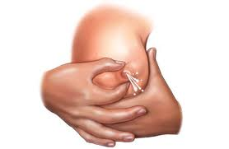

1. Press your thumb and fingers directly back into the breast tissue, towards the wall of your chest. Don't move them further apart. Just press straight back into the breast.
2. Roll your fingers and thumb forward to squeeze milk out of the milk sinuses, which are located under the areola behind the nipple. Don't slide the thumb or fingers along the skin--this will quickly make you sore.
3. Repeat this sequence--position, press, roll--until the milk flow ceases. Then move your hand so that the thumb and fingers are positioned at 11 and 5 o'clock and do it again**.** Use both hands to work your way around one breast, then switch to the other breast until you have emptied all of the milk sinuses. As soon as you see milk squirting from your nipple, you know you are compressing the underlying milk sinuses.
4. Collect 7-8 mls of milk into a sterile screw capped wide-mouthed container such as a urine cup**.** FW or nurse may consider assisting in the collection by holding the collection cup for the mother while she expresses the sample. After collecting 7-8 mls, FW should immediately cover container with the screw cap lid. Make sure the container is not leaking.
5. Record information in the BCM form and properly label the sample container.
6. FW or nurse should place the breast milk container in a fresh plastic bag, and transport in the cold box with fresh ice packs to the laboratory for further processing.
7. Once received in the laboratory, the milk sample should be processed immediately by mixing well then aliquoting into at least four (4) screw capped 2 ml freezer vials (I.5 ml milk per vial) and stored at -80 degrees Centigrade.

|  |  |  |
| --- | --- | --- |
| # | Question | Response |
|  | Child ID | Write the child’s participant ID in the space provided at the upper left corner. |
| 1 | Study Researcher / Nurse / Fieldworker ID | Enter the Study Researcher / Nurse / Fieldworker’s unique ID number here. |
| 2 | Today’s date | Format DD/MMM/YY |
| 3 | Time of Sample Collection | Write the time in 24 hour format HH:MM |
| 4 | Amount of breast milk collected | FW should write the amount collected here in ml. |
| 5 | Time of sample placement in cold box | Write the time in 24 hour format HH:MM. This should be done within 30 minutes within production of sample. |
|  |  |  |
| 6 | Other Comments and Observations. |  |
| Breast milk collection, transport and processing. | | |
| 7 | Lab Technician ID | Enter the technician’s unique ID number who processed the specimen. |
| 8 | Time breast milk sample was received at laboratory | Enter the time that the breast milk specimen was received at the main laboratory or the intermediate field site, if appropriate. |
| 9 | Number of vials aliquotted from field sample | Write the number of vials that the breast milk was aliquotted to (0-9 vials) |
| 10 | Sample ID | Write the 9-digit unique Sample ID. |
| 11 | Observations/Notes |  |

### BCT—Breast Milk Sample Transport and Processing SOP

**This SOP has been read and understood by:**

|  |  |
| --- | --- |
| **Name** | **Date** |
|  |  | |
|  |  | |
|  |  | |
|  |  | |
|  |  | |
|  |  | |
|  |  | |
|  |  | |
|  |  | |
|  |  | |

**Document History:**

|  |  |  |
| --- | --- | --- |
| **Version Number** | **Reason for Changes** | **Date** |
|  |  |  |
|  |  |  |
|  |  |  |
|  |  |  |

1. **Purpose**

This protocol describes the procedure for breast milk specimen collection from MAL-ED research subjects enrolled in the cohort and timely transport to the laboratory for further processing.

1. **Responsibility**

Field coordinator and lab technician are responsible for ensuring that standard methodology described here is followed in breast milk collection and transport.

1. **Materials**
   1. Breast milk sample (7-8 ml)
   2. Pre-printed PID labels (4 plus 1 extra)
   3. Wide-mouthed plastic container suitable for collecting milk from breast
   4. Frozen ice packs
   5. Cold box
   6. Disposable latex gloves
   7. Sealable plastic bags
   8. 2 ml screw capped freezer vials
   9. Pen
   10. Breast Milk Collection form (BCM)
2. **Temporary Storage and Transport Procedures**
3. FW should place the plastic bag with the breast milk sample in the cold box immediately after collection (maximum time: 30 minutes).
4. Breast milk samples should be kept in cold box for a maximum time from of 5 hours before processing in lab.
5. Document if the sample was in a cold environment on the requisition CRF. Also document if specimen is acceptable (estimated quantity, lid closed, and no leakage). If there are any deviations form this protocol, please fill the PDF form.
6. **Processing & Reporting**
7. Label the original breast milk container, with pre-printed PID labels. Write the date of collection (DD/MMM/YY) and time of collection (hh:mm; 24 hour time scale) on the label.
8. Mix the samples before aliquotting 1-1.5ml of breast milk into at least four 2 ml screw capped vials and store in -80°C
9. Record information on the number of vials, time of processing, assigned sample ids in BCM form, question 8-12.

### MSC—Maternal Stool Collection, Processing and Transport to the Laboratory

**This SOP has been read and understood by:**

|  |  |  |
| --- | --- | --- |
| **Name** | **Date** |  |
|  |  | |
|  |  | |
|  |  | |
|  |  | |
|  |  | |
|  |  | |
|  |  | |
|  |  | |
|  |  | |
|  |  | |

**Document History:**

|  |  |  |
| --- | --- | --- |
| **Version Number** | **Reason for Changes** | **Date** |
|  |  |  |
|  |  |  |
|  |  |  |
|  |  |  |

1.0 **Purpose**

This protocol describes the procedure for maternal stool specimen collection from mothers whose children are enrolled in the MAL-ED and BMMI cohort and for the timely transport to the laboratory for further processing.

2.0 **Responsibility**

Field coordinator is responsible for ensuring that standard methodology described here is followed in stool collection and transport.

3.0 **Materials**

3.1 **Unpreserved** stool specimen (10 grams)

3.2 Pre-printed PID labels

3.3 Cotton-tipped wooden stick

3.4 Wide-mouthed plastic container suitable for collecting stools

3.5 Wooden spatula

3.6 Frozen ice packs

3.7 Cold box

3.8 Tube rack

3.9 Disposable latex gloves

3.10 Disposable diaper

3.11 Sealable plastic bags

3.12 Plastic spoon

3.13 Pen

3.14 Maternal Stool Field Collection Form (MSC)

4.0 **Collection Procedure for Maternal Stool Sample**

4.1 The mother’s stool will be collected ONLY once when her child is one month of age. The mother’s stool should be collected on the same day as the scheduled day for completion of the child’s monthly surveillance form (SAF). This visit shall occur on the one month anniversary of the child’s birth (+/- 2 days). So, if a child is born on February 17th, for example, the first month visit would occur from the 15th to the 19th of that month. If you are unable, even with the best of efforts, to visit the mother within the 5 day window (birth date anniversary +/- 2 days), the field worker may visit the home at anytime. However, if the fieldworker is unable to collect a maternal stool sample, a PDF must be filled out. In addition, if the mother has diarrhea/loose stools, please do NOT collect a sample but return later to the home to collect a solid stool.

4.2 For collection of Monthly Stool, inform the mother one day before planned stool collection and request that the mother collect the first available fresh stool sample on the day of the planned visit.

4.3 The mother should be provided with the labeled stool container, cold box, ice packs, gloves, plastic spoon, and 2 plastic bags the evening before planned stool collection. There should be enough ice packs in the cold box to keep it cold for up to 16 hours.

4.4 Instruct the mother to use the plastic spoon to collect enough stool to fill the container, close the lid tightly, and place the container in the plastic bag.

4.5 When a Study Researcher / Nurse / Fieldworker arrives at the home and a sample has already been collected by the mother, ask the mother what time the sample was produced and record that time (on MSC, question #2). In most cases this will only be an estimate. The time that the Study Researcher / Nurse / Fieldworker arrives at the home and collects the specimen should also be recorded on the stool field collection form (MSC) (question 3, Time of visit). The stool sample is an unpreserved stool sample.

If a stool sample has not yet been collected, the Study Researcher / Nurse / Fieldworker should assess the likelihood that they can collect a sample while waiting, taking into consideration the other visits they need to make that day. If they cannot wait, they should leave collection material (specimen receptacle and cold box with ice packs) with the mother if they have not done so previously and provide instructions on collection procedure and plan to return to the home every 2 hours until a sample is collected.

For samples that were collected and weigh less than 5 grams, recollection should be requested. Attempts should be made to collect the desired amount of 10 grams of maternal stool. Recollection of the specimen may ONLY continue for up to 48 hours after the initial stool sample was produced.

5.0 **Temporary Storage and Transport Procedures**

5.1 Instruct the mother to place the plastic bag with the stool in the cold box immediately after collection (maximum time: 1 hour).

5.2 Document if the sample was in a cold environment on form. Also document if specimen is acceptable (estimated quantity, lid closed, and no leakage)

6.0 **Processing**

6.1 Label the original stool container with pre-printed PID labels. Write the date of collection (DD/MMM/YY) and time of collection (hh:mm; 24 hour time scale) on the label.

6.2 Place the original stool container in the tube rack, and transport in the cold box with fresh ice packs to the laboratory for further processing. The sample is an unpreserved stool sample.

7.0 **Reporting**

7.1 Record information on Maternal Stool Field Collection Form (MSC). Please see the table below for assistance.

|  |  |  |
| --- | --- | --- |
| # | Question | Guidance |
|  | Participant ID | Write the mother’s participant ID in the space provided at the upper left corner. |
| 01 | Date of visit | Enter the date of the visit (DD/MMM/YY) by the Study Researcher / Nurse / Fieldworker. |
| 02 | Time stool sample was produced | Enter the time (24 hour time scale, HH:MM) that the stool sample was produced. If this time is not available, estimate the time the sample was produced. |
| 03 | Time stool sample was picked up by field worker | Enter the time (24 hour time scale, HH:MM) that the stool sample was picked up by the field worker. |
| 04 | Was stool specimen on cold pack upon receipt by field worker? | Indicate whether the stool sample was received by the field worker on a cold pack (Yes=01, No=00). |
| 05 | Type of stool collected | Indicate whether the stool sample was the initial stool sample or the recollection sample. |
| 06 | Recollection necessary? | Indicate if recollection is necessary. Every effort must be made to collect 10 grams of stool- the quantity stated in the protocol. Recollection of the specimen may ONLY continue for up to 48 hours. If the stool sample is less than 5 grams, please recollect. |
| 07 | Has the mother ever used antibiotics since child’s birth? | Indicate whether the mother has ever received antibiotics since the child’s birth (Yes=01, No=00). If no, skip question #8. |
| 08 | What types of antibiotics were used? | Specify the type of antibiotics used by the mother since the child’s birth. More than one type of antibiotic may be chosen. Refer to package or rely on maternal report – antibiotic options on MSC form. If there is no package and the mother does not know what kind of antibiotics were given, ask she has any paperwork from the healthcare provider that might list the recommended medications, or if there are pills left over that the Study Researcher / Nurse / Fieldworker can look at. If there is no documentation and the Study Researcher / Nurse / Fieldworker cannot identify the antibiotic by looking at the pills, enter 7 (unknown) in this box. All available information (color of the pills, field researcher’s best guess of what medication names are written) should be entered into the Nursing Notes Form for discussion with the supervisor. If the name of the antibiotic is known, but the data collector does not know what class of antibiotic it is, they should write down the name on the Nursing Notes Form and ask the supervisor. |
| 09 | Has the mother had diarrhea since child’s birth? | Indicate whether the mother has ever had diarrhea since child’s birth (Yes=01, No=00). Diarrhea is defined as having 3 or more loose stools within a 24 hour period. If no, skip questions 10 -13, and proceed to question #14. |
| 10 | How many episodes of diarrhea has the mother had since child’s birth? | Indicate how many episodes of diarrhea the mother has had since the child’s birth. Diarrhea episodes are separated by at least two diarrhea-free days. |
| 11 | How long was the 1st diarrhea episode? | Indicate the number of days the 1st diarrhea episode lasted with a range of 1-31 days. |
| 12 | How long was the 2nd diarrhea episode? | Indicate the number of days the 2nd diarrhea episode lasted with a range of 1-31 days. |
| 13 | How long was the 3rd diarrhea episode? | Indicate the number of days the 3rd diarrhea episode lasted with a range of 1-31 days. |
| 14 | Fieldworker ID | Enter the fieldworker’s unique ID number who picked up the stool sample. |

### MSR—Receiving and Storage of Maternal Stool Samples SOP

**This SOP has been read and understood by:**

|  |  |  |
| --- | --- | --- |
| **Name** | **Date** |  |
|  |  | |
|  |  | |
|  |  | |
|  |  | |
|  |  | |
|  |  | |
|  |  | |
|  |  | |
|  |  | |
|  |  | |

**Document History:**

|  |  |  |
| --- | --- | --- |
| **Version Number** | **Reason for Changes** | **Date** |
|  |  |  |
|  |  |  |
|  |  |  |
|  |  |  |

1. Purpose

This document describes the procedures for receiving maternal stool samples collected from mothers whose child is enrolled in the BMMI cohort, and the assignment of Sample ID to the stool samples. The stool specimens are collected for assessment of enteric infections and gut function. The procedures are designed to maintain the integrity of clinical specimens by proper handling and storage and the management of associated records.

**Materials**

Refrigerator

-70°C freezer

-20°C freezer

Wooden spatula

Sterile cryovials

Cryovial labels

Cryovial racks

Storage boxes

Pipettes (20-200 µl and 100-1000 µl)

Scale

Maternal Stool receiving form (MSR)

**Methods**

**Safety:**

1. Universal precautions must be followed while handling samples (http://www.cdc.gov/ncidod/dhqp/gl_isolation_standard.html).
2. Technicians must wear appropriate proper personal protective equipment (PPE) (e.g. gloves, masks, etc.) when handling samples as well as when handling ultra cold freezer items.
3. Disinfect work areas before and after performing these procedures.
4. Avoid using techniques that are likely to generate aerosols.

Additional information can be found at <http://www.cdc.gov/OD/ohs/biosfty/bmbl5/bmbl5toc.htm>.

**Transfer of samples to the laboratory:**

Proper transfer of samples from field to laboratory will require coordination between field workers and laboratory technicians. Collection and transport of samples should be carried out in clean, labeled, dry, leak-proof containers. Transport the samples to the laboratory as soon as possible after collection. Samples should be transported in an ice chest or insulated carrier containing adequate amount of cold packs as well as cushioning material to protect the samples. Do not use wet ice for transport of clinical specimens. The stool sample will be transferred from the field to the laboratory with pre-printed PID labels, and information regarding time and date of stool collection.

The sample should be immediately stored at -70°C for archiving and shipment.

**Receipt of specimens:**

When the stool sample is received at the laboratory, the Sample ID is immediately assigned using the Sample ID logbook provided to each individual site. Please see Sample ID log (SIL) SOP for detailed instructions. After the Sample ID has been successfully assigned, the Sample ID is written on the existing label on all sets of stool samples made from this stool collection. Any future aliquots of this stool sample collected at that specific time will also have the same Sample ID. Recollection samples have a different Sample ID than the initial sample’s Sample ID.

**Reporting:**

Record information on Maternal Stool Receiving Form (MSR). Please see the table below for assistance.

|  |  |  |
| --- | --- | --- |
| # | Question | Guidance |
|  | Participant ID | Write the mother’s participant ID in the space provided at the upper left corner. |
| 01 | Sample ID | Write the 9-digit unique Sample ID. |
| 02 | Date of collection | Enter the date of collection (DD/MMM/YY) of the stool sample. |
| 03 | Type of stool collected | Indicate whether the stool sample was the initial stool sample or the recollection sample. |
| 04 | Time stool specimen was produced | Enter the time (24 hour time scale, HH:MM) that the stool specimen was produced. If this time is not available, estimate if time cannot be confirmed by mother. |
| 05 | Time stool specimen was picked up by Study Researcher / Nurse / Fieldworker | Enter the time (24 hour time scale, HH:MM) that the stool sample was picked up by the field worker. |
| 06 | Fieldworker ID | Enter the fieldworker’s unique ID number who picked up the stool sample. |
| 07 | Was stool specimen on cold pack upon receipt by FW? | Indicate if the stool specimen was on a cold pack when fieldworker came to pick up stool specimen. |
| 08 | Time stool specimen was received at laboratory | Enter the time (24 hour time scale, HH:MM) that the stool specimen was received at the laboratory. |
| 09 | Was stool specimen on cold pack upon receipt in lab? | Indicate if the stool specimen was on a cold pack when receipt in lab. |
| 10 | Time stool specimen frozen | Enter the time (24 hour time scale, HH:MM) that the stool sample was frozen at -70C. |
| 11 | Technician code | Enter the lab technician’s unique ID number who processed the stool sample. |
| 12 | If recollection, what is Sample ID of initial sample? | If the stool sample is a recollection sample, enter the Sample ID of the initial sample. If the stool sample is not a recollection sample, enter NA. **Recollection samples have a different Sample ID than the initial sample’s Sample ID.** All sample IDs are unique values. |
| 13 | Amount of stool | Enter the number of grams of stool received. |
| 14 | Recollection? | Indicate if recollection was requested. Recollection is requested when stool sample is <5 grams. |
| 15 | Consistency? | Indicate the consistency of the stool sample, WATERY (very loose, watery stool with very little solid material) = 01, LIQUID (loose stool taking the shape of the container) = 02, SOFT (semi-solid, smooth stool) = 03, FORMED (solid, firm stool) = 04 |
| 16 | Bloody? | Indicate if the stool specimen was bloody or not bloody. **If bloody, refer the mother for medical treatment of suspected dysentery.** |
| 17 | Mucus? | Indicate if the stool specimen had mucus or did not have mucus. |

**Internal Log-in of Specimens:**

All specimens must be held at 2 – 8°C until ready to process.

We recommend that sites develop tracking methods for sample testing, short-term sample storing, and general laboratory procedures that are consistent with their local situation. We suggest some general methodology here for consideration. Determine that all specimen information is available on the laboratory’s specimen receipt form (including PID and sample ID). Each laboratory will responsible for creating a logbook to track the specimens internally. The MAL-ED barcode database can be used to assist in storing and tracking of samples.

*A sample stool specimen information form is given below.*

**

The details on the specimen form must agree with the information recorded on the specimen label (include PID and Sample ID on labels).

*An example of a stool specimen label is given below.*



Log in the specimen details (including PID and sample ID) in the designated database or spreadsheet as well as any internal laboratory logbooks for the study. **Recollection samples have a different Sample ID than the initial sample’s Sample ID.**

There should be individual spreadsheets, log sheets and/or laboratory log books for each type of sample (blood, urine, stool, saliva) in the study.

Ensure that all details are entered including participant ID, sample ID, volume of sample collected and date and time of sample collection. Enter the initials of the person handling the specimen in the appropriate column.

Approximately 10 g of stool is collected from the mother. Determine if recollection was requested and/or received. Lab technicians need to communicate to field workers as soon as possible to indicate if recollection is required. Methods of communication may include telephone, email, text message, personal communication. It is essential that field workers are aware that recollection has been requested.

*A sample laboratory log book and MS-Excel worksheet are given below:* 



**Procedure for Aliquoting and Storage:**

1. For each sample, aliquots may be made according to the preference of the site and depending on the volume of original sample available.
2. Prepare the barcode labels per sample. Place each of these labels on individual cryo vials. Refer to SOP “Barcode Sample Tracking” instructions for assistance in creating label for archiving/storage.
3. Sample aliquots are done on ice.
4. Store aliquots at -70˚C.
5. Log-in the information of where the aliquots are stored with details of freezer number and rack both in the barcode database for sample storage as well as in the laboratory specimen storage logbook.
6. Samples will be shipped in batch for the BMMI project.

**Growth and Nutrition**

Dietary Assessment Overview

There are four dietary intake instruments: breast milk and food check list incorporated into the twice weekly Surveillance Assessment Form (SAF), a food frequency questionnaire (FFQ) to be administered monthly from 1 to 8 months as part of the Monthly Combined Form A (MOA), a food frequency questionnaire (FFQ) to be administered monthly from 25 to 36 months as part of the Monthly Combined Form C MOC), and a 24-hr dietary recall to be administered monthly from 9 to 24 months of age (FRQ) (with the option of also collecting monthly from 25 to 36 months of age). These are discussed each in turn.

**Twice weekly surveillance form CRF - SAF**

This form is administered to the caretaker twice weekly at home by the Study Researcher / Nurse / Fieldworker. This component of the questionnaire is used to get frequent and comprehensive information on breast milk intake and the introduction of non-breast milk foods (or on formula/other milk intakes for the non-breast fed child), and to be able to relate variations in gut function with the consumption of specific foods that may affect gut health (prebiotics). The Study Researcher / Nurse / Fieldworker tells the caretaker that s/he wants to know about whether or not the child is eating or drinking these certain foods. The Study Researcher / Nurse / Fieldworker asks the first section about liquids to everyone. Specific probes are provided to overcome answers such as “I don’t know” or “as often as s/he asks”. Following this, there is a question about whether the child is getting any semi-solid or soft or mushy foods. If the answer is “no”, then the Study Researcher / Nurse / Fieldworker ends the interview. In “yes”, then the Study Researcher / Nurse / Fieldworker asks about the consumption of specific foods that may affect gut health. The purpose of these questions is NOT to characterize dietary intake but rather to link the consumption of specific foods with other questions on gut function. The foods listed are sources of lignins, fructo-oligosaccharides (FOS), or resistant starches, which are fermented/digested in the colon and affect gut lymphoid tissue. Therefore, the mother could answer “yes” that she is feeding semi-solids, but answer “no” to the remaining questions.

**Monthly Combined Form A**

The Study Researcher / Nurse / Fieldworker will administer the FFQ to the caretaker/mother monthly from 1 to 8 months of age. The questionnaire is based upon the Demographic and Health Survey (DHS) questionnaires. As such, it can be analyzed in a similar fashion to derive recommended indicators of infant feeding. It will be adapted to each site to include local names for common examples of the food items. The breastfeeding questions are similar to those on the twice weekly surveillance form, but the complementary foods are different, as here the focus in on capturing dietary diversity and an index of food adequacy. It is designed to be completed at the same time and by the same Study Researcher / Nurse / Fieldworkers as the monthly anthropometry.

**Monthly Combined Form C**

The Study Researcher / Nurse / Fieldworker will administer the FFQ to the caretaker/mother monthly from 25 to 36 months of age. The questionnaire is based upon the Demographic and Health Survey (DHS) questionnaires. As such, it can be analyzed in a similar fashion to derive recommended indicators of child feeding. It will be adapted to each site to include local names for common examples of the food items. The questions are somewhat different from those asked on the SAF, as here the focus in on capturing dietary diversity and an index of food adequacy. It is designed to be completed at the same time and by the same Study Researcher / Nurse / Fieldworkers as the monthly anthropometry.

**24 hour recall**

It is important to obtain quantitative estimates of nutrient intakes of non-breast milk food. Therefore, the 24 hr recall represents the best compromise considering cost and feasibility for collecting such data over time for a large sample of infants. Many of the sites have considerable expertise in the administration of recalls and since it is a classical tool of dietetics, there is likely to be expertise at or near each site. The technique does require administration by a dietitian/nutritionist, or someone similarly familiar with food intakes, consumption patterns, recipes, food preparation techniques, portion sizes, etc. This assessment will be administered monthly from 9 to 24 months of age in combination with the Monthly Combined Form B (MOB). From 25 months of age onward, the 24 hour recall is optional, but strongly encouraged. If the FRQ is conducted from 25-36 months of age, it should not be completed on the same day as the MOC.

The nutritionist will tell the mother/caretaker that she would like to know everything that the child ate from when they woke up yesterday until the morning of the interview. This is accomplished by helping the mother remember her day and that of her child, in terms of awakening, and what they ate first, and then working through the day. We will record breast milk feedings but there is no way to quantify this information to obtain nutrient intakes from breast milk. Thus we are obtaining quantitative information on intakes of non-breast milk foods, and not total dietary intake, per se. We can however, query regarding amounts of other milks consumed by the child, and obtain total intakes for the non-breast fed child. After recording the food items, which may be individual items (e.g. piece of banana) or mixed dishes, the interviewer asks about portion size consumed (or served and then consumed). For mixed dishes, the nutritionist asks for the ingredients and amounts – that is, the recipe. Food aids or models (pictures to be developed for each location) help the discussion of portion sizes and recipe determination. After completing this iteration, the nutritionist asks about commonly forgotten foods, additional snacks, and any other foods consumed. The nutritionist makes a final pass looking to see if there are missing pieces of information – does the recipe make sense? There is considerable manipulation of this information after the interview for data entry and analysis. Each site will have to translate this information into either a clean form or an excel spreadsheet (or access program file) that will provide the food item or ingredient, quantity, and food code, amongst other child, day, meal and food identifiers. The food code will provide the link to the food item in the food composition data base which is designated as the appropriate data base for each site and will provide specific nutrient information. It is envisioned that the linking of the recall data with the composition data base and calculation of estimated intakes will be done centrally (at Johns Hopkins with active interaction with each site), but this may change depending on appropriate expertise at the site. Given that the recall is not administered until the child is 9 months old, there is time to develop at each site the expertise and aids for proper administration.

To assess reliability, we intend to go back a few days later (we want a non-consecutive day) and perform a second recall per one child at each time point. This is important information on within subject variability that can be used to calibrate our dietary intake estimates during analysis.

FRQ/FRS—24 Hour Food Recall SOP

1. **Purpose**

It is important to obtain quantitative estimates of nutrient intakes of non-breast milk food. Therefore, the 24 hr food recall represents the best compromise considering cost and feasibility for collecting such data over time for a large sample of infants. Many of the sites have considerable expertise in the administration of recalls and since it is a classical tool of dietetics, there is likely to be expertise at or near each site. The technique does require administration by a dietitian/nutritionist, or someone similarly familiar with food intakes, consumption patterns, recipes, food preparation techniques, portion sizes, etc. This assessment will be administered monthly from 9 to 24 months of age in combination with the Monthly Combined Form B (MOB) with the window range of up to +15 days to allow for a typical day of food intake. From 25 to 36 months of age, the FRQ should not be administered on the same day as the MOC.

1. **Materials**

24 hour recall forms (FRQ - 4 copies)

Recipe form (FRS – 4 copies)

Pen/pencil

Tool kit of food models/pictures and common household measures

Food composition tables local to setting (used after the interview to complete the data collection form)

1. **Method**

The day chosen for completion of this food recall interview should **not** follow a traditional festival, holiday, or celebration at which a non-typical feeding schedule and/or food choices may have been a factor in what the child ate on that day. The purpose of this instrument is to document the child’s diet for a **typical** day.

The nutritionist/interviewer will tell the mother/caretaker that she would like to know everything that the child ate from when they woke up yesterday until the morning of the interview. This is accomplished by helping the mother remember her day and that of her child, in terms of awakening, and what they ate first, and then working through the day. Many may feel that they do not remember, but the interviewer needs to reassure the mother that they will help them remember to the best of their ability and also query others who may be involved in feeding the infant.

We will record breast milk feedings but there is no way to quantify this information to obtain nutrient intakes from breast milk. Thus we are obtaining quantitative information on intakes of non-breast milk foods, and not total dietary intake, per se.

We can however, query regarding amounts of other milks consumed by the child, and obtain total intakes for the non-breast fed child. After recording the food items, which may be individual items (e.g. piece of banana) or mixed dishes, the interviewer asks about portion size consumed (or served and then consumed or left over with the amount consumed estimated by difference).

For mixed dishes, the nutritionist asks for the ingredients and amounts (the recipe). There is a separate Recipe Form (FRS) for capturing recipes and ingredients.

Food aids or models (pictures developed for each location) help the discussion of portion sizes and recipe determination, as do commonly used household measures, bowls, plates.

The interviewer will begin by working with the mother/caregiver to reconstruct the day, and listing all foods offered/consumed, including breastfeeding episodes.

After completing this questioning, the interviewer will go back and query for specific aspects, portion sizes, amount served, amount left over, amount consumed, where and when it was fed, etc.

After filling in as much detail as possible, the interviewer will go back over the form again, and ask about commonly forgotten foods (in that setting), additional snacks, and any other foods consumed, including breast milk feeding during the night until the morning of the interview (when the child woke up in the morning, to complete more or less the 24 hour period).

The interviewer makes one final pass looking to see if there are missing pieces of information – does the recipe make sense? The interviewer should count the number of breast feeds and ask the mother if that number is about right for feeding during the day and then again that number of feeds during the night. Write these numbers down, and check to see if they coincide with the number of feeds enumerated in the recall.

After finishing the interview and leaving the house/site of interview, there is considerable manipulation of this information prior to data entry and analysis. Each site will have to complete the remaining boxes of this form in consultation with an appropriate food composition database to obtain the food codes and portion amounts in grams, for example. Each recipe will receive a unique code, and a recipe code/name database/list will be maintained at each site. When a recipe cannot be obtained from a mother, we may seek to collect recipes for the dish from other local residents to create a composite recipe and nutrient composition, which would then have a unique code and information and be included in the food composition tables for the site.

When the form has been completed and checked, the data will be entered into an Excel spreadsheet (or Access program file) that will provide the food item or ingredient, quantity, and food code, amongst other child, day, meal and food identifiers. The food or recipe code will provide the link to the corresponding information in the food composition data base which is designated as the appropriate data base for each site and will provide specific nutrient information. It is envisioned that the linking of the recall data with the composition data base and calculation of estimated intakes will be done centrally (at Johns Hopkins with active interaction with each site), but this may change depending on appropriate expertise at the different sites. The output of this analysis for each child/day will be entered into the standardized usual nutrient intake form and sent to the data coordinating center.

**For measuring volume in field:**

People use water in a common serving dish to represent the volume of the food served, how much did it fill the bowl, for example. For water, 1 gram of water = 1 cubic centimeter = 1 mL, meaning that the weight of water indicates the volume. What we want is to take the volume measure and relate it to the food that was consumed to then obtain the weight in grams of the actual food.

For example, suppose we weighed 100 g of water in a bowl in a household with the family member saying that was the amount served to the child (that is how full the bowl looked). Say that was a soup – say it was cream of tomato soup. So, now we know the child was served 100 mL of soup, the question then is, “how much does 100 mL of soup weigh?” Because the soup is more dense than water, it will weigh more than 100 g.

However, we can also think logically that since soup is mostly water (remember that even if it were made with milk, milk is also mostly water….), it won’t be that much different from 100 g.

A food composition table usually provides common portion sizes served/eaten and their gram equivalents and then also provides the nutrient composition for the standard 100 g portion. A difficulty here is that in some of the national tables, they do not make this link, but provide only the nutrients per 100 g portion. But we can work around this!

So, if I were to use the USDA database, I would need to convert to the volume equivalents they use to describe foods and then relate that to the gram measure. It is complicated in the US because some units are both volume measures and weight measures and we need to keep them separate! Whether volume or weight measures, there exist known conversion factors. So we can easily convert 100 mL volume = 3.4 oz (ounces being one of the primary units used to describe portion size). If the soup were cream of tomato soup (made with 2% reduced fat milk), that volume of soup would weigh 107 g (again not so different). If it were cream of potato soup, it would also weigh 107 g according to the USDA composition tables.

So suppose it were mashed potatoes with butter and milk, and the volume was 100 mL. So, 100 mL is 0.4 cup (a standard measure in the US for thinking about mashed potatoes -- if you use measuring cups!). 0.4 cups of mashed potatoes according to the food composition table weighs 84 g.

So instead let’s go to the Canadian food composition table (after all they follow the METRIC system). We have our 100 mL of tomato soup, and according to their table (made with 2% reduced fat milk) it would weigh 105 g, and if it were cream of potato soup it would weigh 105 g, and just to follow through, if it were mashed potatoes with butter and milk, 100 mL would weigh 89 g.

These differences are trivial (84 or 89, 105-107). Just in case you are wondering, mashed potatoes have a lot of air in them (remember they are really whipped up!) and so their density is less than water.

So what sites need to do is to develop for commonly eaten foods ways to translate the volume consumed as estimated using water weight (as above) to the volume of the actual food and then to the weight of that food served. There will be common foods to be converted and a sheet of conversion factors can/should be developed. We have discussed this and can work with each site on the preparation of the list.

What we will need to do is to get some examples to help the sites through, and through this process over time, we will get the universe of conversions needed and it will get easier!

**FRQ form: 24 hour recall form**

**Please enter N/A for blanks and no response.**

|  |  |  |
| --- | --- | --- |
| **#** | **Question** | **Guidance** |
| 01 | Child ID | Enter the Study Child’s unique ID number here. |
| 02 | Today’s Date | Format DD/MMM/YY |
| 03 | Study Researcher/  Nutritionist/Fieldworker ID | Enter the Study Researcher / Nutritionist / Fieldworker’s unique ID number here. |
| 04 | Line number | This should be filled in as 1, 2, 3, etc., to enumerate each line of data. Sometimes, the interviewer will use extra space and thus, multiple lines may use the same number to reflect the continuation of information. Sometimes a food is a mix of two items and does not require a recipe form to be filled out, but rather the “food” is composed of two “ingredients” (so 2 line numbers for 1 food number)  Food number corresponds to the sequential food that child had taken in past 24 hours, for example if a child was breastfed then given rice gruel starting with the first meal in the morning, food number would be 1 for breastfeed and 2 for rice gruel. However, if rice gruel was a mixture of two ingredients for example, milk and rice; this **can** be further broken down under the same food number 2 with different line number. See example below.  Same food number would indicate that food was mixed. PLEASE note that line numbers are unique and sequential.   |  |  |  |  | | --- | --- | --- | --- | | Line number | Food number | description | code | | 1 | 1 | breastfeed | 0001 | | 2 | 2 | Rice | 0002 | | 3 | 2 | Milk | 0003 | |
| 05 | Food number | This should be sequentially numbered for each food item, recipe or breast milk feed, etc. |
| 06 | Meal | Please identify each feeding episode/meal/snack separately. All foods/drinks that are offered together should get the same number. |
| 07 | Home | Where was the food consumed? Write “1” if it was consumed at Home and “0” if it was elsewhere. |
| 08 | Time | Record the time of the feed/offering of food or liquid in HH:MM in 24 hour time cycle. Our goal is to get relative times, we do not expect exact times here. |
| 09 | Recipe description | Name the recipe (this name should be the name given to this item on the FRS form). **SINGLE ENTRY ONLY.** |
| 10 | Recipe code | This code will be given to the recipe after the FRS interview. Ensure there is corresponding FRS for each recipe code entered in this field. |
| 11 | Food Item: description | Describe the food item sufficiently to allow identification of proper code. For example, breastfeeding will count as food intake and can be described here. It’s highly encouraged to include breastfeeds as part of food intake to ascertain feeding pattern and behavior. **SINGLE ENTRY ONLY.** |
| 12 | Food Item: Code | Enter the six digit code designated for this food. Please enter 6 digits here and please fill in zeros in the left boxes if there are less than 6 digits. |
| 13 | (R/C):Raw/Cooked | Write “1” if the item was raw and “2” if it was cooked For example, cheese is considered “raw” but if its melted, then it’s considered “cooked” |
| 14 | Food served: Portion Size description | Describe what was served to the child; for example, the recipe code may refer to a vegetable soup, but the child only received the broth, or a potato that was then mashed up. **SINGLE ENTRY ONLY.** Question 14 could have NA (breast milk) but will NEVER have 0.0. |
| 15 | Food served: amount (in g) | Write down the amount in grams served if known, if not known, then column 13 should be sufficiently descriptive to allow a gram amount to be added after the interview is complete. Question 15 could have NA (breast milk) but will NEVER have 0.0. |
| 16 | Food leftover: Portion size description | Describe what amount of each food item was left over by the child. Field Workers ensure that this question refers to the food leftover by the child. If the mother finishes the leftover, write down the estimated amount of food that was consumed by the mother. For example, “¼ banana”, or they ate “almost all of it”, or they ate the peas out of the mashed potato only “. Do not leave this blank. If they ate it all, write “none left over” or “ate it all”. **SINGLE ENTRY ONLY. Question 16 could have NA (breast milk) AND could have 0.0** |
| 17 | Food left over amount (in g) | Write down the amount in grams left over if known, if not known, then column 15 should be sufficiently descriptive to allow a gram amount to be added after the interview is complete. For example, if the child were served ½ banana (under served question) and what was left was ¼ banana, then we would know they ate ¼ of a banana. Later in the office we would find that ½ banana is 20 g and then we would fill in that they were served 20 g of banana and there were 10 g left over and during analysis we would calculate that the child ate 10 g of banana. If the child “ate it all”, then record the number of grams left over as “0” (zero). Do not leave this blank. **Question 16 could have NA (breast milk) AND could have 0.0** |
| 18 | How many times was the child nursed during the daytime: | Write down the number of times the child was put to the breast for feeding during the day (sunrise to sunset) in the last 24 hours |
| 19 | How many times was the child nursed during the night: | Write down the number of times the child was put to the breask for feeding during the nighttime (sunset to sunrise) in the last 24 hours |
| 20 | Total times nursed: | Add the number in question 18 & 19 to get the totale times the baby was nursed in the last 24 hours. |
| 21 | Comments | Relevant details from interviewer or coder after the interview is complete such as special food offered to the child due celebration or other festivities. Ideally interviewer should conduct recall interview on day that is typical but if such instances, please note that in this section. **SINGLE ENTRY ONLY.** |
| 22 | Is this form collected for secondary recall? | This question asks if the form was collected for secondary recall. If it is collected for secondary recall, ensure it was done within 2-7 days since the actual first recall. |

**FRS: 24 Hour Recall Form Part 2**

For each recipe that is not within the food composition table, we need to determine what the ingredients are and how the food was prepared. For this purpose, we have the recipe collection form. Please fill out details on the ingredients, amounts and basic directions on preparation. Once all of identified recipes are collected from the field, standardized recipes codes will be used in FRQ form, if referred to a recipe. **If these codes are created locally, please forward a comprehensive list to Laura.C and Ramya for reference.** Ideally, these forms would be prioritized to be completed and entered before the FRQ form. Recipe codes can be the same if the same ingredients are used irrespective of amount or ratio. Laura will analyze the FRS for the same recipies to examine for potential composite recipes but in the beginning it is encouraged to collect as much FRS for the same recipe to account for seasonal and intrahousehold fluctuations.

**Please enter N/A for blanks and no response.**

|  |  |  |
| --- | --- | --- |
| 01 | Participant ID | Enter the Study Child’s unique ID number here. |
| 02 | Today’s Date | DD/MMM/YY |
| 03 | Fieldworker ID | Enter the Study Researcher / Nutritionist / Fieldworker’s unique ID number here. |
| 04 | Recipe Name | Write down the common name of the recipe here. |
| 05 | Recipe code | Write down the four digit numeric code assigned to this recipe. If only 3 digits are there, add 0 before the code. Example, 0378 instead of 378. |
| 06 | Line Number | This should be filled in as 1, 2, 3, etc., to enumerate each line of data. If more than 14 ingredients is used, please contact Laura Caulfield for further help. |
| 07 | Ingredient | Write down the ingredient name included in the recipe. Each ingredient is a new line number. If more than 14 ingredients, please contact Laura Caulfield for further help. **SINGLE ENTRY ONLY.** |
| 08 | Code | Enter the four digit numeric code for this ingredient. If only 3 digits are there, add 0 before the code. Example, 0378 instead of 378. Please enter 6 digits here and there is no need to fill in left 0 if there are less than 6 digits. |
| 09 | Amount | Write down the description of the food. For example, 1 cup or 2 bowls or 4 teaspoon or other local measurements. |
| 10 | Weight | Enter weight of the ingredient in grams. No need to write the decimals. |
| 11 | Remarks | Write down any remarks that may affect the nutrition content of the ingredient. For example, dried tomatoes verus fresh tomatoes and other relevant information. **SINGLE ENTRY ONLY.** |
| 12 | Cooking methods notes | Write down how the recipe was prepared in terms of boiling/roasting/simmering/brasing/fermentating and list the ingredients added sequentially. More detailed notes is encouraged.  For example, cooking methods notes for chicken soup can be written as: put 3 tablespoons of sunflower oil in large pot; add three small chopped onions to oil, then add 15 small tomatoes to oil and onions. Add 2 liters of water and 1 whole chicken. Then boil all of this for an hour.  This will be entered only once and will be automatically transferred to double data entry. **SINGLE ENTRY ONLY.** |

1. **(FRQ): Interviewing Techniques for the 24-Hour Recall Interview**

Explain to the mother/caregiver that you need to know what the child ate yesterday (from the time they woke up yesterday to the time they woke up this morning, including the number of times they nursed, ate foods at meals, snacks, or drank anything, even water). Explain that there are no right or wrong answers here, we just want to know how much food the child is eating and what kinds. It is important not to express in words or facial expressions either approval or disapproval of foods mentioned during the interview. Also it is important not to ask leading questions that would lead the mother/caregiver to feel s/he should have had a certain food consumed. Finally, it must be remembered that children, especially young ones can eat very different kinds and amounts of foods from one day to the next.

Among infants and young children, an important consideration is whether or not they are still breast fed and the extent to which they are breast fed (night only, 8-15 times/24 hours, just during the day), as this will influence the number and amount of foods that the child can be expected to be consuming.

1. As a first step you will try to get a complete list of all the foods eaten by asking questions to help the mother/caregiver reconstruct her/his day and that of the child.

You want to dialogue with her to re-construct the day with respect to a) time; b) her and her child’s activities; c) food/meal combinations. The following are examples of the kind of questions to be asked:

When did __________wake up yesterday morning? What did they have to eat? Did they eat or drink anything after that?

What did you do after that? At what time was this? Did _________eat or drink anything before or after that?"

When you went to the market, did ______ go with you? Did you buy anything and feed it to him/her while you were out? If ______did not go with you, did you leave food with someone else to feed them while you were gone?

Did s/he take a nap? Did s/he eat or drink anything (or nurse) just before the nap? How about after?

After you went to bed last night, did you nurse ________ during the night? How many times? Did _______ eat or drink anything else during the night?

When you fed ________ porridge, did you add anything to it?

Did ______ have anything to drink with this?

From the soup, what pieces did you give the child to eat?

What else did ________ have at this meal?

Was the bread eaten plain or did you put something on it?

Did you give them more (a second helping)?

1. **(FRQ):** The second step involves going back over the list to get additional descriptions and amounts of the food. Also you want to determine if all of the food was eaten or if some was left on the plate/dish.

To get more information on the type of food:

* 1. Encourage the mother/caregiver to describe foods as clearly as

possible. You may have to restate questions to get more information. Remember that you have tools to help you relate what she tells you with what you need to write down.

* 1. Describe combination dishes carefully. Mixtures such as

soups, stews, etc., can be prepared in many ways. Use the recipe form to gather this information. Do remember to place on 24 hr recall form any details about specific portions of the food that the child may have been fed (only the broth, given a potato and carrot mashed up only, e.g.,)

* 1. If bought, ask to see package or ask the brand name, and record brand name and other pertinent information as available

1. To determine the amount of food eaten, it is important to understand the kinds of information that are needed to estimate the amount of food eaten.
   * 1. Numbers: 2 eggs, 1 cookie, ½ banana
     2. Shapes: slice of cake,
     3. Dimensions: cm (here the use of models is helpful)
     4. Volume: teaspoon, soup spoon, cup/glass/bowl
     5. Weight: grams (here using models and measuring devices are helpful)
2. Have mother/caregiver show you how much by pouring raw rice or dry beans on a plate or by identifying some item in your recall kit that is of similar size. These are components of the tool kit (see below).
3. When appropriate, ask the mother/caregiver to show you the serving container (and ask how much of it the child ate – 2 pieces, a little bit, ½, all, ¾?) (bowl, cup, glass, etc.) that was used and determine the amount it holds by using rice and a standard measuring cup.
4. After completing this second step, read the list back to him/her and ask her/him if there is anything else that he/she may have forgotten before.
5. Thank her/him for his/her cooperation. Do not comment on the information.
6. **The tool kit**

Each interviewer should have her own tool kit and know how to use it. The tool kit helps the interviewer to estimate the amounts of food served/eaten more accurately. The items in the kit will be site specific. The following are guidelines to developing a local tool kit. Since we are interviewing about infants and young children, the bowls, etc., should be the type used to feed children locally.

1. Cups – plastic measuring cups (locally purchased equivalent)
2. Bowls – locally purchased of different shapes – holding 1-2 cups
3. Small bowl/dish - about 1/2 cup
4. Standard measuring spoons: 1 tablespoon; 1 teaspoon; 1/2 teaspoon (local equivalents)
5. Food models/pictures of common foods served/eaten, or picture-based guide if available.
6. Plastic container of 1 to 2 cups rice (with tight fitting lid). Rice can be used as an example of more dense foods
7. Plastic container of 1 to 2 cups dried beans (with tight fitting lid). Beans can be used as an example of foods that are more loosely packed.
8. Plastic ruler - 6" works well
9. 10 Shapes on cardboard or plastic: as described in the following chart.
   1. 1” square
   2. 2" square
   3. 3” square
   4. A slice of pizza (or other dish as appropriate to local context)
   5. A 2 cm slice (cake, quiche, bread, local equivalent)
   6. A 4" circle (pancake, bread, local example)
   7. Additional shapes such as circles for portion sizes (local examples) or for various shapes of meat, fish, as locally relevant.
10. **Training**

It is important to have a local expert conduct the training over a three-day period with the interviewers. The training need not be full time over these days, but rather be spread out to allow the interviewers to learn, absorb and practice their skills. The interviewers will practice their skills on each other (adult intakes), with locally valid scenarios (another interviewer is the “mother” with her child’s intake scripted), and with local mothers of children in this age group. The following components are recommended for successful training.

1. Have tool kits developed so that the interviewers use them from the start. Send them home with them to practice using food and ingredients in their own home.
2. The kits do not have food scales in them to weigh ingredients or foods, and so part of the training sessions should be devoted to relating the “look” of foods, with determining the equivalent gram amounts using measuring devices, so that the interviewers become good judges of weight.
3. During training, provide examples of foods, and have the interviewers determine how the foods would be described. Also give interviewers a food item and have another interviewer practice obtaining the amount of that food.
4. Discuss appropriate ways to ask questions in each setting, without interrogating, how to gain trust and foster communication, how to give the mother time to remember/recall, how to work together with her to help her remember, what to do in varied circumstances.
5. Walk-through of the steps in conducting the 24 hour recall, as a group, multiple times.
6. Interviews with community health workers or other professionals about what is known about infant feeding in the community. Interview or discussion with local key informants (older women knowledgeable about infant/young child feeding).
7. Discussion/presentation of recipes for common foods fed to infants/young children in the community.
8. Much practice, through interviewing each other (with scripted intakes), family members or friends with children, and mothers of local children of varying ages between 8 months and 24 months of age.
9. Visiting local markets to discuss local foods, and make sure all are familiar with grains, cereals, common tubers, fruits and vegetables, and other food ingredients.
10. If possible it would be good for the interviewers to be able to “shadow” a child over a 4-6 hour period to see what their day is like, become familiar with what “a day” would look like. One option would be for each interviewer to have a child of a different age so that they can compare what the day looks like depending on the age of the child from 8 to 24 months. This will help them more effectively communicate with women about their previous day’s activities.
11. For interviewers to understand the importance of their descriptions, they should work together on exercises where they see how the information they gather is translated into the food codes and the gram amounts for data entry
12. **Second Recall FRQ to asses Diet Variability: Reliability of the intake measures/quality assurance**

To assess reliability, each site will go back a 2-7 days later (we want a non-consecutive day) after the original FRQ interview and perform a second recall based on random sampling without replacement at each monthly time point. This means that each child will get only one second recall between 9-24 months of the study. This will also be performed by the field worker, supervisor not required for this second recall. Its highly important that these second recall is done within the projected time point as each child is pre-assigned to capture diet variability among seasons, age and other factors. We are NOT asking about the day of the prior interview, but rather getting a second snapshot of the child’s diet. We have no expectation that the data will be the same, and this needs to be explained to the interviewer. The data may be similar but they may not be! This second snapshot adds important information on within-subject variability that can be used to calibrate our dietary intake estimates during analysis.

Attached is material for the sites to use for assigning a second dietary recall to a child enrolled in MAL-ED at their site. Following our discussion with the DCC, it is not in the scheduler but rather is an excel spreadsheet.  Within the spreadsheet there is a page (worksheet) for each site, in which 2 columns are of greatest interest. The first (column A) lists the PID for children at the site. The PID are listed to the point where they are known.  Column (6 “Age at 2nd visit (month)) states the month of age during which this child should be visited again (per the protocol) to get a second day’s worth of dietary data. Column 4 “age” indicates children’s age on Jan. 20th, 2011.

Each child will be visited only once throughout the study for secondary diet recall. For example, on the first worksheet (Bangladesh), the child in row 2 would be re-visited for a dietary recall at their 22 month visit; the next child is scheduled to be re-visited at their 12 month visit.

Each site would focus on their individual worksheet and they would add PID to the next row as it is assigned (or they decide the child is really in the study).  We note that the list of PID is not consecutive so some triage is already occurring. What we have done is create a list of 300 assignations per site, which should be sufficient.

Sites can decide how they want to organize this information for their work plans.  If they would like to discuss this, the DCC may have ideas and/or Ping Chen and Dr. Laura Caulfield can try to help.

Each child is scheduled for one re-visit within this scheme.  The random allocation method does not create a perfectly normal distribution but it is still nice / adequate. The sampling rate is about 5-7% per month (child’s age) across the study sites.

We considered the impact of 20% loss to follow up (random) on the distribution of second visits that we should have at the end of the study starting with a cohort of 300 enrolled children.  The results of these analyses are shown by site beginning on page 3. What you see is the total number of children allocated, the results of a simulation of 20% drop out/loss to follow up and its impact on the number of second days of dietary data that we would have per month (age of child).  Again, for Bangladesh, based on 300 enrollees, 25 are slated for re-visit at month 9 (the first month of recall data), and our simulation suggests that we would end up with a second day’s recall for 20.  Note that the actual number of assigned varies by month ranging from 13 -28 at this site.  Each site is different.

What we would want to do is to monitor the actual drop outs/loss to follow up considering the assignation for the second day of dietary data.  Because the assignation varies by month and some months in some sites have relatively smaller numbers assigned, it would be bad if we lost even a couple of those children!  So we are thinking that sites would monitor this, and we would figure out how to fill in if needed. Usually fieldworker/ site Nutrionist would at that time, choose some families who wouldn’t mind being asked to provide additional data, or re-allocate from a month that through the procedure seems to have more than adequate numbers at that site.

1. **Coding and data entry and manipulation**

When the interviewer returns to the office, there are still tasks remaining to complete the 24 hour recall and recipe forms. The interviewer must take the information in terms of descriptions and identify the food code for the item in the corresponding food composition data base. They must also assign a weight in grams for each food item or ingredient in each recipe. Afterwards it should be checked for completeness. Each recipe will be analyzed to determine its nutrient values and this composite food will be added to the food composition data tables utilizing the unique identifier determined by the study site. Similarly, any food which is not contained in the data base will be assigned a unique site food code. A list of these will be maintained at each site.

Each site will have Access spreadsheet for double data entry based on this sheet. Please note that cooking methods section in FRS is only single data entry and this will automatically transferred to the double data entry.

To process this information, we will link the food information in the 24 hour recall data base with the nutrients assigned to each food from the food composition data base. This will likely be accomplished by JHU, who may be best suited to trouble shoot issues, such as missing food items, additional recipe collection, etc. They will process the information and return the nutrient intake values to the study site on the standardized form, or send it directly to the study coordinating center.

1. **Food composition tables**

Food composition tables make the link between the identity and amount of foods consumed and the nutrients they provide to the diet. Each site has its own food composition table, specific to that country. In 4 countries, the databases are available electronically. For the other 4 countries, the tables appear to be available only in paper format, but that may not be current. Ideally, we will have all of them available electronically in order to facilitate calculation of nutrient intakes; in some sites, this may involve continuous entry of data on the composition of food products as they are identified throughout the study to create an electronic database specific to the foods consumed by infants/children in the study.

Peru: IIN food composition tables, Lima, Peru. (Available in electronic form)

Brazil: Tablera Brasiliera de Composicao de Alimentos

Franco M. Lajolo (Coordenador), Elizabete W. Menezes (Vice - Coordenadora), Marilene De Vuono C. Penteado, Tullia M.C.C. Filisetti, Ursula M. Lanfer Marquez , Departamento de Alimentos e Nutrição Experimental, Faculdade de Ciências Farmacêuticas da Universidade de São Paulo, 2000 (Portuguese). Email: [tabela@edu.usp.br](mailto:tabela@edu.usp.br)

Web site: <http://www.fcf.usp.br/tabela>

Bangladesh:  Analysis of Some Food Stuffs of Bangladesh, Table I

K Ahmad, MA Malek, Pak J Biol Agr Sc, Vol 9, No 1, 1966

(English)

India: Nutritive Value of Indian Foods.

C Gopalan, BV Rama Sastri, SC Balasubramanian.

National Institute of Nutrition, Hyderabad; Indian Council of Medical Research, New Delhi. Reprinted 1982, 204 pp. (English)

Nepal:  Nutrient Contents in Nepalese Foods

HMG, Ministry of Agriculture, Agriculture Development Department, Nutrition Programme Section. Babarmahal, Kathmandu. 1994 (Hindi and English)

Pakistan:  Food Composition Table for Pakistan

T Hussain, Planning and Development Division, Ministry of Planning and Development, Department of Agricultural Chemistry and Human Nutrition, NWFP, Agricultural University, Peshawar

1985, Reprinted 1990, 70 pp (English)

South Africa: MRC Food Composition Tables. Third edition

Langenhoven ML, Kruger M, Gouws E, Faber M. Third print. Parow: South African Medical Research Council. 1991.227 pp. (English)

Nutritional Intervention Research Unit, Medical Research Council, P.O. Box 19070, Tygerberg 7505, South Africa Tel +27 -21-938 0405, Fax +27-21-938 0321 E-mail: [natasha.danster@mrc.ac.za](mailto:E-mail:%20natasha.danster@mrc.ac.za)

Web site: <http://www.mrc.ac.za/FoodComp/>

Tanzania: *Tanzania Food Composition Tables*

Zohra Lukmanji, Ellen Hertzmark, Nicolas Mlingi, Vincent Assey, Godwin Ndossi, Wafaie Fawzi. Muhimbili University of Health and Allied Sciences (MUHAS), Dar es Salaam - Tanzania and Tanzania Food and Nutrition Centre (TFNC), Dar es Salaam - Tanzania and Harvard School of Public Health (HSPH), Boston, USA. 2008 (English)

Web site:

<https://apps.sph.harvard.edu/publisher/upload/nutritionsource/files/tanzania-food-composition-tables.pdf>

In addition, there are 2 databases that may provide additional information. These are:

1. World Food Dietary Assessment System (<http://www.fao.org/infoods/software_worldfood_en.stm>)
2. USDA Food Composition Database (<http://www.nal.usda.gov/fnic/foodcomp/search/>)

ANM—Anthropometry Measurements of Children and Mothers

**Child**

**I. Purpose**

To measure length, weight, and head circumference of subjects between birth and 24 months of age once a month. Height, weight, and head circumference will be measured from 25 to 36 months of age.

**II. Material**

**General materials:** Form (MOA, MOB, CAF, or ANT), pen, alcohol gel, paper towels, measuring board, scale, measuring tape

**Equipment Options** (note: there are other acceptable options, these are suggested instruments that meet technical specfications)

**Recumbent Length Measuring Board**

a. Schorr Board: This board has 106 cm capacity in 0.1 cm increments and costs $185. For more information contact:

Shorr Productions,

17802 Shotley Bridge Place, Olney, Maryland 20832, USA;

Telephone: 301-774-9006 (toll free 877-900-9007);

Fax: 301-774-0436; Email: [ijshorr@shorrproductions.com](mailto:ijshorr@shorrproductions.com).

b. Seca 417 - Mobile measuring station – Infant 100 cm capacity (price US$149) with Seca 412 carrying case (price US$39)

<http://www.quicksupply.net/p-2978-seca-417-mobile-baby-measuring-station.aspx#specs>

c.UNICEF Model(Item No. 0114500 Infant length/height measuring board) The price of the board is about US$350. For more information contact:

UNICEF Supply Division, Customer Services and Support Center,

UNICEF Plads, Freeport, DK-2000 Copenhagen, Denmark;

Email:supply@unicef.dk;

Website: www.supply.unicef.dk. or contact UNICEF field office

**Infant Scale**

a. Detecto 8440 Portable Baby & Toddler Scale: 0-10kg with detachable tray for weighing children up to 20kg (price US$170) with carrying case (price US$75)

<http://www.quicksupply.net/p-102-detecto-8440-digital-baby-scale.aspx>

b. Seca 354 Dual Purpose Baby Scale: 0-10kg with detachable tray for weighing children up to 20kg (price US$155) with Seca 414 carrying case (US$56)

<http://www.quicksupply.net/p-2630-seca-354-dual-purpose-baby-scale.aspx>

**Infant Head Circumference Tape**

a. Seca 212 - Baby Measuring Tape of non-stretch Teflon synthetic material; 5-59 cm in 0.1cm increments (price US$59/package of 15)

<http://www.quicksupply.net/p-2981-seca-212-head-circumference-tape-for-babies.aspx>

**III. Methods**

1. The Study Nurse and the FWs visit the homes of subjects and take anthropometric measurements.
2. Two FWs are needed to measure the infants accurately.
3. Anthropometry will be measured at the following times:
   * 1. Upon enrollment in the Child Assessment Form (CAF),
     2. Once a month during the 36 months of follow-up as described in the Monthly A and B Surveillance (MOA, MOB, MOC) SOPs, and
     3. For QC purposed, 5% of the participants will be measured a second time within 24 hours of the MOA/MOB/MOC data collection using the ANT form.
4. Explain to the mother what you intend to do in order to ensure that the mother or caretaker understands what is happening to the child. Explain in a non-threatening and culturally relevant manner the purpose while providing the listener an opportunity to ask questions and decline participation if necessary. The equipment should be cool, clean and safely secured. Work out of direct sunlight.
5. FWs wash their hands with alcohol wipes before and after examining the children. The measuring board and scale are wiped clean after measuring each subject.
6. **Weight Measurement:**

FWs weigh the subjects using a digital scale. The child should remain calm. The child is weighed nude or in a clean and dry diaper the weight of which can be estimated.

1. Center the infant on the scale tray. Infants would be laid down to be weighed, while older infants and children will want to sit up. The child may be played with or distracted in order to get the measurement in this manner. The subject will be weighed once.

2. One FW maintains the safety of the child and reads the weight aloud and the other FW writes it on the form. The infant is to be weighed to the nearest 10 g or 0.01 kg.

Scale Quality Control:

On a weekly basis, the scale will be checked/calibrated with suitable standards. Use a 5 kg weight to check the lower range and then add on a 10 kg weight to check the upper range. If the scale is off by greater than the error of the instrument (specific to each model), then consider re-weighing children weighed that week. Record weekly balance values on the Scale QC Form.

1. **Length Measurement:**

The length of subjects will be measured by 2 FWs - even the final measure when they are 24 months of age. They will be measured using a measuring board (see figure 1, below).

1. Cover length board with paper toweling.

2. Remove barrettes, shoes and socks from the infant.

3. One FW places the subject in a supine position on the board with the crown of the head touching the headboard. The FW or the mother/family member maintains the head position during measurement as shown. Note: the mother/household adult can be used to position/hold the head if necessary, but this option is not optimal. If a family member is used, you need to make sure the head does not move away from the headboard when the legs are extended.

4. The legs must be extended at the hips and knees by the measurer and held flat on the board with one hand while the measurer slides the movable board against the heels with his/her other hand.

5. The length is recorded to the nearest 0.1 cm.

*Note:* It is acceptable to take two measurements that agree within 2mm and record either one of those measurements.

H. **Height measurement**

1. See following SOP for maternal measurement.

I. **Head Circumference Measurement:**

1. To measure head circumference, the mother (or FW) should hold the infant/child comfortably on her lap. For younger babies, it may be better to have the mother/measurer hold the baby with one hand supporting the neck and the other supporting the bottom, with the baby face to face with the mother/measurer. This is generally calming to babies, and usually provides the measurer with appropriate access to the head for measurement (check mother’s fingers!). Note, one FW could hold the infant and the other takes and records the measurement.

2. Any caps, braids, barrettes, or other hair decorations that will interfere with the measurement should be removed.

3. The measurer should position the tape just above the eyebrows, above the ears, and around the biggest part of the back of the head. The goal is to locate the maximum circumference of the head (see figure 2, below).

4. The tape is pulled snugly to compress the hair and underlying soft tissues, and the measurement is read to the nearest 0.1 cm. The measurer should call out the measurement and the assistant should note it down on the chart.

1. FWs clean scale, measuring board, tape measure and their hands with alcohol wipes before leaving the home.
2. Completed forms are to be reviewed by the supervisor, returned to the Data Management area, and placed in the cabinet for double entry into the database

**IV. Documentation**

Anthropometric results are hand-written onto the CAF (Child Assessment Form), MOA (Monthly form A), and MOB (Monthly form B).

**V. Verification**

When informed by the Data Management staff, the Study Nurse and FWs will review any form that requires revision or clarification. These forms will be kept in the Data Management archive files.

**References**

- WHO, *Physical Status: the use and interpretation of anthropometry: report of a WHO expert committee,* World HealthOrganization, Geneva, 1995

Figure 1

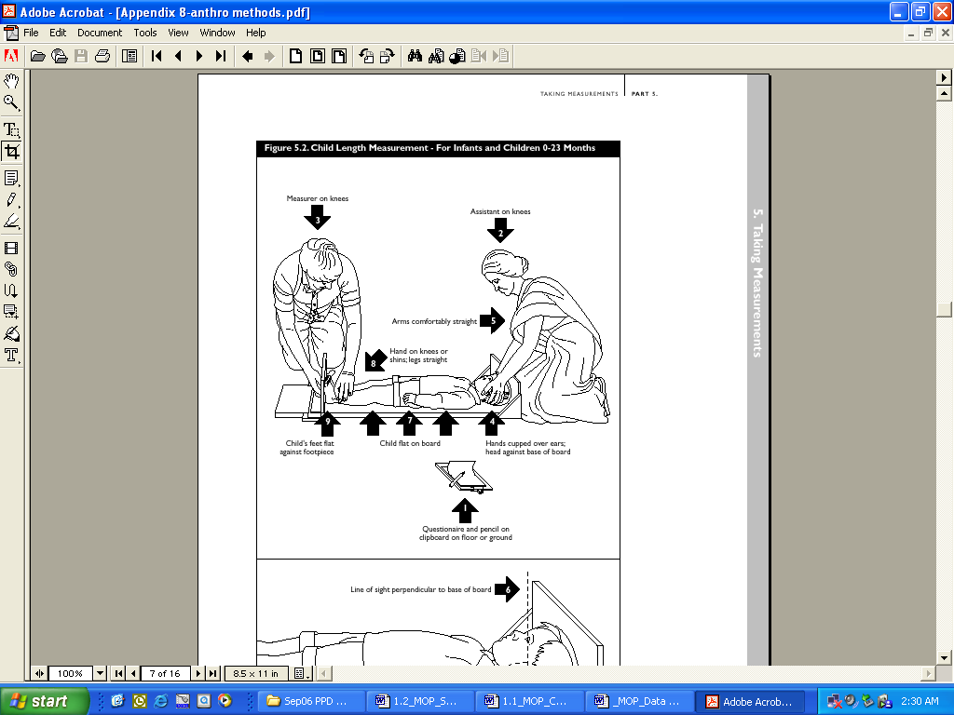

Figure 2. Head circumference

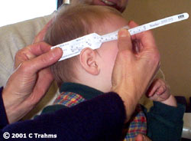

**Adult (Mother) and children 25+ months of age**

**I. Purpose**

To measure weight and height of the mother at the child’s two month visit, and to measure height and weight of children 25+ months of age.

**II. Material**

Maternal Assessment Form (MAF) or MOC, pen, digital scale, and alcohol wipes.

Boards, or what are called stadiometers, that are field friendly can be obtained from the same sources as those listed for children.

Seca 217 – Portable Stadiometer – Adult: 20-205 cm capacity (price US$209) with Seca 412 carrying case (price US$39)

<http://www.quicksupply.net/p-3144-seca-217-portable-stadiometer.aspx>

**III. Methods**

1. The FWs visit the homes of subjects and take anthropometric measurements.
2. For mothers of enrolled subjects, these anthropometric measurements will be collected when the subject is 2 months old. For children 25+ months of age, these anthropometric measurements will be taken every month from 25 to 36 months of age.
3. Explain to the mother or child what you intend to do, to ensure that the mother or child understands what you intend to do/ask of her. Explain in a non-threatening and culturally relevant manner, the purpose while providing the mother an opportunity to ask questions and decline participation if necessary. The equipment should be cool, clean and safely secured. Work out of direct sunlight.
4. FWs wash their hands with alcohol wipes before and after taking the measurements. The measuring board and scale are wiped clean after measuring each subject.
5. Weight Measurement:

1. FWs weigh the mother using a digital scale. The mother or child is weighed in light clothing, the weight of which can be estimated. The scale should be placed on a flat surface, and the mother is asked to stand still on the scale, so that the scale will display a weight. Make sure no one or anything else is on the scale. The subject will be weighed once. One FW reads the weight aloud and the other FW writes it on the form. The mother or child is weighed to the nearest 100 g or 0.1 kg.

Scale Quality Control:

On a weekly basis, the scale will be checked/calibrated with suitable standards. Use a 5 kg weight to check the lower range and then add on a 10 kg weight to check the upper range. If the scale is off by greater than the error of the instrument (specific to each model), then consider re-weighing mothers weighed that week. Record weekly balance values on the Scale QC Form.

1. Height measurement:

The height of subjects will also be measured. They will be measured using a measuring board (see figure 3 below). The subject stands in an upright position against the board. Please identify issues regarding hats/scarves, headdress, or hairstyle issues which will make measurement difficult. If possible, such clothing, hairstyles should be altered or removed for measurement.

1. The subject’s heels should be together if possible and touching the back of the board. The crown of the head will not likely touch the board, but the shoulders will touch, as well as the buttocks. The subject should be told to stand up straight, keep their head up and stare forward. The measurer checks the alignment as shown on the figure, including the line of sight.

*Note:* Although the figure illustrates the touching of the chin/neck and legs to hold the subject in place, this is not necessary with adults! Further, the FW/measurer will likely be standing rather than kneeling as shown in the figure.

2. The measurer slides the movable board down to the top of the crown of the head.

3. The height is recorded to the nearest 0.1 cm.

G. FWs clean scale, measuring board and their hands with alcohol wipes before leaving the home.

H. Completed forms are to be reviewed by the supervisor, returned to the Data Management area, and placed in the cabinet for double entry into the database.

**IV. Documentation**

Anthropometric results are hand-written onto the Maternal Assessment Form (MAF) or the MOC.

**V. Verification**

When informed by the Data Management staff, the Study Nurse and FWs will review any form that requires revision or clarification. These forms will be kept in the Data Management archive files.

**References**

- WHO, *Physical Status: the use and interpretation of anthropometry: report of a WHO expert committee,* World HealthOrganization, Geneva, 1995

Figure 3. Height measurement of older children and adults

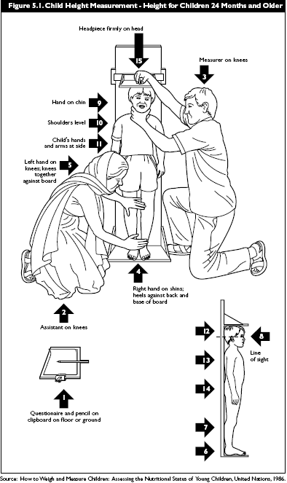

**References**

- NIH/NIAID/DMID Protocol 05-0071: Micronutrient Intervention in Brazil Long Term Impact and Intervention with Micronutrients

- Orientation Manual: Good Clinical Practices (17Jan.1997)

- WHO, *Physical Status: the use and interpretation of anthropometry: report of a WHO expert committee,* World HealthOrganization, Geneva, 1995

DBE─Detection of Bipedal Edema SOP

**Purpose:** The purpose of this SOP is to detect the presence of bipedal pitting edema in MALED participants at each monthly anthropometry assessments. This information will be recorded in the MOA & MOB form.

**Background** Edema (which can be found in types of malnutrition called kwashiorkor or marasmic kwashiorkor) is swelling of body parts from excess fluid in the tissues and is a result of under nutrition. It is usually seen in the feet and lower legs. In severe cases it may also be seen in the upper limbs and face.

**Materials**:

1. MOA &MOB form
2. Pen
3. Clipboard
4. Alcohol wipes

**Methods for detection of edema and text for the field staff**

Edema means swelling from excess fluid in the tissues. It is usually seen in the feet and lower legs. In severe cases it may also be seen in the upper limbs and face.

1. It is recommended (but not required) that FWs wash their hands with alcohol wipes before and after examining the children.
2. In order to check for edema, grasp the foot of the child so that it rests in your hand with your thumb on top of the foot. Press your thumb on the foot gently for three to five seconds (counted as one hundred and one, one hundred and two, and one hundred and three). The child has edema if a pit remains in the foot when you lift your thumb.
3. If you find edema in one foot, look for edema in the other foot. To be considered a **sign of severe acute malnutrition, edema must appear in both feet**. If the swelling is only in one foot, it may be due to a sore or infected foot. If the edema is found in both feet, answer “YES” (01) in MOB form question number 27. If edema is found in both feet, answer “YES” (01) in question 62 in MOA form & question 27 in MOB form. If edema is found in one foot, answer “NO” (00) in the MOA/MOB form and note this information in the nursing notes. If the feet cannot be examined due to burns, amputations or other conditions please record “NA” and fill a PDF and describe the circumstances in the observation/notes section. Pictures of Edema are shown below for reference.
4. If you detect edema in the feet, look for edema in other sites too. Based on the sites involved, edema is classified in the following way. Sites are encouraged to write this observation in their nursing notes.

+ mild: both feet

+ + moderate: both feet, plus lower legs, hands, or lower arms

+ + + severe: generalized edema including feet, legs, hands, arms and face

**Action once edema is detected**

All children with edema should be referred to the clinic for evaluation and appropriate local management.



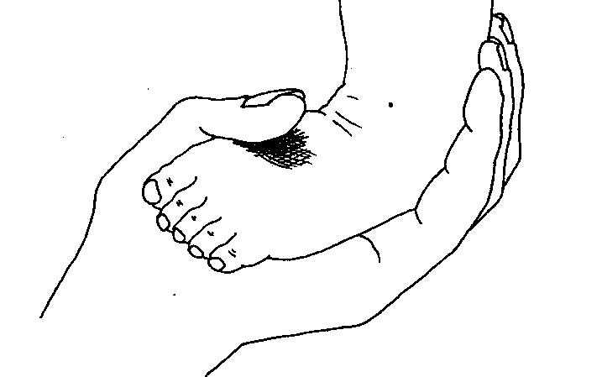

**References**

1. Waterlow JC. Kwashiorkor revisited: the pathogenesis of oedema in kwashiorkor and its significance. Trans Royal Soc Trop Med Hyg 1984;78:436-441.
2. Ahmed T, Rahman S, Cravioto. Oedematous malnutrition. Indian J Med Res 2009;130:651-654.
3. Rao KS, Swaminathan MC, Swarup S, Patwardhan VN. Protein malnutrition in South India. Bull WHO 1959;20.
4. Bhutta ZA, Black RE, Cousens S, Ahmed T. Kwashiorkor and severe acute malnutrition in childhood - Authors' reply. *Lancet* 2008;371:1749.

**Cognitive Development**

Cognitive Development Overview

The cognitive development component of MAL-ED is designed to collect information from the mother, the child, and the environment by assessing the following domains:

1. Global capacity (using the Bayley Scales of Infant Development) which will capture mental/motor/language/and behavior indices in the child
2. Language development (using an adaptation of the MacArthur Communicative Development Inventory) which will capture both receptive and expressive language abilities of the child
3. Temperament (using the Infant Temperament Scale-) which will capture maternal report of the child’s temperament
4. Reasoning ability (using the Raven’s Progressive Matrices) which will capture the mother’s ability to form comparisons, reason by analogy, and organize spatial perceptions into systematically related wholes
5. Depressive symptoms (using the Self Reporting Questionnaire, SRQ-20) which will capture maternal depressive symptoms
6. Environment (using the Home Observations for the Measurement of the Environment) which will measure the quality and quantity of stimulation and support which is available to the child in his/her home environment

These measurements will be completed at the following time points:

1. Bayley Scales: 6, 15, and 24 months (and 36 months, if resources and protocols allow)
2. MacArthur CDI - Words and Gestures: 8 and 15 months (and Words and Sentences at 30 months, if resources and protocols allow)
3. Temperament - Infant Temperament Scale: 6 months
4. Raven’s: 6-8 months
5. SRQ-20: 1, 6, and 15 months (and 24 and 36 months, if resources and protocols allow)
6. HOME (HIT): 6 and 24 months (and 36 months, if resources and protocols allow)

Study personnel should make every effort to administer the cognitive development assessments during the window allowed for that visit (DOB +/- 15 days). If an assessment is administered outside of this 30 day window, a Protocol Deviation Form (PDF) must be completed. Situations may arise which preclude administration of assessments as scheduled (examples: visually impaired mother cannot complete Raven’s; child is lethargic due to illness during the window for Bayley Scales). In these cases a Protocol Deviation Form should be completed to document either why a test was not performed or was performed outside the scheduled window.

The accurate collection of these measures requires formal training in Psychology and Child Development and we will therefore hire 2 individuals with (a minimum of) Master’s Level training in Psychology from each site (Psychological Research Assistants – PRAs). Additionally, 1 individual with senior level Psychology training will be hired by each site to serve a supervisory role for the 2 PRAs. Some of the tests require a quiet and private environment for proper administration while some can be done in the home. Therefore, each site will need to have access to a central clinic area that can be used for the purposes of administering the Bayley Scales and the Raven’s.

**Caregiver Definition**

Overall definition to ask the mother at the beginning of the study:

Who do you consider to be the primary caregiver of this child? By caregiver, we mean the person who is over the age of 16 and:

* is best aware of this child’s development
* best knows and understands this child’s temperament
* best knows this child’s sleep patterns
* most often takes the child to the doctor when the child is ill or takes the child to get his/her regular immunizations
* is best aware of what this child is being fed on a daily basis

The person that the mom identifies in response to the above question will be the one whom we consider the primary caregiver for the MAL-ED study. However, there may be some questionnaires where having someone else’s input makes sense (ie – someone else who spends a lot of time with the child). So, as it approaches the time point to give each of the various questionnaires, the following could be directed to the primary caregiver:

Temperament scale

During our next visit, we will be collecting information about CHILD’s NAME personality. In order to do this, we will be asking you how s/he behaves in various situations. If there are others who play a significant role in helping you take care of CHILD’S NAME, it may be helpful to have them present when we administer this questionnaire as they may be able to provide some insight into your child’s usual personality also. Is there someone else who takes care of CHILD’s NAME for a significant portion of time whom you think should be present for this session in order to help get the best picture of your child’s usual personality?

If the caregiver names someone else, write the name down so that person can be invited for the temperament data collection.

Word list

During our next visit, we will be collecting information about CHILD’s NAME language development. In order to do this, we will be asking you whether or not s/he understands and/or says certain words. If there are others who play a significant role in helping you take care of CHILD’S NAME, it may be helpful to have them present when we administer this questionnaire as they may have heard CHILD’S NAME say some words that you haven’t heard them say or they may realize that the child understands certain words that you might be unaware of. Is there someone else who takes care of CHILD’s NAME for a significant portion of time that you think should be present for this data collection in order to help get the best picture of your child’s language development?

If the caregiver names someone else, write the name down so that person can be invited for the Word list data collection.

Bayley

This should be collected with the mother present (in other words, the mother should be the primary caregiver for the Bayley data collection); this will provide the child with the mom’s comfort, if needed; even if the mom has a full-time job outside of the home, she should be able to provide accurate answers for the socio-emotional questionnaire. If the mother absolutely cannot accompany the child to the testing, and there is someone else whom the mother designates as knowing the child well, we will make and exception and allow this person to bring the child for the testing. This data represents our main development outcome so we don’t want to miss collecting this data from a child simply because the mother is unavailable for the testing.

Raven’s

This will only be administered to the biological mom as we are trying to account for genetics by collecting this data. If the mother has died, we will not collect this data from anyone else. If the biological mother is still alive but divorced, we should try to collect this data from her (presumably, she would have been the one to give the initial consent for the child’s participation in the study and, as such, she agreed to having her reasoning ability measured also).

SRQ-20

This should be administered to the mom as the purpose of this questionnaire is to get at maternal depressive symptoms; in our original proposal, we said we wanted to account for maternal depression so this questionnaire should only be administered to the mom. If the mother has died, we will not collect this data from anyone else. If the mother is still alive but does not live with the child, we will not collect this data as we are hypothesizing that a mom’s depressive symptoms affect her child’s development as a result of the child being exposed to the depression.

HOME

If a family has several caregivers for a child (mom, grandma, aunt, etc) it is quite likely that more than one of these caregivers will be present during the HOME assessment; that is perfectly fine and the form has a field for capturing others who are present; the interview questions will be directed toward the person who was identified as the primary caregiver (using our overall definition above) but we recognize that others who are present and knowledgeable about the issue, may chime in; in this way, we may have input from other caregivers, which will strengthen our data.

**Informed Consent**

The person whom the mom identifies as someone who knows the child well and should be present during the collection of questionnaire data, is not necessarily the person who signed the original informed consent. However, given the nature of the MAL-ED study, where field workers will be visiting the homes twice weekly, anyone identified by the mother as spending significant amounts of time with her child will already be very familiar with the study and the fact that s/he has the right to refuse to answer the questions. As such, we will not need a separate signed consent form from this person but will get their verbal consent to participate after being given a description of what is going to be asked of them as well as a reminder that they may refuse to participate.

HIT—HOME Inventory (Infant/Toddler Version)

1. **Purpose**

The adapted infant/toddler version of the HOME inventory will be administered by a Psychological Research Assistant (PRA) at 6 months ± 15 days and 24 months ± 15 days of age (and 36 months ± 15 days, if resources and protocols allow). We have included this ‘window period’ to make scheduling a bit easier. If the mother or primary caregiver is unable to be tested during this window period (for instance, if she is out of town), we will still collect this data as soon as she is able to be tested (for instance, when she returns). However, the date of test administration will be noted and therefore we will know that this data was collected at a slightly different time for that particular subject. If the date of the test administration is outside the ± 15 day window, a Protocol Deviation Form should be completed. The version we will use for the MAL-ED study was adapted by Maureen Black and used in India, previously. The HOME Inventory is designed to measure the quality of stimulation available to the child in the home.

1. **Materials**

Home Inventory Form (HIT), Home Inventory SOP, clipboard, pen.

1. **Methods**
2. The HOME Assessment should be scheduled at a time when the primary caregiver and child are in the home and the child is awake and not scheduled to be napping. During one of the regularly scheduled bi-weekly visits, a Health Worker will remind the mother of the upcoming HOME assessment to be done and will schedule a time for that assessment with the mother. The Health Worker will tell the mother the following: “As you were told during study enrollment, we will be visiting your home in order to see what the environment is like for your child. In order to do our assessment, we need to schedule a time with you when you and your child will be home and when your child will be awake and active. The assessment will typically take about 1 hour. During this time, we will be asking you some questions and observing your interaction with your child in your home. Therefore, we need to ensure that you and your child will be home during the entire time that we are completing our assessment. I’d like to go ahead and schedule a time for that assessment.” The Health Worker will then schedule a time that is within 6 months ± 15 days (or 24 months ± 15 days).
3. Caregiver: The HOME is scheduled with the primary caregiver and child. In most situations, the primary caregiver will likely be the mother. However, there are times when the primary caregiver will be a grandmother, aunt, sibling, etc. If the primary caregiver identified is less than 12 years of age, the observation/interviewing will be done with the mother. Be sure to identify the primary caregiver whom you are interviewing/observing on the HIT record form.
4. At the beginning of the observation the PRA will tell the caregiver that s/he wants to watch the child’s daily activities for awhile (about one hour) and that the caregiver will be asked a few questions. The PRA will also tell the caregiver that s/he would like to see where the child eats, sleeps, and plays. This will give the PRA access to the entire house and will enable the observation of things such as toys or books. The PRA will tell the caregiver to go about her work, but to keep the child at home (not let the child go to the neighbor’s house, etc). The PRA will assure her that this is routine procedure for all children and families. If the family has a yard/courtyard like area that is considered “part of the house”, the child and/or caregiver should feel free to spend time there during the assessment. They do not have to be indoors only, they just need to remain on the property so they can be observed.
5. The PRA should find a place to sit that is off to the side, but will give a good view of the house. The PRA should try to blend into the background.
6. The PRA should try not to stare at the child and family. Staring would make the family feel uncomfortable. It is OK to chat with the family a bit, especially at the beginning of the observation, to help them feel comfortable with your presence, then excuse yourself and say that you have some work to do. Your “work” is to watch the family, but be discrete. The PRA should be completely familiar with the instrument so that the initial chatting time can actually be used to gather information needed to complete the HIT. While you are working, do not smile or interact with the family – look down at your clipboard.
7. The PRA will record who s/he saw in the house during the observation (relationship to child and total number). Questions should be directed to the primary caregiver, if possible.
8. The PRA will complete each question of the Inventory by answering either no or yes. Some questions require observation only, some require interview, and some can be completed either through observation or interview. The interview questions can be integrated throughout the observation time but are generally asked at the end. This will give the PRA time to observe as much as possible and in the course of the observation/chatting with the primary caregiver, the PRA may get answers to many of the questions that are marked ‘interview’ and/or ‘either’. At the end, the PRA should check for those questions that still need answers and ask these to the primary caregiver. For questions that ask whether or not the caregiver does something (for example: “Caregiver tells the child the name of some object or says the name of a person or object in a teaching style during the visit”, a positive score (score of 1) should be recorded if anyone present in the household (grandma, dad, aunt, older sibling, etc) does this activity. In other words, remember that we are interested in capturing the home environment from the CHILD’S point of view. If someone is naming objects for him/her, then this child is receiving that stimulation. The PRA does not have to observe the primary caregiver engaging in all of these activities in order to score positively (a score of 1), they just have to observe someone present engaging in these activities.
9. In order to ensure that each mother receives the same instructions, the following instructions will be read by the PRA to the mother:

‘I am here today to watch the child’s daily activities for awhile (about one hour) and during this time I will ask you a few questions. In order to do my work today, I would like to see where the child eats, sleeps, and plays. While I do my work, please go about your regular work but be sure to keep CHILD’S NAME at home (don’t let the child go to the neighbor’s house, etc). This is routine procedure for all children and families and will allow me to get my work done in a timely fashion. I am going to sit off to the side so that I can do my work. I need you to go about your regularly scheduled activities while I’m here so that I can get an idea of what your child experiences every day. Please do not feel like you need to entertain me during this time. I will be doing my work. Do you have any questions before I begin?’

1. Question guidance.

|  |  |  |
| --- | --- | --- |
| **#** | **Question** | **Guidance** |
|  | Participant ID | Write the child’s participant ID in the space provided at the upper left corner. |
| 01 | Study Researcher/  Nurse/Fieldworker ID | Enter the Study Researcher / Nurse / Fieldworker’s unique ID number here. |
| 02 | Today’s Date | Format DD/MMM/YY |
| 03 | Identity of primary caregiver (person being interviewed) | This question is to identify the primary caregiver, *ie.* the person to whom the questions are being addressed.  Enter the code for the caregiver: 01=mother, 02=father, 03=grandmother, 04=grandfather, 05=aunt, 06=uncle, 07=other relative, 08=other nonrelative. |
| 04 | # of people present during this observation period | Enter the number of people present in the household during any part of the interview, including the primary caregiver and study child. |
| 05 | Identity of those present in addition to the child and primary caregiver | Identify ALL of the people present *in addition* to the caregiver. Include anyone present for any part of the interview. Do not include the primary caregiver here. Use the following codes: 01=mother, 02=father, 03=brother, 04=sister, 05=grandmother, 06=grandfather, 07=aunt, 08=uncle, 09=cousin, 10=other relative, 11=other nonrelative. These codes may be used more than once. Strike through extra empty boxes—these will be coded as NA during data entry. |
| The possible answers for all of the following questions are: Yes=01, No=00. | | |
| 06 | Caregiver spontaneously vocalizes to the child at least twice during the visit (exclude scolding). (Observation) | “Vocalizes” refers to any sounds or words emitted by the caregiver. For example, she may say “S-s-s” or “sweet baby,” or any random words or sounds. For this item to be scored positively, the caregiver’s vocalizations must have occurred spontaneously, as opposed to having occurred in response to vocalizations by the child. |
| 07 | Caregiver responds to child’s vocalizations with a verbal response. (Observation) | The caregiver’s response may be either a complete word or words or merely clearly differentiated sounds, e.g., “ta-ta” “tsk-tsk”. The key factor here is that the caregiver is responding to the child’s vocalization, not ignoring it. If the child does not vocalize during the interview, the score should be “No.” |
| 08 | Caregiver tells the child the name of some object or says the name of a person or object in a teaching style during the visit. (Observation) | This item measures the adult’s sensitivity to the child’s search for labels of objects. Credit for this item may be earned by a pattern of emphasis with the voice. For example, “Do you remember Miss Jones?” – referring to the interviewer. Caregiver may also name common objects and say something like, “Where is the cup?” A “Yes” on this object is an automatic “Yes” on item #24. This may often occur during the introduction and chatting period so PRA should be on the alert for this type of behavior occurring so that they can record it. |
| 09 | Caregiver’s speech is distinct, clear, and audible. (Observation) | Credit is given if the interviewer can understand and communicate with the caregiver. |
| 10 | Caregiver initiates verbal exchanges with the observer – asks questions, makes spontaneous comments. (Observation) | Caregiver must demonstrate some initiative in asking 2 or 3 questions or making comments that go beyond the bare minimum needed to answer a question.  This may often occur during the introduction and chatting period so PRA should be on the alert for this type of behavior occurring so that they can record it. |
| 11 | Caregiver expresses ideas freely and easily, and uses statements of appropriate length for conversation (i.e., gives more than brief answers). (Observation) | Credit if the caregiver gives more than one-word responses – that is if the caregiver expands a bit on the responses. |
| 12 | Caregiver spontaneously praises child’s qualities or behavior at least twice during visit. (Observation) | Give credit if the caregiver reports any achievement of the child with pride (e.g., He can dress himself.) Be sure to note the caregiver’s affect – for example, she may say, “He is so bad.” But have a smile on her face or continue to add that he insists on doing things himself. |
| 13 | When speaking of or to the child, caregiver’s voice conveys positive feeling. (Observation) | You are looking for evidence that the caregiver feels good about the child – that she sounds animated when speaking about the child. |
| 14 | Caregiver does something affectionate with the child (hugs, caresses, kisses, pats, etc.) at least once during the visit. (Observation) | Any positive physical contact would be a credit. Blowing a kiss or waving affectionately to the child would also be a credit. |
| 15 | Caregiver shows some positive emotional response or praise to the child offered by the observer. (Observation) | The observer should offer a positive comment to the caregiver about the child’s behavior (e.g., She is playing, running, sitting, smiling, listening etc. so well.). The comment must be genuine. Credit if the caregiver agrees, says “thank you,” looks pleased, or gives an indication that she is proud of the child. |
| 16 | Caregiver smiles at the child or laughs with the child. (Observation) | Credit if the caregiver shows some positive affect with the child – could be a slight smile with eyes brightening. |
| 17 | Caregiver does not shout at the child during the visit. (Observation) | Caregiver does not raise her voice toward the child.  Note that this is a negatively worded question and you should therefore be careful with the scoring. If caregiver does NOT raise her voice toward the child, then the answer is yes (i.e. Yes, the caregiver does not raise her voice). |
| 18 | Caregiver does not express overt annoyance or hostility towards the child. (Observation) | Caregiver would receive “No” if she complains that the child is hard to care for or a bother. Note, be sure to look at her affect. For example, she might say that the child is “bad,” but she is smiling and her affect does not suggest annoyance or hostility.  Note that this is a negatively worded question and you should therefore be careful with the scoring. |
| 19 | Caregiver does not slap or spank the child during the visit. (Observation) | Caregiver does not hit the child during the visit or do any physical punishment, such as pinch or spank.  Note that this is a negatively worded question and you should therefore be careful with the scoring. |
| 20 | Caregiver reports no instances of physical punishment during the past week. (Interview) | Say, “Some parents spank their children if they do not listen. Did you have to spank or hit your child in the past week?” Credit if the caregiver reported that she did not hit or spank the child in the past week. If she reports hitting the child, she does not receive credit.  Note that this is a negatively worded question and you should therefore be careful with the scoring. |
| 21 | Caregiver does not scold or criticize the child during the visit. (Observation) | The caregiver receives credit if she does not make any direct negative remarks toward the child. If she says to the child “you are a bad boy” she would receive no credit. On the other hand, if she says to the observer, “He is a bad boy.” She would receive credit because she did not speak DIRECTLY to the child.  Note that this is a negatively worded question and you should therefore be careful with the scoring. |
| 22 | Caregiver tends to keep the child within visual range and looks at the child quite often. (Observation) | The caregiver is clearly aware where the child is located. “Often” means frequently enough to ensure safety of the child and to keep some kind of interpersonal contact with him. |
| 23 | Caregiver talks to the child while doing her housework. (Observation) | “Talking” to the child in this item means that the caregiver finds a way of including the child in what she is doing. She may make a comment to the child or smile at the child. |
| 24 | Caregiver consciously encourages developmental advances. (Either) | The caregiver does some activity that promotes the child’s development. For example, if the child does not walk, the caregiver may position the child in a standing position or helps the child walk. If the child is playing with a toy, the caregiver may name the toy or comment on the color, size, or shape of the toy. |
| 25 | Caregiver structures the child’s day. (Interview) | Ask the caregiver, “Tell me about the child’s typical day. For example, when does he wake up?“ After she responds, ask, “What happens next?” Continue in this manner and ask, “How typical is this?” Credit if there is a structure to the child’s day - the caregiver describes when the child gets up, what happens next, etc. No credit would be given if the caregiver says that there is no structure or schedule, that every day is different, that the child gets up whenever he wants, etc. |
| 26 | Caregiver believes the child’s behavior can be changed or modified and is influenced by the parent’s behavior. (Interview) | Ask, “How does your child learn to do things, such as feed himself (or dress himself – only add this last part of the question at the 24 month assessment)?” Credit if the caregiver responds that she teaches the child or the child learns by watching others or being taught by others. No credit should be given if the caregiver has no idea how the child learns things. |
| 27 | When the primary caregiver is away, care is provided by one of three regular substitutes. (Interview) | Ask, “When you go out and cannot take the child, who looks after him?” Credit if the caregiver reports that there are regular caregivers (e.g., grandmother, aunt, father). No credit would be if the caregiver says, “Anybody, nobody, or I don’t know.” |
| 28 | Child is not cared for by another child (under 12 years of age). (Interview) | Ask, “Is the child ever cared for by another child?” If yes, ask the approximate age of the other child? Credit if the other child is at least 12 years of age. No credit if the other child is less than 12 years.  Note that this is a negatively worded question and you should therefore be careful with the scoring. |
| 29 | There is no evidence that older children or adults handle the child inappropriately. (Observation) | Watch how older children or adults (including the mother) handle the child. Indicate no credit if the child is handled roughly (e.g., picked up by one arm, kicked, tickled too much, teased a lot).  Note that this is a negatively worded question and you should therefore be careful with the scoring. |
| 30 | Someone takes the child to a shop or market at least once a week. (Interview) | Ask. “How often do you take the child shopping with you?” Credit if the child accompanies the caregiver at least once a week. |
| 31 | The child is taken to the health clinic regularly (to be weighed or to get immunizations). (Interview) | Ask, “How often do you take the child to the health clinic?” If the caregiver says that she takes the child to the clinic when he is sick, ask if they go any other time. Credit if the caregiver mentions taking the child to the clinic for regular immunizations or check-ups, beyond times when the child is ill. The children in this study are going to be weighed on a more regular basis than usual. This does not qualify as being taken to a health clinic regularly. For this question, we are interested in occasions when the child is taken to the health clinic for reasons which are distinct from this study. |
| 32 | The child has a special place to keep his toys and “treasures.” (Either) | You may be able to observe where the child’s things are kept. If you do not observe any place for the child’s toys, ask “Where do you keep the child’s toys or things for the child to play with?” Credit if the caregiver has a place to store the child’s things. No credit is she says that he does not have anything to play with or she says that the play materials are “anywhere.” |
| 33 | The child’s play area is relatively safe and free from hazards. (Observation) | The interviewer should watch where the child plays and look for potential hazards. Examples: broken glass lying around, knife, stove turned on, boards with nail, open hole, anything hot, playing on the roof with no ledge or low ledge. Since this is a home environment assessment, do not consider the area outside of the home such as the street but do consider areas such as the yard/courtyard. |
| 34 | The stove is located in a relatively safe area. (Observation) | Having the stove on the floor close to where the child is playing would be regarded as hazardous. On the other hand, if the stove is in a kitchen or in an area that is sectioned off, it would be relatively safe. |
| 35 | The house is relatively light. (Observation) | "Relatively light" should be defined as enough light for the child to safely play with toys and be able to see what s/he is doing. |
| 36 | The house is relatively ventilated. (Observation) | House has some ventilation. Should have at least 2 windows or window and door across from one another for cross ventilation. |
| 37 | The house is relatively clean. (Observation) | There are not dirty dishes, there are no flies or only a few flies, and the house appears to be relatively clean. |
| 38 | The house is relatively neat and orderly. (Observation) | There are not piles of junk lying around. Items seem to be stored in a proper place. |
| 39 | There are some toys, tins, balls, dolls, slates, or material in the house that are appropriate play materials for the child. (Either) | There are some materials in the house that the child can use for playing. If you do not see anything, ask, “What does the child like to play with?” To receive a positive score, the caregiver must name something – she cannot just say “Anything.” |
| 40 | The child has a riding toy or some toy that provides gross motor stimulation. (Either) | If you do not see a gross motor toy, ask, “Does the child have a riding toy or a toy that requires them to use large muscles to play with?” |
| 41 | The caregiver provides toys or interesting activities for the child during the visit. (Observation) | Credit if the caregiver structures something for the child to do during the visit. |
| 42 | There are some magazines, newspapers, or books visible in the house. (Observation) | Credit if there is anything to read in the house even if the child does not have access to it (e.g., film magazines). It is not necessary for the caregiver to be literate. |
| 43 | The family has a pet. (Either) | Credit if the family has an animal that they feed regularly even if they do not “own” the pet. |
| 44 | The father (or a father figure) plays with the child or provides some caregiving every day that the father (or father figure) is home. (Either) | Ask, “Does the father (or a father figure) play with the child or take care of the child?” If the caregiver says yes, ask how often. Credit only if she says "every day that the father (or father figure) is home.” There may be instances where some fathers have jobs which require them to be gone from the house for several days/weeks at a time. In such cases, they can’t be playing with/providing caregiving for their child on a daily basis. We are interested in whether or not the father plays with the child/provides caregiving every day that the father is there. |
| 45 | The caregiver tells the child stories or nursery rhymes at least once a week. (Interview) | Ask, “Do you or another caregiver tell the child stories or nursery rhymes?” If she says yes, ask how often. Credit if she says at least once in a week. |
| 46 | The caregiver sings to the child everyday. (Interview) | Ask, “Do you or another caregiver sing to the child?” If she says yes, ask how often. Credit if she says everyday. Credit will only be given for those instances where the singing/music is for the child specifically. Even playing music on a radio, etc for the child may be credited. The important points are that it has to be music and it has to be directed at the child (a parent who is a singer and therefore practices his/her singing at home is not given credit for this question unless the singing is specifically directed at the child). |
| 47 | The child eats at least one meal per day with the caregiver and the father (or a father figure) on days that the father (or a father figure) is present in the home. (Interview) | Ask, “On days that the father (or a father figure) is present, how often does the child eat a meal with the father (or father figure) and you?” Credit if the child eats with the mother (or other caregiver) and father (or father figure) at least once a day (on days that the father is home). Hence, a single mother may get credit for this question if there is a father figure. |
| 48 | The family has not moved from their primary residence more than once in the past year. (Interview) | Ask, “How many times have you moved from your primary residence in the past year?” Credit if they have not moved more than once in the past one year.  Note that this is a negatively worded question and you should therefore be careful with the scoring. |
| 49 | The family visits or receives visits from relatives at least once per month. (Interview) | Ask, “How often do you visit your relatives or do they visit you?” Credit if the caregiver says at least once per month. |
| 50 | The family visits or receives visits from close friends at least once per month. (Interview) | Ask, “How often do you visit your friends or do they visit you?” Credit if the caregiver says at least once per month. |
| 51 | The child is relatively clean, with no offensive odor. (Observation) | The child’s face and body are relatively clean. Note that the child may be dirty from recent play. If the dirt appears to be older than one day, the child would not receive credit. |
| 52 | The child’s hair is relatively clean. (Observation) | The child’s hair is not greasy or dirty. It appears to have been washed recently. |
| 53 | The child’s clothes are relatively clean. (Observation) | The child’s clothes are not dirty (beyond recent dirt from playing that day). Note that the child’s clothes may be old or torn, but they must be relatively clean to receive credit. |

RCM—Raven’s Combined Progressive Matrices

**I. Purpose**

The Raven’s Combined Progressive Matrices will be administered to the biological mother of the study child in order to assess maternal reasoning ability. We are collecting this information because of the known relation between maternal reasoning ability and child reasoning ability. We therefore want to collect this data in order to control for maternal reasoning abilities in our statistical analyses.

**II. Materials**

Raven’s Combined Progressive Matrices form (RCM), RCM SOP, Raven’s Standard and Coloured Progressive Matrices test books, clipboard, pen, recording equipment.

**III. Methods**

In order to use a standardized administration at all sites, we have decided to use a combination of the Standard Progressive Matrices (SPM) and Coloured Progressive Matrices (CPM). The SPM has 5 sets of problems (A – E) with each set containing 12 problems (1 – 12). The CPM has 3 sets of problems (A, AB, B) with each set containing 12 problems (1 – 12). We will start with set C of the SPM and if a particular woman does not answer the problems from start point to C5 correctly, the tester will go back 1 step to set B of the CPM. The rule to “go back 1 step” will continue as such (if the woman does not answer the problems from start point to B5 from the CPM correctly, she will be given set AB from the CPM, etc). So, sets A and B from the SPM will never be administered. A woman will receive credit for problems that came before her starting point (so, if she successfully completes the problems from start point to C5 from SPM, she will receive credit for all of the sets in the CPM.) The PRA should leave the record form blank for problems that the mother did not need to complete (the database management team will write a program that will automatically give the mothers credit for any problems that came before her starting point).

The Raven’s Combined Progressive Matrices will be administered to each mother by a Psychological Research Assistant (PRA). This will be done at 6-8 months ± 15 days postpartum. We have included this extended ‘window period’ (from 51/2 months to 81/2 months) to make scheduling a bit easier. If a woman is unable to be tested during this window period (for instance, if she is out of town), we will still collect this data as soon as she is able to be tested (for instance, when she returns). However, the date of test administration will be noted and therefore we will know that this data was collected at a slightly different time for that particular subject. If the date of the test administration is outside the 6-8 month ± 15 day window, a Protocol Deviation Form should be completed. It requires a quiet space with good lighting. Therefore, this test will be administered at the central clinic location. Each Raven’s administration will be video recorded and the file will then be downloaded to a computer and stored until certain files are sent to Laura MK for QC purposes. The files that are not sent will be immediately destroyed. The video camera should be set up so that it captures the entire testing area (the mother, the table with the testing materials, and the tester). If there is a problem with the video equipment or there is another problem that precludes you from using the equipment (electrical outage, for instance), the test should still be administered. In other words, although we want to capture all of the testing sessions on video, we understand that issues will arise that preclude us from using the equipment and we do not want that to stop us from collecting the data. The PRA and the mother will sit together in a private and quiet room. No one else will be allowed in the room as this could pose a distraction. The PRA will be sure to place the clipboard with the record form on his/her lap so that the mother cannot see it. They will place the test booklet flat on the table, in front of the mother. The PRA will introduce the Raven’s Combined Progressive Matrices using the following script. The items marked *say* are things the PRA will say, those marked *do* are things the PRA will do. All sites must use this exact script to ensure that every mother receives the same instructions across all 8 MAL-ED sites.

say: This is a test of observation and clear thinking.

do: Show subject problem C1 (from the Standard Progressive Matrices).

say: The top part of C1 is a pattern with a bit cut out of it. Look at the pattern and think what the piece needed to complete the pattern correctly both along and down must look like. Then, find the right piece out of the 8 bits shown below. Only one of these pieces is perfectly correct. These are all…

do: Point to each in turn.

say: …the correct shape to fill the space but only one of them is the right pattern. Number 2 is not the right pattern; #4 is quite wrong; #1 is nearly right but is wrong here.

do: Point to the piece which is correct.

say: #8 is the right piece, isn’t it? So the answer is #8.

do: Write the correct answer on the answer sheet.

do: Flip the page to problem C2.

say: Please point to the correct piece for this problem.

do: Allow sufficient time for subject to respond.

Make sure subject has answered correctly so you are confident she understands the instructions. Write the correct answer on the answer sheet. *If she responds incorrectly, go back to problem C1 and explain the instructions again. Please remember that after a second explanation of problem C1, the woman must go on and complete the rest of the test. That is, only 2 examples of how to solve problem C1 will be given to any 1 subject.Giving further instruction will invalidate the woman’s scores.*

say: On every page of the booklet there is a pattern with a piece missing. You have to choose the correct piece to complete each pattern. When you think you’ve found the right one, point to it. If you want to change your mind, let me know. Do you have any questions? You may work at your own pace. If you are not sure, guess. If you get stuck, let me know and we’ll move on to the next problems and then come back to those you had difficulty with. We will now begin.

do: Turn over to problem C3 and start (note the time in the ‘start time’ boxes on the record form). For *every problem in set C (C1 – C12), before the person taking the test has time to point to one of the pieces:*

say: Look carefully at these pieces (move your finger across them). Only one of these pieces is right to complete the pattern. Be careful. Look at the pattern and each of the 8 pieces first (point to each of the 8 pieces). Now you point to the right one to complete the pattern.

do: Write down the number of the piece that the woman points to as the answer. If they do not correctly answer from start point through C5 (they will all get problem C1 correct because you actually do it for them as part of the instructions), go back and administer set B from the Coloured Progressive Matrices. If they do not correctly answer from start point to B5 (from the Coloured Progressive Matrices), go back and administer set AB from the Coloured Progressive Matrices. If they do not get from start point through AB5 (from the Coloured Progressive Matrices) correct, go back and administer set A from the Coloured Progressive Matrices. Therefore, the order of test administration is as follows:

* + Begin with set C of the Standard Progressive Matrices. If subject responds to problems from start point to C5 correctly, continue on to finish set C and then go on to sets D and E (she will receive credit for all of the problems that came before set C that she did not need to complete). If subject does not respond to problems from start point to C5 correctly:
  + go back and administer set B from the Coloured Progressive Matrices. If subject responds to problems from start point to B5 correctly, continue on to finish set B (from Coloured Progressive Matrices) and then go on to sets C through E of the Standard Progressive Matrices (subject will receive credit for any problems that came before set B that she did not need to complete). If subject does not respond to problems from start point to B5 (from Coloured Progressive Matrices) correctly:
  + go back and administer set AB from the Coloured Progressive Matrices. If subject responds to problems from start point to AB5 correctly, continue on to finish set AB (from Coloured Progressive Matrices) and then go on to set B of the Coloured Progressive Matrices and then sets C through E of the Standard Progressive Matrices (subject will receive credit for any problems that came before set AB that she did not need to complete). If subject does not respond to problems from start point to AB5 (from Coloured Progressive Matrices) correctly:
  + go back and administer set A from the Coloured Progressive Matrices. Administer all problems in set A (from Coloured Progressive Matrices) and then go on to sets AB and B of the Coloured Progressive Matrices and then sets C through E of the Standard Progressive Matrices.

For all of the problems, if the woman is pointing to a choice (whether right or wrong) without taking her time to look at the pattern and each of the possible choices, remind her to take her time and to consider every choice before answering. At the end of 20 minutes, note the number of the problem being worked on but continue until the test is completed.

**Reporting**

Write the mother’s Participant ID in the space provided at the upper left corner.

When the PRA starts the test s/he will start the stopwatch. S/he will note what number item the participant is solving after 20 minutes have passed. If the participant has already finished solving all the problems before 20 minutes the PRA will also note this.

**Start Time**

The PRA will record the time the participant begins testing (testing begins when the participant starts problem C3) on a twenty-four hour clock. The hour and minutes will be recorded separately using two digits. For example, if a participant starts testing at 1:28 PM the PRA will record 13 in the hour box and 28 in the minutes box.

**End Time**

The PRA will record the time when the participant finished the last question on a twenty four hour clock. The hour and minutes will be recorded separately using two digits. For example, if a participant finishes testing at 1:28 PM the PRA will record 13 in the hour box and 28 in the minutes box.

**Answers section A**

For each item, the participant will indicate her answer choice to the PRA by pointing. The PRA will record the answers to each question on the record sheet in the box labeled with that question’s number. The answer to question A1 will be recorded in box A1, the answer to question A2 will be recorded in box A2. The participant will only solve the problems in set A if she is not able to correctly respond to problems from start point to AB5 (from the Coloured Progressive Matrices). If she does not need to solve the problems in set A, write NA in the first box (A1) and strike through the remaining boxes in the section.

**Answers section AB**

For each item, the participant will indicate her answer choice to the PRA by pointing. The PRA will record the answers to each question on the record sheet in the box labeled with that question’s number. The answer to question AB1 will be recorded in box AB1, the answer to question AB2 will be recorded in box AB2. The participant will only solve the problems in set AB if she is not able to correctly respond to problems from start point to B5 (from the Coloured Progressive Matrices). If she does not need to solve the problems in set AB, write NA in the first box (AB1) and strike through the remaining boxes in the section.

**Answers section B**

For each item, the participant will indicate her answer choice to the PRA by pointing. The PRA will record the answers to each question on the record sheet in the box labeled with that question’s number. The answer to question B1 will be recorded in box B1, the answer to question B2 will be recorded in box B2. The participant will only solve the problems in set B if she is not able to correctly respond to problems from start point to C5 (from the Standard Progressive Matrices). If she does not need to solve the problems in set B, write NA in the first box (B1) and strike through the remaining boxes in the section.

**Answers section C**

For each item, the participant will indicate her answer choice to the PRA by pointing. The PRA will record the answers to each question on the record sheet in the box labeled with that question’s number. The answer to question C1 will be recorded in box C1, the answer to question C2 will be recorded in box C2. The participant will solve all the problems in set C before proceeding to set D.

**Answers section D**

For each item, the participant will indicate her answer choice to the PRA by pointing. The PRA will record the answers to each question on the record sheet in the box labeled with that question’s number. The answer to question D1 will be recorded in box D1, the answer to question D2 will be recorded in box D2. The participant will solve all the problems in set D before proceeding to set E.

**Answers section E**

For each item, the participant will indicate her answer choice to the PRA by pointing. The PRA will record the answers to each question on the record sheet in the box labeled with that question’s number. The answer to question E1 will be recorded in box E1, the answer to question E2 will be recorded in box E2. The participant will solve all problems in set E.

**Record the Section and Item number of the problem being worked on at end of 20 minutes**

The PRA will record the problem number the participant is solving when the 20th minute of her test ends. S/he will record the problem number using the codes xA01--xE12. If the participant is finished the test before 20 minutes are up the PRA will record 9999.

SRQ—Self-Reporting Questionnaire 20

**I. Purpose**

The SRQ-20 will be administered to the biological mother of the study child in order to collect data on depressive symptoms. Given the known relation between depressive symptoms in the caregiver and child development, we are collecting this information in order to control for it in our statistical analyses.

**II. Materials**

SRQ-20 form, SRQ-20 SOP, clipboard, pen

**III. Methods**

The SRQ-20 will be administered by a Psychological Research Assistant (PRA) to the mother at 1, 6, and 15 months, (and at 24,and 36 months if resources and protocols allow) postpartum. The collection window for each assessment is ± 15 days (eg 1 month ± 15 days). We have included this ‘window period’ to make scheduling a bit easier. If the mother is unable to be tested during this window period (for instance, if she is out of town), we will still collect this data as soon as she is able to be tested (for instance, when she returns). However, the date of test administration will be noted and therefore we will know that this data was collected at a slightly different time for that particular subject. If the date of the test administration is outside the ± 15 day window, a Protocol Deviation Form should be completed. This will be done during a home visit. Only the PRA and mother will be present during the administration of this questionnaire given the sensitive nature of some of the questions. This questionnaire can be used as a self-administered questionnaire or interviewer administered questionnaire. For purposes of consistency across the sites, we will employ the interviewer administered questionnaire technique.

There are 20 items on the SRQ, each scored 0 or 1. A score of 1 indicates that the symptom was present during the past month while a score of 0 indicates that the symptom was absent. Therefore, the maximum score is 20.

The PRA will begin by introducing herself and explaining that she is asking these questions in order to get a sense of the mother’s mood over the last 30 days. In order to ensure that each mother receives the same instructions, the following instructions will be read by the PRA to the mother:

“The following questions are related to certain pains and problems that may have bothered you the last 30 days. If you think the question applies to you and you had the described problem in the last 30 days, answer yes. On the other hand, if the question does not apply to you and you did not have the problem in the last 30 days, answer no. I am not allowed to discuss the items with you while we are completing the questionnaire. However, after all questions have been asked, I would be happy to go back and discuss any of the questions with you, if you’d like. Please do try to answer yes or no to every question that I ask you, even if it is approximate.”

The PRA proceeds by asking every question on the questionnaire. After every other question, the PRA should remind the mother that the questions are asking about feelings/behaviors in the past 30 days. We want to make sure that the mother remembers that she is not reporting simply on the present. Once all of the questions have been asked and answered, the mother is free to discuss any of the questions with the PRA. This discussion time should not be used to change any of the previously given answers. Rather, this discussion time is used to allow subjects to feel that they are being listened to and serves as a way to discourage the mothers from insisting on discussion while the questionnaire is being administered.

Once the questionnaire is finished, if the PRA is concerned about the mother’s mental health (based on answers that she gave to the questions), s/he must immediately report this concern to his/her supervisor. The supervisor will then proceed with culturally appropriate follow-up/referral. Each site will identify a locally relevant SRQ-20 score cutoff value to recognize respondents who meet the criteria for referral. A positive answer to having suicidal thoughts (question 17) is also grounds for referral, regardless of the total SRQ-20 score. The referral support services will vary by site according to local customs and resources. If a mother is referred, you may record this on the Nursing Notes Form (NUR), which will not be entered into the database.

|  |  |  |
| --- | --- | --- |
| **#** | **Question** | **Guidance** |
|  | Participant ID | Write the mother’s participant ID of the mother in the space provided at the upper left corner. |
|  | Study Researcher/  Nurse/Fieldworker ID | Enter the Study Researcher / Nurse / Fieldworker’s unique ID number here. |
|  | Today’s Date | Format DD/MMM/YY |
|  | Identity of primary caregiver | The mother is the person being interviewed for the SRQ-20. This question asks her to identify *who she considers* the primary caregiver of the study child.  Enter the code for the caregiver: 01=mother, 02=father, 03=grandmother, 04=grandfather, 05=aunt, 06=uncle, 07=other relative, 08=other nonrelative. |
| 01 | Do you often have headaches? | 00 = No; 01 = Yes |
| 02 | Is your appetite poor? | 00 = No; 01 = Yes |
| 03 | Do you sleep badly? | 00 = No; 01 = Yes |
| 04 | Are you easily frightened? | 00 = No; 01 = Yes |
| 05 | Do your hands shake? | 00 = No; 01 = Yes |
| 06 | Do you feel nervous, tense or worried? | 00 = No; 01 = Yes |
| 07 | Is your digestion poor? | 00 = No; 01 = Yes |
| 08 | Do you have trouble thinking clearly? | 00 = No; 01 = Yes |
| 09 | Do you feel unhappy? | 00 = No; 01 = Yes |
| 10 | Do you cry more than usual? | 00 = No; 01 = Yes |
| 11 | Do you find it difficult to enjoy your daily activities? | 00 = No; 01 = Yes |
| 12 | Do you find it difficult to make decisions? | 00 = No; 01 = Yes |
| 13 | Is your daily work suffering? | 00 = No; 01 = Yes |
| 14 | Are you unable to play a useful part in life? | 00 = No; 01 = Yes |
| 15 | Have you lost interest in things? | 00 = No; 01 = Yes |
| 16 | Do you feel that you are a worthless person? | 00 = No; 01 = Yes |
| 17 | Has the thought of ending your life been on your mind? | 00 = No; 01 = Yes |
| 18 | Do you feel tired all the time? | 00 = No; 01 = Yes |
| 19 | Do you have uncomfortable feelings in your stomach? | 00 = No; 01 = Yes |
| 20 | Are you easily tired? | 00 = No; 01 = Yes |

BSD—Bayley Scales of Infant Development

The Bayley Scales of Infant Development III (BSID III) will be administered by a Psychological Research Assistant (PRA) at 6, and 15 months, (and 24 and 36 months of age if resources and protocols allow). The collection window for each assessment is ± 15 days (eg 6 months ± 15 days). We have included this ‘window period’ to make scheduling a bit easier. If the mother or primary caregiver is unable to bring the child to be tested during this window period (for instance, if she is out of town), we will still collect this data as soon as she is available (for instance, when she returns). However, the date of test administration will be noted and therefore we will know that this data was collected at a slightly different time for that particular subject. If the date of the test administration is outside the ± 15 day window, a Protocol Deviation Form should be completed. The Bayley III has 2 additional scales (relative to the BSID II). The new scales are social-emotional and adaptive behavior. So, there are 5 scales for the BSID III as follows:

* + - 1. Cognitive

Assessed through child interaction

* + - 1. Motor
      2. Language
      3. Social-emotional

Assessed through caregiver questionnaire

* + - 1. Adaptive

Although we already have a measure of language development (the adaptation of the MacArthur CDI), we will also administer the language scale from the Bayley. The MacArthur CDI is a maternal report while the language scale of the BSID is observer rated. This will give us two independent measures of this important variable. We have decided against the collection of the adaptive behavior questionnaire. This was decided in the interest of time and because we felt that many of the items overlapped with items on the temperament scale and therefore we would already be capturing much of this data.

The BSID III requires a quiet space with good lighting. Therefore, this test will be administered at the central clinic location. Each Bayley administration will be video recorded and the file will then be downloaded to a computer and stored until certain files are sent to Laura MK for QC purposes. The files that are not sent will be immediately destroyed. The video camera should be set up so that it captures the entire testing area (the child, the mother, the table with the testing materials, and the tester). If there is a problem with the video equipment or there is another problem that precludes you from using the equipment (electrical outage, for instance), the test should still be administered. In other words, although we want to capture all of the testing sessions on video, we understand that issues will arise that preclude us from using the equipment and we do not want that to stop us from collecting the data. The PRA will conduct the test in a private room with only the child and mother present. For information about details of particular item administration, refer to the Bayley manual.

The PRA will begin by introducing herself and explaining the test administration to the mother so that she knows what is expected of her during the testing situation. This explanation should be done before the official beginning of testing. The child should be given a toy to play with and the tester should take this time to give an explanation to the mother. The official beginning of the testing situation is reserved for establishing rapport between PRA and child; PRAs who divert their attention to the mother during this initial phase are likely to lose the child’s interest and attention. The PRAs will introduce the mother to the Bayley by saying the following:

"I will be presenting game-like tasks to your child. Some of the things I give her will be too easy, some will be too hard, and some will be just right. Please try not to talk to your child while we're doing this because I want her to pay attention to me. This may be hard for you, especially if she doesn't do some things you know she can do, or if she surprises you by doing some new things. I think you will really enjoy watching this part of the visit."

At times, a child will refuse to do things for the PRA. If this is the case, it is acceptable for the PRA to ask the mother to present items. This procedure is discouraged, however, because it tends to involve the mother too actively in the testing. If the PRA feels it is necessary to involve the mother, this should be done at the conclusion of the assessment, when the PRA has already obtained as much information and scoring as she can without the mother's involvement.

If a mother is intrusive or tries to interact with the PRA or the child, the PRA should repeat the instructions already given. A PRA should say:

"I need to have CHILD pay attention to me. I'll let you know when to help. Otherwise, I'd appreciate your not talking right now."

If a mother asks the PRA about the results of the assessment, or asks for a score or her child's IQ, the PRA should say:

"This test is being used for research purposes. We use it to get a picture of your child's abilities as compared with other children his/her age and not to get a particular score for your child.”

If a mother is particularly insistent, testers might continue:

"I am not qualified to interpret the results of any of the measures we use in this study. I would be happy to ask *SENIOR PSYCHOLOGICAL RESEARCH ASSOCIATE* to talk more with you about the study."

The pace at which the PRA presents items to the child is important in maintaining the child's interest and involvement. This pace should be adjusted to the individual child, but in general must be more rapid than an "ideal" interaction between an adult and child. The Bayley is not an opportunity for children to explore materials, but an assessment of the child's developmental status. It is better to move to the next item before the child is tired of the current one. If the child protests, he or she can maintain possession of one toy while the PRA presents the next, and once his or her attention has shifted to the new toy, the PRA can gently remove the previous one from his or her hand. Items that are timed or that may require the child to use both hands should not be presented until the previous materials are removed. If a child seems to be getting frustrated, it may be helpful to give him or her an attractive material to manipulate and explore for a minute or two before going on to the next item. PRAs must remember that this takes time, however. A better strategy is to alternate easy and difficult items to maintain the child's involvement.

Enthusiasm on the PRA's part is also important. It is especially crucial that the PRA's enthusiasm not vary with the child's success on particular tasks. Thus, the PRA must be just as likely to say "Good job" or "Nice work" when the child fails an item as when the child succeeds, as long as the child's attempts are directed toward the task. If the PRA is not able to do this, she should avoid using these phrases. In all cases, praise should be kept general and not include specific feedback. Avoid saying, "You got all the pegs in the board" or "You stacked five of them" or even "That's right." Instead, focus on the child's effort or the attractiveness of the materials: "Great try" or "This is fun" or "You're working hard."

**Cleaning the materials:**

The toys in the Bayley kit need to be washed thoroughly between each use, whether or not children put them in their mouths. The best routine for washing toys is to put them in soapy water, then rinse in clear water, then dip in a solution of 1 tsp chlorine bleach mixed with 1 gallon water. Then they should be dried thoroughly with clean towels. Some Bayley materials cannot be soaked in water. These should be wiped with a bleach solution or other disinfectant.

**Start point for test administration:**

For purposes of the MAL-ED study, all children tested at the 6 month time point will be considered 6 months of age, those tested at the 15 month time point will be considered 15 months of age, etc. In other words, we will not adjust the start point for prematurity or for our window period of ± 15 days. The exclusion criteria for the MAL-ED study are such that very premature babies will likely not be included in the study. In order to facilitate consistency across all sites, every child coming for the 6 month assessment will start at start point F, for the 15 month assessment, they will start at start point J, for the 24 month assessment, they will start at start point M, and for the 36 month assessment (if resources allow us to complete this assessment), they will start at start point P.

**Social emotional questionnaire:**

Please note that the following questions on the social emotional questionnaire are administered, depending on the child’s age:

6 months: Questions 1-15

15 months: Questions 1-21

24 months: Questions 1-24

36 months: Questions 1-35

**Scoring:**

Raw scores for the various subtests (cognitive, language, motor, etc) will be calculated and recorded on the BSD record form. All items on these subtests are scored either 0 or 1. For those items administered to the child, add the number of points that the child received (within any given subtest). In addition to those points, the child will receive credit for every item that came before the child’s start point (within that same subtest).

**Finishing the test:**

The entire test should be administered in one session. If the child appears to be getting tired or hungry, the PRA should take appropriate measures to remedy the situation. However, there are times when the PRA will try every possibility and will still not be able to get the child to finish the entire test in one session. In these instances, we would still rather get the data than lose it. Therefore, in the instances when all other options have been exhausted, the PRA will need to schedule a time for the child to complete the rest of the test. This testing session should be scheduled as close to the original testing session as possible. A protocol deviation form will then need to be completed.

ITS—Infant Temperament Scale

**I. Purpose**

The ITS will be administered to the primary caregiver in order to collect data on child temperament. Child temperament has been shown to affect the manner in which a caregiver behaves toward the child and thus has the potential to affect child development. We are therefore collecting this information in order to control for it in our statistical analyses.

**II. Materials**

ITS form, ITS SOP, clipboard, pen

**III. Methods**

The ITS will be administered by a Psychological Research Assistant (PRA) to the mother at 6 months ± 15 days postpartum. We have included this ‘window period’ to make scheduling a bit easier. If the mother or primary caregiver is unable to be tested during this window period (for instance, if she is out of town), we will still collect this data as soon as she is able to be tested (for instance, when she returns). However, the date of test administration will be noted and therefore we will know that this data was collected at a slightly different time for that particular subject. If the date of the test administration is outside the ± 15 day window, a Protocol Deviation Form should be completed. This will be done during a home visit. The questionnaire can be used as a self-administered questionnaire or interviewer administered questionnaire. For purposes of consistency across the sites, we will employ the interviewer administered questionnaire technique.

There are 47 items on the ITS, scored on a 5-point Likert scale ranging from ‘My child is always like this’ to ‘My child is never like this’.

The PRA will begin by introducing herself and explaining that she is asking these questions in order to get a sense of the child’s usual personality. In order to ensure that each mother receives the same instructions, the following instructions will be read by the PRA to the mother:

“I am going to read you descriptions of a baby’s behavior. Think about whether the description is like your child or not. You have several choices for your answer. These choices are: ‘My child is always like this’, ‘My child is like this most of the time’, ‘My child is like this half of the time’, ‘My child is like this less than half of the time’ and ‘My child is never like this’. Choose one of these answers to indicate how often your child behaves like the description that I read to you. If the description is like the way your child behaves all of the time, then answer ‘always’. For example, if your child is always moving his arms, legs, or body a lot when you play with him and I read a description that says ‘when you play with this child, he moves his arms, legs, or body a lot’, then you would answer ‘always’. If, on the other hand, he tends to move them only about half of the time that you play with him, then you would answer ‘half of the time’. So remember, your choices are ‘always’, ‘most of the time’, ‘half of the time’, ‘less than half of the time’, or ‘never’. I will repeat these choices often so that you remember them.”

The PRA proceeds by reading every statement on the questionnaire. The statement should be read slowly two times. After the second time that the statement is read, the PRA should read each of the choices on the Likert scale. Please note that most of the statements use the phrasing ‘this child’. When reading the statements to the mother, it is preferable to insert the child’s name in place of ‘this child’. The PRA is allowed to clarify any wording that the mother does not understand as long as the word the examiner uses is equivalent to what is being described in the statement. If the mother appears unsure, the PRA can encourage the mother to think about her child’s behavior described in the statement, as long as the examiner does not tell the mother how to respond to the statement.

Be sure to write down any questions the mother asks during administration of the questionnaire and the answers you gave. Write down any problem the mother seems to have with specific questions, noting the number of the statement and the nature of her problem. Some of the statements may not be relevant for all of the sites that are being studied for MAL-ED. For instance, at some of the sites, it is common practice to cut a child’s nails while s/he is sleeping. So, the statement that says “when this child is awake he stays still when his nails are being cut” may not apply to a particular site. For this reason, we have added an ‘NA’ option to the statements. However, we would really like to encourage the mothers to give us an answer for all of the statements. The NA option should be used in those rare instances where the behavior is never observed and therefore cannot be rated.The PRA should double-check the questionnaire before leaving to ensure that they have received and marked an answer for every statement.

1. **Subscales and scoring:**

We have adapted this temperament scale so that we are collecting information on 5 temperament subscales: activity, emotionality (both positive and negative), sociability, attention, soothability. Instead of arranging the questionnaire by subscale, we have decided to arrange it by activity as this seems to facilitate the administration of the questionnaire. As such, answers to every item will be entered into the computer program and the database management team will write a script for calculating the individual subscale scores.

1. **Question guidance:**

|  |  |  |
| --- | --- | --- |
| **#** | **Question** | **Guidance** |
|  | Participant ID | Write the child’s participant ID in the space provided at the upper left corner. |
| 01 | Enter the Study Researcher / Nurse / Fieldworker’s unique ID number here. | Enter the Study Researcher / Nurse / Fieldworker’s unique ID number here. |
| 02 | Format DD/MMM/YY | Format DD/MMM/YY |
| 03 | Identity of primary caregiver (person being interviewed) | This question is to identify the primary caregiver, *ie.* the person to whom the questions are being addressed.  Enter the code for the caregiver: 01=mother, 02=father, 03=grandmother, 04=grandfather, 05=aunt, 06=uncle, 07=other relative, 08=other nonrelative. |
| 04 | # of additional people responding to the questionnaire | Enter the number of people present in the household who are helping the primary caregiver respond to the questionnaire. Enter 00-05. |
| 05 | Identity of those responding to the questionnaire in addition to the primary caregiver | Identify ALL of the people present *in addition* to the primary caregiver who are assisting the primary caregiver to respond to the questionnaire. Do not include the primary caregiver here. Do not include people who may be present in the household during the interview but do not regularly assist in caring for the study child. Use the following codes: 01=mother, 02=father, 03=brother, 04=sister, 05=grandmother, 06=grandfather, 07=aunt, 08=uncle, 09=cousin, 10=other relative, 11=other nonrelative. |
| *Use the following scale to record the answers:* 01=My child is always like this; 02=My child is like this most of the time; 03=My child is like this half of the time; 04=My child is like this less than half of the time; 05=My child is never like this; NA=Not applicable. | | |
| 06 | This child moves his body or legs a lot when his diaper/wet clothing is changed or he is being dressed. | This implies a situation where the child is briefly restrained. |
| 07 | This child smiles or laughs when his diaper or wet clothing is being changed. | Child is in a positive mood and shows it physically with smiles and/or laughter while they are briefly restrained for a change of diaper or wet clothing. |
| 08 | When the diaper or wet clothes of this child is/are being changed, he gets upset. | Child doesn’t like having his clothes or diaper changed and expresses this negatively. |
| 09 | When this child is upset because his diaper/clothing is/are being changed, he calms down if he is talked to, sung to, or given something to play with. | We are asking about whether the child is relatively easy to soothe during times when he gets upset because his diaper or clothing is being changed (ie: does he calm down with fairly easy measures such as talking/singing to him or giving him something to play with.) |
| 10 | This child smiles or laughs when he is being dressed. | This question refers to being dressed first thing in the morning; ie – when this child’s clothes are first put on him/her for the day. |
| 11 | This child stays still when his face is being washed. | Staying still does not imply that the child is not moving at all. There may be normal movements of arms and legs going on during the face washing that would still be counted as the child “staying still”. Movements that would not be characterized as “staying still” are aggressive, evasive (child obviously doesn’t like what you’re doing) type movements. |
| 12 | This child smiles when his face is being washed. | This question is looking for positive physical reactions of happiness while the child’s face is being washed. |
| 13 | When this child is upset because his face is being washed, he calms down if he is talked to, sung to, or given something to play with. | We are asking about whether the child is relatively easy to soothe during times when he gets upset that his face is being washed (ie: does he calm down with fairly easy measures such as talking/singing to him or giving him something to play with.) |
| 14 | When this child is seated, he tries to turn/twist his body. | We are asking about volitional movements displayed by the child when seated. |
| 15 | When you play with this child he moves his arms, legs, or body a lot. | We are asking about the child’s physical movements during play with the caregiver. |
| 16 | When the child or others move objects or toys around, the child follows the objects or toys with his eyes. | This includes the movement of toys, food or any objects the child may be aware of. |
| 17 | When something is of interest to this child, he tries to reach it or grab it. | The child uses his body to touch (or try to touch) an object of interest. |
| 18 | This child smiles or expresses happiness by making sounds. | We are looking for any physical or verbal expressions the child uses to show approval or happiness. Includes laughing, cooing, smiles, etc. |
| 19 | This child pays attention to the sounds and noises made by toys or objects. | This refers both to toys or objects that the child is currently playing with as well as ones that he may not be currently playing with (someone else may be playing with them but he can hear them.) |
| 20 | This child stops playing and watches when a person passes by. | This refers to any person who the child can observe passing by, even if a stranger or familiar person. |
| 21 | This child pays attention to the sounds that occur outside the room. | We are talking about noises that are different from usual background noise and the noise could come from another room in the house or even outside of the home. |
| 22 | When this child wakes up after a nap or first thing in the morning, he smiles and looks happy. | We are looking for any positive expressions when waking up from a period of sleep. Including giggling, laughing, smiling. |
| 23 | When this child is awake lying on his bed he moves his body or kicks a lot. | We are asking about when the child is wide awake, not while asleep or just waking up. |
| 24 | This child cries or is upset when he is going to bed. | The child expresses negative emotions when he is put down to bed. |
| 25 | This child smiles and cuddles when he is put down for a nap or bedtime. | This question refers to child’s reactions only when being laid down for rest (apart from primary caregiver; in other words, it’s not referring to times when the child may just fall asleep while on caregiver’s back, etc). |
| 26 | When this child is awake he stays still when his nails are being cut. | We are asking about the child’s reaction to this process only when child is awake. The same definition of “staying still” as above also applies here. |
| 27 | This child is happy (smiles) a lot when people talk or play with him. | Child generally displays positive emotions when someone talks or plays with him. |
| 28 | When this child is being talked to, he answers by trying to talk or smiling. | This refers to when the child is being talked to by a familiar person or a stranger. |
| 29 | When an unknown person for this child comes home, the child takes a lot of interest in him | This implies when a stranger (to the child) enters the home, the child may look at him or try to touch him. |
| 30 | This child looks and stares when a person calls him or talks to him. | This refers all people including both familiar people and strangers. |
| 31 | With people that the child has just met, he makes noises as if talking or trying to talk to them. | This refers to child attempting to communicate verbally with people the child has just met for the first time. |
| 32 | When this child meets a person for the first time, he lets him pick him up without protesting. | This refers to the child allowing the person to pick him up immediately upon meeting for the first time. |
| 33 | This child is scared of strangers even after a while of being in the same room with them (and they are not holding him) | The child appears scared of the stranger even though the stranger is not holding them |
| 34 | This child gets upset (cries or complains) easily. | The child will cry or complain easily or with little or no provocation. |
| 35 | This child gets upset or cries even when he has been fed and is healthy. | The child becomes upset or cries from little provocation even when he has been fed, cleaned and is in good health (in other words, there’s not an obvious reason for which we would expect the child to be getting upset). |
| 36 | This child cries easily when something is taken away from him. | We are referring to the loss of toys and objects of interest that the child is using. |
| 37 | This child cries when he is alone. | When the child is left alone, he becomes upset and cries. |
| 38 | When this child cries he kicks and shakes his arms. | We are asking if when the child cries it also kicks or shakes his arms. |
| 39 | When this child is upset, he throws things. | The child expresses negative emotions by throwing objects. |
| 40 | If the child is crying because he is hungry, he calms down if he is held in arms or talked to. | We are asking about whether the child is relatively easy to soothe during times when he gets upset because he is hungry (ie: does he calm down with fairly easy measures such as talking to him or picking him up.) |
| 41 | If this child is upset or frightened by a sudden noise, he calms down on his own. | We are asking about whether the child soothes himself (calms down on his own) after being frightened by a noise. |
| 42 | When he is upset, this child calms down if he is rocked or held in arms. | In general, during those times that the child is upset, he will calm down if he is held in someone’s arms or rocked. |
| 43 | When this child is upset, he calms down if a toy is given to him. | In general, during those times that the child is upset, he will calm down if he is given a toy. |
| 44 | This child gets bored or annoyed easily (cries, complains). | Child may express boredom by crying, complaining, or showing no interest in the objects around him. |
| 45 | When this child has to wait to be fed, he gets annoyed. | When the child does not get fed when he expects food, he gets annoyed. |
| 46 | When this child gets too much attention/care (touch his cheeks, give him lots of kisses) this child gets annoyed, complains or cries. | Child dislikes too much attention such as when someone touches his cheeks, give him a lot of kisses. |
| 47 | When this child is angry, he calms down easily if he is taken for a ride. | In general, during those times that the child is angry, he will calm down if he is taken for a ride (this could be in a car, stroller, on someone’s back, etc.; the idea here is that you are taking the child out of his normal environment for either a ride/walk.) |
| 48 | When you are holding this child in your arms, he moves his body or legs a lot. | When the child is held by the caregiver (person being interviewed), the child moves arms, legs and body a lot. |
| 49 | When this child’s arms or legs are being held, he moves his legs a lot. | When the child is partly restrained (such as when dressing the child or changing the child’s diaper), it reacts by moving or kicking legs more than normal. |
| 50 | When this child is being held in arms gently, he smiles and looks happy. | This question refers to any positive reactions the child has when being held gently in someone’s arms. |
| 51 | When your child is being held in another person’s arms, your child looks at this person’s face. | This refers to instances when the child is being held while awake. |
| 52 | When the child is able to see your face, this child looks at your face while you are breast-feeding him (or giving him the bottle). | This includes during breast-feeding or bottle feeding. |

MWG—MacArthur Adapted Communicative Development Inventory (CDI): Words and Gestures

**I. Purpose**

The CDI will be administered to the primary caregiver in order to collect data on child language development. This is being collected as one of the primary cognitive outcome variables.

**II. Materials**

MWG form, MWG SOP, clipboard, pen

**III. Methods**

An adapted version of the MacArthur CDI, Words and Gestures will be administered by a Psychological Research Assistant (PRA) to the mother at 8 and 15 months postpartum. The collection window for each assessment is ± 15 days (eg 8 months ± 15 days). We have included this ‘window period’ to make scheduling a bit easier. If the mother or primary caregiver is unable to be tested during this window period (for instance, if she is out of town), we will still collect this data as soon as she is available (for instance, when she returns). However, the date of test administration will be noted and therefore we will know that this data was collected at a slightly different time for that particular subject. If the date of the test administration is outside the ± 15 day window, a Protocol Deviation Form should be completed. This will be done during a home visit. There are 60 words on the questionnaire, each scored 0 or 1. A score of 1 indicates that the child understands or understands and says that particular word while a score of 0 indicates that the child does not understand or does not understand and say that particular word.

Write the child’s participant ID in the space provided at the upper left corner of the MWG form. The PRA will begin by introducing herself and explaining that she is asking these questions in order to get a sense of the child’s language abilities. In order to ensure that each mother receives the same instructions, the following instructions will be read by the PRA to the mother:

“I am going to read you a list of words. For words your child understands but does not yet say, please say ‘understands’. For words that your child not only understands but also says, please say ‘understands and says’. If your child uses a different pronounciation of a word, that is fine, so you would still say ‘understands and says’.”

The PRA proceeds by reading each word on the questionnaire. Once all of the words have been read and the mother has provided an answer for each, the PRA should double check the form to make sure they have marked an answer for every item.

**IV. Scoring**

Each of the words being tested has a rating of easy, moderately difficult, or difficult. Scoring will be done overall and by subset based on the difficulty of the word. The record form contains boxes for recording the number of words a child understands and the number of words a child understands and says both overall (total) as well as by subset of word difficulty. For the overall scores, the PRA will add the number of words the child understands and record this in the ‘Total understands’ column. S/he will then add the number of words the child understands and says and record this in the ‘Total understands and says’ column. The PRA will proceed by doing these same calculations by subset of word difficulty (i.e. for “Easy understands’, the PRA will add all of the words rated as easy that the child understands and record this, etc.) After the scores have been entered, a second PRA should double check all entries to make sure they are correct before the form is given to the data entry personnel.

VID—Video Collection SOP

1. Purpose and rationale

The cognitive development component of MAL-ED is designed to collect information from the mother, the child, and the environment by assessing several domains. The assessments that will be videotaped for quality control purposes include:

1. Global capacity (using the Bayley Scales of Infant Development) which will capture mental/motor/language/and behavior indices in the child
2. Reasoning ability (using the Raven’s Progressive Matrices) which will capture the mother’s ability to form comparisons, reason by analogy, and organize spatial perceptions into systematically related wholes
3. Materials

Video Camera

Testing Materials

1. Methodology
   1. The PRA will begin by introducing herself and explaining the test administration to the mother so that she knows what is expected of her during the testing situation. This explanation should be done before the official beginning of testing.
   2. Video camera instructions –
2. A video camera will be employed when the Raven and Bayley Tests are performed at the study sites. These tests require a quiet space with good lighting, therefore, these tests will be administered at the central clinic location or other quiet location.
3. Critical points:
   1. All video recordings must be kept in a secure, coded, password-protected file that is to be destroyed after analyses for quality control are completed.
   2. Special care must be taken to be sensitive to *any* concerns about the testing or recording, and to stop at any point that is deemed intrusive or a concern to any participants or their family members.
4. Setting up video camera
   1. The video camera should be set up so that it captures the entire testing area (the child, the mother, the table with the testing materials, and the tester).

Note: If there is a problem with the video equipment or there is another problem that precludes you from using the equipment (electrical outage, for instance), the test should still be administered. In other words, although we want to capture the testing sessions on video, we understand that issues will arise that preclude us from using the equipment and we do not want that to stop us from collecting the data.

* 1. The PRA inserts a memory card into the video camera and notes the card # on the case report form (BSD or RCM)

1. The PRA turns on the video camera and leaves it running until the completion of the testing
2. Before the testing begins, the PRA will hold up a piece of paper that has the subject’s ID number and the date clearly written. No names are to appear on this paper.
3. When the testing situation calls for a change in the positioning of the child or tester (i.e. when they need to move from the table to the floor for testing), the PRA needs to adjust the camera so that it is capturing the tester, child, and testing materials.
4. Upon completion of testing:
   1. PRA turns off the video camera and removes the memory card
   2. PRA packs all of the video and testing supplies into the carrying bag
   3. Storage procedure:
      * 1. Memory cards are delivered to the Data Management team where all data is removed and empty cards are returned to the PRA for re-use.
        2. Video will be downloaded from the video camera memory cards to the password protected database at each site. Each file will only be labeled with the coded PID#.
        3. Files from the site will be sent via Dropbox to Laura Murray-Kolb’s password protected database in the US.
        4. The files that are not sent will be immediately destroyed.
   4. Removal of data

Upon completion of the quality control evaluation and analyses, Dr. Murray-Kolb will send a report to the site, indicating her review of the videotaped sessions. Once the field acknowledges receipt of the report, Dr. Murray-Kolb will delete files from her computer. Once the site PRAs have had a chance to review the report the data management team should be notified that the files on-site can be destroyed.

1. Factors to keep in mind:
2. Steps will be taken to protect the privacy of the subjects - Subject identification will be by PID and SID# only, no identifying information
3. Data will be captured from the videotape - Tapes will be used for quality control purposes to verify that psychologists from the different sites are administering the cognitive function tests accurately and similarly to each other
4. Tapes will be destroyed - on completion of analysis for quality control purposes
5. Participates will NOT be photographed or recorded on videotape without their knowledge

VFT—Video File Transfer SOP

**Video file transfer instructions:**

* + 1. Dropbox and Folder set up
  1. Each site accepts the invitation to be member of "MAL-ED Cog Dev TSC" team.
  2. Each site should create a folder “Site name Video Transfer” (for example Bangladesh site will create a folder named "Bangladesh Video Transfer ", Brazil will create a folder name "Brazil Video Transfer" and so.
  3. Share this folder with Dr. Laura Murray Kolb (lem118@psu.edu)

1. Transfer the video file
   1. Save the video file from memory cards to the temporary folder
   2. Convert the video file using Any Video Converter application
   3. Send an E-mail to notify Dr. Murray-Kolb that the file is available for downloading
   4. Wait for Dr. Murray-Kolb to confirm downloading successfully
   5. Delete the video file from the “Site name Video Transfer” folder

**Application used to convert the video file**

Application name: Any Video Converter (AVC)

Website: <http://www.any-video-converter.com/download-freeware/>

**How to download and install the AVC application**

1. Click on the link above to open the Any Video Converter website
2. On Column “Product”, look for “Any Video Converter Free”, then click Download link 1 or Download link 2

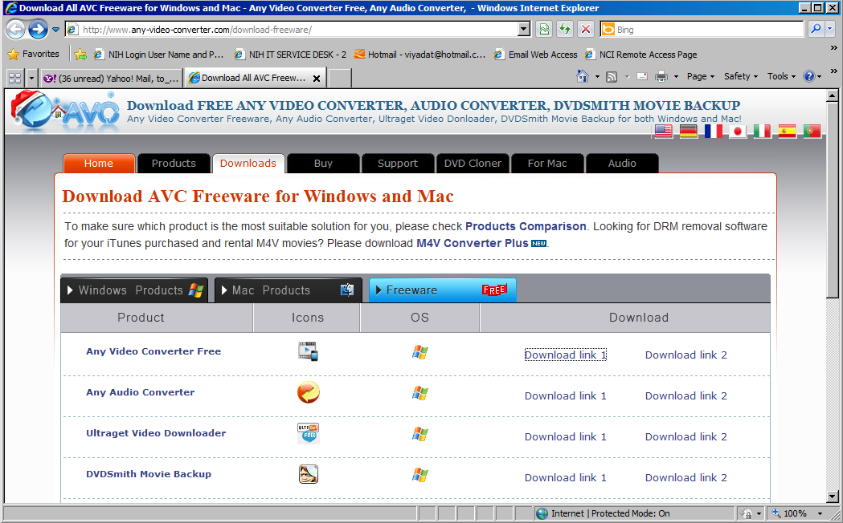

1. Click “download link manually” if the download process does not begin automatically, otherwise go to Step 4

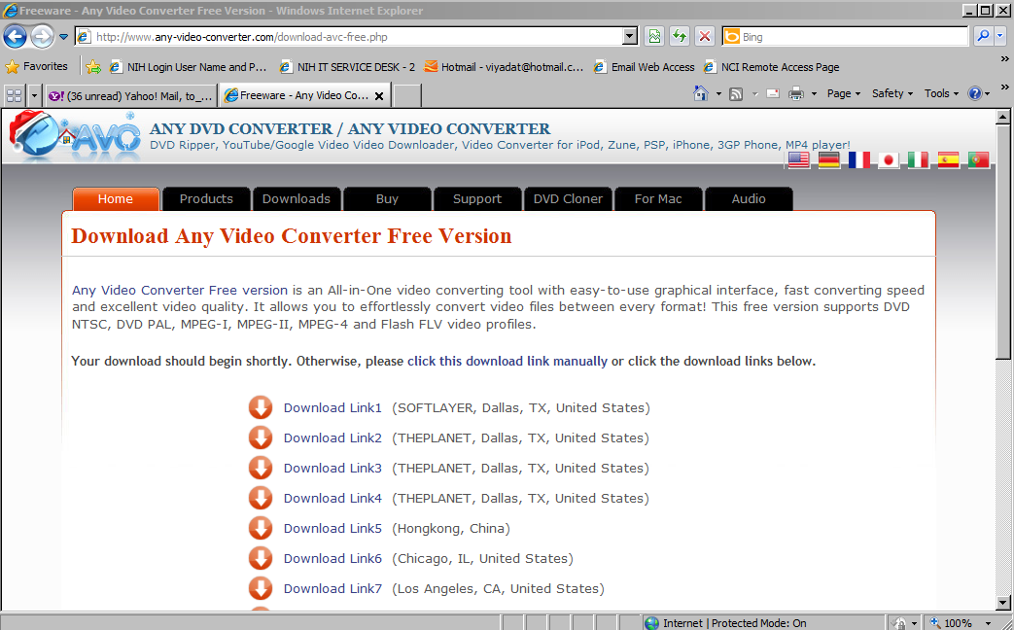

1. On the pop-up window , click “Save” button

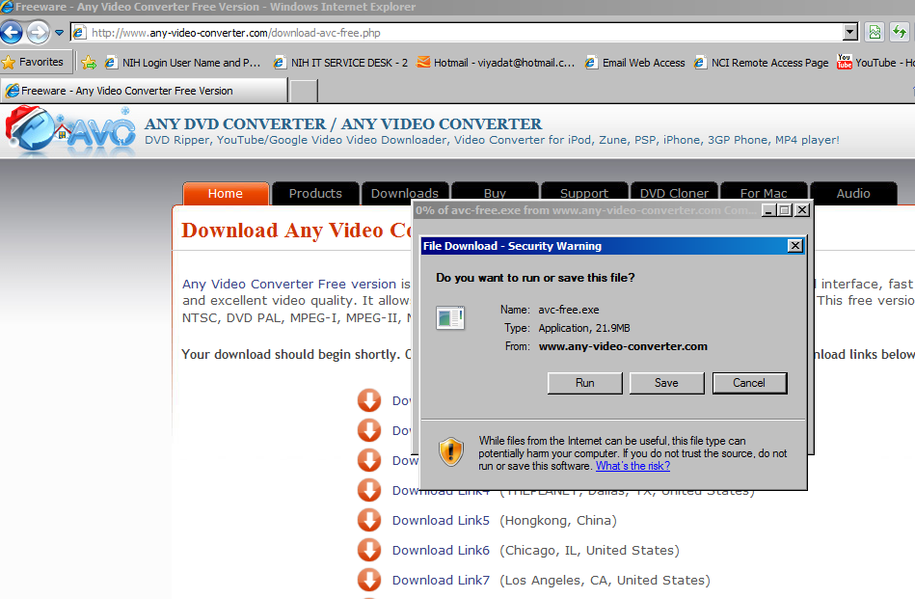

1. Select a location to save the application, then click “Save”

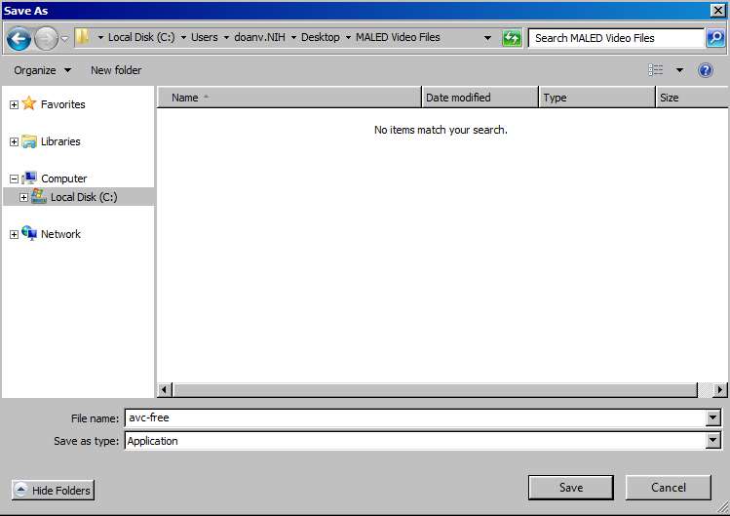

1. After downloading is complete, click “Run”

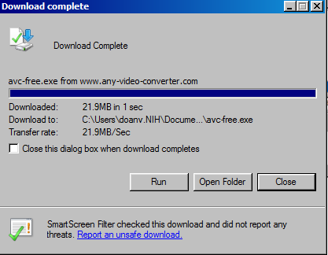

1. Click “Run” again to start installation process

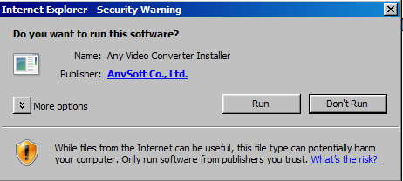

1. Click “Next

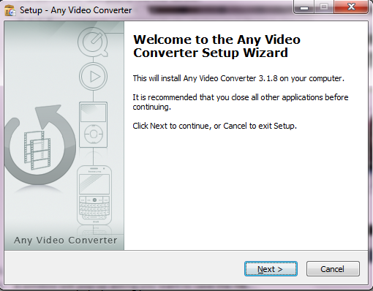

1. Select “I accept the agreement”, then click “Next”

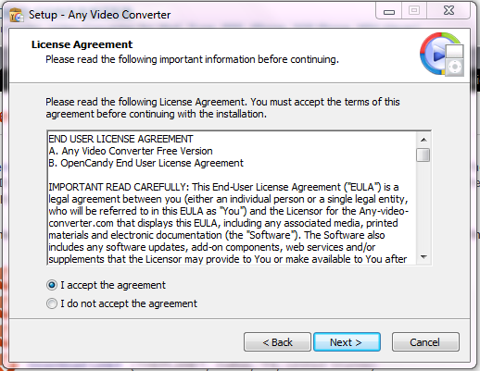

1. Click “Next” on the following screens

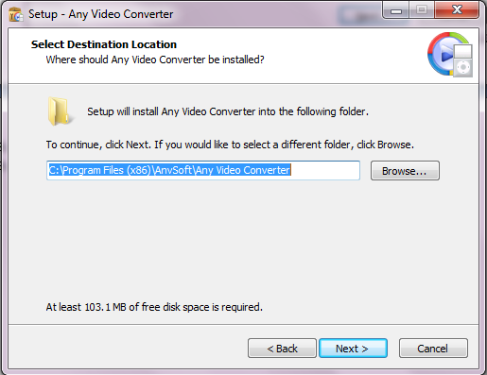

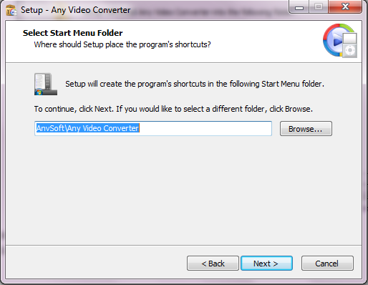

1. Check “Create a desktop icon” , then click “Next”

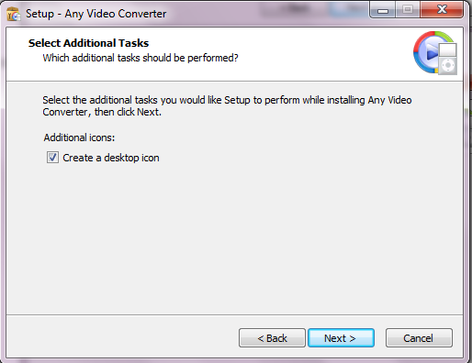

1. Select “Do not Install RealPlayer”, then click “Next”

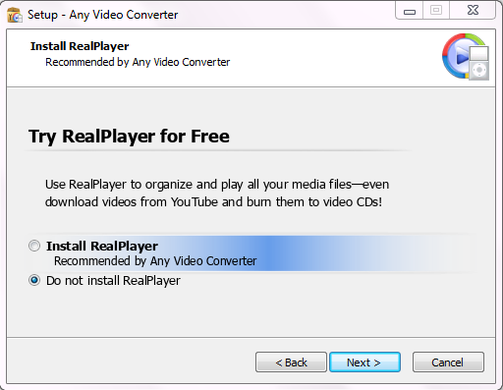

1. 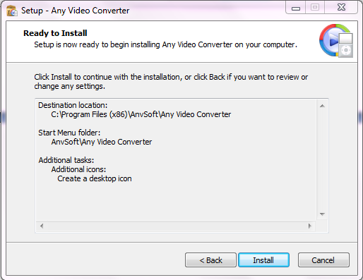Click “Install”
2. Check “Launch Any Video Converter” if you want to run the application immediately, then Click “Finish”

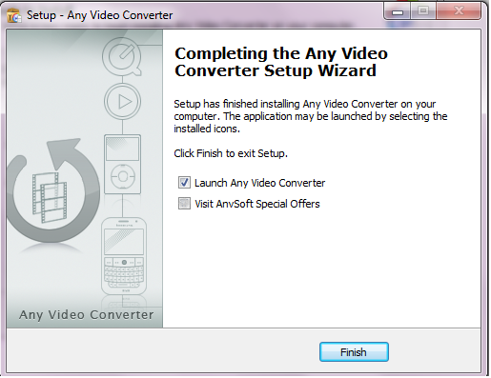

**How to convert the video file**

1. Double click on the Any Video Converter desktop icon



1. Click “ADD VIDEO” icon on the top left of screen

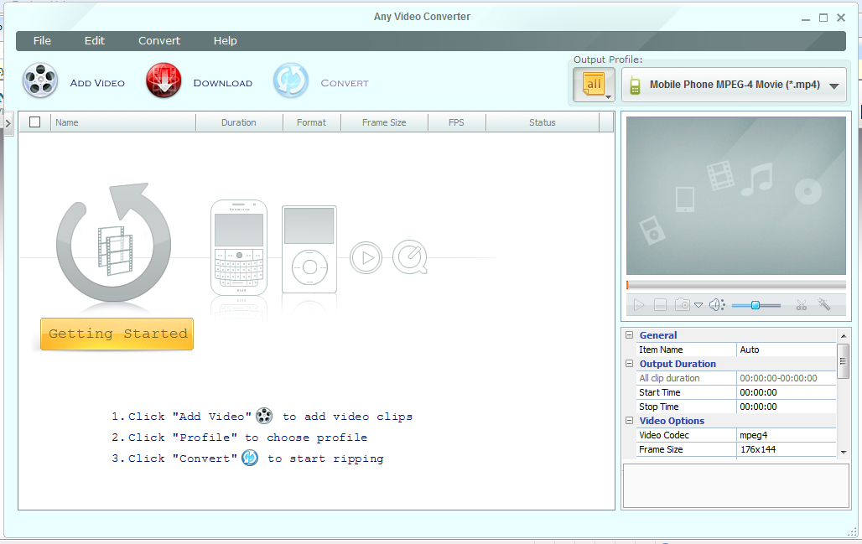

1. Navigate to where you have your video that you need converted, select the file and

click “Open”

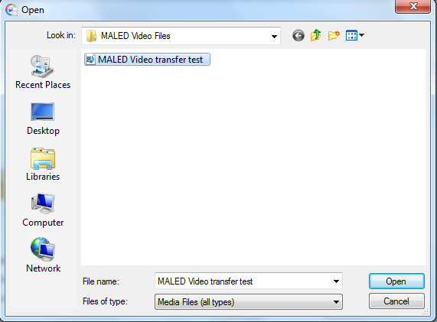

1. The selected file will be loaded on the screen

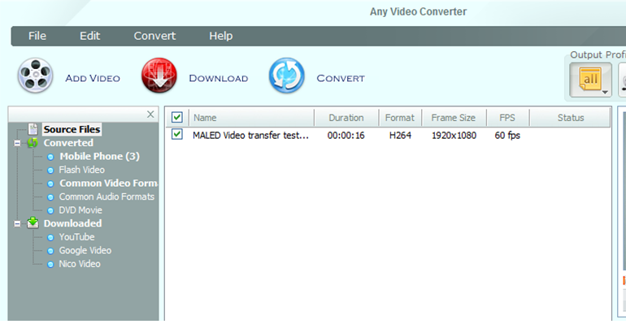

1. Click output Profile dropdown list, and select the output format “Customized MP4 Movie (*.mp4)”

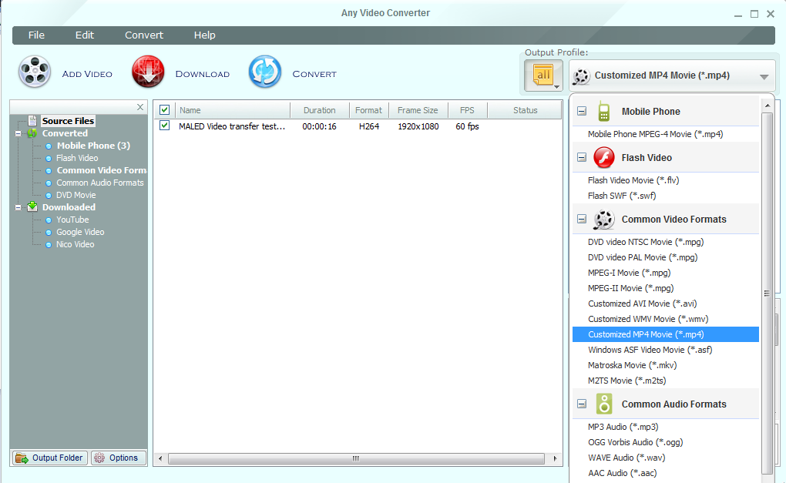

1. Set up the output folder by clicking on the “File” from the menu bar, then click “Set Output Folder”

Note: if you do not set up the output folder, the converted file will be saved in the default output folder: Any Video Converter/ MP4

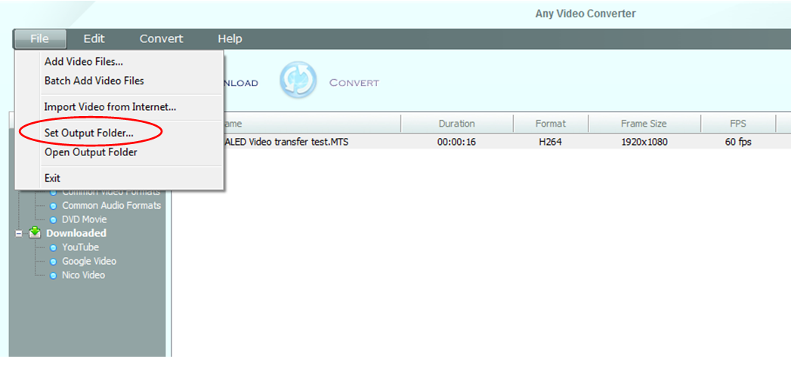

1. Select location for which you want the converted file to be saved, then click “OK”

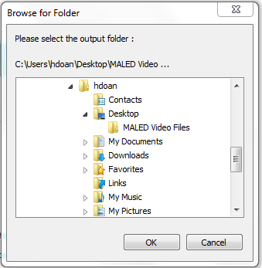

1. You are now ready to convert the file. From main screen click on “CONVERT” icon



1. Once the converting process is complete, the pop-up screen below will appear.

Click “No Thanks!”

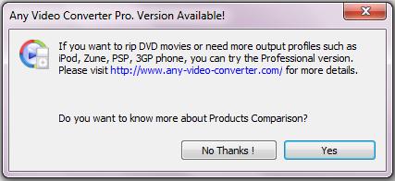

1. The program will automatically take you to the location that the converted file is saved.

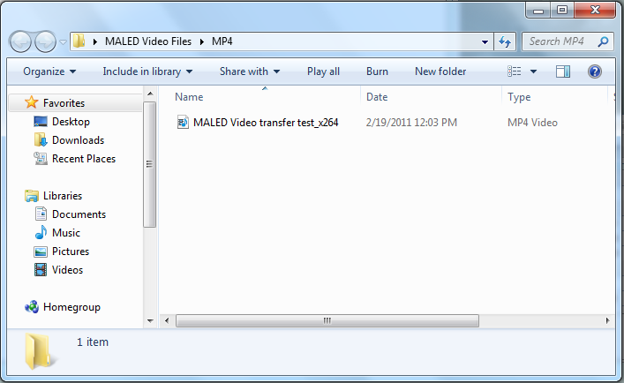

1. To access the converted file anytime,

1) Click on “File” menu, then click “Open Output Folder”, or

2) Click on “Output Folder” button on the bottom left of screen.

All converted files should appear as shown on the figure in step 10.

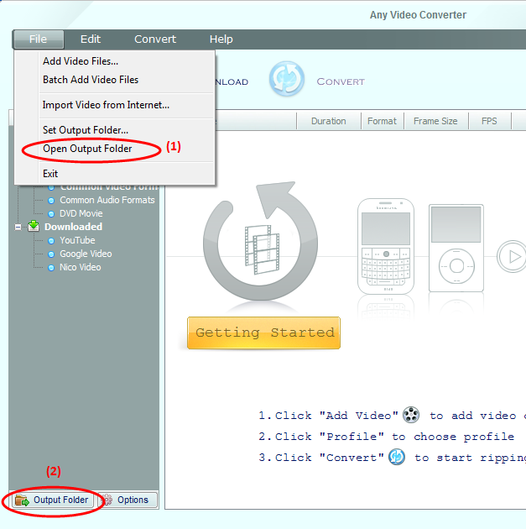

**OTHER**

PDF—Protocol Deviation Form SOP

I. Purpose

To record deviations from the MAL-ED standard protocols.

II. Material

Protocol Deviation Form, pen.

III. Methods

The Principal Local Investigator or Supervisor is notified immediately when an event occurs outside of the standards of practice (this event is called a **protocol deviation,** which is any unapproved change, deviation, or departure from the study design or procedures). A Protocol Deviation Form is completed by the individual having committed the deviation or having been on duty at the time at which the deviation occurred (e.g., if a mother fails to collect stool, the field worker should complete the PDF) and the study coordinator and/or sponsor and/or IRBs are notified, depending on the severity of the protocol deviation. We recommend that the IRBs should only be notified of Protocol Deviations that may require changes in the informed consent forms to better inform and protect the rights of the subjects, but sites should follow their own protocols regarding notification about protocol deviations.

These documents should be retained at the site in a folder labeled (Protocol Deviations) and should be entered into the database. They will be narrative in form, detailing what was done differently than called for in the protocol and why. Both the person commiting the protocol deviation and the Supervisor should sign and date the Protocol Deviation Form. If a study visit is missed due to the study subject permanently moving out of the study area (absence of 60 days or greater), a Non Continuation Form (NCF) should be completed but a PDF is not needed.

An example of a protocol deviation is if a data form is collected outside the ideal date range. If this occurs, a PDF should be filled out. See the specific form SOP for exceptions to this rule.

|  |  |  |  |
| --- | --- | --- | --- |
| Forms | Form name | Month(s) | Visit range |
| BCH | Blood collection | 7, 15 | DOB - 2/+12 DAYS |
| BSD | Bayley Scales | 6, 15, 24 | DOB (+/-) 15 DAYS |
| FRQ | 24 hour food recall | 9 TO 24 | DOB (+/-) 15 DAYS |
| FSE | Follow-up SES | 6, 12,18,24 | DOB (+/-) 15 DAYS |
| FSQ | Food security questionnaire | 6, 12,18,24 | DOB (+/-) 15 DAYS |
| HIT | HOME | 6, 24 | DOB (+/-) 15 DAYS |
| ITS | Infant temperament scale | 6 | DOB (+/-) 15 DAYS |
| MAF | Maternal assessment form | 2 | DOB (+/-) 2 DAYS |
| MOA | Monthly form A | 1 TO 8 | DOB (+/-) 2 DAYS |
| MOB | Monthly form B | 9 TO 24 | DOB (+/-) 2 DAYS |
| MWG | MacArthur words and gestures | 8, 15 | DOB (+/-) 15 DAYS |
| RCM | Raven's combined matrices | 6-8 | DOB (+/-) 15 DAYS |
| SFC | Stool field collection | 1 TO 24 | DOB (+/-) 2 DAYS |
| SRQ | SRQ-20 | 1,6,15 | DOB (+/-) 15 DAYS |
| UCF | Urine collection form | 3,6,9,15 | DOB -2/+7 DAYS |

|  |  |  |
| --- | --- | --- |
| # | Question | Guidance |
| 1 | Fieldworker ID/Lab technician ID | Enter the fieldworker or lab technician’s unique ID number here. |
| 2 | Today’s date | Enter the today’s date. Format DD/MMM/YY Today’s date is the day you are filling out the PDF. |
| 3 | What is the three letter ID of the affected SOP? | Enter the SOP ID code here. Enter the primary SOP that is affected by the deviation. If additional SOPs are affected, you may note them in the Observation section at the bottom of the form. |
| 4 | Date of deviation or target date of assessment/collection | Enter the date of deviation or, if an assessment/collection was missed or performed out of the window, enter the target date of the assessment/collection. Format DD/MMM/YY. The target date of a missed collection is the birth date anniversary, eg, for the MAF, if a child is born on January 1st, 2011, the birth date anniversary for the missed or out of window MAF would be March 1st, 2011. |
| 5 | Participant ID of the affected subject | Enter the ID of the affected subject |
| 6 | Sample ID of the affected subject | Enter the sample ID here. If the protocol deviation does not apply to a specimen enter NA. |
| 7 | Did the deviation result in an adverse event? | Enter 00 for no; enter 01 for yes. If yes, complete adverse event form. |
| 8 | Reason for deviation | Enter the reason for the deviation. Possible answers include: Subject illness=01; Subject unable to comply=02; Subject refusal=03; Fieldworker/Laboratory technician error=04; Specimen leaked, test not performed=05; Specimen not labeled, test not performed=06; Clerical error (incorrect PID, SID or test result)=07; Test failure (technical)=08; Investigator/study decision=09; Other=10 |
| 9 | Observation/Notes | Describe the circumstances, reasons for, and implications for the study, if any, of the protocol deviation |

### AEF—Adverse Event Recording and Reporting SOP

I. Purpose

To document and report adverse events that may occur to participants during the course of the MAL-ED study.

II. Materials

Adverse Events Form (AEF), pen

III. Methods

During the course of this study, adverse events (AE’s) will almost certainly occur that involve study subjects (enrolled child, mother, or other care givers). Most of these events will be minor, but some may be more serious and even life threatening. Whether minor or serious, they may impact our ability to obtain data and interpret it correctly. It is, therefore, important to record and report these events as they occur. As MAL-ED is not an interventional study involving experimental treatments or drugs, we do not anticipate that serious events will be related to the study procedures we will employ. However it is possible that serious illness or accidents will occur amongst our enrollees that result in serious injury or even death and will impact their continued participation in the study. These events should be recorded and analyzed by site investigators, including the site PI, to evaluate the relatedness of the event to our study protocol and its likely or real impact on our results. Adverse events, especially serious ones, may be reportable to your local IRB as dictated by site specific protocols.

Examples of AE’s that may be study related include: bruising at the site of blood draw and vomiting or loose stools following ingestion of the lactulose:mannitol solution. Both the person completing the AEF and the supervisor should sign the form. Sites will maintain a file labeled “Adverse Events” where all AEF forms will be kept. These forms will not be uploaded to the central database but you may wish to enter them into your own database (at the discretion of the site PI). An AEF form should be completed by staff and the site PI or supervisor notified immediately. In those instances where an AE is determined to be possibly related to a study procedure, as well as all SAE’s whether study realed or not, a scanned copy of the AEF should be sent by email (or FAX if scanning is not possible) should be sent to Dennis Lang (Lang4@fnih.org) or Rebecca Blank ([rblank@fnih.org](mailto:rblank@fnih.org)) for our records. We will look for any trends across sites and determine if we need to adjust any study procedure as a result.

|  |  |  |
| --- | --- | --- |
| # | Question | Guidance |
| 01 | Study researcher / Nurse / Fieldworker ID | Enter the fieldworker or lab technician’s unique ID number here. |
| 02 | Today’s date | Enter the today’s date. Format DD/MMM/YY |
| 03 | Did the adverse event result in death | Enter 00 for no; enter 01 for yes. |
| 04 | Date of adverse event | Enter the date of the event. Format DD/MMM/YY |
| 05 | Date of event resolved | Enter the date of the resolution if applicable. Format DD/MMM/YY |
| 06 | Is the adverse event possibly study related? | Enter 00 for no; enter 01 for yes. |
|  | Description | Provide details on the diagnosis, medical management; attach additional page if needed). If answer to #6 above is yes, explain why you believe the event may be study related |

**Purpose**

The purpose of this SOP is to provide guidance to study personnel and laboratory staff on the internal transport of specimens and to provide guidance to Laboratory Personnel regarding the regulations and procedures for the international shipping of protocol specimens. The goal of this procedure is to develop a process to ensure that all specimens are handled and shipped in the same manner following IATA shipping regulations

**Scope**

This SOP is divided into 2 sections I. Internal transport of specimens and II. Shipping specimens. These procedures will provide laboratory personnel with guidelines on how to ship protocol specimens to testing facilities and/or to a central repository Personnel must be IATA certified to package or monitor the packaging of specimens for shipment. Personnel are required to follow all current IATA rules.

**Definitions**

* IATA – International Air Transportation Authority

**Safety**

STANDARD PRECAUTIONS

Wear gloves when handling patient specimens to protect from exposure to bloodborne pathogens..

**I. Internal Transport of Specimens**

A. All Specimens transported internally i.e.: to or from the laboratory clinic or study areas, must first be placed in a biohazard bag and then into a secondary specimen transport container (usually a hard cooler). Specimens must not be transported from the clinic to laboratories by hand.

The secondary container must be:

* Able to contain the contents if the primary container were to leak or break.
* Dedicated to specimen transport
* Closeable
* Labeled with the biohazard symbol, affixed to the outer surface of the transport container

B. Notify the laboratory staff of any problems that occurred in the transportation of specimens.

C. Refer to Specimen Collection Procedures in the MOP for details regarding the collection of blood and other samples and for the receipt, distribution and processing of specimens for laboratory tests.

**II. Shipping of Specimens**

The Laboratory may ship specimens by air for testing or storage. All shipments will be sent in compliance with the International Air Transportation Authority (IATA) regulations. Additionally, export and/or import permits may be required and varies by country for both exports and imports. All permits must arranged before the specimens are prepared for shipment as the time to aquire permits may take weeks or months,

**IATA Shipping Certification**

1. IATA regulations require that persons who package, are in charge of packaging supervise the packaging by a courier service of regulated packages must have passed an IATA shipping training class and have a valid IATA certificate that is available for inspection.
2. Shipping certification is obtained via in person training, the Saf-T-Pak CD or internet-base training. IATA shipping certification must be renewed every two years.
3. At least 2 persons from each project should be certified.
4. If the packaging is done by a courier service an IATA certified staff member must supervise the packaging of each shipment and sign the airway bill. This person is legally responsible should anything happen in transit that is a result of improper packaging.
5. Copies of IATA certificates should be sent to MAL-ED FNIH for shipping certification tracking.

GPS - Geographic Positioning System SOP (GPS)

**Purpose:** The purpose of this SOP is to provide guidance in accurately collecting coordinates for the participant’s household and other landmark places. Currently, this information is not entered into the database.

**Material**:

1. GPS Location Form
2. Recommended GPS unit: Etex or GPSMAP garmin

**Instructions to record waypoints (Households & Landmarks)**

1. Verify GPS settings in table prior to leaving for the study area.
   1. *Position Format* is the format of the Latitude and Longitude. The setting should be in decimal degrees (HDDD.DDDDD)
   2. *Map Datum* is the datum assumed by the GPS to record Latitude & Longitude. Set to WGS 84, which is the most general
   3. *Distance* is the distance metric used to display distances. You can use Metric or Feet.
   4. *Track Record Method* is the duration between recorded track points for recording polylines (roads) and geo-references photos. We set this to automatic and normal. If you want to record points more often, you can change Normal to More Often
   5. *Data Card Track Record* indicates that the data card is also recording tracks. You set this option in the Track menu by selecting “Data Card Setup” and then indicating that the Data Card also record tracks.
   6. *Camera & GPS* refers to the verification that the camera time and GPS time are the same. You need to change the Camera time rather than the GPS time since the GPS time is synched to satellites
   7. *Battery Power* is a reminder that you need to verify that you have full battery power and back-up batteries. Full power is not necessary, but back-up batteries are required. Some batteries, even when fully charged, will only run the GPS for 8 hours.
   8. *# Waypoints Stored* refers to the number of waypoints currently stored on the GPS. This is checked by pushing the button “FIND” and then looking for the largest Waypoint ID. Assuming that you are NOT naming waypoints manually, the waypoints should be ordered from smallest to largest. A maximum of 1000 Waypoints can be stored. You should download Waypoints to a secure laptop as often as possible
   9. *# Tracks Stored* refers to the total number of tracks saved on the GPS device. If the total number is 20 and you have not downloaded the tracks, you must delete 1 track in order to record a new track or make a decision to record tracks another day. If you want to delete a track, choose the shortest track and the area most accessible to delete (indicated by track length) so that you can easily return to that spot to record new tracks. Since the data card also records tracks, you may be able to recover your tracks even if you delete them on the Garmin
2. Recording a point in the study area
   1. Stand 1-3 meters from the front entrance of the structure or household
   2. Verify you are connected to at least 4 satellites – if you do not have 4 satellites, continue moving away from the structure until you have satellite reception. Once you have reception, move as close as possible to the structure keeping connection to the satellites
   3. When you are satisfied with your reception and distance from the structure, push the MARK button, then select AVG icon to average the location (this will improve the accuracy of the recording). Wait until the error is under 3 meters or 2 minutes (120 seconds) – whichever comes first. Then select OK.
   4. Record Waypoint ID, Latitude, Longitude and Landmark Code on the Form (or write a description of the landmark). Note if picture was taken.
   5. If you had to stand further than 10 meters from the structure, indicate where you were when recording the data on the Landmark Form

**Landmark Type Codes**

|  |  |
| --- | --- |
| **Code** | **Landmark** |
| **00** | **Household** |
| *Shops and Markets* a | |
| 01 | Open Community Market (not daily) |
| 02 | Open Community Market (daily) |
| 03 | Supermarket |
| 04 | Fuel Station |
| 05 | Small Shop / Kiosk |
| 06 | Small Shop / Kiosk with FP / Medical / Health Supplies |
| 07 | Bakery |
| 08 | Butchers |
| 09 |  |
| *Schools* a | |
| 10 | Pre-School |
| 11 | Primary School |
| 12 | Middle School |
| 13 | Prepatory School |
| 14 | Secondary School |
| 15 | Junior High / Jr Secondary |
| 16 | Senior High / Sr. Secondary |
| 17 | Ordinary School |
| 18 | Advanced School |
| 19 | Technical / Vocational School |
| 20 | College or University |
| 21 | Religious School |
| 22 | Special Schools |
| *Public Transport System* | |
| 23 | Bus Station / Motor Park |
| 24 | Train Station |
| 25 | Railroad Terminal |
| 26 | Tram Stop |
| 27 | Trolley Stop |
| 28 | Motor Bike Station |
| 29 | Mini-Bus Station |
| 30 | Bus Stop |
| *Community / Local Government* | |
| 31 | Police Station |
| 32 | Local Council Administrative Office |
| 33 | Post Office |
| 34 | Palace |
| 35 | Telecommunications Office |
| 36 | Water Utility Office |
| 37 | Electricity (Power) Office |
| 38 | Community Center / Town Hall |
| *Water Sources* | |
| 39 | Deep well (covered) |
| 40 | River |
| 41 | Lake / Pond |
| 42 | Bore Hole |
| 43 | Well / Spring (open) |
| 44 | Piped (Public Source) |
| 45 | Water Tank |
| Restaurants & Bars | |
| 46 | Coffee / Smoking Shop |
| 47 | Eating Places / Food Canteen |
| 48 | Bar / Disco |
| 49 | Internet Café |
| *Religious Structures* | |
| 50 | Orthodox Church |
| 51 | Protestant Church |
| 52 | Catholic Church |
| 53 | Other Churches |
| 54 | Mosque |
| 55 | Monestary |
| 56 | Traditionalists |
| 57 | Other |
|  |  |
|  |  |
|  |  |
|  |  |
|  |  |
|  |  |
|  |  |
|  |  |

|  |  |  |  |  |  |  |  |  |  |
| --- | --- | --- | --- | --- | --- | --- | --- | --- | --- |
| **LLF_Date** | **Collector** | **Community** | **WPTID** | **LCODE** | **HHID** | **Latitude** | **Longitude** | **Picture** | **Notes** |
| 051909 | WP | BALTIMORE | 001 | 42 |  | 39.295319 | -76.590682 | 1 |  |
| 051909 | WP | BALTIMORE | 002 | 11 |  | 39.294716 | -76.590682 | 1 |  |
| 051909 | WP | BALTIMORE | 003 | 42 |  | 39.293559 | -76.590723 | 0 |  |
| … |  |  |  |  |  |  |  |  |  |

|  |  |  |  |
| --- | --- | --- | --- |
| **GPS Location Form (GPS)** | | | |
|  | | | |
| **#** | **Question** | **Code** | **Response** |
| 01 | Waypoint ID |  | ⬜ ⬜ ⬜ |
| 02 | Landmark code |  | ⬜ ⬜ |
| 03 | Latitude |  | **.** |
| 04 | Longitude |  | **.** |

Child ID: ⬜ ⬜ ⬜ ⬜ ⬜ ⬜ ⬜ ⬜

Today’s date (DD/MMM/YY): ⬜ ⬜ / ⬜ ⬜ ⬜ / ⬜ ⬜

Study researcher / Nurse / Fieldworker ID: ⬜ ⬜ ⬜

|  |  |  |  |
| --- | --- | --- | --- |
| 05 | Waypoint ID |  | ⬜ ⬜ ⬜ |
| 06 | Landmark code |  | ⬜ ⬜ |
| 07 | Latitude |  | **.** |
| 08 | Longitude |  | **.** |

|  |  |  |  |
| --- | --- | --- | --- |
| 09 | Waypoint ID |  | ⬜ ⬜ ⬜ |
| 10 | Landmark code |  | ⬜ ⬜ |
| 11 | Latitude code |  | **.** |
| 12 | Longitude |  | **.** |

**Notes: ____________________________________________________________________________________________________________________________________________________________________________________**

**Double Data Entry and Barcode Sample Tracking**

BST—Barcode Sample Tracking Database SOP

**Version – 1.2**

**I. Purpose**

This document describes the procedure for using the barcode sample tracking database for inventory management of the samples in the laboratory. The database will be used for printing barcode labels for storage/archival samples.

**II. Material**

Barcode Printer

Barcode Scanner

-70°C resistant labels

Barcode printer wax-resin ribbon

Computer with MS access barcode database

Regular labels (for use in laboratory operations and not for archiving)

**III. Method**

Please refer to Appendix I for an example of a sample tracking workflow. Different sites may have slightly different protocol.

**Barcode Printer and Scanner setup**

Please refer Appendix II - **Barcode Printer and Scanner setup**.

**Set-up instructions for Database Administrator:**

***New with Release 1.2 (10 April, 2010)***

1. ***ONE TIME UPDATE - MALED_UpdateStructureTables.mdb*:** Two new options – “Add/Edit Sample types” module and “Config” module are added to the Barcode Sample tracking database. Follow these steps to upgrade your application to v1.2:

* 1. Copy ***MALED_UpdateStructureTables.mdb*** database in the same folder as MALED_BarcodeSampleTracking_be.mdb as in Fig. 1.

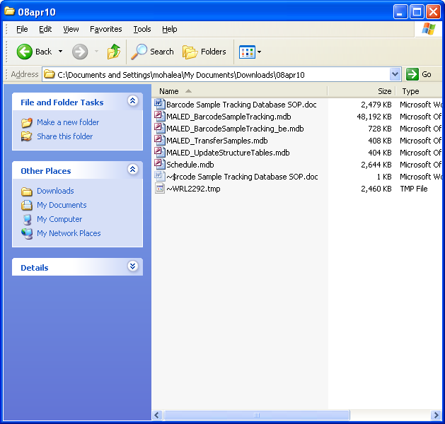

Fig. 1

* 1. Open MALED_UpdateStructureTables.mdbdatabase. The update will run and update completion confirmation appears. Fig. 2.

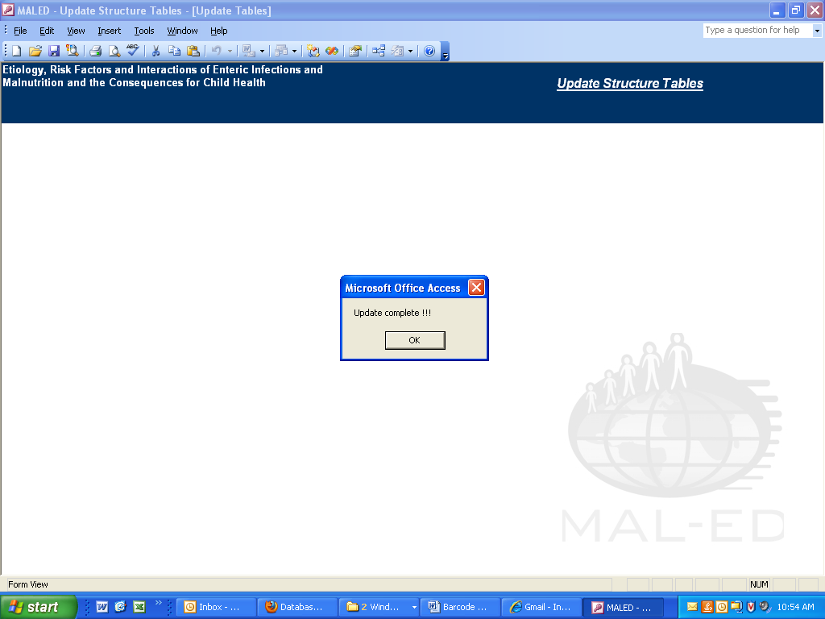

Fig. 2

* 1. Close MALED_UpdateStructureTables.mdb database. The MALED_BarcodeSampleTracking_be.mdb database is now updated.

***The first – time the database is opened or database is moved to different folder****;* one MUST follow these steps to link data tables to the application:

1. Open barcode sample tracking database **MALED_BarcodeSampleTracking.mdb.** Fig 3.



Fig. 3

1. From menu bar, click **Option** 🡪 **Relink Tables**. Fig. 4.



Fig. 4.

1. Select database **MALED_BarcodeSampleTracking_be.mdb** from the file selection pop-up and click **Link.** Fig. 5.

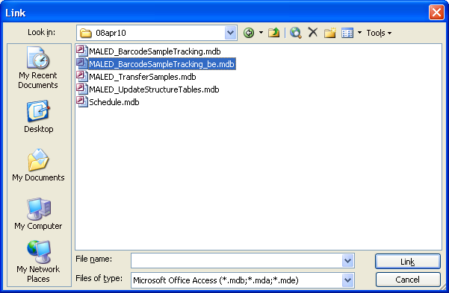

Fig. 5

1. From **Link Tables** pop-up window, click **Select All** and click **OK.** Fig. 6

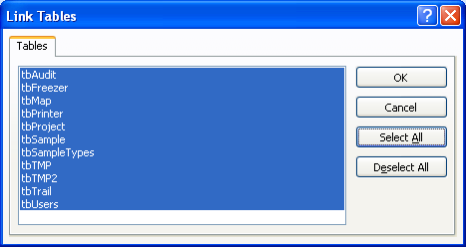

Fig. 6

1. The main screen will appear (Fig. 3) and the Sample tracking database is now ready to use. User can login and start using the database.
2. If the database is not linked correctly and you notice error pop-up, fig. 7a, follow steps 4-6 again.

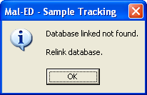

Fig. 7a

**Login:**

1. Open barcode sample tracking database. Fig. 3.

Menu options to select

Fig. 3 

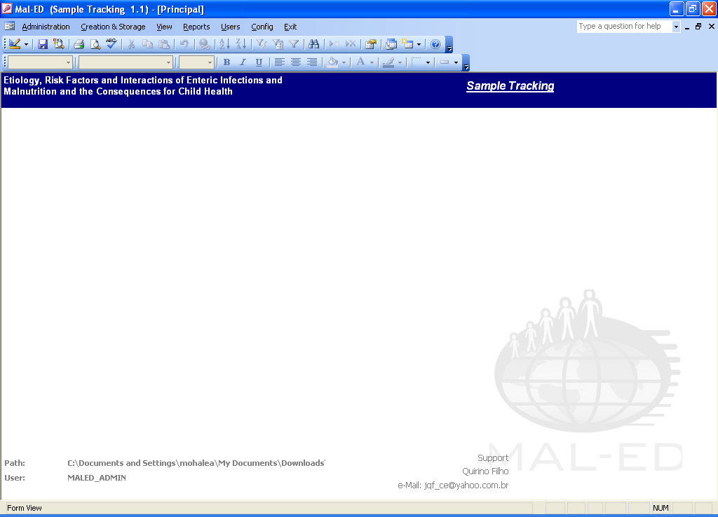

Fig.8

1. Database administrator will be able to create accounts for new users as explained in Users 🡪 Accounts by clicking on the menu option, Fig. 8.
2. Users will be able to login with the username and password provided by the database administrator.

**User accounts and Auditing:**

**Users 🡪 Accounts:**

Database Administrator creates user accounts and provides different levels of access to different types of users, Fig. 9. Database administrator should make sure that their “Country” is selected from the drop down list for the user account to work properly.

Access levels available:

1. Viewer – View and print reports.
2. Lab User – View and edit data in the application, including sample administration (e.g. creating new freezers and viewing sample trial).
3. DB Admin – Full access to the application, including creating user accounts, audit trail and sample administration.

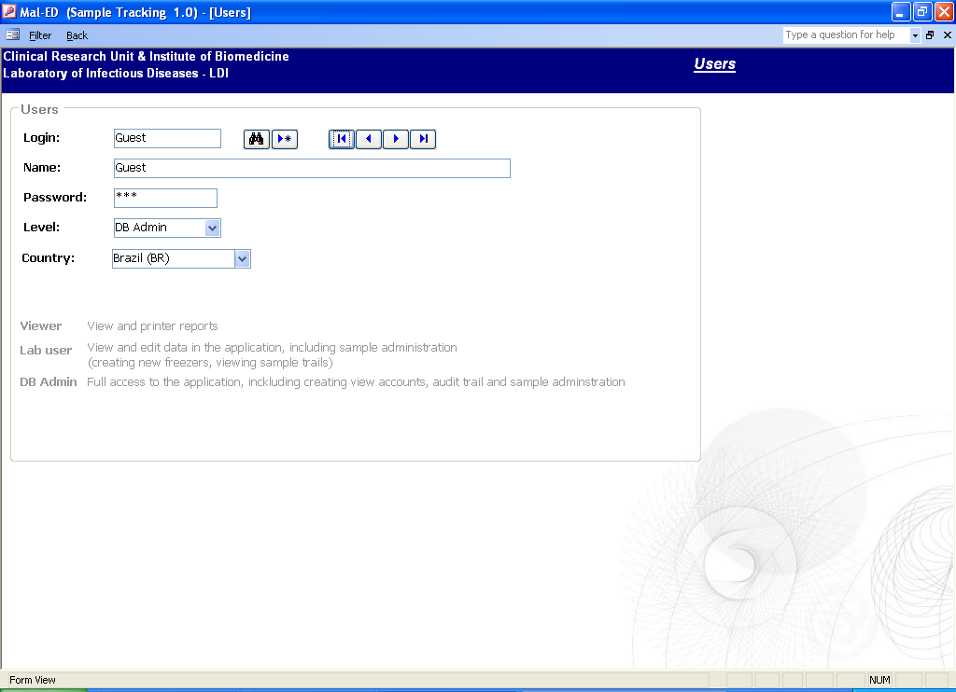

Fig. 9

**Barcode label for samples:**

1. Specimens will be collected in the field or clinic and pre-printed labels will be used to collect the specimens. Please refer to Stool collection SOP for information on the use of the pre-printed labels.
2. The specimens and relevant data forms will be transported to the data entry/ specimen accession location (for some sites this will be the laboratory, some sites use an intermediate processing location). The Sample ID will be assigned to the specimen immediately upon receipt at the specimen accession location. Please refer to Sample ID (SIL) SOP to assign unique Sample ID to the specimens.
3. Specimens are recorded in the MS Access barcode sample tracking database as explained below.
4. Barcode labels are created before sample is divided in different aliquots for storage and archival purposes.

**Creation and Storage 🡪 Create Sample:**

1. Date of collection, Sample ID, Participant ID and Specimen and derivative will be entered in the Create Sample module, Fig. 10. Please refer to Appendix III for Participant ID, Specimen ID, Sample ID and Specimen derivative information.

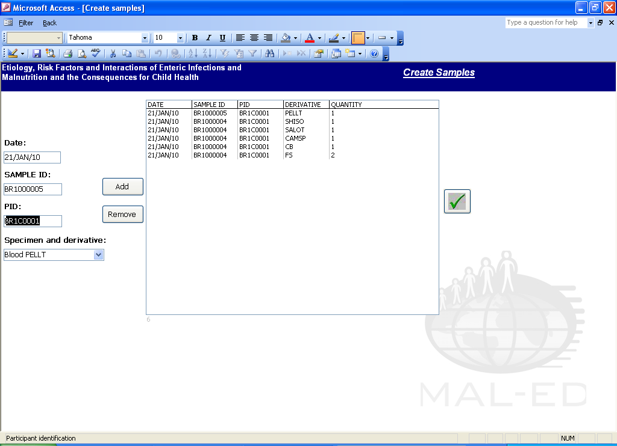

Click to remove samples from the list to be printed.

Click to add as many labels as required to generate labels.

Fig. 10

Click to create samples in the database and print labels.

1. After clicking √, the sample is created in the database. Fig. 10a-b.

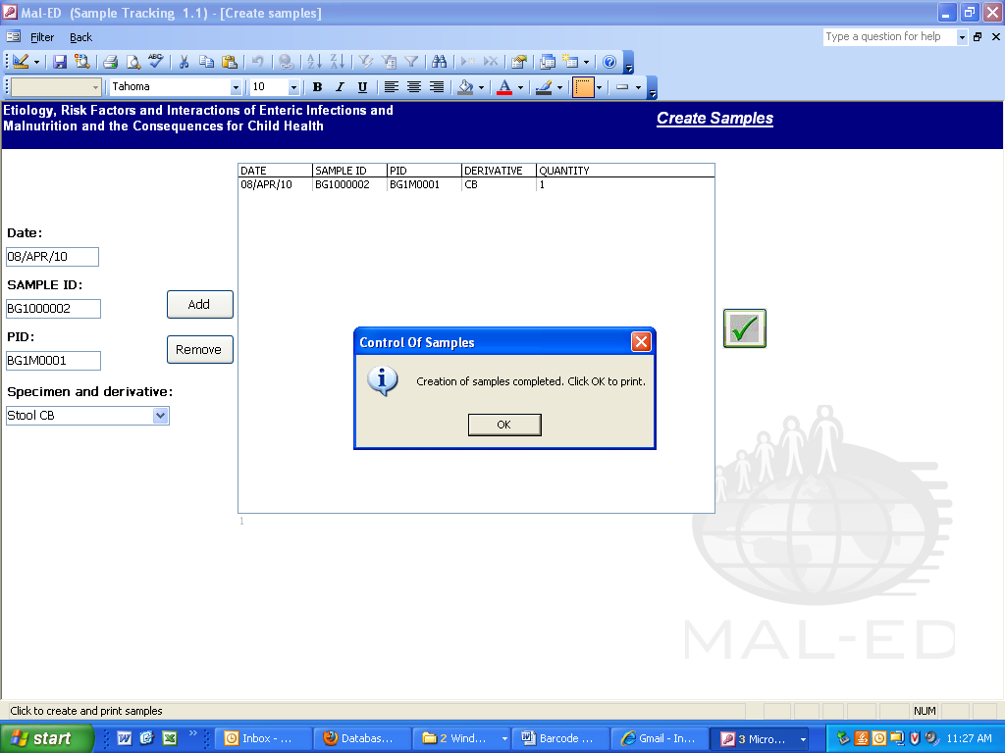

Fig. 10a

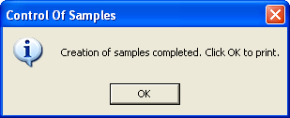

Fig. 10b

1. The pop-up window to print label appears, Fig. 11.
2. Make sure that barcode printer is connected to your computer and turned on with green light, indicating ready to print.
3. Click print icon on the pop-up window to start printing barcode labels, Fig. 11.
4. Barcode labels with barcode (1D and 2D), Sample ID, Participant ID, and Specimen derivative will be printed from the database to be placed on the tubes for storage/archival, Fig. 12.

Note: The steps 1 and 2 will create the sample in the database. In case the printer is not available to print barcode labels, user can print the existing samples at later stage using Reports 🡪 RE-Print Labels. See Reports section.

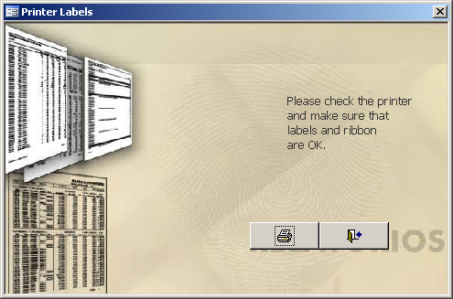 🡪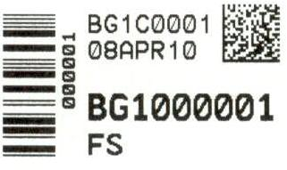

Fig. 11 Fig. 12

**Sample tracking:**

**Creation and Storage 🡪 Box:**

1. The information of where the samples are stored in the freezer including position of the sample within the box is entered in the database using barcode scanners or by typing in the 6-digit unique sample tracking ID found on the barcode label under the barcode, Fig. 12. This is not the Sample ID or the Participant ID, but a unique sample tracking ID used by the database.
2. The database provides the option to select the box size - 9*9 or 10*10, Fig. 13.
3. The database creates, updates or transfers the sample boxes to the appropriate location/s using the barcode scanner.
4. The scanner scans the barcode and puts the sample tracking ID in the box position selected by the user.
5. The box position is selected by clicking inside the appropriate box.
6. Click the √ to create the box. Click the undo icon to remove the last sample entry in the box.

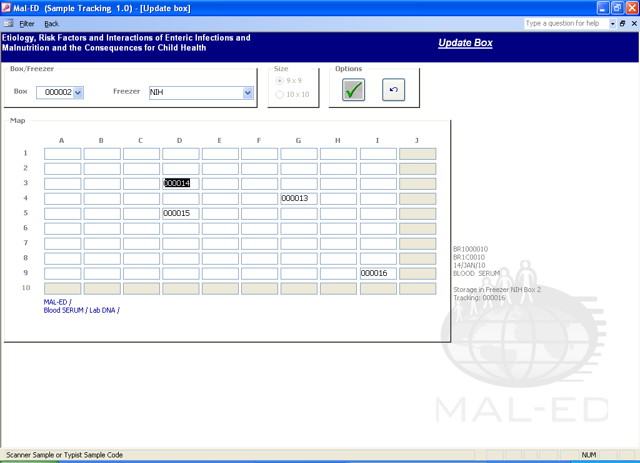

Fig. 13

Click here to undo changes

On moving mouse over the box position, the sample detail is shown here

Click here to save the box

**Creation and Storage 🡪 Sample Discard:**

Information regarding discarded samples can also be tracked in the database using the barcode scanners.

1. User enters date sample was discarded and either scans the barcode from the aliquot or types the 6-digit tracking number in the field to add to the list, Fig. 14.
2. Clicking **√** marks the samples in the database as “discarded”. The >x icon removes samples from the list to be discarded.
3. The database also updates the freezer box where these samples were stored.

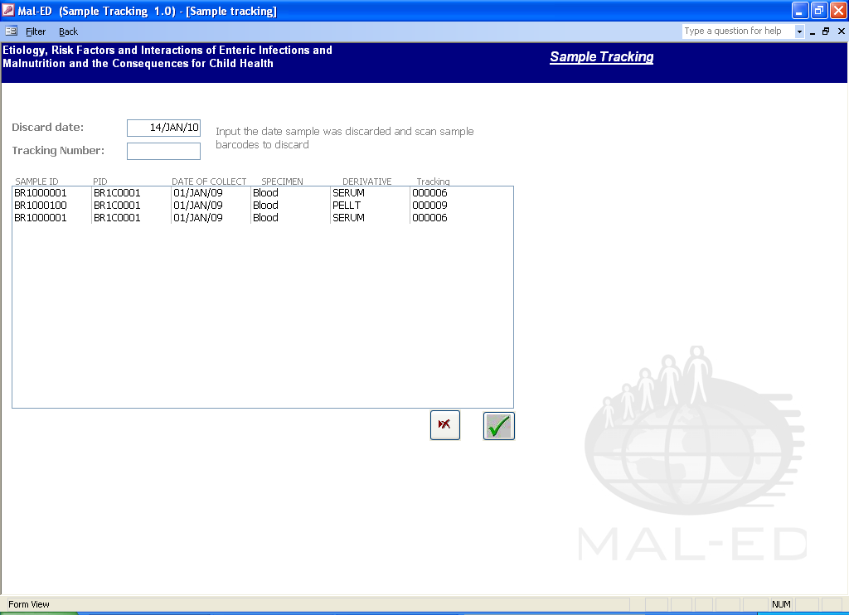

Fig. 14

**Reports:**

**Reports 🡪 RE-Print Labels:**

Barcode database facilitates the option to generate additional labels for existing samples, Fig. 15. The module provides option to print labels by entering:

* Sample ID only
* Specimen type AND derivatives only
* Specimen type AND derivatives and Range of specimen collection dates

Double click the list of available derivatives to select all or de-select all.

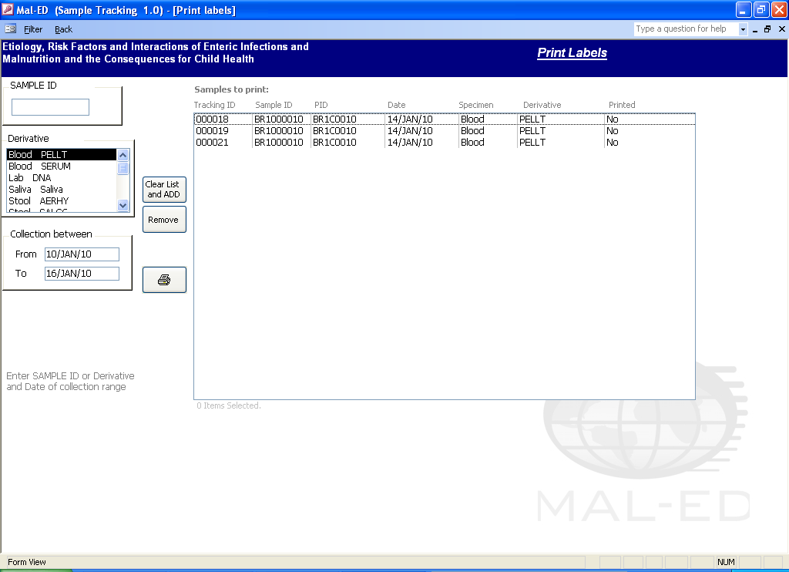

Fig. 15

**Reports 🡪 Map of the box:**

This report provides a diagram of the freezer box specified by the user with map of the box and description of each specimen in each box position, Fig.17.

1. User enters the box number in the pop-up window, Fig. 16, to view map of a particular box.
2. User can leave the text field empty to view map reports of all boxes.

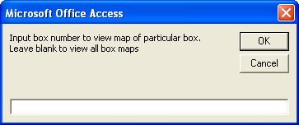

Fig. 16

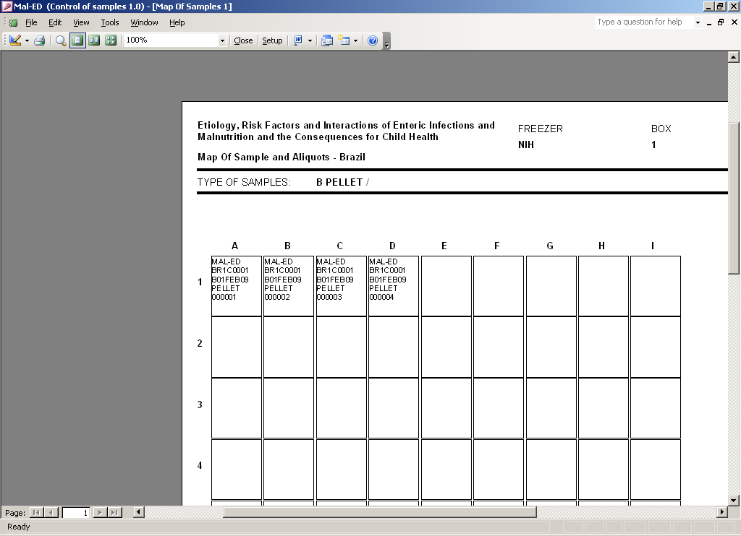

Fig. 17

**Administration:**

**Administration 🡪 Sample details:**

Barcode database user will be able to view all the information regarding samples entered in the database including freezer location, box position and audit log for each sample, Fig. 18. This is read only view.

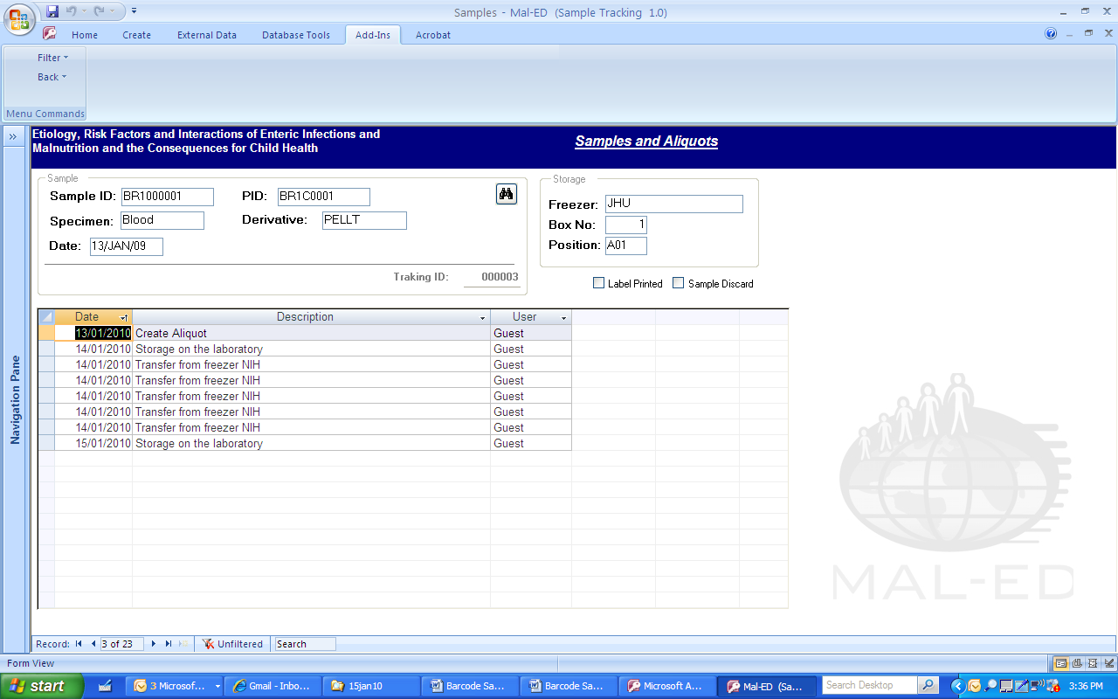

Fig. 18**Administration 🡪 Freezer:**

Lab and data administrators will be able to create new freezers to track specimen storage and transfer, Fig.19.

1. User clicks >* icon to create a new freezer. A record is saved in the database as user types the information in the form.
2. User can update existing records by editing the freezer information in the form.

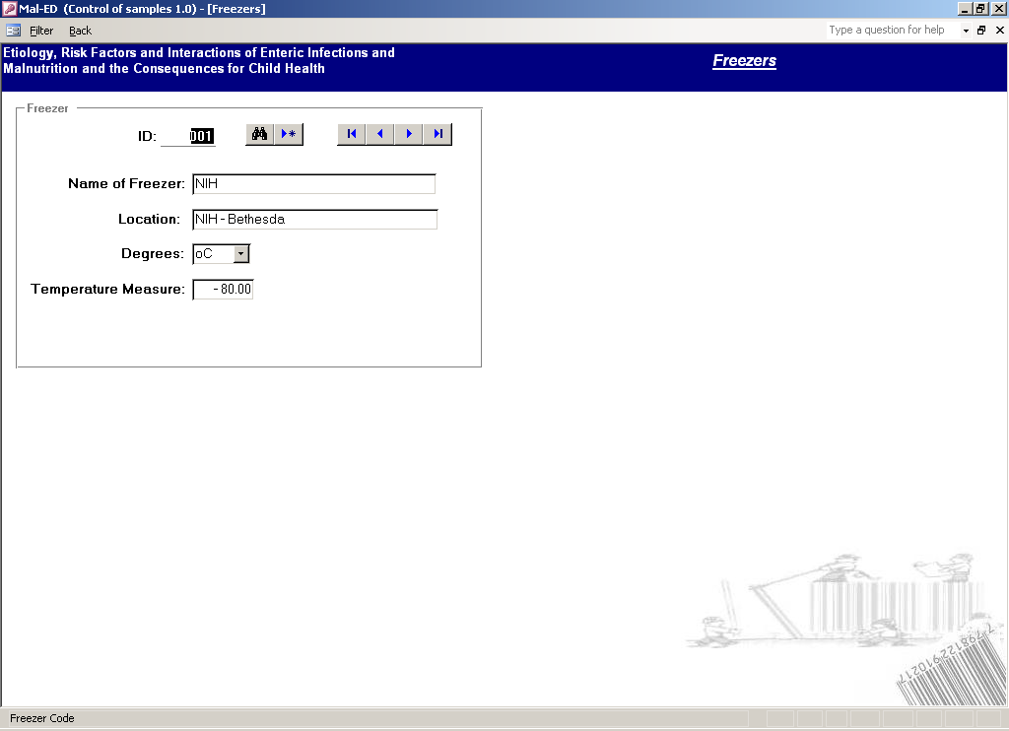

Fig. 19

***New with Release 1.2 (10 April, 2010)***

**Administration 🡪 Specimen:**

Lab and data administrators will be able to add/update/delete new specimen derivatives to create samples, Fig. 20.

1. User clicks >* icon to create a new specimen derivative. A record is saved in the database as user types the information in the form. The new derivative will appear in the Creation and Storage 🡪 Create Sample 🡪 Specimen and derivative drop down list, Fig. 21.
2. User cannot update or delete original list of specimen derivatives.
3. To update user created derivative, go to the record and update, change will be saved in the database in real-time.
4. To delete user created derivative, click on >x icon.

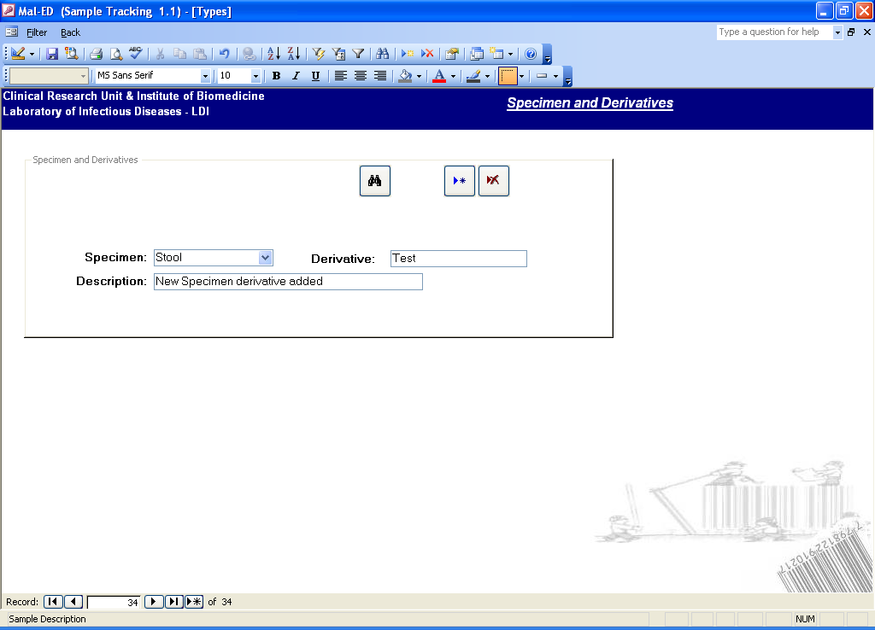

Fig. 20

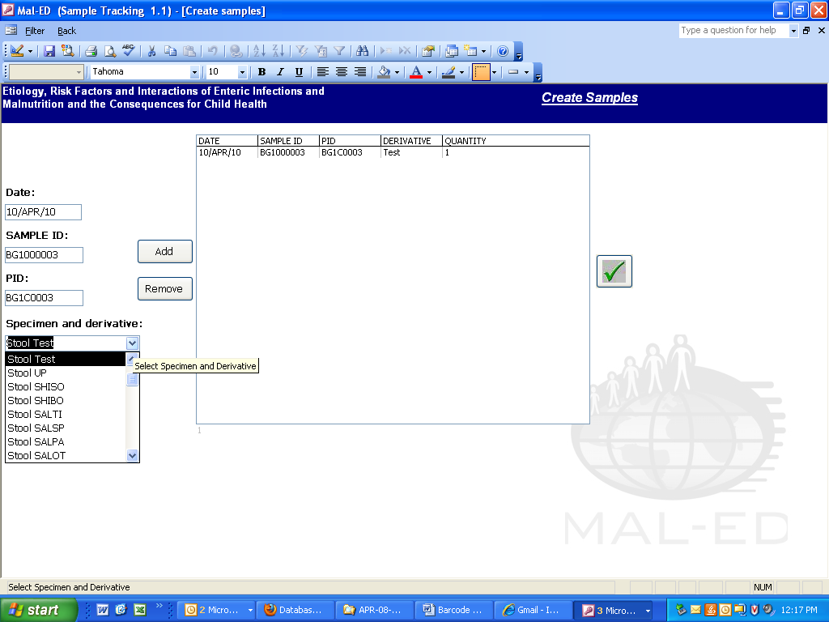

Fig. 21

**View:**

Users can view samples created in the database with different tree views, Fig. 22.

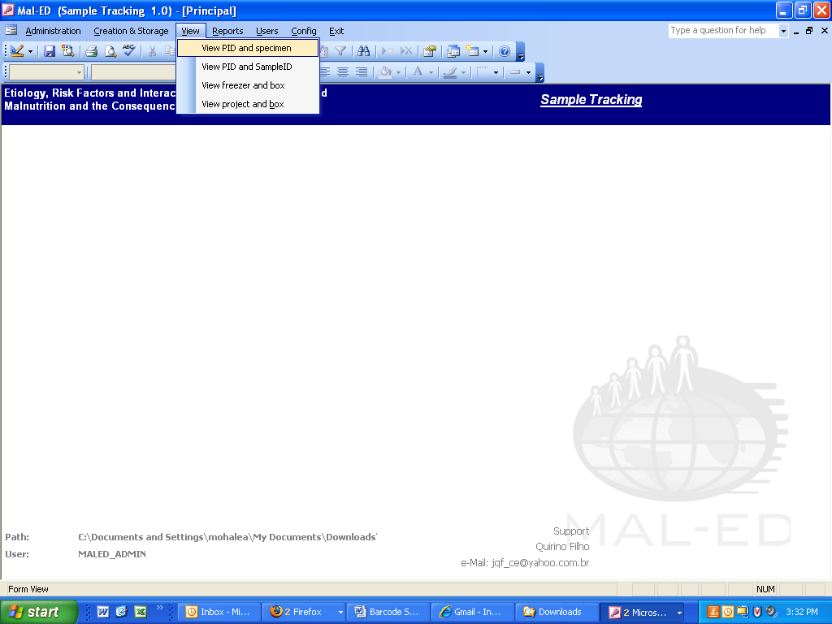

Fig. 22

View 🡪 View PID and specimen

This view displays samples grouped by PID and then by Specimen derivative, Fig. 23.

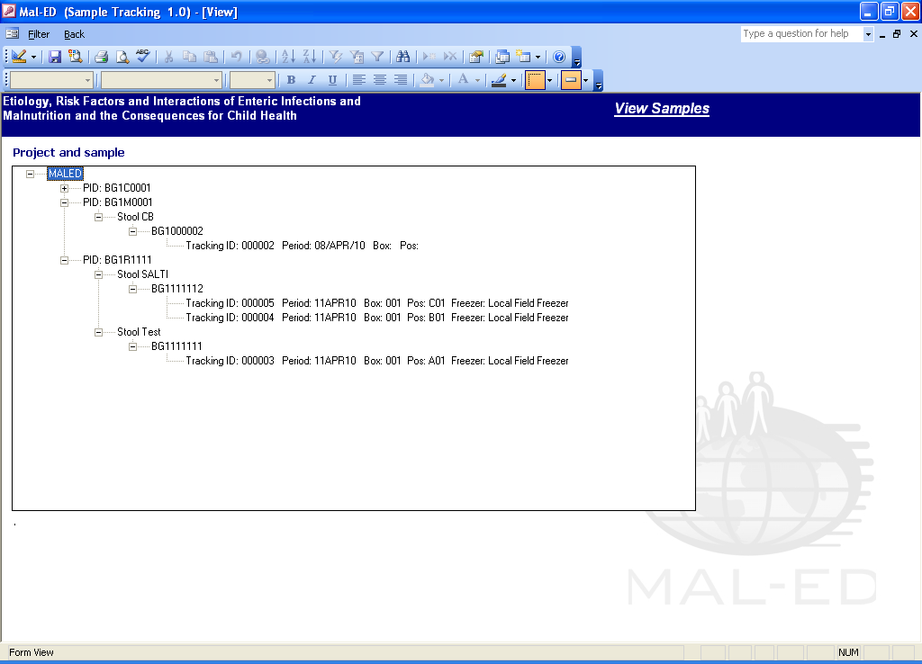

View 🡪 PID and Sample ID

This view displays samples grouped by PID and then by Sample ID. Fig. 24.

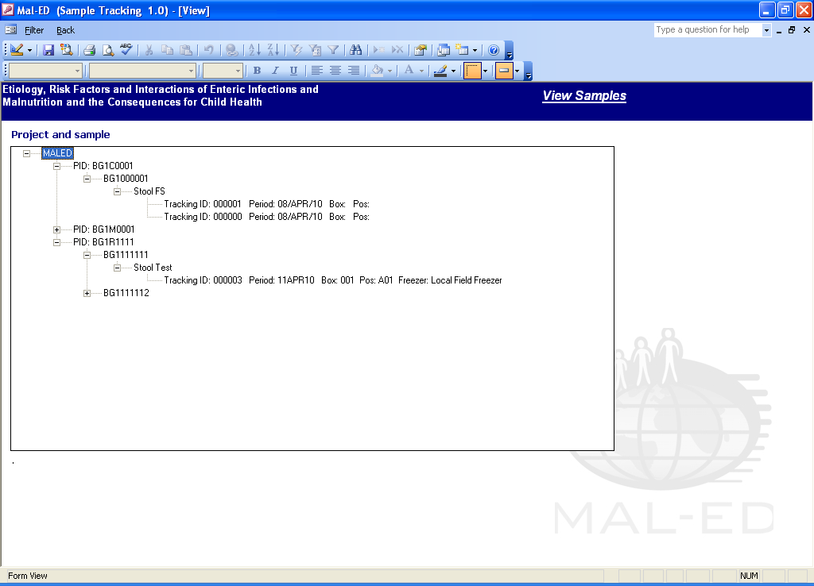

Fig. 24

View 🡪 Freezer and box

This view displays samples stored in each freezer and the box position. Fig. 25.

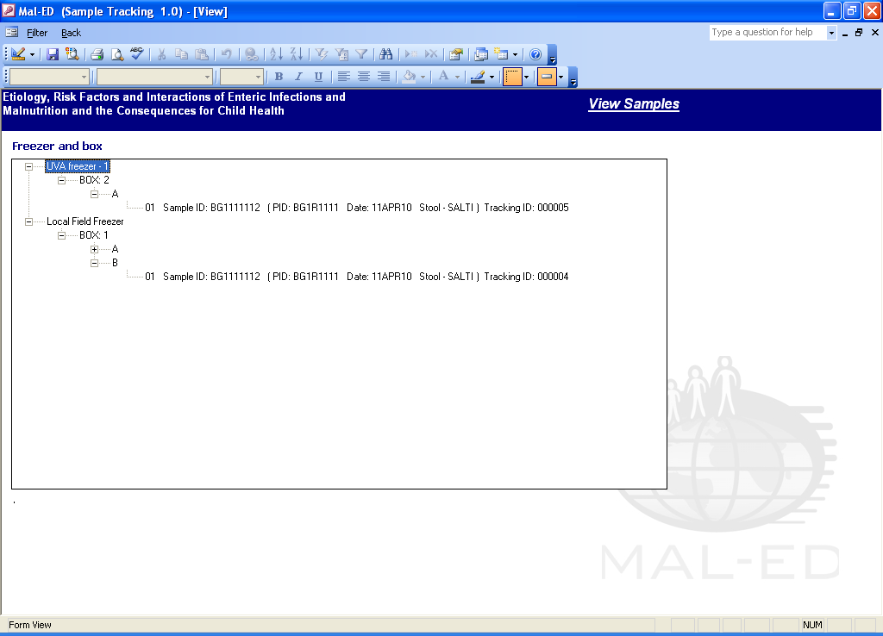

Fig. 25

View 🡪 Project and box

This view displays samples in each box for MALED project. Fig. 26.

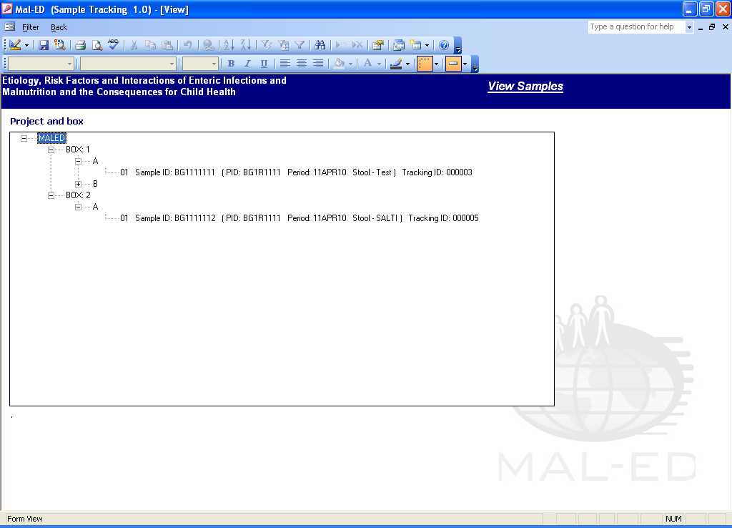

Fig. 26

***New with Release 1.2 (10 April, 2010)***

**Transfer Samples database**:

MALED_TransferSamples.mdb application will be used by sites that have different field lab station and main lab station. Sites that create samples at their field processing station and would like to transfer the samples to their lab can utilize this application by following these steps:

1. Save MALED_TransferSamples.mdb in the same folder as MALED_BarcodeSampleTracking_be.mdb, Fig. 27.

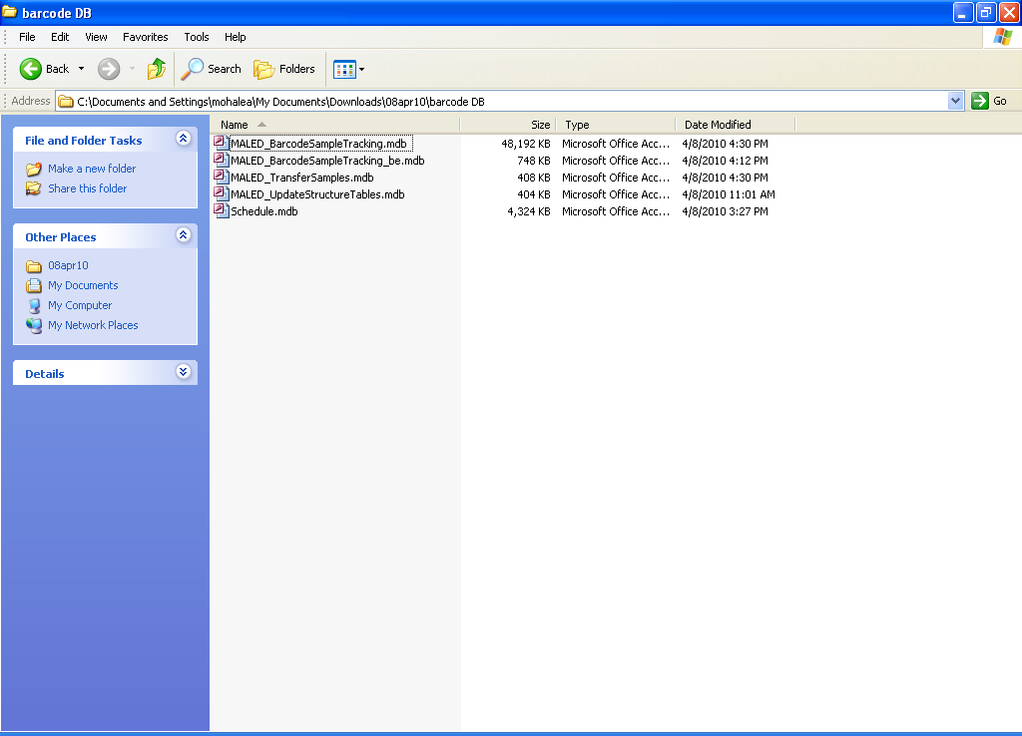

Fig. 27

1. Open MALED_TransferSamples.mdb and scan 2D barcode label from samples created field processing station, Fig. 28.

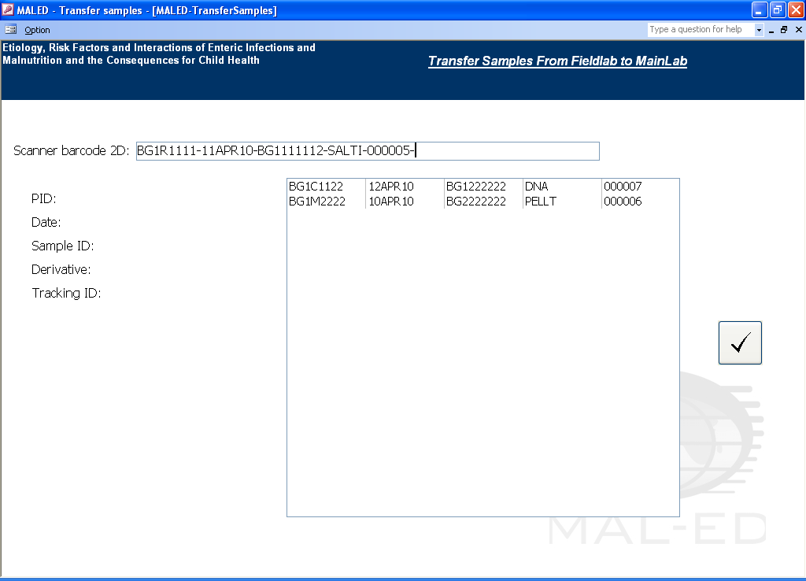

Fig. 28

1. Click the √ to include the samples in the main lab site database. The confirmation pop-up appears. Fig. 29.

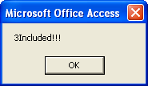

Fig. 29

***New with Release 1.2 (10 April, 2010)***

**Config:**

**Hostname or IP address:**

This option will also be useful for sites that require printing using one printer and different workstations connected via network.

1. Set one computer as MAIN. Install zebra printer driver, see Appendix II and connect the printer.
2. Connect other computers, WORKSTATIONS, to the MAIN computer through network.
3. From any WORKSTATION, open MALED_BarcodeSampleTracking.mdb, click on Config menu item. Fig. 30.
4. Enter IP address or Host name of the MAIN computer to which the barcode printer is connected.
5. The workstation will now be able to use the barcode database and print labels to the barcode printer.

**Blocked Number:**

This option will be used by sites that have different field and lab stations and would like to create sample at different processing stations and transfer samples to main lab site.

1. Enter the tracking ID for the database application at the field site or main lab site to initiate unique sample creation.
2. This will avoid duplication of tracking ID when samples are created at different processing stations and transferred to main lab station.

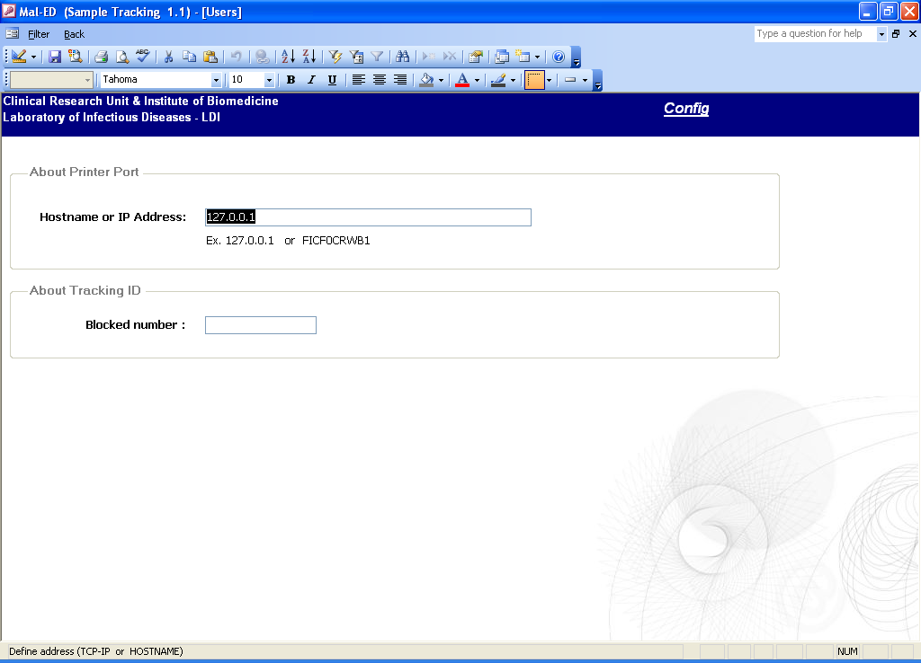

Fig. 30

**APPENDIX I**

**Barcode Sample Tracking Workflow**

This is an example workflow. Different sites may have slightly different protocol.

Pre-printed labels are provided to the Field worker (FW).

FW goes to participant’s home/clinic, collects sample and puts the pre-printed label on the bottle and marks sample type, date and time.

FW completes the collection forms at the time of sample collection.

FW delivers sample to lab. Waits while lab person generates Sample ID using logbook

Lab person hand writes Sample ID on bottles and completes the sample receiving form

The FW leaves.

Lab person prints freezer safe labels for storage/archive tubes using barcode sample tracking database.

Lab tests are performed and more freezer safe labels are printed from the barcode sample tracking database for freezing the bacterial isolates.

**APPENDIX II**

**Barcode Printer and Scanner setup**

**Barcode Printer setup and Driver installation instructions**

1. Insert Zebra printer CD included with the barcode printer in the CD drive.
2. If CD does not auto run, double click on **RunCD.**

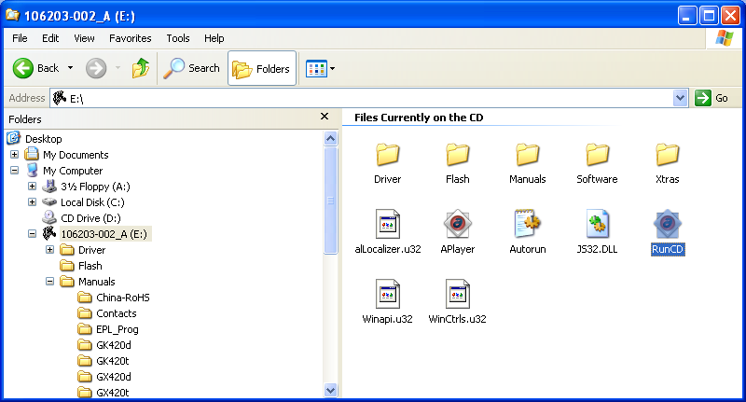

1. Select GK420t from the menu.

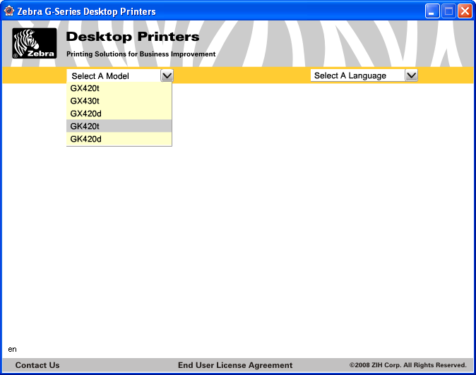

1. Follow the instructions to connect printer to the desktop, load media and install printer driver.

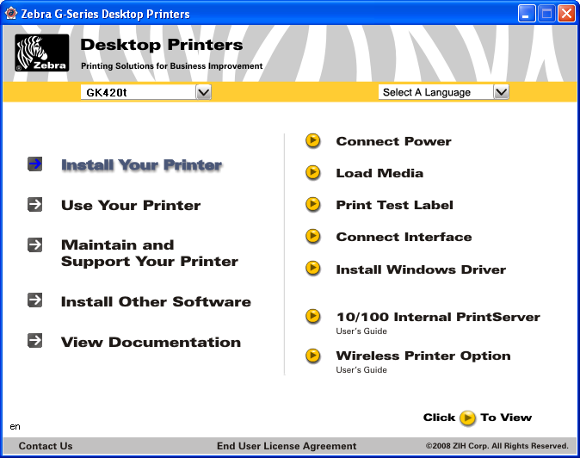

1. Once the printer is connected to the desktop and turned on, Windows should automatically recognize the printer and give pop-up.

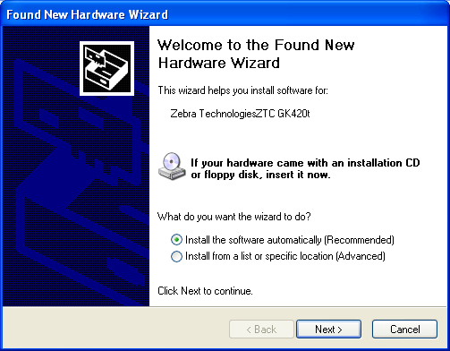

1. Click Ok and start installation. The below screen appears. Select driver and click Next.

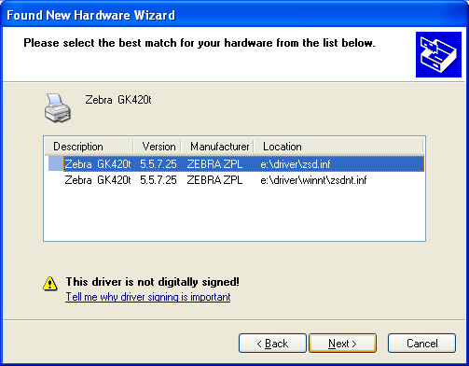

1. Click “Continue Anyway”.

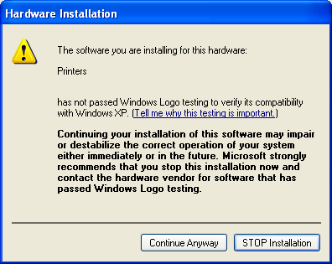

1. Driver installation begins.

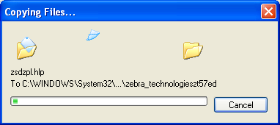

1. Click Finish once installation is complete.

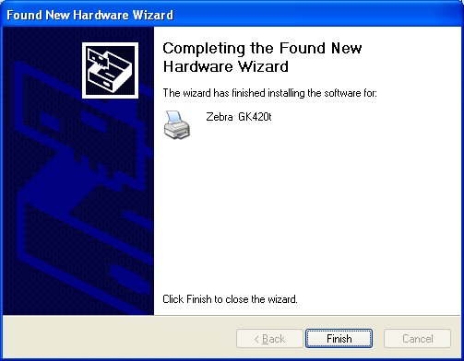

1. If the pop-up does not appear automatically, refer to the instructions on CD and click on “Install Windows Driver. On clicking, following screen appears that provides instructions to load the driver.

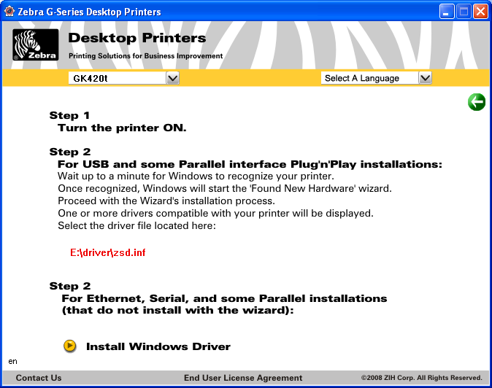

1. Check under Printer and Faxes, (Start 🡪 Control Panel 🡪 Printers and Faxes), the “Zebra GK 420t” printer is available.

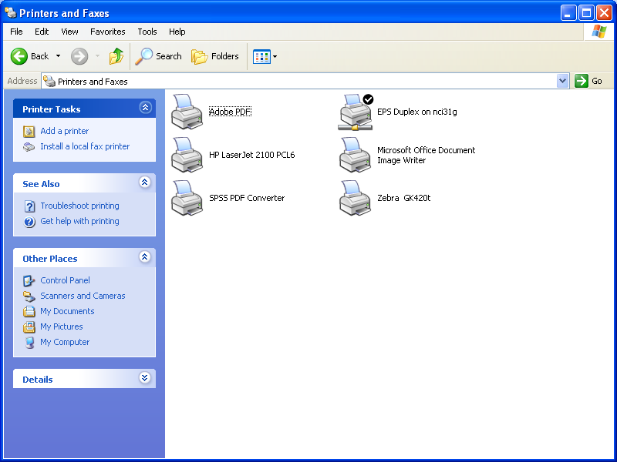

1. Share the Zebra GK 420t printer by right-clicking on it and selecting “Sharing…”

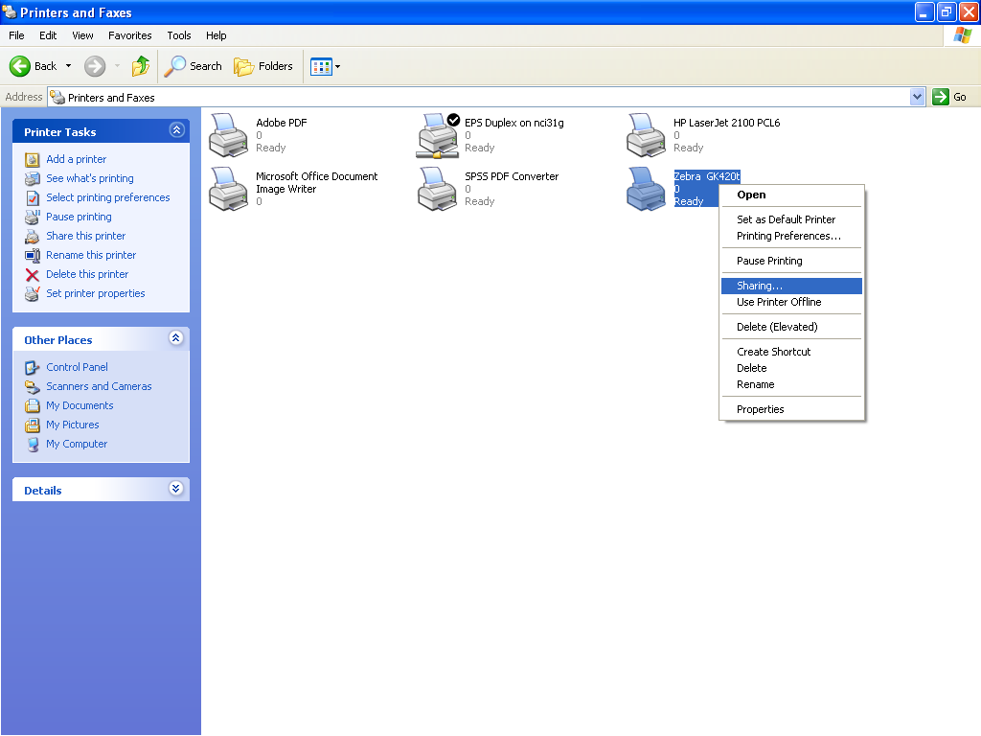

1. Select “Share this printer” and provide share name as **Zebra**. Click OK.

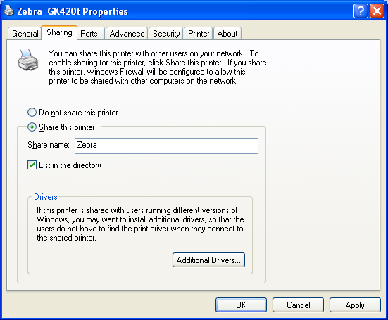

1. The below printer icon appears for shared printer.

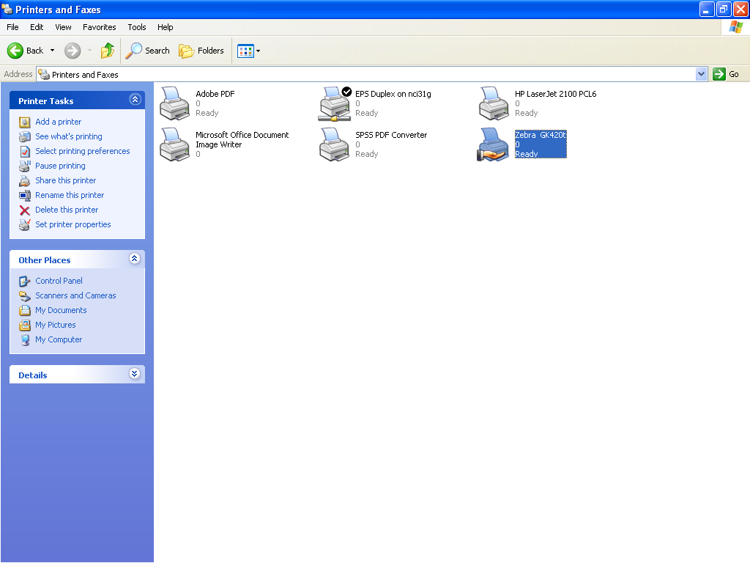

1. Printer setup and installation is complete.

**Scanner setup**

**Installing the Interface Cable**

1. Plug the interface cable modular connector into the cable interface port on the bottom of the scanner handle.
2. Gently tug the cable to ensure the connector is properly secured.
3. Connect the other end of the interface cable to the USB drive in the desktop.
4. An acknowledgement beep could be heard.
5. See DS6707 Quick start Guide for detailed instructions.

**APPENDIX III**

1. **Participant ID**

* Unique identifier for participating children will consist of eight alphanumeric characters with the following format:

|  |  |  |  |  |  |  |  |
| --- | --- | --- | --- | --- | --- | --- | --- |
| A1 | A2 | N1 | A3 | N1 | N2 | N3 | N4 |
| Site ID | | | Subject | Subject ID | | | |

* **Site IDs** will have three alphanumeric digits, where A1-A2 identifies the country (e.g. Bangladesh - BG, Brazil - BR, India - IN, Nepal - NP, Peru - PE, Pakistan - PK, Tanzania - TZ, South Africa - SA) and N1 identifies different field sites within one country
* A3 identifies the type of **subject**. Subject codes are as follows:

|  |  |
| --- | --- |
| C | Study child |
| M | Mother |
| F | Father |
| S | Sibling |
| R | Relative |
| N | Non-relative household member |

* **Subject ID** N1-N4 span 0001 to 9999
  + Total of 9,999 subjects can be enrolled at any particular field site
  + Ideally, household members should have the same subject code (e.g., BG1C0001 and BG1M0001, indicate child-mother pair in Bangladesh site 1)
  + **This coding is constructed under the assumption that only 1 child will be recruited per household, to avoid the need to control for clustering.**

1. **Sample ID**

* A unique identifier for samples collected from participants will consist of 9 alphanumeric characters with following format:

|  |  |  |  |  |  |  |  |  |
| --- | --- | --- | --- | --- | --- | --- | --- | --- |
| A1 | A2 | N1 | N1 | N2 | N3 | N4 | N5 | N6 |
| Site ID | | | Sample counter | | | | | |

* **Site IDs** will have three alphanumeric digits, where A1-A2 identifies the country (e.g. Bangladesh - BG, Brazil - BR, India - IN, Nepal - NP, Peru - PE, Pakistan - PK, Tanzania - TZ, South Africa - SA) and N1 identifies different field sites within one country
* **Sample counter** N1-N6 span 000001 to 999999
  + Total of 999,999 samples can be collected at any particular field site.

1. **Specimen Derivative**

|  |  |  |
| --- | --- | --- |
| **Primary** | **Specimen Derivative** |  |
| Stool (micro) | CB | One Cary-Blair Stool collected in the field |
| Stool  (micro, gut function) | UP | One Unpreserved Stool collected in the field  Four aliquots prepared in lab (is this always true?) |
| Stool (micro) | FS | One Formol-Saline collected in the field |
| Lab Process  (micro) | DNA | As needed in the lab only |
| Lab Process (Micro) | I-1-organism code * | As needed in the lab Only |
| Urine (gut function) | LM | L:M |
| Urine (gut function) | IODN | Iodine |
| Blood | PELLT | Pellet |
| Blood | SERUM | Serum |
| Saliva | Saliva | n/a |

* Organism codes listed here (for specimen derivatives):

|  |  |
| --- | --- |
| **Organism** | **Code** |
| Salmonella Typhi | SALTI |
| Salmonella Paratyphi A | SALPA |
| Salmonella Cholerasuis | SALCH |
| Salmonella Gallinarum | SALGL |
| Salmonella spp | SALSP |
| Salmonella GpB | SALGB |
| Salmonella GpC | SALGC |
| Salmonella GpD | SALGD |
| Other Salmonella | SALOT |
| Shigella boydii C | SHIBO |
| Shigella sonnei D | SHISO |
| Shigella sp non-typable | SHNTY |
| Aeromonas spp | AERSP |
| Aeromonas hydrophila | AERHY |
| Plesiomonas shigilloides | PLESH |
| Yersinia enterocolitica | YEREN |
| Vibrio cholera | VIBCH |
| Vibrio Parahaemolyticus | VIBPA |
| Vibrio cholera 01,Inaba | VIBCI |
| Vibrio cholera 01,Ogawa | VIBCO |
| Vibrio cholera 0139 | VIBCN |
| Campylobacter jejuni | CAMJE |
| Campylobacter spp | CAMSP |
| Isolate archived for further testing | IAFFT |